Synthesis of Novel Pyridine and Pyrimidine Thioglycoside Phosphoramidates for the Treatment of COVID-19 and Influenza A Viruses

Mamdouh A. Abu-Zaiedª, Galal H. Elgemeie^{b*}, Fathi T. Halaweish^{c} and Sherif F. Hammad^{d,e}
ªGreen Chemistry Department, National Research Centre, Dokki, Giza, Egypt; ^{b}Chemistry Department, Faculty of Science, Helwan University, Helwan, Cairo, Egypt; ^{c}Department of Chemistry & Biochemistry, South Dakota State University, Brookings, SD 57007, USA; ^{d}Pharmaceutical Chemistry Department, Faculty of Pharmacy, Helwan University, Helwan, Cairo, Egypt; ^{e}Basic and Applied Sciences Institute, Egypt-Japan University of Science and Technology, New Borg El-Arab City, Alexandria, Egypt.

s₁
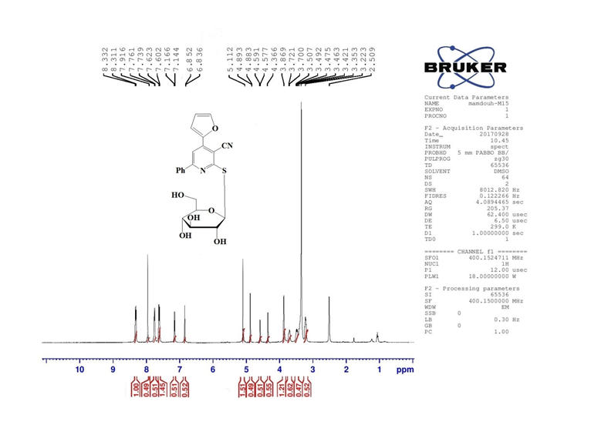
Figure s₁: ¹H-NMR spectrum of compound 4a

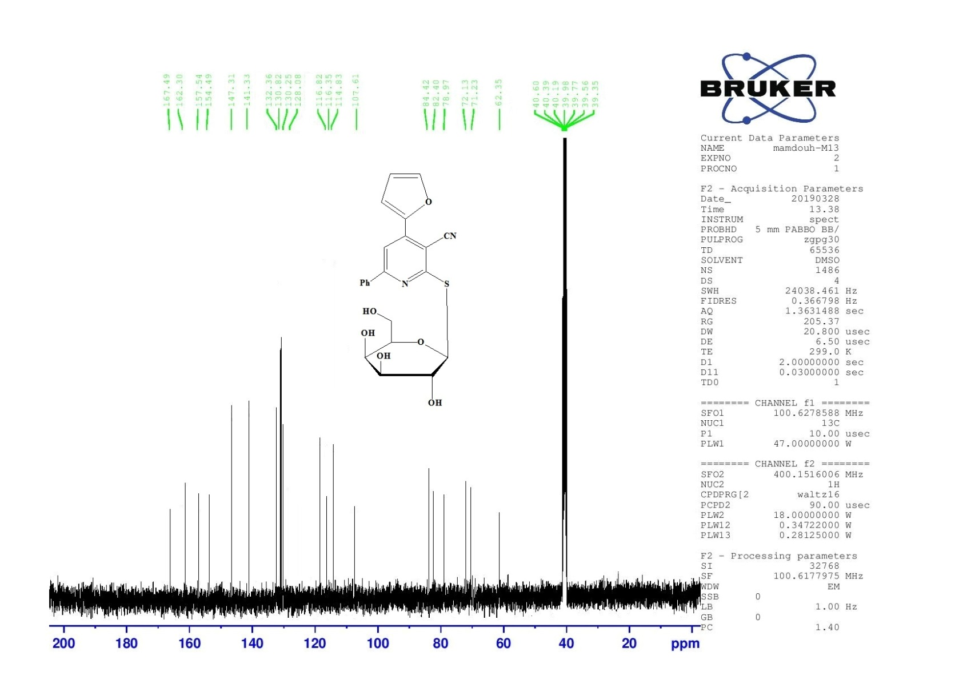
s₂

figure s_{2:}¹³C NMR of compound 4b

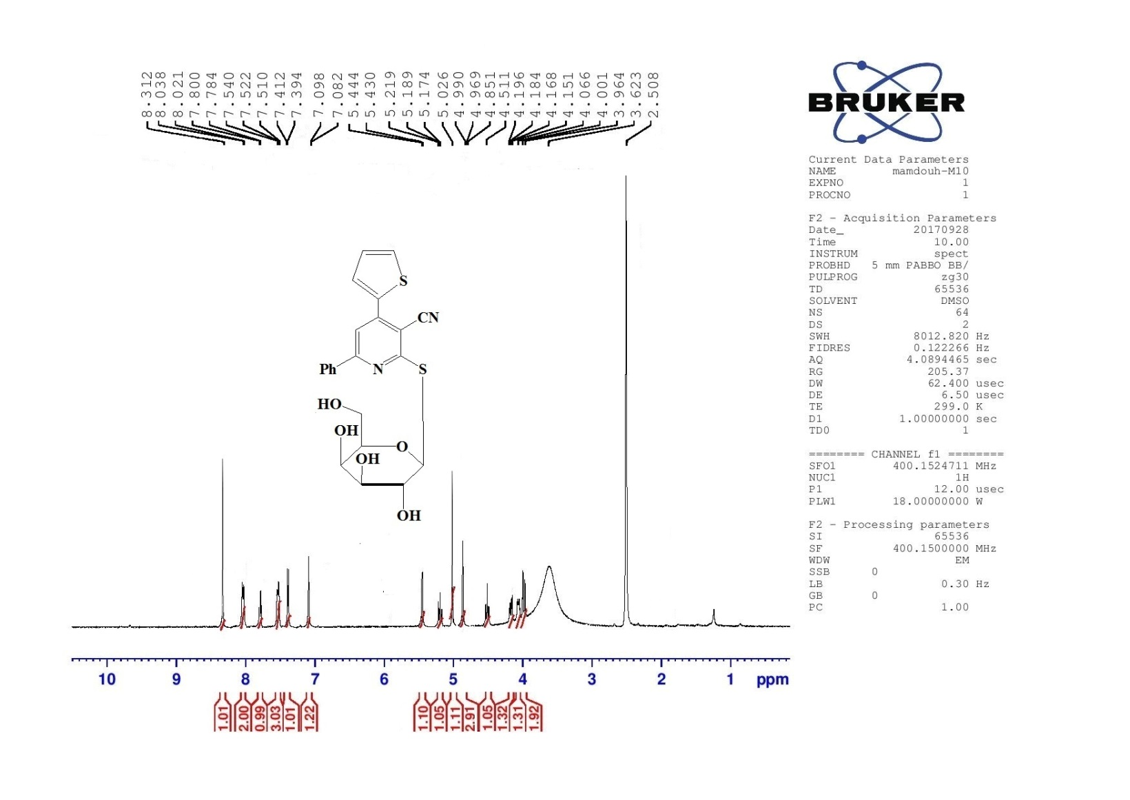
s₃
figure s₃: ¹H NMR of compound 4c

s₄
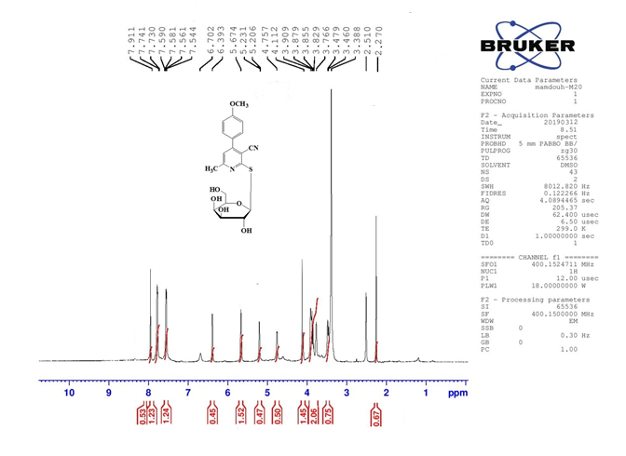
Figure s₄: ¹H NMR of compound 4e

s₅
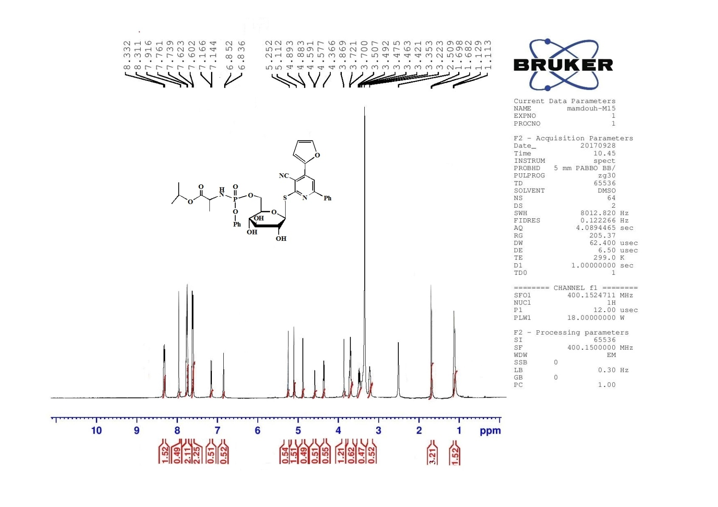
figure s_{5:} ¹HNMR of compound 6a

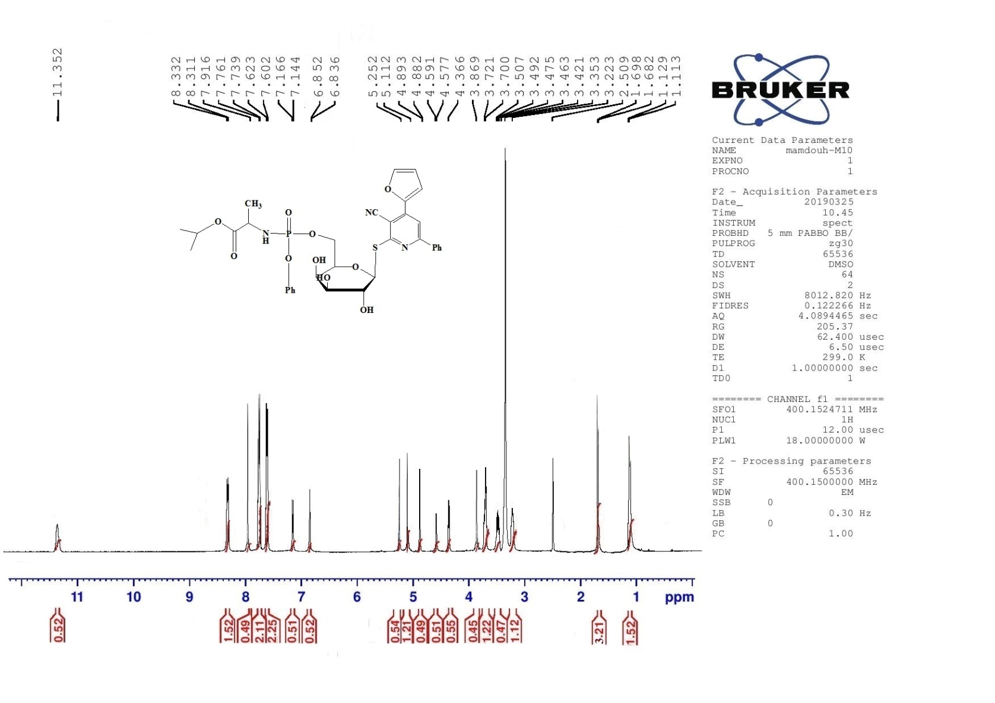
s₆
figure s₆: ¹HNMR of compound 6b

s₇
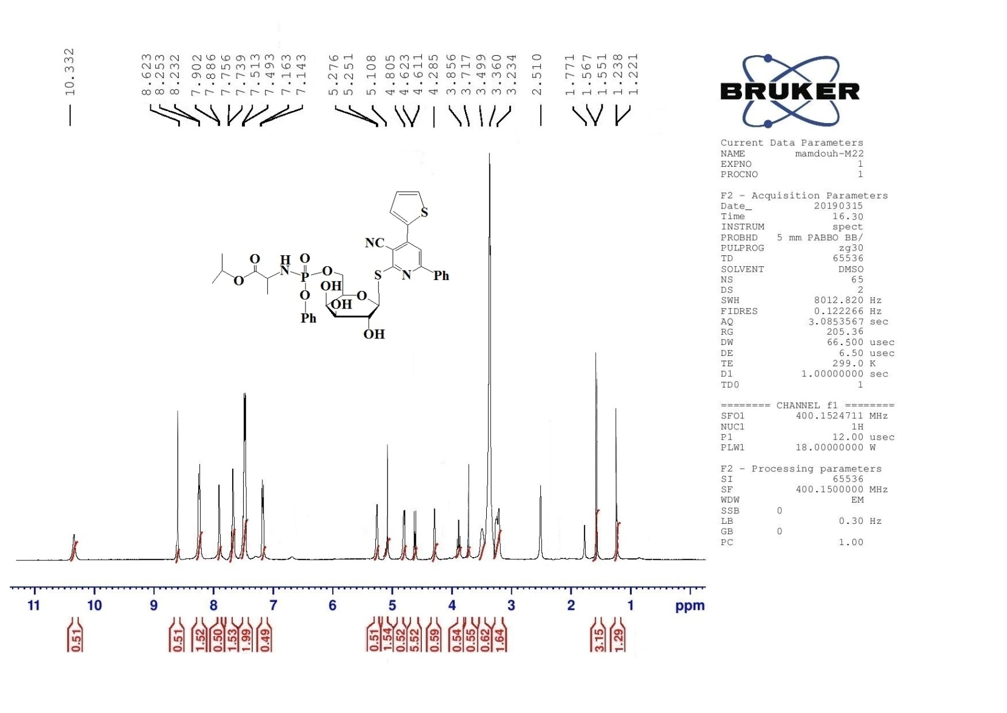
figure s₇: ¹HNMR of compound 6c

S₈
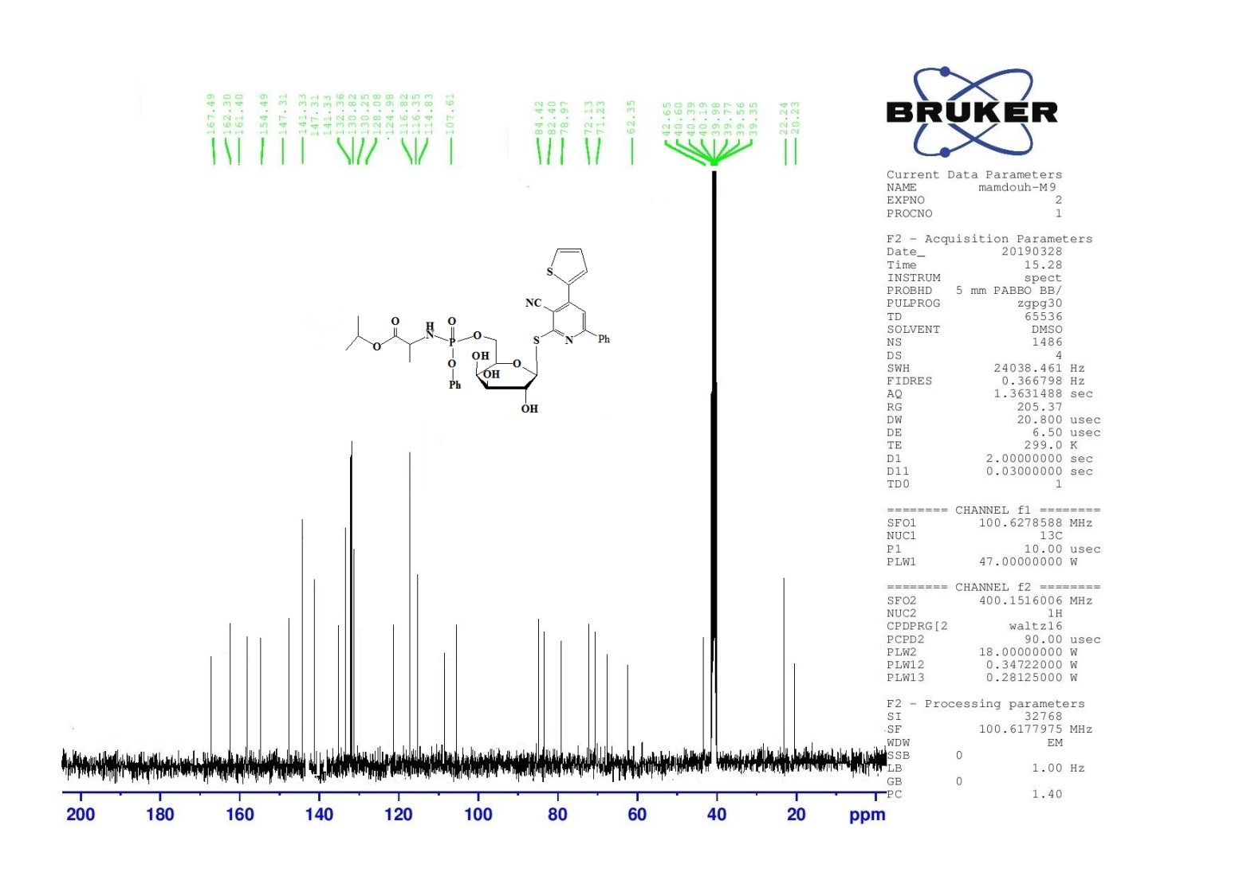
Figure s₈: ¹³C NMR of compound 6c

S₉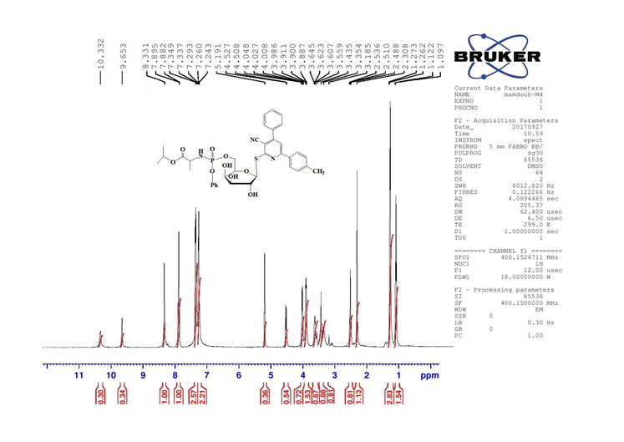 figure s₉: ¹H NMR of compound 6d

S₁₀
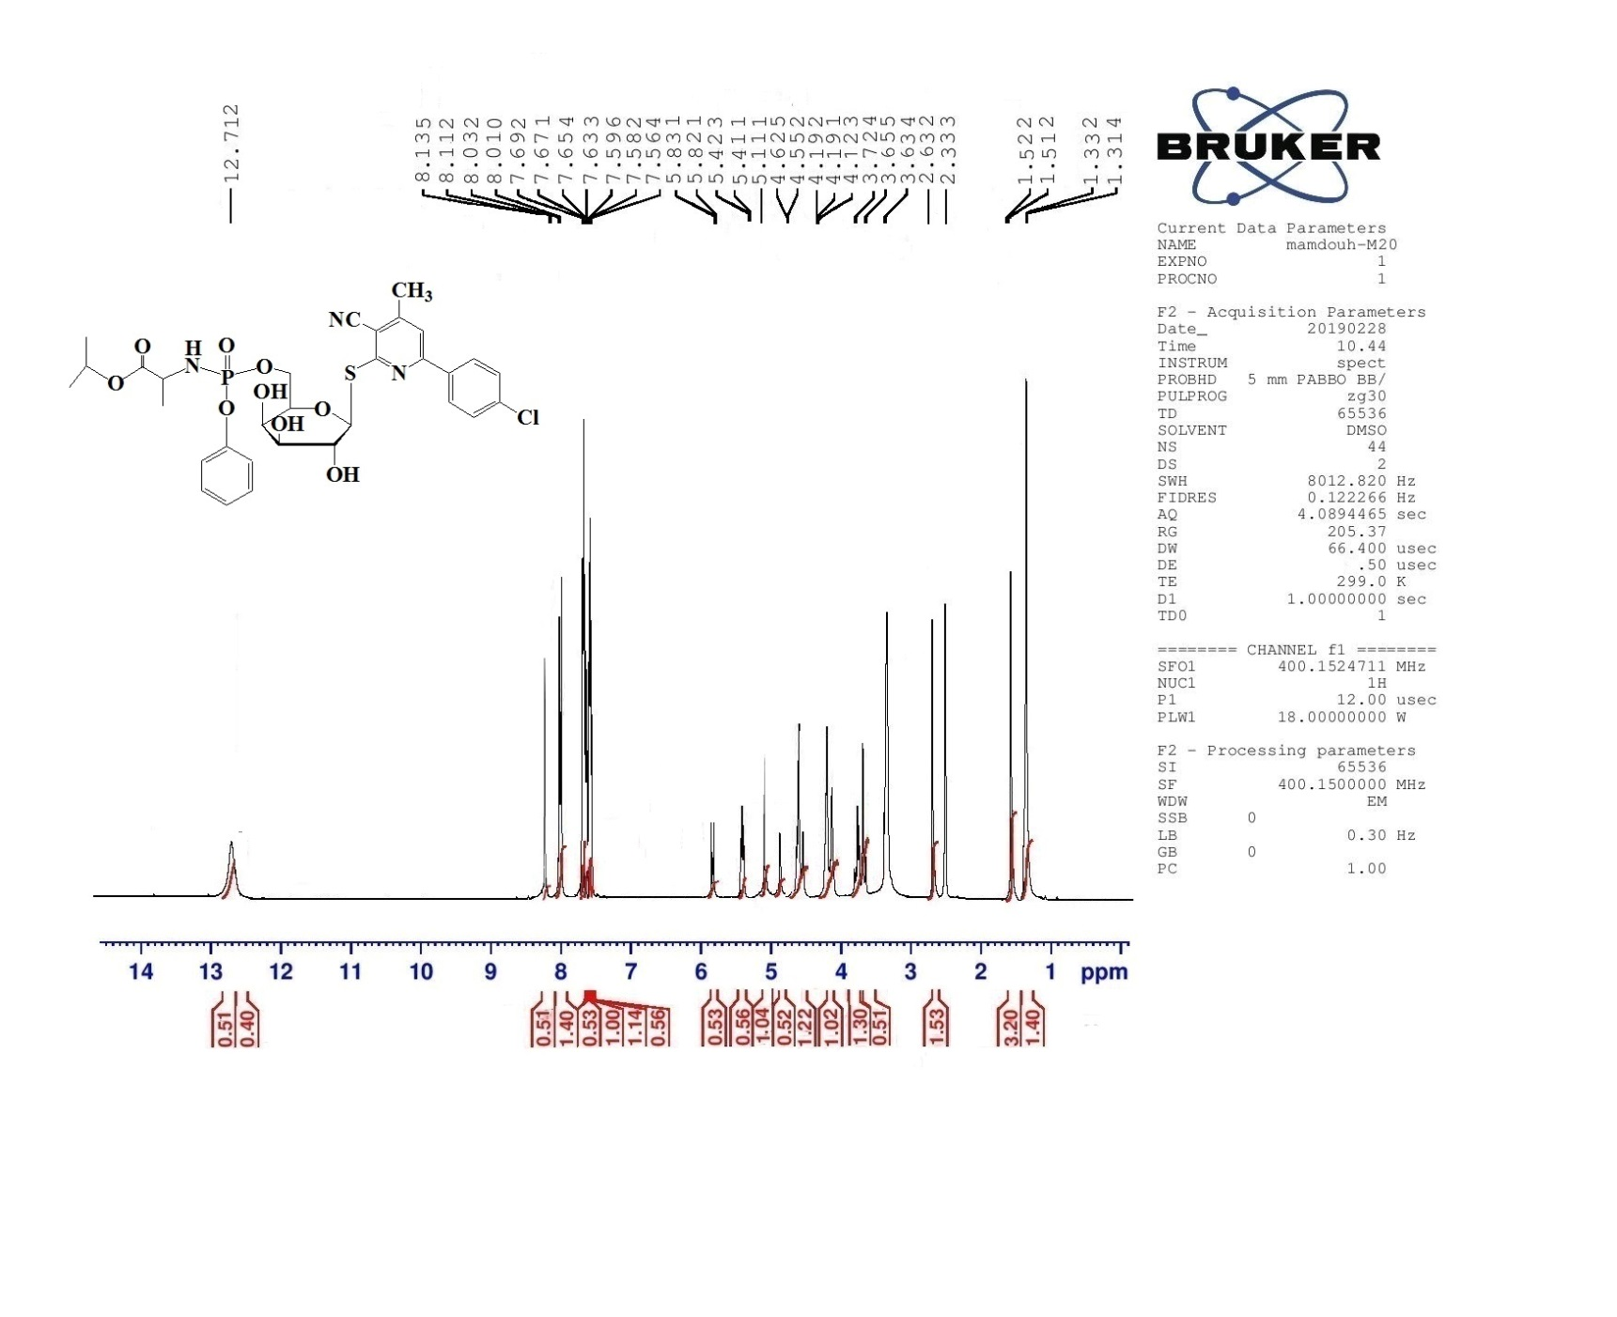
Figure s₁₀: ¹H NMR of compound 6f

S₁₁
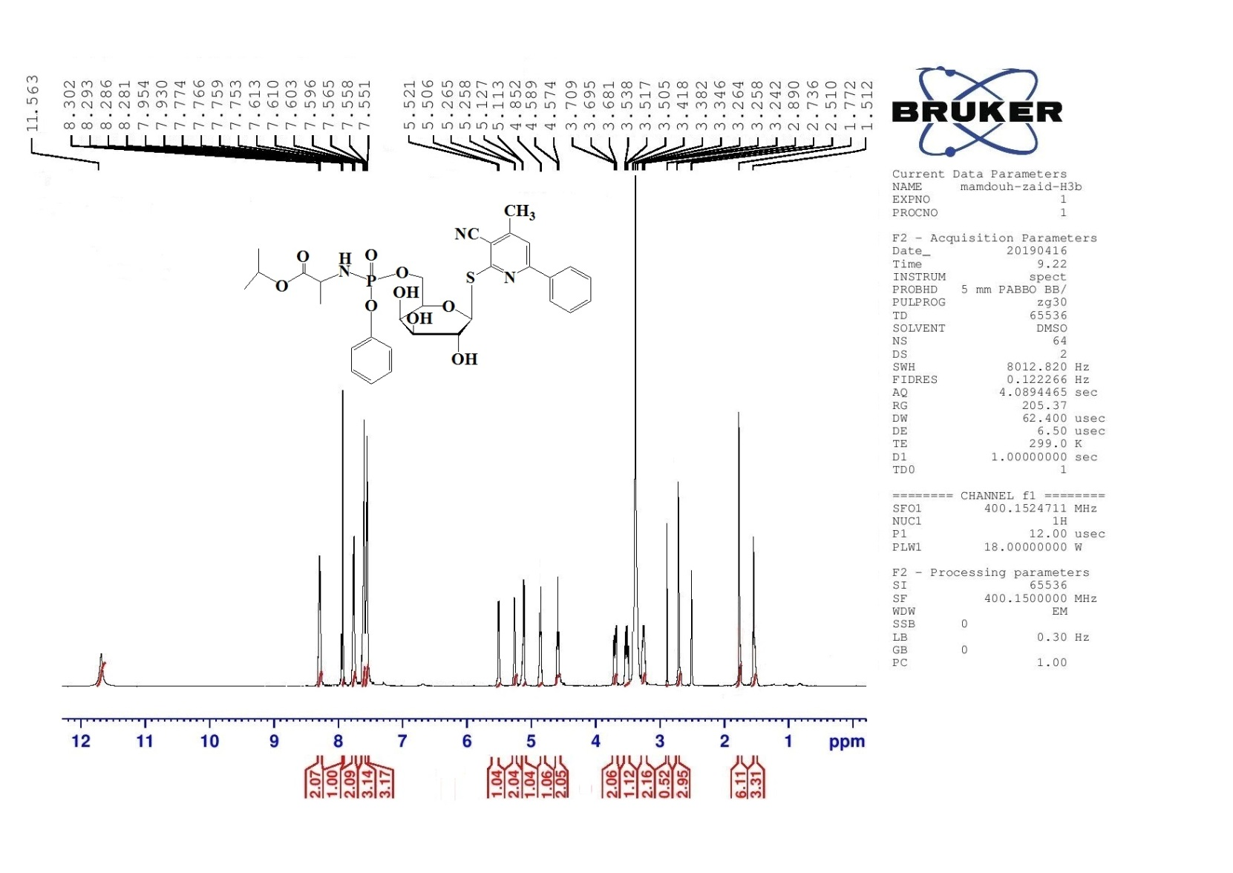
Figure s₁₁: ¹H NMR of compound 6g

S₁₂

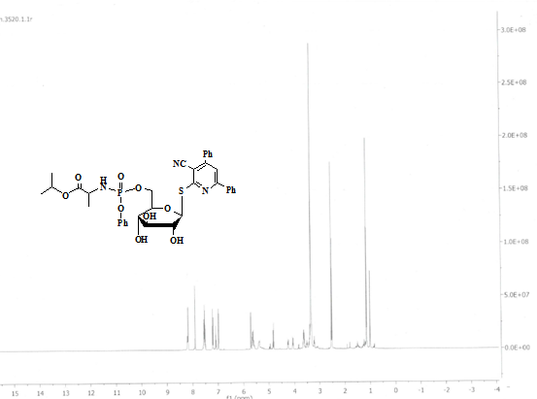
Figure s₁₂: ¹H NMR of compound 6h

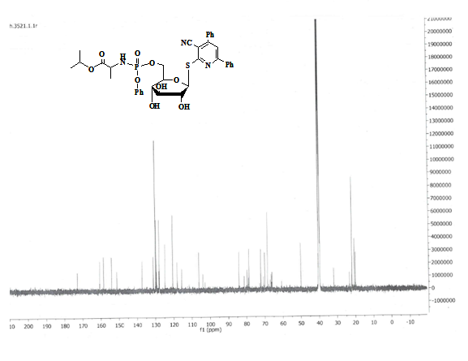
Figure s₁₃: ¹³C NMR of compound 6h

S₁₄

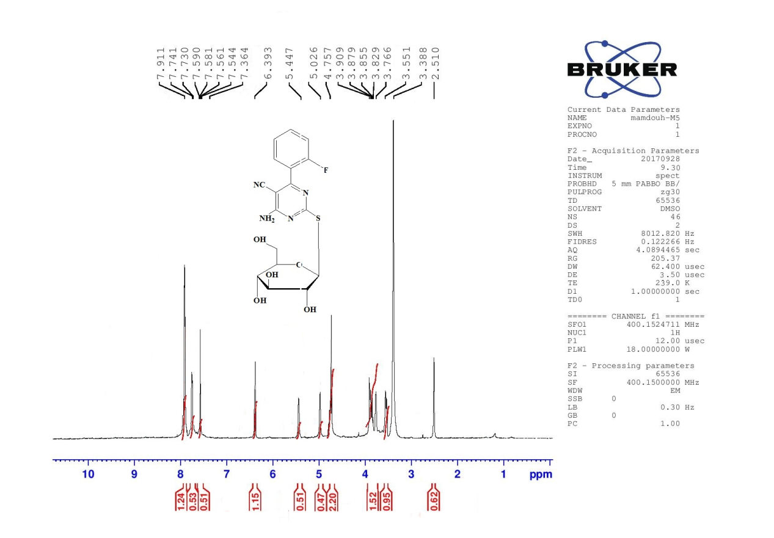
Figure s₁₄: ¹H NMR of compound 9a

S₁₅

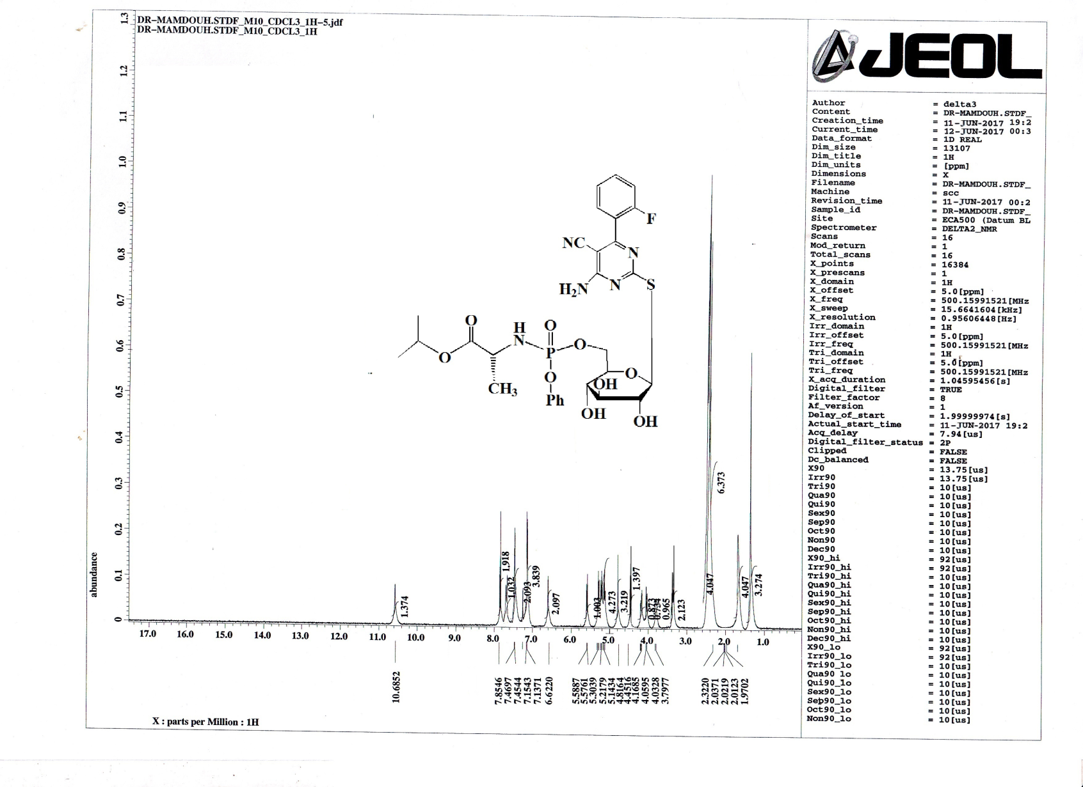
Figure s₁₅: ¹H NMR of compound 10a

S₁₆

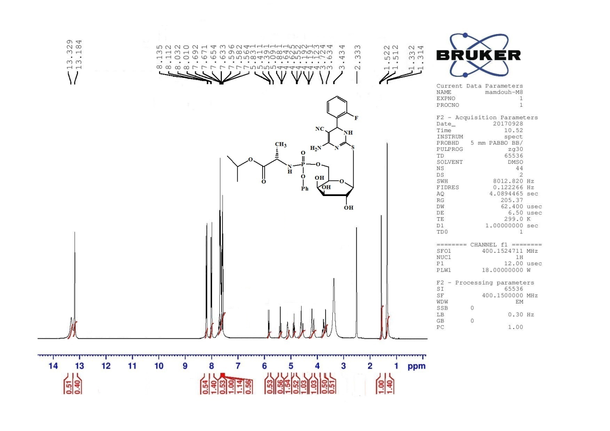
Figure s₁₆: ¹H NMR of compound 10b

S₁₇
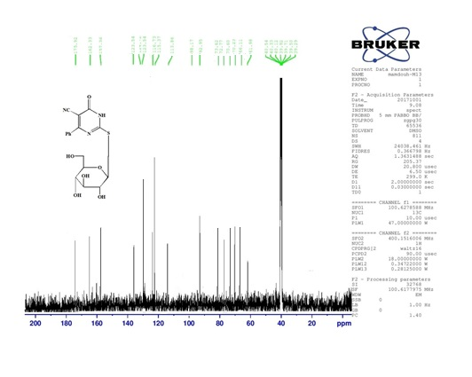
Figure s₁₇: ¹³C NMR of compound 13a

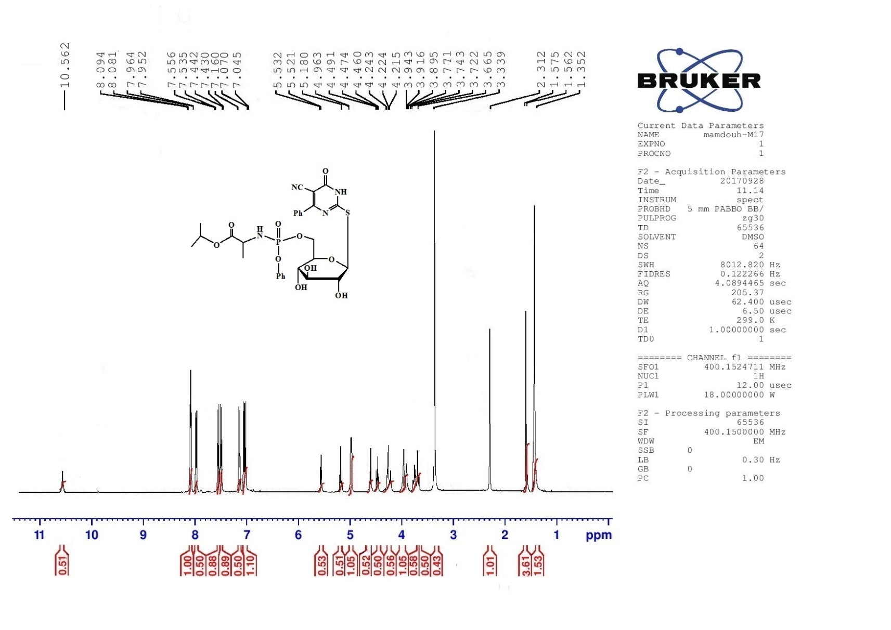
s₁₈
figure s₁₈: ¹H NMR of compound 14a

S₁₉
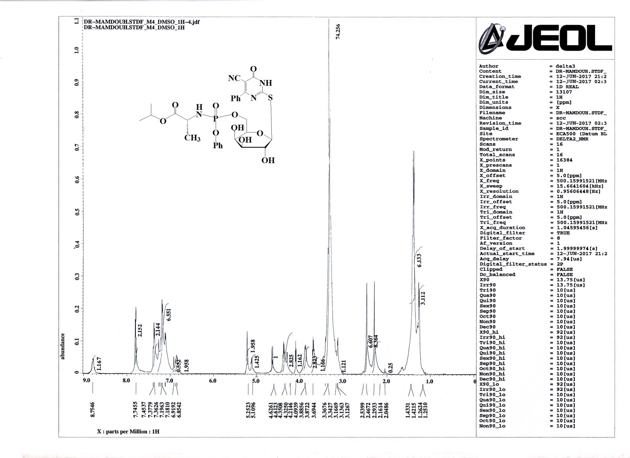

Figure s₁₉: ¹H NMR of compound 14b

S₂₀

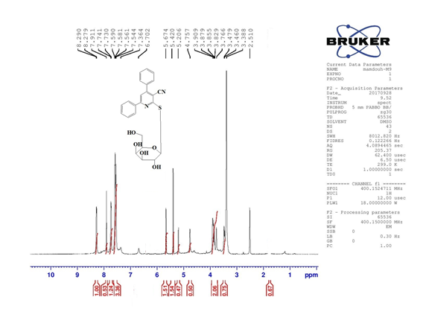
Figure s₂₀: ¹H NMR of compound 4i

S₂₁
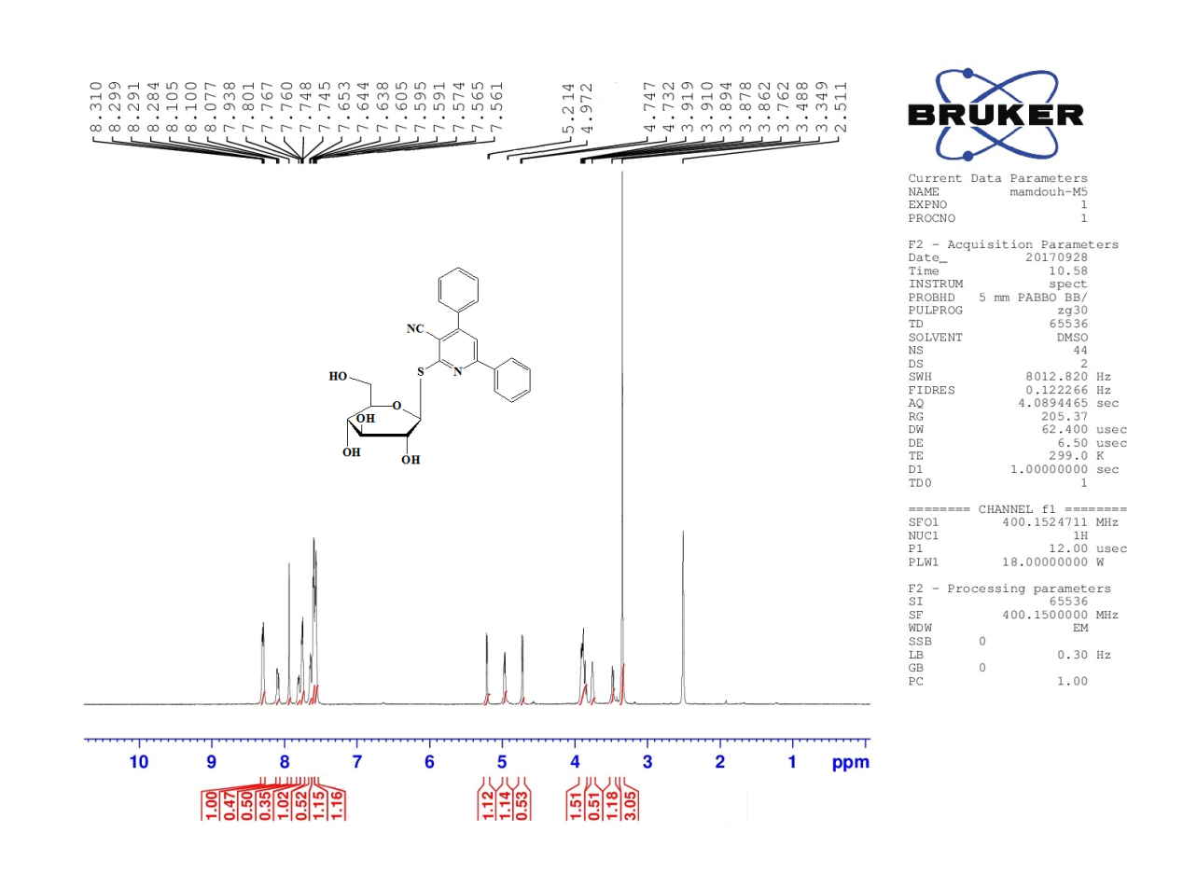
Figure s₂₁: ¹H NMR of compound 4h

S₂₂

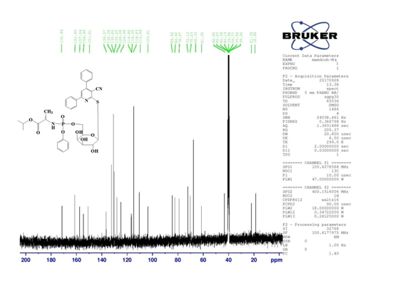

Figure s₂₂: ¹³C NMR of compound 6i

S₂₃
Inhibition %
Compd.No.
Figure 1. Cytotoxicity of compounds 4a, 4b, 4c, 4d, 4e, 4h and 4i at concentration 0.25 and
0.125 µM.

S₂₄

Inhibition %
Compd. No.
Figure 2. Cytotoxicity of compounds 6a, 6b, 6d, 6e, 6f, 6g and 6h at concentration 0.25
and 0.125 µM.

S₂₅

.
Compd. No.
Inhibition %
Figure 3. Cytotoxicity of compounds 9a, 9b, 10a, 10b, 14a and 14b at concentration
0.25 and 0.125 µM.

S₂₆

Figure 4. Graphs of Inhibitory concentration 50 (IC₅₀) of tested compounds (4a.4b, 4c, 4d, 4e, 4i, 6a, 6b, 6d, 6e, 6f, 6g, 9a, 9b, 10a, 10b, 14a and 14b): Antiviralactivity against Severe Acute Respiratory Syndrome Corona virus 2 (SARS-CoV-2) (hCoV19/Egypt/NRC-03/2020 (Accession Number on GSAID: EPI_ISL_430820.

S₂₇

Figure 5. Graphs of Cytotoxicity concentration 50 (CC₅₀) of tested compounds (4a.4b, 4c, 4d, 4e, 4i, 6a, 6b, 6d, 6e, 6f, 6g, 9a, 9b, 10a, 10b, 14a and 14b): on Vero E6 cells

