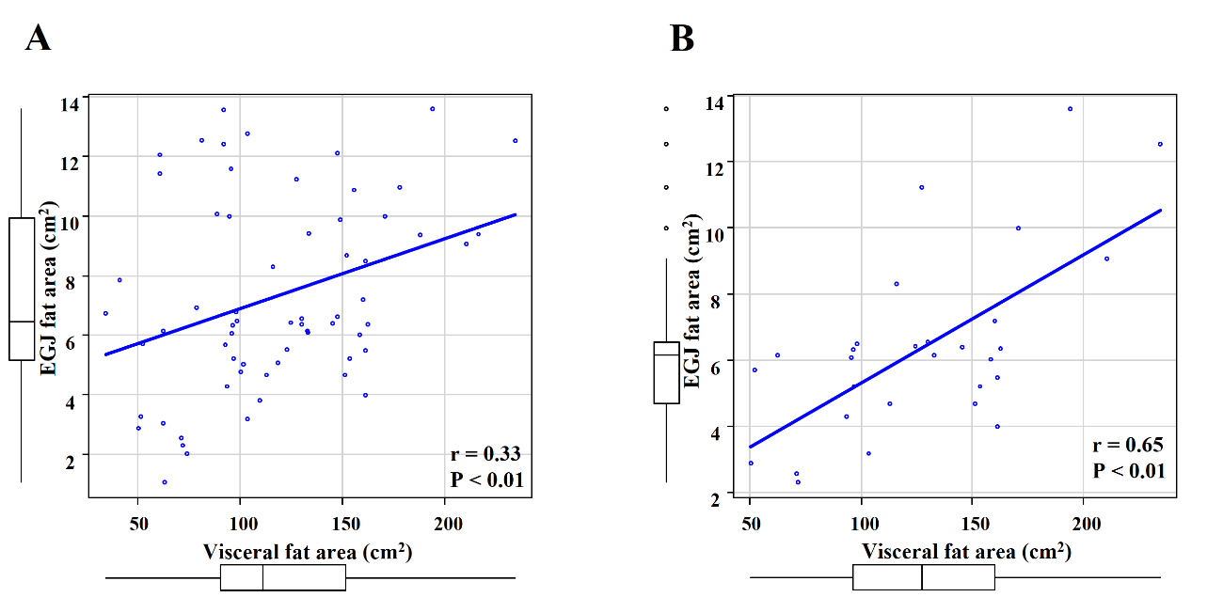
Supplementary Figure 1. Correlation coefficients between the EGJ fat areas and visceral fat areas among the entire EGJAC cases (A) and EGJAC cases with absent- or closed-type gastric mucosal atrophy (B). EGJ: esophago-gastric junction, EGJAC: esophago-gastric junctional adenocarcinoma.

