Supplemental figure

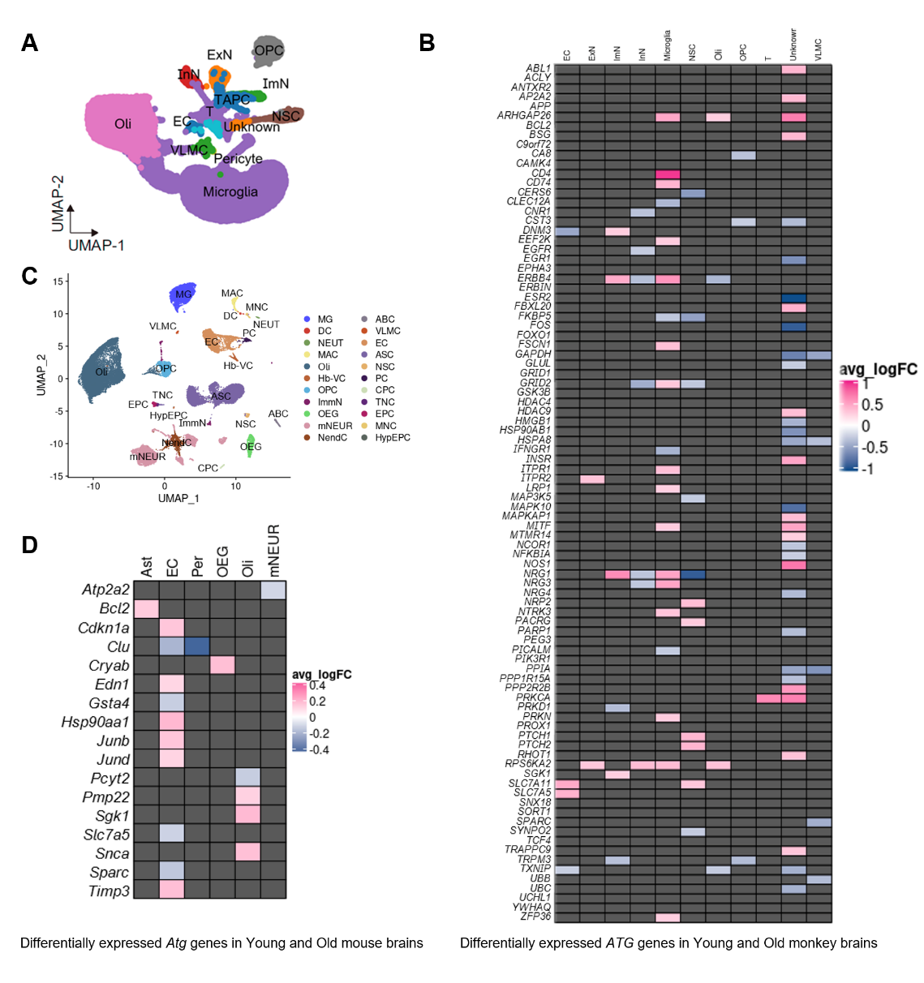
Fig. S1. Dissection of aging-associated expression of Atg genes in monkey and mouse brains. (A) UMAP plots showing the distribution of different cell types in young and aged monkey brains. EC, endothelial cells; ExN, excitatory neurons; ImN, immature neurons; InN, inhibitory neurons; Microglia; NSC, neural stem cells; Oli, oligodendrocytes; OPC, oligodendrocyte progenitor cells; T, T cells; a kind of cells with unknown function, Unknown; VLMC, vascular leptomeningeal cells. (B) Heat map showing differentially expressed Atg genes in indicated cell types between old and young monkey brains. (C) UMAP plots showing cell types in young and aged mouse brains. OPC, oligodendrocyte precursor cells; Oli, oligodendrocytes; OEG, olfactory ensheathing glia; NSC, neural stem cells; ARP, astrocyte-restricted precursors; ASC, astrocytes; NRP, neuronal restricted precursors; ImmN, immature neurons; mNEUR, mature neurons; NendC, neuroendocrine cells; EPC, ependymocytes; HypEPC, hypendymal cells; CPC, choroid plexus epithelial cells; TNC, tanycytes; EC, endothelial cells; PC, pericytes; VSMC, vascular smooth muscle cells; Hb-VC, hemoglobin-expressing vascular cells; VLMC, vascular and leptomeningeal cells; ABC, arachnoid barrier cells; MG, microglia; MNC, monocytes; MAC, macrophages; DC, dendritic cells; NEUT, neutrophils. (D) Heat map showing differentially expressed Atg genes in indicated cell types between old and young mouse brains.

