Appendix
Table of Contents
Figures 2
Figure 1 2
Figure 2 2
Figure 3 3
Figure 4 3
Figure 5 4
Figure 6 4
Figure 7 5
Figure 8 5
Tables 6
Procedure related complications 6
Late complications 9
CHA₂DS₂-VASC-parametres 11
Cardiac history 16
Arrhythmia 22
Medication, baseline 24
Medication, follow-up 28
Relapse 32
EHRA class at baseline 33
EHRA class at follow-up 35
Table 1: Dichotomization of continous data 37
Table 2: Example of how the PPV and NPV-values were acquired 38

Figures

Figure 1
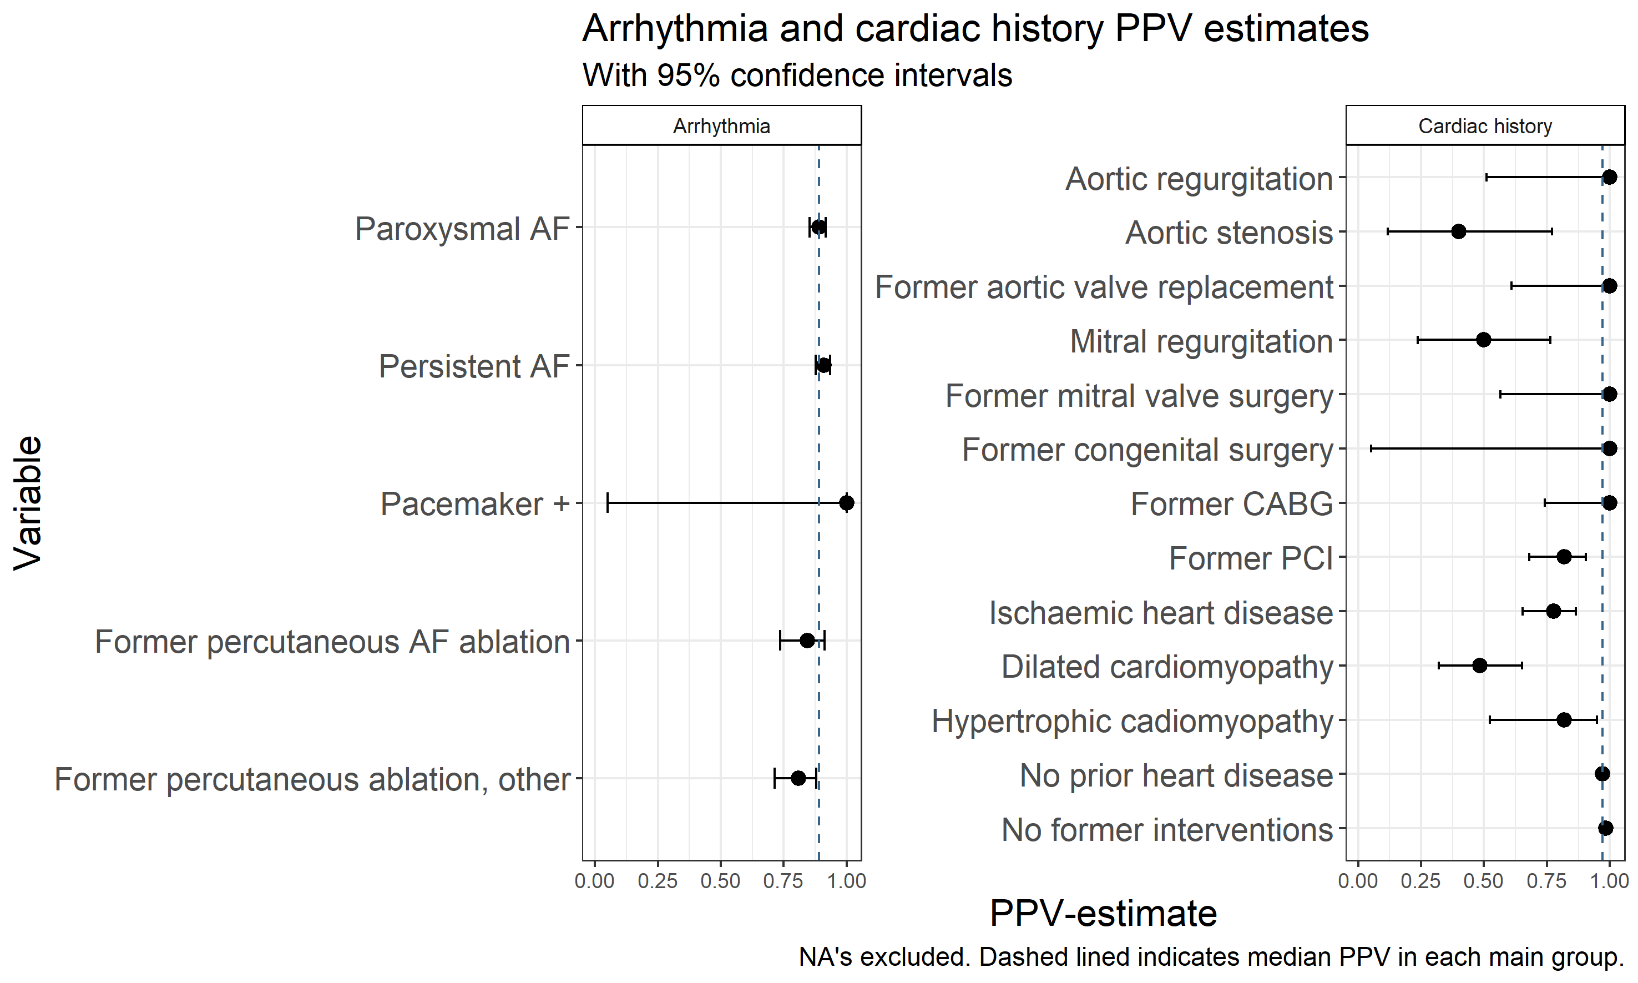

Figure 2
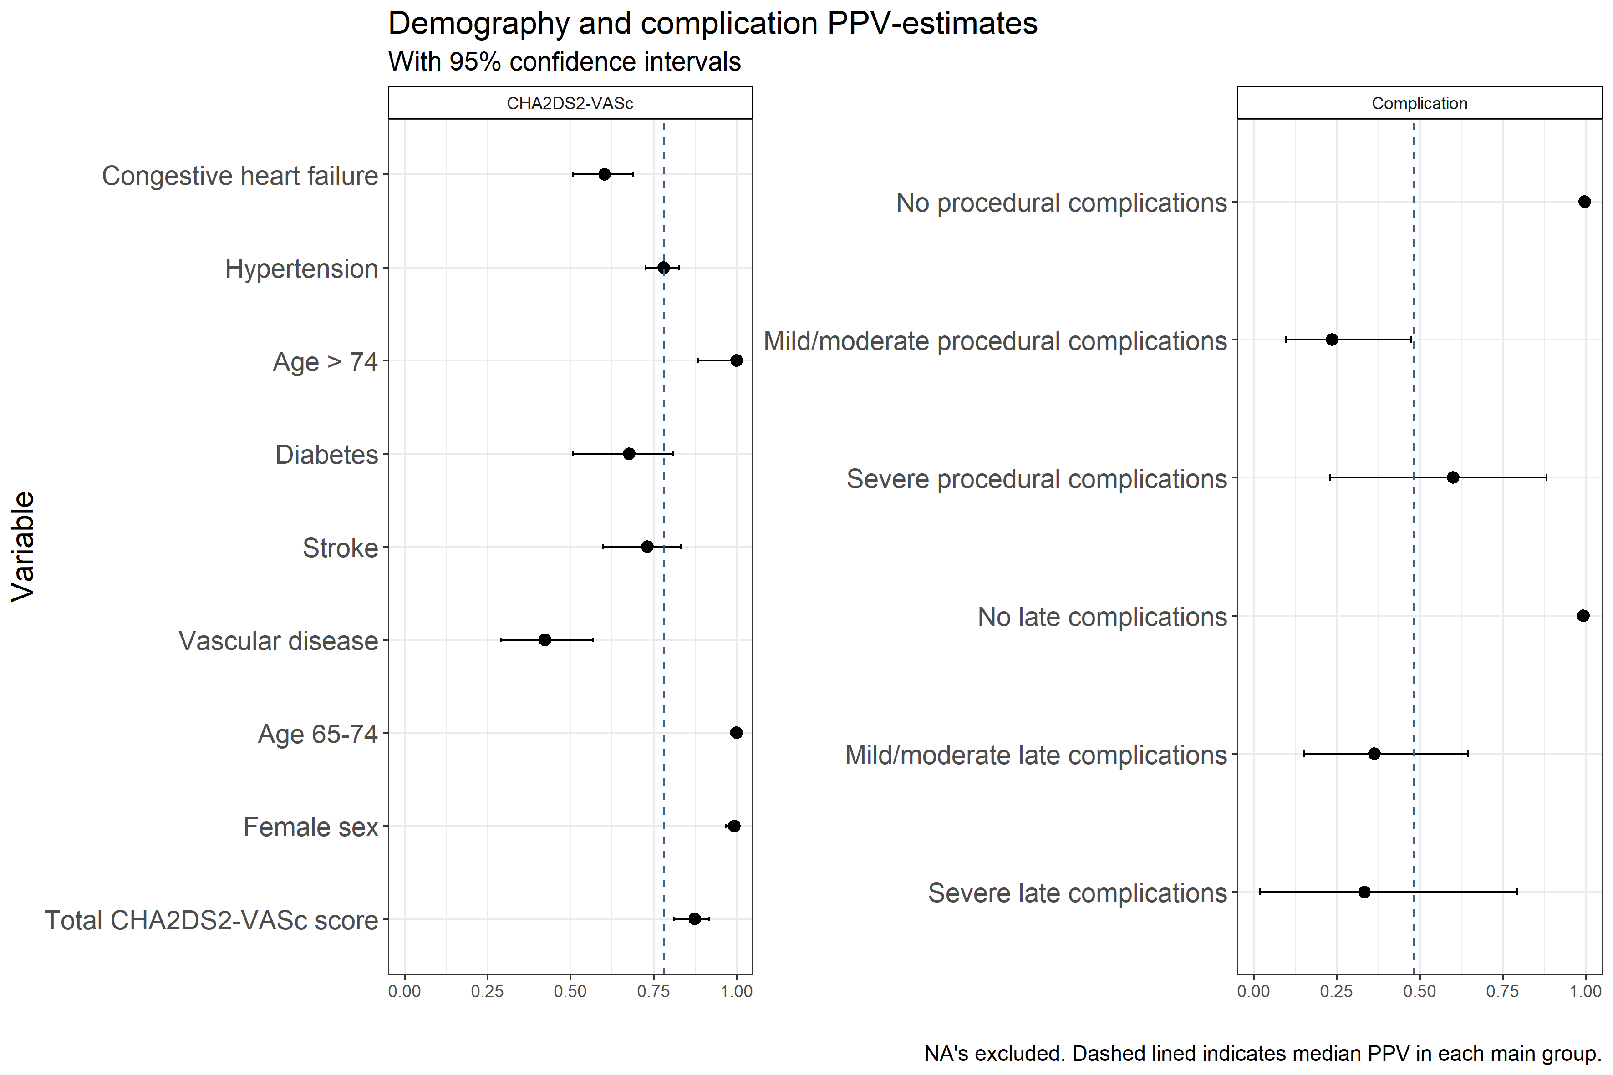

Figure 3
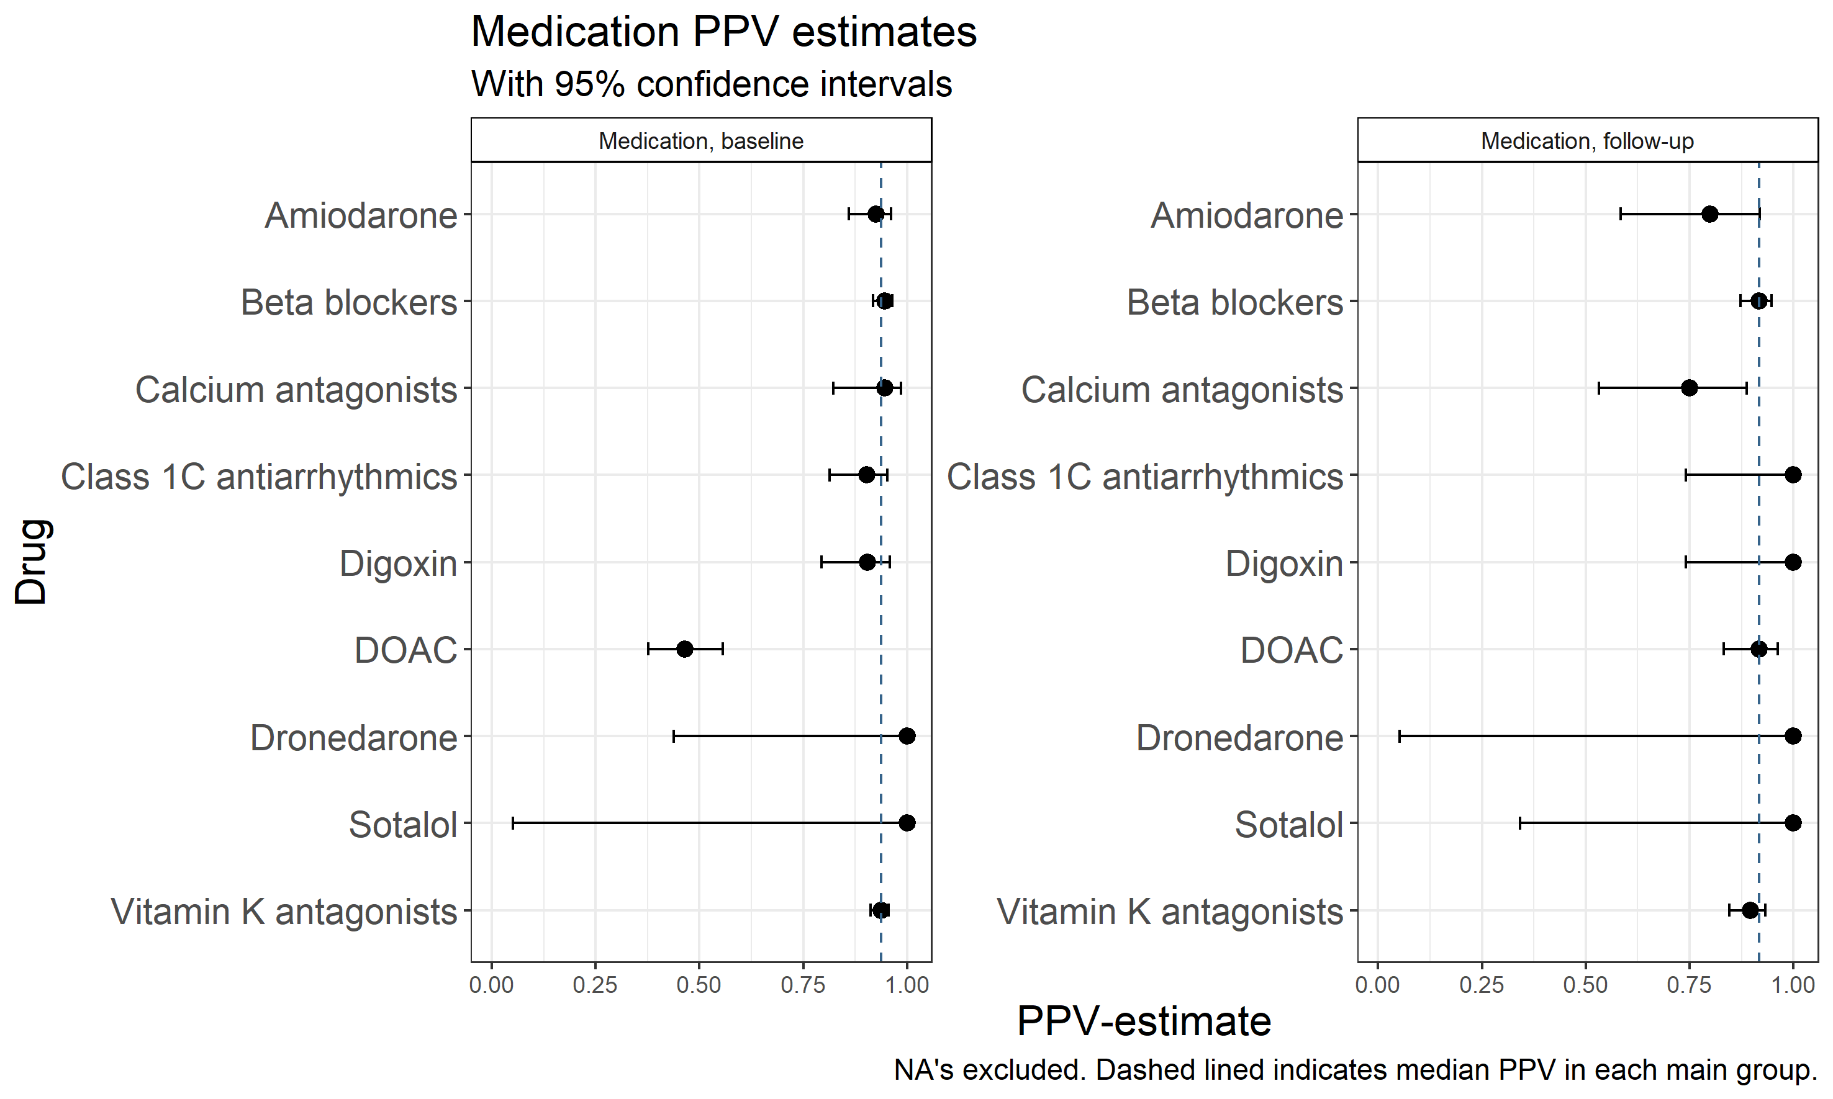

Figure 4
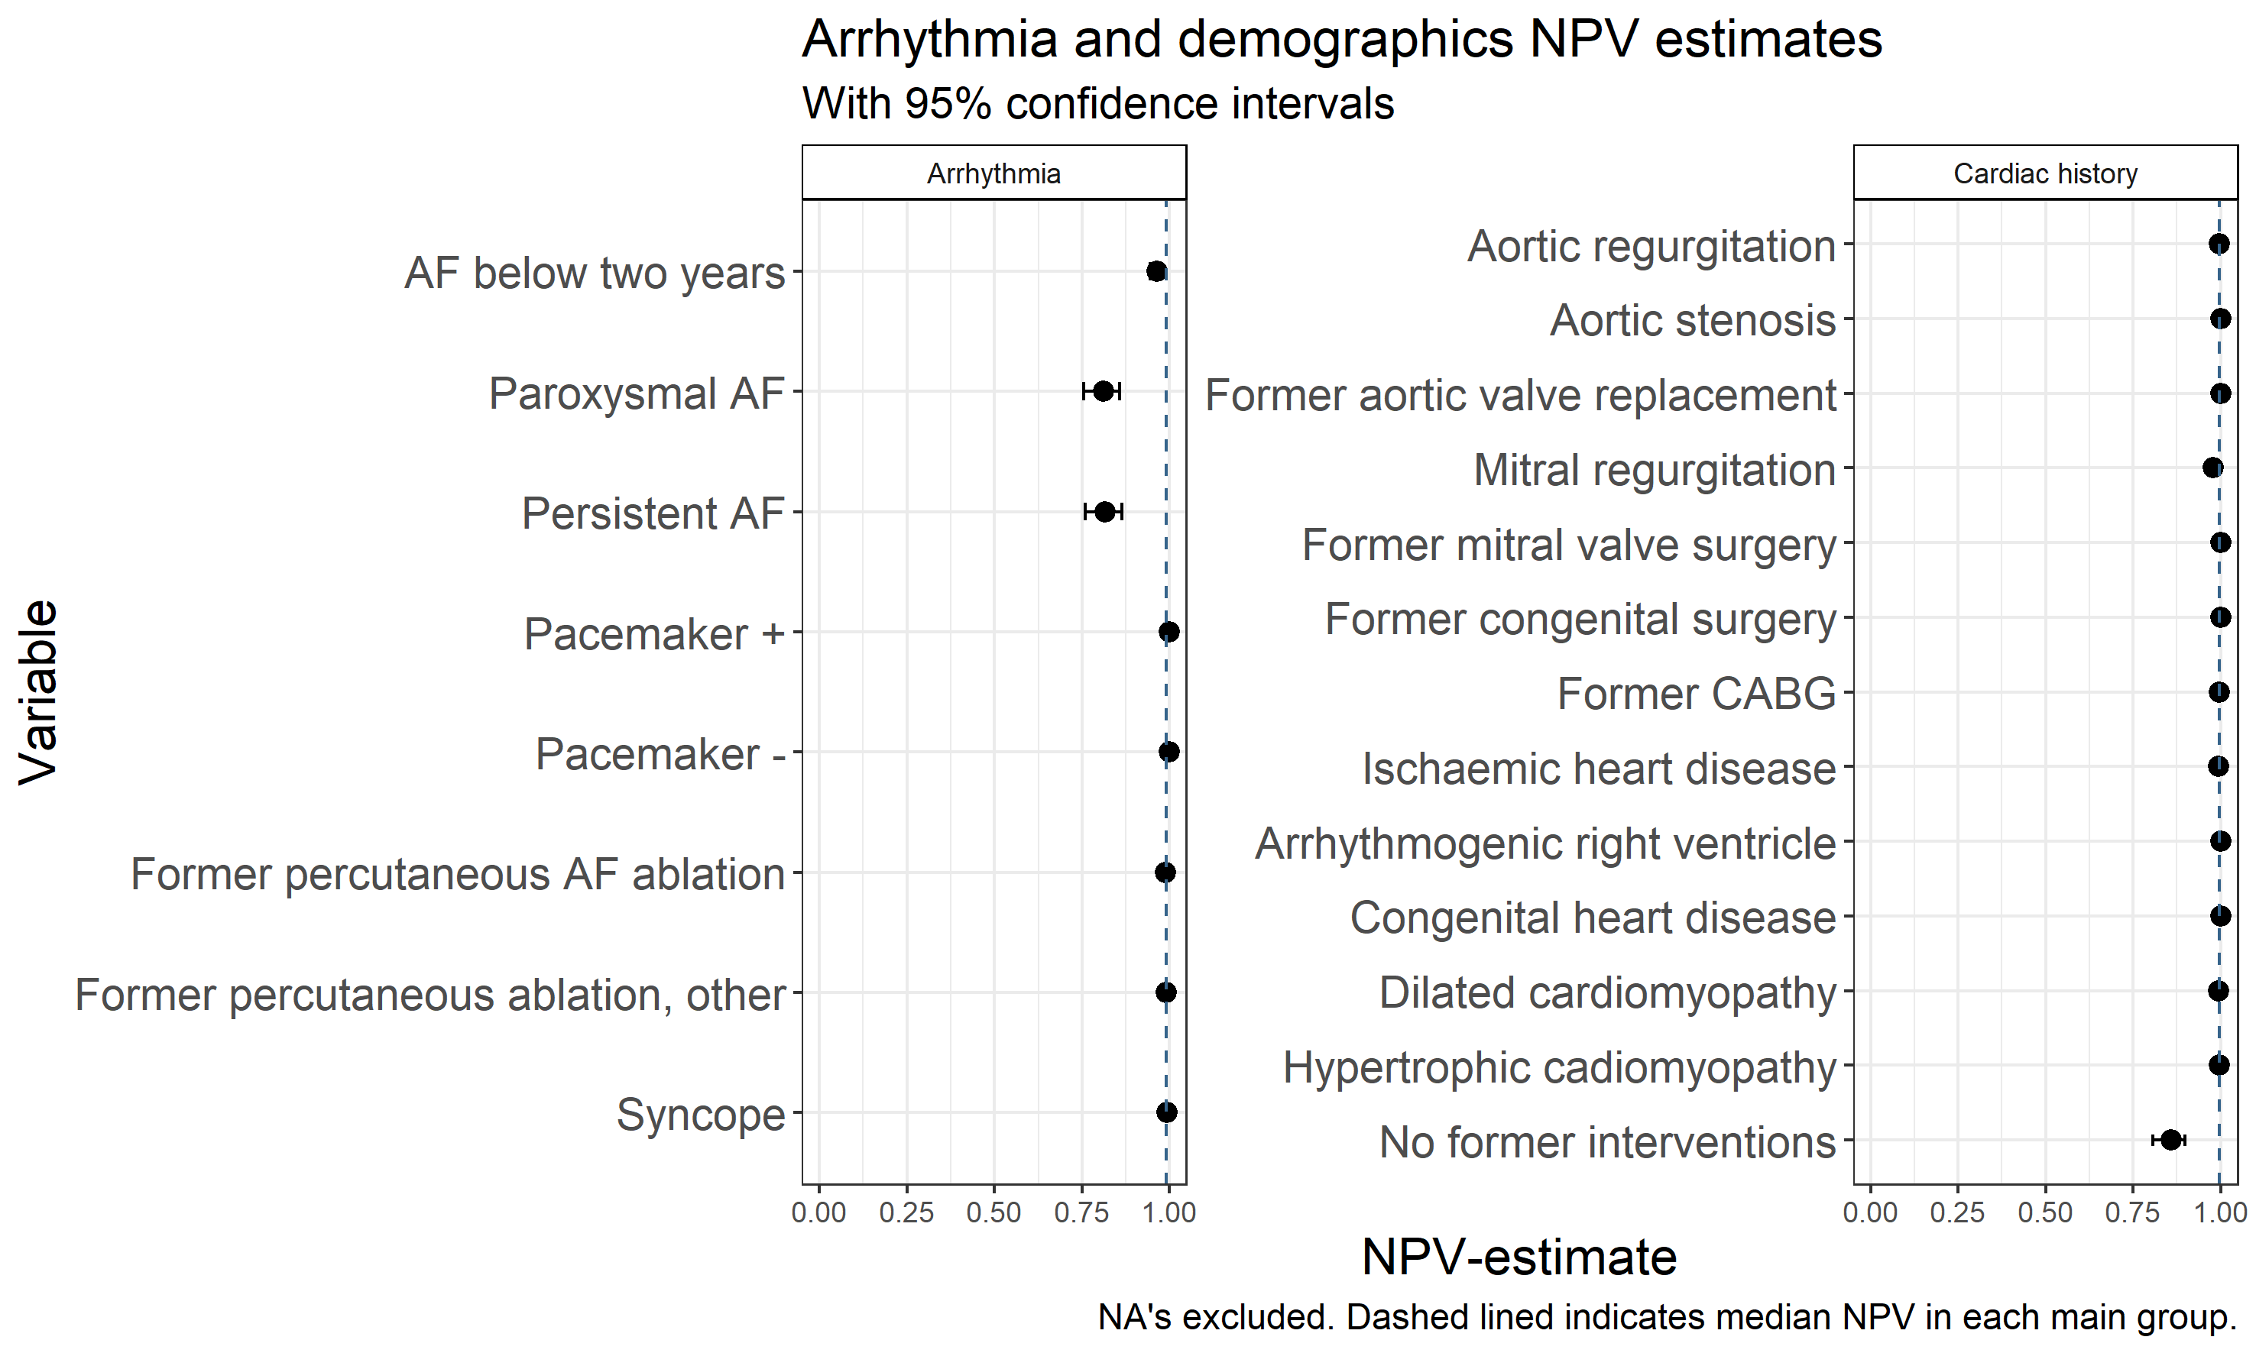

Figure 5
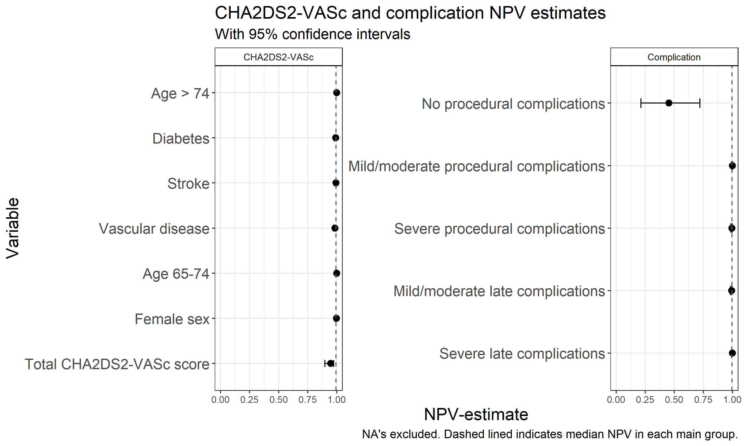

Figure 6
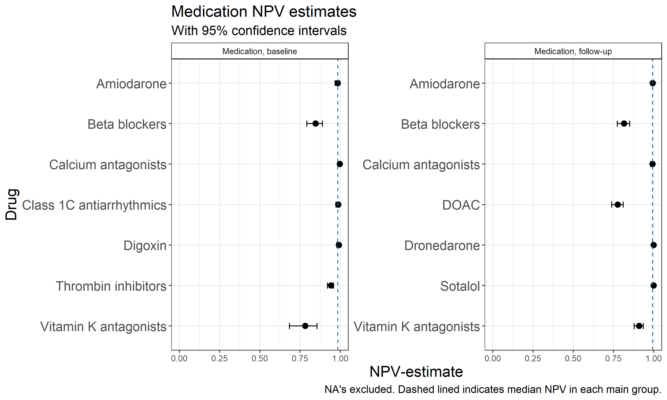

Figure 7
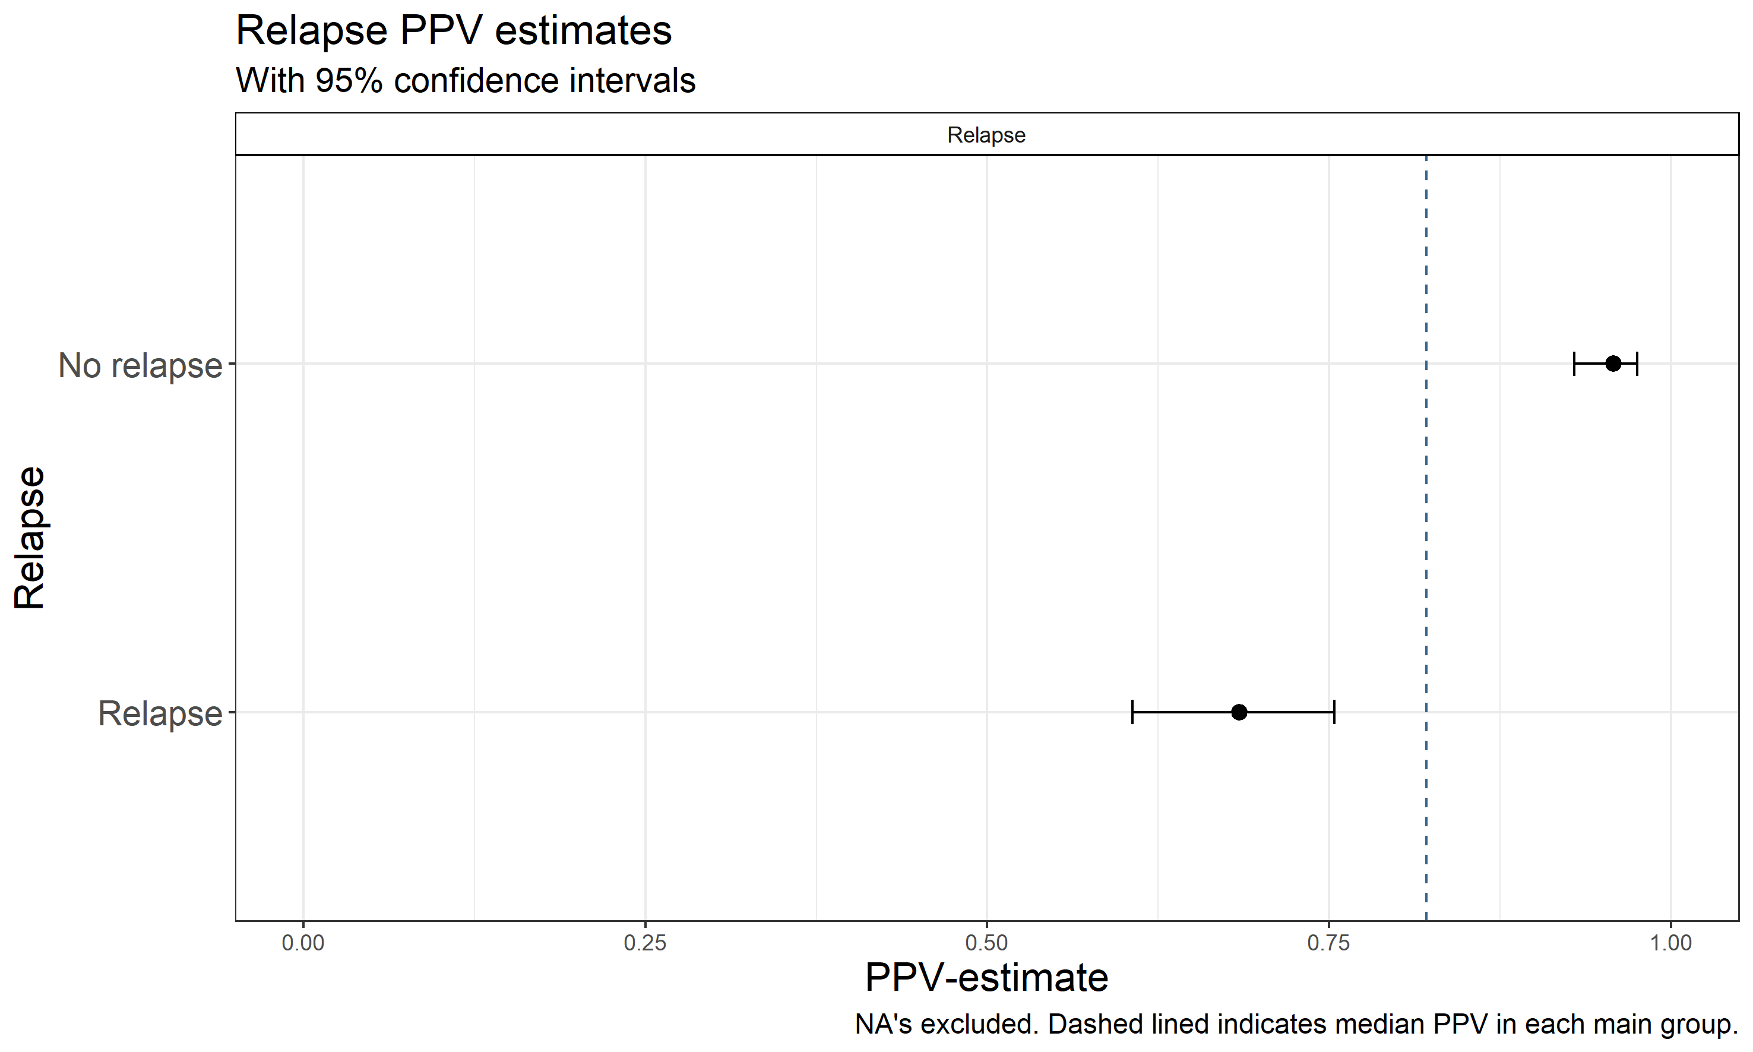

Figure 8
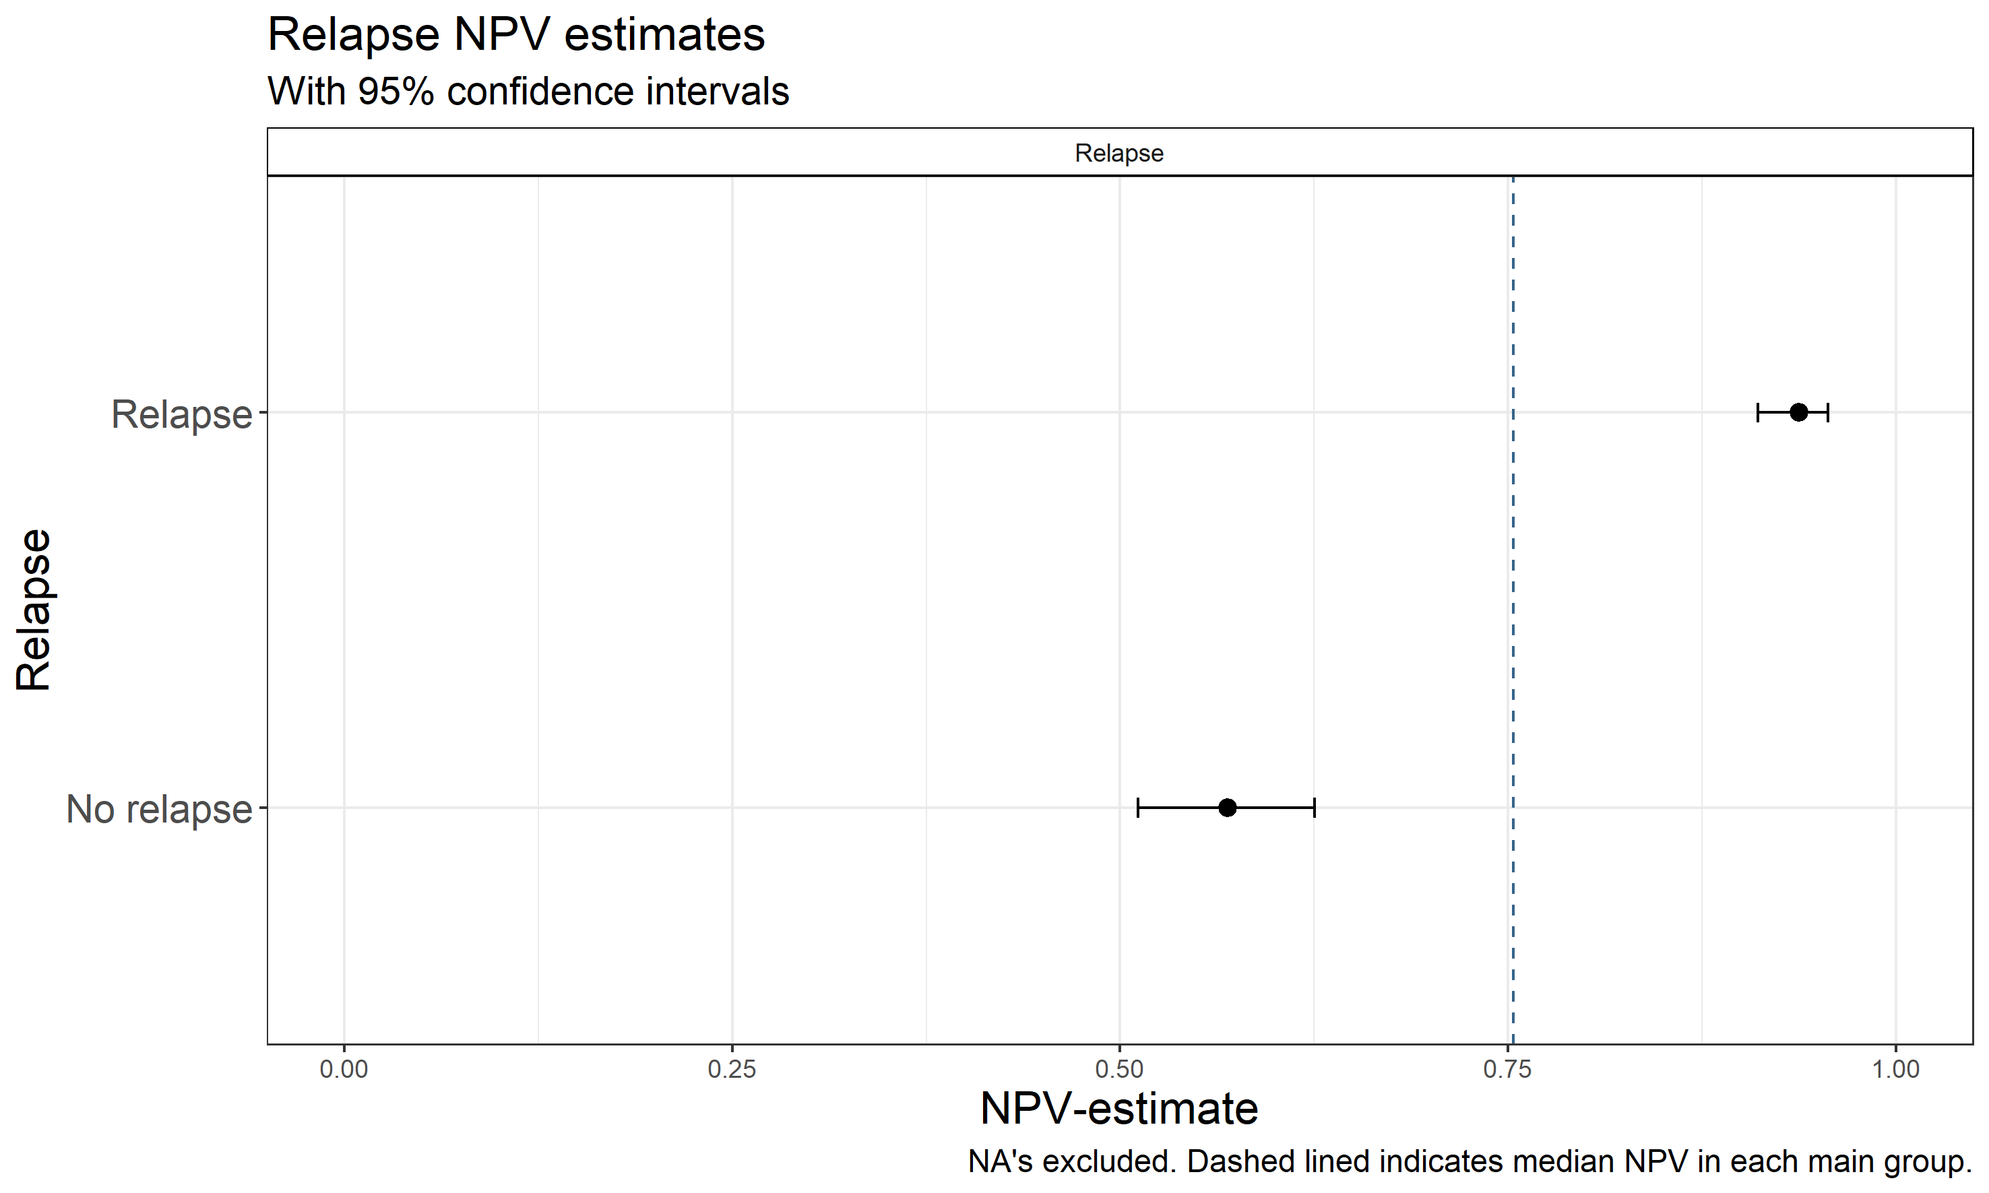

Tables

Procedure related complications
# Atrioventricular block
 | Medical record + | Medical record - | Total
NDAD + | 0 | 0 | 0
NDAD - | 0 | 597 | 597
Total | 0 | 597 | 597
Positive predictive value: NaN
Negative predictive value: 1.00
# Cardiac tamponade
 | Medical record + | Medical record - | Total
NDAD + | 2 | 0 | 2
NDAD - | 2 | 593 | 595
Total | 4 | 593 | 597
Positive predictive value: 1.00
Negative predictive value: 1.00
# Embolism
 | Medical record + | Medical record - | Total
NDAD + | 0 | 1 | 1
NDAD - | 0 | 596 | 596
Total | 0 | 597 | 597
Positive predictive value: 0.00
Negative predictive value: 1.00

# Haematoma
 | Medical record + | Medical record - | Total
NDAD + | 1 | 2 | 3
NDAD - | 0 | 594 | 594
Total | 1 | 596 | 597
Positive predictive value: 0.33
Negative predictive value: 1.00
# Other/unspecified complications
 | Medical record + | Medical record - | Total
NDAD + | 2 | 3 | 5
NDAD - | 0 | 592 | 592
Total | 2 | 595 | 597
Positive predictive value: 0.40
Negative predictive value: 1.00
# Paresis of n. phrenicus
 | Medical record + | Medical record - | Total
NDAD + | 0 | 0 | 0
NDAD - | 0 | 597 | 597
Total | 0 | 597 | 597
Positive predictive value: NaN
Negative predictive value: 1.00

# Perioperative death
 | Medical record + | Medical record - | Total
NDAD + | 0 | 0 | 0
NDAD - | 0 | 597 | 597
Total | 0 | 597 | 597
Positive predictive value: NaN
Negative predictive value: 1.00
# Pneumothorax
 | Medical record + | Medical record - | Total
NDAD + | 0 | 0 | 0
NDAD - | 0 | 597 | 597
Total | 0 | 597 | 597
Positive predictive value: NaN
Negative predictive value: 1.00
# No complications
 | Medical record + | Medical record - | Total
NDAD + | 584 | 2 | 586
NDAD - | 6 | 5 | 11
Total | 590 | 7 | 597
Positive predictive value: 1.00
Negative predictive value: 0.45

Late complications
# Deep vein thrombosis
 | Medical record + | Medical record - | Total
NDAD + | 0 | 0 | 0
NDAD - | 0 | 597 | 597
Total | 0 | 597 | 597
Positive predictive value: NaN
Negative predictive value: 1.00
# Infection
 | Medical record + | Medical record - | Total
NDAD + | 0 | 2 | 2
NDAD - | 1 | 594 | 595
Total | 1 | 596 | 597
Positive predictive value: 0.00
Negative predictive value: 1.00
# Pulmonary vein stenosis
 | Medical record + | Medical record - | Total
NDAD + | 1 | 0 | 1
NDAD - | 0 | 596 | 596
Total | 1 | 596 | 597
Positive predictive value: 1.00
Negative predictive value: 1.00

# Oesophageal fistula
 | Medical record + | Medical record - | Total
NDAD + | 0 | 1 | 1
NDAD - | 0 | 596 | 596
Total | 0 | 597 | 597
Positive predictive value: 0.00
Negative predictive value: 1.00
# Trancient cerebral ischaemia /ischaemic stroke
 | Medical record + | Medical record - | Total
NDAD + | 0 | 1 | 1
NDAD - | 0 | 596 | 596
Total | 0 | 597 | 597
Positive predictive value: 0.00
Negative predictive value: 1.00
# No late complications
 | Medical record + | Medical record - | Total
NDAD + | 579 | 4 | 583
NDAD - | 9 | 5 | 14
Total | 588 | 9 | 597
Positive predictive value: 0.99
Negative predictive value: 0.36

CHA₂DS₂-VASC-parametres
# Congestive heart failure
 | Medical record + | Medical record - | Total
NDAD + | 65 | 43 | 108
NDAD - | 3 | 486 | 489
Total | 68 | 529 | 597
Positive predictive value: 0.60
Negative predictive value: 0.99
# Hypertension
 | Medical record + | Medical record - | Total
NDAD + | 196 | 55 | 251
NDAD - | 19 | 327 | 346
Total | 215 | 382 | 597
Positive predictive value: 0.78
Negative predictive value: 0.95
# Age 75+
 | Medical record + | Medical record - | Total
NDAD + | 29 | 0 | 29
NDAD - | 0 | 568 | 568
Total | 29 | 568 | 597
Positive predictive value: 1.00
Negative predictive value: 1.00

# Diabetes
 | Medical record + | Medical record - | Total
NDAD + | 23 | 11 | 34
NDAD - | 5 | 558 | 563
Total | 28 | 569 | 597
Positive predictive value: 0.68
Negative predictive value: 0.99
# Trancient cerebral ischaemia / ischaemic stroke
 | Medical record + | Medical record - | Total
NDAD + | 38 | 14 | 52
NDAD - | 3 | 542 | 545
Total | 41 | 556 | 597
Positive predictive value: 0.73
Negative predictive value: 0.99
# Peripheral artery disease
 | Medical record + | Medical record - | Total
NDAD + | 19 | 26 | 45
NDAD - | 8 | 544 | 552
Total | 27 | 570 | 597
Positive predictive value: 0.42
Negative predictive value: 0.99

# Age 65-74
 | Medical record + | Medical record - | Total
NDAD + | 214 | 0 | 214
NDAD - | 0 | 383 | 383
Total | 214 | 383 | 597
Positive predictive value: 1.00
Negative predictive value: 1.00
# Female sex
 | Medical record + | Medical record - | Total
NDAD + | 167 | 1 | 168
NDAD - | 1 | 428 | 429
Total | 168 | 429 | 597
Positive predictive value: 0.99
Negative predictive value: 1.00
# CHA2DS2-VASc-score 0
 | Medical record + | Medical record - | Total
NDAD + | 424 | 26 | 450
NDAD - | 17 | 130 | 147
Total | 441 | 156 | 597
Positive predictive value: 0.94
Negative predictive value: 0.88

# CHA2DS2-VASc-score 1
 | Medical record + | Medical record - | Total
NDAD + | 394 | 47 | 441
NDAD - | 24 | 132 | 156
Total | 418 | 179 | 597
Positive predictive value: 0.89
Negative predictive value: 0.85
# CHA2DS2-VASc-score 2
 | Medical record + | Medical record - | Total
NDAD + | 406 | 37 | 443
NDAD - | 43 | 111 | 154
Total | 449 | 148 | 597
Positive predictive value: 0.92
Negative predictive value: 0.72
# CHA2DS2-VASc-score 3
 | Medical record + | Medical record - | Total
NDAD + | 485 | 31 | 516
NDAD - | 28 | 53 | 81
Total | 513 | 84 | 597
Positive predictive value: 0.94
Negative predictive value: 0.65

# CHA2DS2-VASc-score 4
 | Medical record + | Medical record - | Total
NDAD + | 546 | 8 | 554
NDAD - | 28 | 15 | 43
Total | 574 | 23 | 597
Positive predictive value: 0.99
Negative predictive value: 0.35
# CHA2DS2-VASc-score 5
 | Medical record + | Medical record - | Total
NDAD + | 581 | 1 | 582
NDAD - | 11 | 4 | 15
Total | 592 | 5 | 597
Positive predictive value: 1.00
Negative predictive value: 0.27
# CHA2DS2-VASc-score 6
 | Medical record + | Medical record - | Total
NDAD + | 594 | 2 | 596
NDAD - | 1 | 0 | 1
Total | 595 | 2 | 597
Positive predictive value: 1.00
Negative predictive value: 0.00

Cardiac history
# Aortic stenosis
 | Medical record + | Medical record - | Total
NDAD + | 2 | 3 | 5
NDAD - | 0 | 592 | 592
Total | 2 | 595 | 597
Positive predictive value: 0.40
Negative predictive value: 1.00
# Aortic regurgitation
 | Medical record + | Medical record - | Total
NDAD + | 4 | 0 | 4
NDAD - | 2 | 591 | 593
Total | 6 | 591 | 597
Positive predictive value: 1.00
Negative predictive value: 1.00
# Arrhythmogenic right ventricle
 | Medical record + | Medical record - | Total
NDAD + | 0 | 0 | 0
NDAD - | 0 | 597 | 597
Total | 0 | 597 | 597
Positive predictive value: NaN
Negative predictive value: 1.00

# Congenital cardiac disease
 | Medical record + | Medical record - | Total
NDAD + | 0 | 1 | 1
NDAD - | 0 | 596 | 596
Total | 0 | 597 | 597
Positive predictive value: 0.00
Negative predictive value: 1.00
# Dilated cardiomyopathy
 | Medical record + | Medical record - | Total
NDAD + | 15 | 16 | 31
NDAD - | 4 | 562 | 566
Total | 19 | 578 | 597
Positive predictive value: 0.48
Negative predictive value: 0.99
# Hypertrophic cardiomyopathy
 | Medical record + | Medical record - | Total
NDAD + | 9 | 2 | 11
NDAD - | 2 | 584 | 586
Total | 11 | 586 | 597
Positive predictive value: 0.82
Negative predictive value: 1.00

# Ischaemic heart disease
 | Medical record + | Medical record - | Total
NDAD + | 45 | 13 | 58
NDAD - | 3 | 536 | 539
Total | 48 | 549 | 597
Positive predictive value: 0.78
Negative predictive value: 0.99
# Mitral stenosis
 | Medical record + | Medical record - | Total
NDAD + | 0 | 1 | 1
NDAD - | 1 | 595 | 596
Total | 1 | 596 | 597
Positive predictive value: 0.00
Negative predictive value: 1.00
# Mitral regurgitation
 | Medical record + | Medical record - | Total
NDAD + | 5 | 5 | 10
NDAD - | 13 | 574 | 587
Total | 18 | 579 | 597
Positive predictive value: 0.50
Negative predictive value: 0.98

# No cardiac disease
 | Medical record + | Medical record - | Total
NDAD + | 456 | 14 | 470
NDAD - | 40 | 87 | 127
Total | 496 | 101 | 597
Positive predictive value: 0.97
Negative predictive value: 0.69
# Aortic valve replacement
 | Medical record + | Medical record - | Total
NDAD + | 6 | 0 | 6
NDAD - | 0 | 591 | 591
Total | 6 | 591 | 597
Positive predictive value: 1.00
Negative predictive value: 1.00
# Congenital surgery
 | Medical record + | Medical record - | Total
NDAD + | 1 | 0 | 1
NDAD - | 0 | 596 | 596
Total | 1 | 596 | 597
Positive predictive value: 1.00
Negative predictive value: 1.00

# Coronary artery bypass-graft surgery
 | Medical record + | Medical record - | Total
NDAD + | 11 | 0 | 11
NDAD - | 2 | 584 | 586
Total | 13 | 584 | 597
Positive predictive value: 1.00
Negative predictive value: 1.00
# Percutaneous coronary intervention
 | Medical record + | Medical record - | Total
NDAD + | 36 | 8 | 44
NDAD - | 4 | 549 | 553
Total | 40 | 557 | 597
Positive predictive value: 0.82
Negative predictive value: 0.99
# Mitral valve surgery
 | Medical record + | Medical record - | Total
NDAD + | 5 | 0 | 5
NDAD - | 0 | 592 | 592
Total | 5 | 592 | 597
Positive predictive value: 1.00
Negative predictive value: 1.00

# No previous cardiac interventions
 | Medical record + | Medical record - | Total
NDAD + | 373 | 6 | 379
NDAD - | 31 | 187 | 218
Total | 404 | 193 | 597
Positive predictive value: 0.98
Negative predictive value: 0.86

Arrhythmia
# Paroxysmal AF
 | Medical record + | Medical record - | Total
NDAD + | 337 | 42 | 379
NDAD - | 41 | 177 | 218
Total | 378 | 219 | 597
Positive predictive value: 0.89
Negative predictive value: 0.81
# Persistent AF
 | Medical record + | Medical record - | Total
NDAD + | 169 | 38 | 207
NDAD - | 35 | 355 | 390
Total | 204 | 393 | 597
Positive predictive value: 0.82
Negative predictive value: 0.91
# Pacemaker +
 | Medical record + | Medical record - | Total
NDAD + | 1 | 0 | 1
NDAD - | 0 | 596 | 596
Total | 1 | 596 | 597
Positive predictive value: 1.00
Negative predictive value: 1.00

# Pacemaker -
 | Medical record + | Medical record - | Total
NDAD + | 0 | 0 | 0
NDAD - | 1 | 596 | 597
Total | 1 | 596 | 597
Positive predictive value: NaN
Negative predictive value: 1.00
# Former percutaneous ablation for AF
 | Medical record + | Medical record - | Total
NDAD + | 54 | 10 | 64
NDAD - | 6 | 527 | 533
Total | 60 | 537 | 597
Positive predictive value: 0.84
Negative predictive value: 0.99
# Former percutaneous ablation, other
 | Medical record + | Medical record - | Total
NDAD + | 68 | 16 | 84
NDAD - | 5 | 508 | 513
Total | 73 | 524 | 597
Positive predictive value: 0.81
Negative predictive value: 0.99

Medication, baseline
# Amiodarone
 | Medical record + | Medical record - | Total
NDAD + | 99 | 8 | 107
NDAD - | 8 | 482 | 490
Total | 107 | 490 | 597
Positive predictive value: 0.93
Negative predictive value: 0.98
# Beta blockers
 | Medical record + | Medical record - | Total
NDAD + | 367 | 21 | 388
NDAD - | 32 | 177 | 209
Total | 399 | 198 | 597
Positive predictive value: 0.95
Negative predictive value: 0.85
# Class 1C antiarrhythmics
 | Medical record + | Medical record - | Total
NDAD + | 65 | 7 | 72
NDAD - | 7 | 518 | 525
Total | 72 | 525 | 597
Positive predictive value: 0.90
Negative predictive value: 0.99

# Digoxin
 | Medical record + | Medical record - | Total
NDAD + | 47 | 5 | 52
NDAD - | 5 | 540 | 545
Total | 52 | 545 | 597
Positive predictive value: 0.90
Negative predictive value: 0.99
# Dronedarone
 | Medical record + | Medical record - | Total
NDAD + | 3 | 0 | 3
NDAD - | 3 | 591 | 594
Total | 6 | 591 | 597
Positive predictive value: 1.00
Negative predictive value: 0.99
# Factor Xa inhibitors
 | Medical record + | Medical record - | Total
NDAD + | 17 | 31 | 48
NDAD - | 4 | 545 | 549
Total | 21 | 576 | 597
Positive predictive value: 0.35
Negative predictive value: 0.99

# Sotalol
 | Medical record + | Medical record - | Total
NDAD + | 1 | 0 | 1
NDAD - | 2 | 594 | 596
Total | 3 | 594 | 597
Positive predictive value: 1.00
Negative predictive value: 1.00
# Thrombin inhibitors
 | Medical record + | Medical record - | Total
NDAD + | 10 | 2 | 12
NDAD - | 34 | 551 | 585
Total | 44 | 553 | 597
Positive predictive value: 0.83
Negative predictive value: 0.94
# Calcium antagonists
 | Medical record + | Medical record - | Total
NDAD + | 35 | 2 | 37
NDAD - | 2 | 558 | 560
Total | 37 | 560 | 597
Positive predictive value: 0.95
Negative predictive value: 1.00

# Vitamin K antagonists
 | Medical record + | Medical record - | Total
NDAD + | 478 | 32 | 510
NDAD - | 19 | 68 | 87
Total | 497 | 100 | 597
Positive predictive value: 0.94
Negative predictive value: 0.78

Medication, follow-up
# Amiodarone
 | Medical record + | Medical record - | Total
NDAD + | 16 | 4 | 20
NDAD - | 3 | 574 | 577
Total | 19 | 578 | 597
Positive predictive value: 0.80
Negative predictive value: 0.99
# Beta blockers
 | Medical record + | Medical record - | Total
NDAD + | 199 | 18 | 217
NDAD - | 70 | 310 | 380
Total | 269 | 328 | 597
Positive predictive value: 0.92
Negative predictive value: 0.82
# Class 1C
 | Medical record + | Medical record - | Total
NDAD + | 11 | 0 | 11
NDAD - | 3 | 72 | 75
Total | 14 | 72 | 86
Positive predictive value: 1.00
Negative predictive value: 0.96

# Digoxin
 | Medical record + | Medical record - | Total
NDAD + | 11 | 0 | 11
NDAD - | 2 | 584 | 586
Total | 13 | 584 | 597
Positive predictive value: 1.00
Negative predictive value: 1.00
# Dronedarone
 | Medical record + | Medical record - | Total
NDAD + | 1 | 0 | 1
NDAD - | 0 | 596 | 596
Total | 1 | 596 | 597
Positive predictive value: 1.00
Negative predictive value: 1.00
# Factor Xa inhibitors
 | Medical record + | Medical record - | Total
NDAD + | 50 | 8 | 58
NDAD - | 70 | 469 | 539
Total | 120 | 477 | 597
Positive predictive value: 0.86
Negative predictive value: 0.87

# Sotalol
 | Medical record + | Medical record - | Total
NDAD + | 2 | 0 | 2
NDAD - | 0 | 595 | 595
Total | 2 | 595 | 597
Positive predictive value: 1.00
Negative predictive value: 1.00
# Thrombin inhibitors
 | Medical record + | Medical record - | Total
NDAD + | 13 | 2 | 15
NDAD - | 52 | 530 | 582
Total | 65 | 532 | 597
Positive predictive value: 0.87
Negative predictive value: 0.91
# Calcium antagonists
 | Medical record + | Medical record - | Total
NDAD + | 15 | 5 | 20
NDAD - | 4 | 573 | 577
Total | 19 | 578 | 597
Positive predictive value: 0.75
Negative predictive value: 0.99

# Vitamin K antagonists
 | Medical record + | Medical record - | Total
NDAD + | 174 | 20 | 194
NDAD - | 36 | 367 | 403
Total | 210 | 387 | 597
Positive predictive value: 0.90
Negative predictive value: 0.91

Relapse
# Relapse
 | Medical record + | Medical record - | Total
NDAD + | 102 | 47 | 149
NDAD - | 28 | 420 | 448
Total | 130 | 467 | 597
Positive predictive value: 0.68
Negative predictive value: 0.94
# No relapse
 | Medical record + | Medical record - | Total
NDAD + | 296 | 13 | 309
NDAD - | 124 | 164 | 288
Total | 420 | 177 | 597
Positive predictive value: 0.96
Negative predictive value: 0.57

EHRA class at baseline
# EHRA 0
 | Medical record + | Medical record - | Total
NDAD + | 532 | 5 | 537
NDAD - | 37 | 23 | 60
Total | 569 | 28 | 597
Positive predictive value: 0.99
Negative predictive value: 0.38
# EHRA 1
 | Medical record + | Medical record - | Total
NDAD + | 574 | 3 | 577
NDAD - | 15 | 5 | 20
Total | 589 | 8 | 597
Positive predictive value: 0.99
Negative predictive value: 0.25
# EHRA 2
 | Medical record + | Medical record - | Total
NDAD + | 353 | 30 | 383
NDAD - | 72 | 142 | 214
Total | 425 | 172 | 597
Positive predictive value: 0.92
Negative predictive value: 0.66

# EHRA 3
 | Medical record + | Medical record - | Total
NDAD + | 199 | 105 | 304
NDAD - | 26 | 267 | 293
Total | 225 | 372 | 597
Positive predictive value: 0.65
Negative predictive value: 0.91
# EHRA 4
 | Medical record + | Medical record - | Total
NDAD + | 579 | 8 | 587
NDAD - | 1 | 9 | 10
Total | 580 | 17 | 597
Positive predictive value: 0.99
Negative predictive value: 0.90

EHRA class at follow-up
# EHRA 0
 | Medical record + | Medical record - | Total
NDAD + | 359 | 3 | 362
NDAD - | 119 | 116 | 235
Total | 478 | 119 | 597
Positive predictive value: 0.99
Negative predictive value: 0.49
# EHRA 1
 | Medical record + | Medical record - | Total
NDAD + | 226 | 103 | 329
NDAD - | 10 | 258 | 268
Total | 236 | 361 | 597
Positive predictive value: 0.69
Negative predictive value: 0.96
# EHRA 2
 | Medical record + | Medical record - | Total
NDAD + | 486 | 36 | 522
NDAD - | 17 | 58 | 75
Total | 503 | 94 | 597
Positive predictive value: 0.93
Negative predictive value: 0.77

# EHRA 3
 | Medical record + | Medical record - | Total
NDAD + | 572 | 7 | 579
NDAD - | 5 | 13 | 18
Total | 577 | 20 | 597
Positive predictive value: 0.99
Negative predictive value: 0.72
# EHRA 4
 | Medical record + | Medical record - | Total
NDAD + | 594 | 2 | 596
NDAD - | 0 | 1 | 1
Total | 594 | 3 | 597
Positive predictive value: 1.00
Negative predictive value: 1.00

Table 1: Dichotomization of continous data
 | Registered CHA₂DS₂VASc-score |  | CHA₂DS₂VASC-score NDAD |  |  |  |  |  |  | CHA₂DS₂VASC-score, medical record
Patient ID | NDAD | MR | 0 | 1 | 2 | 3 | 4 | 5 | 6 | 0 | 1 | 2 | 3 | 4 | 5 | 6
1 | 1 | 2 | 0 | 1 | 0 | 0 | 0 | 0 | 0 | 0 | 0 | 1 | 0 | 0 | 0 | 0
2 | 3 | 4 | 0 | 0 | 0 | 1 | 0 | 0 | 0 | 0 | 0 | 0 | 0 | 1 | 0 | 0
3 | 3 | 6 | 0 | 0 | 0 | 1 | 0 | 0 | 0 | 0 | 0 | 0 | 0 | 0 | 0 | 1
4 | 4 | 3 | 0 | 0 | 0 | 0 | 1 | 0 | 0 | 0 | 0 | 0 | 1 | 0 | 0 | 0
5 | 2 | 2 | 0 | 0 | 1 | 0 | 0 | 0 | 0 | 0 | 0 | 1 | 0 | 0 | 0 | 0
6 | 3 | 3 | 0 | 0 | 0 | 1 | 0 | 0 | 0 | 0 | 0 | 0 | 1 | 0 | 0 | 0

Table 2: Example of how the PPV and NPV-values were acquired
