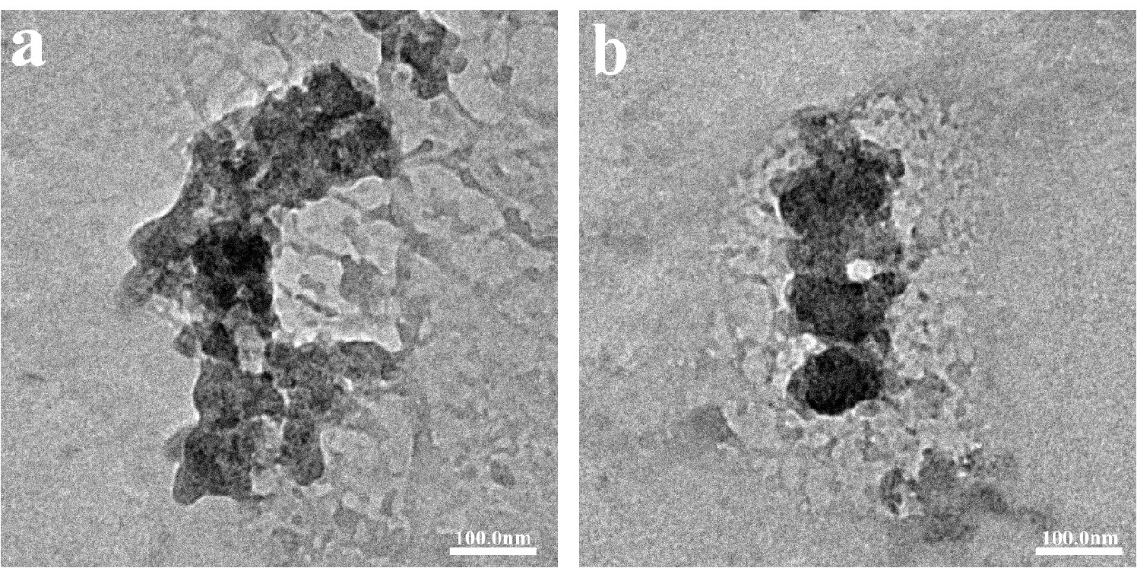
Fig. S1. TEM imaging of HM (a) and CM (b) were processed in pH 6.6 medium for 8 h.
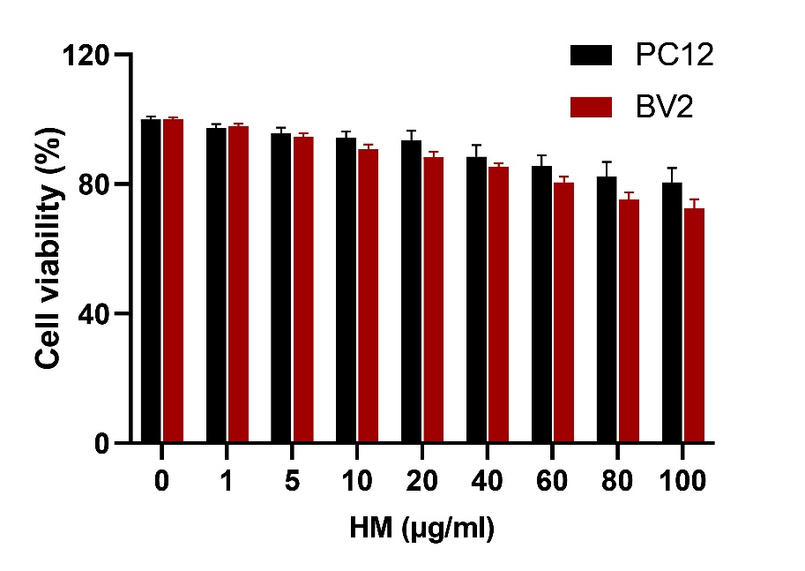
Fig. S2. The cytotoxicity of HM on PC12 cells and BV2 cells.78
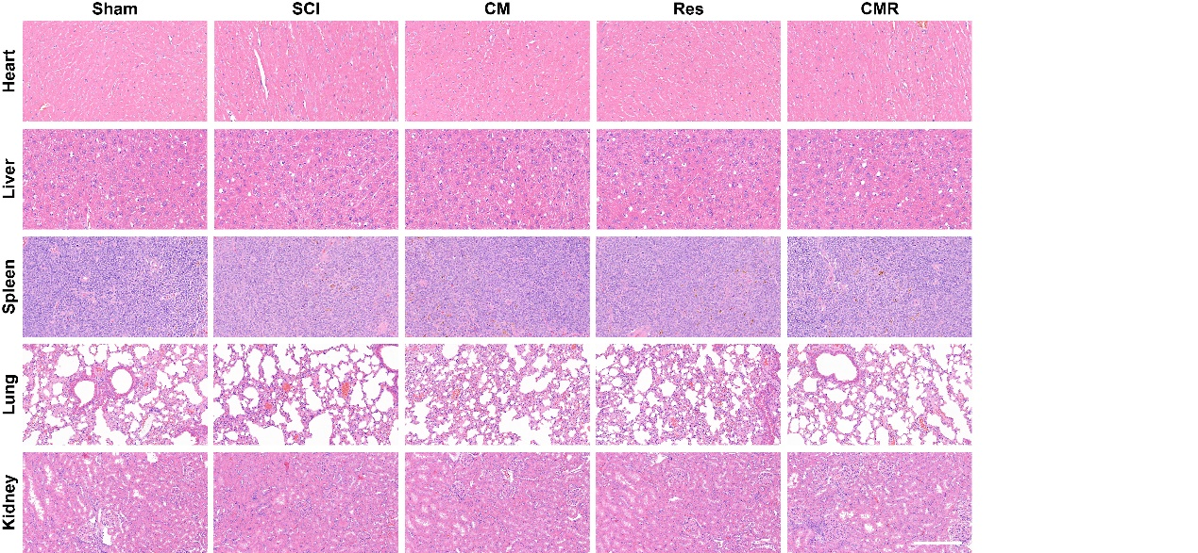
Fig. S3 H&E staining was performed on tissue sections of heart, liver, spleen, lung and kidney from different groups

