Online Supplement 1 (OS1)
Item-Level Descriptive Statistics for the CATS-2 self-report (n = 283)
CATS2 Item | Item Description | Diagnostic Allocation* | M | SD | Skew | Kurtosis | Range
Item1 | Intrusions | ◊ | 1.54 | 0.99 | 0.03 | -1.04 | 0-3
Item2 | Nightmares | ◊ ; ○ | 1.01 | 1.09 | 0.66 | - 0.92 | 0-3
Item3 | Flashbacks | ◊ ; ○ | 1.07 | 1.07 | 0.55 | -1.00 | 0-3
Item4 | Psychological Cue Reactivity | ◊ | 1.79 | 1.08 | -0.33 | -1.2 | 0-3
Item5 | Physiological  Cue Reactivity | ◊ | 1.36 | 1.07 | 0.20 | -1.21 | 0-3
Item6 | Avoidance internal reminders | ◊ ; ○ | 1.89 | 1.12 | -0.50 | -1.15 | 0-3
Item7 | Avoidance external reminders | ◊ ; ○ | 1.44 | 1.15 | 0.06 | -1.43 | 0-3
Item8 | Amnesia | ◊ | 1.03 | 1.10 | 0.61 | -1.02 | 0-3
Item 9 | Negative Beliefs | ◊ highest | 1.93 | 1.07 | -0.48 | -1.1 | 0-3
Item 9a | Bad Life |  | 1.07 | 1.08 | 0.58 | -0.97 | 0-3
Item 9b | No Trust | ● | 1.40 | 1.08 | 0.14 | -1.23 | 0-3
Item 9c | Negative World |  | 1.16 | 1.07 | 0.48 | -1.02 | 0-3
Item 9d | Negative Self | ● | 1.21 | 1.21 | 0.41 | -1.41 | 0-3
Item10 | Blame | ◊ highest | 1.14 | 1.09 | 0.49 | -1.06 | 0-3
Item10a | Self-Blame | ● | 1.04 | 1.11 | 0.64 | -1.00 | 0-3
Item10b | Blames others |  | 0.24 | 0.53 | 2.26 | 4.89 | 0-3
Item11 | Negative Feelings | ◊ | 1.69 | 1.03 | -0.20 | -1.13 | 0-3
Item12 | Loss of interest | ◊ | 1.24 | 1.10 | 0.32 | -1.24 | 0-3
Item13 | Detachment | ◊ ; ● | 1.16 | 1.11 | 0.44 | -1.17 | 0-3
Item14 | Numbing | ◊ ; ● | 1.00 | 0.98 | 0.60 | -0.75 | 0-3
Item15 | Irritability | ◊ highest | 1.82 | 1.01 | -0.27 | -1.12 | 0-3
Item15a | Affect regulation | ● | 1.69 | 1.06 | -0.19 | -1.2 | 0-3
Item15b | Angry Outbursts |  | 1.07 | 1.01 | 0.61 | -0.72 | 0-3
Item16 | Reckless behavior | ◊ | 0.56 | 0.81 | 1.38 | 1.21 | 0-3
Item17 | Hypervigilance | ◊ ; ○ | 1.38 | 1.12 | 0.18 | -1.30 | 0-3
Item18 | Startle Response | ◊ ; ○ | 1.33 | 1.14 | 0.25 | -1.35 | 0-3
Item19 | Concentration | ◊ | 1.64 | 1.08 | -0.11 | -1.26 | 0-3
Item20 | Sleep Disturbance | ◊ | 1.63 | 1.15 | -0.09 | -1.44 | 0-3
DSM-5 PTSD | Total Score |  | 27.63 | 12.17 | -0.09 | -0.47 | 0-59
ICD-11 PTSD | Total Score |  | 8.11 | 4.13 | -0.05 | -0.65 | 0-18
ICD-11 CPTSD | Total Score |  | 15.58 | 7.82 | -0.09 | -0.63 | 0-36
Note. *Symbols for Diagnostic Allocation (DSM-5 PTSD Score = ◊; ICD-11 PTSD Score = ○; ICD-11 DSO Score ●.

Online Supplement 2 (OS2)
Item-Level Descriptive Statistics for the CATS-2 caregiver-report (n = 255)
CATS2 Item | Item Description | Diagnostic Allocation* | M | SD | Skew | Kurtosis | Range
Item1 | Intrusions | ◊ | 1.20 | 0.95 | 0.27 | -0.91 | 0-3
Item2 | Nightmares | ◊ ; ○ | 1.01 | 0.97 | 0.69 | -0.49 | 0-3
Item3 | Flashbacks | ◊ ; ○ | 0.48 | 0.79 | 1.57 | 1.55 | 0-3
Item4 | Psychological Cue Reactivity | ◊ | 1.59 | 1.11 | -0.08 | -1.32 | 0-3
Item5 | Physiological  Cue Reactivity | ◊ | 1.24 | 1.06 | 0.30 | -1.16 | 0-3
Item6 | Avoidance internal reminders | ◊ ; ○ | 1.50 | 1.10 | 0.03 | -1.31 | 0-3
Item7 | Avoidance external reminders | ◊ ; ○ | 1.19 | 1.10 | 0.39 | -1.18 | 0-3
Item8 | Amnesia | ◊ | 0.65 | 0.92 | 1.30 | 0.64 | 0-3
Item9 | Negative Beliefs | ◊ highest | 1.81 | 1.06 | -0.32 | -1.17 | 0-3
Item9a | Bad life |  | 1.10 | 1.00 | 0.45 | -0.90 | 0-3
Item9b | No Trust | ● | 1.13 | 1.00 | 0.45 | -0.89 | 0-3
Item9c | Negative World |  | 1.00 | 1.00 | 0.66 | -0.67 | 0-3
Item9d | Negative Self | ● | 1.56 | 1.12 | -0.04 | -1.35 | 0-3
Item10 | Blame | ◊ highest | 1.19 | 1.10 | 0.44 | -1.15 | 0-3
Item10a | Self-Blame | ● | 0.92 | 1.07 | 0.82 | -0.64 | 0-3
Item10b | Blames others |  | 0.63 | 0.91 | 1.35 | 0.81 | 0-3
Item11 | Negative Feelings | ◊ | 1.65 | 1.00 | -0.18 | -1.00 | 0-3
Item12 | Loss of interest | ◊ | 1.06 | 1.07 | 0.51 | -1.08 | 0-3
Item13 | Detachment | ◊ ; ● | 0.91 | 0.97 | 0.68 | -0.70 | 0-3
Item14 | Numbing | ◊ ; ● | 1.30 | 0.98 | 0.21 | -0.97 | 0-3
Item15 | Irritability | ◊ highest | 1.73 | 0.99 | -0.20 | -1.02 | 0-3
Item15a | Affect regulation | ● | 1.55 | 1.05 | -0.04 | -1.19 | 0-3
Item15b | Angry Outbursts |  | 1.37 | 1.01 | 0.22 | -1.02 | 0-3
Item16 | Reckless behavior | ◊ | 0.67 | 0.93 | 1.21 | 0.35 | 0-3
Item17 | Hypervigilance | ◊ ; ○ | 1.09 | 1.0 | 0.47 | -0.965 | 0-3
Item18 | Startle Response | ◊ ; ○ | 1.08 | 0.99 | 0.43 | -0.96 | 0-3
Item19 | Concentration | ◊ | 1.71 | 1.00 | -0.22 | -1.04 | 0-3
Item20 | Sleep Disturbance | ◊ | 1.63 | 1.13 | -0.16 | -1.36 | 0-3
DSM-5 PTSD | Total Score |  | 24.16 | 12.26 | -0.02 | -0.75 | 0-51
ICD-11 PTSD | Total Score |  | 6.20 | 4.14 | 0.42 | -0.41 | 0-18
ICD-11 CPTSD | Total Score |  | 13.42 | 7.65 | 0.14 | -0.64 | 0-32
Note. *Symbols for Diagnostic Allocation (DSM-5 PTSD Score = ◊; ICD-11 PTSD Score = ○; ICD-11 DSO Score ●.

Online Supplement 3 (OS3)
Standardized factor loadings for the two-factor higher-order model (Model 4): Self-report (n=283)
Items | RE | AV | TH |  | AD | NSC | DR
Re1: Nightmares | .64
Re2: Flashbacks | .76
Av1: Avoidance internal reminders |  | .63
Av: 2 Avoidance external reminders |  | .55
Th1: Hypervigilance |  |  | .67
Th2: Startle response |  |  | .72
AD1: Problems calming down |  |  |  |  | .50
AD2: Numbing |  |  |  |  | .71
NSC1: Not good enough |  |  |  |  |  | .84
NSC2: Self-Blame |  |  |  |  |  | .73
DR1: Detachment |  |  |  |  |  |  | .69
DR2: Trust in others |  |  |  |  |  |  | .75
First order factors | PTSD |  |  | DSO
RE | .82
AV | .75
TH | .54
AD |  |  |  | 1.00
NSC |  |  |  | .72
DR |  |  |  | .83
Note. PTSD=Posttraumatic Stress Disorder; DSO = Disturbances in Self-Organization; RE=Re-experiencing; Av=Avoidance; Th=Sense of Threat; AD=Affect Dysregulation; NSC=Negative Self-concept; DR=Disturbances in Relationships

Online Supplement 4 (OS4)
Standardized factor loadings for the Two-Factor higher-order model (Model 4): Caregiver-report (n=255)
Items | RE | AV | TH |  | AD | NSC | DR
Re1: Nightmares | .71
Re2: Flashbacks | .69
Av1: Avoidance internal reminders |  | .79
Av: 2 Avoidance external reminders |  | .74
Th1: Hypervigilance |  |  | .67
Th2: Startle response |  |  | .75
AD1: Problems calming down |  |  |  |  | .68
AD2: Numbing |  |  |  |  | .80
NSC1: Not good enough |  |  |  |  |  | .75
NSC2: Self-Blame |  |  |  |  |  | .57
DR1: Detachment |  |  |  |  |  |  | .70
DR2: Trust in others |  |  |  |  |  |  | .76
First order factors | PTSD |  |  | DSO
RE | .85
AV | .76
TH | .83
AD |  |  |  | .90
NSC |  |  |  | .97
DR |  |  |  | .96
Note. PTSD=Posttraumatic Stress Disorder; DSO = Disturbances in Self-Organization; RE=Re-experiencing; Av=Avoidance; Th=Sense of Threat; AD=Affect Dysregulation; NSC=Negative Self-concept; DR=Disturbances in Relationships

Online Supplement 5 (OS5)
Receiving operator characteristic curve (ROC-curve) for CATS2-DSM-5 PTSD scale (Self-report) relative to CAPS-CA-5 DSM-5 PTSD diagnosis
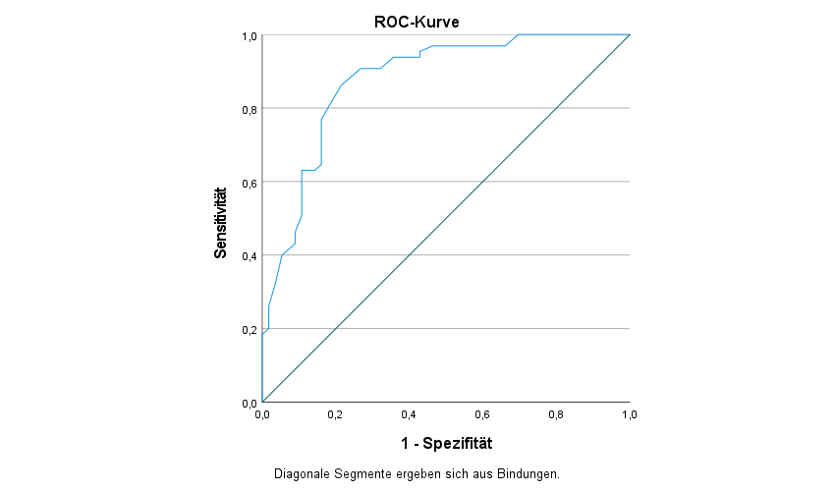
Note. Accuray (AUC) = .88 (95% CI = .81-.94)

Online Supplement 6 (OS6)
Receiving operator characteristic curve (ROC-curve) for CATS2-ICD-11 PTSD scale (Self-report) relative to CAPS-CA-5 ICD-11 PTSD diagnosis
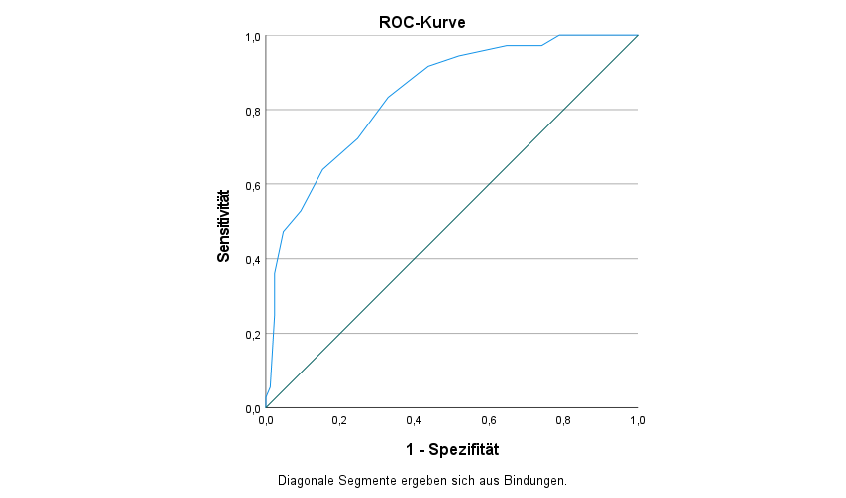
Note. Accuray (AUC) = .84 (95% CI = .77-.92)

Online Supplement 7 (OS7)
Discrimination Index (corrected item-scale correlations) for items regarding the DSM-5 PTSD scale, the ICD-11 scale and the ICD-11 CPTSD scale of the CATS-2 (Self-report)
CATS2 Item | Item Description | Diagnostic Allocation* | DSM-5 PTSD | ICD-11 PTSD | ICD-11 CPTSD
Item1 | Intrusions | ◊ | 0.59
Item2 | Nightmares | ◊ ; ○ | 0.54 | 0.45 | 0.49
Item3 | Flashbacks | ◊ ; ○ | 0.60 | 0.45 | 0.55
Item4 | Psychological Cue Reactivity | ◊ | 0.58
Item5 | Physiological  Cue Reactivity | ◊ | 0.55
Item6 | Avoidance internal reminders | ◊ ; ○ | 0.51 | 0.37 | 0.44
Item7 | Avoidance external reminders | ◊ ; ○ | 0.41 | 0.41 | 0.39
Item8 | Amnesia | ◊ | 0.22
Item 9 | Negative Beliefs | ◊ highest | 0.66
Item 9a | Bad Life
Item 9b | No Trust | ● |  |  | 0.57
Item 9c | Negative World
Item 9d | Negative Self | ● |  |  | 0.57
Item10 | Blame | ◊ highest | 0.52
Item10a | Self-Blame | ● |  |  | 0.51
Item10b | Blames others
Item11 | Negative Feelings | ◊ | 0.62
Item12 | Loss of interest | ◊ | 0.60
Item13 | Detachment | ◊ ; ● | 0.48 |  | 0.47
Item14 | Numbing | ◊ ; ● | 0.62 |  | 0.59
Item15 | Irritability | ◊ highest | 0.50
Item15a | Affect regulation | ● |  |  | 0.47
Item15b | Angry Outbursts
Item16 | Reckless behavior | ◊ | 0.44
Item17 | Hypervigilance | ◊ ; ○ | 0.39 | 0.38 | 0.38
Item18 | Startle Response | ◊ ; ○ | 0.39 | 0.36 | 0.39
Item19 | Concentration | ◊ | 0.45
Item20 | Sleep Disturbance | ◊ | 0.53
Note. *Symbols for Diagnostic Allocation (DSM-5 PTSD Score = ◊; ICD-11 PTSD Score = ○; ICD-11 DSO Score ●.

Online Supplement 8 (OS8)
Discrimination Index (corrected item-scale correlations) for items regarding the DSM-5 PTSD scale, the ICD-11 scale and the ICD-11 CPTSD scale of the CATS-2 (caregiver report)
CATS2 Item | Item Description | Diagnostic Allocation* | DSM-5 PTSD | ICD-11 PTSD | ICD-11 CPTSD
Item1 | Intrusions | ◊ | 0.66
Item2 | Nightmares | ◊ ; ○ | 0.61 | 0.53 | 0.52
Item3 | Flashbacks | ◊ ; ○ | 0.54 | 0.53 | 0.54
Item4 | Psychological Cue Reactivity | ◊ | 0.63
Item5 | Physiological  Cue Reactivity | ◊ | 0.66
Item6 | Avoidance internal reminders | ◊ ; ○ | 0.56 | 0.57 | 0.55
Item7 | Avoidance external reminders | ◊ ; ○ | 0.47 | 0.56 | 0.49
Item8 | Amnesia | ◊ | 0.27
Item 9 | Negative Beliefs | ◊ highest | 0.65
Item 9a | Bad Life
Item 9b | No Trust | ● |  |  | 0.64
Item 9c | Negative World
Item 9d | Negative Self | ● |  |  | 0.59
Item10 | Blame | ◊ highest | 0.51
Item10a | Self-Blame | ● |  |  | 0.54
Item10b | Blames others
Item11 | Negative Feelings | ◊ | 0.72
Item12 | Loss of interest | ◊ | 0.57
Item13 | Detachment | ◊ ; ● | 0.51 |  | 0.52
Item14 | Numbing | ◊ ; ● | 0.64 |  | 0.59
Item15 | Irritability | ◊ highest | 0.60
Item15a | Affect regulation | ● |  |  | 0.53
Item15b | Angry Outbursts
Item16 | Reckless behavior | ◊ | 0.39
Item17 | Hypervigilance | ◊ ; ○ | 0.49 | 0.54 | 0.50
Item18 | Startle Response | ◊ ; ○ | 0.55 | 0.53 | 0.57
Item19 | Concentration | ◊ | 0.47
Item20 | Sleep Disturbance | ◊ | 0.51
Note. *Symbols for Diagnostic Allocation (DSM-5 PTSD Score = ◊; ICD-11 PTSD Score = ○; ICD-11 DSO Score ●.

Online Supplement 9 (OS9)
Descriptives of the CAPS-CA-5 sample (n = 121)
Characteristic | Total  sample  (N = 121) | US  sample  (n = 30) | Norwegian sample  (n = 28) | German sample  (n = 63)
Age (M, SD) | 13.94 (2.86) | 12.43 (3.54) | 14.29 (2.21) | 14.51 (2.51)
Gender (% female) | 64.5 | 50.0 | 71.4 | 68.3
Living situation (%)
Biological parents | 79.3 | 63.3 | 82.1 | 85.7
Foster Parents/Adoptive Parents | 12.4 | 30.0 | 14.3 | 3.2
Child Welfare | 5.8 | 0.0 | 3.6 | 9.5
Somewhere else | 2.5 | 6.7 | 0 | 1.6
Race*
American Indian | - | 13.3 | - | -
Black or African American | - | 6.7 | - | -
White | - | 80.0 | - | -
Ethnicity*
Hispanic or Latino | - | 14.3 | - | -
Country of origin*
Not Norwegian/German | - | - | 18.2 | 11.1
Note. values are means (stand deviations) or % as appropriate. *Race and Ethnicity were only assessed in the US sample; Country of origin was only assessed in the Norwegian and German sample

Online Supplement 10 (OS10)
Frequencies of traumatic events of the CATS-2 self-reports and mean differences in CATS-2 scales regarding the endorsement of each specific traumatic event (yes/no).
 |  | Mean differences in PTSD scales
Traumatic Event | Frequency (%) | DSM-5 PTSD | ICD-11 PTSD | ICD-11 CPTSD
Natural disaster | 19.4 | 0.89 | -0.09 | 0.88
Accident/ injury | 41.3 | -0.85 | -0.24 | -0.56
Experiencing family violence | 36.7 | -4.75*** | -1.28* | -2.93**
Experiencing Community Violence | 41.7 | -3.24* | -1.12* | -2.16*
Attacked with weapon | 8.5 | -3.14 | -1.33 | -1.77
Seeing family violence | 45.2 | -5.07*** | -1.82*** | -3.28***
Seeing Community Violence | 33.6 | -3.68** | -1.30** | -2.26*
Sexual | 28.6 | -7.61*** | -2.56*** | -5.07***
Online sexual | 14.5 | -10.87*** | -2.78*** | -7.17***
Bullying | 59.4 | -7.70*** | -2.26*** | -4.92***
Online bullying | 20.1 | -10.56*** | -2.86*** | -6.55***
Sudden loss | 40.6 | -1.13 | -0.58 | -0.38
Medical | 23.4 | -0.86 | -0.49 | -0.10
War | 1.4 | -4.62 | -2.67 | -2.18
Other not specified event | 38.9 | -2.02 | -0.21 | -0.98
Note. N = 28; * = p < .05; ** = p < .01; *** = p < .001

