Supplementary Information (SI):

Numerical investigations on the difference between aiding and opposing flows in the developing regime of laminar mixed convection in vertical tubes
Somenath Gorai^{a,b}, Sarit K. Das^{c}* and Devranjan Samantaª*
ªDepartment of Mechanical Engineering, Indian Institute of Technology Ropar, Rupnagar, India;
^{b}Department of Mechanical Engineering, Manipal University Jaipur, Jaipur, India;
^{c}Department of Mechanical Engineering, Indian Institute of Technology Madras, Chennai, India
*Corresponding author: devranjan.samanta@iitrpr.ac.in

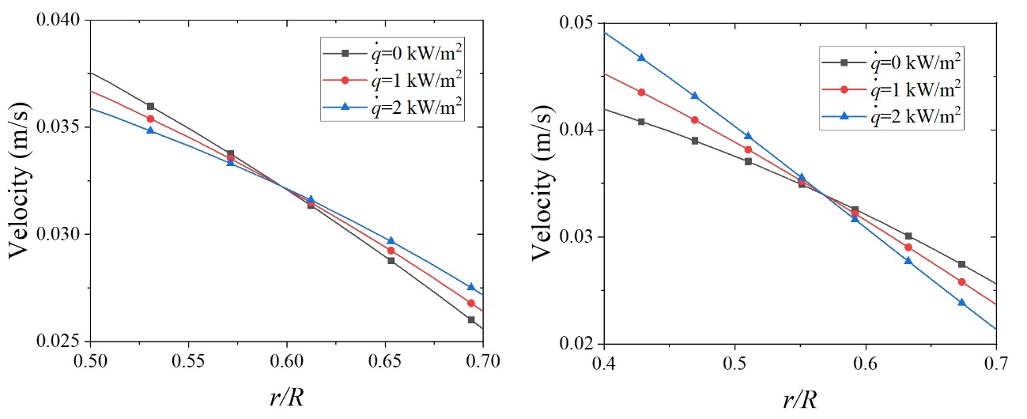
(a) (b)
Fig. SI-1: Magnified view of (a) Fig. 5b and (b) Fig. 16b within region $0.5≤\frac{r}{R}≤0.70$
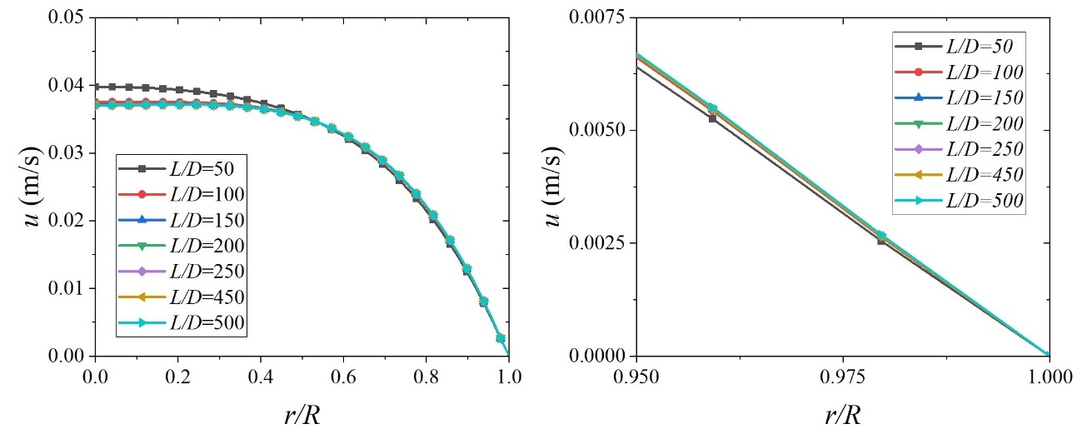
(a) (b)
Fig. SI-2: (a) Velocity profile and (b) magnified velocity near the walls ($0.95≤\frac{r}{R}≤1$) at different axial length (for Fig. 5b at $\dot{q}=2 kW/m^{2}$)
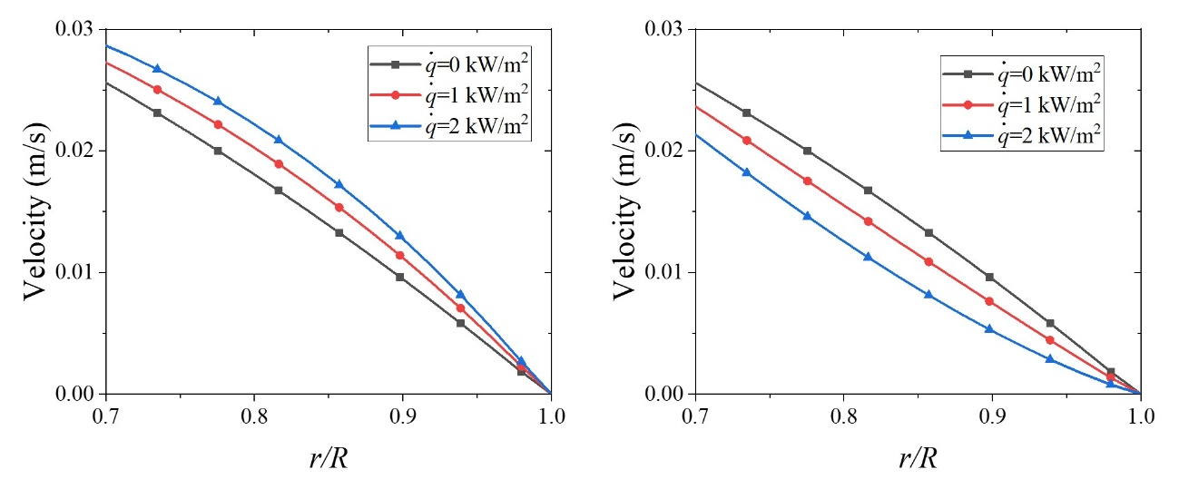
(a) (b)
Fig. SI-3: Magnified view of (a) Fig. 5b and (b) Fig. 16b adjacent to the wall i.e., $0.7≤\frac{r}{R}≤1$, based upon which the friction factor is defined
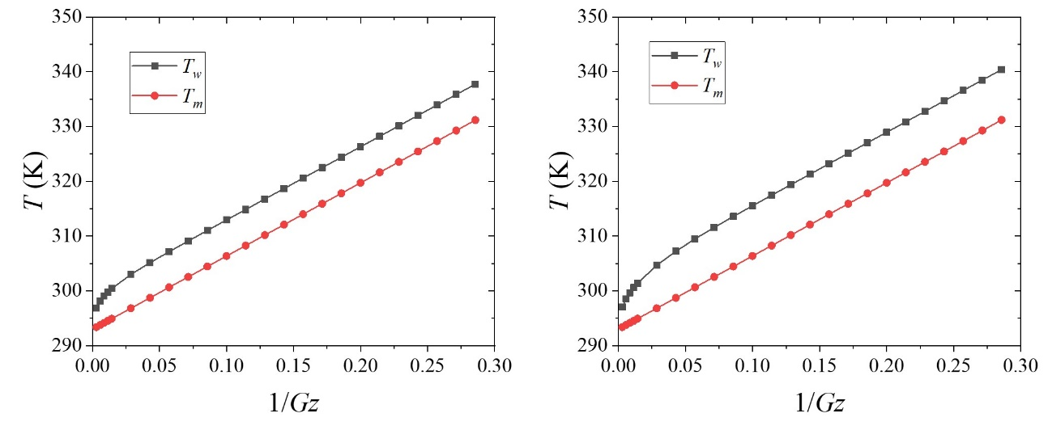
(a) (b)
Fig. SI-4: Wall temperature ($T_{w}$) and mean temperature ($T_{m}$) variation at different axial length (for Fig. 7b and 18b at $\dot{q}=2 kW/m^{2}$) for (a) assisting and (b) opposing flow

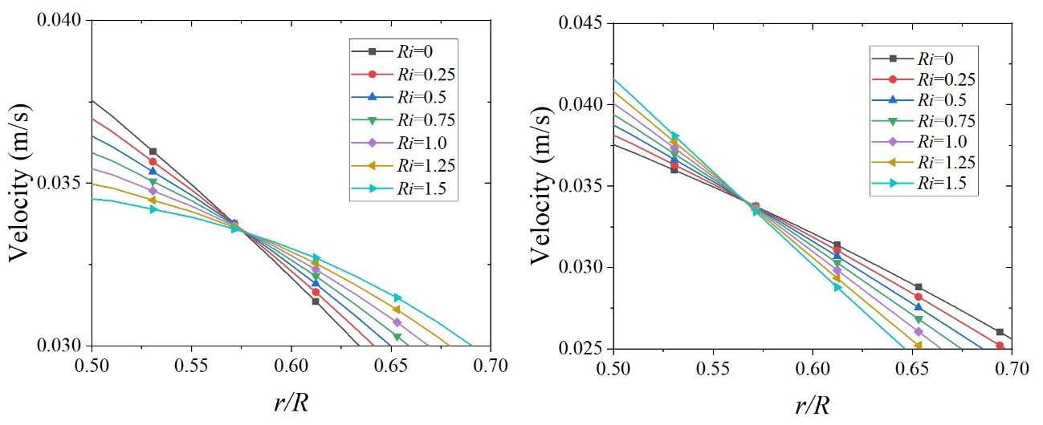
(a) (b)
Fig. SI-5: Magnified view of (a) Fig. 8b and (b) Fig. 19b
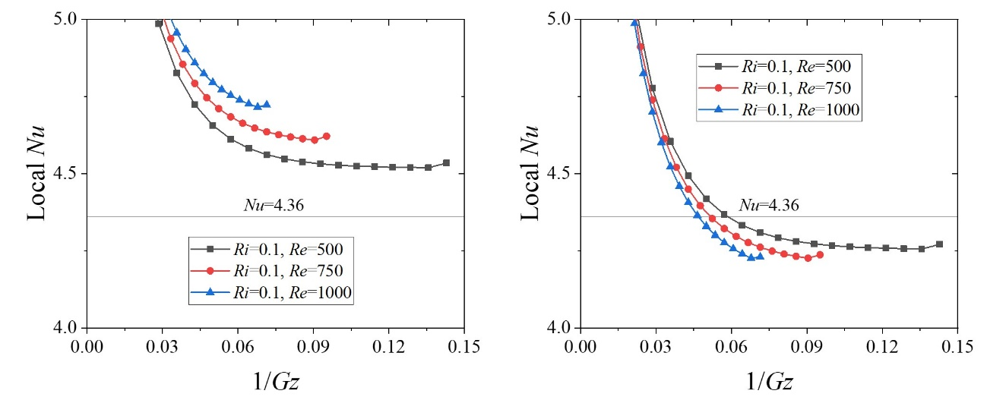
(a) (b)
Fig. SI-6: Magnified view of (a) Fig. 12b and (b) Fig. 23b

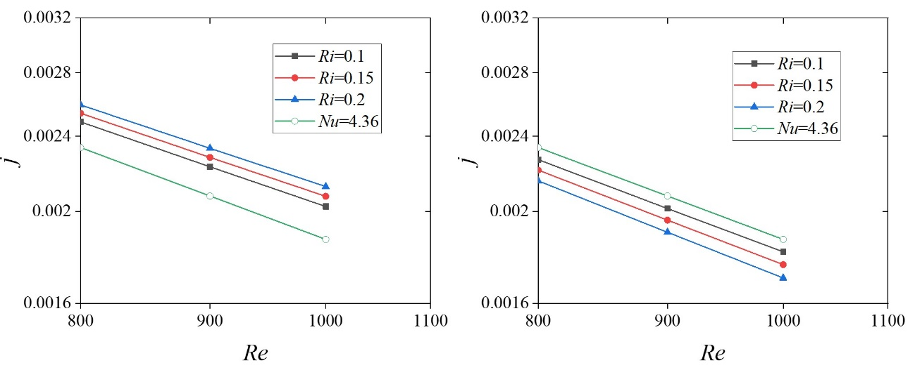
(a) (b)
Fig. SI-7: Magnified view of (a) Fig. 14 and (b) Fig. 25
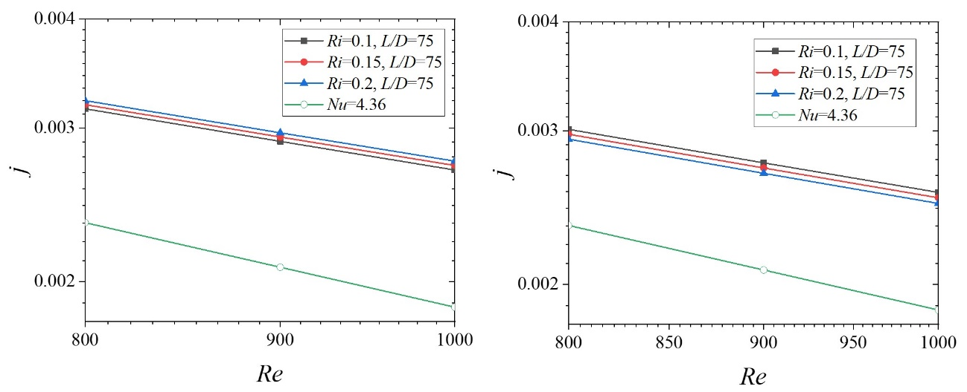
(a) (b)
Fig. SI-8: Enlarged view of (a) Fig. 15b and (b) Fig. 26b

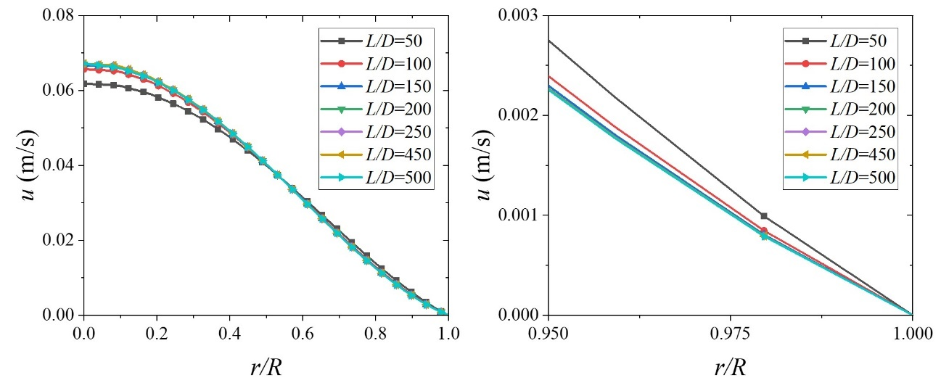
(a) (b)
Fig. SI-9: (a) Velocity profile and (b) magnified velocity near the walls ($0.95≤\frac{r}{R}≤1$) at different axial length (for Fig. 16b at $\dot{q}=2 kW/m^{2}$)

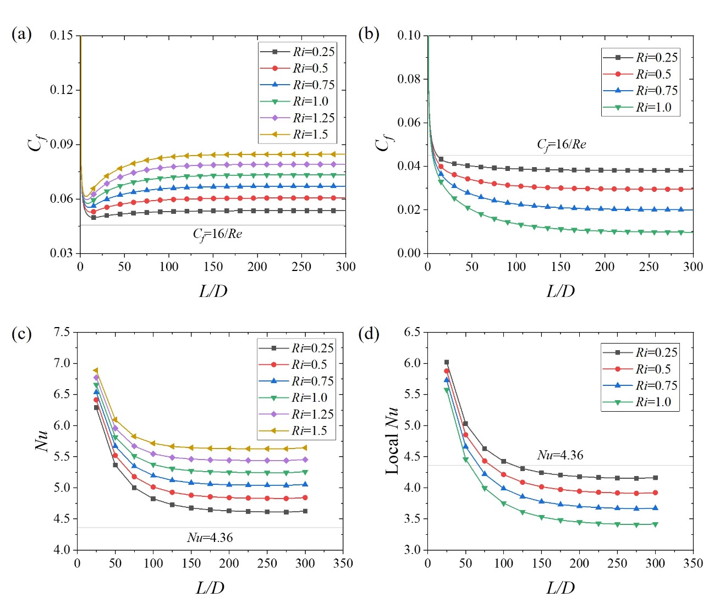
Fig. SI-10: Local $C_{f}$ and $Nu$ plot corresponding to different $Ri$ at $Re=350$ for (a, c) assisting and (b, d) opposing flow (numerical instability observed after $Ri=1.0$)
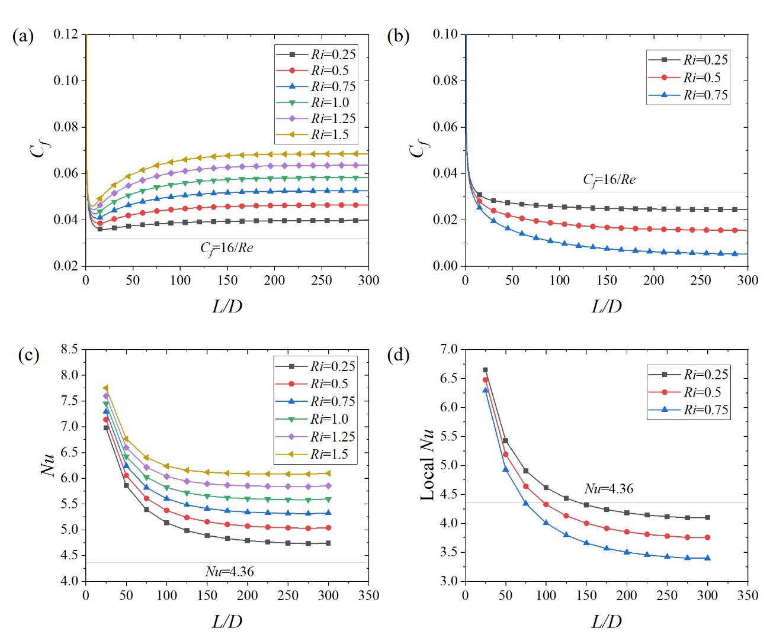
Fig. SI-11: Local $C_{f}$ and $Nu$ plot corresponding to different $Ri$ at $Re=500$ for (a, c) assisting and (b, d) opposing flow (numerical instability observed after $Ri=0.75$)
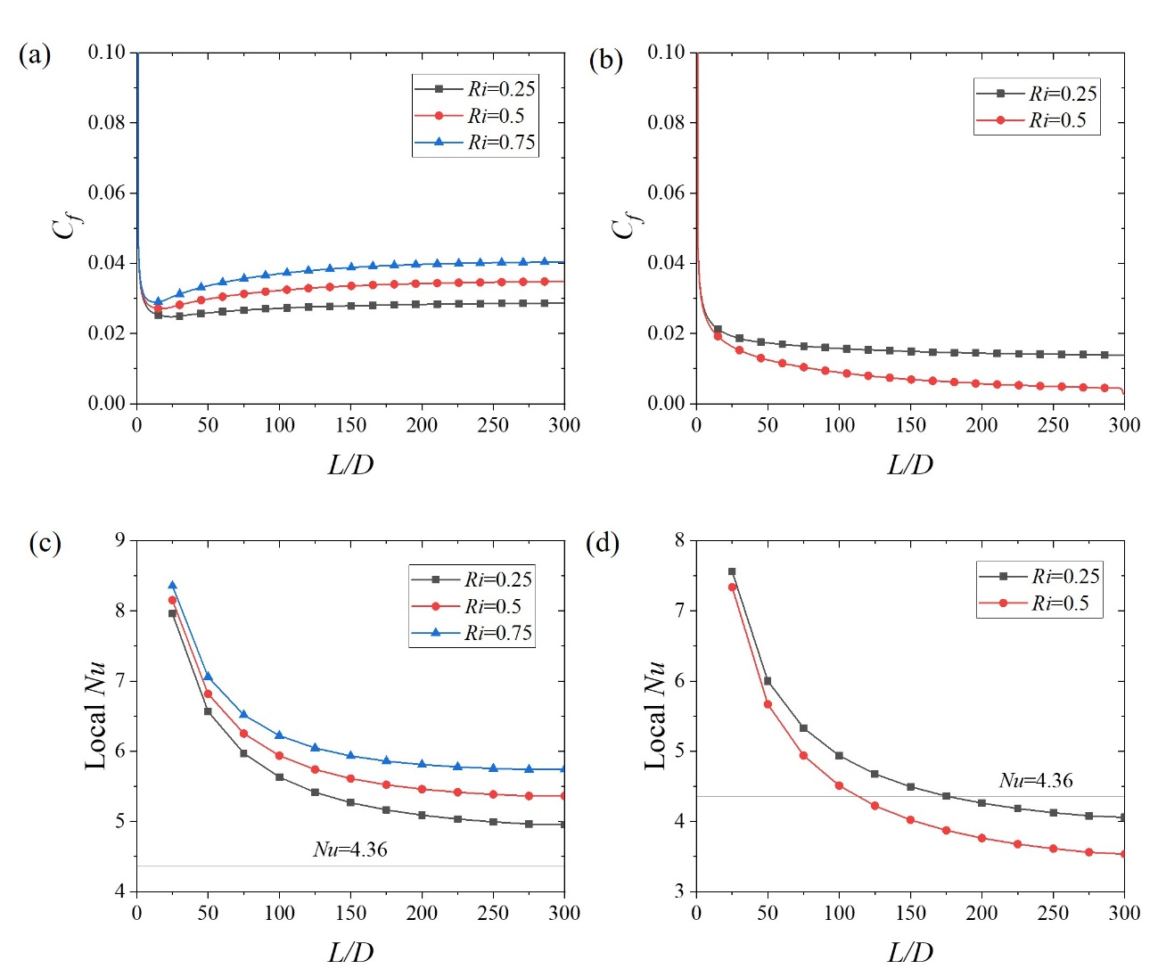
Fig. SI-12: Local $C_{f}$ and $Nu$ plot corresponding to different $Ri$ at $Re=750$ for (a, c) assisting and (b, d) opposing flow (numerical instability observed after $Ri=0.5$)
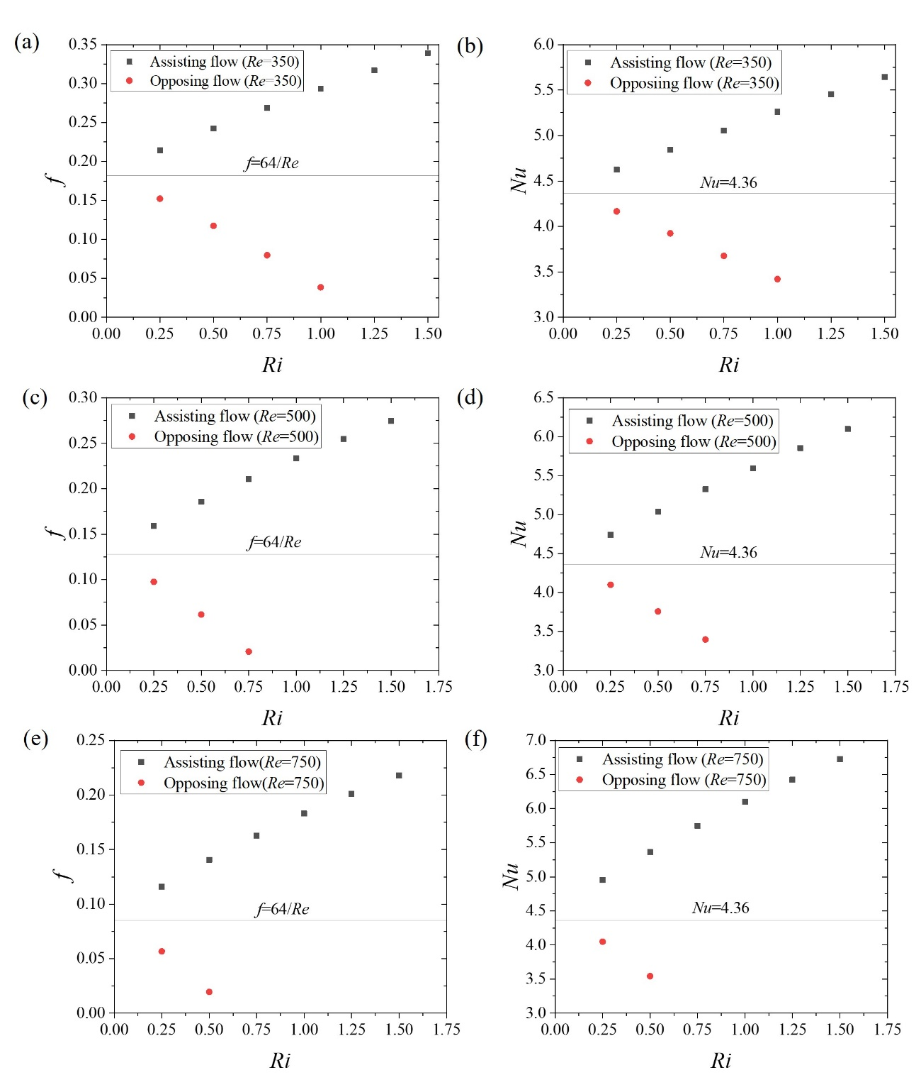
Fig. SI-13: Fully developed $f$ Vs $Ri$ and $Nu$ Vs $Ri$ plots corresponding to (a, b) $Re=350$ (c, d) $500$ and (e, f) $750$ for assisting and opposing flow (numerical instability observed after $Ri=1.0$ for $Re=350$, after $Ri=0.75$ for $Re=500$ and after $Ri=0.5$ for $Re=750$

