SUPPORTING INFORMATION

Pineapple fiber hybrids prepared by the fusion of radiation-induced graft polymerization and Kabachnik-Fields three-component reaction (RIGP-KF3CR)

Synthesis of vanillin methacrylate

Vanillin (99%) was purchased from Loba Chemie while 4-dimethylaminopyridine (DMAP, ≥99%) and methacrylic anhydride (MA, 94%, with 2000 ppm Topanol A) were purchased from Sigma Aldrich. Vanillin, DMAP (2 mol% of MA), and MA (1.2 meq vanillin) were placed in a round bottom flask and placed under nitrogen atmosphere. The solution was kept at 45 °C for 24 h with stirring. The solution was then diluted with ethyl acetate followed by workup using saturated sodium bicarbonate, sodium hydroxide, hydrochloric acid, and water. The solvent was evaporated, and the crude product was recrystallized. The crystals were finally dried in a vacuum oven at 35 °C to constant weight. This method yielded a white crystalline solid at 60% yield. Unlike vanillin, the product was insoluble in water. Synthesized vanillin methacrylate showed distinct peaks of vanillin at 2845, 2750 and 1689 cm⁻¹ corresponding to aldehydic C-H and C=O stretching, as well as peaks at 1597 and 1505 cm⁻¹ corresponding to C=C and C-C stretches of the aromatic ring (SD1a). Additionally, the product spectrum showed the absence of O-H peak at 3157 cm⁻¹ and the appearance of peaks for ester C=O and vinyl C=C at 1730 and 1634 cm⁻¹ respectively, indicating successful methacrylation. The importance of recrystallization can be seen in the presence of small anhydride contaminants at 1810 and 1782 cm⁻¹ in the crude product. Meanwhile, the ¹H-NMR spectra of the compounds are shown in SD1b. VM showed chemical shifts from both vanillin [δ=9.98 (s, 1H), 7.65–7.30 (bm, 3H), 3.81 (s, 3H)] and MA [6.27 (s, 1H), 5.89 (t, 1H), 1.96 ppm (s, 3H)], some of which slightly shifted downfield due to the combined presence of pi conjugation from the aromatic ring and vinyl ester functional groups. The synthesized VM had extraneous peaks indicating the presence of contaminants, most likely from methacrylic anhydride (94% purity with 2000 ppm Topanol A). Recrystallization reduced the amount of contaminant, but some residue remained. Further purification may be considered in future works, but for this study, the r-VM was used as-is.

Supplementary Data 1. (a) ATR-FTIR and (b) ¹H-NMR spectra with peak assignment for vanillin, methacrylic anhydride (MA), crude VM (c-VM), and recrystallized VM (r-VM).

Additional characterization data
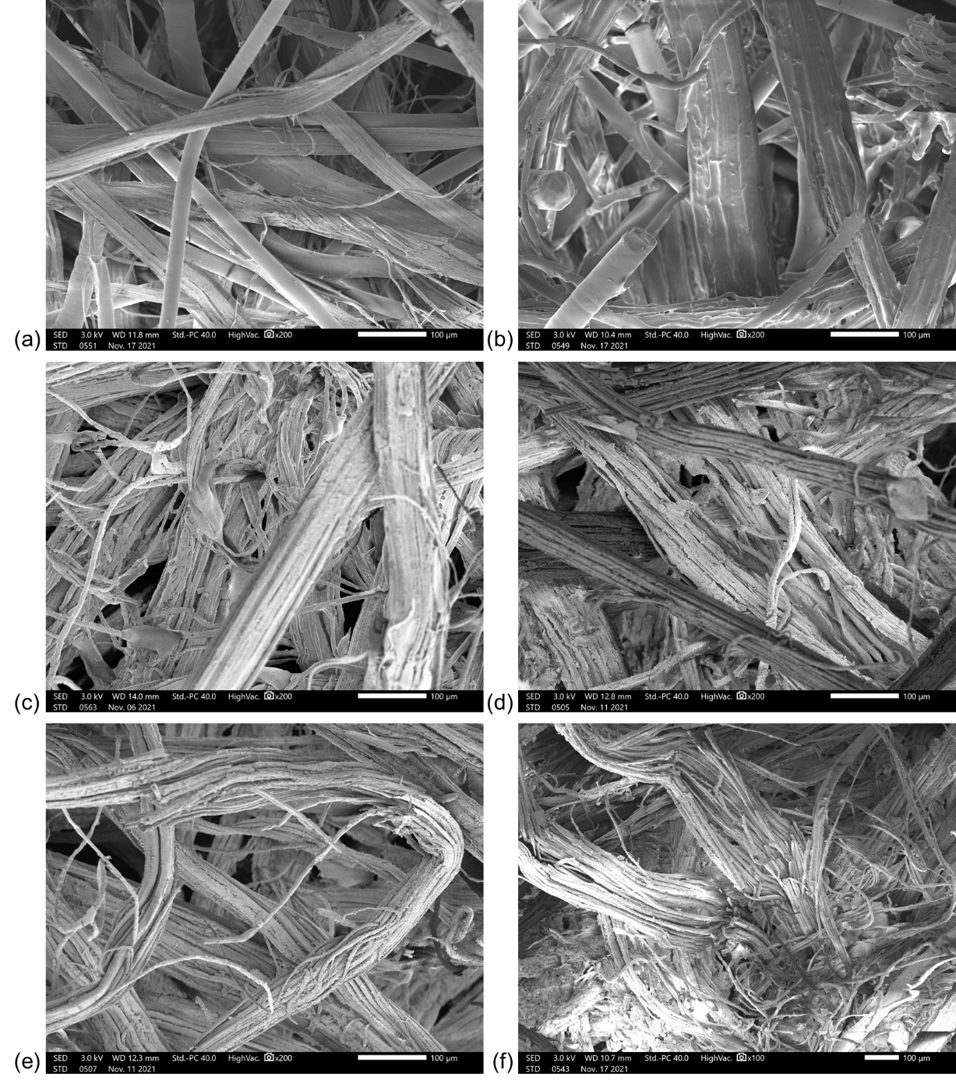
Supplementary Data 2. SEM images of pineapple nonwoven fabric: (a) pristine; (b) grafted, DG 100%; and functionalized with diisopropyl phosphite with (c) p-anisidine, (d) 4-chloroaniline, (e) 4-bromoaniline, and (f) 4-iodoaniline

(a) (b)
(c) (d)
Supplementary Data 3. Thermogravimetric analysis of PNWF-g-PAP: TG (solid) and DTG (dashed) curves of fabric functionalized with diisopropyl phosphite with (a) p-anisidine, (b) 4-chloroaniline, (c) 4-bromoaniline, and (d) 4-iodoaniline

(a) (b)
(c) (d)
Supplementary Data 4. Thermogravimetric analysis of PNWF-g-PAP: TG (solid) and DTG (dashed) curves of fabric functionalized with dibutyl phosphite with (a) p-anisidine, (b) 4-chloroaniline, (c) 4-bromoaniline, and (d) 4-iodoaniline

