Poloxamers | Sol – gel transition temperature (°C) | Viscosity (Pa.s)
 |  | 25°C | 37°C
PF 127 w/w
15 | >40 | 5.66 | 398.6
20 | 31.90 | 610.2 | 3190
25 | 27.50 | 2.78 | 289.6
30 | 24.95 | 477.4 | 1121.56
P 87 w/w
15 | >40 | 0.03 | 0.07
20 | >40 | 0.04 | 2.56
25 | 33.87 | 0.54 | 67.59
30 | 29.50 | 0.51 | 968.45
Table S1: Poloxamers concentration, gelation temperatures and viscosity at 25ºC and 37ºC (n=3)

Table S2 Average depths of penetration (DOP) in neonatal porcine skin tissues and moisture contents (%) of fabricated MNs
Sample codes | Samples composition | Weight ratio  (% w/w) | Square Grid | Heights  (µm) | Average  Depth of penetration (µm) n=3 | Moisture  Contents (%)  N=3
PG10000 | Gantrez® S-97/PEG10000 | 10: 7.5 % | 19x19 | 600 | 578± 33.56 | 8 ± 0.265
Gelatin | Gelatin B | 15% | 19x19 | 600 | 549±27.40 | 5.23 ± 0.218

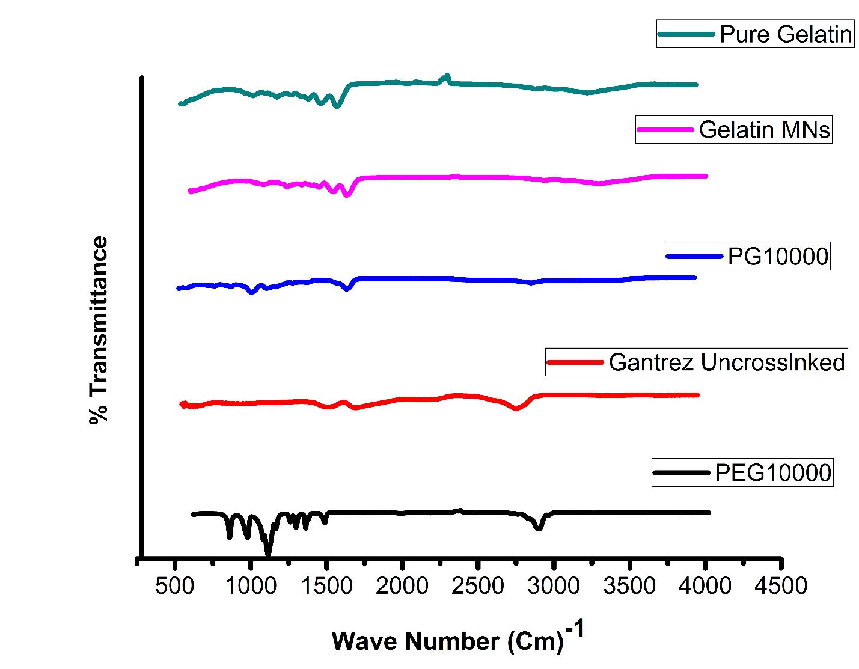
Figure S1. FTIR spectroscopic analysis of uncrosslinked Gantrez® S-97, Pure gelatin, Pure PEG10000, cross-linked PG10000 MN arrays and gelatin MNs.

