Low-Toxin Clostridioides difficile RT027 Strains Exhibit Robust Virulence

Farhan Anwar¹, Bryan Angelo P. Roxas¹, Kareem W. Shehab², Neil Ampel³, VK Viswanathan^{1,4,5}, and Gayatri Vedantam^{1, 4, 5, 6}

¹School of Animal and Comparative Biomedical Sciences, The University of Arizona, Tucson, AZ, USA, ²Department of Pediatrics, The University of Arizona College of Medicine, Tucson, AZ, USA, ³Mayo Clinic, Phoenix, AZ, ⁴Department of Immunobiology, The University of Arizona College of Medicine, Tucson, AZ, USA, ⁵BIO5 Institute for Collaborative Research, The University of Arizona, Tucson, AZ, ⁶Southern Arizona VA Healthcare System, Tucson, AZ⁴.

*Correspondence to:
Gayatri Vedantam, Ph.D.
University of Arizona
School of Animal & Comparative Biomedical Sciences
1117, E. Lowell St. Bldg. 90, Room 227
Tucson, AZ 85721
Phone: 520-626-6839
gayatri@email.arizona.edu

Supplemental Table S1: Primers Used In this Study

Primer name |  | Gene Target | Sequence | Ref
RIBO-F |  | 16S rDNA | 5′-GCTGGATCACCTCCTTTCTAAG | Janežič et al. J Clin Microbiol (2011)
RIBO-R |  | 23S rDNA | 5′-TGACCAGTTAAAAAGGTTTGATAGATT
B1C |  | tcdB | 5' - AGAAAATTTTATGAGTTTAGTTAATAGAAA | Rupnik et al. FEMS Microbiol Lett (2006)
B2N |  | tcdB | 5' - CAGATAATGTAGGAAGTAAGTCTATAG
A1C |  | tcdA | 5' - GGAGGTTTTTATGTCTTTAATATCTAAAGA
A2N |  | tcdA | 5' - CCCTCTGTTATTGAGGTAGTACATTTA
cdtA-F |  | cdtA | 5′-TGAACCTGGAAAAGGTGATG | Pituch et al. J Med Microbiol (2005)
cdtA-R |  | cdtA | 5′-AGGATTATTTACTGGACCATTTG
cdtB-F |  | cdtB | 5′-CTTAATGCAAGTAAATACTGAG
cdtB-R |  | cdtB | 5′-AACGGATCTCTTGCTTCAGTC
Tim2 |  | tcdC | 5’-GCACCTCATCACCATCTTCA | Cohen et al. J Infect Dis (2000)
Struppi2 |  | tcdC | 5’-TGAAGACCATGAGGAGGTCAT

Strain | NCBI Accession Numbers |  | Coverage
 | Biosample | BioProject
GV106 | SAMN26752631 | PRJNA817265 | 630x
GV135 | SAMN26752621 | PRJNA817265 | 2060x
GV144 | SAMN26752619 | PRJNA817265 | 65x
GV145 | SAMN26752625 | PRJNA817265 | 142x
GV147 | SAMN26752628 | PRJNA817265 | 69x
GV148 | SAMN26752630 | PRJNA817265 | 751x
GV153 | SAMN26752620 | PRJNA817265 | 51x
GV155 | SAMN26752626 | PRJNA817265 | 142x
GV161 | SAMN26752624 | PRJNA817265 | 134x
GV163 | SAMN26752633 | PRJNA817265 | 145x
GV165 | SAMN26752635 | PRJNA817265 | 157x
GV175 | SAMN26752627 | PRJNA817265 | 120x
GV178 | SAMN26752623 | PRJNA817265 | 118x
GV183 | SAMN26752629 | PRJNA817265 | 98x
GV736 | SAMN26752622 | PRJNA817265 | 195x
GV745 | SAMN26752634 | PRJNA817265 | 120x
GV752 | SAMN26752632 | PRJNA817265 | 318x
Supplemental Table S2: GenBank Accession Numbers of LT-027 Isolates

Supplemental Table S3: MIC of Select Antibiotics of High- and Low-Toxin Strains

MIC (µg/mL) | Cefotaxime | Rifampicin | Levofloxacin | Metronidazole | Vancomycin
BI-1 | >16 * | 1 | >32 * | >256 * | 3
GV106 | >16 * | 1 | >32 * | >256 * | 3
GV135 | 0.75 * | 3 | 0.75 | >256 * | 3
GV148 | >16 * | >32 * | >32 * | 1 | 4

Units are in µg/mL.
*Denotes that the strain is highly resistant as per CLSI breakpoints:

Cefotaxime: >16 µg/mL
Rifampicin: > 16 µg/mL
Levofloxacin: > 8 µg/mL
Metronidazole: >32 µg/mL
Vancomycin: not defined.

Supplemental Table S4: Unique genes harbored by LT-027 strains

Gene ID | Function
fig|1496.1250.peg.42 | FIG002813: LPPG:FO 2-phospho-L-lactate transferase like, CofD-like
fig|1496.1250.peg.146 | FIG00514768: hypothetical protein
fig|1496.1250.peg.155 | Anaerobic sulfite reductase subunit B
fig|1496.1250.peg.164 | N-acetylmannosamine-6-phosphate 2-epimerase (EC 5.1.3.9)
fig|1496.1250.peg.173 | ATPase associated with various cellular activities, AAA_5
fig|1496.1250.peg.198 | FIG00522519: hypothetical protein
fig|1496.1250.peg.371 | tRNA and rRNA cytosine-C5-methylases
fig|1496.1250.peg.394 | FIG00520447: hypothetical protein
fig|1496.1250.peg.407 | FIG00512777: hypothetical protein
fig|1496.1250.peg.408 | FIG00515422: hypothetical protein
fig|1496.1250.peg.470 | Cytosol nonspecific dipeptidase (EC 3.4.13.18)
fig|1496.1250.peg.661 | Osmosensitive K+ channel histidine kinase KdpD (EC 2.7.3.-)
fig|1496.1250.peg.755 | Chloride channel protein
fig|1496.1250.peg.845 | D-aminopeptidase dipeptide-binding protein DppA (EC 3.4.11.-)*
fig|1496.1250.peg.965 | LSU ribosomal protein L13p (L13Ae)
fig|1496.1250.peg.1001 | DNA topoisomerase I (EC 5.99.1.2)
fig|1496.1250.peg.1050 | Translocation-enhancing protein TepA
fig|1496.1250.peg.1145 | RNA polymerase sporulation specific sigma factor SigE
fig|1496.1250.peg.1158 | Acyl-CoA:1-acyl-sn-glycerol-3-phosphate acyltransferase (EC 2.3.1.51)
fig|1496.1250.peg.1173 | 3-dehydroquinate synthase (EC 4.2.3.4)
fig|1496.1250.peg.1221 | AzlC family protein
fig|1496.1250.peg.1256 | N-acetylmuramoyl-L-alanine amidase (EC 3.5.1.28)*
fig|1496.1250.peg.1324 | Transcriptional regulator
fig|1496.1250.peg.1335 | Hydantoinase/oxoprolinase family protein
fig|1496.1250.peg.1416 | putative membrane protein (putative phage infection protein)*
fig|1496.1250.peg.1419 | Rubrerythrin
fig|1496.1250.peg.1455 | FIG00519734: hypothetical protein
fig|1496.1250.peg.1483 | FIG00514478: hypothetical protein
fig|1496.1250.peg.1580 | Peptide methionine sulfoxide reductase MsrA (EC 1.8.4.11) / Peptide methionine sulfoxide reductase MsrB (EC 1.8.4.12)
fig|1496.1250.peg.1736 | V-type ATP synthase subunit D (EC 3.6.3.14)
fig|1496.1250.peg.2084 | Stage III sporulation protein AB
fig|1496.1250.peg.2198 | SSU ribosomal protein S20p
fig|1496.1250.peg.2205 | Cell wall-binding protein*
fig|1496.1250.peg.2206 | Uracil-DNA glycosylase, family 1
fig|1496.1250.peg.2337 | FIG013354: hypothetical protein
fig|1496.1250.peg.2338 | UDP-N-acetylglucosamine 1-carboxyvinyltransferase (EC 2.5.1.7)*
fig|1496.1250.peg.2342 | MreB-like protein (Mbl protein)
fig|1496.1250.peg.2378 | hypothetical protein
fig|1496.1250.peg.2379 | RNA polymerase sporulation specific sigma factor SigK
fig|1496.1250.peg.2413 | Peptidoglycan N-acetylglucosamine deacetylase (EC 3.5.1.-)*
fig|1496.1250.peg.2440 | ATP phosphoribosyltransferase (EC 2.4.2.17)
fig|1496.1250.peg.2466 | FIG00522895: hypothetical protein
fig|1496.1250.peg.2476 | FIG006036: phage encoded DNA polymerase I (EC 2.7.7.7)
fig|1496.1250.peg.2527 | HNH homing endonuclease
fig|1496.1250.peg.2560 | ABC transporter, permease protein*
fig|1496.1250.peg.2609 | Formate dehydrogenase H (EC 1.2.1.2) @ selenocysteine-containing
fig|1496.1250.peg.2611 | Response regulator
fig|1496.1250.peg.2670 | Arsenic efflux pump protein*
fig|1496.1250.peg.2790 | Dihydropyrimidinase (EC 3.5.2.2) @ D-hydantoinase (EC 3.5.2.2)
fig|1496.1250.peg.2815 | Transcriptional regulator, MerR family
fig|1496.1250.peg.2862 | Transcriptional regulator, MecI family
fig|1496.1250.peg.2904 | FIG004454: RNA binding protein
fig|1496.1250.peg.2992 | FIG00516716: hypothetical protein
fig|1496.1250.peg.3048 | Sarcosine reductase component B beta subunit (EC 1.21.4.3)
fig|1496.1250.peg.3092 | Hydrolase, HAD superfamily
fig|1496.1250.peg.3097 | Membrane component of multidrug resistance system*
fig|1496.1250.peg.3102 | Beta-glucoside bgl operon antiterminator, BglG family
fig|1496.1250.peg.3114 | RecA regulator RecX
fig|1496.1250.peg.3123 | Phosphate regulon transcriptional regulatory protein PhoB (SphR)
fig|1496.1250.peg.3218 | FIG00518106: hypothetical protein
fig|1496.1250.peg.3269 | Foldase protein PrsA precursor (EC 5.2.1.8)
fig|1496.1250.peg.3342 | Glycerol-3-phosphate regulon repressor GlpR
fig|1496.1250.peg.3462 | ATP-dependent DNA helicase UvrD/PcrA
fig|1496.1250.peg.3656 | FIG001621: Zinc protease
fig|1496.1250.peg.3859 | putative PTS system, IIa component
fig|1496.1250.peg.3966 | Ribonucleotide reductase of class III (anaerobic), activating protein  (EC 1.97.1.4)

Cell-wall associated genes denoted by asterisk

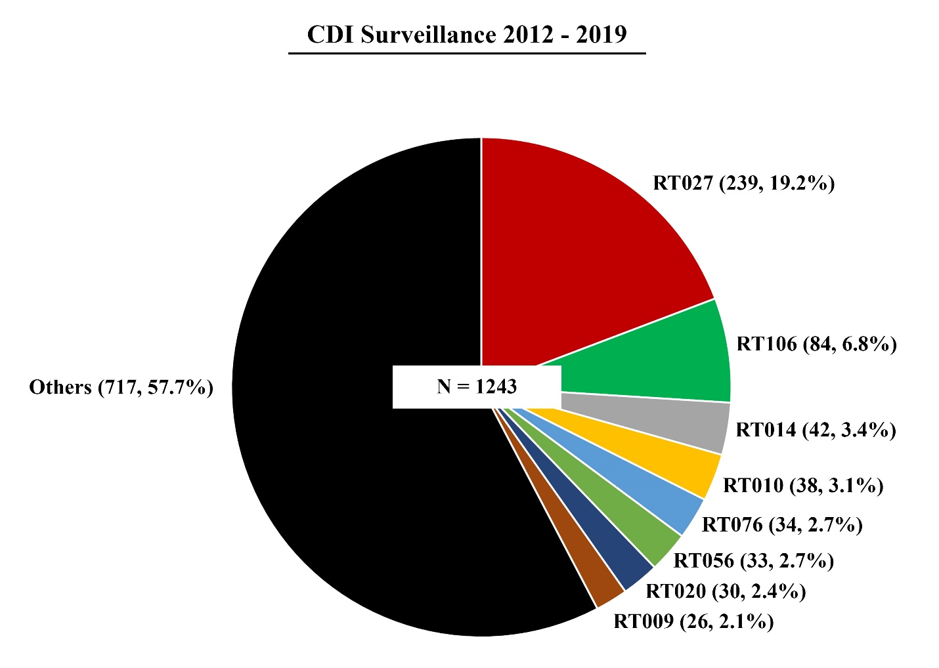

Supplemental Figure S1: Clostridioides difficile Ribotype RT027 is Prevalent in Tucson-area Hospitals

Ribotype distribution of C. difficile strains isolated from patient stool specimens collected from 2012-2019 (n=1243). Ribotype frequency and percent of total sample size are shown in parentheses (number of isolates, and percent of total). RT027 is the predominant ribotype. ‘Others’ refers to ribotypes that each constitute 2% or less of the total.
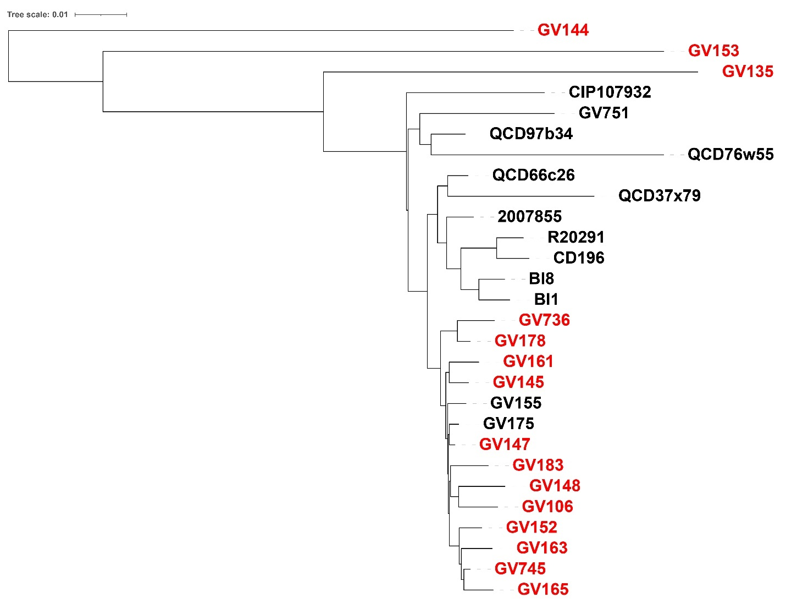

Supplemental Figure S2: Phylogenetic Comparison of High- and Low-Toxin RT027 Strains
Whole genome comparison between clinically derived, low-toxin producing (n = 15; red) and high toxin producing strains (n = 13; black). The high toxin strains (black) were previously published (except for GV155 and GV175). Low- and high-toxin strains cluster into distinct sub-clades. There are, at minimum, 80 single nucleotide polymorphism (SNP) differences between the most closely related low-toxin strains indicating that isolates are not identical, and, therefore, clonal.

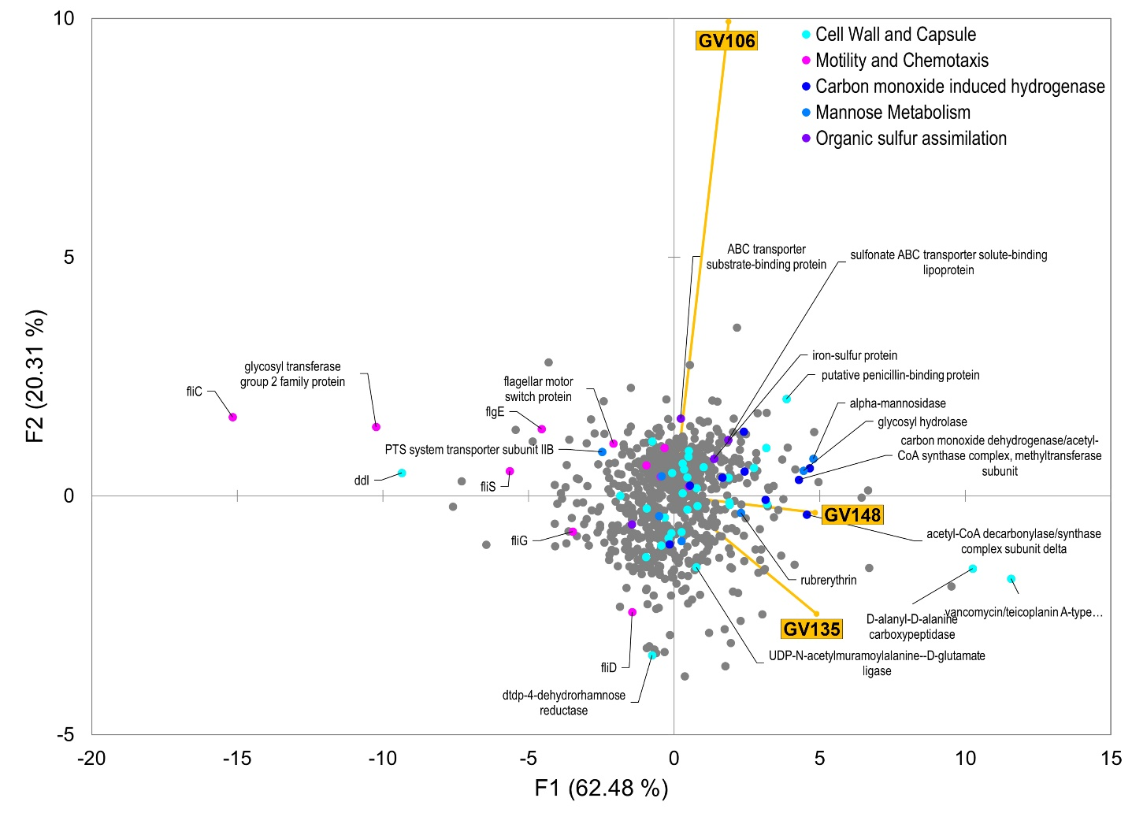
Supplemental Figure S3: PCA of LT-027 protein abundances relative to BI-1.
Protein abundances of low-toxin strains (at mid-logarithmic growth phase), were compared to the high-toxin producer BI-1. Each dot represents a protein hit; colored dots are proteins involved in selected biological processes, and which were displayed statistically significant differences in abundance compared with BI-1. Several of these proteins are predicted to be involved in cell wall and capsular biology.
Supplemental Table S5: KEGG Subcategories of LT-027 unique genes.
Gene ID | Function | KEGG Classification ID | KEGG Classification | KEGG Classification Description | KEGG Gene ID | KEGG Gene Description
fig|1496.1250.peg.155 | Anaerobic sulfite reductase subunit B | ko01100 | Pathway | Metabolic pathways | K16951 | asrB; anaerobic sulfite reductase subunit B
fig|1496.1250.peg.155 | Anaerobic sulfite reductase subunit B | ko01120 | Pathway | Microbial metabolism in diverse environments | K16951 | asrB; anaerobic sulfite reductase subunit B
fig|1496.1250.peg.155 | Anaerobic sulfite reductase subunit B | ko00920 | Pathway | Sulfur metabolism | K16951 | asrB; anaerobic sulfite reductase subunit B
fig|1496.1250.peg.164 | N-acetylmannosamine-6-phosphate 2-epimerase (EC 5.1.3.9) | ko01100 | Pathway | Metabolic pathways | K01788 | nanE; N-acylglucosamine-6-phosphate 2-epimerase [EC:5.1.3.9]
fig|1496.1250.peg.164 | N-acetylmannosamine-6-phosphate 2-epimerase (EC 5.1.3.9) | ko00520 | Pathway | Amino sugar and nucleotide sugar metabolism | K01788 | nanE; N-acylglucosamine-6-phosphate 2-epimerase [EC:5.1.3.9]
fig|1496.1250.peg.164 | N-acetylmannosamine-6-phosphate 2-epimerase (EC 5.1.3.9) | ko01000 | Brite | Enzymes | K01788 | nanE; N-acylglucosamine-6-phosphate 2-epimerase [EC:5.1.3.9]
fig|1496.1250.peg.198 | FIG00522519: hypothetical protein | ko01100 | Pathway | Metabolic pathways | K00074 | paaH; 3-hydroxybutyryl-CoA dehydrogenase [EC:1.1.1.157]
fig|1496.1250.peg.198 | FIG00522519: hypothetical protein | ko01120 | Pathway | Microbial metabolism in diverse environments | K00074 | paaH; 3-hydroxybutyryl-CoA dehydrogenase [EC:1.1.1.157]
fig|1496.1250.peg.198 | FIG00522519: hypothetical protein | ko01200 | Pathway | Carbon metabolism | K00074 | paaH; 3-hydroxybutyryl-CoA dehydrogenase [EC:1.1.1.157]
fig|1496.1250.peg.198 | FIG00522519: hypothetical protein | ko00362 | Pathway | Benzoate degradation | K00074 | paaH; 3-hydroxybutyryl-CoA dehydrogenase [EC:1.1.1.157]
fig|1496.1250.peg.198 | FIG00522519: hypothetical protein | ko00650 | Pathway | Butanoate metabolism | K00074 | paaH; 3-hydroxybutyryl-CoA dehydrogenase [EC:1.1.1.157]
fig|1496.1250.peg.198 | FIG00522519: hypothetical protein | ko00360 | Pathway | Phenylalanine metabolism | K00074 | paaH; 3-hydroxybutyryl-CoA dehydrogenase [EC:1.1.1.157]
fig|1496.1250.peg.198 | FIG00522519: hypothetical protein | ko01000 | Brite | Enzymes | K00074 | paaH; 3-hydroxybutyryl-CoA dehydrogenase [EC:1.1.1.157]
fig|1496.1250.peg.198 | FIG00522519: hypothetical protein | M00878 | Module | Phenylacetate degradation, phenylaxetate => acetyl-CoA/succinyl-CoA | K00074 | paaH; 3-hydroxybutyryl-CoA dehydrogenase [EC:1.1.1.157]
fig|1496.1250.peg.198 | FIG00522519: hypothetical protein | ko02020 | Pathway | Two-component system | K03406 | mcp; methyl-accepting chemotaxis protein
fig|1496.1250.peg.198 | FIG00522519: hypothetical protein | ko02030 | Pathway | Bacterial chemotaxis | K03406 | mcp; methyl-accepting chemotaxis protein
fig|1496.1250.peg.198 | FIG00522519: hypothetical protein | ko02035 | Brite | Bacterial motility proteins | K03406 | mcp; methyl-accepting chemotaxis protein
fig|1496.1250.peg.394 | FIG00520447: hypothetical protein | ko03000 | Brite | Transcription factors | K03973 | pspC; phage shock protein C
fig|1496.1250.peg.394 | FIG00520447: hypothetical protein | ko02048 | Brite | Prokaryotic defense system | K03973 | pspC; phage shock protein C
fig|1496.1250.peg.394 | FIG00520447: hypothetical protein | ko01000 | Brite | Enzymes | K03669 | mdoH; membrane glycosyltransferase [EC:2.4.1.-]
fig|1496.1250.peg.394 | FIG00520447: hypothetical protein | ko01003 | Brite | Glycosyltransferases | K03669 | mdoH; membrane glycosyltransferase [EC:2.4.1.-]
fig|1496.1250.peg.407 | FIG00512777: hypothetical protein | ko01100 | Pathway | Metabolic pathways | K00616 | E2.2.1.2; transaldolase [EC:2.2.1.2]
fig|1496.1250.peg.407 | FIG00512777: hypothetical protein | ko01120 | Pathway | Microbial metabolism in diverse environments | K00616 | E2.2.1.2; transaldolase [EC:2.2.1.2]
fig|1496.1250.peg.407 | FIG00512777: hypothetical protein | ko01110 | Pathway | Biosynthesis of secondary metabolites | K00616 | E2.2.1.2; transaldolase [EC:2.2.1.2]
fig|1496.1250.peg.407 | FIG00512777: hypothetical protein | ko01230 | Pathway | Biosynthesis of amino acids | K00616 | E2.2.1.2; transaldolase [EC:2.2.1.2]
fig|1496.1250.peg.407 | FIG00512777: hypothetical protein | ko01200 | Pathway | Carbon metabolism | K00616 | E2.2.1.2; transaldolase [EC:2.2.1.2]
fig|1496.1250.peg.407 | FIG00512777: hypothetical protein | ko00030 | Pathway | Pentose phosphate pathway | K00616 | E2.2.1.2; transaldolase [EC:2.2.1.2]
fig|1496.1250.peg.407 | FIG00512777: hypothetical protein | ko01000 | Brite | Enzymes | K00616 | E2.2.1.2; transaldolase [EC:2.2.1.2]
fig|1496.1250.peg.407 | FIG00512777: hypothetical protein | M00007 | Module | Pentose phosphate pathway, non-oxidative phase, fructose 6P => ribose 5P | K00616 | E2.2.1.2; transaldolase [EC:2.2.1.2]
fig|1496.1250.peg.407 | FIG00512777: hypothetical protein | M00004 | Module | Pentose phosphate pathway (Pentose phosphate cycle) | K00616 | E2.2.1.2; transaldolase [EC:2.2.1.2]
fig|1496.1250.peg.407 | FIG00512777: hypothetical protein | ko01100 | Pathway | Metabolic pathways | K00942 | gmk; guanylate kinase [EC:2.7.4.8]
fig|1496.1250.peg.407 | FIG00512777: hypothetical protein | ko01232 | Pathway | Nucleotide metabolism | K00942 | gmk; guanylate kinase [EC:2.7.4.8]
fig|1496.1250.peg.407 | FIG00512777: hypothetical protein | ko00230 | Pathway | Purine metabolism | K00942 | gmk; guanylate kinase [EC:2.7.4.8]
fig|1496.1250.peg.407 | FIG00512777: hypothetical protein | ko01000 | Brite | Enzymes | K00942 | gmk; guanylate kinase [EC:2.7.4.8]
fig|1496.1250.peg.407 | FIG00512777: hypothetical protein | M00050 | Module | Guanine ribonucleotide biosynthesis, IMP => GDP,GTP | K00942 | gmk; guanylate kinase [EC:2.7.4.8]
fig|1496.1250.peg.470 | Cytosol nonspecific dipeptidase (EC 3.4.13.18) | ko01100 | Pathway | Metabolic pathways | K01270 | pepD; dipeptidase D [EC:3.4.13.-]
fig|1496.1250.peg.470 | Cytosol nonspecific dipeptidase (EC 3.4.13.18) | ko00480 | Pathway | Glutathione metabolism | K01270 | pepD; dipeptidase D [EC:3.4.13.-]
fig|1496.1250.peg.470 | Cytosol nonspecific dipeptidase (EC 3.4.13.18) | ko01000 | Brite | Enzymes | K01270 | pepD; dipeptidase D [EC:3.4.13.-]
fig|1496.1250.peg.470 | Cytosol nonspecific dipeptidase (EC 3.4.13.18) | ko01002 | Brite | Peptidases and inhibitors | K01270 | pepD; dipeptidase D [EC:3.4.13.-]
fig|1496.1250.peg.661 | Osmosensitive K+ channel histidine kinase KdpD (EC 2.7.3.-) | ko02020 | Pathway | Two-component system | K07646 | kdpD; two-component system, OmpR family, sensor histidine kinase KdpD [EC:2.7.13.3]
fig|1496.1250.peg.661 | Osmosensitive K+ channel histidine kinase KdpD (EC 2.7.3.-) | ko01000 | Brite | Enzymes | K07646 | kdpD; two-component system, OmpR family, sensor histidine kinase KdpD [EC:2.7.13.3]
fig|1496.1250.peg.661 | Osmosensitive K+ channel histidine kinase KdpD (EC 2.7.3.-) | ko02022 | Brite | Two-component system | K07646 | kdpD; two-component system, OmpR family, sensor histidine kinase KdpD [EC:2.7.13.3]
fig|1496.1250.peg.661 | Osmosensitive K+ channel histidine kinase KdpD (EC 2.7.3.-) | ko01001 | Brite | Protein kinases | K07646 | kdpD; two-component system, OmpR family, sensor histidine kinase KdpD [EC:2.7.13.3]
fig|1496.1250.peg.845 | D-aminopeptidase dipeptide-binding protein DppA (EC 3.4.11.-) | ko01000 | Brite | Enzymes | K16203 | dppA1; D-amino peptidase [EC:3.4.11.-]
fig|1496.1250.peg.845 | D-aminopeptidase dipeptide-binding protein DppA (EC 3.4.11.-) | ko01002 | Brite | Peptidases and inhibitors | K16203 | dppA1; D-amino peptidase [EC:3.4.11.-]
fig|1496.1250.peg.965 | LSU ribosomal protein L13p (L13Ae) | ko03010 | Pathway | Ribosome | K02871 | RP-L13; large subunit ribosomal protein L13
fig|1496.1250.peg.965 | LSU ribosomal protein L13p (L13Ae) | ko03011 | Brite | Ribosome | K02871 | RP-L13; large subunit ribosomal protein L13
fig|1496.1250.peg.1001 | DNA topoisomerase I (EC 5.99.1.2) | ko01000 | Brite | Enzymes | K03168 | topA; DNA topoisomerase I [EC:5.6.2.1]
fig|1496.1250.peg.1001 | DNA topoisomerase I (EC 5.99.1.2) | ko03400 | Brite | DNA repair and recombination proteins | K03168 | topA; DNA topoisomerase I [EC:5.6.2.1]
fig|1496.1250.peg.1001 | DNA topoisomerase I (EC 5.99.1.2) | ko03032 | Brite | DNA replication proteins | K03168 | topA; DNA topoisomerase I [EC:5.6.2.1]
fig|1496.1250.peg.1145 | RNA polymerase sporulation specific sigma factor SigE | ko03021 | Brite | Transcription machinery | K03091 | sigH; RNA polymerase sporulation-specific sigma factor
fig|1496.1250.peg.1158 | Acyl-CoA:1-acyl-sn-glycerol-3-phosphate acyltransferase (EC 2.3.1.51) | ko01100 | Pathway | Metabolic pathways | K00655 | plsC; 1-acyl-sn-glycerol-3-phosphate acyltransferase [EC:2.3.1.51]
fig|1496.1250.peg.1158 | Acyl-CoA:1-acyl-sn-glycerol-3-phosphate acyltransferase (EC 2.3.1.51) | ko01110 | Pathway | Biosynthesis of secondary metabolites | K00655 | plsC; 1-acyl-sn-glycerol-3-phosphate acyltransferase [EC:2.3.1.51]
fig|1496.1250.peg.1158 | Acyl-CoA:1-acyl-sn-glycerol-3-phosphate acyltransferase (EC 2.3.1.51) | ko00561 | Pathway | Glycerolipid metabolism | K00655 | plsC; 1-acyl-sn-glycerol-3-phosphate acyltransferase [EC:2.3.1.51]
fig|1496.1250.peg.1158 | Acyl-CoA:1-acyl-sn-glycerol-3-phosphate acyltransferase (EC 2.3.1.51) | ko00564 | Pathway | Glycerophospholipid metabolism | K00655 | plsC; 1-acyl-sn-glycerol-3-phosphate acyltransferase [EC:2.3.1.51]
fig|1496.1250.peg.1158 | Acyl-CoA:1-acyl-sn-glycerol-3-phosphate acyltransferase (EC 2.3.1.51) | ko01000 | Brite | Enzymes | K00655 | plsC; 1-acyl-sn-glycerol-3-phosphate acyltransferase [EC:2.3.1.51]
fig|1496.1250.peg.1158 | Acyl-CoA:1-acyl-sn-glycerol-3-phosphate acyltransferase (EC 2.3.1.51) | ko01004 | Brite | Lipid biosynthesis proteins | K00655 | plsC; 1-acyl-sn-glycerol-3-phosphate acyltransferase [EC:2.3.1.51]
fig|1496.1250.peg.1158 | Acyl-CoA:1-acyl-sn-glycerol-3-phosphate acyltransferase (EC 2.3.1.51) | M00089 | Module | Triacylglycerol biosynthesis | K00655 | plsC; 1-acyl-sn-glycerol-3-phosphate acyltransferase [EC:2.3.1.51]
fig|1496.1250.peg.1173 | 3-dehydroquinate synthase (EC 4.2.3.4) | ko01100 | Pathway | Metabolic pathways | K01735 | aroB; 3-dehydroquinate synthase [EC:4.2.3.4]
fig|1496.1250.peg.1173 | 3-dehydroquinate synthase (EC 4.2.3.4) | ko01110 | Pathway | Biosynthesis of secondary metabolites | K01735 | aroB; 3-dehydroquinate synthase [EC:4.2.3.4]
fig|1496.1250.peg.1173 | 3-dehydroquinate synthase (EC 4.2.3.4) | ko01230 | Pathway | Biosynthesis of amino acids | K01735 | aroB; 3-dehydroquinate synthase [EC:4.2.3.4]
fig|1496.1250.peg.1173 | 3-dehydroquinate synthase (EC 4.2.3.4) | ko00400 | Pathway | Phenylalanine, tyrosine and tryptophan biosynthesis | K01735 | aroB; 3-dehydroquinate synthase [EC:4.2.3.4]
fig|1496.1250.peg.1173 | 3-dehydroquinate synthase (EC 4.2.3.4) | ko01000 | Brite | Enzymes | K01735 | aroB; 3-dehydroquinate synthase [EC:4.2.3.4]
fig|1496.1250.peg.1173 | 3-dehydroquinate synthase (EC 4.2.3.4) | M00022 | Module | Shikimate pathway, phosphoenolpyruvate erythrose-4P => chorismate | K01735 | aroB; 3-dehydroquinate synthase [EC:4.2.3.4]
fig|1496.1250.peg.1256 | N-acetylmuramoyl-L-alanine amidase (EC 3.5.1.28) | ko01503 | Pathway | Cationic antimicrobial peptide | K01448 | amiABC; N-acetylmuramoyl-L-alanine amidase [EC:3.5.1.28]
fig|1496.1250.peg.1256 | N-acetylmuramoyl-L-alanine amidase (EC 3.5.1.28) | ko01000 | Brite | Enzymes | K01448 | amiABC; N-acetylmuramoyl-L-alanine amidase [EC:3.5.1.28]
fig|1496.1250.peg.1256 | N-acetylmuramoyl-L-alanine amidase (EC 3.5.1.28) | ko01011 | Brite | Peptidoglycan biosynthesis and degradation proteins | K01448 | amiABC; N-acetylmuramoyl-L-alanine amidase [EC:3.5.1.28]
fig|1496.1250.peg.1256 | N-acetylmuramoyl-L-alanine amidase (EC 3.5.1.28) | ko03036 | Brite | Chromosome and associated proteins | K01448 | amiABC; N-acetylmuramoyl-L-alanine amidase [EC:3.5.1.28]
fig|1496.1250.peg.1324 | Transcriptional regulator | ko03000 | Brite | Transcription factors | K07729 | putative transcriptional regulator
fig|1496.1250.peg.1455 | FIG00519734: hypothetical protein | ko01000 | Brite | Enzymes | K03929 | pnbA; para-nitrobenzyl esterase [EC:3.1.1.-]
fig|1496.1250.peg.1483 | FIG00514478: hypothetical protein | ko02048 | Brite | Prokaryotic defense system | K09951 | cas2; CRISPR-associated protein Cas2
fig|1496.1250.peg.1483 | FIG00514478: hypothetical protein | ko01100 | Pathway | Metabolic pathways | K02798 | cmtB; mannitol PTS system EIIA component [EC:2.7.1.197]
fig|1496.1250.peg.1483 | FIG00514478: hypothetical protein | ko02060 | Pathway | Phosphotransferase system | K02798 | cmtB; mannitol PTS system EIIA component [EC:2.7.1.197]
fig|1496.1250.peg.1483 | FIG00514478: hypothetical protein | ko00051 | Pathway | Fructose and mannose metabolism | K02798 | cmtB; mannitol PTS system EIIA component [EC:2.7.1.197]
fig|1496.1250.peg.1483 | FIG00514478: hypothetical protein | ko01000 | Brite | Enzymes | K02798 | cmtB; mannitol PTS system EIIA component [EC:2.7.1.197]
fig|1496.1250.peg.1483 | FIG00514478: hypothetical protein | ko02000 | Brite | Transporters | K02798 | cmtB; mannitol PTS system EIIA component [EC:2.7.1.197]
fig|1496.1250.peg.1580 | Peptide methionine sulfoxide reductase MsrA (EC 1.8.4.11) / Peptide methionine sulfoxide reductase MsrB (EC 1.8.4.12) | ko01000 | Brite | Enzymes | K12267 | msrAB; peptide methionine sulfoxide reductase msrA/msrB [EC:1.8.4.11 1.8.4.12]
fig|1496.1250.peg.1736 | V-type ATP synthase subunit D (EC 3.6.3.14) | ko01100 | Pathway | Metabolic pathways | K02120 | ATPVD; V/A-type H?transporting ATPase subunit D
fig|1496.1250.peg.1736 | V-type ATP synthase subunit D (EC 3.6.3.14) | ko00190 | Pathway | Oxidative phosphorylation | K02120 | ATPVD; V/A-type H?transporting ATPase subunit D
fig|1496.1250.peg.1736 | V-type ATP synthase subunit D (EC 3.6.3.14) | M00159 | Module | V/A-type ATPase, prokaryotes | K02120 | ATPVD; V/A-type H?transporting ATPase subunit D
fig|1496.1250.peg.2198 | SSU ribosomal protein S20p | ko03010 | Pathway | Ribosome | K02968 | RP-S20; small subunit ribosomal protein S20
fig|1496.1250.peg.2198 | SSU ribosomal protein S20p | ko03011 | Brite | Ribosome | K02968 | RP-S20; small subunit ribosomal protein S20
fig|1496.1250.peg.2206 | Uracil-DNA glycosylase, family 1 | ko03410 | Pathway | Base excision repair | K03648 | UNG; uracil-DNA glycosylase [EC:3.2.2.27]
fig|1496.1250.peg.2206 | Uracil-DNA glycosylase, family 1 | ko05340 | Pathway | Primary immunodeficiency | K03648 | UNG; uracil-DNA glycosylase [EC:3.2.2.27]
fig|1496.1250.peg.2206 | Uracil-DNA glycosylase, family 1 | ko01000 | Brite | Enzymes | K03648 | UNG; uracil-DNA glycosylase [EC:3.2.2.27]
fig|1496.1250.peg.2206 | Uracil-DNA glycosylase, family 1 | ko03400 | Brite | DNA repair and recombination proteins | K03648 | UNG; uracil-DNA glycosylase [EC:3.2.2.27]
fig|1496.1250.peg.2338 | UDP-N-acetylglucosamine 1-carboxyvinyltransferase (EC 2.5.1.7) | ko01100 | Pathway | Metabolic pathways | K00790 | murA; UDP-N-acetylglucosamine 1-carboxyvinyltransferase [EC:2.5.1.7]
fig|1496.1250.peg.2338 | UDP-N-acetylglucosamine 1-carboxyvinyltransferase (EC 2.5.1.7) | ko00520 | Pathway | Amino sugar and nucleotide sugar metabolism | K00790 | murA; UDP-N-acetylglucosamine 1-carboxyvinyltransferase [EC:2.5.1.7]
fig|1496.1250.peg.2338 | UDP-N-acetylglucosamine 1-carboxyvinyltransferase (EC 2.5.1.7) | ko00550 | Pathway | Peptidoglycan biosynthesis | K00790 | murA; UDP-N-acetylglucosamine 1-carboxyvinyltransferase [EC:2.5.1.7]
fig|1496.1250.peg.2338 | UDP-N-acetylglucosamine 1-carboxyvinyltransferase (EC 2.5.1.7) | ko01250 | Pathway | Biosynthesis of nucleotide sugars | K00790 | murA; UDP-N-acetylglucosamine 1-carboxyvinyltransferase [EC:2.5.1.7]
fig|1496.1250.peg.2338 | UDP-N-acetylglucosamine 1-carboxyvinyltransferase (EC 2.5.1.7) | ko01000 | Brite | Enzymes | K00790 | murA; UDP-N-acetylglucosamine 1-carboxyvinyltransferase [EC:2.5.1.7]
fig|1496.1250.peg.2338 | UDP-N-acetylglucosamine 1-carboxyvinyltransferase (EC 2.5.1.7) | ko01011 | Brite | Peptidoglycan biosynthesis and degradation proteins | K00790 | murA; UDP-N-acetylglucosamine 1-carboxyvinyltransferase [EC:2.5.1.7]
fig|1496.1250.peg.2342 | MreB-like protein (Mbl protein) | ko02048 | Brite | Prokaryotic defense system | K03569 | mreB; rod shape-determining protein MreB and related proteins
fig|1496.1250.peg.2342 | MreB-like protein (Mbl protein) | ko03036 | Brite | Chromosome and associated proteins | K03569 | mreB; rod shape-determining protein MreB and related proteins
fig|1496.1250.peg.2342 | MreB-like protein (Mbl protein) | ko04812 | Brite | Cytoskeleton proteins | K03569 | mreB; rod shape-determining protein MreB and related proteins
fig|1496.1250.peg.2379 | RNA polymerase sporulation specific sigma factor SigK | ko03021 | Brite | Transcription machinery | K03091 | sigH; RNA polymerase sporulation-specific sigma factor
fig|1496.1250.peg.2413 | Peptidoglycan N-acetylglucosamine deacetylase (EC 3.5.1.-) | ko01000 | Brite | Enzymes | K22278 | pgdA; peptidoglycan-N-acetylglucosamine deacetylase [EC:3.5.1.104]
fig|1496.1250.peg.2440 | ATP phosphoribosyltransferase (EC 2.4.2.17) | ko01100 | Pathway | Metabolic pathways | K00765 | hisG; ATP phosphoribosyltransferase [EC:2.4.2.17]
fig|1496.1250.peg.2440 | ATP phosphoribosyltransferase (EC 2.4.2.17) | ko01110 | Pathway | Biosynthesis of secondary metabolites | K00765 | hisG; ATP phosphoribosyltransferase [EC:2.4.2.17]
fig|1496.1250.peg.2440 | ATP phosphoribosyltransferase (EC 2.4.2.17) | ko01230 | Pathway | Biosynthesis of amino acids | K00765 | hisG; ATP phosphoribosyltransferase [EC:2.4.2.17]
fig|1496.1250.peg.2440 | ATP phosphoribosyltransferase (EC 2.4.2.17) | ko00340 | Pathway | Histidine metabolism | K00765 | hisG; ATP phosphoribosyltransferase [EC:2.4.2.17]
fig|1496.1250.peg.2440 | ATP phosphoribosyltransferase (EC 2.4.2.17) | ko01000 | Brite | Enzymes | K00765 | hisG; ATP phosphoribosyltransferase [EC:2.4.2.17]
fig|1496.1250.peg.2440 | ATP phosphoribosyltransferase (EC 2.4.2.17) | M00026 | Module | Histidine biosynthesis, PRPP => histidine | K00765 | hisG; ATP phosphoribosyltransferase [EC:2.4.2.17]
fig|1496.1250.peg.2466 | FIG00522895: hypothetical protein | ko01000 | Brite | Enzymes | K23415 | papA1; 2'-acyl-2-O-sulfo-trehalose (hydroxy)phthioceranyltransferase [EC:2.3.1.283]
fig|1496.1250.peg.2476 | FIG006036: phage encoded DNA polymerase I (EC 2.7.7.7) | ko01000 | Brite | Enzymes | K02334 | dpo; DNA polymerase bacteriophage-type [EC:2.7.7.7]
fig|1496.1250.peg.2560 | ABC transporter, permease protein | ko02000 | Brite | Transporters | K25155 | evrB; viologen exporter family transport system permease protein
fig|1496.1250.peg.2609 | Formate dehydrogenase H (EC 1.2.1.2) @ selenocysteine-containing | ko01100 | Pathway | Metabolic pathways | K22015 | fdhF; formate dehydrogenase (hydrogenase) [EC:1.17.98.4 1.17.98.-]
fig|1496.1250.peg.2609 | Formate dehydrogenase H (EC 1.2.1.2) @ selenocysteine-containing | ko01120 | Pathway | Microbial metabolism in diverse environments | K22015 | fdhF; formate dehydrogenase (hydrogenase) [EC:1.17.98.4 1.17.98.-]
fig|1496.1250.peg.2609 | Formate dehydrogenase H (EC 1.2.1.2) @ selenocysteine-containing | ko01200 | Pathway | Carbon metabolism | K22015 | fdhF; formate dehydrogenase (hydrogenase) [EC:1.17.98.4 1.17.98.-]
fig|1496.1250.peg.2609 | Formate dehydrogenase H (EC 1.2.1.2) @ selenocysteine-containing | ko00720 | Pathway | Carbon fixation pathways in prokaryotes | K22015 | fdhF; formate dehydrogenase (hydrogenase) [EC:1.17.98.4 1.17.98.-]
fig|1496.1250.peg.2609 | Formate dehydrogenase H (EC 1.2.1.2) @ selenocysteine-containing | ko00680 | Pathway | Methane metabolism | K22015 | fdhF; formate dehydrogenase (hydrogenase) [EC:1.17.98.4 1.17.98.-]
fig|1496.1250.peg.2609 | Formate dehydrogenase H (EC 1.2.1.2) @ selenocysteine-containing | ko01000 | Brite | Enzymes | K22015 | fdhF; formate dehydrogenase (hydrogenase) [EC:1.17.98.4 1.17.98.-]
fig|1496.1250.peg.2609 | Formate dehydrogenase H (EC 1.2.1.2) @ selenocysteine-containing | M00377 | Module | Reductive acetyl-CoA pathway (Wood-Ljungdahl pathway) | K22015 | fdhF; formate dehydrogenase (hydrogenase) [EC:1.17.98.4 1.17.98.-]
fig|1496.1250.peg.2611 | Response regulator | ko02020 | Pathway | Two-component system | K20488 | nisR; two-component system, OmpR family, lantibiotic biosynthesis response regulator NisR/SpaR
fig|1496.1250.peg.2611 | Response regulator | ko02024 | Pathway | Quorum sensing | K20488 | nisR; two-component system, OmpR family, lantibiotic biosynthesis response regulator NisR/SpaR
fig|1496.1250.peg.2611 | Response regulator | ko02022 | Brite | Two-component system | K20488 | nisR; two-component system, OmpR family, lantibiotic biosynthesis response regulator NisR/SpaR
fig|1496.1250.peg.2790 | Dihydropyrimidinase (EC 3.5.2.2) @ D-hydantoinase (EC 3.5.2.2) | ko01100 | Pathway | Metabolic pathways | K01464 | DPYS; dihydropyrimidinase [EC:3.5.2.2]
fig|1496.1250.peg.2790 | Dihydropyrimidinase (EC 3.5.2.2) @ D-hydantoinase (EC 3.5.2.2) | ko00983 | Pathway | Drug metabolism - other enzymes | K01464 | DPYS; dihydropyrimidinase [EC:3.5.2.2]
fig|1496.1250.peg.2790 | Dihydropyrimidinase (EC 3.5.2.2) @ D-hydantoinase (EC 3.5.2.2) | ko00240 | Pathway | Pyrimidine metabolism | K01464 | DPYS; dihydropyrimidinase [EC:3.5.2.2]
fig|1496.1250.peg.2790 | Dihydropyrimidinase (EC 3.5.2.2) @ D-hydantoinase (EC 3.5.2.2) | ko00410 | Pathway | beta-Alanine metabolism | K01464 | DPYS; dihydropyrimidinase [EC:3.5.2.2]
fig|1496.1250.peg.2790 | Dihydropyrimidinase (EC 3.5.2.2) @ D-hydantoinase (EC 3.5.2.2) | ko00770 | Pathway | Pantothenate and CoA biosynthesis | K01464 | DPYS; dihydropyrimidinase [EC:3.5.2.2]
fig|1496.1250.peg.2790 | Dihydropyrimidinase (EC 3.5.2.2) @ D-hydantoinase (EC 3.5.2.2) | ko01000 | Brite | Enzymes | K01464 | DPYS; dihydropyrimidinase [EC:3.5.2.2]
fig|1496.1250.peg.2790 | Dihydropyrimidinase (EC 3.5.2.2) @ D-hydantoinase (EC 3.5.2.2) | ko04147 | Brite | Exosome | K01464 | DPYS; dihydropyrimidinase [EC:3.5.2.2]
fig|1496.1250.peg.2790 | Dihydropyrimidinase (EC 3.5.2.2) @ D-hydantoinase (EC 3.5.2.2) | M00046 | Module | Pyrimidine degradation, uracil => beta-alanine, thymine => 3-aminoisobutanoate | K01464 | DPYS; dihydropyrimidinase [EC:3.5.2.2]
fig|1496.1250.peg.2862 | Transcriptional regulator, MecI family | ko01501 | Pathway | beta-Lactam resistance | K02171 | blaI; BlaI family transcriptional regulator, penicillinase repressor
fig|1496.1250.peg.2862 | Transcriptional regulator, MecI family | ko03000 | Brite | Transcription factors | K02171 | blaI; BlaI family transcriptional regulator, penicillinase repressor
fig|1496.1250.peg.2862 | Transcriptional regulator, MecI family | ko01504 | Brite | Antimicrobial resistance genes | K02171 | blaI; BlaI family transcriptional regulator, penicillinase repressor
fig|1496.1250.peg.2862 | Transcriptional regulator, MecI family | M00627 | Module | beta-Lactam resistance, Bla system | K02171 | blaI; BlaI family transcriptional regulator, penicillinase repressor
fig|1496.1250.peg.2904 | FIG004454: RNA binding protein / RNA-binding protein YhbY | ko03009 | Brite | Ribosome biogenesis | K07574 | yhbY; RNA-binding protein
fig|1496.1250.peg.2992 | FIG00516716: hypothetical protein | ko01100 | Pathway | Metabolic pathways | K00763 | pncB; nicotinate phosphoribosyltransferase [EC:6.3.4.21]
fig|1496.1250.peg.2992 | FIG00516716: hypothetical protein | ko01240 | Pathway | Biosynthesis of cofactors | K00763 | pncB; nicotinate phosphoribosyltransferase [EC:6.3.4.21]
fig|1496.1250.peg.2992 | FIG00516716: hypothetical protein | ko00760 | Pathway | Nicotinate and nicotinamide metabolism | K00763 | pncB; nicotinate phosphoribosyltransferase [EC:6.3.4.21]
fig|1496.1250.peg.2992 | FIG00516716: hypothetical protein | ko01000 | Brite | Enzymes | K00763 | pncB; nicotinate phosphoribosyltransferase [EC:6.3.4.21]
fig|1496.1250.peg.2992 | FIG00516716: hypothetical protein | ko02010 | Pathway | ABC transporters | K05845 | opuC; osmoprotectant transport system substrate-binding protein
fig|1496.1250.peg.2992 | FIG00516716: hypothetical protein | ko02000 | Brite | Transporters | K05845 | opuC; osmoprotectant transport system substrate-binding protein
fig|1496.1250.peg.3048 | Sarcosine reductase component B beta subunit (EC 1.21.4.3) | ko01000 | Brite | Enzymes | K10672 | grdB; glycine reductase complex component B subunit gamma [EC:1.21.4.2]
fig|1496.1250.peg.3102 | Beta-glucoside bgl operon antiterminator, BglG family | ko03000 | Brite | Transcription factors | K03488 | licT; beta-glucoside operon transcriptional antiterminator
fig|1496.1250.peg.3114 | RecA regulator RecX | ko03400 | Brite | DNA repair and recombination proteins | K03565 | recX; regulatory protein
fig|1496.1250.peg.3123 | Phosphate regulon transcriptional regulatory protein PhoB (SphR) | ko02020 | Pathway | Two-component system | K07776 | regX3; two-component system, OmpR family, response regulator RegX3
fig|1496.1250.peg.3123 | Phosphate regulon transcriptional regulatory protein PhoB (SphR) | ko02022 | Brite | Two-component system | K07776 | regX3; two-component system, OmpR family, response regulator RegX3
fig|1496.1250.peg.3269 | Foldase protein PrsA precursor (EC 5.2.1.8) | ko01000 | Brite | Enzymes | K07533 | prsA; foldase protein PrsA [EC:5.2.1.8]
fig|1496.1250.peg.3269 | Foldase protein PrsA precursor (EC 5.2.1.8) | ko03110 | Brite | Chaperones and folding catalysts | K07533 | prsA; foldase protein PrsA [EC:5.2.1.8]
fig|1496.1250.peg.3342 | Glycerol-3-phosphate regulon repressor GlpR | ko03000 | Brite | Transcription factors | K03436 | fruR2; DeoR family transcriptional regulator, fructose operon transcriptional repressor
fig|1496.1250.peg.3462 | ATP-dependent DNA helicase UvrD/PcrA | ko03430 | Pathway | Mismatch repair | K03657 | uvrD; ATP-dependent DNA helicase UvrD/PcrA [EC:5.6.2.4]
fig|1496.1250.peg.3462 | ATP-dependent DNA helicase UvrD/PcrA | ko03420 | Pathway | Nucleotide excision repair | K03657 | uvrD; ATP-dependent DNA helicase UvrD/PcrA [EC:5.6.2.4]
fig|1496.1250.peg.3462 | ATP-dependent DNA helicase UvrD/PcrA | ko01000 | Brite | Enzymes | K03657 | uvrD; ATP-dependent DNA helicase UvrD/PcrA [EC:5.6.2.4]
fig|1496.1250.peg.3462 | ATP-dependent DNA helicase UvrD/PcrA | ko03400 | Brite | DNA repair and recombination proteins | K03657 | uvrD; ATP-dependent DNA helicase UvrD/PcrA [EC:5.6.2.4]
fig|1496.1250.peg.3859 | putative PTS system, IIa component | ko01120 | Pathway | Microbial metabolism in diverse environments | K17464 | dgaA; D-glucosaminate PTS system EIIA component [EC:2.7.1.203]
fig|1496.1250.peg.3859 | putative PTS system, IIa component | ko00030 | Pathway | Pentose phosphate pathway | K17464 | dgaA; D-glucosaminate PTS system EIIA component [EC:2.7.1.203]
fig|1496.1250.peg.3859 | putative PTS system, IIa component | ko02060 | Pathway | Phosphotransferase system | K17464 | dgaA; D-glucosaminate PTS system EIIA component [EC:2.7.1.203]
fig|1496.1250.peg.3859 | putative PTS system, IIa component | ko01000 | Brite | Enzymes | K17464 | dgaA; D-glucosaminate PTS system EIIA component [EC:2.7.1.203]
fig|1496.1250.peg.3859 | putative PTS system, IIa component | ko02000 | Brite | Transporters | K17464 | dgaA; D-glucosaminate PTS system EIIA component [EC:2.7.1.203]
fig|1496.1250.peg.3966 | Ribonucleotide reductase of class III (anaerobic), activating protein (EC 1.97.1.4) | ko01000 | Brite | Enzymes | K04068 | nrdG; anaerobic ribonucleoside-triphosphate reductase activating protein [EC:1.97.1.4]

Supplemental Table S6: Statistically significant alterations in protein abundances on GV148 compared to BI-1
Locus | Locus ID | Strain | Name | GV148:BI-1
 |  |  |  | Fold Change  (Log2 Ratio) | P-value (-Log10)
CDBI1_08005 | CDBI1_08005 | Peptoclostridium difficile BI1 | vancomycin/teicoplanin A-type resistance protein  [D-alanine-D-serine Ligase] | 2.950 | 4.074
CDBI1_11295 | CDBI1_11295 | Peptoclostridium difficile BI1 | NAD-dependent 4-hydroxybutyrate dehydrogenase | 2.432 | 1.452
CDBI1_08010 | CDBI1_08010 | Peptoclostridium difficile BI1 | D-alanyl-D-alanine carboxypeptidase | 2.285 | 3.328
CDBI1_02690 | CDBI1_02690 | Peptoclostridium difficile BI1 | NADP-dependent glyceraldehyde-3-phosphate dehydrogenase | 2.166 | 2.014
CDBI1_13615 | CDBI1_13615 | Peptoclostridium difficile BI1 | S-layer precursor protein  [Surface layer protein A] | 1.847 | 6.220
obgE | CDBI1_05225 | Peptoclostridium difficile BI1 | GTPase CgtA | 1.355 | 2.353
CDBI1_07840 | CDBI1_07840 | Peptoclostridium difficile BI1 | putative O-acetylserine sulfhydrylase | 1.076 | 2.863
CDBI1_13635 | CDBI1_13635 | Peptoclostridium difficile BI1 | hypothetical protein CDBI1_13635  [Calcium-binding adhesion protein] | 1.010 | 1.675
CDBI1_01045 | CDBI1_01045 | Peptoclostridium difficile BI1 | chaperonin GroEL | 0.718 | 1.517
CDBI1_05845 | CDBI1_05845 | Peptoclostridium difficile BI1 | cysteine desulfurase | 0.571 | 1.398
CDBI1_11245 | CDBI1_11245 | Peptoclostridium difficile BI1 | sigma-54 interacting transcription antiterminator | 0.425 | 1.398
CDBI1_04765 | CDBI1_04765 | Peptoclostridium difficile BI1 | butyryl-CoA dehydrogenase | 0.345 | 1.333
CDBI1_14240 | CDBI1_14240 | Peptoclostridium difficile BI1 | bifunctional acetaldehyde-CoA/alcohol dehydrogenase | 0.093 | 7.116
CDBI1_00265 | CDBI1_00265 | Peptoclostridium difficile BI1 | prolyl-tRNA synthetase | -0.332 | 1.595
thrS | CDBI1_02630 | Peptoclostridium difficile BI1 | threonyl-tRNA synthetase | -0.452 | 1.564
CDBI1_10630 | CDBI1_10630 | Peptoclostridium difficile BI1 | cyclomaltodextrinase | -0.465 | 1.786
CDBI1_11470 | CDBI1_11470 | Peptoclostridium difficile BI1 | quinolinate synthetase | -0.651 | 1.705
rplB | CDBI1_00425 | Peptoclostridium difficile BI1 | 50S ribosomal protein L2 | -0.731 | 1.678
CDBI1_17325 | CDBI1_17325 | Peptoclostridium difficile BI1 | methionyl-tRNA synthetase | -1.023 | 1.520
prdB | CDR20291_3101 | Peptoclostridium difficile R20291 | proline reductase | -1.050 | 1.560
CDBI1_03635 | CDBI1_03635 | Peptoclostridium difficile BI1 | formate acetyltransferase | -1.116 | 6.190
guaA | CDBI1_01065 | Peptoclostridium difficile BI1 | GMP synthase | -1.342 | 1.795
CDBI1_04210 | CDBI1_04210 | Peptoclostridium difficile BI1 | ABC transporter substrate-binding protein | -3.681 | 2.001
CDBI1_13585 | CDBI1_13585 | Peptoclostridium difficile BI1 | cell surface-associated cysteine protease [Cwp84] | -3.681 | 2.001

Red indicates high abundance; green indicates less abundance. Increasing fold changes are reported as brighter color.
Fold changes reported in Log2 values.
P-values reported as -log10 values; a P value higher than 2 denotes very high significance.

Supplemental Table S7: Statistically significant alterations in protein abundances of GV135 compared to BI-1.

Locus | Locus ID | Strain | Name | GV135:BI-1
 |  |  |  | Fold Change  (Log2 Ratio) | P-value (-Log10)
CDBI1_08005 | CDBI1_08005 | Peptoclostridium difficile BI1 | vancomycin/teicoplanin A-type resistance protein  [D-alanyl-D-serine ligase] | 3.030 | 2.495
CDBI1_08010 | CDBI1_08010 | Peptoclostridium difficile BI1 | D-alanyl-D-alanine carboxypeptidase | 2.339 | 4.292
CDBI1_11295 | CDBI1_11295 | Peptoclostridium difficile BI1 | NAD-dependent 4-hydroxybutyrate dehydrogenase | 2.033 | 1.437
obgE | CDBI1_05225 | Peptoclostridium difficile BI1 | GTPase CgtA | 1.595 | 2.361
CDBI1_01045 | CDBI1_01045 | Peptoclostridium difficile BI1 | chaperonin GroEL | 1.143 | 2.314
CDBI1_07840 | CDBI1_07840 | Peptoclostridium difficile BI1 | putative O-acetylserine sulfhydrylase | 0.704 | 2.829
CDBI1_05845 | CDBI1_05845 | Peptoclostridium difficile BI1 | cysteine desulfurase | 0.611 | 1.819
cysS | CDBI1_00275 | Peptoclostridium difficile BI1 | cysteinyl-tRNA synthetase | 0.611 | 1.333
CDBI1_13280 | CDBI1_13280 | Peptoclostridium difficile BI1 | putative serine hydroxymethyltransferase | 0.558 | 1.429
CDBI1_13425 | CDBI1_13425 | Peptoclostridium difficile BI1 | phosphoenolpyruvate-protein phosphotransferase | 0.505 | 2.426
dnaK | CDBI1_11965 | Peptoclostridium difficile BI1 | molecular chaperone DnaK | 0.306 | 1.766
CDBI1_14240 | CDBI1_14240 | Peptoclostridium difficile BI1 | bifunctional acetaldehyde-CoA/alcohol dehydrogenase | 0.120 | 4.820
CDBI1_15490 | CDBI1_15490 | Peptoclostridium difficile BI1 | phosphoglyceromutase | -0.532 | 1.320
CDBI1_09460 | CDBI1_09460 | Peptoclostridium difficile BI1 | hypothetical protein CDBI1_09460 | -0.558 | 1.840
CDBI1_03470 | CDBI1_03470 | Peptoclostridium difficile BI1 | acetyl-CoA decarbonylase/synthase complex subunit gamma | -0.651 | 1.684
CDBI1_03635 | CDBI1_03635 | Peptoclostridium difficile BI1 | formate acetyltransferase | -0.704 | 1.407
prfA | CDBI1_17040 | Peptoclostridium difficile BI1 | peptide chain release factor 1 | -0.917 | 1.308
CDBI1_15485 | CDBI1_15485 | Peptoclostridium difficile BI1 | enolase | -1.621 | 2.186
CDBI1_13595 | CDBI1_13595 | Peptoclostridium difficile BI1 | cell surface protein  [Cell wall binding repeat-containing protein] | -2.684 | 1.858
CDBI1_04210 | CDBI1_04210 | Peptoclostridium difficile BI1 | ABC transporter substrate-binding protein | -4.292 | 2.180
CDBI1_13585 | CDBI1_13585 | Peptoclostridium difficile BI1 | cell surface-associated cysteine protease  [Cell wall binding protein Cwp84] | -4.292 | 2.180

Red indicates high abundance; green indicates less abundance. Increasing fold changes are reported as brighter color.
Fold changes reported in Log2 values.
P-values reported as -log10 values; a P value higher than 2 denotes very high significance.

Supplemental Table S8: Statistically significant alterations in protein abundances of GV106 compared to BI-1.

Locus | Locus ID | Strain | Name | GV106:BI-1
 |  |  |  | Fold Change  (Log2 Ratio) | P-value (-Log10)
CDBI1_11245 | CDBI1_11245 | Peptoclostridium difficile BI1 | sigma-54 interacting transcription antiterminator | 0.997 | 1.549
addA | QO7_0989 | Peptoclostridium difficile F314 | helicase-exonuclease AddAB, AddA subunit | 0.385 | 2.995
CDBI1_15555 | CDBI1_15555 | Peptoclostridium difficile BI1 | diaminopropionate ammonia-lyase | 0.319 | 2.891
CDBI1_09370 | CDBI1_09370 | Peptoclostridium difficile BI1 | acetyl-coenzyme A carboxylase carboxyl transferase subunit alpha | -0.080 | 1.495
CDBI1_12720 | CDBI1_12720 | Peptoclostridium difficile BI1 | cell-division initiation protein | -0.146 | 1.480
CDBI1_16555 | CDBI1_16555 | Peptoclostridium difficile BI1 | HPr kinase/phosphorylase | -0.372 | 2.049
CDBI1_01350 | CDBI1_01350 | Peptoclostridium difficile BI1 | flagellum-specific ATP synthase | -0.598 | 2.116
CDBI1_17110 | CDBI1_17110 | Peptoclostridium difficile BI1 | bifunctional tetrapyrrole (Corrin/Porphyrin) methylase/nucleoside triphosphate pyrophosphohydrolase | -0.625 | 1.538
CDBI1_13605 | CDBI1_13605 | Peptoclostridium difficile BI1 | S-layer protein | -0.691 | 1.679
CDBI1_11885 | CDBI1_11885 | Peptoclostridium difficile BI1 | tRNA binding protein | -0.877 | 1.483
CDBI1_15775 | CDBI1_15775 | Peptoclostridium difficile BI1 | amidohydrolase | -1.143 | 2.345
CDBI1_17610 | CDBI1_17610 | Peptoclostridium difficile BI1 | hypothetical protein CDBI1_17610 | -1.342 | 1.918
rpsE | CDBI1_00495 | Peptoclostridium difficile BI1 | 30S ribosomal protein S5 | -1.541 | 1.718
CDBI1_12555 | CDBI1_12555 | Peptoclostridium difficile BI1 | methionyl-tRNA formyltransferase | -1.568 | 1.433
rpoB | CDBI1_00375 | Peptoclostridium difficile BI1 | DNA-directed RNA polymerase subunit beta | -1.688 | 1.428
CDBI1_04460 | CDBI1_04460 | Peptoclostridium difficile BI1 | hypothetical protein CDBI1_04460 | -1.727 | 1.315
CDBI1_00070 | CDBI1_00070 | Peptoclostridium difficile BI1 | seryl-tRNA synthetase | -1.754 | 1.787
CDBI1_13170 | CDBI1_13170 | Peptoclostridium difficile BI1 | amidohydrolase | -1.781 | 1.860
ileS | CDBI1_12715 | Peptoclostridium difficile BI1 | isoleucyl-tRNA synthetase | -1.847 | 1.563
CDBI1_01980 | CDBI1_01980 | Peptoclostridium difficile BI1 | putative fructose-bisphosphate aldolase | -1.953 | 3.021
tpiA | CDBI1_15495 | Peptoclostridium difficile BI1 | triosephosphate isomerase | -2.020 | 1.346
tsf | CDBI1_10370 | Peptoclostridium difficile BI1 | elongation factor Ts | -2.073 | 1.371
CDBI1_11280 | CDBI1_11280 | Peptoclostridium difficile BI1 | inosine 5-monophosphate dehydrogenase | -2.073 | 1.315
obgE | CDBI1_05225 | Peptoclostridium difficile BI1 | GTPase CgtA | -2.126 | 1.374
CDBI1_14055 | CDBI1_14055 | Peptoclostridium difficile BI1 | regulatory protease | -2.192 | 1.346
CDBI1_16190 | CDBI1_16190 | Peptoclostridium difficile BI1 | ATP-dependent protease La | -2.219 | 1.801
CDBI1_03635 | CDBI1_03635 | Peptoclostridium difficile BI1 | formate acetyltransferase | -2.272 | 1.401
CDBI1_08180 | CDBI1_08180 | Peptoclostridium difficile BI1 | guanine deaminase | -2.285 | 1.840
CDBI1_16485 | CDBI1_16485 | Peptoclostridium difficile BI1 | 6-phosphofructokinase | -2.299 | 1.518
CDBI1_11970 | CDBI1_11970 | Peptoclostridium difficile BI1 | heat shock protein | -2.312 | 1.600
QUI_3846 | QUI_3846 | Peptoclostridium difficile P59 | vitamin B12 dependent methionine synthase, activation domain protein | -2.352 | 1.338
CDBI1_13615 | CDBI1_13615 | Peptoclostridium difficile BI1 | S-layer precursor protein  [Surface layer protein A] | -2.379 | 1.967
CDBI1_02215 | CDBI1_02215 | Peptoclostridium difficile BI1 | MarR family transcriptional regulator | -2.432 | 1.883
CDBI1_13610 | CDBI1_13610 | Peptoclostridium difficile BI1 | preprotein translocase subunit SecA | -2.432 | 1.754
CDBI1_12685 | CDBI1_12685 | Peptoclostridium difficile BI1 | peptidase | -2.525 | 2.259
CDBI1_09460 | CDBI1_09460 | Peptoclostridium difficile BI1 | hypothetical protein CDBI1_09460  [Coenzyme F420-0:L-glutamate ligase] | -2.631 | 2.625
CDBI1_01960 | CDBI1_01960 | Peptoclostridium difficile BI1 | acyl-CoA dehydrogenase family protein | -2.671 | 2.345
rplD | CDBI1_00415 | Peptoclostridium difficile BI1 | 50S ribosomal protein L4 | -2.697 | 1.373
cysS | CDBI1_00275 | Peptoclostridium difficile BI1 | cysteinyl-tRNA synthetase | -2.724 | 1.781
CDBI1_10585 | CDBI1_10585 | Peptoclostridium difficile BI1 | aromatic compounds hydrolase | -2.737 | 1.562
CDBI1_13425 | CDBI1_13425 | Peptoclostridium difficile BI1 | phosphoenolpyruvate-protein phosphotransferase | -2.777 | 1.987
CDBI1_01940 | CDBI1_01940 | Peptoclostridium difficile BI1 | isocaprenoyl-CoA:2-hydroxyisocaproate CoA-transferase | -2.804 | 1.342
aspS | CDBI1_13350 | Peptoclostridium difficile BI1 | aspartyl-tRNA synthetase | -2.870 | 1.349
CDBI1_01965 | CDBI1_01965 | Peptoclostridium difficile BI1 | electron transfer flavoprotein subunit beta | -2.883 | 2.352
CDBI1_01770 | CDBI1_01770 | Peptoclostridium difficile BI1 | putative aminopeptidase 2 | -2.883 | 1.643
CDBI1_13210 | CDBI1_13210 | Peptoclostridium difficile BI1 | cell surface protein  [Cell wall binding protein Cwp22] | -2.897 | 1.349
CDBI1_13280 | CDBI1_13280 | Peptoclostridium difficile BI1 | putative serine hydroxymethyltransferase | -2.937 | 2.908
CDBI1_04210 | CDBI1_04210 | Peptoclostridium difficile BI1 | ABC transporter substrate-binding protein | -2.937 | 1.846
CDBI1_13585 | CDBI1_13585 | Peptoclostridium difficile BI1 | cell surface-associated cysteine protease  [Cell wall binding protein Cwp84] | -2.937 | 1.846
CDBI1_16105 | CDBI1_16105 | Peptoclostridium difficile BI1 | glucose-6-phosphate isomerase | -3.030 | 2.258
CDBI1_11210 | CDBI1_11210 | Peptoclostridium difficile BI1 | transketolase | -3.056 | 3.527
CDBI1_13050 | CDBI1_13050 | Peptoclostridium difficile BI1 | pyruvate-flavodoxin oxidoreductase | -3.069 | 2.510
CDBI1_16960 | CDBI1_16960 | Peptoclostridium difficile BI1 | F0F1 ATP synthase subunit beta | -3.176 | 2.746
CDBI1_15505 | CDBI1_15505 | Peptoclostridium difficile BI1 | glyceraldehyde-3-phosphate dehydrogenase 2 | -3.176 | 2.528
tig | CDBI1_16215 | Peptoclostridium difficile BI1 | trigger factor | -3.176 | 1.358
CdifQCD-_020200013241 | CdifQCD-_020200013241 | Clostridium difficile QCD-97b34 | pyruvate-flavodoxin oxidoreductase | -3.242 | 2.018
rplK | CDBI1_00350 | Peptoclostridium difficile BI1 | 50S ribosomal protein L11 | -3.269 | 1.470
CDBI1_00930 | CDBI1_00930 | Peptoclostridium difficile BI1 | redox-sensing transcriptional repressor Rex | -3.295 | 2.421
CDBI1_03375 | CDBI1_03375 | Peptoclostridium difficile BI1 | aminoacyl-histidine dipeptidase | -3.415 | 1.998
CDBI1_00265 | CDBI1_00265 | Peptoclostridium difficile BI1 | prolyl-tRNA synthetase | -3.442 | 2.961
thiH | CDBI1_10450 | Peptoclostridium difficile BI1 | thiamine biosynthesis protein ThiH | -3.468 | 1.650
greA | CDBI1_17400 | Peptoclostridium difficile BI1 | transcription elongation factor GreA | -3.614 | 2.091
CDBI1_03405 | CDBI1_03405 | Peptoclostridium difficile BI1 | adenosylcobamide-dependent radical SAM protein | -3.628 | 1.344
CDBI1_01505 | CDBI1_01505 | Peptoclostridium difficile BI1 | hypothetical protein CDBI1_01505 | -3.760 | 1.590
CDBI1_16090 | CDBI1_16090 | Peptoclostridium difficile BI1 | formate acetyltransferase | -3.960 | 1.373
CDBI1_13380 | CDBI1_13380 | Peptoclostridium difficile BI1 | adenine phosphoribosyltransferase | -4.053 | 1.476
rplF | CDBI1_00485 | Peptoclostridium difficile BI1 | 50S ribosomal protein L6 | -4.265 | 2.321
CDBI1_17105 | CDBI1_17105 | Peptoclostridium difficile BI1 | DNA-binding protein HU | -4.823 | 2.403
CDBI1_19448 | CDBI1_19448 | Peptoclostridium difficile BI1 | hypothetical protein CDBI1_19448 | -6.298 | 1.328
CDBI1_05205 | CDBI1_05205 | Peptoclostridium difficile BI1 | ribonuclease g | -6.405 | 1.400
CDBI1_00450 | CDBI1_00450 | Peptoclostridium difficile BI1 | 50S ribosomal protein L29 | -6.431 | 1.509
CDBI1_01190 | CDBI1_01190 | Peptoclostridium difficile BI1 | dtdp-4-dehydrorhamnose reductase | -6.498 | 1.484

Red indicates high abundance; green indicates less abundance. Increasing fold changes are reported as brighter color.
Fold changes reported in Log2 values.
P-values reported as -log10 values; a P value higher than 2 denotes very high significance.

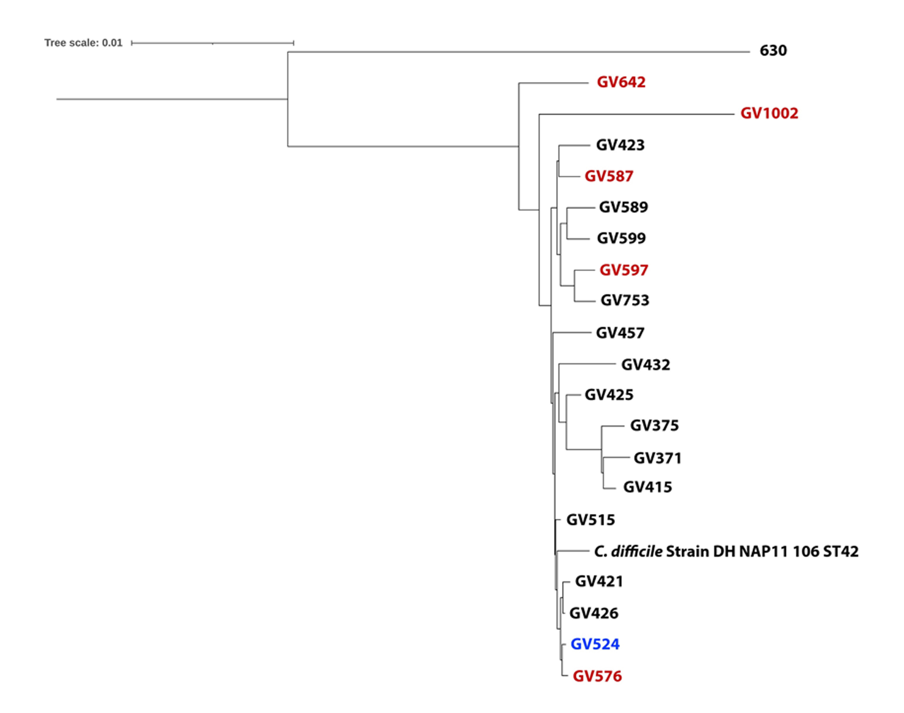
Supplemental Figure S4: Composite Vector Tree of High- and Low-Toxin RT106 Strains
Whole genome comparison was done between clinically derived, low-toxin producing (n = 5; red) and high toxin producing strains (n = 14; black). Strain 630 is a low-toxin comparator and GV524 is a Tox⁻/NAAT⁻ strain. Whole genome comparison of these strains show that low-toxin RT106 strains do not clade separately and are interspersed between high-toxin strains.

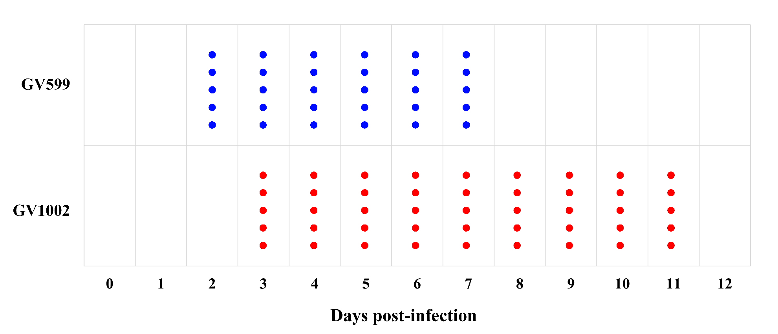
Supplemental Figure S5: Mouse Infection with High- and Low-toxin RT106 Strains
C57L/6 mice (n = 5 / group) were infected with a high-toxin RT106 strain, GV599 (blue), or a low-toxin RT106 strain, GV1002 (red). Each dot represents an animal that had detectable C. difficile in the stool. The high-toxin strain GV599 was detected on Day 2 post-infection and subsequently cleared in all mice by Day 8 post-infection resulting in a 6-day infectious course. The low-toxin strain was detected on Day 3 post-infection and was subsequently cleared by all mice by Day 12 post-infection resulting in a 9-day infectious course.

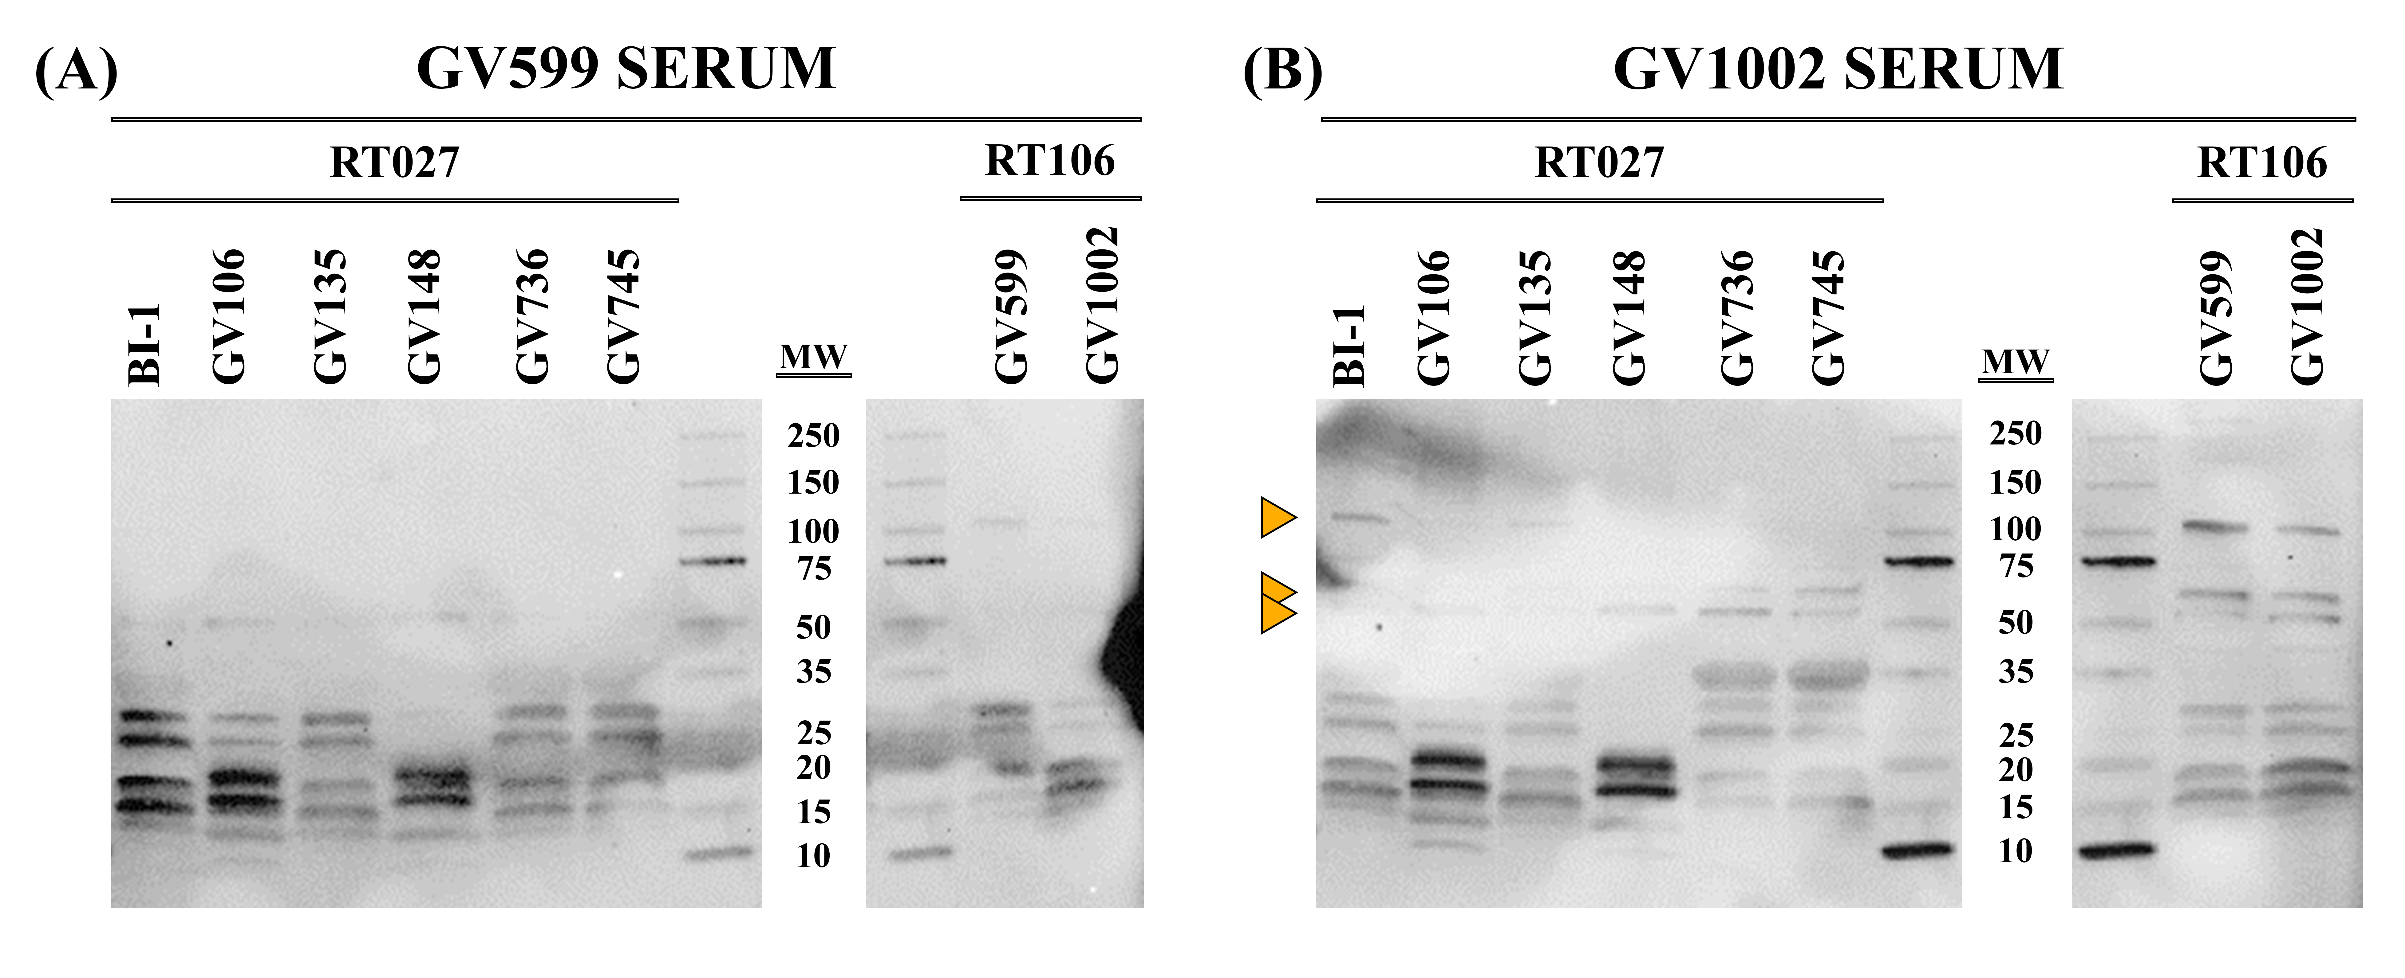
Supplemental Figure S6: Membrane Fractions Probed with High- and Low-toxin RT106 Infected Mouse Serum
Membrane extracts from high-toxin strains BI-1 (RT027) and GV599 (RT106), as well as the low-toxin strains GV106, GV135, GV148, GV736, GV745 (RT027s) and GV1002 (RT106) were probed with serum from mice infected with GV599 and GV1002. Similar to the results described for RT027-infected mouse serum (Figure 4), the low-toxin RT106 strain serum (GV1002) recognizes distinct bands that are not evident when probing with high-toxin strain serum (GV599; right-hand side blot in Panels A and B). Additionally, the GV1002-derived serum recognizes distinct protein bands in all strains irrespective of toxin status (orange arrows) suggestive of conserved presence or surface display of conserved moieties only in low-toxin strains.
Supplemental Table S9: Discrepant RT106-specific Genes Compared to Discrepant RT027 Genes.

Gene ID | AA Length | Function | Found In LT027 Pangenome? | Found in GV148? | Found in BI-1?
fig|1496.6344.peg.314 | 913 | PAS domain histidine kinase | N | N | N
fig|1496.6344.peg.709 | 187 | Mobile element protein | N | N | N
fig|1496.6344.peg.831 | 98 | Mobile element protein | N | N | N
fig|1496.6344.peg.1058 | 308 | hypothetical protein | N | Y | Y
fig|1496.6344.peg.1149 | 1129 | Transcription-repair coupling factor | N | Y | Y
fig|1496.6344.peg.1255 | 123 | Functional domain: RNA-binding protein YhbY | Y | Y | N
fig|1496.6344.peg.1360 | 39 | hypothetical protein | N | N | N
fig|1496.6344.peg.1711 | 458 | Arginine utilization regulatory protein RocR | N | Y | Y
fig|1496.6344.peg.1854 | 44 | LytR family transcriptional regulator domain | N | N | N
fig|1496.6344.peg.1937 | 200 | hypothetical protein | N | Y | Y
fig|1496.6344.peg.2047 | 898 | peptidoglycan transglycosylase (EC 2.4.1.129) | N | Y | N
fig|1496.6344.peg.2128 | 637 | Phosphonoacetaldehyde hydrolase (EC 3.11.1.1) / 2-aminoethylphosphonate:pyruvate aminotransferase (EC 2.6.1.37) | N | Y | Y
fig|1496.6344.peg.2343 | 50 | hypothetical protein | N | N | N
fig|1496.6344.peg.2544 | 289 | FIG00512787: hypothetical protein | N | Y | Y
fig|1496.6344.peg.2729 | 445 | Pyridine nucleotide-disulfide oxidoreductase; NADH dehydrogenase (EC 1.6.99.3) | N | Y | Y
fig|1496.6344.peg.2831 | 44 | hypothetical protein | N | N | N
fig|1496.6344.peg.3114 | 699 | CocE/NonD family hydrolase | N | Y | Y
fig|1496.6344.peg.3564 | 425 | Two-component sensor histidine kinase | N | Y | Y

Discrepant RT106 strains (N=5); non-discrepant RT106 strains (N=4)

