Isolation, solubilization of inorganic phosphate and production of organic acids by individual and co-inoculated microorganisms

2.07 Oxalic acid



2.91 Succinic acid

AAC1

2.07 Oxalic acid



2.91 Succinic acid

AAW1



2.47 Citric acid

2.91 Succinic acid

AAP3

2.19 Gluconic acid



2.91 Succinic acid

2.07 Oxalic acid

AAP4

2.91 Succinic acid



2.07 Oxalic acid

AAP8

2.19 Gluconic acid



2.91 Succinic acid

2.47 Citric acid

2.07 Oxalic acid

AAP11

2.19 Gluconic acid



AAP13

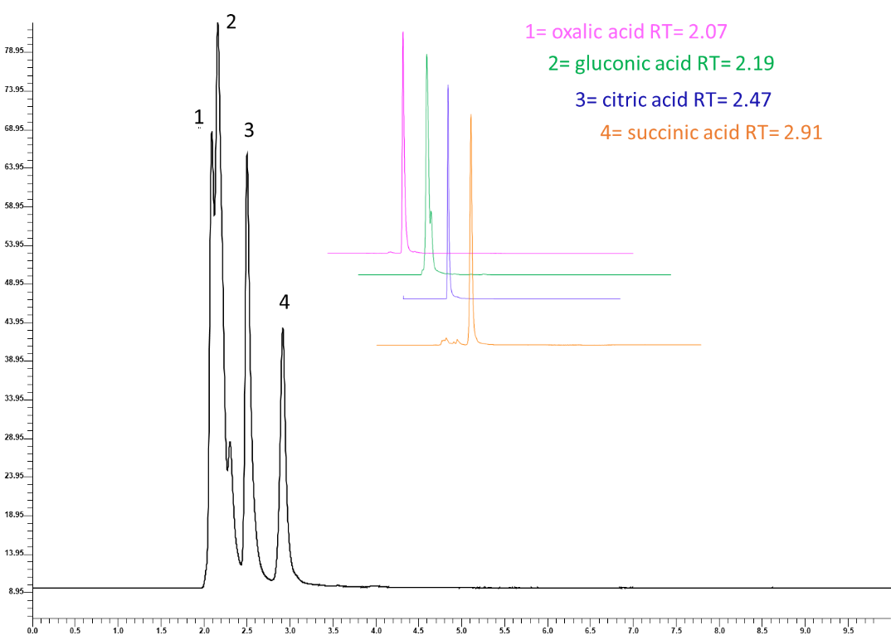

Standards

**Figure S1.** Representative HPLC chromatogram of organic acids. The chromatogram shows the combined run of four organic acids together with peaks marked 1-4. The inset represents individual organic acid chromatogram with respective retention times.

**Table S1.** Phosphate solubilization of isolated PSM strains and pH reduction in (NBRIP) broth medium at different intervals at 30 °C

|  |  |  |  |  |  |
| --- | --- | --- | --- | --- | --- |
| **Strains code** | **Phosphate solubilization(mg/l)** | | | | **pH reduction** |
| **Days** | | | |
| **3rd** | **6th** | **9th** | **12th** |
| AAB1 | 0.20 ± 0.01 | 0.25 ± 0.07 | 0.31 ± 0.05 | 0.35± 0.04 | 6.2 ± 0.4 |
| AAB2 | 0.10 ± 0.00 | 0.22 ± 0.04 | 0.41 ± 0.02 | 0.92± 0.10 | 5.0 ± 0.3 |
| AAB3 | 0.00 ± 0.04 | 0.20 ± 0.00 | 0.38 ± 0.07 | 0.58 ± 0.02 | 5.6 ± 0.0 |
| **AAB4** | **0.14 ± 0.05** | **0.67 ± 0.03** | **1.02 ± 0.04** | **1.13 ± 0.03** | **4.8 ± 0.1** |
| **AAB5** | **0.20 ± 0.05** | **0.45 ± 0.08** | **0.93 ± 0.06** | **1.82 ± 0.03** | **4.9 ± 0.0** |
| **AAB6** | **0.19 ± 0.03** | **0.54 ± 0.07** | **1.06 ± 0.05** | **1.02 ± 0.08** | **4.5± 0.2** |
| AAB7 | 0.13 ± 0.00 | 0.20 ± 0.02 | 0.44 ± 0.02 | 0.53 ± 0.02 | 5.1 ± 0.3 |
| **AAB8** | **0.26 ± 0.04** | **0.50 ± 0.02** | **1.07 ± 0.04** | **1.74 ± 0.07** | **4.5 ± 0.6** |
| **AAB9** | **0.20 ± 0.05** | **0.39 ± 0.06** | **1.00 ± 0.03** | **1.58 ± 0.02** | **4.8 ± 0.2** |
| AAB10 | 0.10 ± 0.06 | 0.22 ± 0.07 | 0.51 ± 0.02 | 0.53 ± 0.07 | 5.5 ± 0.1 |
| AAB11 | 0.17 ± 0.07 | 0.23 ± 0.04 | 0.42 ± 0.00 | 0.28± 0.04 | 6.6 ± 0.0 |
| **AAB12** | **0.24 ± 0.05** | **0.46 ± 0.05** | **0.83 ± 0.00** | **1.94± 0.08** | **4.4± 0.4** |
| **AAB13** | **0.00 ± 0.00** | **0.57 ± 0.06** | **1.03 ± 0.03** | **1.44± 0.02** | **4.9 ± 0.0** |
| **AAB14** | **0.23 ± 0.03** | **0.70 ± 0.04** | **0.92 ± 0.05** | **1.48± 0.03** | **4.5 ± 0.3** |
| AAB15 | 0.10 ± 0.02 | 0.26 ± 0.03 | 0.32 ± 0.00 | 0.26± 0.02 | 6.5± 0.1 |
| AAB16 | 0.00 ± 0.00 | 0.26 ± 0.07 | 0.41 ± 0.02 | 0.95± 0.08 | 5.0 ± 0.2 |
| AAB17 | 0.12 ± 0.00 | 0.31 ± 0.02 | 0.35 ± 0.01 | 0.77± 0.02 | 5.4 ± 0.4 |
| AAB18 | 0.09 ± 0.06 | 0.22 ± 0.04 | 0.30 ± 0.06 | 0.57 ± 0.05 | 5.1 ± 0.4 |
| AAB19 | 0.00 ± 0.00 | 0.29 ± 0.05 | 0.41 ± 0.04 | 0.82± 0.05 | 5.0 ± 0.6 |
| AAB20 | 0.17 ± 0.05 | 0.26 ± 0.05 | 0.36 ± 0.05 | 0.66± 0.06 | 5.2 ± 0.2 |
| AAB21 | 0.16 ± 0.02 | 0.21 ± 0.03 | 0.34 ± 0.07 | 0.33± 0.01 | 6.0± 0.5 |
| AAB22 | 0.10 ± 0.03 | 0.24 ± 0.01 | 0.32 ± 0.03 | 0.56± 0.02 | 5.4 ± 0.9 |
| AAB23 | 0.19 ± 0.04 | 0.36 ± 0.05 | 0.35 ± 0.02 | 0.32± 0.00 | 6.2 ± 0.5 |
| AAB24 | 0.13 ± 0.08 | 0.26 ± 0.03 | 0.43 ± 0.08 | 0.37± 0.02 | 6.0 ± 0.3 |
| AAB25 | 0.20 ± 0.00 | 0.36 ± 0.08 | 0.37 ± 0.02 | 0.55± 0.05 | 5.9 ± 0.5 |
| AAB26 | 0.11 ± 0.04 | 0.26 ± 0.02 | 0.32 ± 0.07 | 0.71± 0.03 | 5.1 ± 0.2 |
| AAB27 | 0.18 ± 0.06 | 0.29 ± 0.00 | 0.31 ± 0.04 | 0.73± 0.02 | 5.4 ± 0.5 |
| AAB28 | 0.20 ± 0.12 | 0.25 ± 0.01 | 0.51 ± 0.00 | 0.83± 0.05 | 5.0 ± 0.4 |
| **AACI** | **0.00 ± 0.00** | **0.27 ± 0.07** | **0.25 ± 0.02** | **1.29 ± 0.01** | **4.25 ± 0.03** |
| AAC2 | 0.15 ± 0.09 | 0.26 ± 0.04 | 0.33 ± 0.02 | 0.21 ± 0.05 | 5.25 ± 0.05 |
| AAC3 | 0.22 ± 0.04 | 0.29 ± 0.05 | 0.35 ± 0.06 | 0.22 ± 0.05 | 5.29 ± 0.06 |
| AAC4 | 0.24 ± 0.00 | 0.28 ± 0.02 | 0.41 ± 0.05 | 0.24 ± 0.04 | 4.71 ± 0.03 |
| **AAWI** | **0.21 ± 0.05** | **0.51 ± 0.04** | **0.55 ± 0.01** | **1.05 ± 0.1** | **3.20 ± 0.01** |
| AAW2 | 0.13 ± 0.04 | 0.28 ± 0.07 | 0.35 ± 0.02 | 0.39 ± 0.10 | 6.2 ± 0.5 |
| AAW3 | 0.22 ± 0.02 | 0.25 ± 0.03 | 0.41 ± 0.05 | 0.51 ± 0.04 | 5.3 ± 0.0 |
| AAP1 | 0.16 ± 0.08 | 0.22 ± 0.05 | 0.38 ± 0.04 | 0.58 ± 0.03 | 5.1 ± 0.0 |
| AAP2 | 0.00 ± 0.00 | 0.30 ± 0.03 | 0.36 ± 0.03 | 0.53 ± 0.01 | 5.7 ± 0.5 |
| **AAP3** | **0.22 ± 0.05** | **0.58 ± 0.08** | **1.08 ± 0.02** | **1.61 ± 0.08** | **4.66 ± 0.41** |
| **AAP4** | **0.24 ± 0.04** | **0.83 ± 0.01** | **1.13 ± 0.03** | **1.21 ± 0.03** | **4.15 ± 0.03** |
| AAP5 | 0.21 ± 0.03 | 0.22 ± 0.00 | 0.33 ± 0.04 | 0.68 ± 0.06 | 5.5 ± 0.1 |
| AAP6 | 0.00 ± 0.00 | 0.27 ± 0.02 | 0.37 ± 0.06 | 0.39 ± 0.10 | 5.9 ± 0.0 |
| **AAP7** | **0.14 ± 0.12** | **0.82 ± 0.03** | **1.03 ± 0.04** | **1.05 ± 0.03** | **3.24 ± 0.05** |
| **AAP8** | **0.00 ± 0.00** | **0.74 ± 0.07** | **0.90 ± 0.06** | **0.97 ± 0.08** | **4.27 ± 0.50** |
| AAP9 | 0.12 ± 0.02 | 0.31 ± 0.04 | 0.47 ± 0.03 | 0.38 ± 0.01 | 6.0 ± 0.2 |
| AAP10 | 0.17 ± 0.05 | 0.28 ± 0.06 | 0.38 ± 0.02 | 0.48 ± 0.04 | 6.2 ± 0.0 |
| A**AP11** | **0.00 ± 0.00** | **0.53 ± 0.04** | **0.83 ± 0.04** | **1.02 ± 0.08** | **3.71 ± 0.25** |
| AAP12 | 0.13 ± 0.06 | 0.22 ± 0.06 | 0.51 ± 0.00 | 0.58 ± 0.03 | 5.0 ± 0.2 |
| **AAP13** | **0.00 ± 0.00** | **0.53 ± 0.07** | **0.39 ± 0.10** | **0.69 ± 0.03** | **5.50 ± 0.16** |
| AAP14 | 0.12 ± 0.04 | 0.24 ± 0.05 | 0.30 ± 0.03 | 0.33 ± 0.02 | 6.2 ± 0.2 |
| AAP15 | 0.20 ± 0.00 | 0.30 ± 0.00 | 0.44 ± 0.05 | 0.55 ± 0.04 | 5.6 ± 0.5 |
| AAP16 | 0.16 ± 0.05 | 0.30 ± 0.05 | 0.40 ± 0.00 | 0.25 ± 0.03 | 6.5± 0.0 |
| AAP17 | 0.25 ± 0.05 | 0.40 ± 0.03 | 0.50 ± 0.04 | 0.53 ± 0.01 | 5.3 ± 0.5 |
| AAP18 | 0.21 ± 0.01 | 0.30 ± 0.05 | 0.40 ± 0.03 | 0.57 ± 0.08 | 6.1 ± 0.0 |
| **Control** | **0.00 ± 0.00** | **0.00 ± 0.00** | **0.00 ± 0.00** | **0.00 ± 0.00** | **7.04 ± 0.04** |

Values are present in the mean of triplicates with standard deviation

|  |  |  |  |  |  |
| --- | --- | --- | --- | --- | --- |
| **Isolate** | **Most closely related organisms** | **% Similarity** | **Sequence query coverage (%)** | **16 S rRNA accession no.** | **Strain** |
| AAB4 | *Pseudomonas aeruginosa* | 100% | 100% | KT943976.1 | W935-H |
| AAB5 | *Serratia marcescens* | 97.35% | 100% | FM163466.1 | P6 |
| AAB6 | *Pseudomonas aeruginosa* | 100% | 100% | KT943976.1 | W935-H |
| AAB8 | *Bacillus sp.* | 97.94% | 100% | ON417365.1 | AzoM2 |
| AAB9 | *Bacillus licheniformis* | 98.52% | 99% | OP001793.1 | BC-2 |
| AAB12 | *Bacillus sp.* | 97.94% | 100% | OK236176.1 | 459 |
| AAB13 | *Bacillus sp.* | 99.26% | 100% | MK106115.1 | IITRDVM-5 |
| AAB14 | *Bacillus subtilis* | 98.32% | 100% | ON999053.1 | GZCB-12 |
| AAC1 | *Pseudomonas aeruginosa* | 99.80% | 100% | KT943976.1 | W935-H |
| AAW1 | *Pseudomonas mosselii* | 99.09% | 94% | MH091341.1 | ABAP1 |
| AAP3 | *Aspergillus flavus* | 100.00% | 100.00% | OM250384.1 | BF3 |
| AAP4 | *Aspergillus foetidus* | 100.00% | 100.00% | MZ955454.1 | PPMO2 |
| AAP7 | *Aspergillus tubingensis* | 100.00% | 100.00% | MN413686.1 | MJU-3 |
| AAP8 | *Penicillium chrysogenum* | 96.95% | 100.00% | MH777428.1 | 4 |
| AAP11 | *Aspergillus tubingensis* | 100.00% | 100.00% | MT318169.1 | Mktt12 |
| AAP13 | *Aspergillus niger* | 99.52% | 100.00% | KX011017.1 | LF13 |

**Table S2**. Molecular characterization of isolates