Supporting Information
Fabrication of Semi-Transparent SrTaO₂N Photoanodes with a GaN Underlayer Grown via Atomic Layer Deposition
Can Luª, Nathan J. O´Brien^{b}, Polla Rouf^{b}, Richard Dronskowski^{a,c}, Henrik Pedersen*^{b} and Adam Slabon*^{d}
ªInstitute of Inorganic Chemistry, RWTH Aachen University, Aachen, Germany;
^{b}Department of Physics, Chemistry and Biology, Linköping University, Linköping, Sweden;
^{c}Hoffmann Institute of Advanced Materials, Shenzhen Polytechnic, Shenzhen, China;
^{d}Chair of Inorganic Chemistry, University of Wuppertal, Wuppertal, Germany
*Corresponding authors E-mails: slabon@uni-wuppertal.de; henrik.pedersen@liu.se

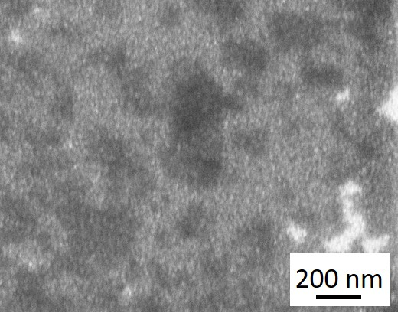
Figure S1. SEM image of 60 nm GaN/SiC.

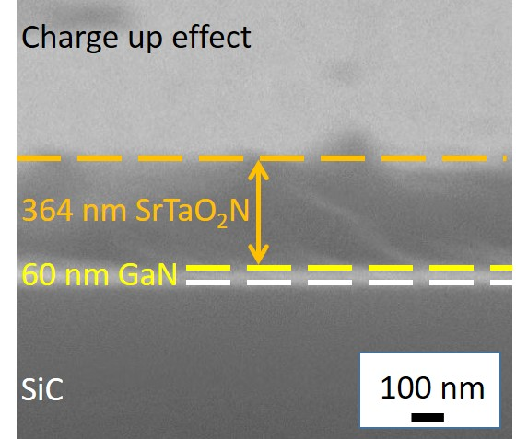
Figure S2. Cross-sectional SEM image of SrTaO₂N/60 nm GaN/SiC.

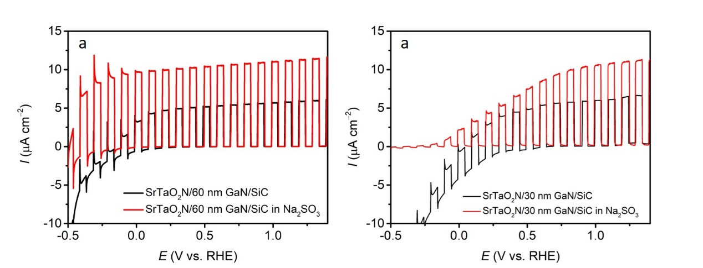
Figure S3. LSV curves of (a) SrTaO₂N/60 nm GaN/SiC and (b) SrTaO₂N/30 nm GaN/SiC measured in electrolyte with (red curves) and without (dark curves) Na₂SO₃ scavenger.

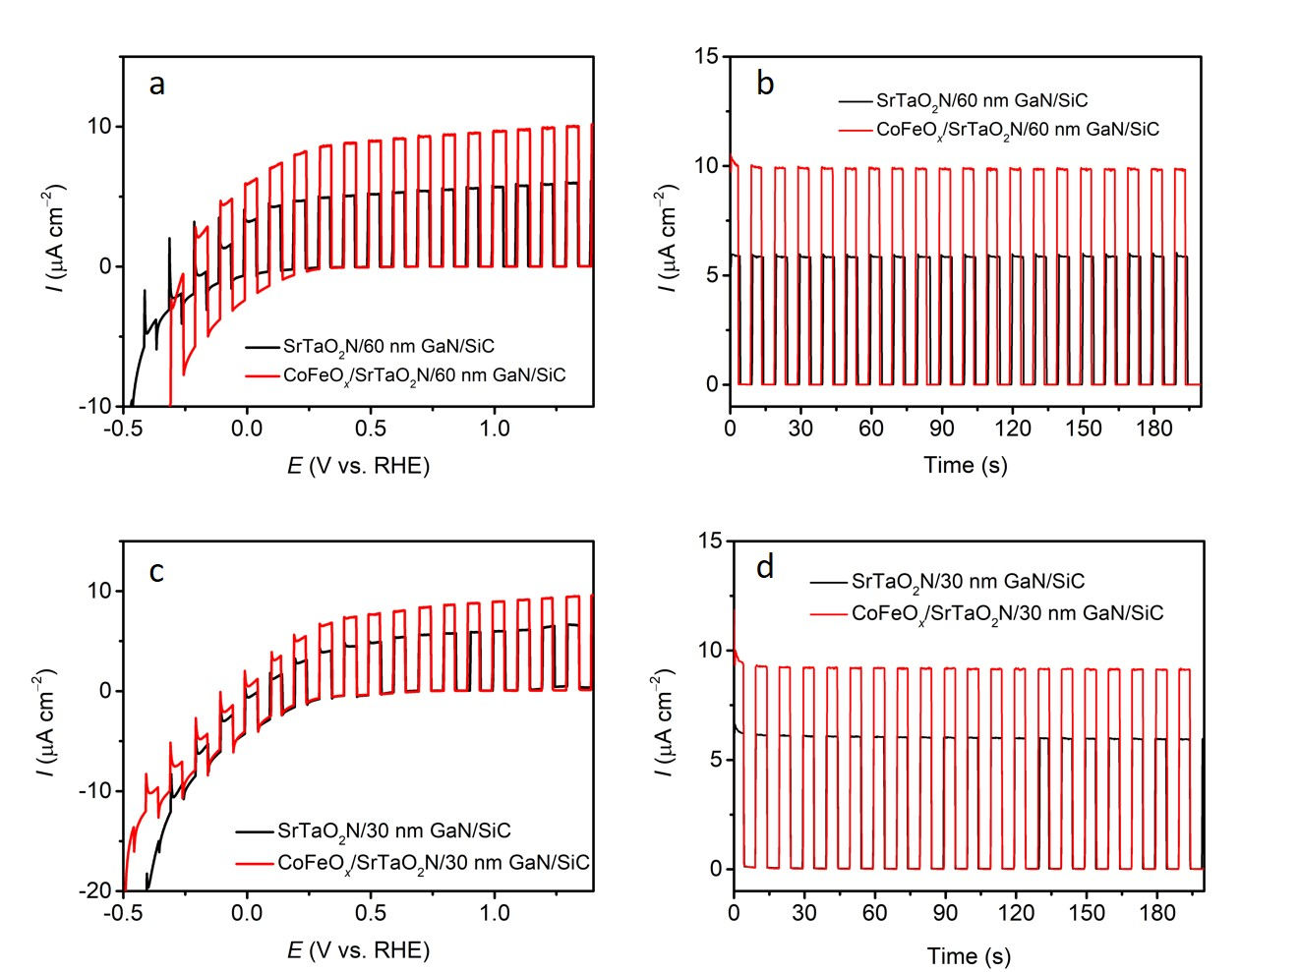
Figure S4. (a) LSV and (b) CA curves at 1.23 V vs. reversible hydrogen electrode (V_{RHE}) of SrTaO₂N/60 nm GaN/SiC and CoFeO_{x}/SrTaO₂N/60 nm GaN/SiC. (c) LSV and (d) CA curves at 1.23 V_{RHE} of SrTaO₂N/30 nm GaN/SiC and CoFeO_{x}/SrTaO₂N/30 nm GaN/SiC.

