Supporting Information for Original article
Identification of potent CAMKK2 inhibitors by virtual screening and dynamics simulation

Le Fu^{1,2 †} Linan Zhao^{1†} Meichen Liang² Kun Ran² Jing Fu² Haoyu Qiu²
Fei Li^{2,*} Mao Shu^{1,*}

¹School of Pharmacy and Bioengineering, Chongqing University of Technology, Chongqing 400054, China
²Qianjiang Central Hospital of Chongqing, Chongqing 409099, China

*Address correspondence to Fei Li, 17563241@qq.com and Mao Shu, shumao@cqut.edu.cn
† Equal contribution.

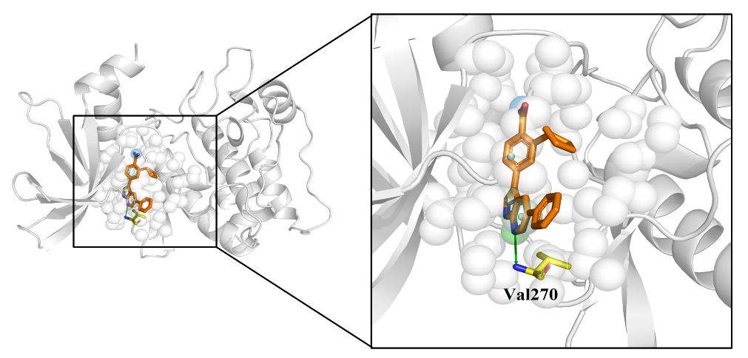
Fig. S1 The pharmacophore model for CAMKK2 selected for virtual screening.

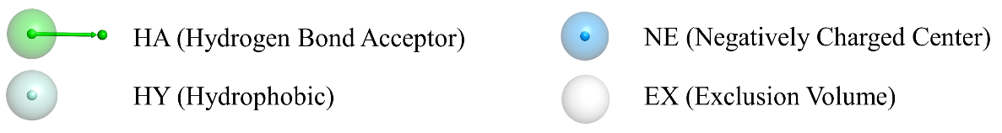
Fig. S2 Visual representation of four pharmacophore characteristics and exclusion of volume constraints used in AncPhore.

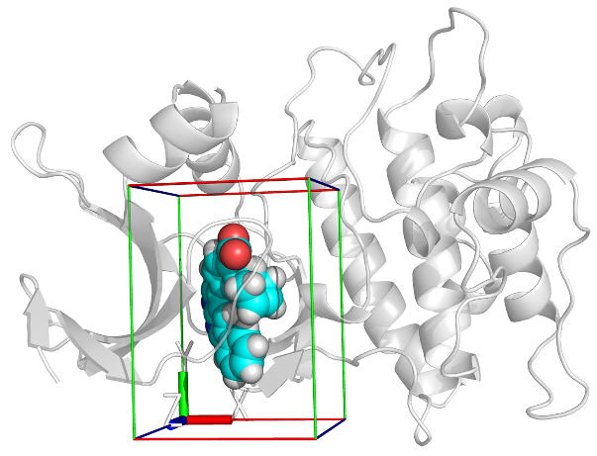
Fig. S3 Active cavity of CAMKK2. The parameters of the active cavity are set as follows: xmin: -31.1Å, xmax: -14.4Å, ymin: -27.4Å, ymax: -4.1Å, zmin: -20.2Å, zmax: -3.2Å.

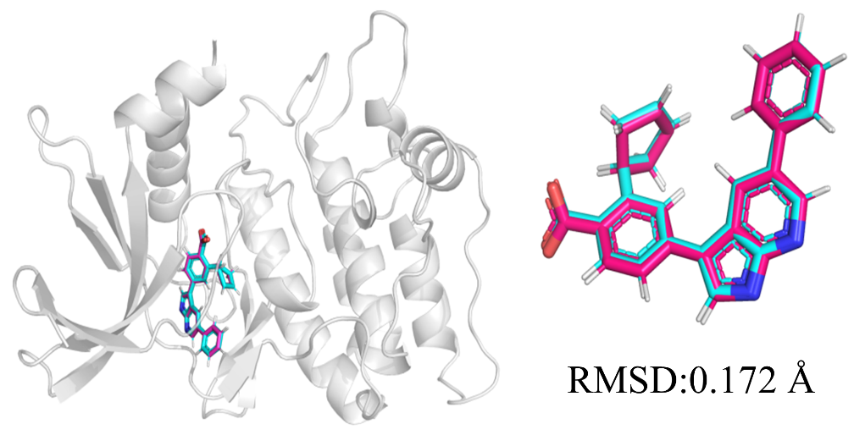
Fig. S4 Comparison of docking conformation and crystal conformation of CAMKK2. Pink is the docked conformation and blue is the initial crystal conformation. The RMSD value is 0.172 Å, which proves the reliability of molecular docking.

Table. S1 Results of the Güner-Henry Method.
Parameter | Value
Total number of molecules(D) | 533
Number of active molecules(A) | 12
Total hits(H_{t}) | 16
Active hits(H_{a}) | 12
Yield of actives(H_{a}/H_{t})% | 75
Ratio of actives (H_{a}/A) % | 100
False positives(FP= H_{t} -H_{a}) | 4
False negatives(FN=A-H_{a}) | 0
Enrichment Factor (EF) | 33.31
Goodness of hit (GH) % | 80.63

