Supplementary Materials
Figure S1. The Stability of Strength Centrality Scores Using Case-Dropping Bootstrapping at T1-4

Figure S2. The Stability of Bridge Expected Influence (BEI) Scores Using Case-Dropping Bootstrapping at T1-4

Table S3-6. Bootstrapped Confidence Intervals of All Edge-Weights at T1-4

Figure S7-10. Bootstrapped Difference Tests for Strength Centrality Index at T1-4

Figure S11-14 Bootstrapped Difference Tests for Edge-Weights at T1-4

Figure S15. A Directed Acyclic Graph (DAG) of PSTD and Depression Symptoms at T1 (N = 340)

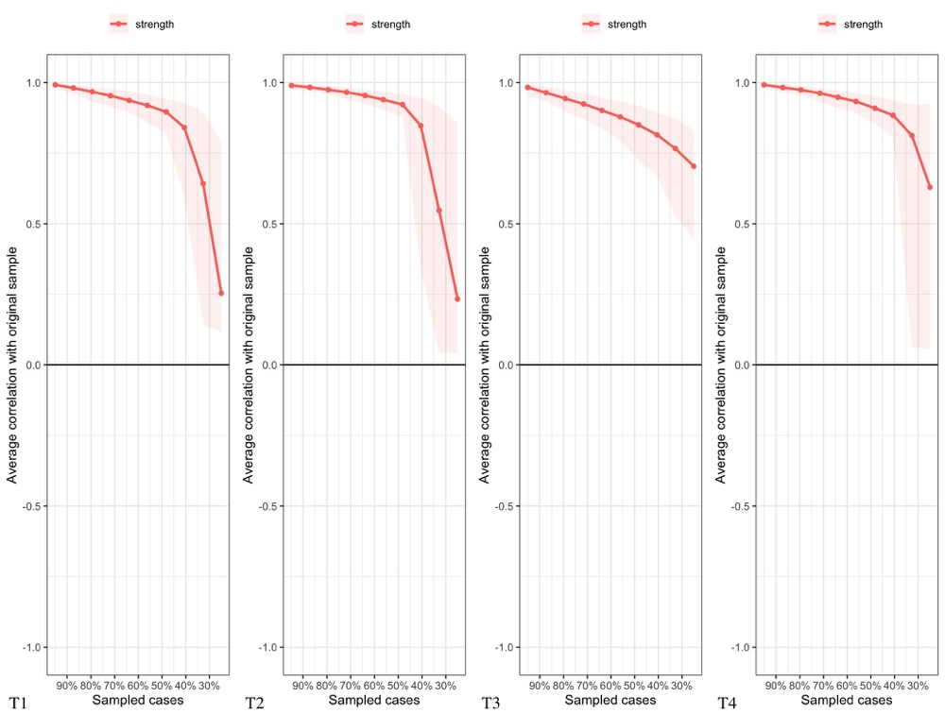
Figure S1. The Stability of Strength Centrality Scores Using Case-Dropping Bootstrapping at T1-4
Note. The x-axis denotes the percentage of participants of the original sample included in the new samples. The y-axis indicates the averaged correlations between the centrality scores from the original network and the centrality scores from the networks that were newly estimated after dropping increasing percentages of participants.

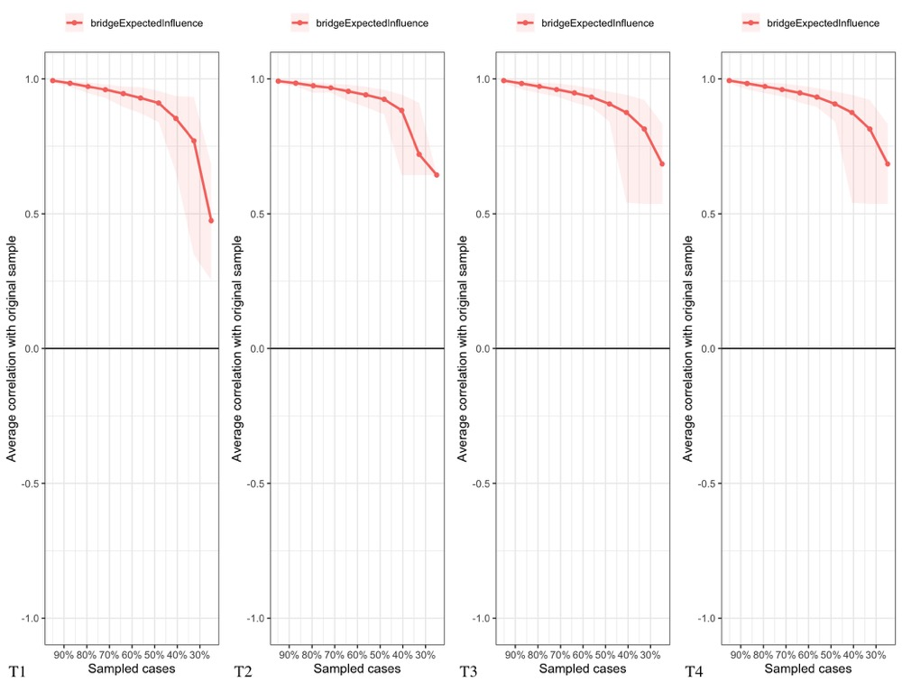
Figure S2. The Stability of Bridge Expected Influence (BEI) Scores Using Case-Dropping Bootstrapping at T1-4
Note. The x-axis denotes the percentage of participants of the original sample included in the new samples. The y-axis indicates the averaged correlations between the BEI scores from the original network and the BEI scores from the networks that were newly estimated after dropping increasing percentages of participants.

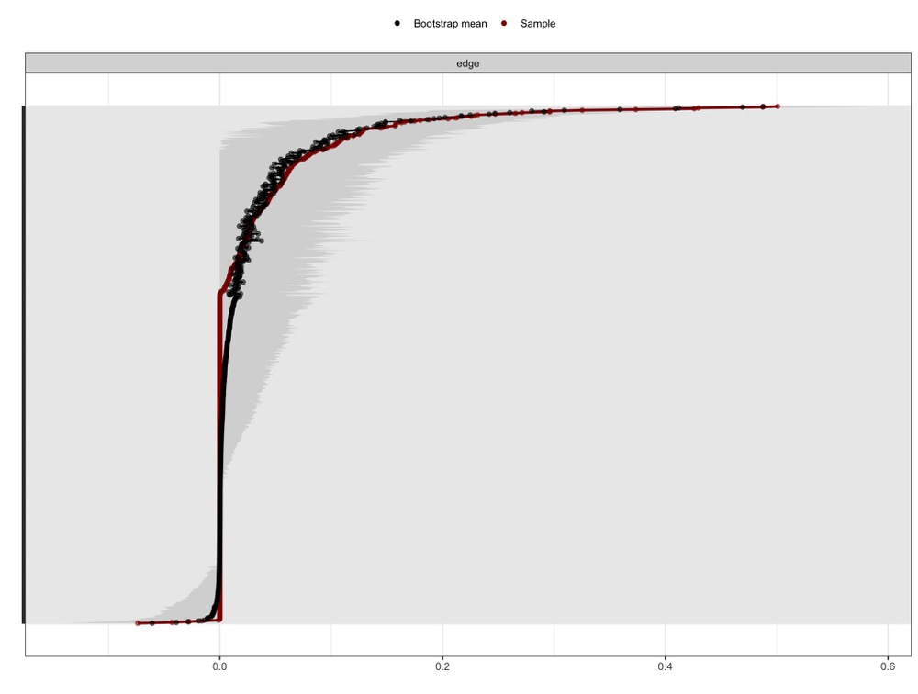
Figure S3. Bootstrapped Confidence Intervals of All Edge-Weights at T1

Note. The red dots represent each edge-weight’s score in the network, while the black dots represent each edge-weight’s estimated score estimated by means of non-parametric bootstrapping with 5,000 bootstraps (nboots = 5,000. The gray area shows the 95% confidence intervals of each edge-weight, estimated by means of non-parametric bootstrapping with 5,000 bootstraps (nboots = 5,000). Wider confidence intervals denote lower stability and narrower intervals denote higher stability.
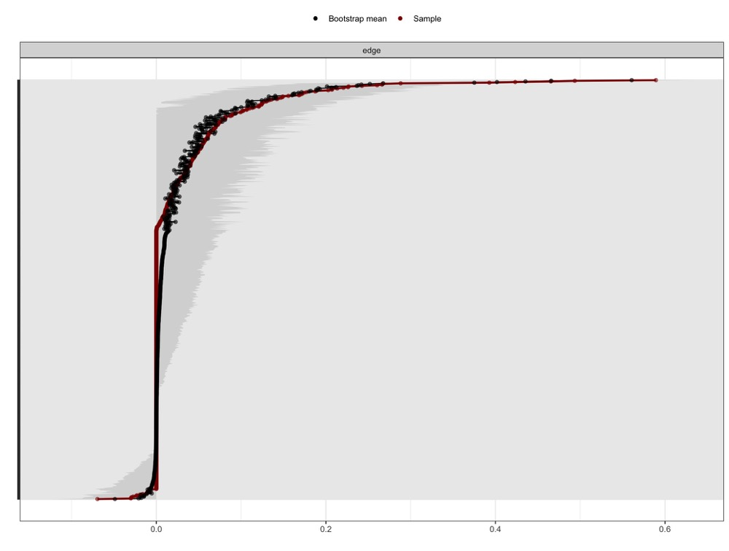
Figure S4. Bootstrapped Confidence Intervals of All Edge-Weights at T2

Note. The red dots represent each edge-weight’s score in the network, while the black dots represent each edge-weight’s estimated score estimated by means of non-parametric bootstrapping with 5,000 bootstraps (nboots = 5,000. The gray area shows the 95% confidence intervals of each edge-weight, estimated by means of non-parametric bootstrapping with 5,000 bootstraps (nboots = 5,000). Wider confidence intervals denote lower stability and narrower intervals denote higher stability.
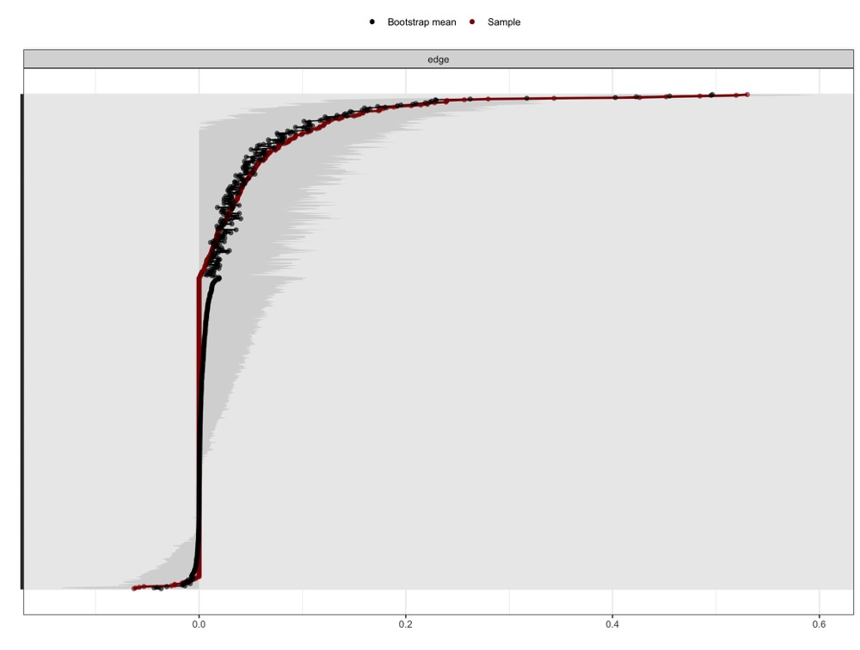
Figure S5. Bootstrapped Confidence Intervals of All Edge-Weights at T3

Note. The red dots represent each edge-weight’s score in the network, while the black dots represent each edge-weight’s estimated score estimated by means of non-parametric bootstrapping with 5,000 bootstraps (nboots = 5,000. The gray area shows the 95% confidence intervals of each edge-weight, estimated by means of non-parametric bootstrapping with 5,000 bootstraps (nboots = 5,000). Wider confidence intervals denote lower stability and narrower intervals denote higher stability.

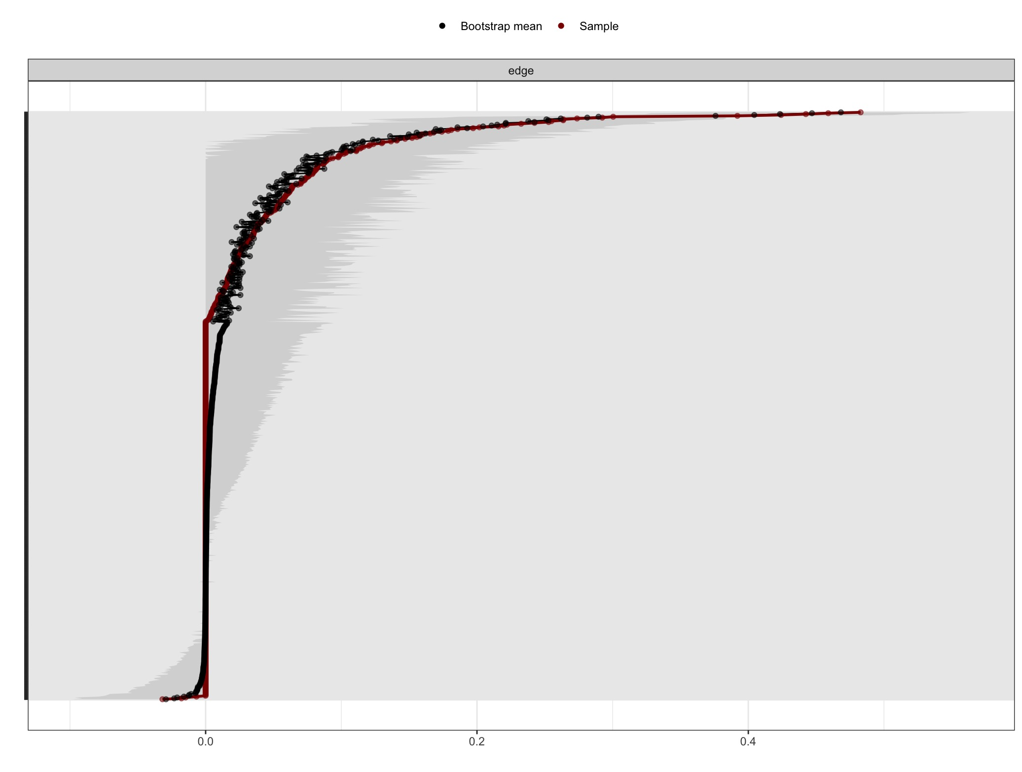
Figure S6. Bootstrapped Confidence Intervals of All Edge-Weights at T4

Note. The red dots represent each edge-weight’s score in the network, while the black dots represent each edge-weight’s estimated score estimated by means of non-parametric bootstrapping with 5,000 bootstraps (nboots = 5,000. The gray area shows the 95% confidence intervals of each edge-weight, estimated by means of non-parametric bootstrapping with 5,000 bootstraps (nboots = 5,000). Wider confidence intervals denote lower stability and narrower intervals denote higher stability.

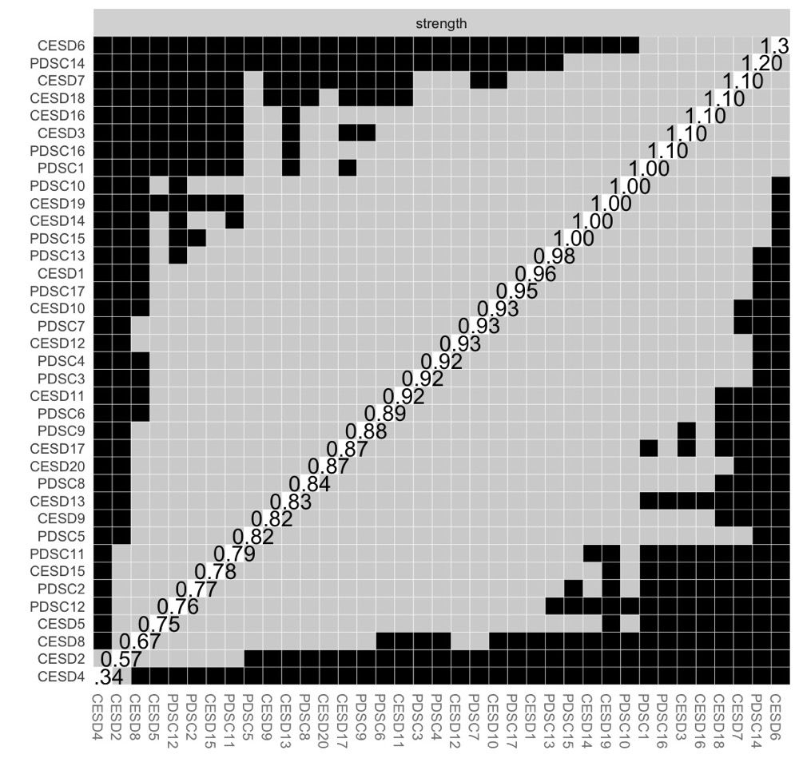
Figure S7. Bootstrapped Difference Tests for Strength Centrality Index at T1
Note. The difference tests for strength centrality are depicted in this Figure. The color of the boxes indicates whether there is a significant difference in their centrality operationalized by their strength centrality scores between nodes. Grey boxes indicate no significant differences and black boxes indicate significant differences (α = 0.05). The value in the white boxes indicates the value of node strength centrality scores of a specific node.

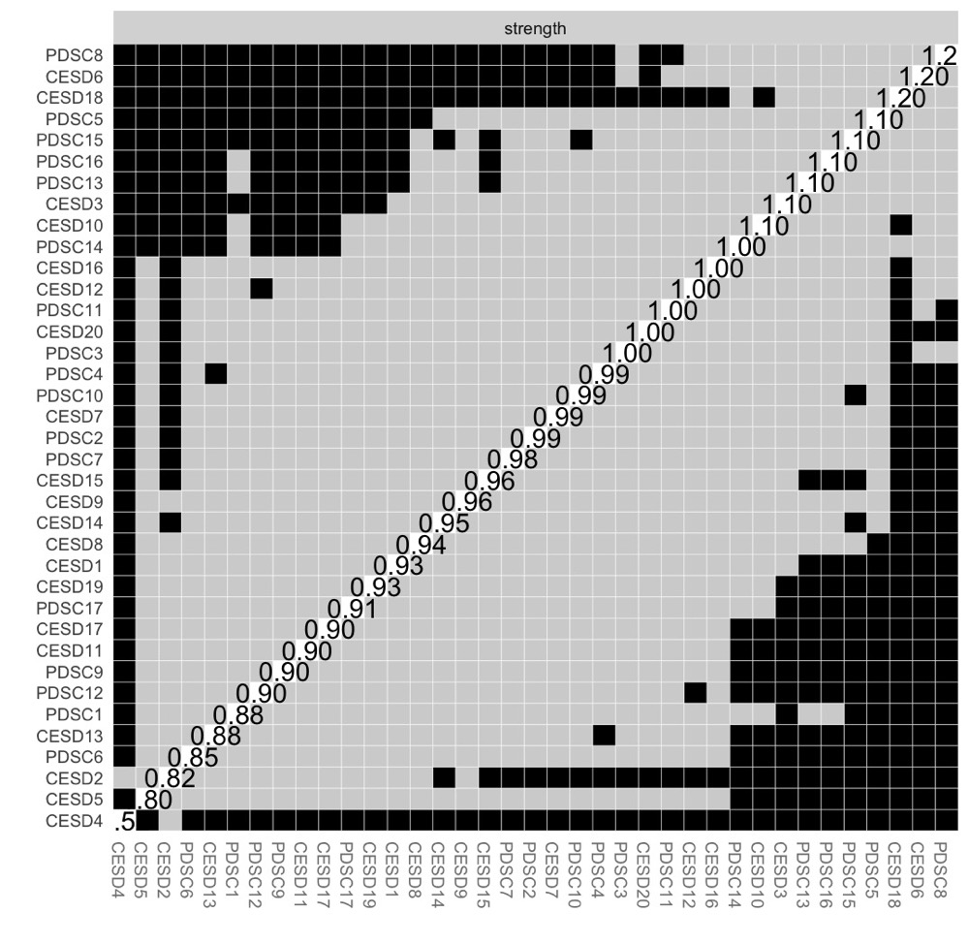

Figure S8. Bootstrapped Difference Tests for Strength Centrality Index at T2

Note. The difference tests for strength centrality are depicted in this Figure. The color of the boxes indicates whether there is a significant difference in their centrality operationalized by their strength centrality scores between nodes. Grey boxes indicate no significant differences and black boxes indicate significant differences (α = 0.05). The value in the white boxes indicates the value of node strength centrality scores of a specific node.

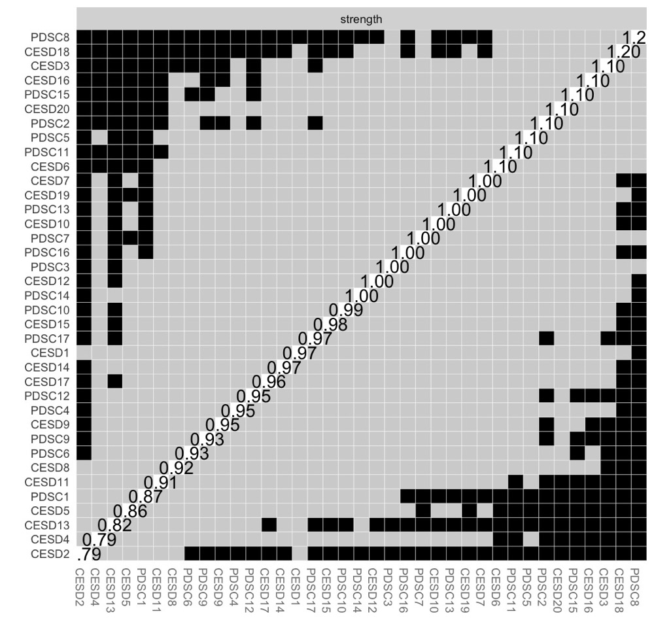Figure S9. Bootstrapped Difference Tests for Strength Centrality Index at T3

Notes. The difference tests for strength centrality are depicted in this Figure. The color of the boxes indicates whether there is a significant difference in their centrality operationalized by their strength centrality scores between nodes. Grey boxes indicate no significant differences and black boxes indicate significant differences (α = 0.05). The value in the white boxes indicates the value of node strength centrality scores of a specific node.

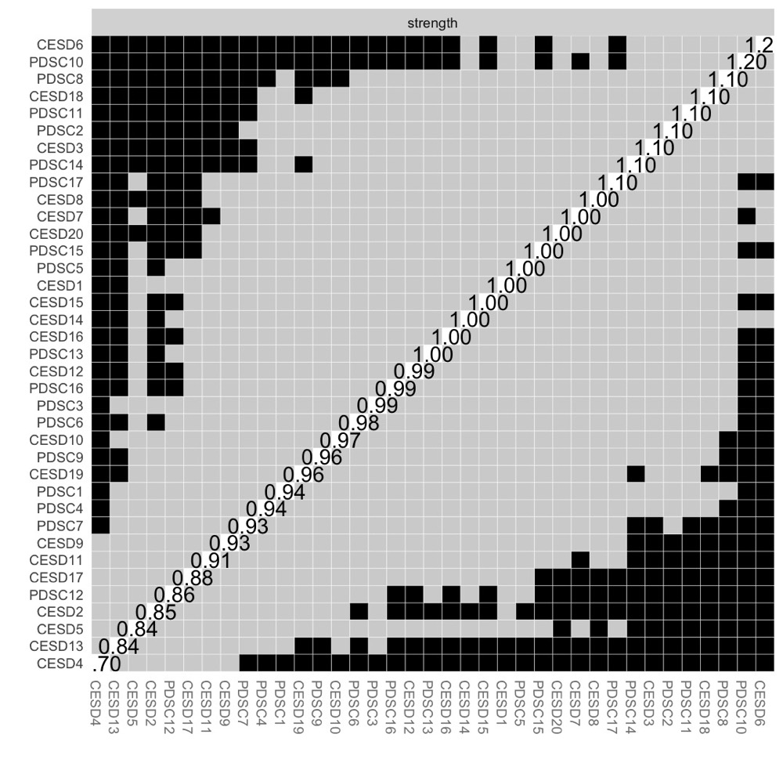
Figure S10. Bootstrapped Difference Tests for Strength Centrality Index at T4

Notes. The difference tests for strength centrality are depicted in this Figure. The color of the boxes indicates whether there is a significant difference in their centrality operationalized by their strength centrality scores between nodes. Grey boxes indicate no significant differences and black boxes indicate significant differences (α = 0.05). The value in the white boxes indicates the value of node strength centrality scores of a specific node.

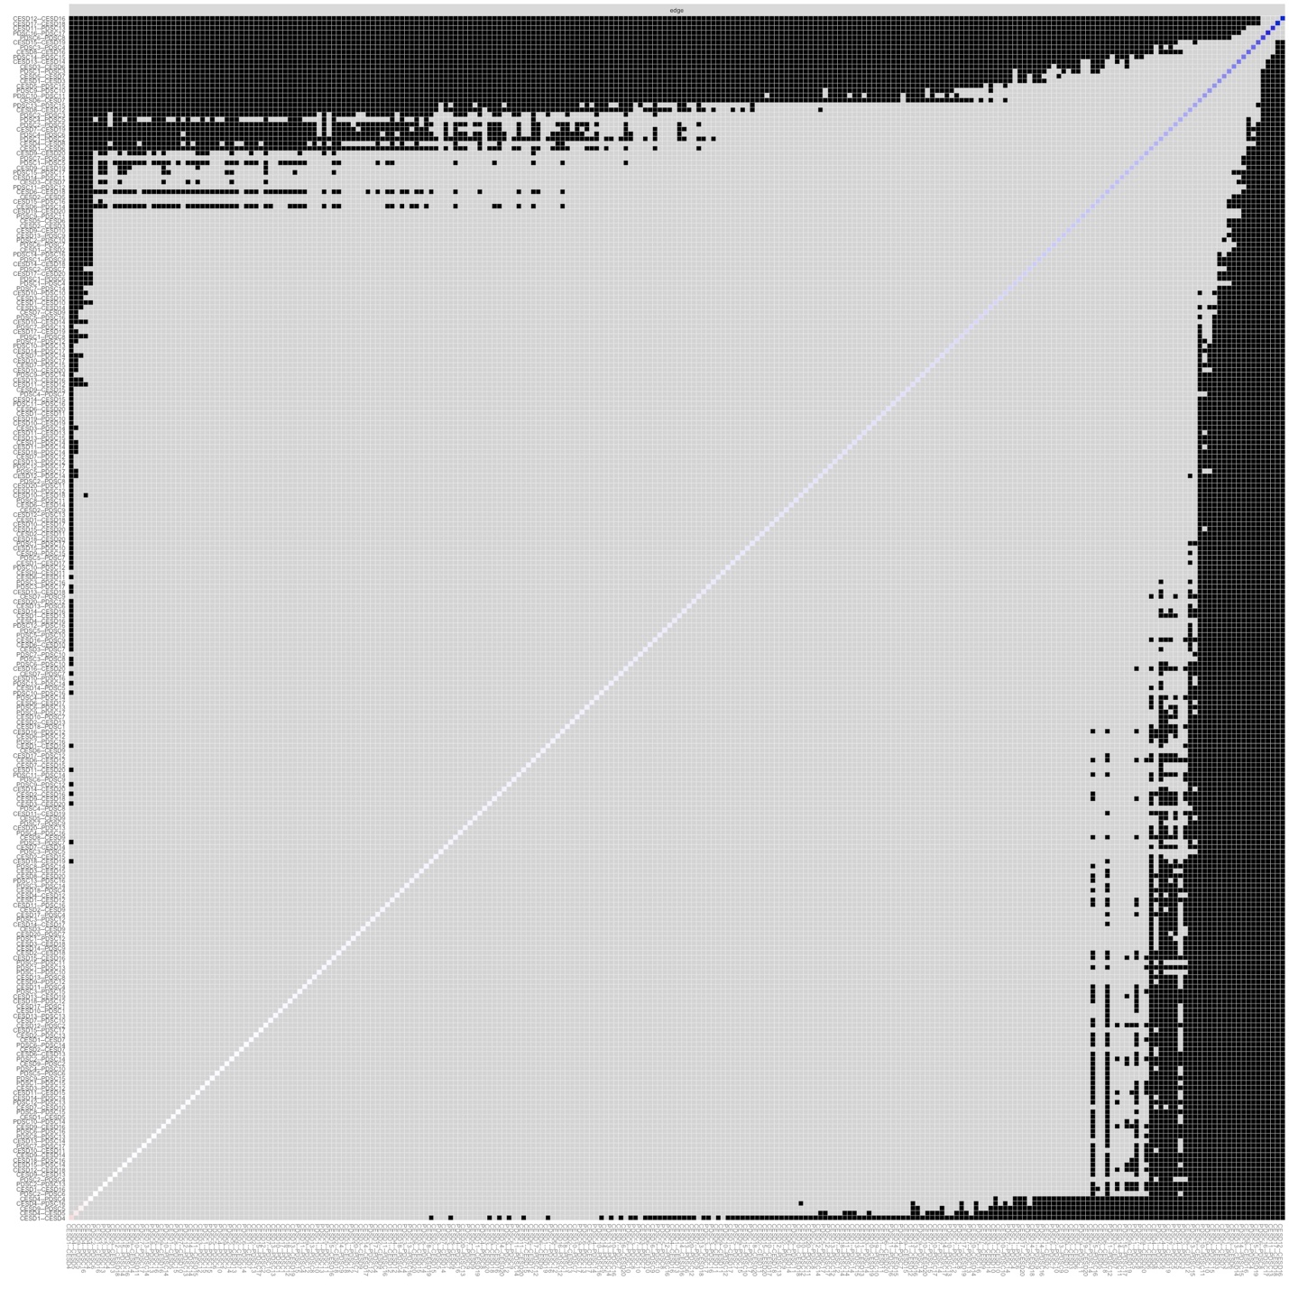
Figure S11. Bootstrapped Difference Tests for Edge-Weights at T1
Notes. The results of the bootstrapped difference tests for edge-weights are depicted in this figure. In total, there were (37*(37-1))/2 = 666 edges between 37 symptoms (20-item CES-D and 17-item PDS-C). The color of the boxes indicates whether there is a significant difference in edge-weights (α = 0.05). Grey boxes indicate no significant differences, while black boxes indicate significant differences (α = 0.05). The mostly white boxes forming the diagonal line indicate the strength of each edge-weight. Red boxes indicate negative associations; white boxes indicate weaker associations; blue boxes indicate stronger associations.

Figure S12. Bootstrapped Difference Tests for Edge-Weights at T2
Notes. The results of the bootstrapped difference tests for edge-weights are depicted in this figure. In total, there were (37*(37-1))/2 = 666 edges between 37 symptoms (20-item CES-D and 17-item PDS-C). The color of the boxes indicates whether there is a significant difference in edge-weights (α = 0.05). Grey boxes indicate no significant differences, while black boxes indicate significant differences (α = 0.05). The mostly white boxes forming the diagonal line indicate the strength of each edge-weight. Red boxes indicate negative associations; white boxes indicate weaker associations; blue boxes indicate stronger associations.

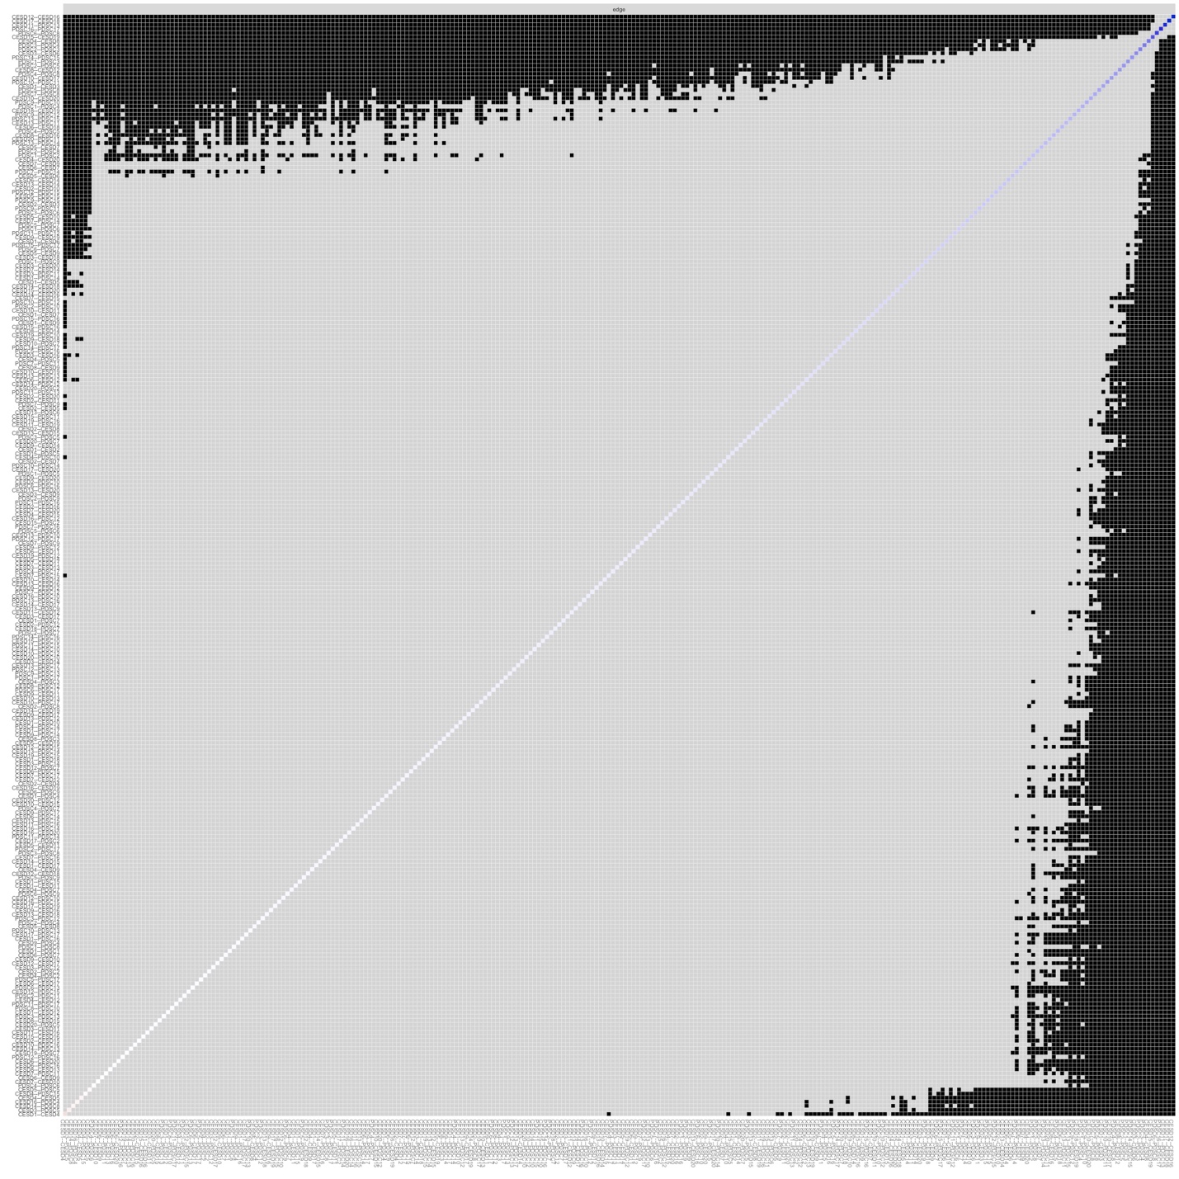
Figure S13. Bootstrapped Difference Tests for Edge-Weights at T3
Notes. The results of the bootstrapped difference tests for edge-weights are depicted in this figure. In total, there were (37*(37-1))/2 = 666 edges between 37 symptoms (20-item CES-D and 17-item PDS-C). The color of the boxes indicates whether there is a significant difference in edge-weights (α = 0.05). Grey boxes indicate no significant differences, while black boxes indicate significant differences (α = 0.05). The mostly white boxes forming the diagonal line indicate the strength of each edge-weight. Red boxes indicate negative associations; white boxes indicate weaker associations; blue boxes indicate stronger associations.
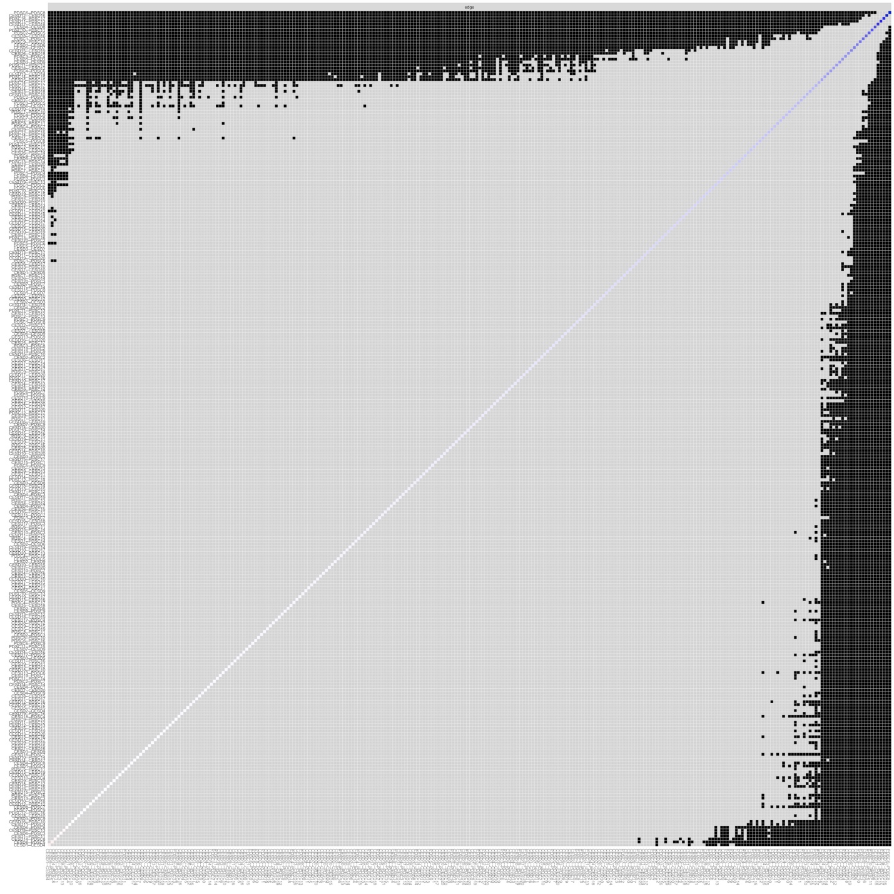
Figure S14. Bootstrapped Difference Tests for Edge-Weights at T4
Notes. The results of the bootstrapped difference tests for edge-weights are depicted in this figure. In total, there were (37*(37-1))/2 = 666 edges between 37 symptoms (20-item CES-D and 17-item PDS-C). The color of the boxes indicates whether there is a significant difference in edge-weights (α = 0.05). Grey boxes indicate no significant differences, while black boxes indicate significant differences (α = 0.05). The mostly white boxes forming the diagonal line indicate the strength of each edge-weight. Red boxes indicate negative associations; white boxes indicate weaker associations; blue boxes indicate stronger associations.

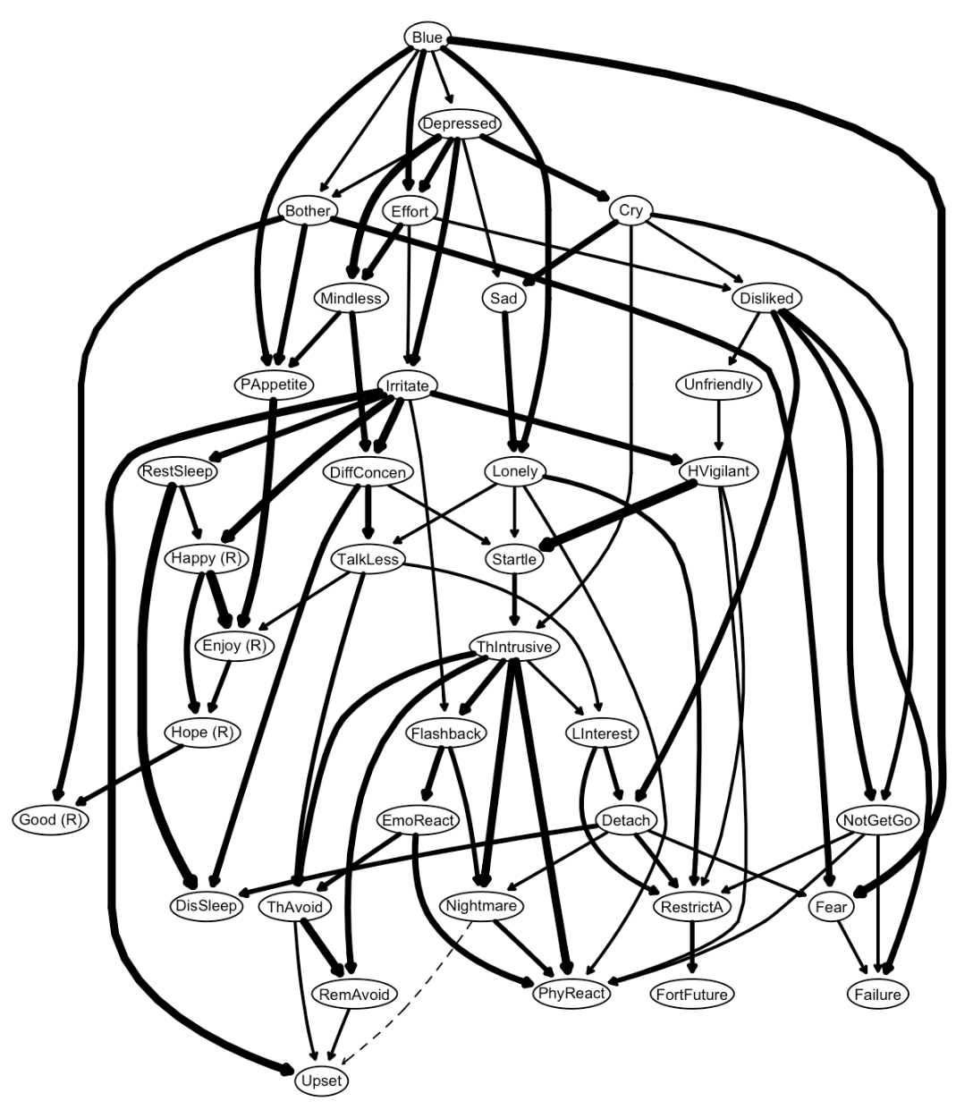
Figure S15. A Directed Acyclic Graph (DAG) of PSTD and Depression Symptoms at T1 (N = 340)
Note. (R) = reverse scored and worded. Bother = Feel bothered. PAppetite = Poor Appetite. Blue = Feel blue. Good (R) = Lack feeling good. Mindless = Trouble keeping my mind. Depressed = Depressed mood. Effort = Effortful. Hope (R) = Hopelessness. Failure = Feel failure. Fear = Fearful. RestSleep = Restless sleep. Happy (R) = Lack happiness. TalkLess = Talk less. Lonely = Lonely. Unfriendly = Find people unfriendly. Enjoy (R) = Lack enjoyment. Cry = Crying. Sad = Sadness. Disliked = Feel disliked. NotGetGo = Cannot get going. ThIntrusive = Intrusive thought. Nightmare = Nightmare. Flashback = Flashback. EmoReact Emotional cue. PhyReact = Physiological cue. ThAvoid = Avoid thought. Upset = Upset. RemAvoid = Avoid reminder. LInterest = Loss of interest. Detach = Detachment. RestrictA = Restricted affect. FortFuture = Foreshortened future. DisSleep = Sleep disturbance. Irritate = Irritability/anger. DiffConcen = Difficulty concentrating. HVigilant = Hypervigilance. Startle = Exaggerated startle.

