Supplementary Figures

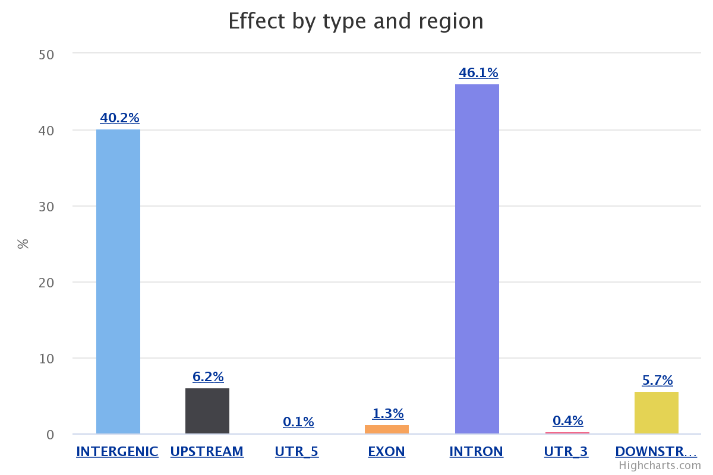
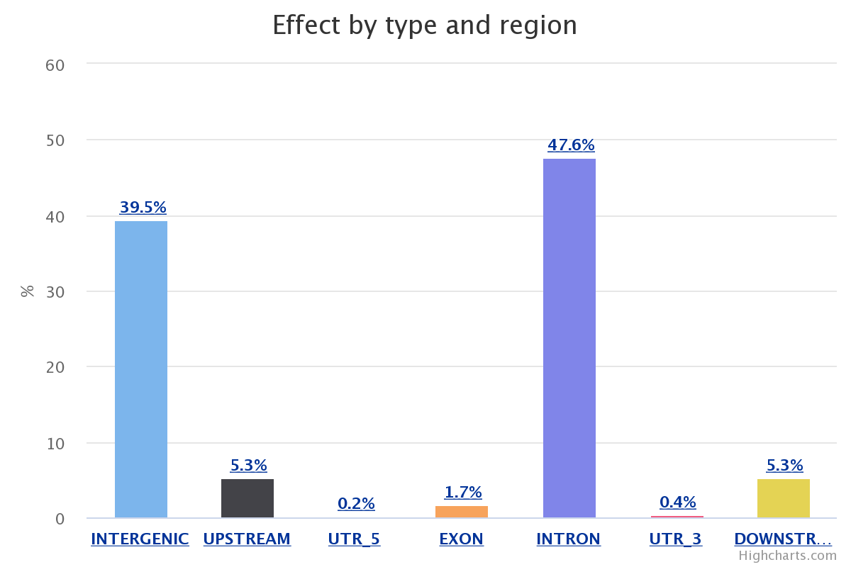
A
B

Fig1. Region specific count of identified SNPs in Crossbred bull spermatozoa.

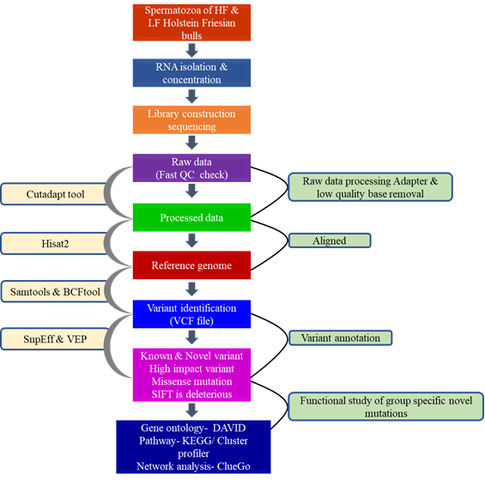
Fig. 2. Sequential and overall Flow of the study

