Supplementary Information:

Valence shell electronically excited states of imidazole and 1-methylimidazole

D. M. P. Hollandª, D. A. Shawª, D. Townsend^{b,c} and I. Powis^{d}

ª Daresbury Laboratory, Daresbury, Warrington, Cheshire WA4 4AD, UK
^{b} Institute of Photonics and Quantum Sciences, Heriot-Watt University, EH14 4AS, United
Kingdom
^{c} Institute of Chemical Sciences, Heriot-Watt University, EH14 4AS, United Kingdom
^{d} School of Chemistry, The University of Nottingham, University Park, Nottingham NG7 2RD, United Kingdom

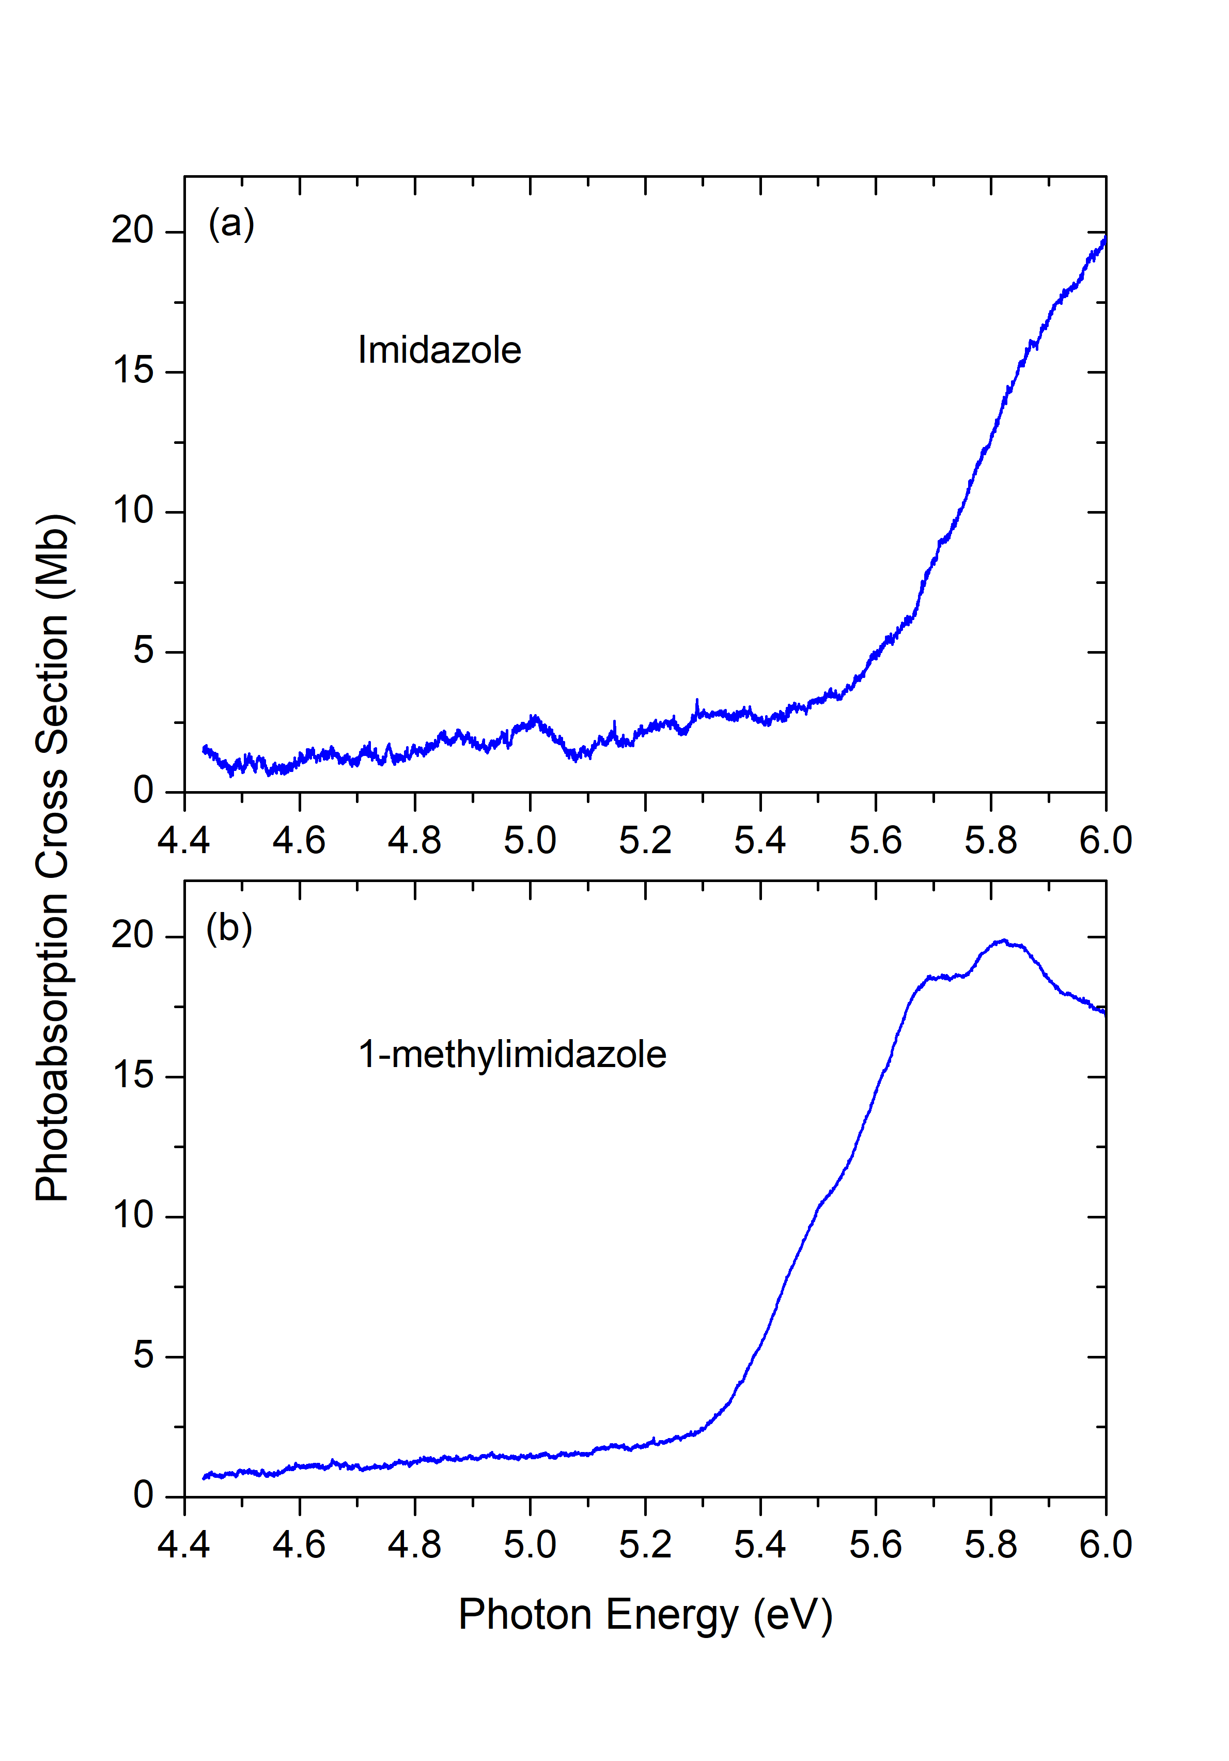

Figure S1
Expanded views of the near threshold regions of the imidazole and 1-methylimidazole VUV absorption spectra. See Figure 3 in the main paper for the full range scans of these spectra.

Table S1
Calculated harmonic vibrational frequencies (unscaled*) for imidazole neutral, X ¹Aʹ, and cation, X ²Aʺ, ground electronic states.
Mode | B3LYP/cc-pVTZ |  | MP2/cc-pVTZ
 | Neutral (cm⁻¹) | Cation (cm⁻¹) | Neutral (cm⁻¹) | Cation (cm⁻¹)
1aʹ | 3655.79 | 3569.5 | 3686.38 | 3608.6
2aʹ | 3271.65 | 3249.45 | 3317.71 | 3303.16
3aʹ | 3241.86 | 3241.98 | 3295.07 | 3291.66
4aʹ | 3239.52 | 3235.5 | 3289.95 | 3286.1
5aʹ | 1558.71 | 1539.14 | 1537.82 | 1626.34
6aʹ | 1502.36 | 1454.15 | 1509.29 | 1501.72
7aʹ | 1431.27 | 1417.42 | 1466.92 | 1478.44
8aʹ | 1365.39 | 1295.51 | 1372.36 | 1338.23
9aʹ | 1287.17 | 1266.12 | 1279.34 | 1311.25
10aʹ | 1161.31 | 1211.6 | 1188.33 | 1214.22
11aʹ | 1145.89 | 1126.12 | 1152.32 | 1142.85
12aʹ | 1094.98 | 1042.82 | 1104.58 | 1071.1
13aʹ | 1074.63 | 965.01 | 1085.82 | 1037.03
14aʹ | 947.1 | 923.05 | 935.54 | 925.23
15aʹ | 909.27 | 825.73 | 897.62 | 793.38
16aʺ | 879.64 | 934.66 | 864.59 | 1005.83
17aʺ | 823.9 | 888.92 | 804.17 | 967.82
18aʺ | 737.33 | 796.74 | 730.29 | 816.37
19aʺ | 684.81 | 705.58 | 686.11 | 705.5
20aʺ | 648.3 | 543.81 | 654.03 | 561.11
21aʺ | 526.19 | 494.63 | 548.99 | 497.79
* The recommended harmonic scaling factors are 0.968 for the B3LYP/cc-pVTZ calculations and 0.956
for the MP2/cc-pVTZ calculations [1]

Table S2
Calculated harmonic vibrational frequencies (unscaled*) for 1-methylimidazole neutral, X ¹Aʹ, and cation, X ²Aʺ, ground electronic states.
Mode | B3LYP/cc-pVTZ |  | MP2/cc-pVTZ
 | Neutral (cm⁻¹) | Cation (cm⁻¹) | Neutral (cm⁻¹) | Cation (cm⁻¹)
1aʹ | 3261.29 | 3248.89 | 3304.72 | 3298.16
2aʹ | 3233.1 | 3240.69 | 3280.72 | 3283.75
3aʹ | 3227.78 | 3236.15 | 3278.14 | 3281.61
4aʹ | 3127.05 | 3167.56 | 3196.82 | 3226.07
5aʹ | 3037.35 | 3070.76 | 3088.55 | 3113.24
6aʹ | 1542.91 | 1573.96 | 1557.11 | 1649.11
7aʹ | 1538.27 | 1499.59 | 1538.19 | 1526.77
8aʹ | 1513.49 | 1464.29 | 1514.6 | 1522.2
9aʹ | 1454.48 | 1431.33 | 1456.15 | 1474.66
10aʹ | 1388.61 | 1361.87 | 1439.19 | 1393.58
11aʹ | 1377.81 | 1296.09 | 1375.02 | 1369.01
12aʹ | 1309.98 | 1254.71 | 1319.82 | 1309.33
13aʹ | 1265.74 | 1207.28 | 1268.42 | 1243.77
14aʹ | 1140.96 | 1170.58 | 1157.38 | 1155.3
15aʹ | 1099.12 | 1090.07 | 1096.15 | 1088.61
16aʹ | 1074.49 | 1013.97 | 1087.65 | 1071.48
17aʹ | 1044.38 | 968.15 | 1050.21 | 984.66
18aʹ | 918.84 | 782.26 | 908.82 | 712.47
19aʹ | 676.56 | 640.85 | 679.2 | 635.88
20aʹ | 350.0 | 346.93 | 342.73 | 340.07
21aʺ | 3092.22 | 3152.06 | 3174.9 | 3221.56
22aʺ | 1487.85 | 1486.62 | 1503.85 | 1504.75
23aʺ | 1149.24 | 1146.54 | 1156.95 | 1164.35
24aʺ | 876.1 | 924.33 | 858.77 | 1011.17
25aʺ | 822.49 | 877.28 | 797.41 | 972.37
26aʺ | 734.78 | 779.33 | 723.6 | 831.96
27aʺ | 678.56 | 541.83 | 676.78 | 562.77
28aʺ | 629.82 | 508.56 | 631.46 | 508.26
29aʺ | 212.15 | 237.02 | 215.91 | 230.75
30aʺ | 77.07 | -77.35 | 71.1 | 39.9
* The recommended harmonic scaling factors are 0.968 for the B3LYP/cc-pVTZ calculations and 0.956
for the MP2/cc-pVTZ calculations [1]

Reference
[1] J. P. Merrick, D. Moran, and L. Radom, J. Phys. Chem. A 111, 11683 (2007).

