Appendix Species identification of common native Arctic mammals in Inuit fur clothing based on hair microscopy

As the reference to ‘Species identification of common native Arctic mammals in Inuit fur clothing based on hair microscopy,' representative micrographs of hairs from common species of Arctic mammals, used in Inuit clothing, are presented. Hair samples originated from furs belonging to the Natural History Museum of Denmark (NHMD) or fur garments from the National Museum of Denmark (NMD). The author studied longitudinal mounts and cross-sections of hairs by transmitted light microscopy.
As an introduction, a brief description begins of each animal's fur characteristics and its use in Inuit clothing.
Photos by the author, 2017-2021.

marks where sample was taken.

Page Contents
2 Reindeer/caribou (Rangifer tarandus)
3 Muskox (Ovibos moschatus)
4 Hooded seal (Cystophora cristata)
5 Bearded seal (Erignathus barbatus)
6 Harp seal (Pagophilus groenlandicus)
7 Ring seal (Phoca vitulina)
8 Harbour seal (Phoca hispida)
9 Largha seal (Phoca largha)
10 Domestic dog (Canis lupus familiaris)
11 Wolf (Canis lupus)
12 Arctic fox (Vulpes lagopus)
13 Polar bear (Ursus maritimus)
14 Wolverine (Gulo gulo)

Reindeer/caribou (Rangifer tarandus)

Reindeer/caribou skin varies considerably with the age, gender, health, diet of the animal, climate conditions, and season (Issenman, 1997, 69). New-born calves have soft, shiny, silk-like, but not durable skin (Issenman, 1997, 69), while four month old calves, slaughtered in August, have light skin which is used for finer garments due to their excellent fur (Hatt, 1969, 8). Calves slaughtered in the autumn provide a heavier fur, while skins taken in spring and summer may not be suitable due to botfly larvae that have perforated the back of the animals (Hatt, 1969, 8), and also because of shedding that makes way for the summer coat (Jenness, 1946, 9).

Skin from reindeer/caribou was the most common and most appropriate clothing material among Inuit in Arctic Canada, and various parts of the skin were used for specific garments (Hatt, 1969, 7-8; Saladin D’Anglure, 1984, 481). The fur has an insufficient capacity for conducting heat because of the hairs’ air-filled medulla, but the strands are quickly shed (Hatt, 1969, 8). Female animals moult later than male, and the coat is lighter. Skin from female animals was used for clothing for children and females (Issenman, 1997, 71). Clothing made from heavy skins is rarely seen in museum collections (Hatt, 1969, 8).

The preparation of R. tarandus samples from NHMD failed. Instead, NMD’s Inuit parkas from Arctic Canada and Greenland were studied. DNA analyses previously identified these garments to R. tarandus or Cervidae, i.e., R. tarandus.
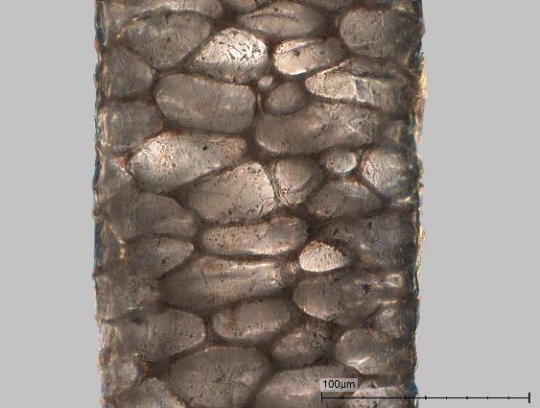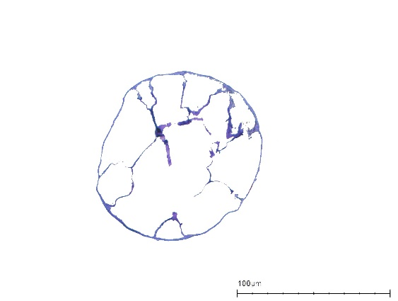 | 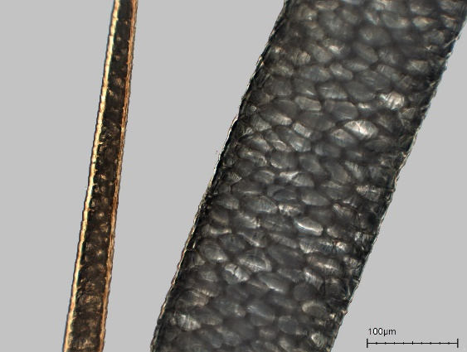
Top: Longitudinal mount. Primary hair, wide lattice medulla.  Bottom: Cross-section of round primary hair with wide medulla lattice remnants. | Top: Longitudinal mount. Two primary hairs, wide lattice medulla; left, near tip of hair.  Bottom: Cross-section of oval primary hairs, with wide to medium wide medulla lattice remnants. Round secondary hair.
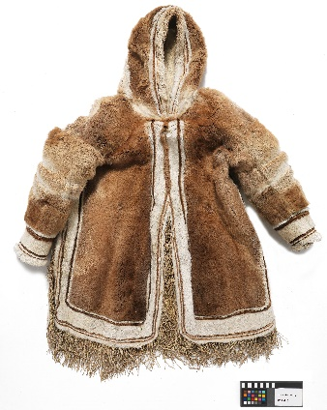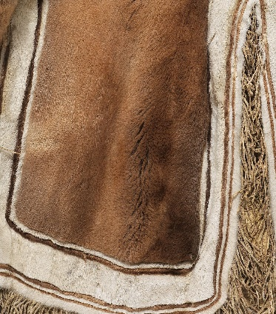 | 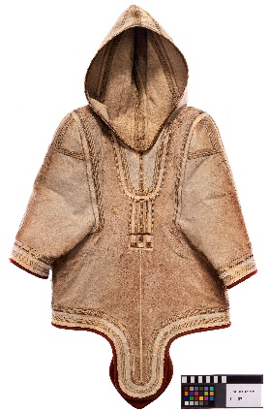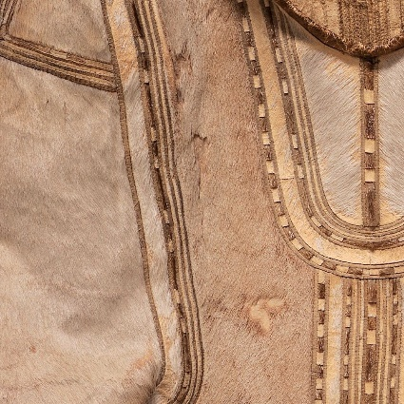
NMD, P27.410. Male parka. Long-haired brown and shorthaired white R. tarandus fur, de-haired fringes of caribou skin. From Iglulingmiut, Mittimatalik (Ponds Inlet), 5th Thule-expedition, 1924. Photo Roberto Fortuna. | NMD, Lc.187a. Female parka. Sheared R. tarandus fur with decoration of fur and de-haired caribou skin. Edges made of wool textile. From Kalaalliit, Aasiaat, Aito. Governor for North Greenland Ludvig Fasting, 1844. Photo Roberto Fortuna.
Musk ox (Ovibos moschatus)

Musk ox hides have up to 60 cm long primary hair and very fine secondary hair. The ratio of primary hair to secondary hair (in Greenlandic: qiviut) is 1:37, which makes musk ox fur one of the densest and extremely water resistant (Trolle & Goldman, 38-39; Rowell, et al., 2001, 1671).

The use of musk ox skin in Inuit clothing has rarely been mentioned, but the long-haired fur has been used in caps, where it was useful to keep insects away (Issenman, 1997, 34). Among Inuinnait, the skin was used for heavy coats (Jenness, 1946, 9).

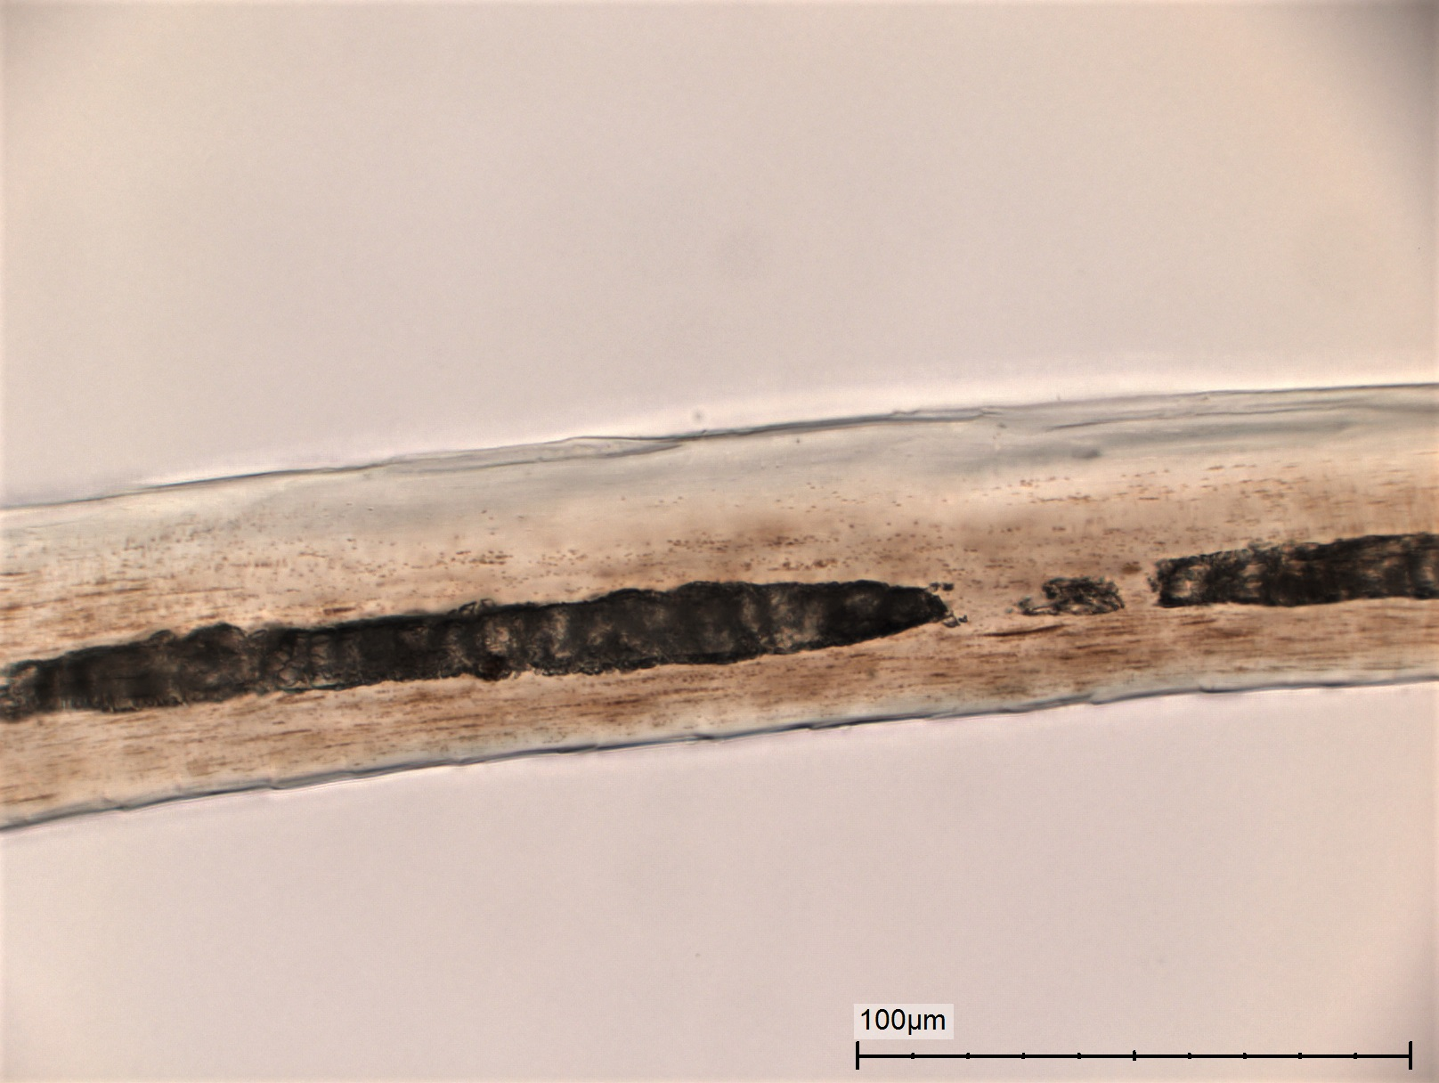  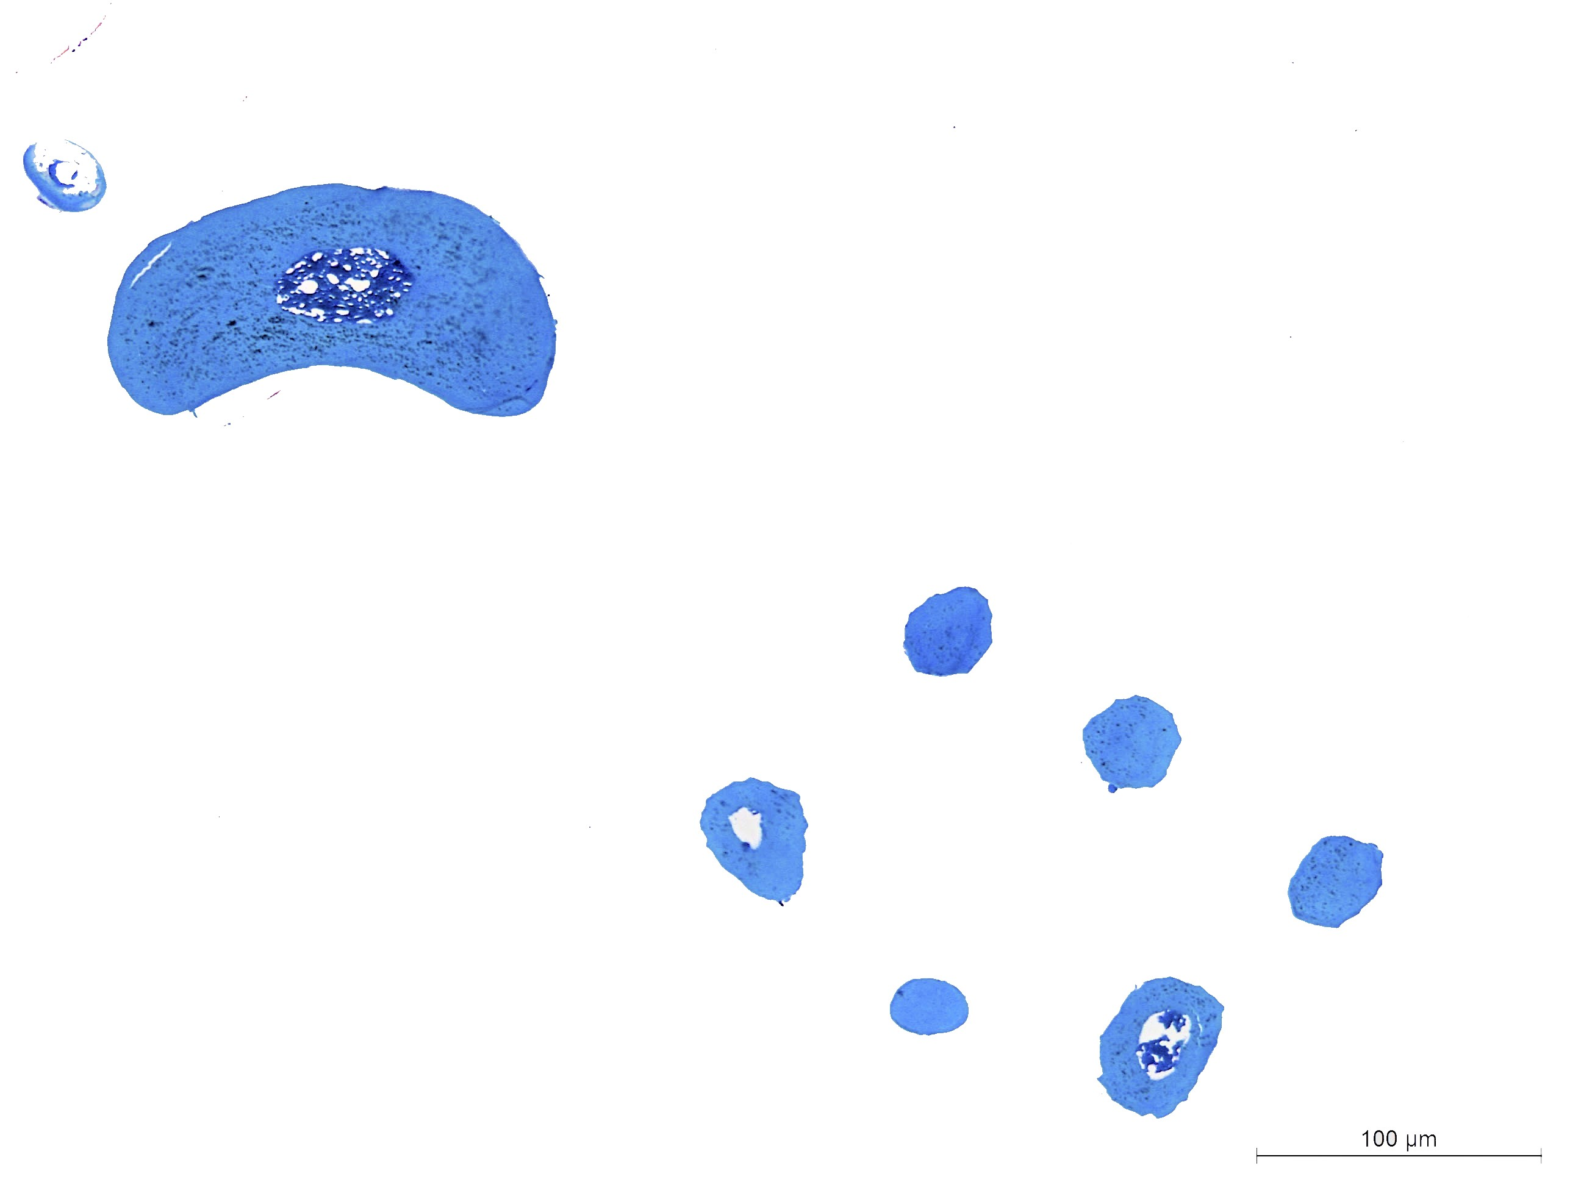 | 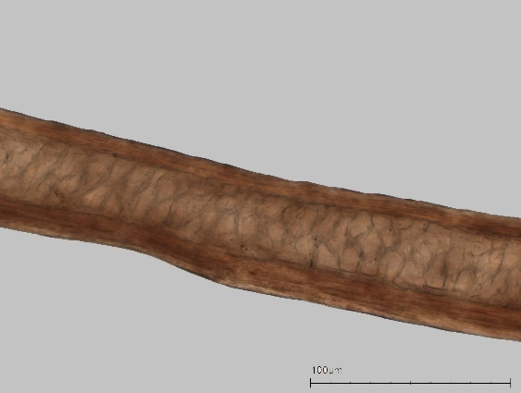  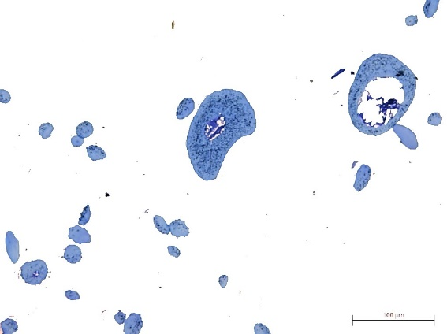
NHMD: CN 3444, dorsal sample.  Top: Longitudinal mount. Intermediate hair, medium width medulla.  Bottom: Cross-section. Kidney shaped primary hair. Intermediate nut shaped and round to oblong hairs. Medulla lattice remnants. Round secondary hair. All hairs with cortex pigmentation. | NHMD: CN 3444, abdominal sample.  Top: Longitudinal mount. Primary hair, medium width lattice medulla.  Bottom: Cross-section. Kidney shaped and round to oblong primary hairs. Intermediate nut shaped hair. Medulla lattice remnants. Round secondary hair. All hairs with cortex pigmentation.
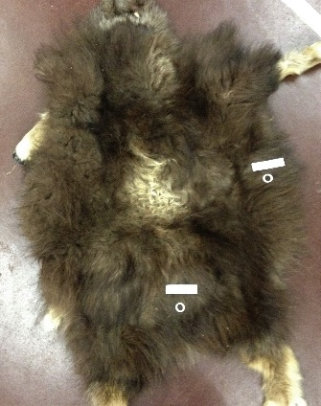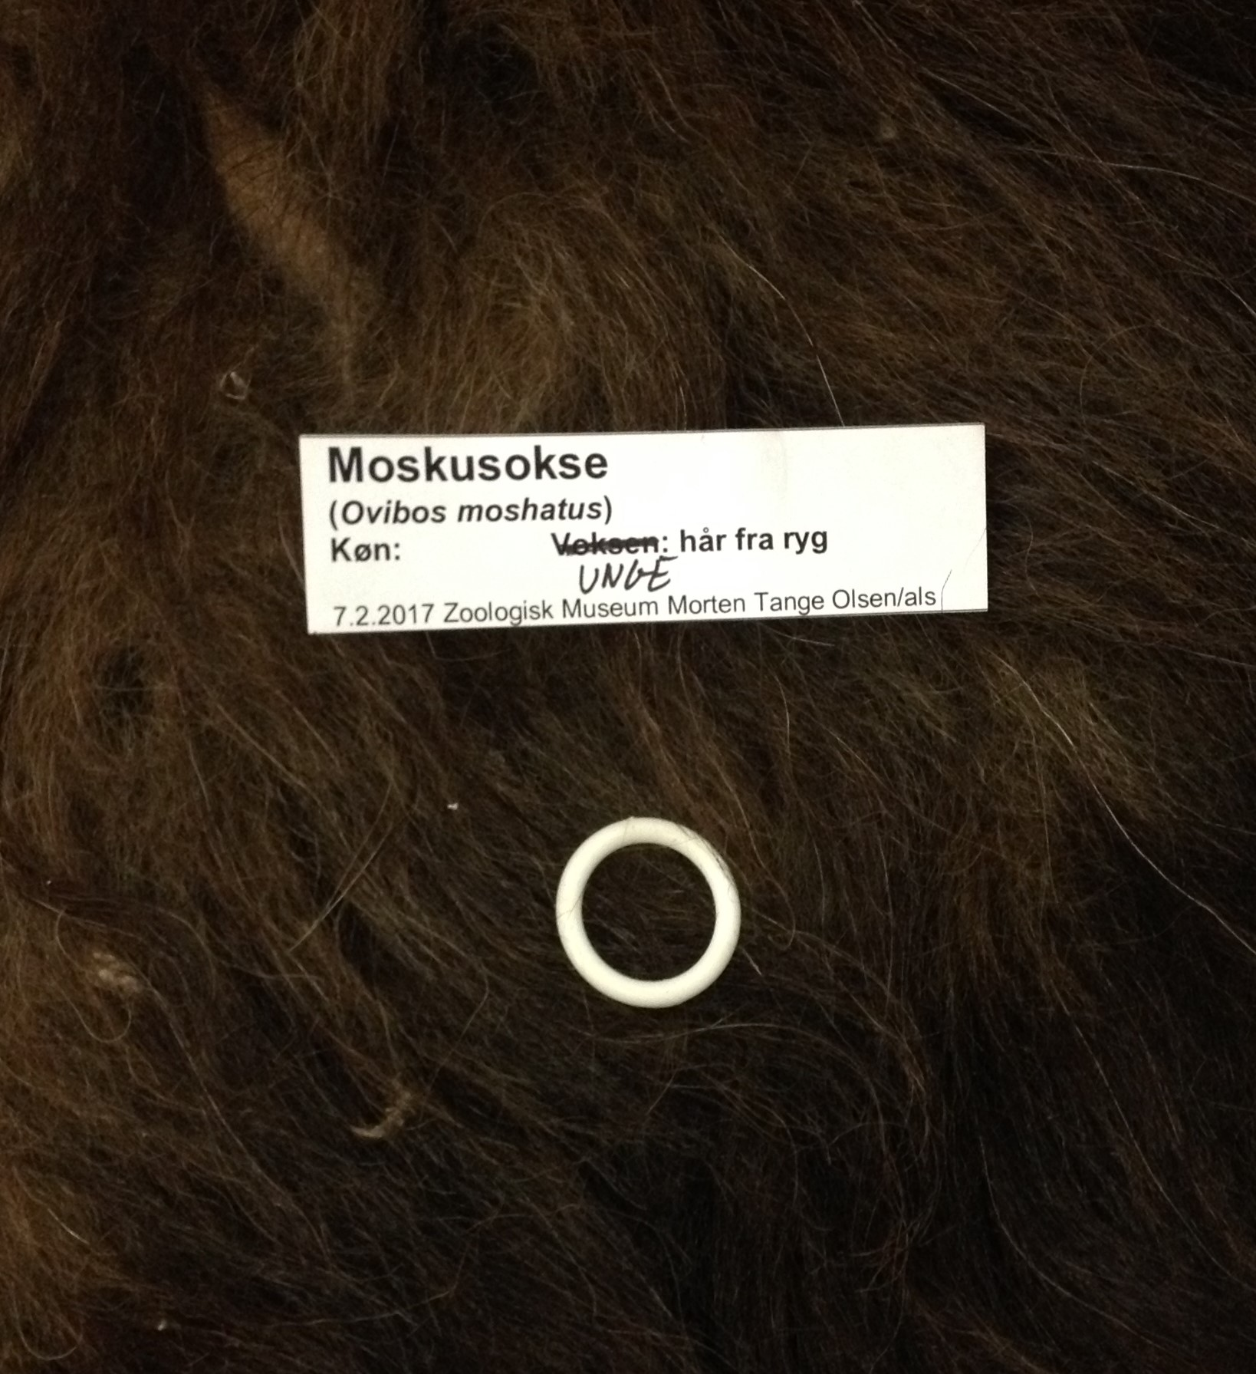 | 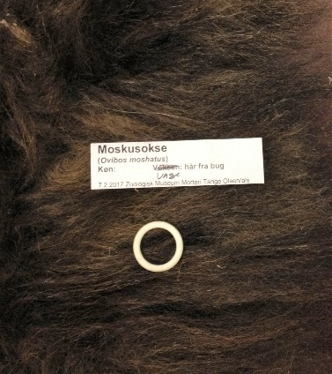
NHMD: CN 3444.  Ovibos moschatus. Juv. male, ZOO Copenhagen, 19 November 1964 .Whole skin, dorsal sample. | NHMD: CN 3444.  Ovibos moschatus. Juv. male, ZOO Copenhagen, 19 November 1964 .Whole skin, abdominal sample.
Hooded seal (Cystophora cristata)

The pelage of adult hooded seal is whitish to pale silver gray with black irregular spots (Shirihai & Jarrett, 2009, 311).

Kalaalliit women used juvenile skins for their very best clothing in the late 17th century (Kapel, 2005, 99).

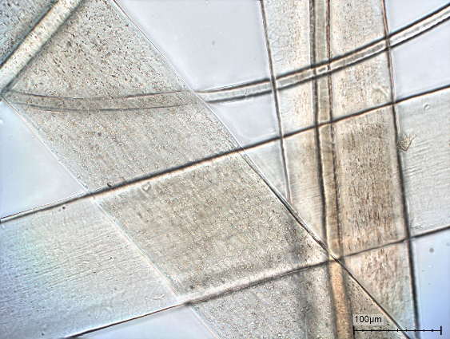 | 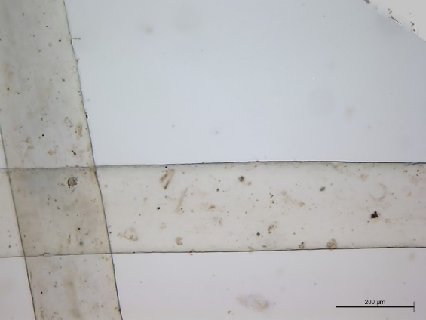  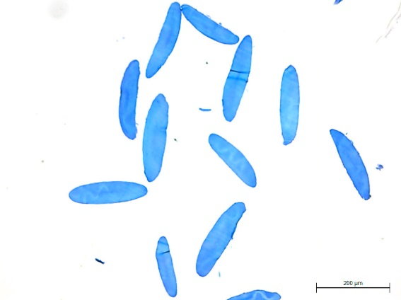
NHMD: M 1260, abdominal sample.  Top: Longitudinal mount. Primary hairs; absent medulla. Secondary hairs with visible cuticular pattern.  Bottom: Cross-section. Oblong and oval primary hair, oval to round secondary hair with cortex pigmentation; absent medulla. All hairs with pigmentation. | NHMD: CN 1143, abdominal sample.  Top: Longitudinal mount. Primary hairs; absent medulla.  Bottom: Cross-section. Oblong primary hairs with cortex pigmentation; absent medulla.
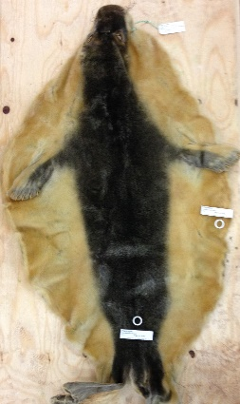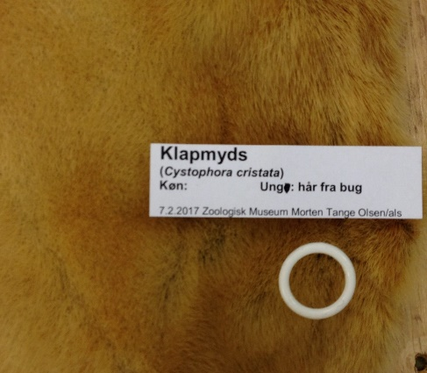 | 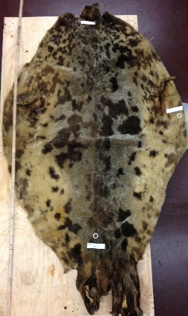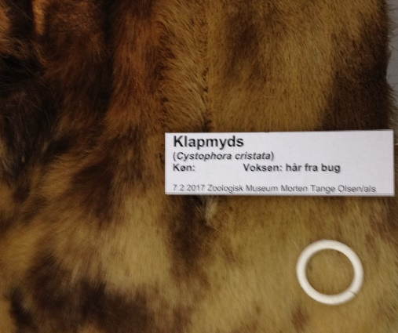
NHMD: M 1260.  Cystophora cristata. Juv. East Greenland, no date. Whole skin, abdominal sample. | NHMD: CN 1143.  Cystophora cristata. Ad. Lofoten, June 1977. Whole skin, abdominal sample.

Bearded seal (Erignathus barbatus)

The pelage of juvenile bearded seal often has numerous dark blotches, while the pelage of adults is contrasting markings (Shirihai & Jarrett, 2009, 319).

Among Nunavimmiut de-haired skins were used for boot soles (Saladin D’Anglure, 1984, 481). Inuit in Greenland used juvenile skin with proper fur for trousers, but the majority of the skins was used for lines (Kapel, 2005, 105).

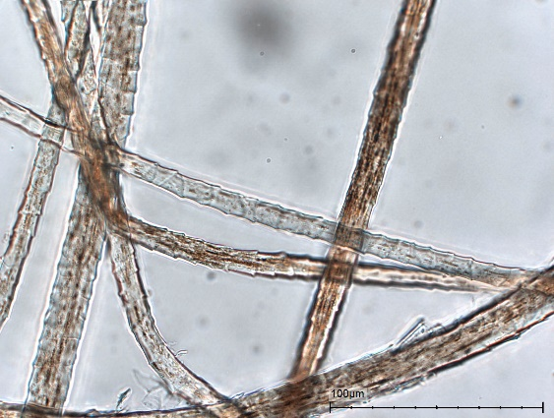  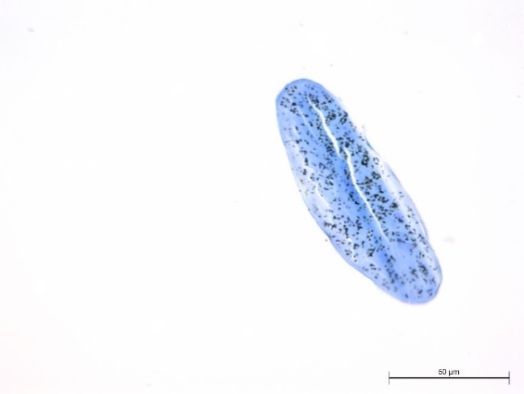 | 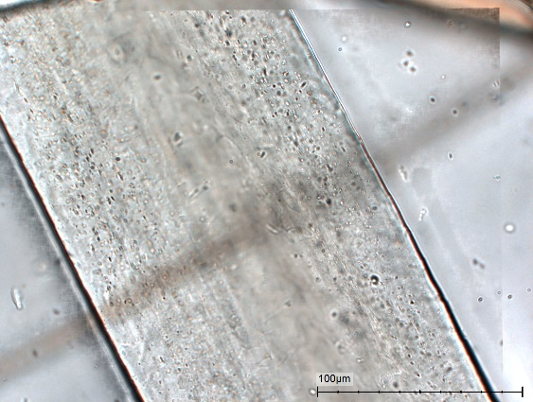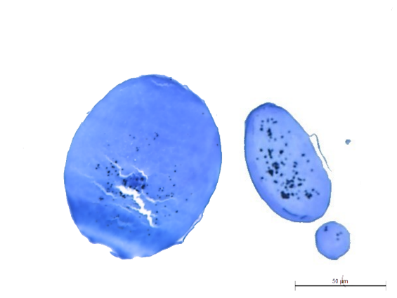
NHMD: CN 826, dorsal sample.  Top: Longitudinal mount. Secondary hairs with visible cuticular pattern.  Bottom: Cross-section. Oblong primary hair with cortex pigmentation; absent medulla. | NHMD: CN 826, abdominal sample.  Top: Longitudinal mount. Primary hair; absent medulla.  Bottom: Cross-section. Oval primary hairs and round secondary hair with cortex pigmentation; absent medulla.
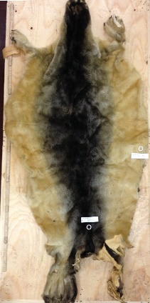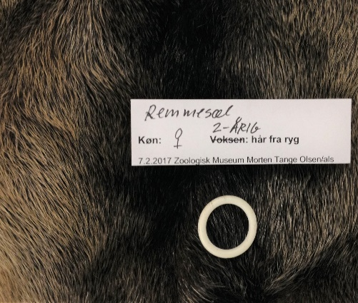 | 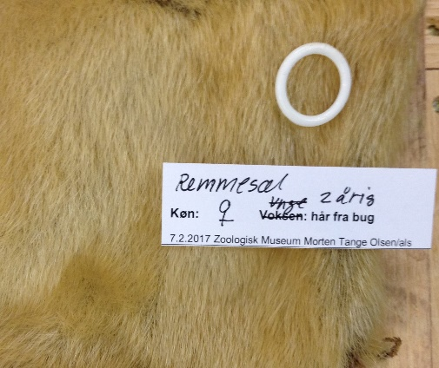
NHMD: CN 826.  Erignathus barbatus. Juv. female, Qeqertarsuup Tunua (Disko Bay), 29 May 1952. Whole skin, dorsal sample. | NHMD: CN 826.  Erignathus barbatus. DMN: Juv. female, Qeqertarsuup Tunua (Disko Bay), 29 May 1952. Whole skin, abdominal sample.

Harp seal (Pagophilus groenlandicus)

The pelage of the harp seal changes with age. New-borns have brilliant white coats. Juveniles are dark and grey with black spots, which over time become larger and darker. The full-grown seal has a black head and black back saddle; the rest of body is cream or white (Kapel, 2005, 58; Shirihai & Jarrett, 2009, 316).

Inuit in eastern Arctic Canada used the skin for clothing (Issenman, 1997, 35), but documentation of the extent is scarce. Inuit in West Greenland used skin from juvenile P. groenlandicus for all types of clothing in the late 17th century (Kapel, 2005, 75).

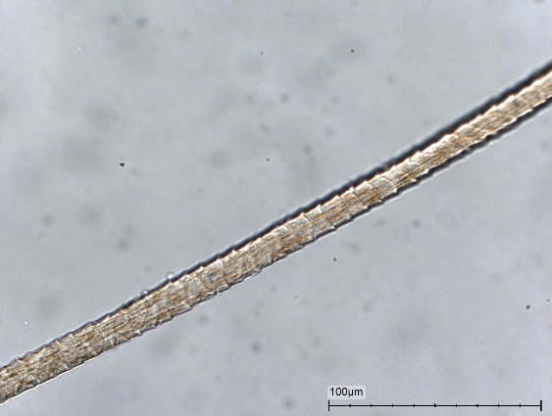  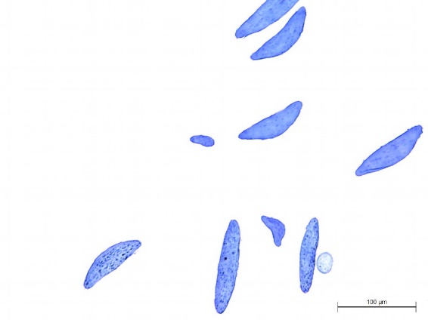 | 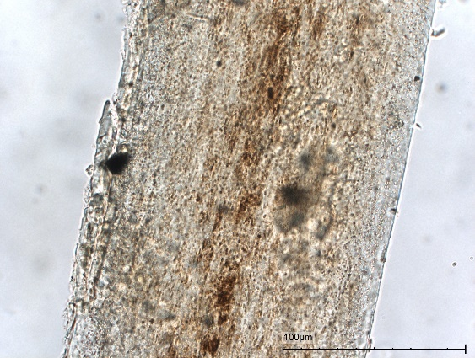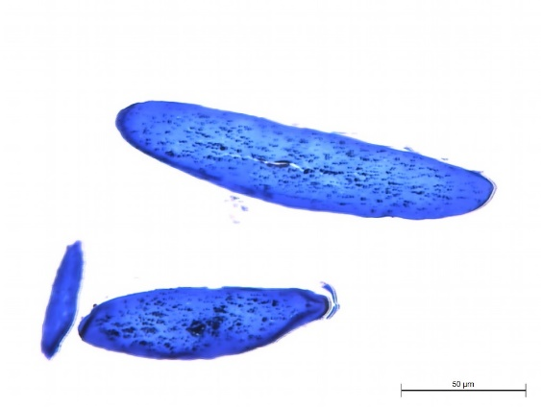
NHMD: CN 695, dorsal sample.  Top: Longitudinal mount. Secondary hair with visible cuticular pattern.  Bottom: Cross-section. Oblong, eye and hat shaped primary hairs with cortex pigmentation; absent medulla. | NHMD: CN 694, dorsal sample.  Top: Longitudinal mount. Primary hair with pigmentation; absent medulla.  Bottom: Cross-section. Oblong primary hairs with cortex pigmentation; absent medulla.
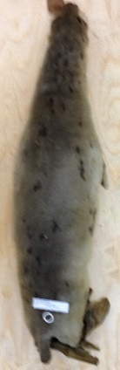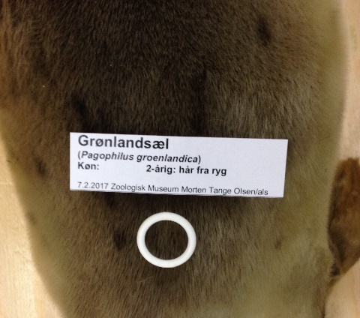 | 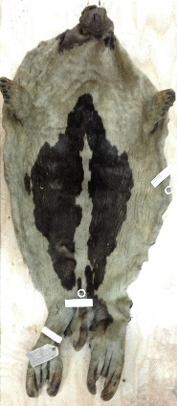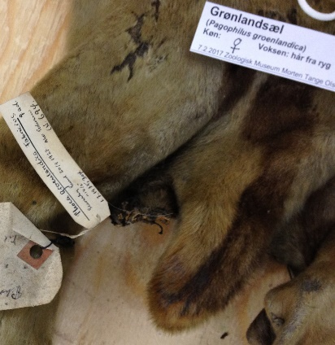
NHMD: CN 695.  Phoca groenlandicus. Juv. male, Ittoqqortoormiit (Scoresbysund), 20 September 1928. Stuffed animal, dorsal sample. | NHMD: CN 694.  Phoca groenlandicus. Ad. female, Ittoqqortoormiit (Scoresbysund), 20 September 1927. Whole skin, dorsal sample.

Ringed seal (Phoca hispida)

New-born ringed seals have whitish secondary hair pelage. Juveniles have an evenly coloured dark grey back, and a silver abdomen with few rings. Adults have dark pelage with rings similar to P. vitulina or widespread mottled pattern without conspicuous rings. P. hispida can be confused with P. vitulina and P. largha (Shirihai & Jarrett,2009, 322).

Canadian Inuit used ringed seal skin for spring and summer parkas and trousers because of its light weight and protective qualities e.g., transfer of humidity and water repellency. Footwear made ringed seal skin was used all year round (Issenman, 1997, 35-36). Nunavimmiut used skins for summer garments and boot shafts (Saladin D’Anglure, 1984, 481). In West Greenland, small skins of ringed seal, with a dark back and a white belly, were used for fine parkas for females. Generally, among Kalaalliit, skins were used for parkas, trousers, stockings, and mittens for both sexes in the late 17th century (Kapel, 2005, 85).

 | 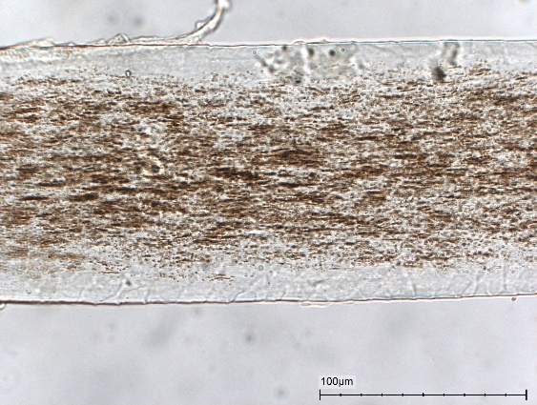
NHMD: CN 1255, dorsal sample.  Top: Longitudinal mount. Secondary hairs with visible cuticular pattern and pigmentation.  Bottom: Cross-section. Eye shaped primary hair with cortex pigmentation; absent medulla. | NHMD: CN 1249, abdominal sample.  Top: Longitudinal mount. Primary hair with pigmentation; absent medulla.  Bottom: Cross-section. Oblong and oval primary and round secondary hair with cortex pigmentation; absent medulla.
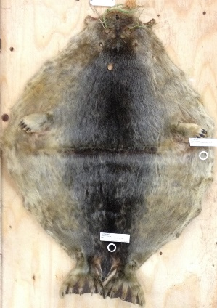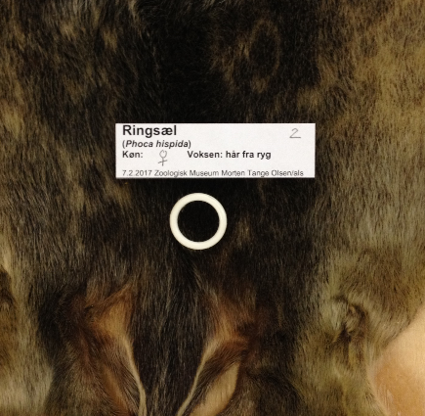 | 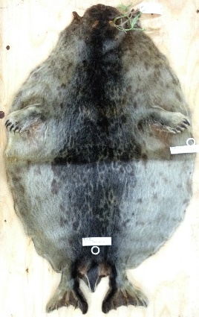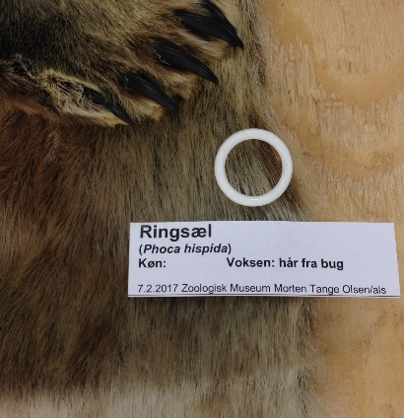
NHMD: CN 1255.  Phoca hispida. Juv. female, Qeqertarsuaq (Godhavn), 3 May 1994. Whole skin, dorsal sample. | NHMD: CN 1249.  Phoca hispida. Sub. ad. male, Qeqertarsuaq (Godhavn), 27 April 1994. Whole skin, abdominal sample.

Harbour seal (Phoca vitulina)

New-born harbour seals have white, long-haired coats. Adults appear in two colour varieties, pale (cream to silver grey) and
dark (metallic black), both with irregular spots, blotches and broken rings. In nature, the species may be confused with largha seal (Shirihai & Jarrett, 2009, 325).

Information about the use of harbour seal among Inuit in North America is not available (Issenman, 1997, 35). Kalaalliit regarded young skins as the most handsome material for parka and trousers, for both genders in the late 17th century (Kapel, 2005, 91).

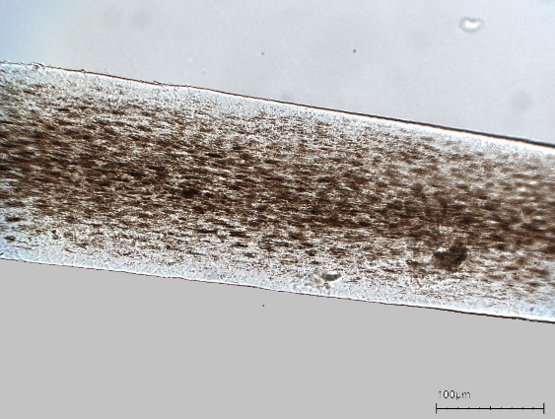  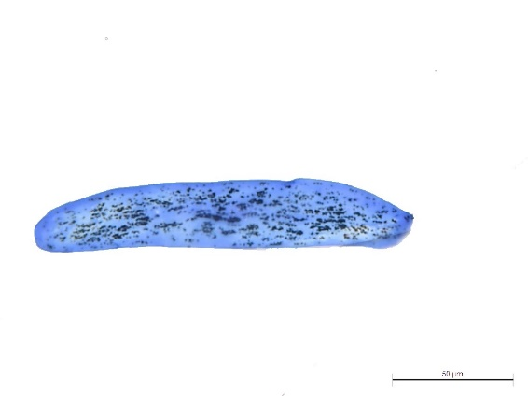 | 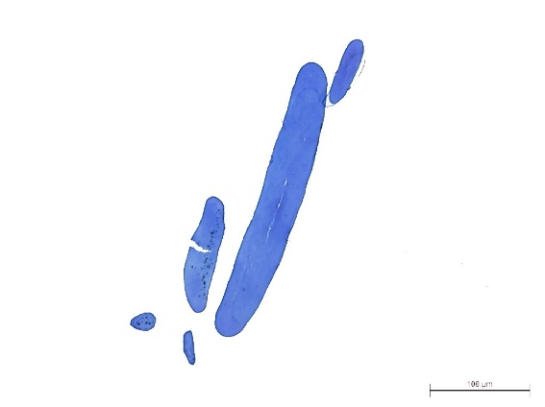
NHMD: CN 1075, dorsal sample.  Top: Longitudinal mount. Primary hair with pigmentation; absent medulla.  Bottom: Cross-section. Oblong primary hair with cortex pigmentation; absent medulla. | NHMD: CN 1075, abdominal sample.  Top: Longitudinal mount. Oblong primary hair with pigmentation.  Bottom: Cross-section. Oblong primary hairs, oval to round secondary hairs with sparse cortex pigmentation; absent medulla.
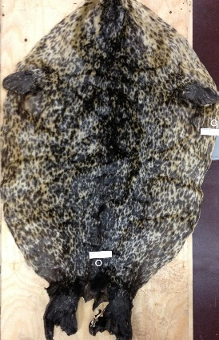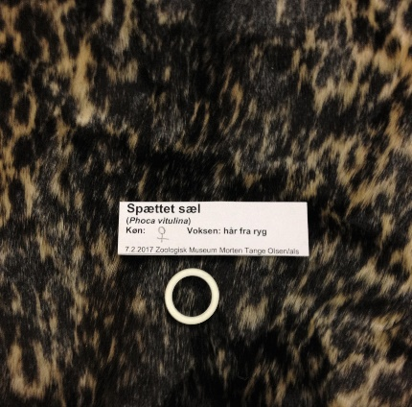 | 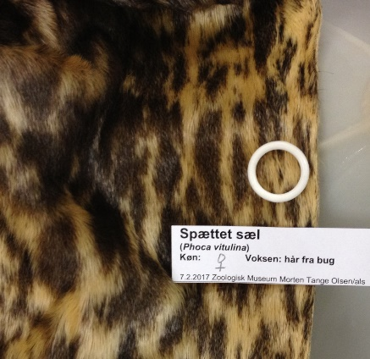
NHMD: CN 1075.  Phoca vitulina. Ad. female, Hesselø, 5 September 1968. Whole skin, dorsal sample. | NHMD: CN 1075.  Phoca vitulina. Ad. female, Hesselø, 5 September 1968. Whole skin, abdominal sample.

Largha seal (Phoca largha)

The fur of the largha seal is similar to the harbour seal but is generally paler or brown with numerous small dark spots without rings (Shirihai & Jarrett, 2009, 323).

Information was not found on skin of this species used for Inuit clothing. In the NMD’s Arctic collection, one Siberian skin garment: K.905, female skirt, was identified as P. largha by DNA analyses.

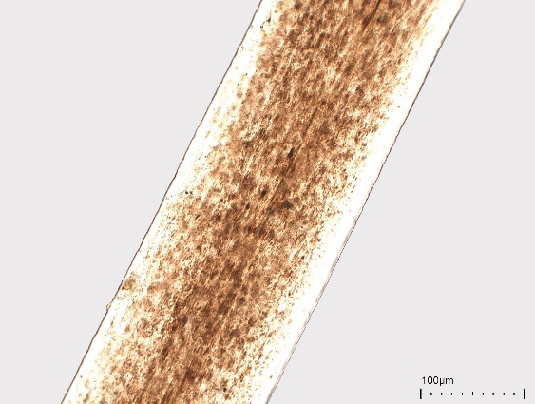
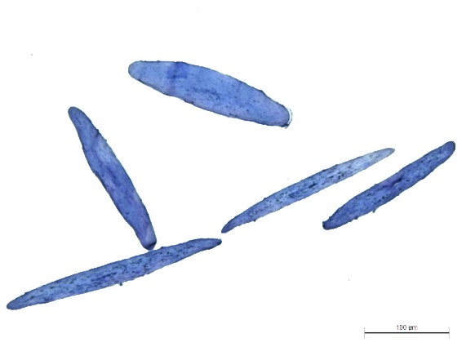
NMD, K.905.
Top: Longitudinal mount. Primary hair with pigmentation; absent medulla.
Bottom: Cross-section. Oblong primary hairs with cortex pigmentation; absent medulla.

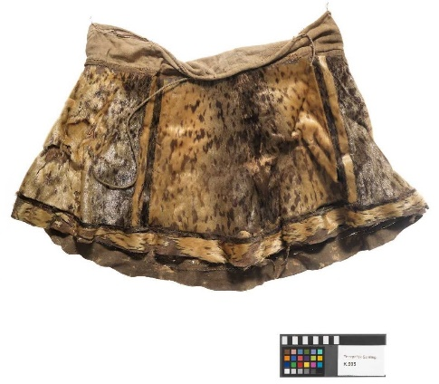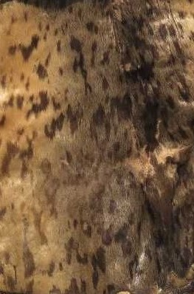
NMD: K. 905
Female skirt of fur from P. largha with waistband of cotton textile. From Nanai, Sakhalin. Professor Benedikt Balogh von Barathos, 1937. Photo Roberto Fortuna.

Domestic dog (Canis lupus familiaris)

The fur of the domestic dog (i.e., the sledge dog) has long primary and dense secondary hairs, which are not shed. The durable fur creates an insulating microclimate (Issenman, 1997, 33-34), and the fur is not damaged by repeated moisture and drying cycles (Harris, et al., 2020, 2).

Among Western Inuit, dog skin was a valued material for trimmings, i.e. as hood ruff or sleeve trimming (Issenman, 1997, 34), while in Arctic Canada, the Kivallirmiut obviously excluded the use of dog skin for clothing “due to the aversion of the Eskimos to it” (Birket-Smith, 1929, 191). Among Inughuit, dog skin was frequently used for clothing (Birket-Smith 1924, 173), while among southern Kalaalliit, the use of dog skin was regarded as a sign of poverty (Dalager, 1915, 43). Among Iivit, dog skin had the connotation of fertility (Buijs, 2004, 36).

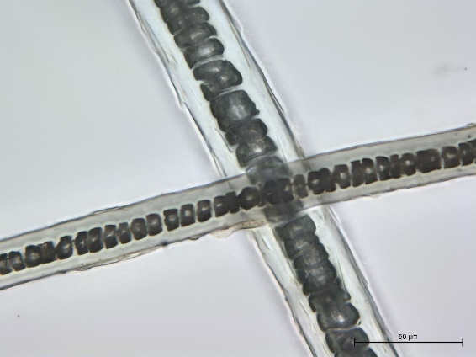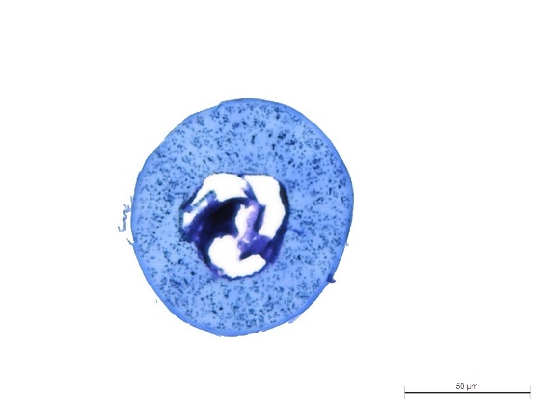 | 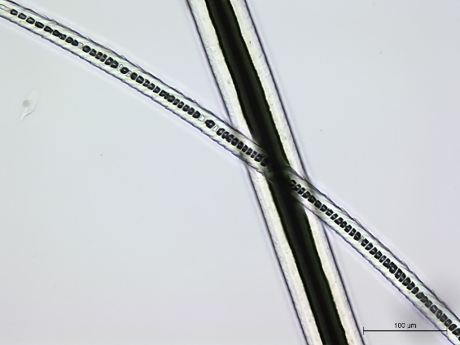  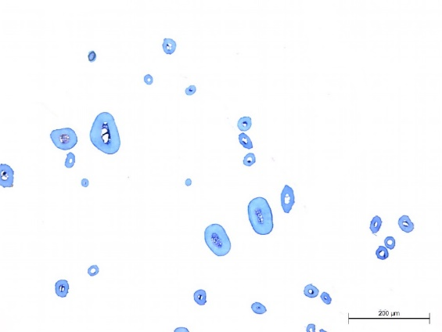
NHMD: CN 3294, dorsal sample.  Top: Longitudinal mount. Intermediate hairs with uniserial ladder medulla, medium width.  Bottom: Cross-section. Round primary hair with cortex pigmentation. Medium width medulla with remnants. | NHMD: CN 3294, abdominal sample.  Top: Longitudinal mount. Primary hair with medium width medulla (not filled with mounting media), and intermediate hair with uniserial ladder medulla.  Bottom: Cross-section. Round to oval primary hairs with, nut shaped intermediate hair. Medium width medulla with remnants, sparse cortex pigmentation. Round secondary hair.
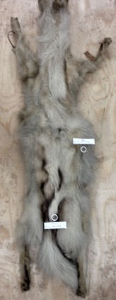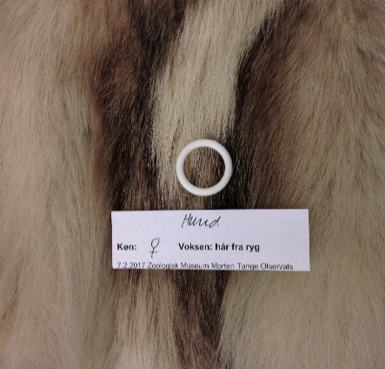 | 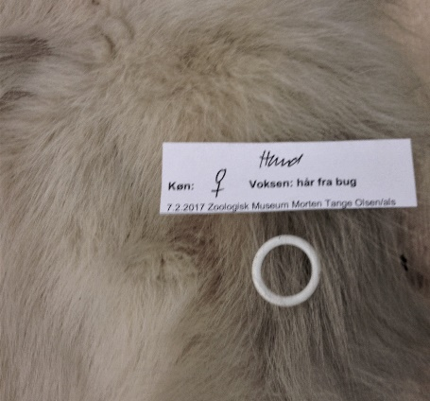
NHMD: CN 3294.  Canis lupus familiaris. Ad. female, Ittoqqortoormiit (Scoresbysund), 10 January 1928. Whole skin, dorsal sample. | NHMD: CN 3294.  Canis lupus familiaris. Ad. female, Ittoqqortoormiit (Scoresbysund), 10 January 1928. Whole skin, abdominal sample.

Wolf (Canis lupus)

The wolf has white winter fur and grayish summer fur (Génsbøl 1999, 300), although sometimes also black. The coat is thick, with long, coarse primary hairs and dense secondary hair (Bockstoce, 2009, 43).

Among Inuit, this species was favored for trimmings around hoods, sleeves, and on parkas. In the Bering Strait region and Alaska, a so-called ‘sunburst’ used as a hood ruff was sewn from long strips of long-haired dorsal skin from wolf, wolverine, and dog (Issenman, 1997, 100). Wolf fur had the ability to create a warm microclimate near the face, similar to wolverine and dog skin (Issenman, 1997, 39). In Arctic Canada, only few wolves and wolverines were killed before the Inuinnait obtained rifles (Jenness, 1946, 9).

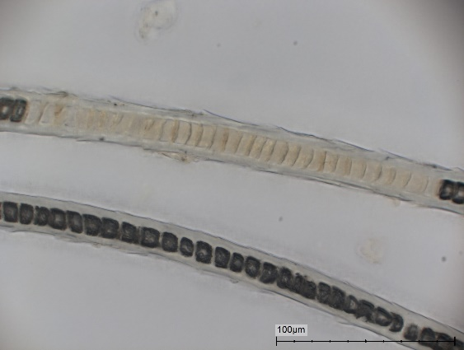  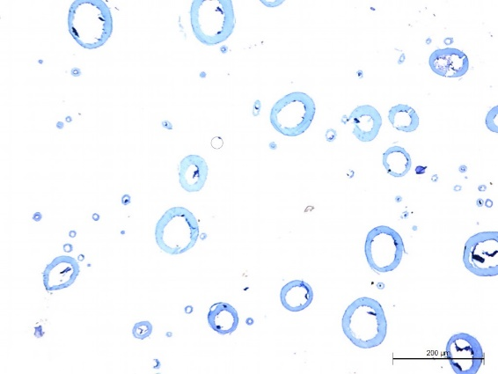 | 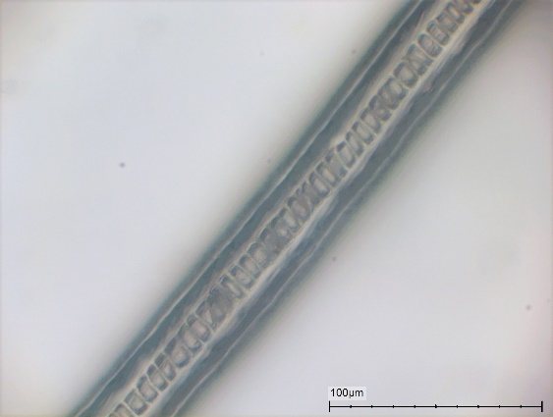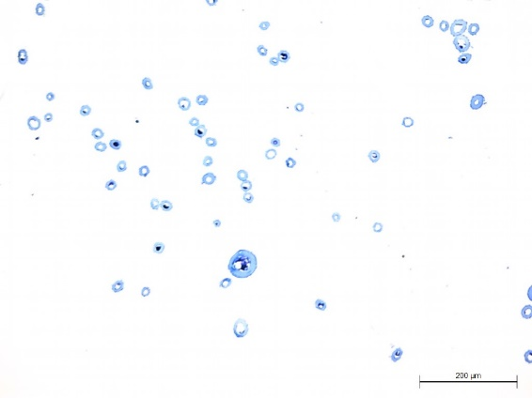
NHMD: CN 4094, dorsal sample.  Top: Longitudinal mount. Intermediate hair with uniserial ladder medulla, with and without mounting media. Medium width medulla.  Bottom: Cross-section. Many round to oval primary hairs, many nut shaped intermediate hairs. Medium width medullae with remnants. Few round secondary hairs. | NHMD: CN 4094, abdominal sample.  Top: Longitudinal mount. Intermediate hair with uniserial ladder medulla. Medium width medulla.  Bottom: Cross-section. A few round to oval primary hairs, many nut shaped intermediate hairs. Medium width medullae with remnants.
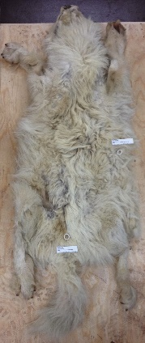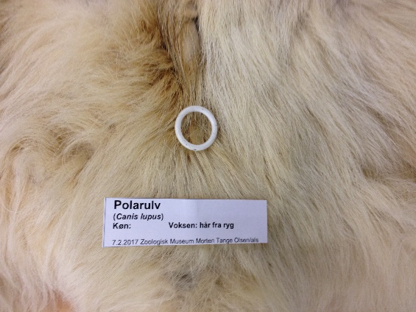 | 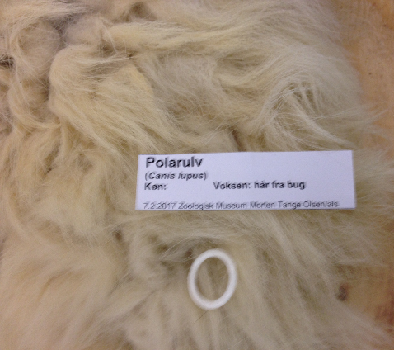
NHMD: CN 4094.  Canis lupus. Ad. male, Umingmak Nuna (Ellesmere Island) 10 November 1953. Whole skin, dorsal sample. | NHMD: CN 4094.  Canis lupus. Ad. male, Umingmak Nuna (Ellesmere Island) 10 November 1953. Whole skin, abdominal sample.

Arctic fox (Vulpes lagopus)

Two races of arctic fox exist: the blue fox, living near the coast, and the white fox, living in the inland. They can be genetically mixed (Haarløv, 1986, 48; Génsbøl, 1999, 300).

Among Inuit in Greenland, skin from V. lagopus was used for parka trimmings and ruffs (Issenman, 1997, 34). Among Inughuit, arctic fox skins were used for male and female parkas and female trousers (Holtved, 1967, 36-37, 49-50, 52-54). Iivit used the skins for male caps and footwear trimmings (Thalbitzer, 2010, 576-577, 589, 591).

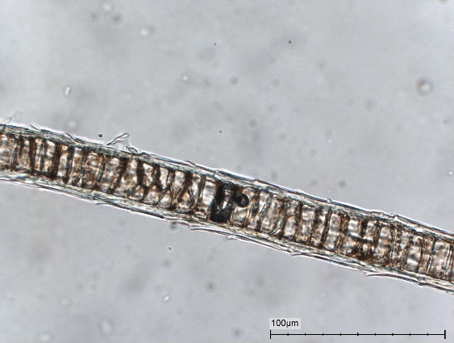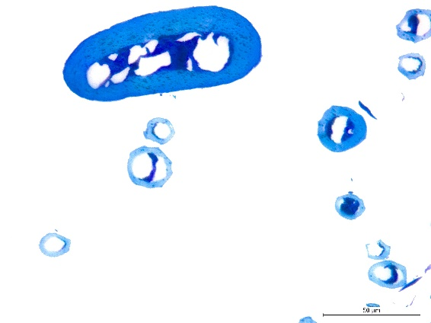 | 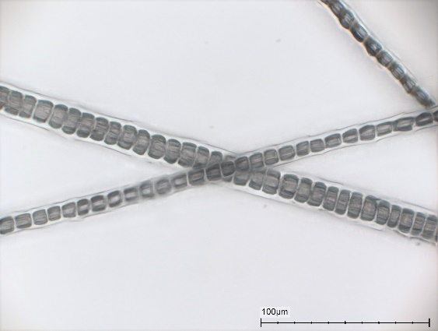  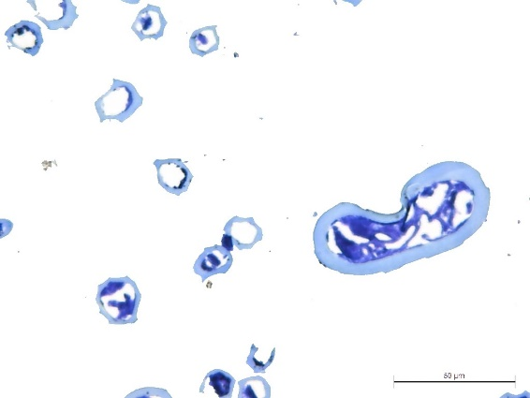
NHMD: CN 2357, dorsal sample.  Top: Longitudinal mount. Intermediate hair with medium width uniserial ladder medulla.  Bottom: Cross-section. Oblong primary hair with pigmentation, nut shaped intermediate hair. Medium width medullae with remnants. | NHMD: CN 2036, dorsal sample.  Top: Longitudinal mount. Intermediate hair with medium width uniserial ladder medulla.  Bottom: Cross-section. Kidney shaped primary hair, nut shaped intermediate hair. Medium width medullae with remnants.
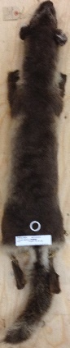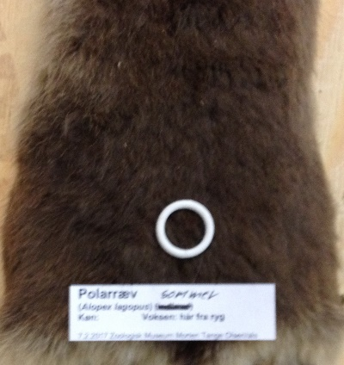 | 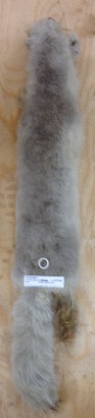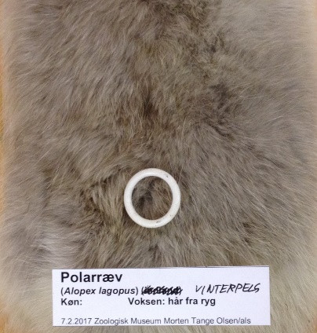
NHMD: CN 2357.  Vulpes lagopus. Summer, ad., Naujaat (Repulse Bay), 14 June 1922. Whole skin, dorsal sample. | NHMD: CN 2036.  Vulpes lagopus. Winter, ad., Parry? Bay, 1 March 1923 or 28. Whole skin, dorsal sample.

Polar bear (Ursus maritimus)

In the winter, the new coat of a polar bear is white, turning golden yellow in summer time (Issenman, 1997, 74). Water-repellent primary hair, dense secondary hair (Bockstoce, 2009, 49).

Among Inuit in Arctic North America, polar bear skin was rarely used for clothing because of the abundance of R. tarandus and Phocidae. When used, skins from young animals were preferred, as the skin of adults is too stiff and uncomfortable for clothing (Issenman, 1997, 74). Among Inughuit and Iivit, skin from U. maritimus was used for a hunter's winter trousers (Holm 2010, 29; Buijs, 2004, 41). The skin with long hairs on the back of the front legs were especially appreciated for decorative trimmings e.g. on female stockings. Short-cut hair from U. maritimus, C. lupus familiaris (Thalbitzer, 2010, 575), or new born seals (Buijs, 2004, 43) was used for ornamental stripes on e.g. outer parkas, and on the upper edges of female boots (Buijs, 2004, 34). Skin from U. maritimus was used for men’s parka, trousers and footwear (Buijs, 2004, 55).

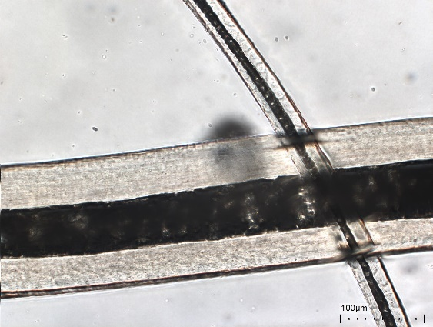  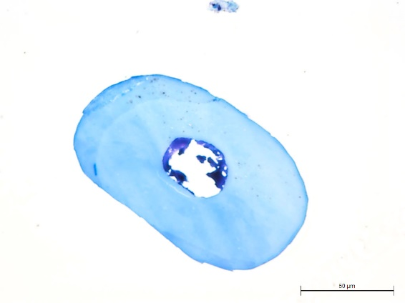 | 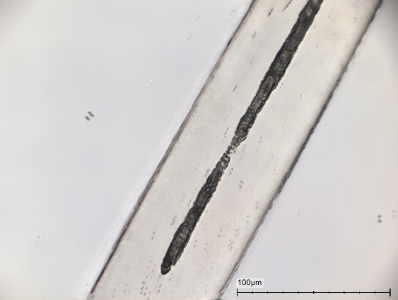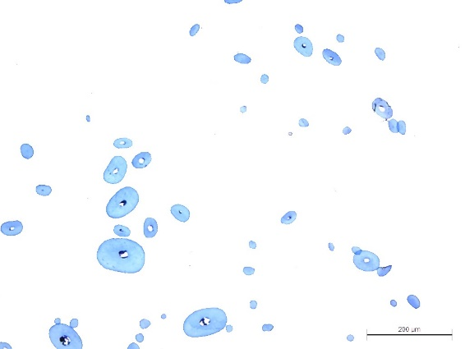
NHMD: M 8009, dorsal sample.  Top: Longitudinal mount. Primary hair with unbroken, medium width medulla. Intermediate hair with uniserial ladder medulla.  Bottom: Cross-section. Oval primary hair with sparse cortex pigmentation. Medium width medulla with remnants. | NHMD: M 8009, abdominal sample.  Top: Longitudinal mount. Intermediate hair with fragmental narrow medulla.  Bottom: Cross-section. Oval primary and intermediate hair. Medium to narrow width medulla with remnants. Round secondary hair.
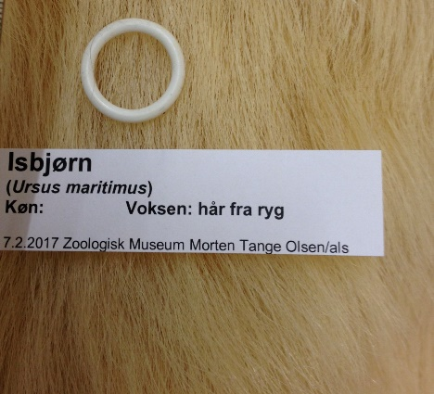 | 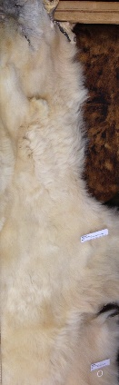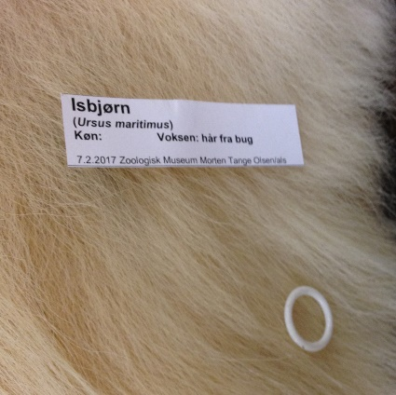
NHMD: M 8009.  Ursus maritimus. Ad. female ZOO Copenhagen 28 November 1970. Whole skin, dorsal sample. | NHMD: M 8009.  Ursus maritimus. Ad. female ZOO Copenhagen 28 November 1970. Whole skin, abdominal sample.

Wolverine (Gulo gulo)

The fur of a wolverine has dense secondary hairs and coarse primary hairs (Bockstoce 2009, 43).

Wolverine fur was highly appreciated for trim on the parka hood because the long primary hairs reduce the problems related to accumulation of humidity from the wearer’s breath (Bockstoce 2009, 43). When the breath meets the long and uneven primary hair, hoarfrost is built upon its surface. This is easily removed by brushing the ruff with the hand regularly. Besides, wolverine fur reduces the wind velocity by creating eddies inside the hood, which maintain a warm micro-environment (Issenman, 1997,38).

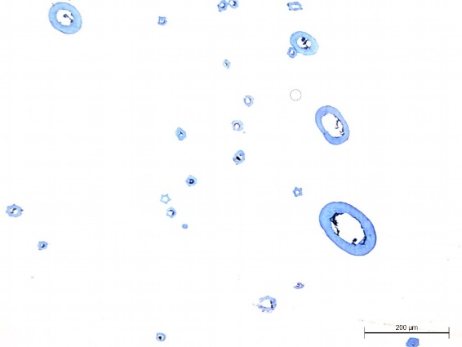 | 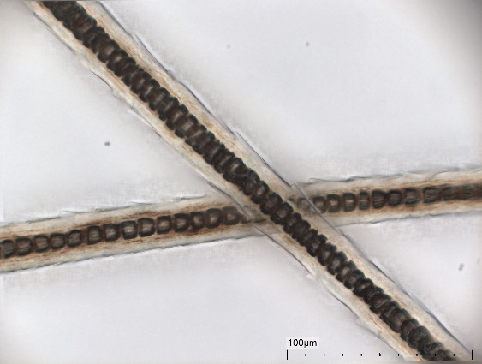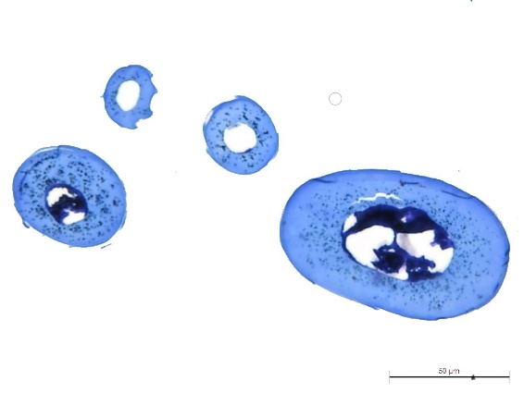
NHMD: CN 401, dorsal sample.  Top: Longitudinal mount. Primary hair with unbroken, medium width medulla. Intermediate hairs with uniserial ladder medulla, medium width.  Bottom: Cross-section. Oval primary hairs with cortex pigmentation. Nut shaped intermediate hairs. Medullae medium width, with remnants | NHMD: CN 401, abdominal sample.  Top: Longitudinal mount. Intermediate hairs with uniserial ladder medulla, medium width.  Bottom: Cross-section. Oval primary hairs. Nut shaped intermediate hairs. Pigmentation in cortex. Medullae medium width, with remnants.
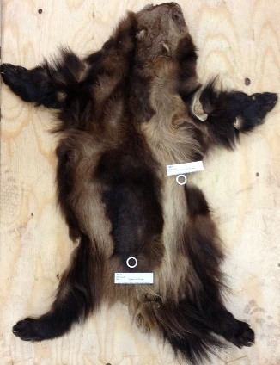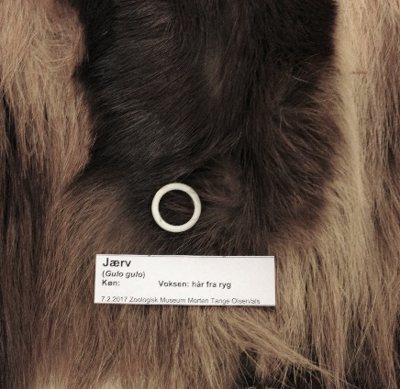 | 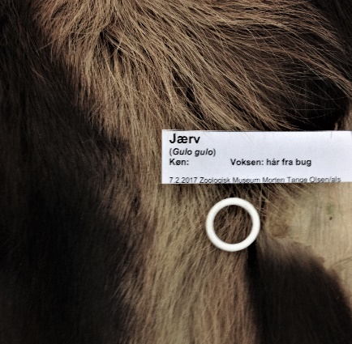
NHMD: CN 401.  Gulo gulo. Ad. Jämtland, 12 August 1834. Dorsal sample. | NHMD: CN 401.  Gulo gulo. Ad. Jämtland, 12 August 1834. Abdominal sample.

References [heading]

Birket-Smith, K. 1924, Ethnography of the Egedesminde District. Meddelelser om Grønland, Vol. 66. Copenhagen: C.A. Reitzels Forlag.

Birket-Smith, K. 1929, The Caribou Eskimos. Report of the Fifth Thule Expedition 1921-24, Vol. 5 (1-2). Copenhagen: Gyldendal.

Bockstoce, J.R. 2009, Furs and frontiers in the Far North. The Contest among Native and Foreign Nations for the Bering Strait Fur Trade. Yale University Press, New Haven & London.

Buijs, C. 2004, Furs and Fabrics. Transformation and Identity in East Greenland. CNWS Publications and Mededelingen van het Rijksmuseum voor Volkenkunde, Leiden.

Dalager, L. 1915, Grønlandske Relationer, L. Bobé (red.). Det grønlandske Selskabs Skrifter, vol. 2.

Génsbøl, B. 1999, Naturguide til Grønland. København: Gads Forlag.

Holm, G. 2010 [1914], Ethnological Sketch of the Angmagsalik Eskimo. In Thalbitzer, W., 2010, Ammassalik Eskimo. Contributions to the Ethnology of the East Greenland Natives. Meddelelser om Grønland, Vol. 39, First Part. Museum Tusculanum Press, 1-147.

Holtved, E. 1967, Contributions to Polar Eskimo Ethnography. Meddelelser om Grønland, Bd. 182, no. 2. Copenhagen: C.A. Reitzels Forlag.

Jenness, D. 1946, Material Culture of the Copper Eskimo. In Report of the Canadian Arctic Expedition 1913-18. Ottawa.

Kapel, F.O. 2005, Otto Fabricius and the Seals of Greenland, Meddelelser om Grønland, Bioscience 55. København: Det Danske Polarcenter.

Saladin d’Anglure, B. 1984, The Inuit of Quebec. In Arctic, ed. by David Damas, Handbook of North American Indians, Vol. 5, Smithsonian Institute, Washington, 476-507.

Shirihai, H. and Jarrett, B. 2009, Whales, Dolphins and Seals. A Field Guide to the Marine Mammals of the World. A & C Black, London.

Thalbitzer, W., 2010 [1914], Ammassalik Eskimo. Contributions to the Ethnology of the East Greenland Natives. Meddelelser om Grønland, Vol. 39, First Part. Museum Tusculanum Press.

Trolle, M. & Goldman, U. 2012, Grønlands dyreliv, Gyldendal.

