Supplementary information

Distribution, sources and health risk assessment of DDT and its metabolites in agricultural soils in Zhejiang Province, China

Ning Cui^{1*}, Xiong Pan², Jing Liu¹

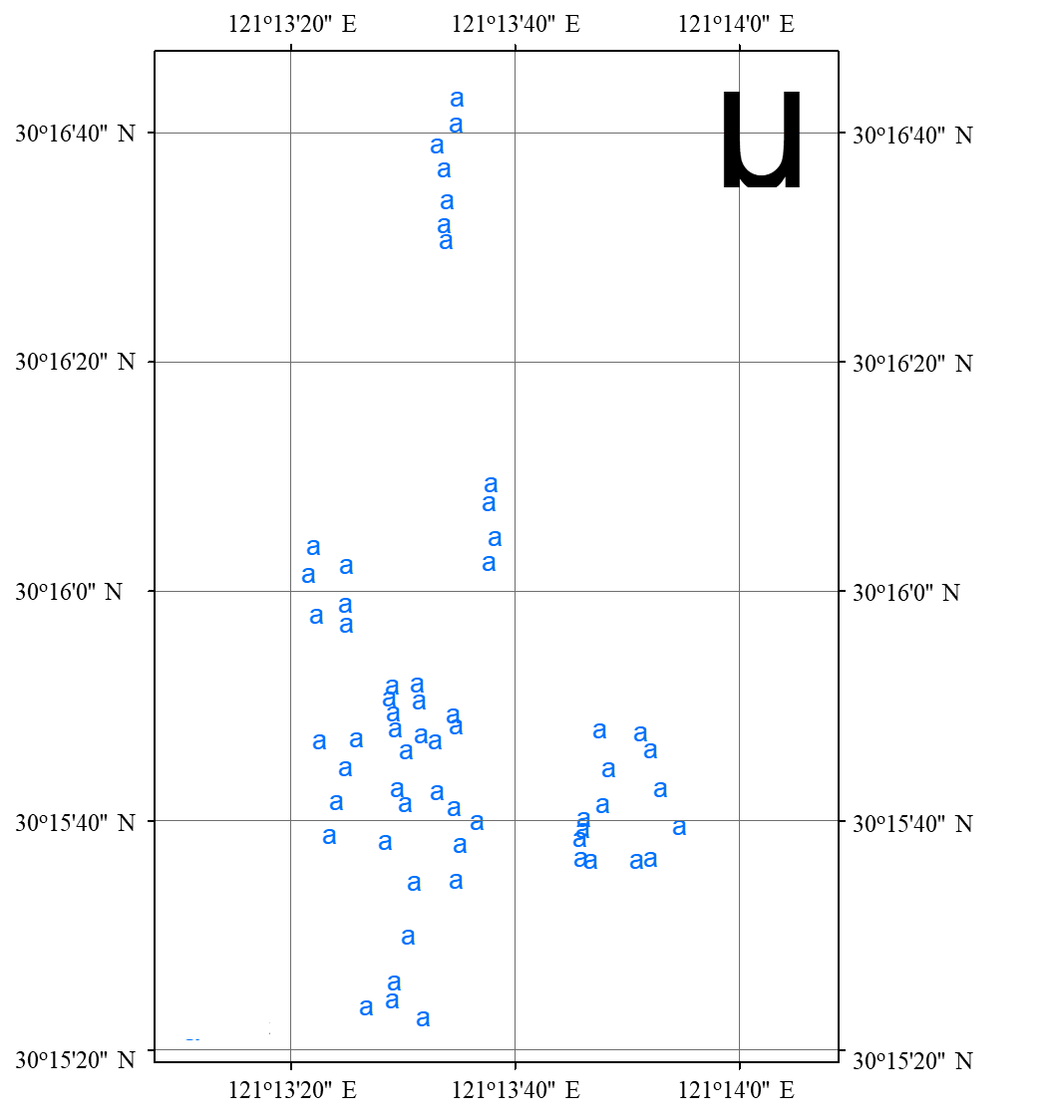
Fig. S1 Distribution of sampling sites in previous cotton fields, a represents the sampling point.

Table S1 Recoveries and coefficient variations of DDTs in soil
DDTs | Concentration  (mg/kg) | Recoveries  ª(%) | RSD(%)
p,p'-DDT | 0.001 | 97.1 | 5.8
 | 0.1 | 96.2 | 3.2
 | 2 | 99.7 | 0.9
p,p'-DDE | 0.001 | 93.3 | 3.7
 | 0.1 | 92.8 | 3.1
 | 2 | 100.2 | 1.6
p,p'-DDD | 0.001 | 93.7 | 5.1
 | 0.1 | 97.7 | 4.5
 | 2 | 96.2 | 2.0
o,p'-DDT | 0.001 | 93.7 | 4.7
 | 0.1 | 95.5 | 3.1
 | 2 | 95.1 | 2.2

ª: The recovery rate was the average of 3 replicates

Table S2 Concentrations of DDTs at each sampling point
N | E | total DDTs | p,p'-DDT | p,p'-DDE | p,p'-DDD | o,p'-DDT
 |  | （mg/kg)
30º15'22.5’' | 121º13'31.8’' | 0.0417±0.0043 | 0.0075±0.0010 | 0.0279±0.0002 | 0.0042±0.0001 | 0.0007±0.0000
30º15'24.1’' | 121º13'29.1’' | 0.0832±0.0095 | 0.0089±0.0022 | 0.0454±0.0005 | 0.0063±0.0003 | 0.0012±0.0001
30º15'25.7’' | 121º13'29.4’' | 0.0874±0.0073 | 0.0091±0.0015 | 0.0469±0.0001 | 0.0060±0.0001 | 0.0011±0.0000
30º15'23.7’' | 121º13'26.6’' | 0.0798±0.0058 | 0.0094±0.0019 | 0.0477±0.0003 | 0.0061±0.0002 | 0.0015±0.0001
30º15'29.9’' | 121º13'30.1’' | 0.0940±0.0056 | 0.0103±0.0033 | 0.0483±0.0007 | 0.0076±0.0006 | 0.0019±0.0002
30º15'34.4’' | 121º13'30.9’' | 0.1363±0.0101 | 0.0268±0.0017 | 0.0673±0.0006 | 0.0081±0.0003 | 0.0037±0.0006
30º15'34.5’' | 121º13'34.7’' | 0.1298±0.0086 | 0.0303±0.0091 | 0.0739±0.0020 | 0.0085±0.0002 | 0.0045±0.0008
30º15'36.5’' | 121º13'45.6’' | 0.0339±0.0025 | 0.0153±0.0047 | 0.0159±0.0005 | 0.0022±0.0002 | 0.0006±0.0001
30º15'36.2’' | 121º13'46.5’' | 0.0341±0.0034 | 0.0161±0.0034 | 0.0162±0.0001 | 0.0027±0.0004 | 0.0006±0.0001
30º15'38.2’' | 121º13'45.6’' | 0.0330±0.0067 | 0.0159±0.0019 | 0.0139±0.0007 | 0.0030±0.0001 | 0.0005±0.0000
30º15'38.8’' | 121º13'45.8’' | 0.0318±0.0055 | 0.0150±0.0036 | 0.0132±0.0003 | 0.0021±0.0005 | 0.0004±0.0001
30º15'39.9’' | 121º13'45.8’' | 0.0322±0.0098 | 0.0167±0.0033 | 0.0126±0.0003 | 0.0025±0.0005 | 0.0005±0.0000
30º15'40.9’' | 121º13'47.6’' | 0.0347±0.0023 | 0.0139±0.0075 | 0.0115±0.0011 | 0.0022±0.0002 | 0.0003±0.0000
30º15'44.1’' | 121º13'48.1’' | 0.0277±0.0015 | 0.0145±0.0032 | 0.0104±0.0009 | 0.0021±0.0001 | 0.0003±0.0001
30º15'47.7’' | 121º13'47.4’' | 0.0297±0.0053 | 0.0153±0.0049 | 0.0121±0.0005 | 0.0027±0.0003 | 0.0004±0.0000
30º15'36.2’' | 121º13'50.6’' | 0.0367±0.0034 | 0.0185±0.0026 | 0.0135±0.0004 | 0.0020±0.0002 | 0.0004±0.0001
30º15'36.4’' | 121º13'52.0’' | 0.0334±0.0039 | 0.0209±0.0049 | 0.0129±0.0002 | 0.0025±0.0001 | 0.0004±0.0001
30º15'38.7’' | 121º13'54.5’' | 0.0372±0.0045 | 0.0192±0.0021 | 0.0141±0.0003 | 0.0027±0.0003 | 0.0003±0.0000
30º15'42.4’' | 121º13'52.9’' | 0.0388±0.0029 | 0.0179±0.0035 | 0.0132±0.0003 | 0.0021±0.0003 | 0.0003±0.0001
30º15'45.8’' | 121º13'51.9’' | 0.0361±0.0044 | 0.0194±0.0061 | 0.0138±0.0007 | 0.0032±0.0004 | 0.0003±0.0000
30º15'47.3’' | 121º13'51.1’' | 0.0384±0.0036 | 0.0185±0.0021 | 0.0129±0.0002 | 0.0034±0.0005 | 0.0003±0.0000
30º16'02.2’' | 121º13'37.7’' | 0.1698±0.0068 | 0.0351±0.0047 | 0.0628±0.0046 | 0.0067±0.0007 | 0.0131±0.0034
30º16'04.4’' | 121º13'38.2’' | 0.1811±0.0112 | 0.0451±0.0089 | 0.0631±0.0058 | 0.0162±0.0011 | 0.0127±0.0047
30º16'08.1’' | 121º13'37.6’' | 0.1748±0.0084 | 0.0457±0.0103 | 0.0752±0.0071 | 0.0129±0.0009 | 0.0308±0.0055
30º16'09.1’' | 121º13'37.8’' | 0.1849±0.0108 | 0.0448±0.0077 | 0.0748±0.0081 | 0.0138±0.0023 | 0.0322±0.0021
30º16'30.3’' | 121º13'33.7’' | 0.1235±0.0143 | 0.0399±0.0067 | 0.0421±0.0023 | 0.0118±0.0021 | 0.0017±0.0003
30º16'33.7’' | 121º13'33.7’' | 0.1296±0.0106 | 0.0415±0.0071 | 0.0402±0.0012 | 0.0120±0.0018 | 0.0021±0.0006
30º16'36.6’' | 121º13'33.6’' | 0.1204±0.0121 | 0.0407±0.0100 | 0.0427±0.0027 | 0.0114±0.0022 | 0.0022±0.0007
30º16'38.5’' | 121º13'33.0’' | 0.1211±0.0136 | 0.0398±0.0085 | 0.0416±0.0030 | 0.0119±0.0031 | 0.0018±0.0003
30º16'40.3’' | 121º13'34.8’' | 0.1224±0.0094 | 0.0420±0.0093 | 0.0410±0.0021 | 0.0123±0.0019 | 0.0018±0.0005
30º16'42.6’' | 121º13'34.8’' | 0.1252±0.0089 | 0.0418±0.0084 | 0.0418±0.0018 | 0.0116±0.0026 | 0.0019±0.0005
30º15'57.6’' | 121º13'22.9’' | 0.2014±0.0179 | 0.0450±0.0112 | 0.1201±0.0106 | 0.0147±0.0038 | 0.0462±0.0043
30º16'01.1’' | 121º13'21.5’' | 0.1957±0.0158 | 0.0444±0.0093 | 0.1240±0.0126 | 0.0151±0.0029 | 0.0537±0.0051
30º16'03.5’' | 121º13'21.9’' | 0.1994±0.0199 | 0.0459±0.0105 | 0.1211±0.0146 | 0.0144±0.0037 | 0.0656±0.0037
30º15'56.7’' | 121º13'24.9’' | 0.2108±0.0201 | 0.0604±0.0141 | 0.1228±0.0144 | 0.0163±0.0028 | 0.0275±0.0059
30º15'58.5’' | 121º13'24.8’' | 0.2086±0.0184 | 0.0718±0.0139 | 0.1194±0.0089 | 0.0169±0.0033 | 0.0369±0.0077
30º16'01.9’' | 121º13'24.8’' | 0.1998±0.0169 | 0.0452±0.0165 | 0.1205±0.0165 | 0.0143±0.0031 | 0.0502±0.0064
30º16'38.3’' | 121º13'23.4’' | 0.2543±0.0211 | 0.0935±0.0108 | 0.0756±0.0071 | 0.0213±0.0049 | 0.0102±0.0017
30º16'41.2’' | 121º13'24.1’' | 0.2562±0.0179 | 0.0968±0.0137 | 0.0781±0.0088 | 0.0209±0.0037 | 0.0122±0.0025
30º16'44.2’' | 121º13'24.8’' | 0.2672±0.0267 | 0.0959±0.0149 | 0.1187±0.0145 | 0.0255±0.0061 | 0.0146±0.0038
30º16'46.7’' | 121º13'25.8’' | 0.2712±0.0194 | 0.1055±0.0112 | 0.0763±0.0056 | 0.0220±0.0056 | 0.0209±0.0062
30º16'46.6’' | 121º13'22.4’' | 0.2703±0.0238 | 0.1047±0.0163 | 0.0884±0.0075 | 0.0253±0.0033 | 0.0453±0.0058
30º16'37.9’' | 121º13'28.5’' | 0.1674±0.0182 | 0.0464±0.0092 | 0.0743±0.0041 | 0.0216±0.0069 | 0.0128±0.0026
30º16'41.1’' | 121º13'30.1’' | 0.2536±0.0134 | 0.1003±0.0151 | 0.0796±0.0072 | 0.0210±0.0036 | 0.0315±0.0037
30º16'42.4’' | 121º13'29.9’' | 0.2723±0.0289 | 0.1185±0.0184 | 0.0803±0.0049 | 0.0225±0.0044 | 0.0257±0.0025
30º16'45.3’' | 121º13'30.1’' | 0.2740±0.0301 | 0.1267±0.0147 | 0.1107±0.0115 | 0.0211±0.0049 | 0.0193±0.0012
30º16'47.6’' | 121º13'29.3’' | 0.2736±0.0365 | 0.1168±0.0128 | 0.0957±0.0087 | 0.0208±0.0034 | 0.0098±0.0014
30º16'49.1’' | 121º13'29.1’' | 0.2740±0.0383 | 0.1012±0.0152 | 0.0945±0.0064 | 0.0215±0.0041 | 0.0129±0.0035
30º16'50.3’' | 121º13'28.7’' | 0.2728±0.0368 | 0.0938±0.0117 | 0.0971±0.0077 | 0.0205±0.0058 | 0.0158±0.0056
30º16'51.3’' | 121º13'29.1’' | 0.2731±0.0397 | 0.0905±0.0100 | 0.0955±0.0098 | 0.0224±0.0081 | 0.0167±0.0029
30º16'47.0’' | 121º13'31.5’' | 0.2691±0.0338 | 0.1167±0.0107 | 0.0918±0.0076 | 0.0228±0.0074 | 0.0119±0.0037
30º16'46.6’' | 121º13'32.9’' | 0.2616±0.0402 | 0.1129±0.0178 | 0.0924±0.0064 | 0.0217±0.0033 | 0.0128±0.0059
30º16'47.8’' | 121º13'34.8’' | 0.2729±0.0371 | 0.1102±0.0129 | 0.0941±0.0081 | 0.0252±0.0047 | 0.0183±0.0041
30º16'48.8’' | 121º13'34.7’' | 0.2735±0.0389 | 0.1099±0.0138 | 0.0945±0.0060 | 0.0222±0.0051 | 0.0199±0.0034
30º16'50.1’' | 121º13'31.5’' | 0.2740±0.0327 | 0.1078±0.0176 | 0.0931±0.0073 | 0.0235±0.0042 | 0.0132±0.0057
30º16'51.6’' | 121º13'31.4’' | 0.2738±0.0411 | 0.1042±0.0148 | 0.0944±0.0089 | 0.0281±0.0038 | 0.0118±0.0038
30º16'37.6’' | 121º13'35.0’' | 0.1604±0.0212 | 0.0435±0.0047 | 0.0984±0.0057 | 0.0219±0.0069 | 0.0134±0.0025
30º16'39.5’' | 121º13'36.6’' | 0.1725±0.0283 | 0.0428±0.0083 | 0.0999±0.0068 | 0.0224±0.0031 | 0.0107±0.0031
30º16'40.8’' | 121º13'34.6’' | 0.1704±0.0197 | 0.0471±0.0073 | 0.0981±0.0063 | 0.0232±0.0079 | 0.0177±0.0046
30º16'42.2’' | 121º13'33.0’' | 0.2718±0.0404 | 0.1126±0.0164 | 0.0885±0.0082 | 0.0210±0.0088 | 0.0194±0.0051

