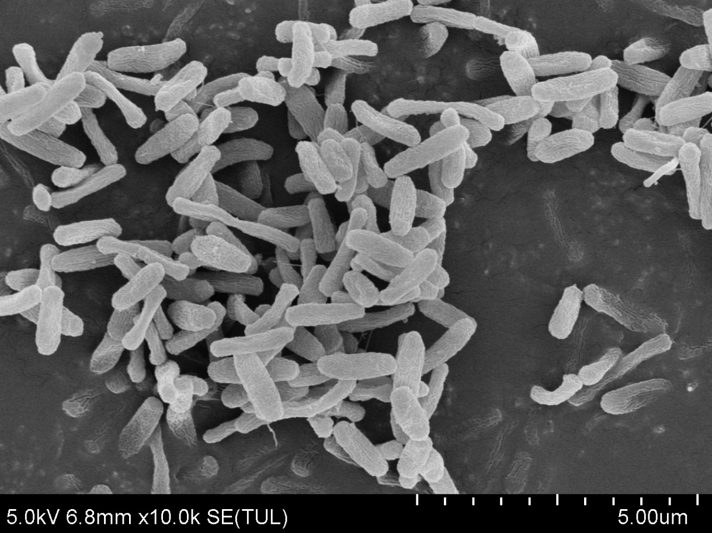
Figure S1 The scanning electronic microscope photographs of LW2 cells.

Figure S2. Growth of Pythium ultimum in 3 and 5 days

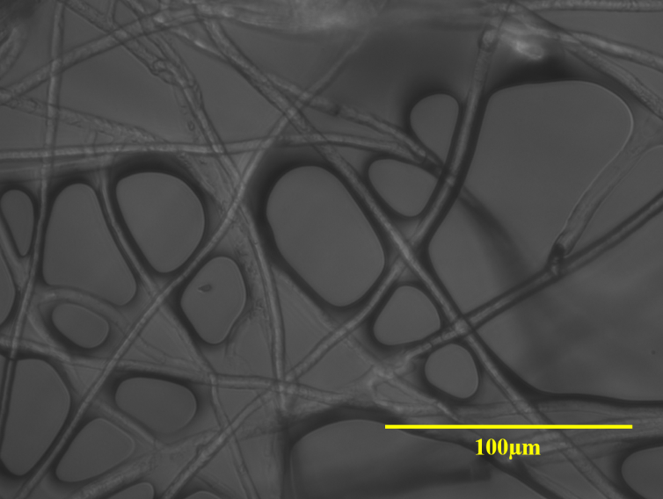
Figure S3 Micrograph of Pythium ultimum hyphae (bar 100 μm).

Figure S4. The picture of LW2 and Pythium ultimum coexisting for 15 days in the mutual inhibition experiment

