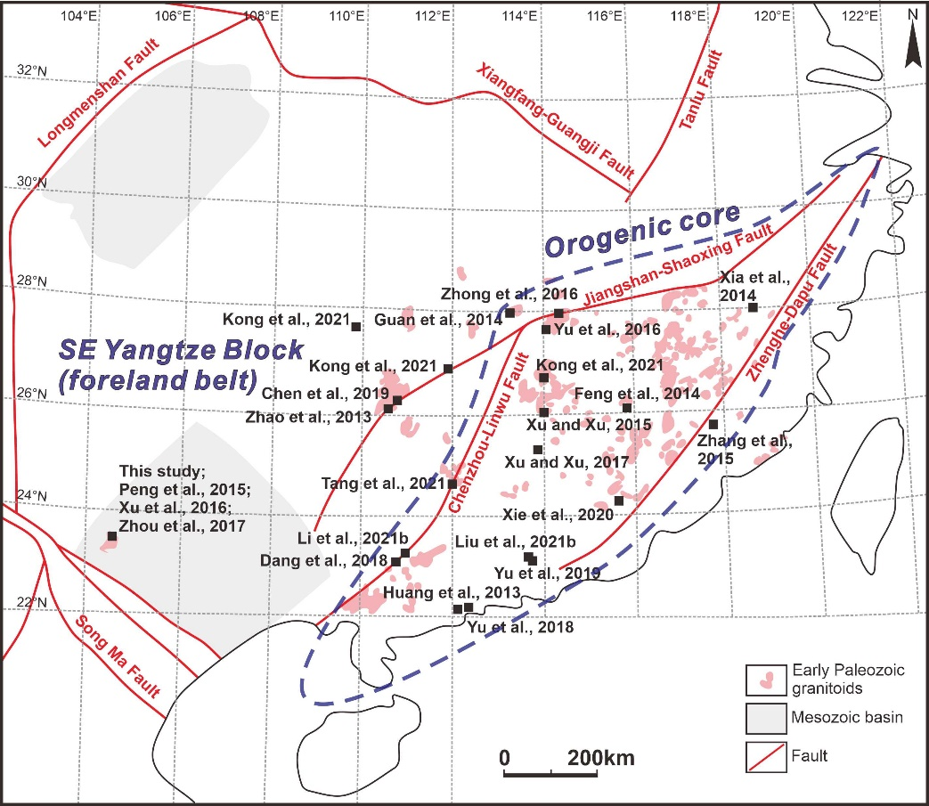
Supp. Fig. 1 The location of collected geochemical data for the early Paleozoic granitoids in the SE Yangtze Block (foreland belt) and orogenic core.
References
Chen, J.F., Sheng, D., Shao, Y.J., Zhang, J.X., Liu, Z.F., Wei, H.T., Yang, Q.D., Luo, X.Y., Du, Y., 2019. Silurian S-type granite-related W-(Mo) mineralization in the Nanling Range, South China: A case study of the Pingtan W-(Mo) deposit. Ore Geology Reviews 107, 186–200.
Dang, Y., Chen, M.H., Fu, B., Mao, J.W., Fanning, C.M., Li, Z.Y., 2018. Petrogenesis of the Yupo W-bearing and Dali Mo-bearing granitoids in the Dayaoshan area, South China: Constraints of geochronology and geochemistry. Ore Geology Reviews 92, 643–655.
Feng, S.J., Zhao, K.D., Ling, H.F., Chen, P.R., Chen, W.F., Sun, T., Jiang, S.Y., Pu, W., 2014. Geochronology, elemental and Nd–Hf isotopic geochemistry of Devonian A-type granites in central Jiangxi, South China: Constraints on petrogenesis and post-collisional extension of the Wuyi–Yunkai orogeny. Lithos 206–207, 1–18.
Guan, Y.L., Yuan, C., Sun, M., Wilde, S., Long, X.P., Huang, X.L., Wang, Q., 2014. I-type granitoids in the eastern Yangtze Block: implications for the Early Paleozoic intracontinental orogeny in South China. Lithos 206–207, 34–51.
Huang, X.L., Yu, Y., Li, J., Tong, L.X., Chen, L.L., 2013. Geochronology and petrogenesis of the early Paleozoic I-type granite in the Taishan area, South China: Middle-lower crustal melting during orogenic collapse. Lithos 177, 268–284.
Kong, H., Wu, J.H., Li, H., Chen, S.F., Liu, B., Wang, G., 2021. Early Paleozoic tectonic evolution of the South China Block: Constraints from geochemistry and geochronology of granitoids in Hunan Province. Lithos 380–381, 105891.
Li, X.L., Yu, J.H., Jiang, D.S., Griffin, W.L., Jiang, W., Xu, H., 2021b. Linking ocean subduction with early Paleozoic intracontinental orogeny in South China: Insights from the Xiaying complex in eastern Guangxi Province. Lithos 398–399, 106258.
Liu, X., Wang, Q., Ma, L., Yang, J.H., Ma, Y.M., Huang, T.Y., 2021b. Early Paleozoic and Late Mesozoic crustal reworking of the South China Block: Insights from Early Silurian biotite granodiorites and Late Jurassic biotite granites in the Guangzhou area of the south-east Wuyi-Yunkai orogeny. Journal of Asian Earth Sciences 219, 104890.
Peng, T.P., Fan, W.M., Zhao, G.C., Peng, B.X., Xia, X.P., Mao, Y.S., 2015. Petrogenesis of the early Paleozoic strongly peraluminous granites in the Western South China Block and its tectonic implications. Journal of Asian Earth Sciences 98, 399–420.
Tang, Y.L., Shi, Y., Hu, X.M., Liu, X.J., Huang, C.W., 2021. Petrogenesis of Early Paleozoic I-type granitoids in the Wuyi-Yunkai Orogen, South China: implications for the tectono-magmatic evolution of the Cathaysia Block. Journal of Asian Earth Sciences 220: 104906.
Xia, Y., Xu, X.S., Zou, H.B., Liu, L., 2014. Early Paleozoic crust–mantle interaction and lithosphere delamination in South China Block: Evidence from geochronology, geochemistry, and Sr–Nd–Hf isotopes of granites. Lithos 184–187, 416–435.
Xie, Y.X., Ma, L.Y., Zhao, G.C., Xie, C.F., Han, Y.G., Li, J.H., Liu, Q., Yao, J.L., Zhang, Y.Y., Lu, Y.F., 2020. Origin of the Heping granodiorite pluton: Implications for syn-convergent extension and asthenosphere upwelling accompanying the early Paleozoic orogeny in South China. Gondwana Research 85, 149–168.
Xu, B., Jiang, S.Y., Hofmann, A.W., Wang, R., Yang, S.Y., Zhao, K.D., 2016. Geochronology and geochemical constraints on petrogenesis of Early Paleozoic granites from the Laojunshan district in Yunnan Province of South China. Gondwana Research 29, 248–263.
Xu, W.J., Xu, S.H., 2015. Early Paleozoic intracontinental felsic magmatism in the South China Block: Petrogenesis and geodynamics. Lithos 234–235, 79–92.
Xu, W.J., Xu, S.H., 2017. An early Paleozoic monzonorite–granite suite in the South China block: Implications for the intracontinental felsic magmatism. Mineralogy and Petrology 111, 709–728.
Yu, P.P., Zhang, Y.Z., Zhou, Y.Z., Weinberg, R.F., Zheng, Y., Yang, W.B., 2019. Melt evolution of crustal anatexis recorded by the Early Paleozoic Baiyunshan migmatite-granite suite in South China. Lithos 332–333, 83–98.
Yu, Y., Huang, X.L., He, P.L., Li, J., 2016. I-type granitoids associated with the early Paleozoic intracontinental orogenic collapse along pre-existing block boundary in South China. Lithos 248–251, 353–365.
Yu, Y., Huang, X.L., Sun, M., He, P.L., 2018. Petrogenesis of granitoids and associated xenoliths in the early Paleozoic Baoxu and Enping plutons, South China: Implications for the evolution of the Wuyi-Yunkai intracontinental orogen. Journal of Asian Earth Sciences 156, 59–74.
Zhang, Q., Jiang, Y.H., Wang, G.C., Liu, Z., Ni, C.Y., Qing, L., 2015. Origin of Silurian gabbros and I-type granites in central Fujian, SE China: implications for the evolution of the early Paleozoic orogen of South China. Lithos 216–217, 285–297.
Zhao, K.D., Jiang, S.Y., Sun, T., Chen, W.F., Ling, H.F., Chen, P.R., 2013. Zircon U–Pb dating, trace element and Sr–Nd–Hf isotope geochemistry of Paleozoic granites in the Miao’ershan–Yuechengling batholith, South China: Implication for petrogenesis and tectonic–magmatic evolution. Journal of Asian Earth Sciences 74, 244–264.
Zhong, Y.F., Wang, L.X., Zhao, J.H., Liu, L., Ma, C.Q., Zheng, J.P., Zhang, Z.J., Luo, B.J., 2016. Partial melting of an ancient sub-continental lithospheric mantle in the early Paleozoic intracontinental regime and its contribution to petrogenesis of the coeval peraluminous granites in South China. Lithos 264, 224–238.
Zhou, X.Y., Yu, J.H., O'Reilly, S.Y., Griffin, W.L., Wang, X.L., Sun, T., 2017. Sources of the Nanwenhe - Song Chay granitic complex (SW China – NE Vietnam) and its tectonic significance. Lithos, 290–291, 76–93.

