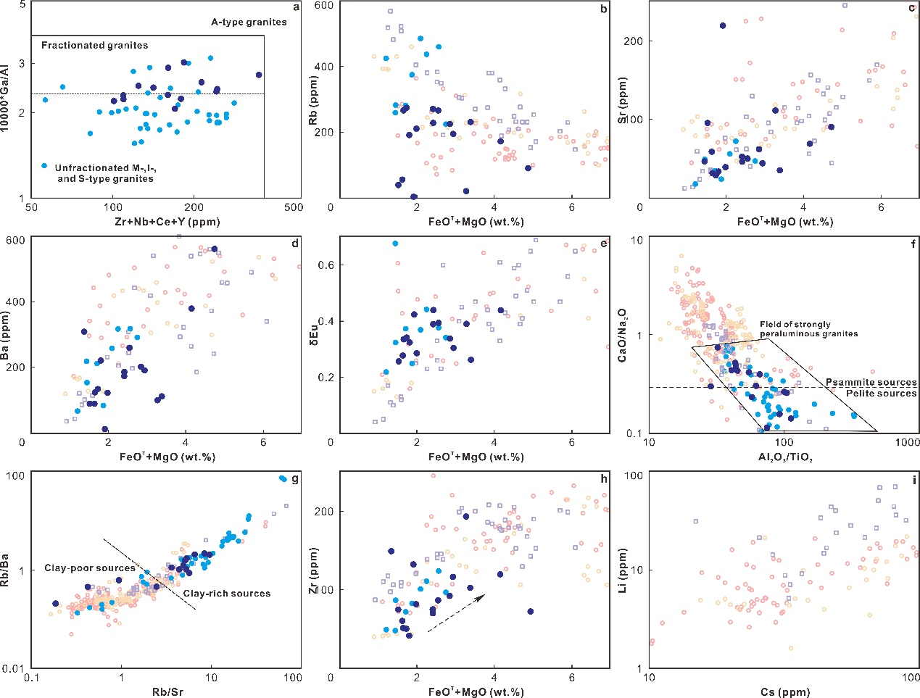
Supp. Fig. 3 Variation diagrams of (a) 10000Ga/Al vs. Zr+Nb+Ce+Y (Eby, 1990) and (b-e) Rb, Sr, Ba, and δEu vs. FeO^{T}+MgO. Chemical discrimination diagrams of (f) CaO/Na₂O vs. Al₂O₃/TiO₂ (Sylvester, 1998) and (g) Rb/Ba vs. Rb/Sr (Sylvester, 1998). Variation diagrams of (h) Zr vs. FeO^{T}+MgO, (i) Li vs. Cs.
References
Eby, G.N., 1990. The A-type granitoids: A review of their occurrence and chemical characteristics and speculations on their petrogenesis. Lithos 26 (1–2), 115–134.
Sylvester, P.J., 1998. Post-collisional strongly peraluminous granites. Lithos 45, 29–44.

