Synthesis of new benzimidazole derivatives containing 1,3,4-thiadiazole: Their in vitro antimicrobial, in silico molecular docking and molecular dynamic simulations studies
Ulviye Acar Çevik¹*, Ayşen Işık², Asaf Evrim Evren^{1,3}, Özge Kapusız⁴, Ülküye Dudu Gül⁵, Yusuf Özkay¹, Zafer Asım Kaplancıklı¹
¹ Department of Pharmaceutical Chemistry, Faculty of Pharmacy, Anadolu University, Eskişehir 26470, Turkey.
² Department of Biochemistry, Faculty of Science, Selçuk University, Konya, Turkey.
³ Department of Pharmacy Services, Bilecik Şeyh Edebali University, Vocational School of Health Services, 11000, Bilecik, Turkey.
⁴ Bilecik Şeyh Edebali University, Graduate School of Educational Sciences, Bioengineering, Bilecik, Turkey.
⁵ Department of Bioengineering, Faculty of Engineering, Bilecik Seyh Edebali University, Bilecik, Turkey
* Corresponding Author. E-mail: uacar@anadolu.edu.tr; Tel. +90-222-335-0580/3775
Address: Anadolu University, Faculty of Pharmacy, Department of Pharmaceutical Chemistry, 26470, Eskişehir, Turkey.

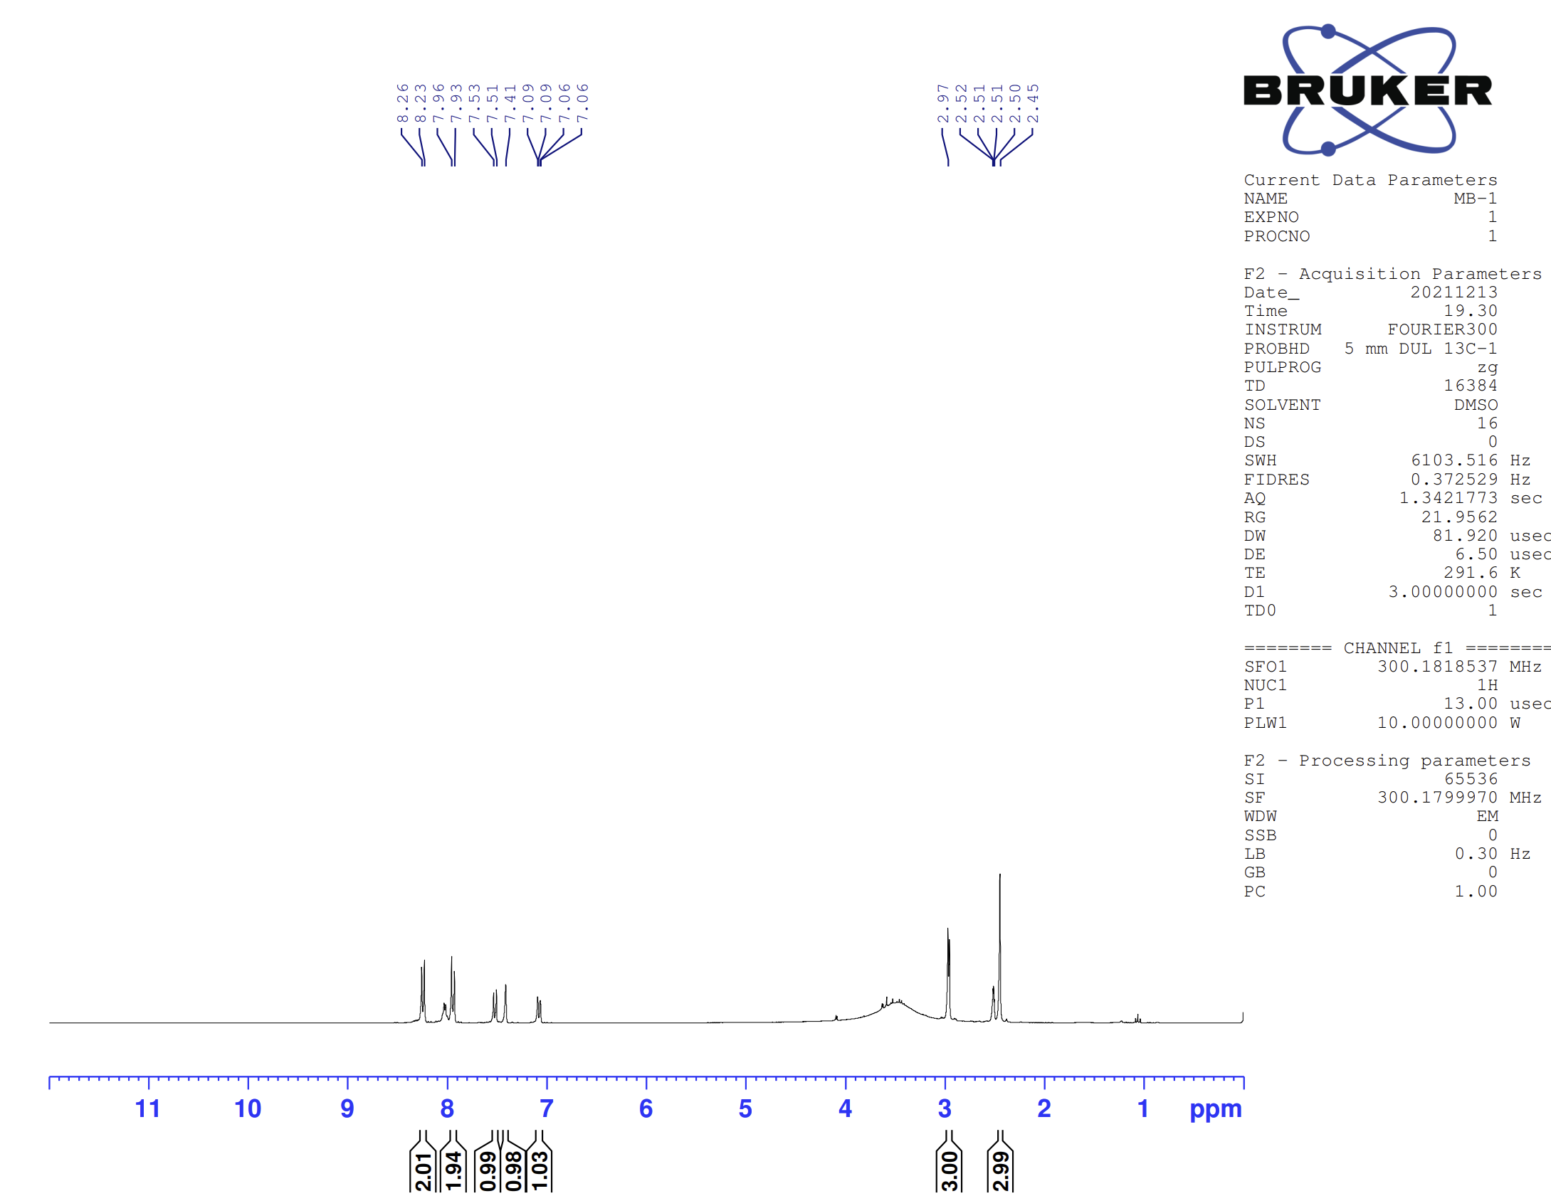Figure 1. ¹H-NMR spectrum of compound 4a
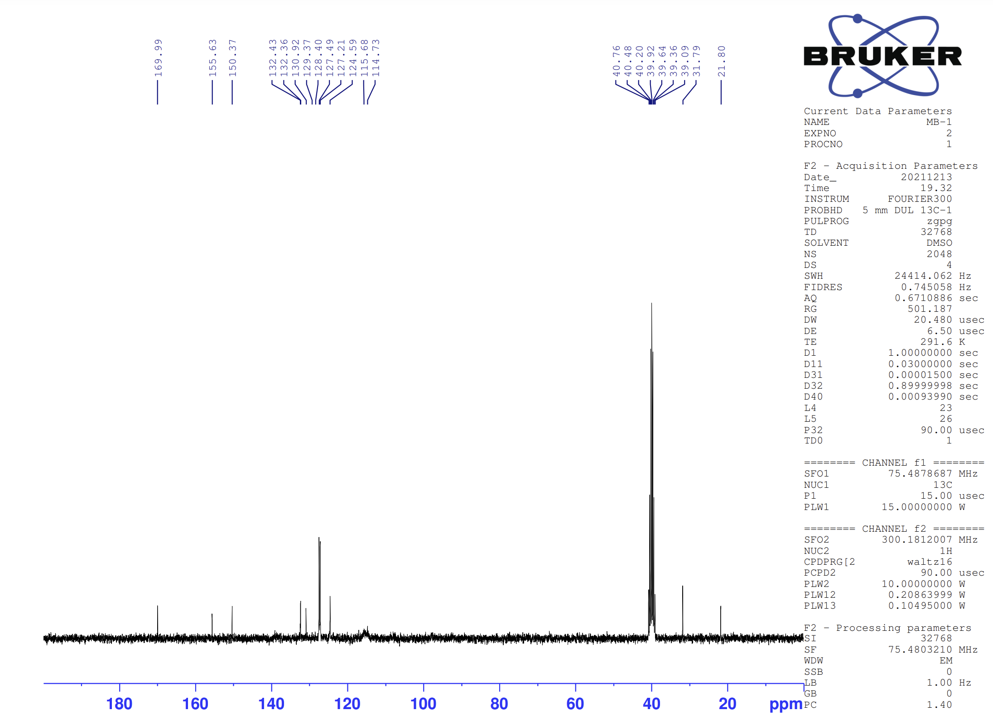
Figure 2. ¹³C-NMR spectrum of compound 4a
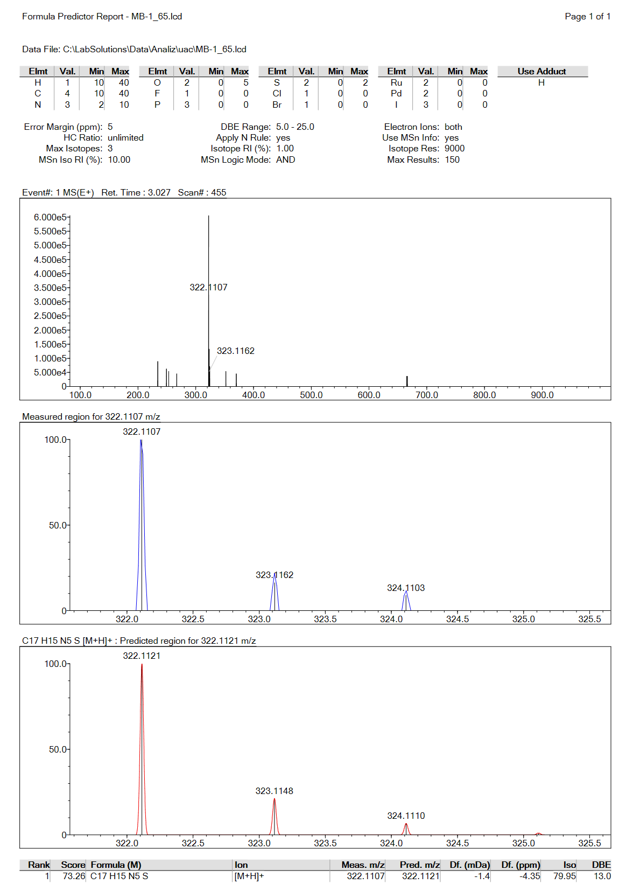Figure 3. Mass spectrum of compound 4a

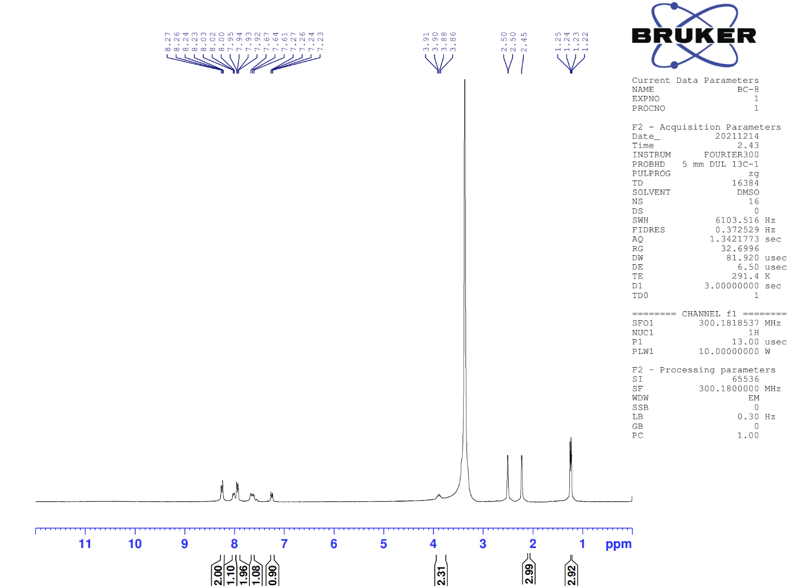
Figure 4. ¹H-NMR spectrum of compound 4b
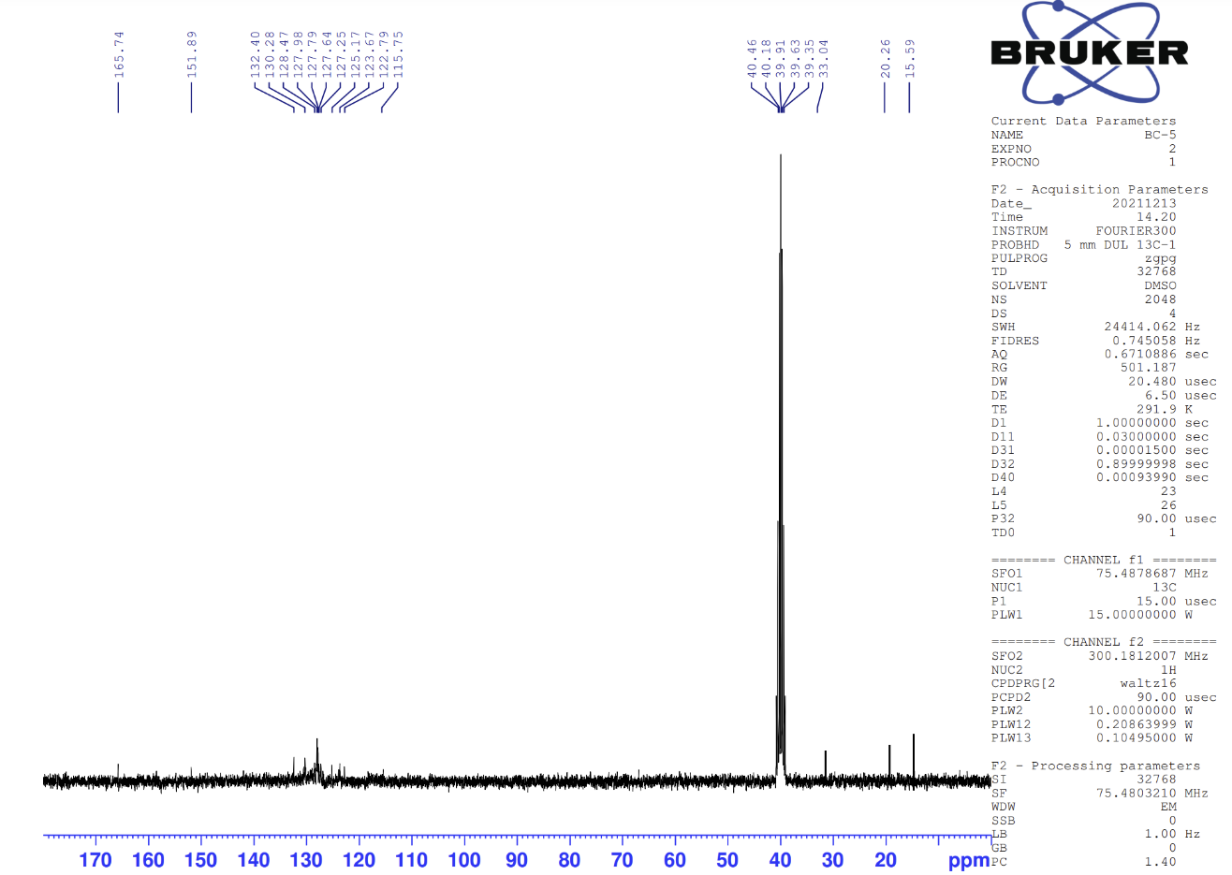
Figure 5. ¹³C-NMR spectrum of compound 4b
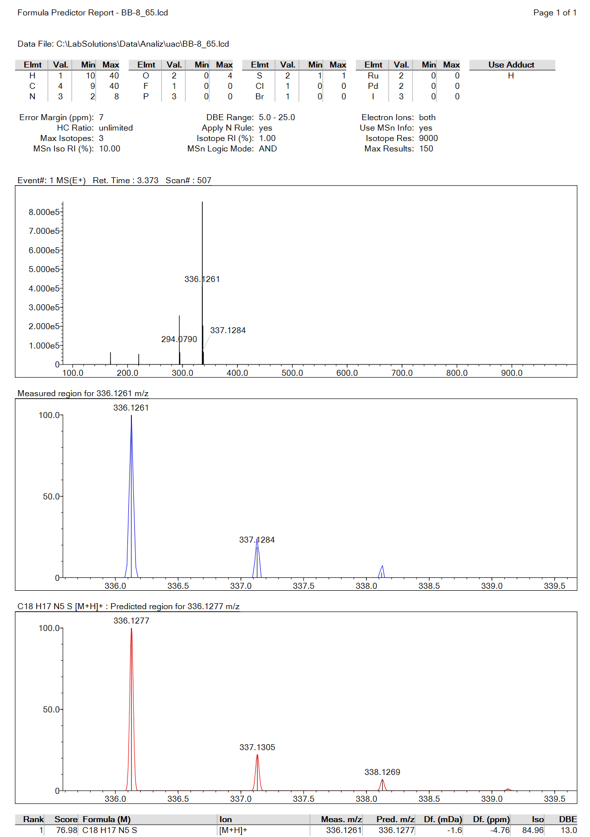Figure 6. Mass spectrum of compound 4b

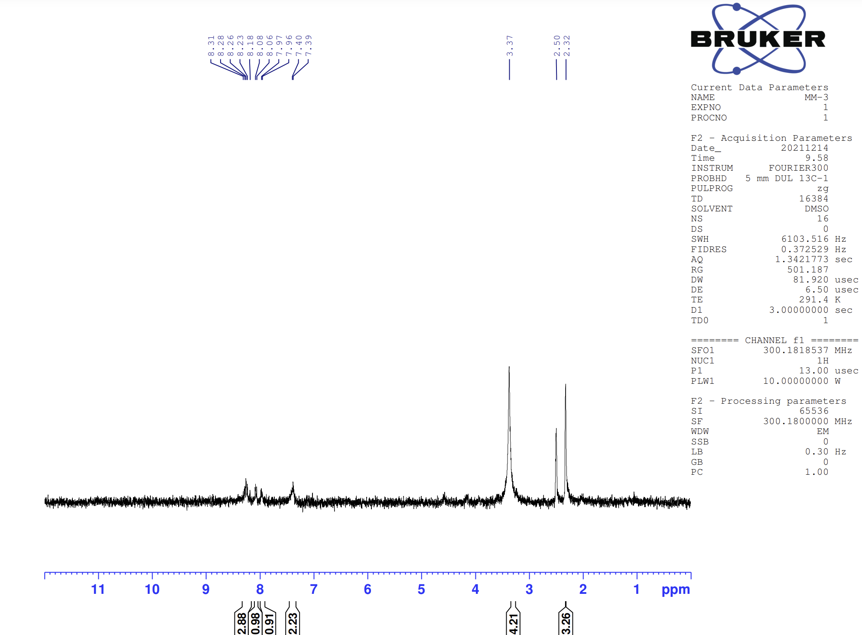
Figure 7. ¹H-NMR spectrum of compound 4c
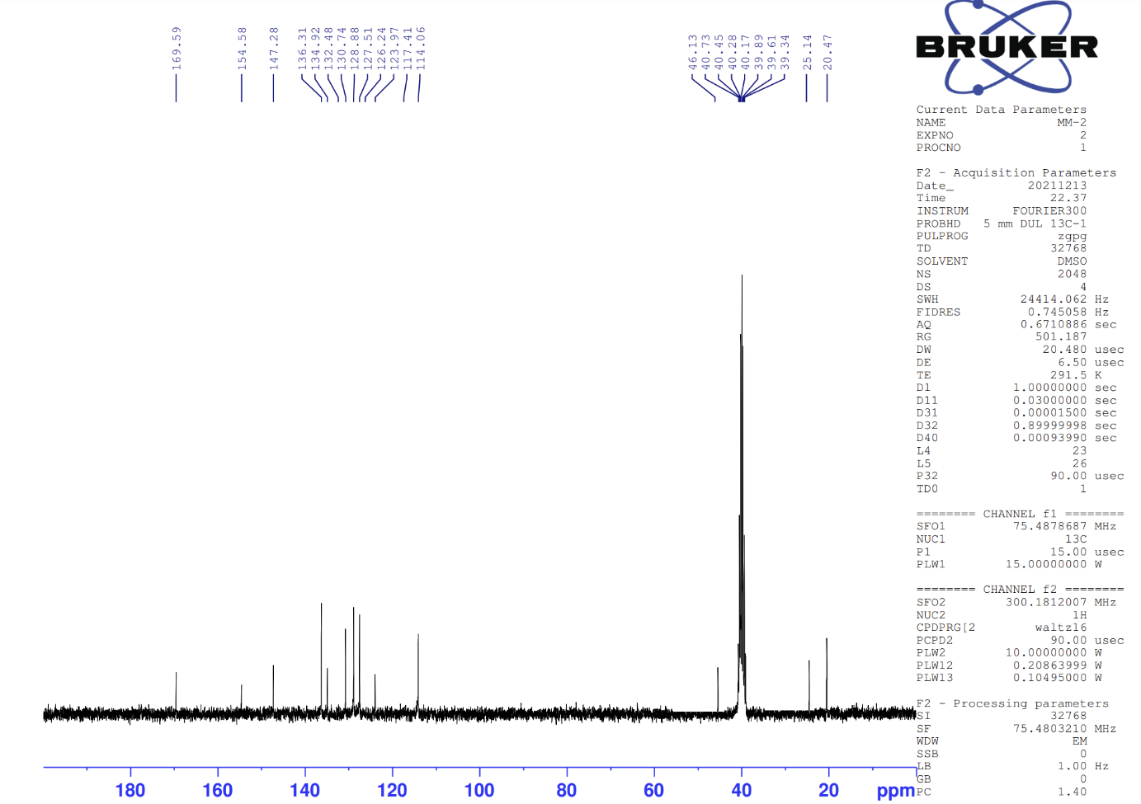
Figure 8. ¹³C-NMR spectrum of compound 4c
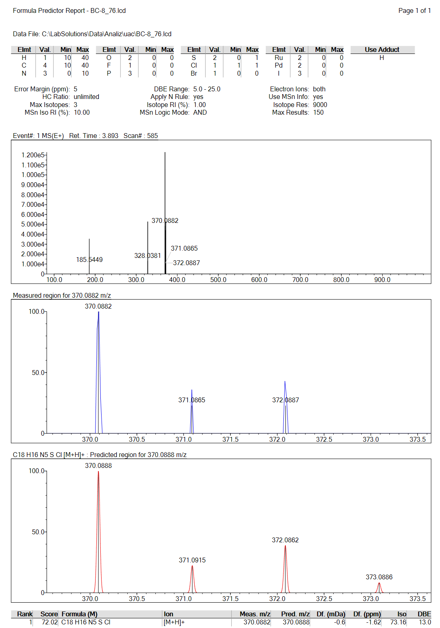
Figure 9. Mass spectrum of compound 4c

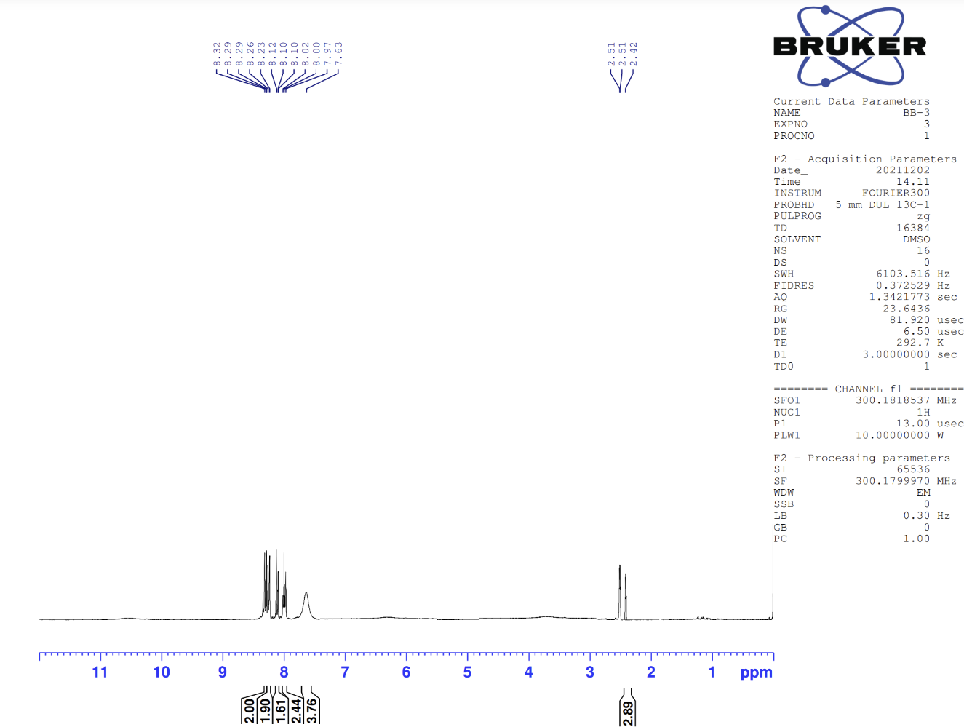
Figure 10. ¹H-NMR spectrum of compound 4d
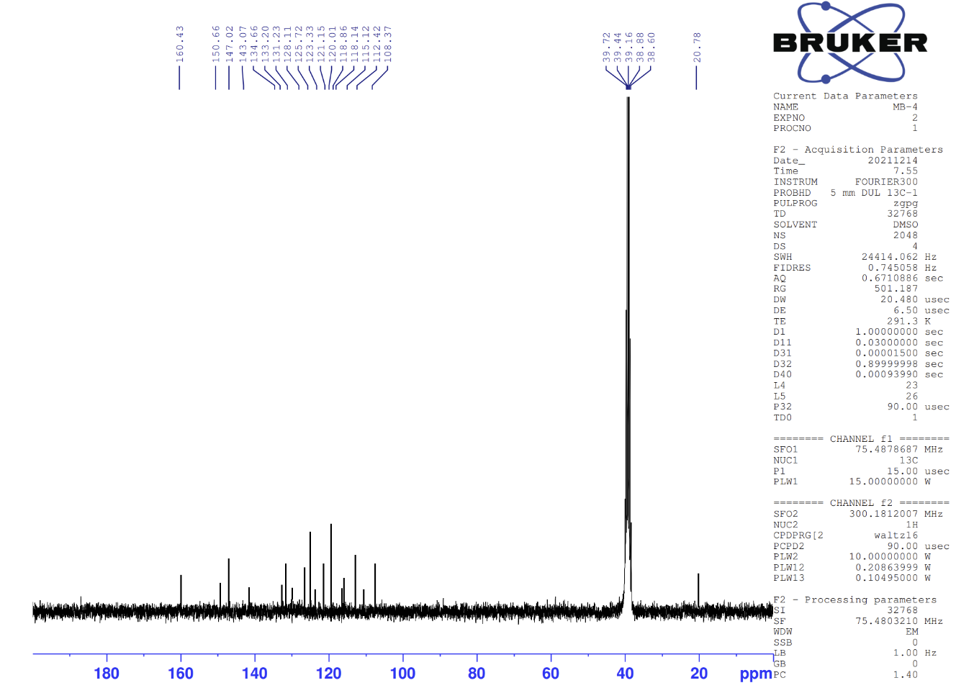
Figure 11. ¹³C-NMR spectrum of compound 4d
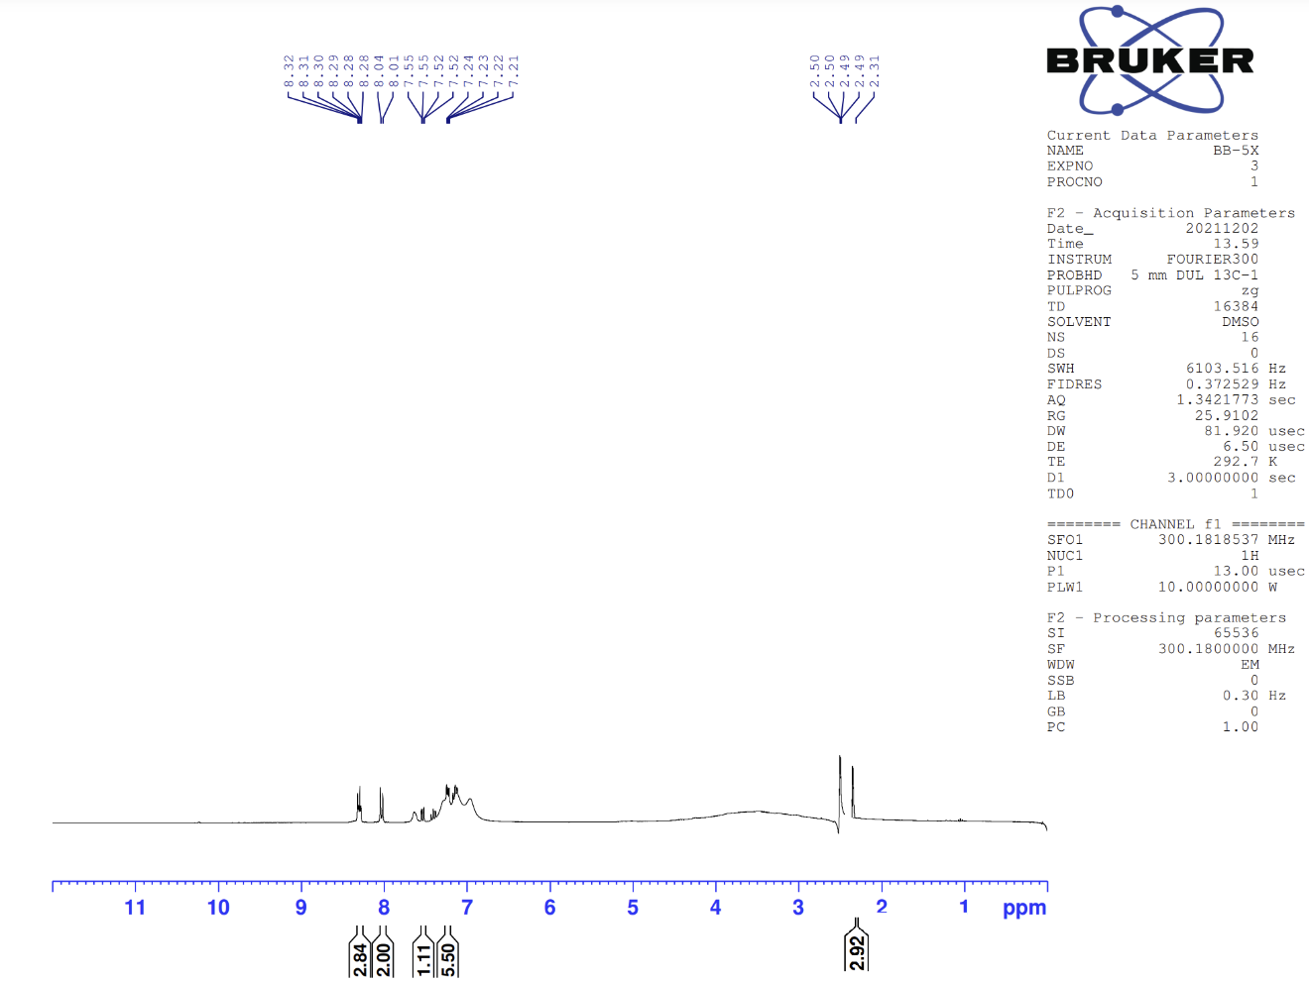
Figure 13. ¹H-NMR spectrum of compound 4e
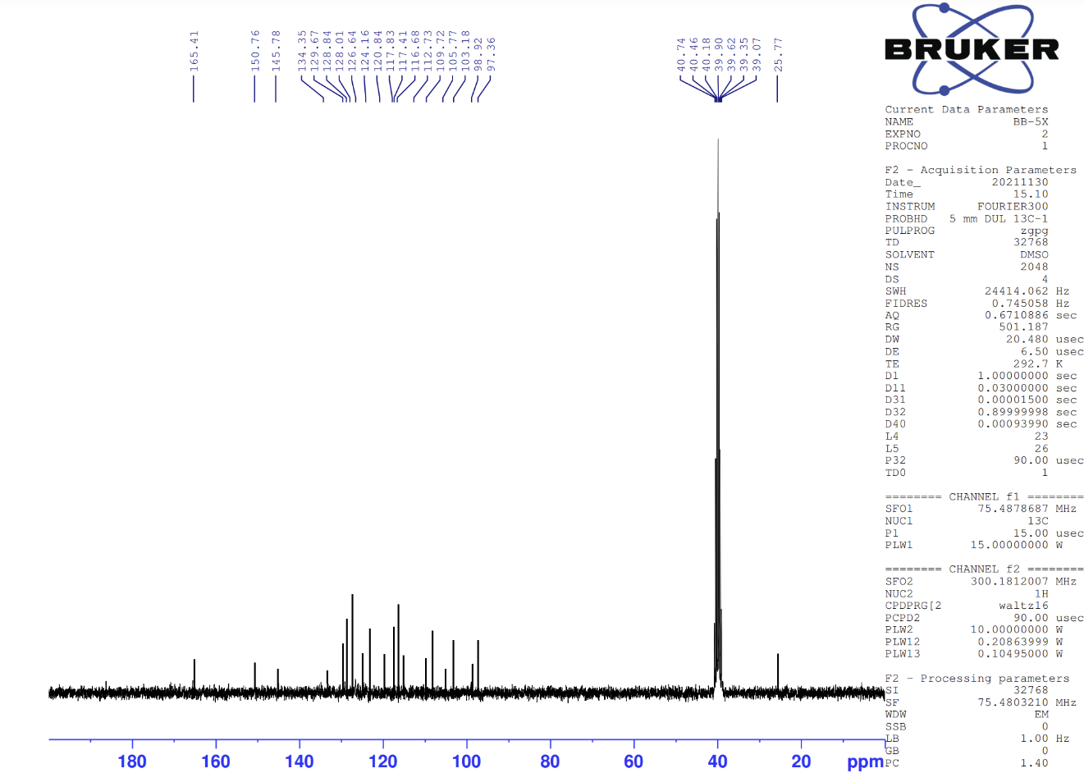
Figure 14. ¹³C-NMR spectrum of compound 4e
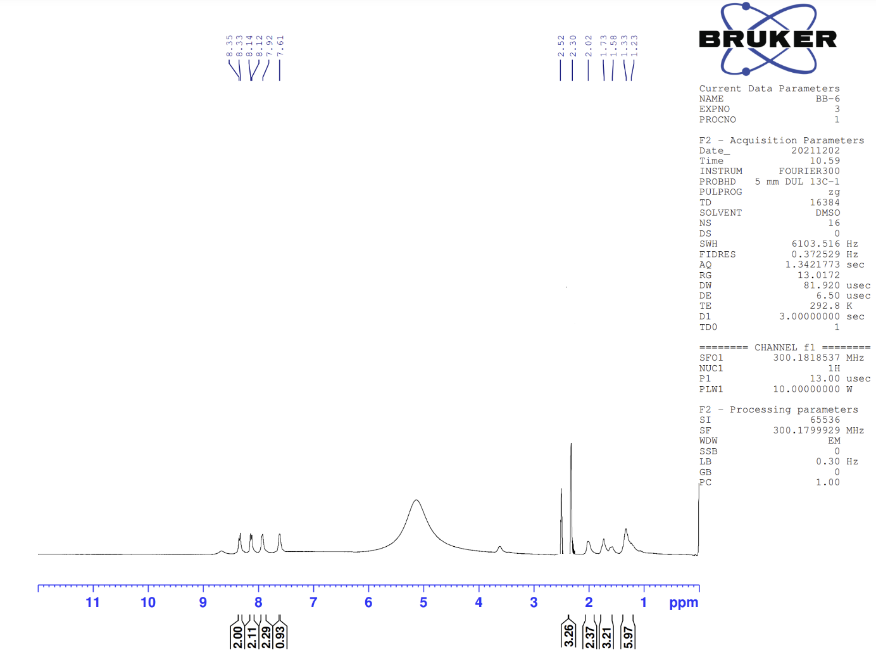
Figure 15. ¹H-NMR spectrum of compound 4f
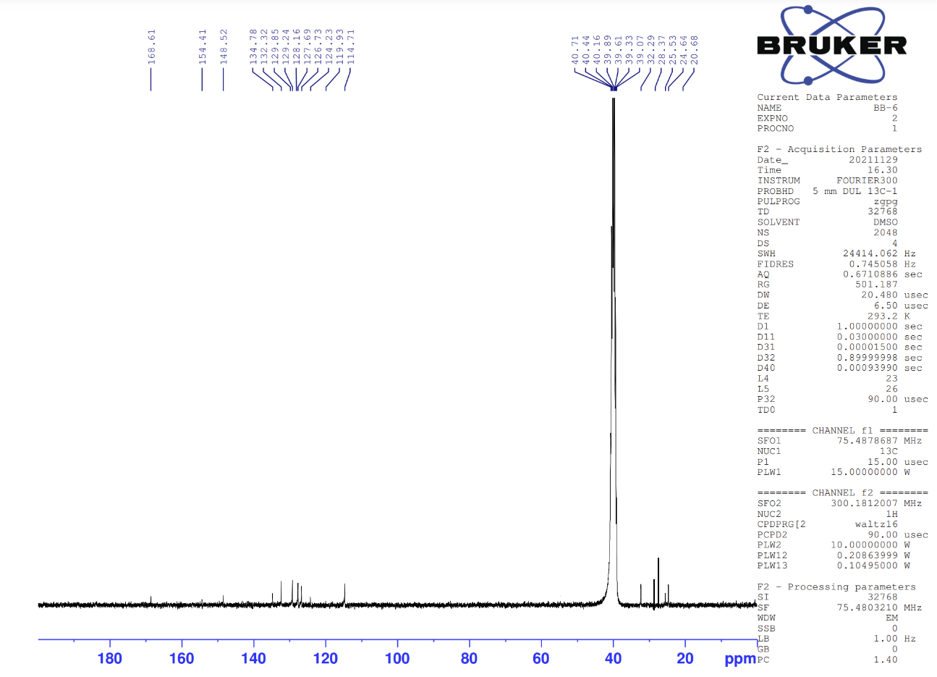
Figure 17. ¹³C-NMR spectrum of compound 4f
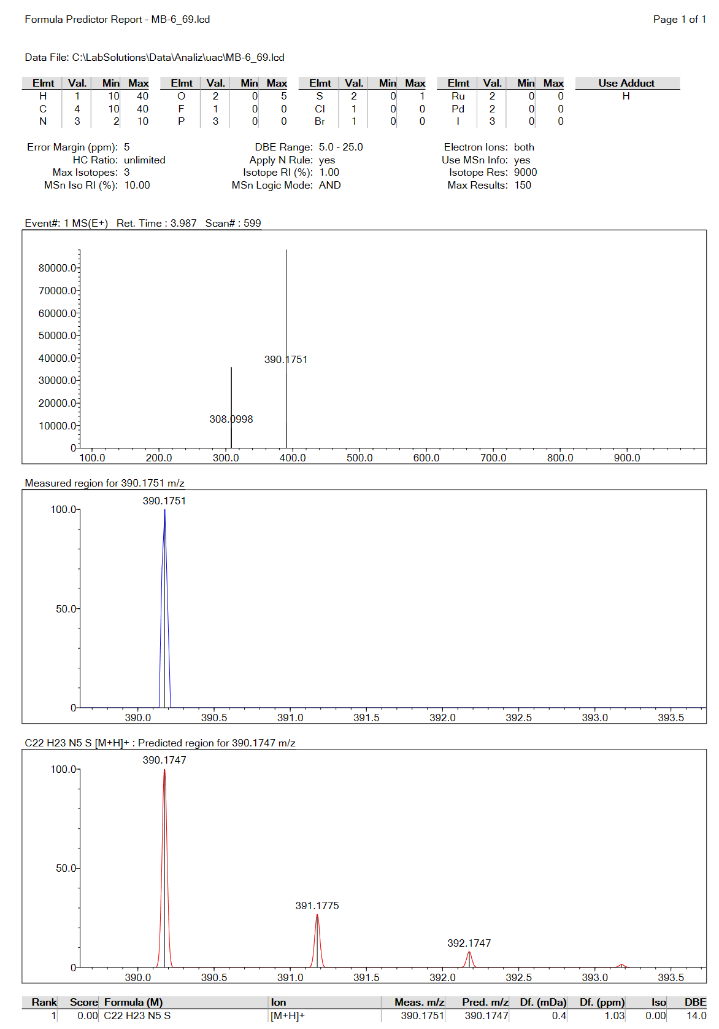
Figure 18. Mass spectrum of compound 4f

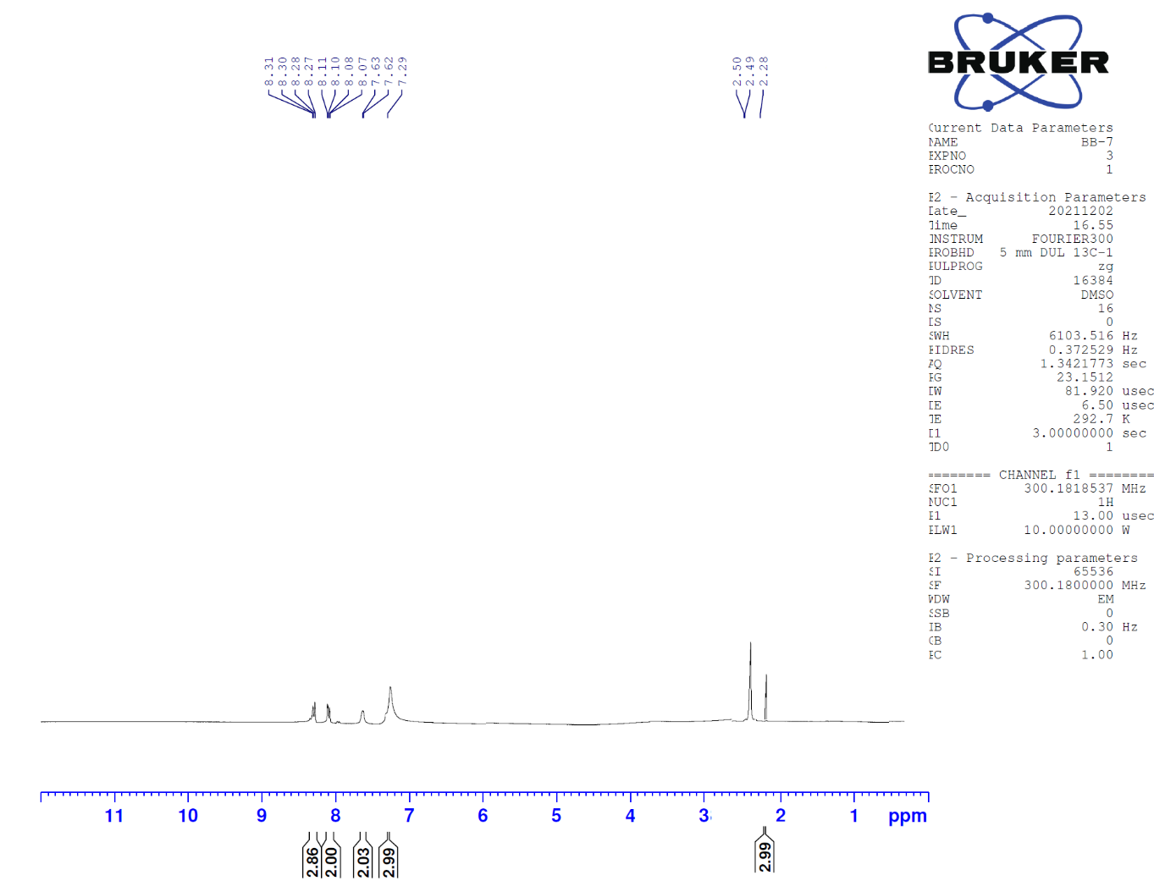
Figure 19. ¹H-NMR spectrum of compound 4g
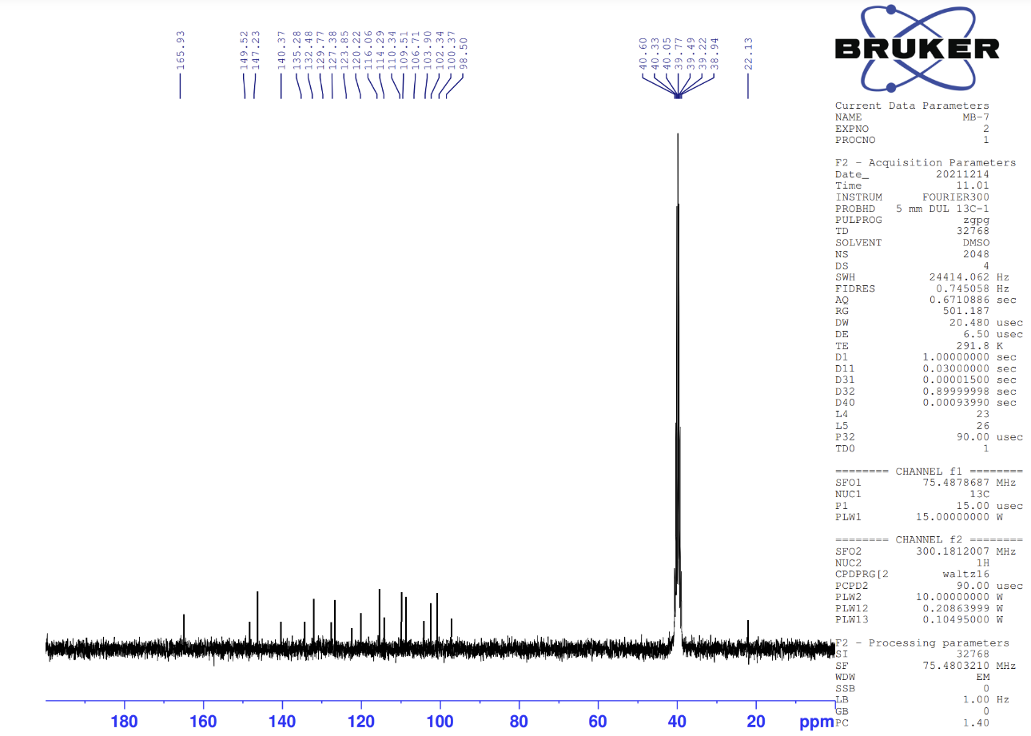
Figure 20. ¹³C-NMR spectrum of compound 4g
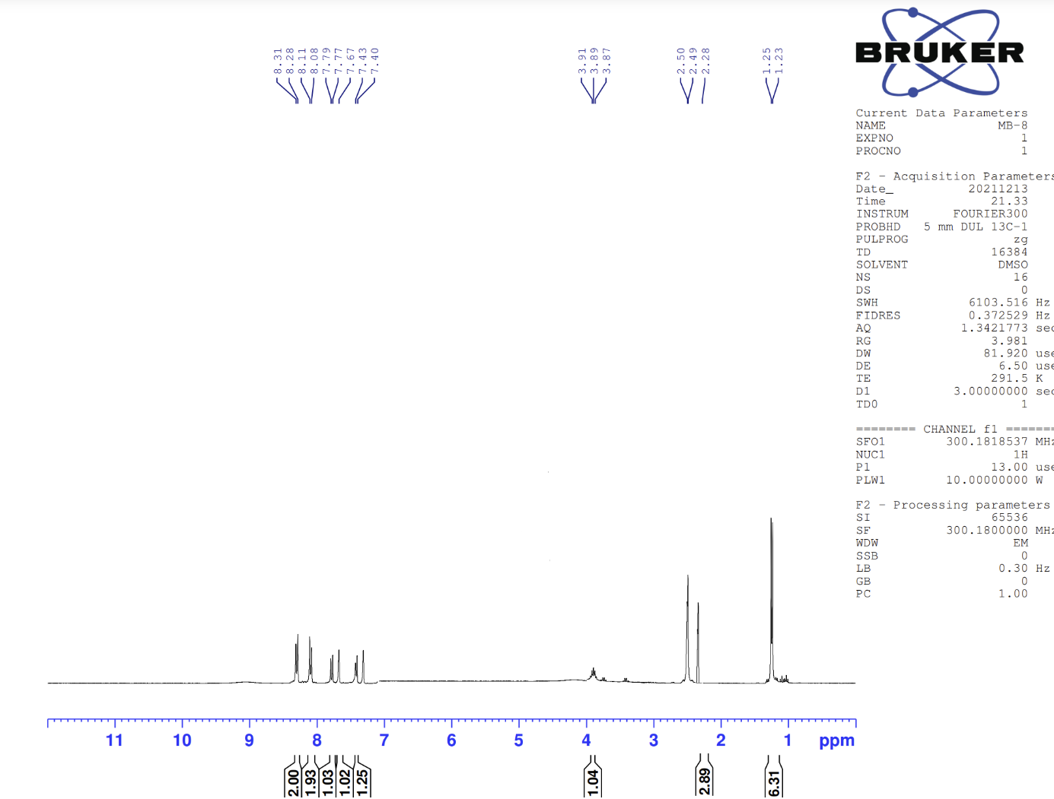
Figure 22. ¹H-NMR spectrum of compound 4h
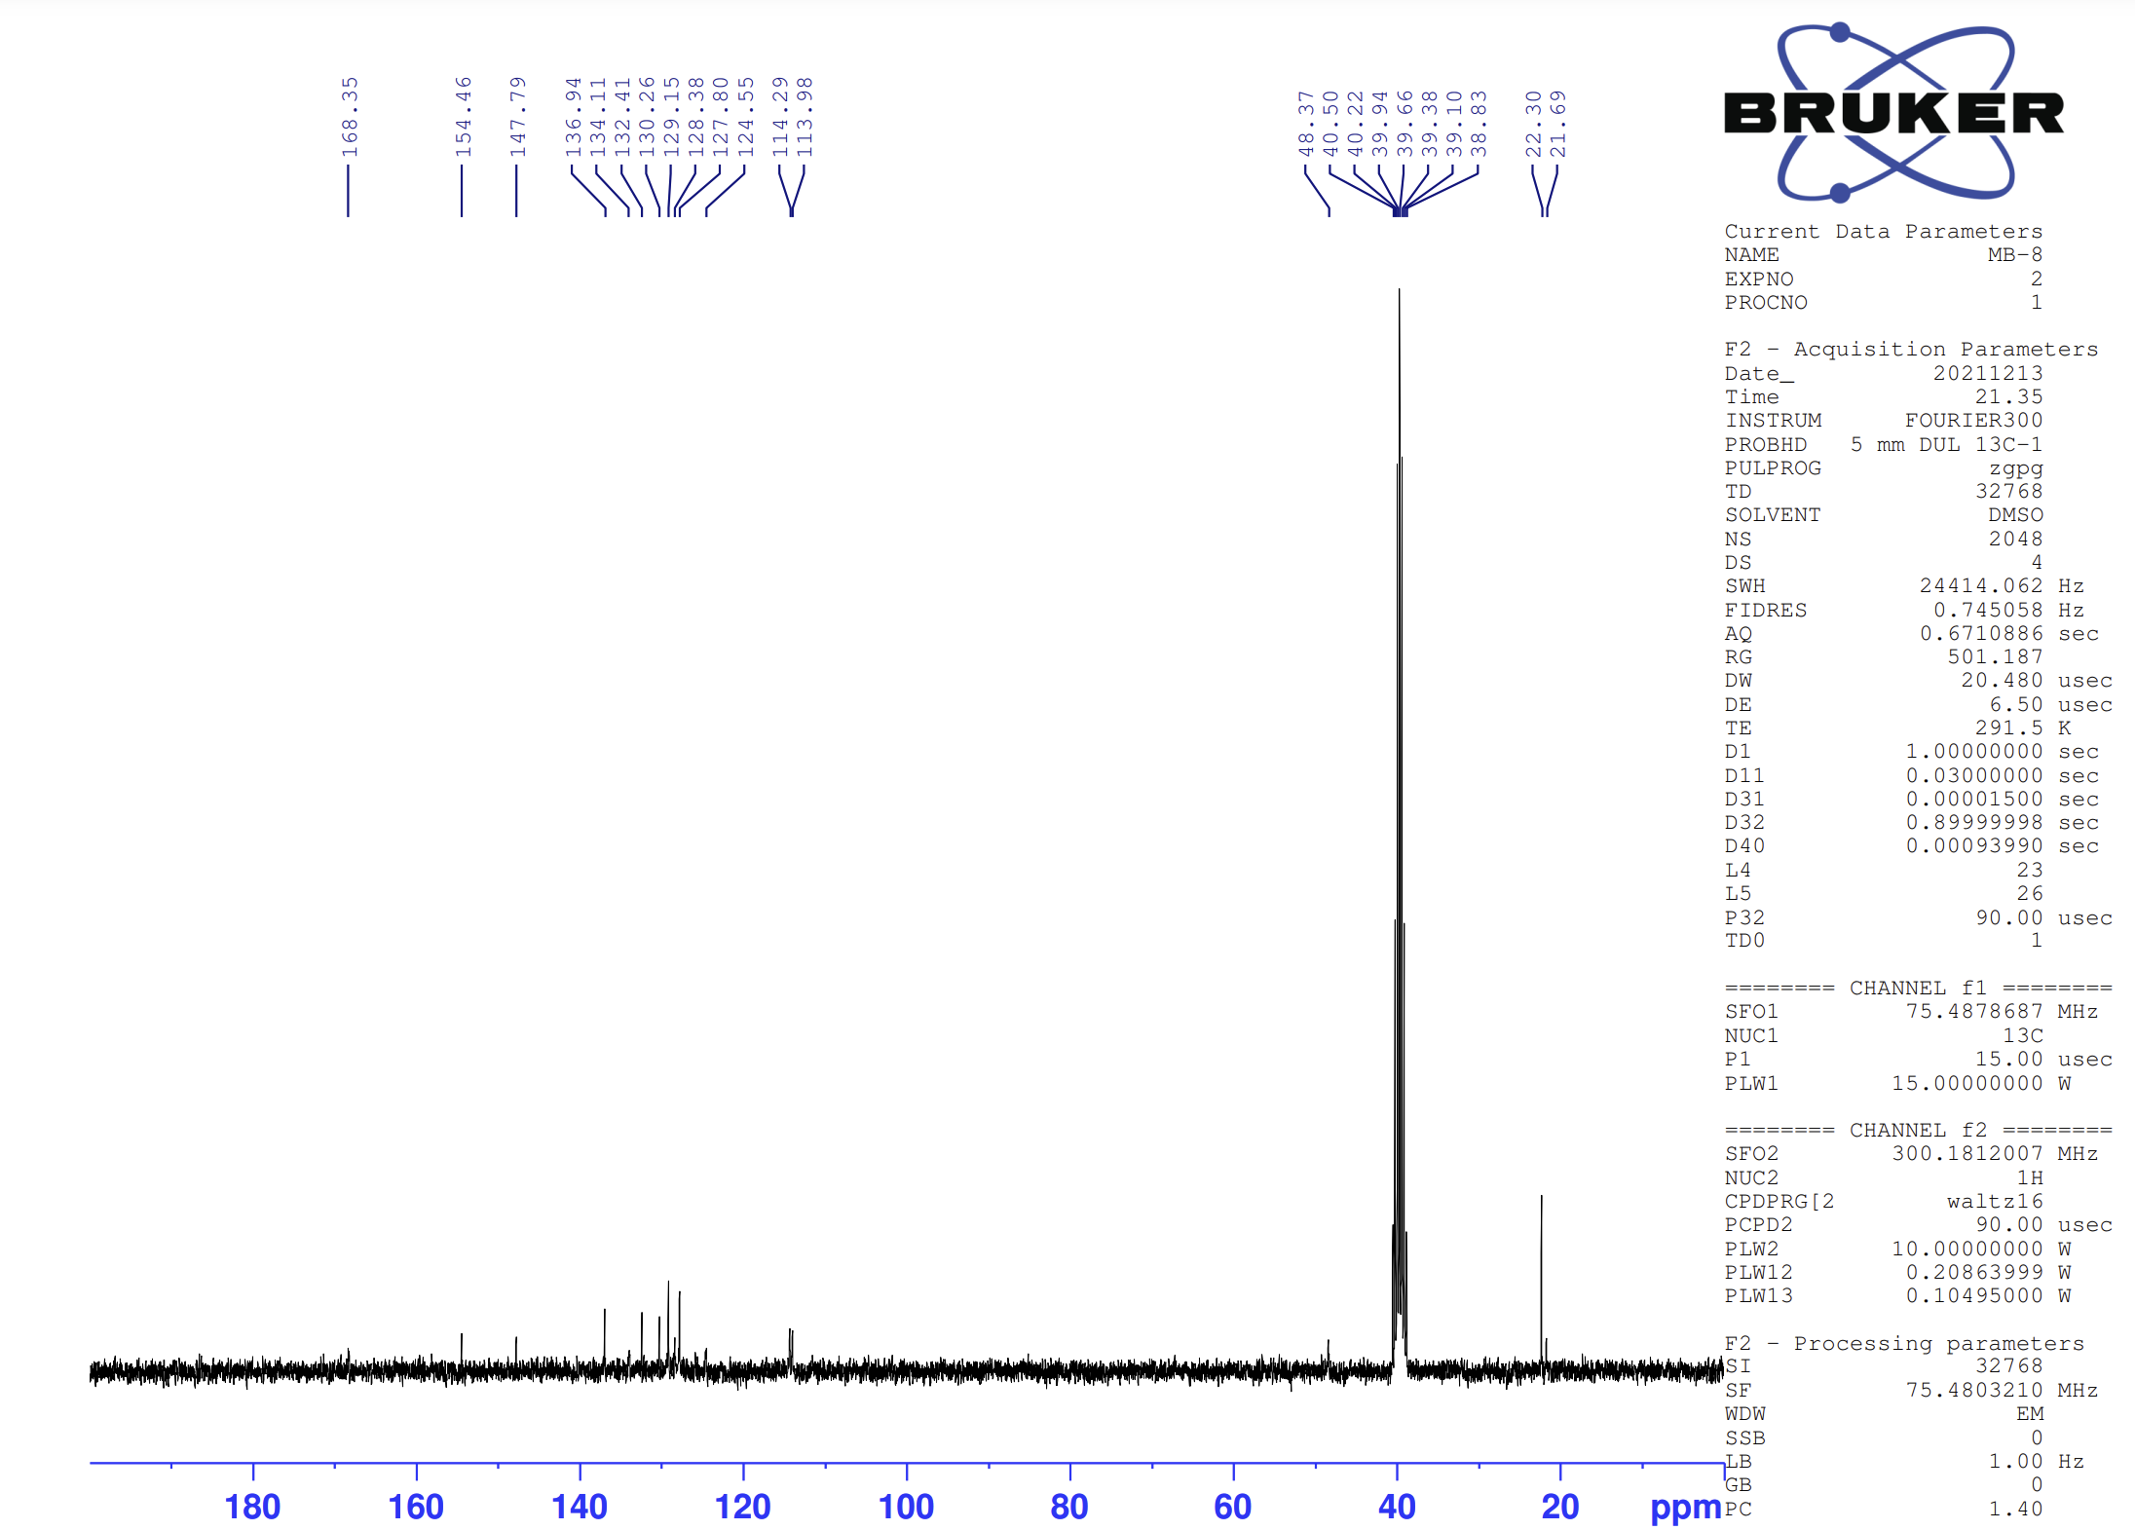
Figure 23. ¹³C-NMR spectrum of compound 4h
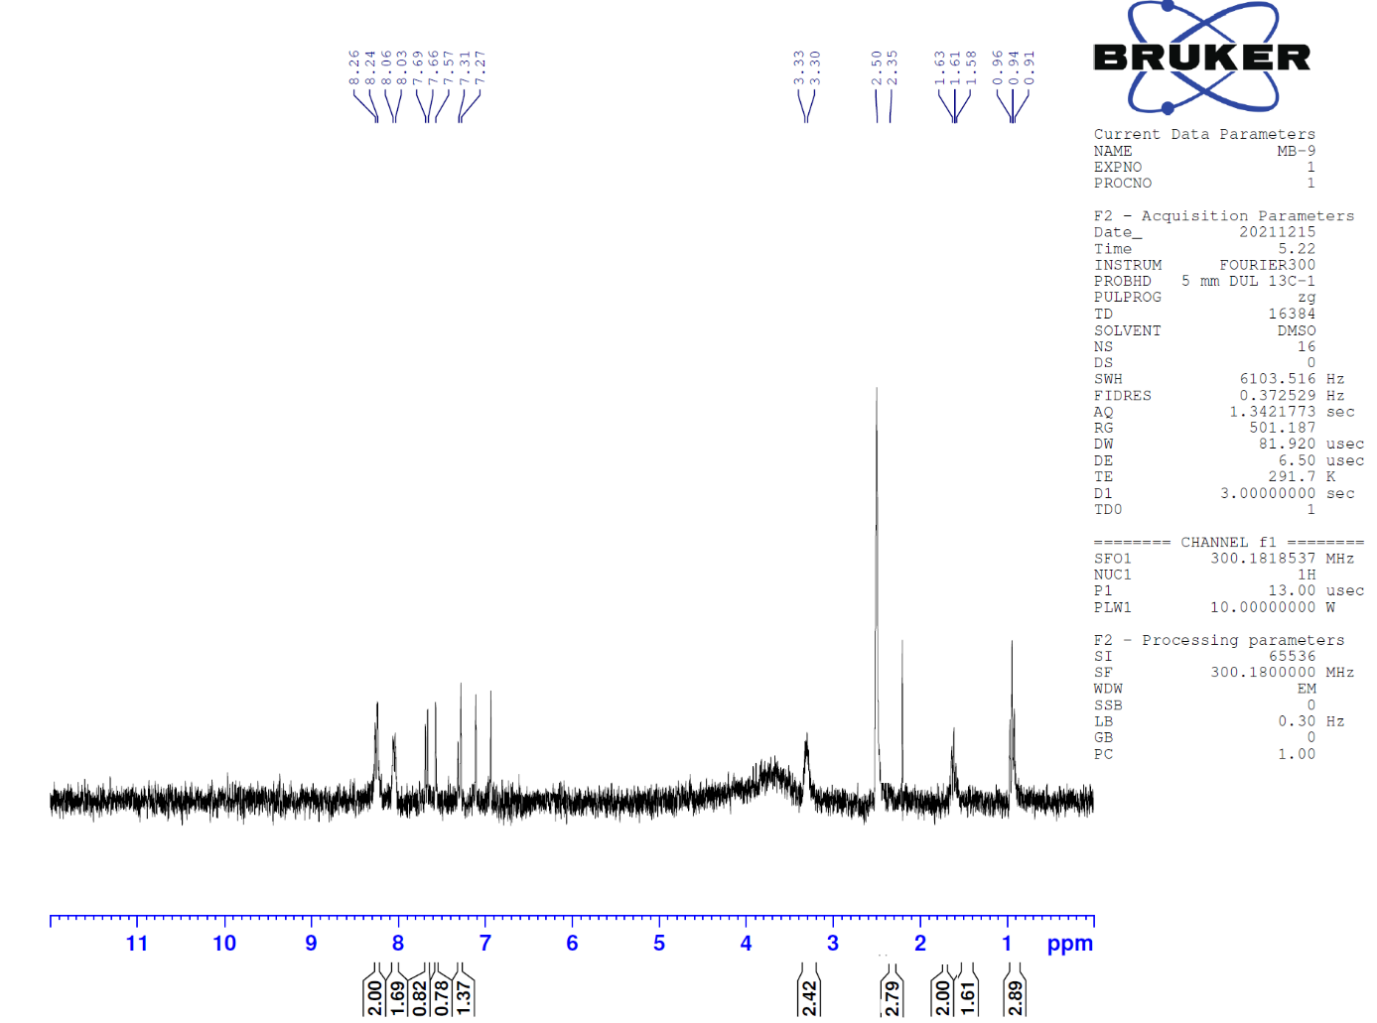
Figure 25. ¹H-NMR spectrum of compound 4i
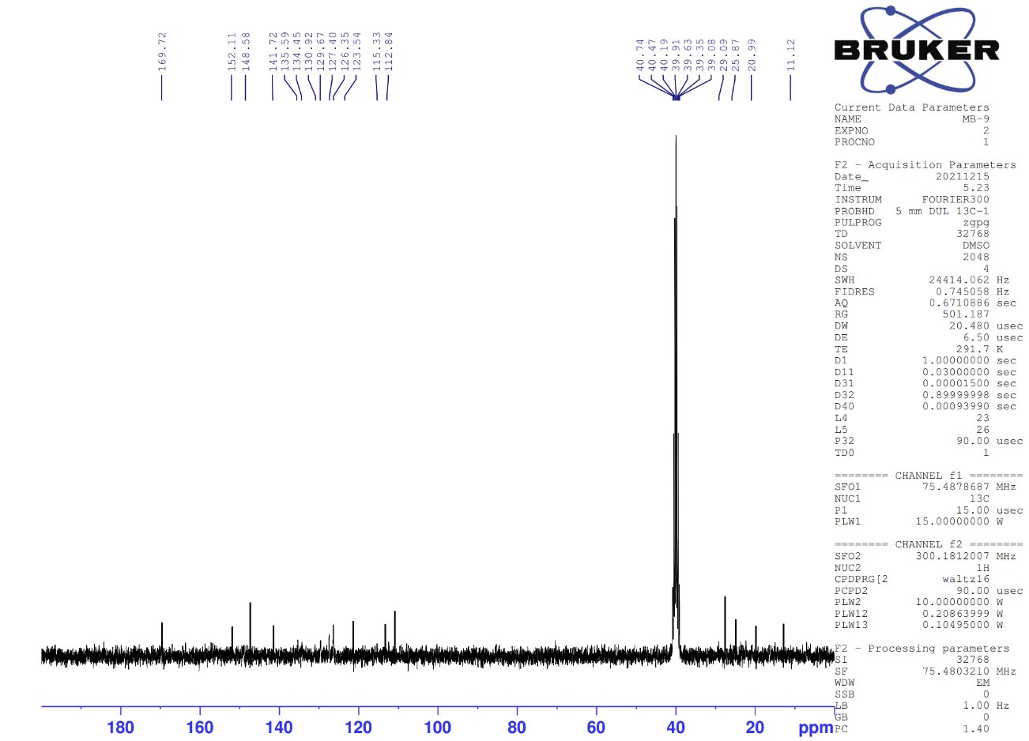
Figure 26. ¹³C-NMR spectrum of compound 4i
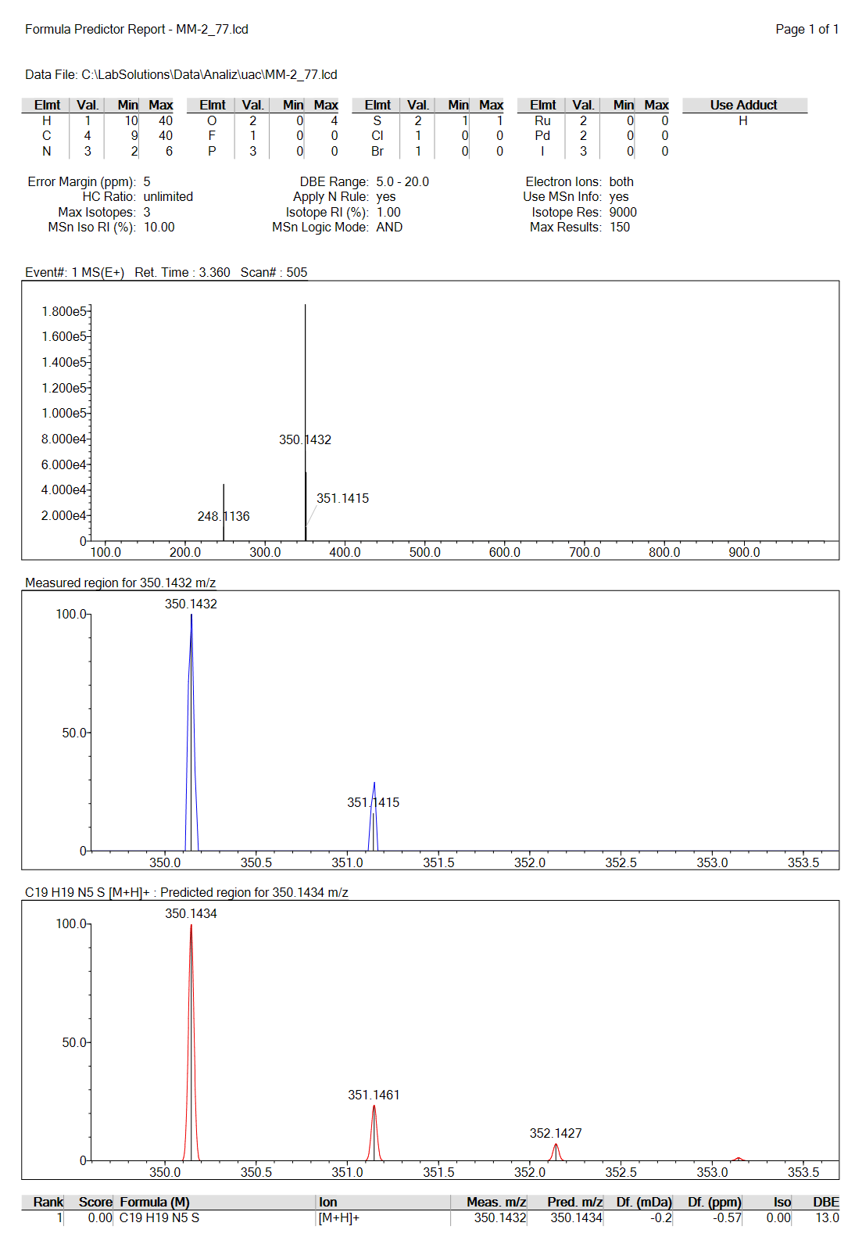
Figure 27. Mass spectrum of compound 4i
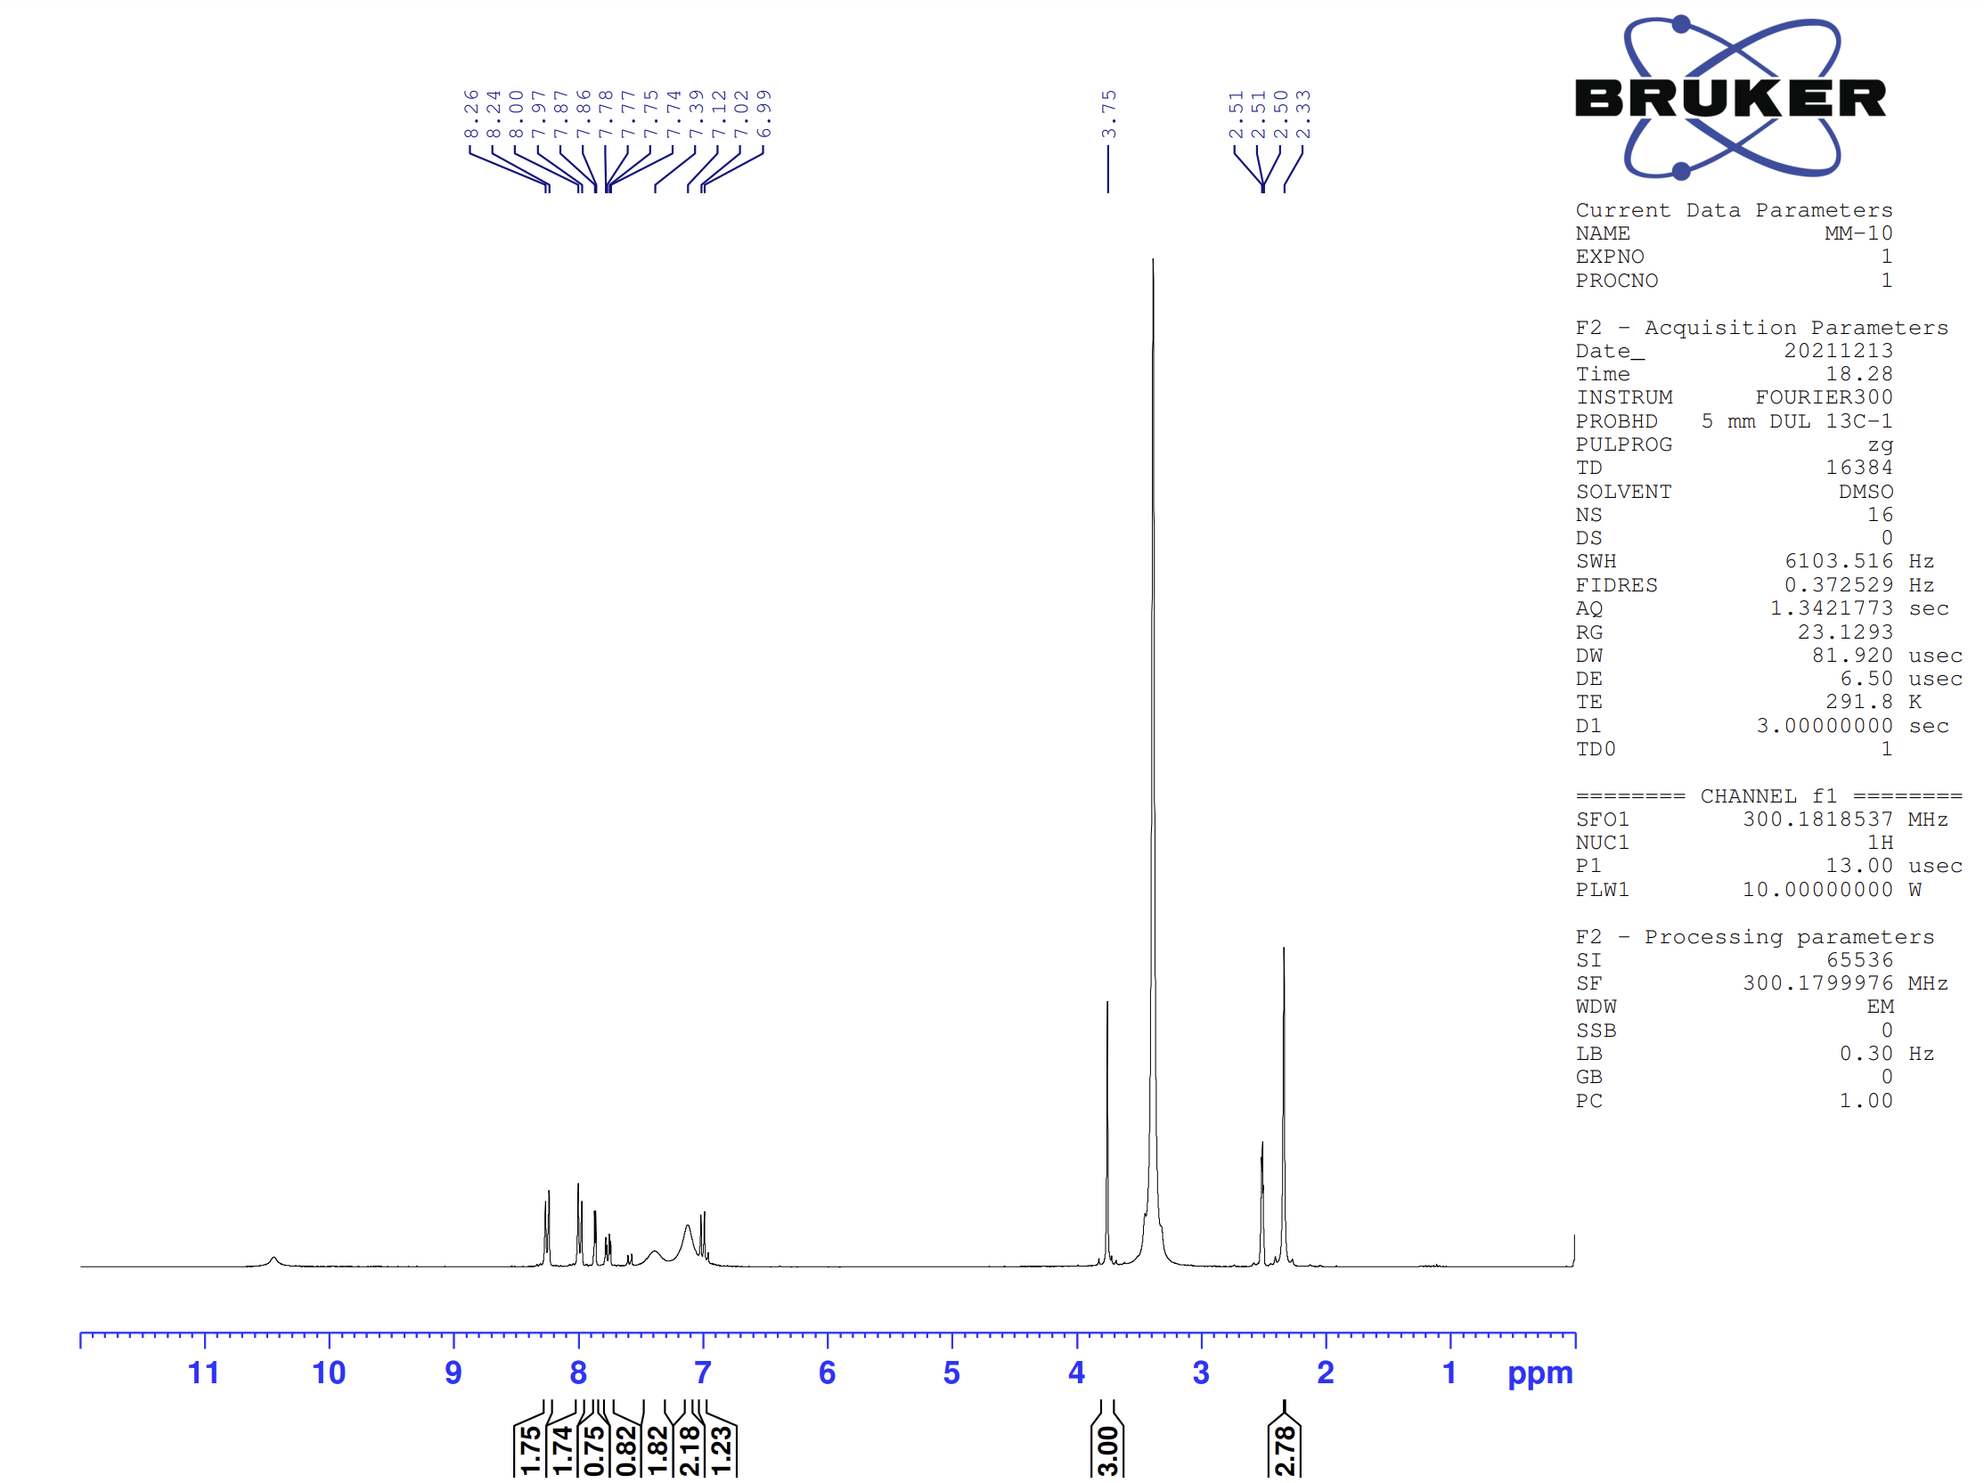
Figure 28. ¹H-NMR spectrum of compound 4j
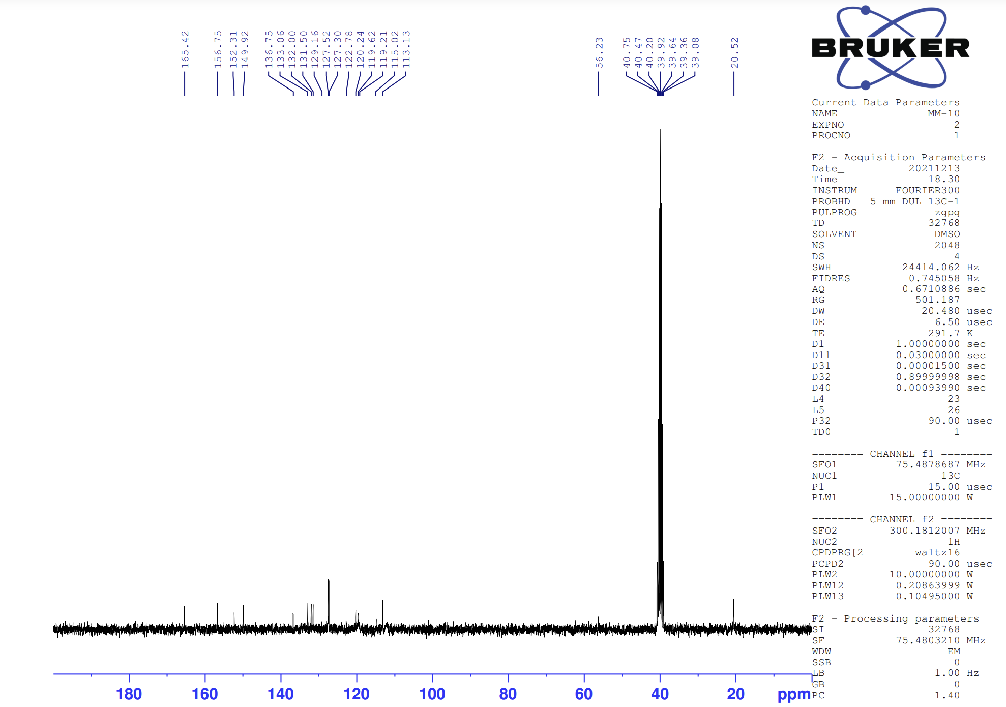
Figure 29. ¹³C-NMR spectrum of compound 4j
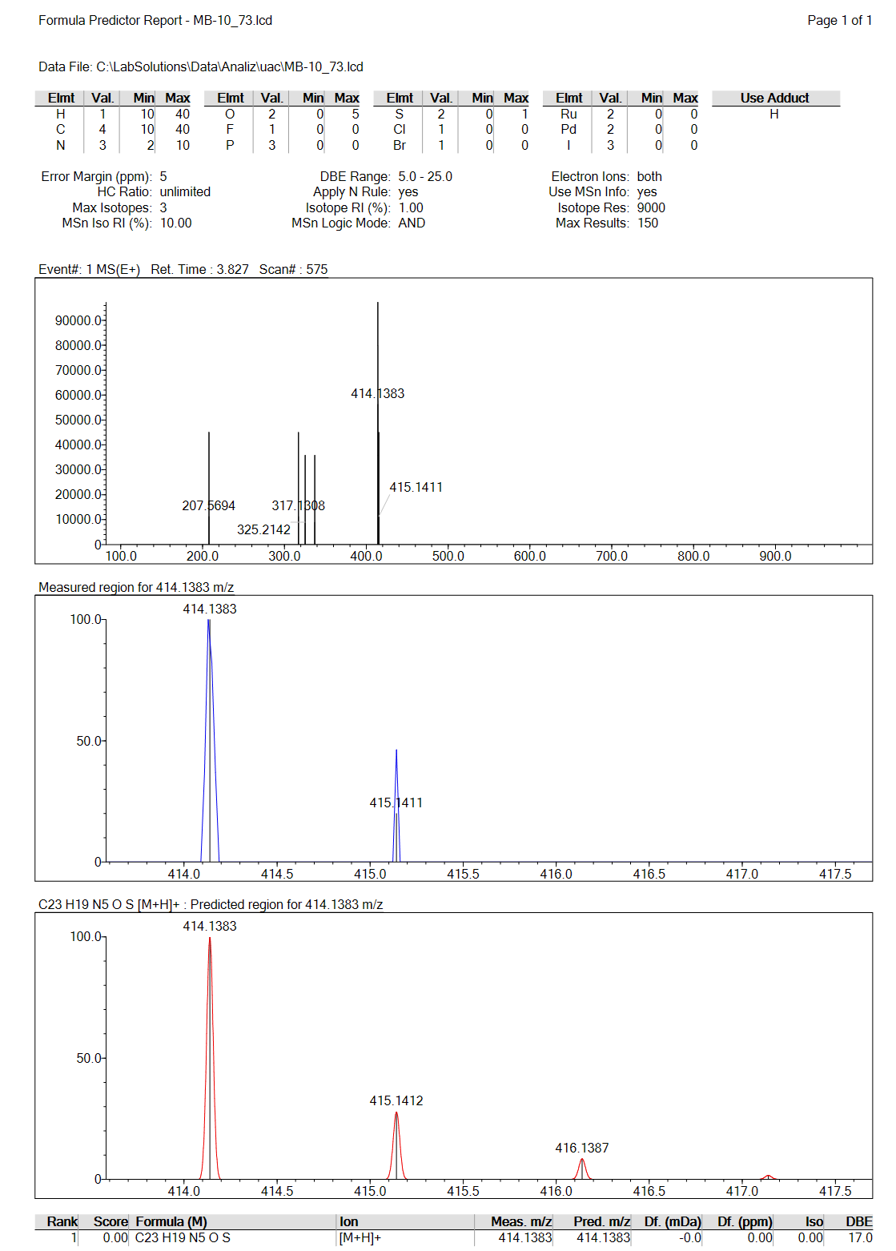
Figure 30. Mass spectrum of compound 4j

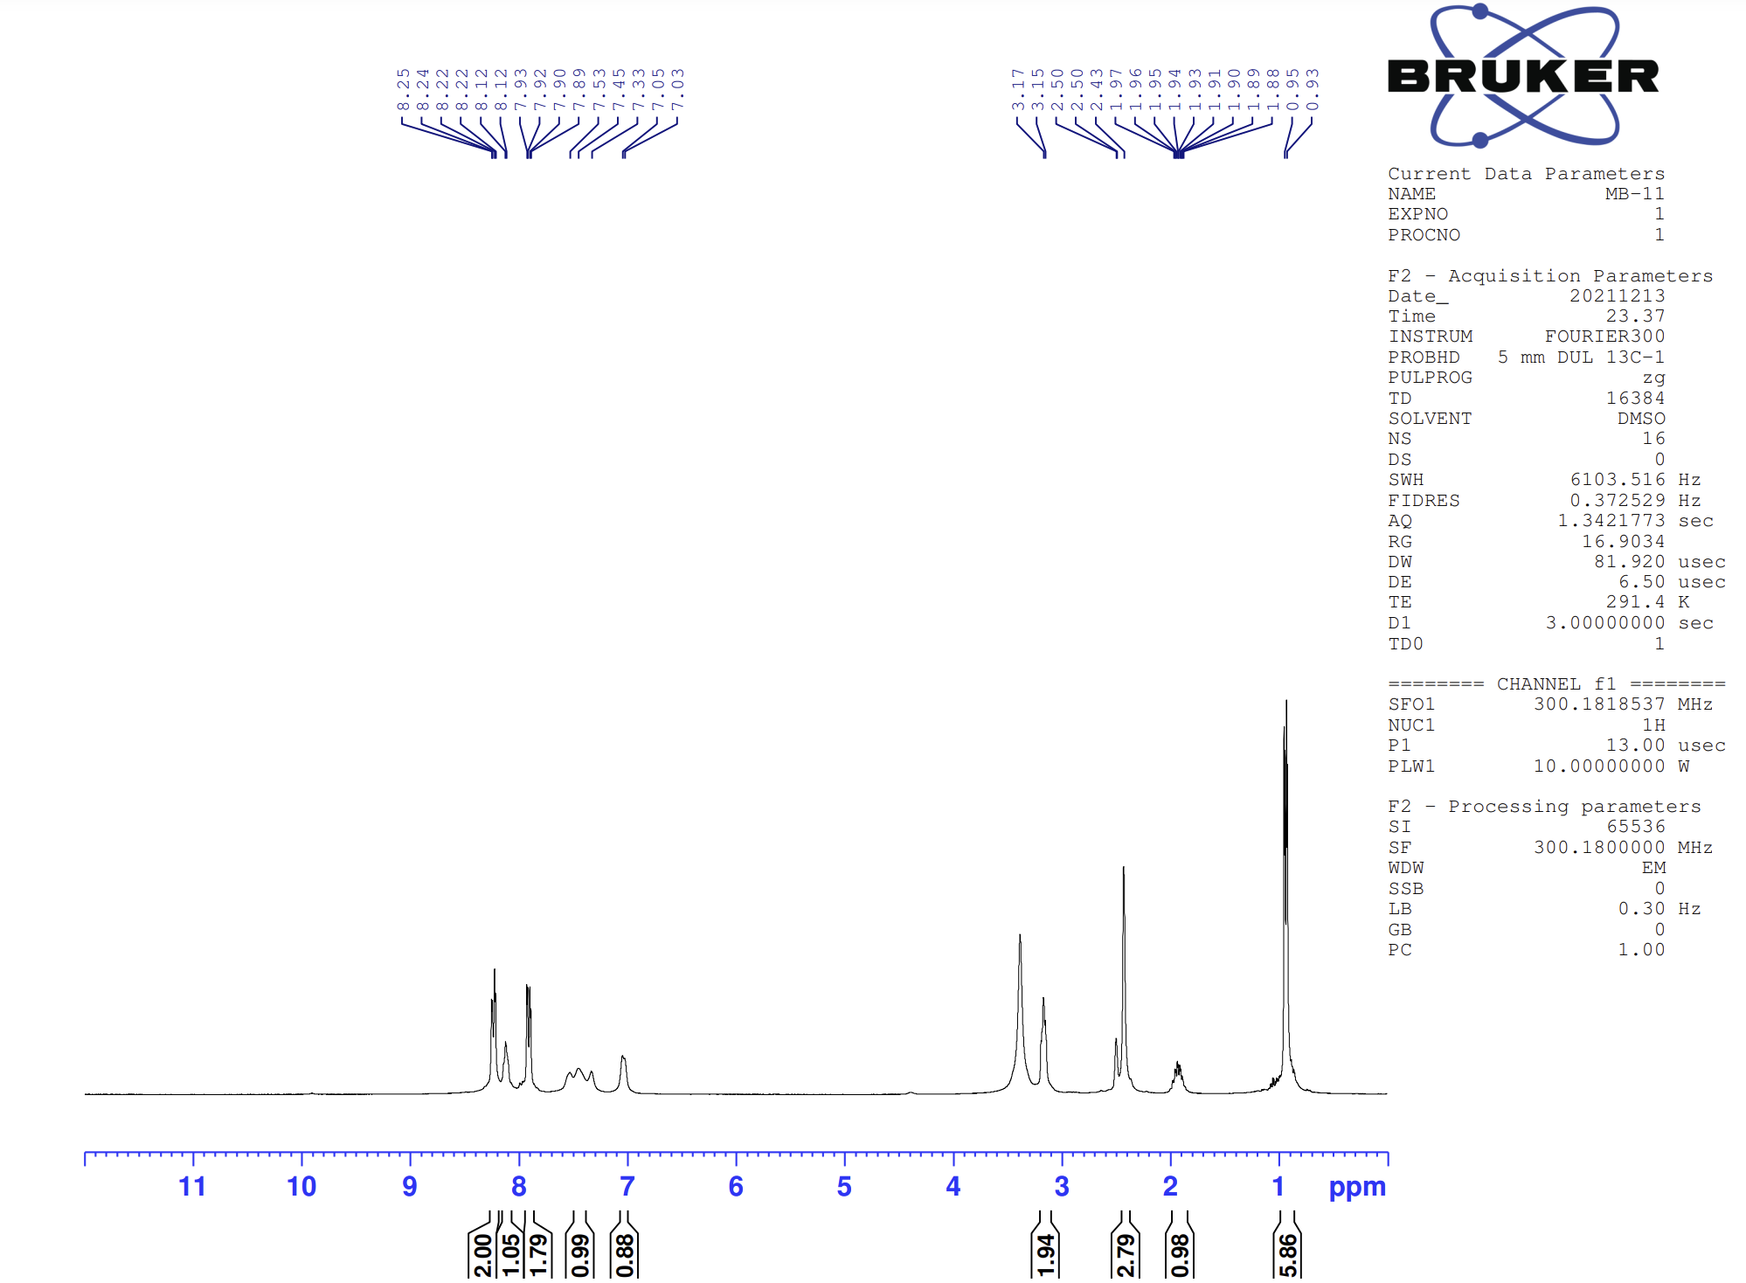Figure 31. ¹H-NMR spectrum of compound 4k
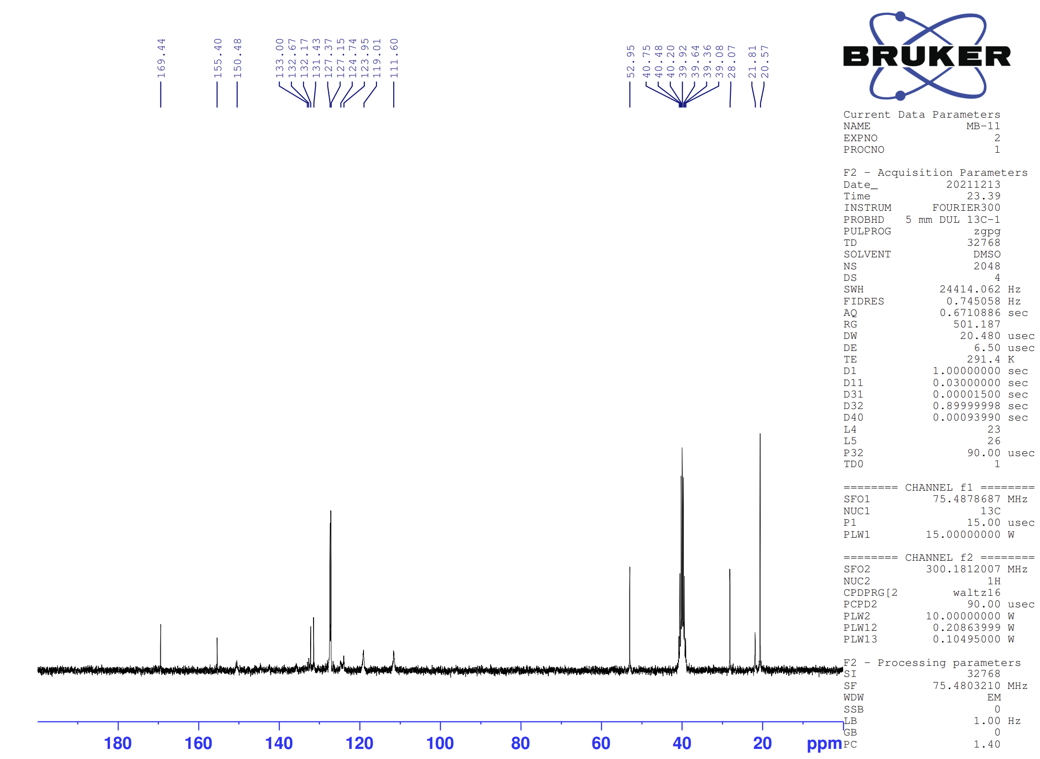
Figure 32. ¹³C-NMR spectrum of compound 4k
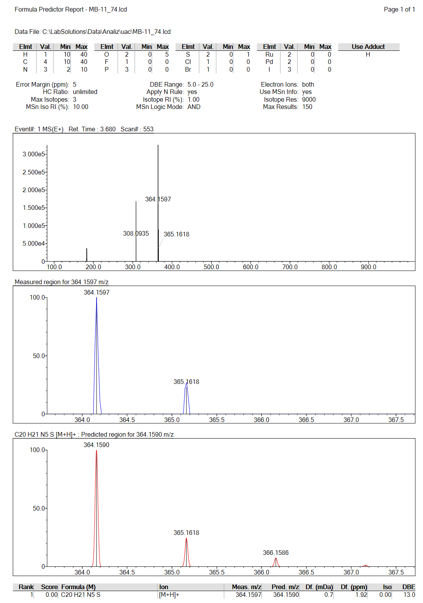
Figure 33. Mass spectrum of compound 4k

