Supplementary Material
Optimal cropping pattern based on short-term streamflow forecasts to improve agricultural economic benefits and crop productivity under uncertainty conditions
Gaurav Talukdarª*, Rajib Kumar Bhattacharjya^{b}, and Arup Kumar Sarma^{b}
ªPh.D. scholar, Department of Civil Engineering, Indian Institute of Technology, Guwahati, Guwahati, India
^{b}Professor, Department of Civil Engineering, Indian Institute of Technology, Guwahati, Guwahati, India
*Corresponding author: Gaurav Talukdar, Indian Institute of Technology, Guwahati, Assam, India, 781039
E-mail address: gauravt@iitg.ac.in
Full postal address: Department of Civil Engineering, Indian Institute of Technology, Guwahati, Assam, India, 781039

5-6 feet height  (a) | 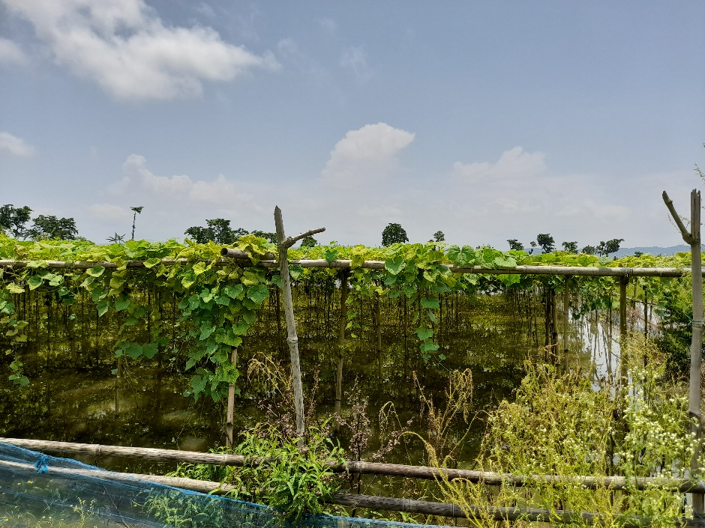  Flood water rising in sandbars  (b)
Figure S1. Pattern of vegetable grown during the onset of monsoon period in a sandbar within the Brahmaputra River to avoid damage due to flood (a) Before flooding condition (Farm 1); (b) during nominal flooding (Farm 2). The maximum depth of water measured was 0.4-0.5m. (Location: 26°14’37” N, 91°46’37” E, Date: 4th July 2021: 12.33 pm. Picture courtesy: The Author)

Table S1. Flood tolerant varieties of crops
Crop | Flood tolerant crop varieties
Rice | CR Dhan 502, CR Dhan 505, Durga, Gayatri, Sarla, Hemavathi, Jaladhi 1, Jaladhi 2, JalaMani, , Jalnidhi, Neerja, Pooja, Prateeksha, Sambha Mahsuri, Sub-1Swarna Sub-1, Varshadhan
Maize | HM-5, Seed Tech-2324, HM-10, HTL lines, PMH-2, B73, SUS lines,  *Z. luxurians, and *Z. mays ssp. huehuetenangensis *Z. nicaraguensis
Barley | *H. marinum and *H. spontaneum
Wheat | *Triticum macha L. or T. dicoccum cv., T. spelta
Rapeseed | *B. juncea and *B. carinata, *GH01, *Zhongshuang 9,
Jute | Bidhan Pat-1, JRC 321, JRC 532, JRC-517, JRC 7447, JRO 878, JRO 7835
Pulses | Pigeon pea (Asha (ICPL 87119)
(Source: Ministry of Agriculture and Farmers Welfare, Government of India) https://pib.gov.in/newsite/PrintRelease.aspx?relid=123999
*other flood tolerant varieties (Verhoeven et al., 2010)

