Executive Functions in Migraine Patients: A Systematic Review with Meta-Analysis

Authors: Luciane Kaiser Pinotti¹*; Anderson da Silva Castro²; Gabriel Henrique de Oliveira Garcia³; Pedro Henrique Pereira Alvim^{1,3}; Thiago Henrique Roza⁴; Fabiana Antunes Andrade⁵; Pedro André Kowacs^{1,2}; Raffael Massuda^{1,3}.
¹ Postgraduate Program in Internal Medicine and Health Sciences (PPGMICS), Federal University of Paraná (UFPR), Curitiba-PR, Brazil.
² Complexo Hospital de Cllínicas do Paraná (CHC)- Neurology Service - Federal University of Paraná (UFPR), Curitiba-PR, Brazil.
³ Department of Psychiatry, Federal University of Paraná (UFPR), Curitiba-PR, Brazil.
⁴ Department of Psychiatry, Universidade Federal do Rio Grande do Sul, Curitiba-PR, Brazil.
⁵ Laboratory of Molecular Immunopathology, Federal University of Paraná (UFPR) , Curitiba-PR, Brazil.
*Corresponding Author: Luciane Kaiser Pinotti – PPGMICS, Rua General Carneiro, 181, 11 andar. Curitiba, PR, Brazil. ZIP: 80060-150. Phone number/Fax: +55 41 3360 1099. Email: luciane.kaiser1@gmail.com

SUPPLEMENTARY MATERIAL 1 – SEARCH STRATEGY
Distribution of standardized and non-standardized descriptors, according to the acronym of the PICO strategy.
Acronym | Clinical Situations | Selected Descriptors
P  (OR) | Patients with migraine | ("migraine" OR "migraine with aura" OR "migraine without aura" OR "migraine disorder" OR "migrane" OR "migaines")
I  (OR) | Neuropsychological assessment | ("neuropsychological test" OR "neuro-psychological test" OR "neuropsychologic test" OR "neuropsychological test" OR "neuropsychology test" OR "test, neuropsychological" OR "cognitive function test" OR "cognition test" OR "cognitive abilities test" OR "cognitive ability test" OR "cognitive function test" OR "cognitive functioning test")
C  (OR) | Patients without migraine | Does not apply
O  (OR) | Altered executive function | ("cognition" OR "cognitive defect" OR "cognition disorder" OR "cognition disorders" OR "cognitive defect." OR "cognitive defects" OR "cognitive deficit" OR "cognitive disability" OR "cognitive disorder" OR "cognitive disorders" OR "cognitive dysfunction" OR "cognitive impairment" OR "delirium, dementia, amnestic, cognitive disorders" OR "response interference" OR "executive function" OR "memory" OR "attention" OR "attention OR attentiveness")

SUPPLEMENTARY MATERIAL 2 - TABLE OF TESTS USED BY SUB-FUNCTION
Sub-function | Test
Attention | Go/No-Go Test; Digit Span Backward; Stroop Test; TMT; Attention Network Task (ANT); Neurobehavioral Evaluation System (NES); SWITCH Task; Shape Trail Test (STT); Clock-Drawing Test.
Working Memory | Digits; N-Back Task; Corsi Block-Tapping Task.
Verbal Fluency | Controlled Oral Word Association Test (COWAT).
Mental Flexibility | TMT; Stroop Test, Wisconsin Card Sorting Test; Frontal Assessment Battery (FAB); Shape Trail Test (STT); Object Alternation Test (OAT); Clock-Drawing Test.
Inhibitory Control | Go/No-Go Test; Stroop Test; D-KEFS Color Word Interference Test; Frontal assessment Battery (FAB); Neurobehavioral Evaluation System (NES); SWITCH Task.
Response Maintenance | Wisconsin Card Sorting Test; Object Alternation Test (OAT).
Problem-Solving | Tower of Hanoi; Gambling Task.

SUPPLEMENTARY MATERIAL 3 – SUMMARY OF THE SYSTEMATIC REVIEW
QUALITATIVE EVALUATION OF STUDIES
Code | Author (Year) | Migraine Sample (N) | Control Sample (N) | Applied neuropsychological tests
I | CALANDRE, E. P. et al. (2002) | 60 | 30 | Rey Auditory-Verbal Learning Test (RAVLT); Logical memory – Weschler memory scale (WMS);  Visual reproduction – Weschler memory scale (WMS);  Digit Span Backward;  Picture completion;  Stroop Test; Trail Making Test (TMT) A and B; Strub and Black letter list.
II | HOOKER, W. ; RASKIN, N. H. (1986) | 31 | 15 | Trail Making Test (TMT) A and B; Wisconsin Card Sorting Test; Wechsler Adult Intelligence Scale – Revised (WAIS-R) Subtest; Raven's Progressive Matrices; Tactual Performance Test (TPT); Wechsler Memory Scale
III | POORNIMA, K. N. et al. (2017) | 30 | 30 | Trail Making Test (TMT) A and B; Stroop Test;
IV | LE PIRA, F. et al. (2013) | 44 | 16 | Frontal Assessment Battery (FAB); Trail Making Test (TMT) A and B; Verbal Fluency; Boston Scanning Test.
V | MONGINI, F. et al. (2005) | 23 | 23 | Gambling Task;  Tower of Hanoi;  Object Alternation Test (OAT); Beck Depression Inventory (BDI).
VI | LE PIRA, F. et al. (2000) | 30 | 14 | Boston Scanning Test; Raven's Progressive Matrices; Verbal Fluency; Rey Complex Figure; Completing Figures; Digit Span Forward and Backward); Corsi Block-Tapping Test; California Verbal Learning Test (CVLT); Hamilton Depression Scale (HAM-D); Hamilton Anxiety Scale (HAM-A).
VII | KOPPEN, H. et al. (2011) | 16 | 18 | Attentional Network Task; Global-Local Task; N-Back Task
VIII | FOGANG, Y. F et al. (2013) | 25 | 45 | Delis-Kaplan Executive Function System (D-KEFS)
IX | DRESLER, T. et al. (2012) | 23 | 31 | Trail Making Test (TMT) A and B;  Go/No-Go Task;  Stroop Test
X | CAMARDA, C. et al. (2007) | 45 | 90 | Trail Making Test (TMT) A and B;  Wisconsin Card Sorting Test;  Verbal Fluency; Hamilton Depression Scale (HAM-D); Hamilton Anxiety Scale (HAM-A).

Code | Author (Year) | Migraine Sample (N) | Control Sample (N) | Applied neuropsychological tests
XI | MARTINS, I. P. et al. (2012) | 61 | 367 | Digits Span Backward; Trail Making Test (TMT) A and B; Verbal Fluency; Matrix Reasoning; Mazes; California Verbal Learning Test (CVLT); WMS – visual memory; WASI vocabulary; WASI information.
XII | LO BUONO V. et al. (2018) | 28 | 14 | Trail Making Test (TMT) A and B; Verbal Fluency; Rey Auditory-Verbal Learning Test (RAVLT); Attention Matrix.
XIII | WANG, N. et al. (2016) | 80 | 40 | Trail Making Test (TMT) A and B; Mini-Mental State Examination (MMSE).
XIV | ROON, K. et al. (2000) | 12 | 12 | Critical Flicker Fusion Test (CFF);  Lexical Decision Task (LEXDEC); Wechsler Memory Scale (WMS); Trail Making Test (TMT) A and B.
XV | FERREIRA, K. S et al. (2018) | 30 | 30 | Montreal Cognitive Assessment (MoCA); Verbal Fluency;  Stroop Test; Color Trails Test (CTT); Wechsler Adult Intelligence Scale (WAIS-III) subtests: Digit Span Forward, Vocabulary and Matrix Reasoning; Ray Auditory-Verbal Learning Test (RAVLT); Beck Anxiety Inventory; Beck Depression Inventory.
XVI | LEIJDEKKERS, M. L. et al. (1990) | 37 | 34 | Block Design Test;  Symbol Digit Substitution Test; Neurobehavioral Evaluation System (NES).
XVII | SCHMITZ N., et al. (2008) | 24 | 24 | Go/No-Go Task; Tower of Hanoi-3; Object Alternation Test (OAT); Stroop Test; SWITCH.
XVIII | GIL-GOUVEIA, R. et al. (2016) | 24 | 24 | Trail Making Test (TMT) A and B; Verbal Fluency; Stroop Test; Digit Span Backward; Finger Tapping Test.
XIX | LO BUONO, V. et al. (2017) | 100 | 50 | Attentive matrices (AT);  Trail Making Test (TMT) A and B; Rey Auditory-Verbal Learning Test (RAVLT); Verbal Fluency.
XX | ZEITLIN, C. et al. (1984) | 19 | 13 | Trail Making Test (TMT) A and B; Stroop Test; Choice Reaction Time Test.
XXI | HAN, M. et al. (2018) | 32 | 32 | Screening Test; Stroop Test; Attention Network Task (ANT).
XXII | EL-SENOUSY & MOBARAK (1995) | 40 | 40 | Bender Gestalt Test; Trail Making Test
XXIII | MARTINEZ, S. et al. (2010) | 10 | 10 | Verbal Fluency; Trail Making Test; Wisconsin Card Sorting test; Continuous Performance Test; Rey Auditory-Verbal Learning Test (RAVLT); Wechsler Memory Scale – Revised (WMS–R); Rey's Complex Figures; Self-Ordered Pointing (SOP); Temporal Ordering (TO); Benton’s Judgment of  Line Orientation Test (JOLO), Beck Depression Inventory; Fatigue Severity Scale.
XXIV | BURKER, E. et al. (1989) | 47 | 24 | Tactual Performance Test; Finger Tapping Test; Trail Making Test; Finger Recognition Test; Number Writing Test; Selective Reminding Test; Rey-Osterrieth Complex Figure Test.
XXV | GÓMEZ-BELDARRAIN, M. et al. (2011) | 84 | 41 | Trail Making Test B; Wisconsin; Beck Depression Inventory; Beck Anxiety Inventory; Zuckerman-Kuhlman Personality Questionnaire; Faux-Pas Test.

CHART 3 – SUMMARY OF RESULTS – NARRATIVE REVIEW
Code / Author | Results
I - CALANDRE, E. P. et al. (2002) | The study sought to evaluate the neuropsychological performance of migraine patients during periods without headache, emphasizing the cognitive and emotional functioning. The applied neuropsychological testing showed a worse performance among migraine patients only in the visuomotor system and processing speed. There was no difference between the group with aura and the group without aura, although the groups were not compatible with respect to the n of the sample.
II - HOOKER, W. D.; RASKIN, N. H. (1986) | This study aimed to evaluate the cognitive functioning of migraine patients compared to healthy individuals (control group). The findings from the applied neuropsychological testing suggest that migraine patients had average cognitive impairment when compared to the control group.
III - POORNIMA, K. N. et al. (2017) | The study was conducted in order to identify whether cognitive decline is associated with migraine and whether there is a relationship between migraine and body mass index (BMI). The results suggest the existence of cognitive decline in patients with migraine when compared to controls, and also a relationship with the incidence of higher BMI in the migraine group.
IV - LE PIRA, F. et al. (2013) | This study was conducted to determine if there is any correlation between executive dysfunction and white matter lesions in migraine. According to the findings in the neuropsychological testing, there seems to be no evidence of neuropsychological deficits arising from white matter lesions. However, the testing showed worse executive function and language scores in migraine patients when compared to controls.
V - MONGINI, F. et al. (2005) | The purpose of this study was to evaluate the prefrontal functioning of patients with chronic migraine through neuropsychological testing and to see if these functions are affected. According to the applied tests, migraine patients did not show a difference in results when decision-making was evaluated, however, they showed worse results in all other tests.
VI - LE PIRA, F. et al (2000) | This study evaluated the presence of cognitive deficits in a group of patients affected by migraine with and without aura compared to a control group. The results indicated that individuals with migraine showed impaired neuropsychological performance on tests that assessed working memory when compared to the control group.

Author | Results
VII - KOPPEN, H. et al. (2011) | This study also compared migraine patients and healthy patients (control group) to identify possible cognitive impairments, and some functions seem to be unaffected in migraine, such as attention and working memory. On the other hand, migraineurs had worse results in tests that evaluated deficiencies in the processing of global visual resources when compared to the control group.
VIII - FOGANG, Y. F et al. (2013) | This study aimed to evaluate the selective attention of headache patients (including migraine) in a pain-free period and compare them with healthy individuals. The results indicate that, indeed, selective attention, as well as mental flexibility, seem to be reduced in primary headache patients.
IX - DRESLER, T. et al. (2012) | The purpose of this study was to determine whether there are clinical differences related to executive functioning (inhibition, response monitoring, and cognitive control) between a group with migraine and a control group. The neuropsychological testing allowed us to identify that, indeed, executive functioning seems to be altered in patients with migraine when compared to the control group. Considering that the testing was performed outside the attacks, the findings suggest that there may be altered brain functions in migraine patients.
X - CAMARDA, C. et al. (2007) | This study sought to identify whether migraine is associated with executive function disorders. The results indicated that, indeed, executive functioning seems to be lower in migraineurs than in the control group, especially in TMT (B) and WCST.
XI - MARTINS, I. P. et al. (2012) | This study aimed to evaluate specifically the possible effects of migraine on executive functions in comparison with a control group. The results suggest that migraine in late adulthood seems to be associated with poorer performance related to executive functions.
XII - LO BUONO V. et al. (2018) | The purpose of this study was to explore the association between cognitive functions and brain functional connectivity in migraine patients, both with and without aura, in between episodes (interictal period). The neuropsychological testing revealed no abnormalities in individuals with migraine, however, a specific alteration was found in the cortical network when migraine with aura and migraine without aura were compared.
XIII - WANG, N. et al. (2016) | This study investigated the impact of migraine-associated vertigo (MAV) on the cognitive state of patients. The neuropsychological testing indicated that patients with MAV had worse cognitive outcomes than patients with simple migraine and control patients.
XIV - ROON, K. et al. (2000) | This study sought to quantify the differences in the psychological impact and cognitive performance of migraine patients who did or did not abuse ergotamine. The results indicated that migraine patients had a higher degree of cognitive impairment when compared to healthy individuals; this result was even worse when migraineurs who misused ergotamine were considered.

Author | Results
XV - FERREIRA, K. S. et al. (2018) | This study sought to assess the presence of cognitive deficits in patients with chronic migraine, as well as assess the main factors that trigger cognitive disorders, such as comorbidities or medication use. The results indicated that the group with chronic migraine had a worse performance in neuropsychological tests, including the Stroop Test, Verbal Fluency, and TMT A and B when compared to the control group, but these deficits were not associated with medication use or comorbidities.
XVI - LEIJDEKKERS, M. L. et al. (1990) | This study assessed whether migraine is associated with cognitive impairment and whether such impairment is associated with a long history of migraine, as well as if there is any difference between migraine with and without aura. The applied neuropsychological testing showed no cognitive deficits in migraineurs when compared to the control group; the history and type of migraine also did not present such a relationship.
XVII - SCHMITZ N. et al. (2008) | This study simultaneously investigated cortex structure and executive function (EF) in individuals with migraine and healthy controls. The results indicated that, in cognitive terms, migraineurs seem to have a slower response time to set-shifting (mental flexibility) than healthy individuals, which indicates EF deficits.
XVIII - GIL-GOUVEIA, R. et al. (2016) | The objective of this study was to compare the cognitive performance of individuals with migraine to that of healthy individuals using a neuropsychological battery set up with a focus on executive functions. The results indicated that migraineurs and healthy individuals had similar performance in both applications of the battery, thus showing no evidence of executive function deficits.
XIX - LO BUONO, V. et al. (2017) | This study investigated the cognitive profile of migraineurs with and without aura and compared it to a healthy control group. The results indicated that individuals with migraine had worse results when compared to the control group. The group of migraineurs without aura showed deficits in tests related to verbal fluency, while migraineurs with aura had worse results related to delayed memory.
XX - ZEITLIN, C. et al. (1984) | This study investigated the presence of cognitive deficits in individuals with severe migraine compared to healthy controls and sought to identify whether these deficits are cumulative according to the duration of the history of episodes. The results indicated that migraineurs had lower scores than the control group in all applied tests. They also had higher scores on the scales that assessed anxiety, obsessionality, and somatic complaints, which may be correlated to worse performance on the neuropsychological assessment.
XXI - HAN, M. et al. (2018) | The purpose of this study was to evaluate the attention function of migraineurs compared to a control group. Indeed, migraineurs had worse test results, including the assessment of executive functions, when compared to the control group.
XXII - EL-SENOUZY, M. Y. & MOBARAK, A. (1995) | This study sought to evaluate personality traits and psychiatric changes in migraine patients, including cognitive functions related to emotional processes. The results suggest attentional and visual memory impairment in migraineurs when compared to the control group.
XXIII - MARTINEZ, S. et al. (2010) | The objective of this study was to assess executive dysfunction in Sjögren's Syndrome, considering individuals with migraine and healthy individuals. The overall results indicated cognitive deficits in both the Sjögren’s Syndrome and migraine groups, with significant deficits in social skills and executive functions.
XXIV - BURKER, E. et al. (1989) | This study sought to identify the neuropsychological and psychiatric profile of individuals with migraine, all of them female and middle-aged, comparing migraine with aura, without aura, and healthy individuals. The results showed no difference in neuropsychological assessments between the groups, and the results of psychiatric scales were conflicting, indicating a higher likelihood of hysteria and paranoia in migraineurs, but with no necessary relationship with obsessive disorders.
XXV - GÓMEZ-BELDARRAIN, M. et al. (2011) | This study sought to identify whether migraineurs with medication overuse have worse outcomes related to orbitofrontal dysfunctions compared to migraineurs without medication overuse and healthy individuals. According to the results, migraineurs with medication overuse presented orbitofrontal dysfunctions compared to the other groups. Disorders such as anxiety and depression also seem to be more comorbid in this population.

SUPPLEMENTARY 4 - Assessment of the risk of bias of studies

Criterion | Study ID
 | I | II | III | IV | V | VI | VII | VIII | IX | X | XI | XII | XIII | XIV | XV | XVI | XVII | XVIII | XIX | XX | XXI | XXII | XXIII | XXIV | XXV
1. Was the research question or objective in this paper clearly stated? | Yes | Yes | Yes | Yes | Yes | Yes | Yes | Yes | Yes | Yes | Yes | Yes | Yes | Yes | Yes | Yes | Yes | Yes | Yes | Yes | Yes | Yes | Yes | Yes | Yes
2. Was the study population clearly specified and defined? | Yes | No | Yes | Yes | Yes | No | Yes | Yes | Yes | Yes | No | Yes | Yes | Yes | Yes | Yes | Yes | Yes | Yes | Yes | Yes | Yes | Yes | Yes | Yes
3. Was the participation rate of eligible persons at least 50%? | NA | NA | NA | NA | NA | NA | NA | NA | NA | NA | NA | NA | NA | NA | NA | NA | NA | NA | NA | NA | NA | NA | NA | NA | NA
4. Were all the subjects selected or recruited from the same or similar populations (including the same time period)? Were inclusion and exclusion criteria for being in the study prespecified and applied uniformly to all participants? | Yes | No | Yes | Yes | No | No | Yes | Yes | No | Yes | No | Yes | Yes | Yes | Yes | Yes | Yes | Yes | Yes | Yes | Yes | No | Yes | Yes | Yes

Criterion | Study ID
 | I | II | III | IV | V | VI | VII | VIII | IX | X | XI | XII | XIII | XIV | XV | XVI | XVII | XVIII | XIX | XX | XXI | XXII | XXIII | XXIV | XXV
5. Was a sample size justification, power description, or variance and effect estimates provided? | No | No | No | No | No | No | No | No | No | No | No | No | No | No | No | No | No | No | No | No | No | No | No | No | No
6. For the analyses in this paper, were the exposure(s) of interest measured prior to the outcome(s) being measured? | No | No | No | No | No | No | No | No | No | No | No | No | No | No | No | No | No | No | No | No | No | No | No | No | No
7. Was the timeframe sufficient so that one could reasonably expect to see an association between exposure and outcome if it existed? | No | No | No | No | No | No | No | No | No | No | No | No | No | No | No | No | No | No | No | No | No | No | No | No | No

Criterion | Study ID
 | I | II | III | IV | V | VI | VII | VIII | IX | X | XI | XII | XIII | XIV | XV | XVI | XVII | XVIII | XIX | XX | XXI | XXII | XXIII | XXIV | XXV
8. For exposures that can vary in amount or level, did the study examine different levels of the exposure as related to the outcome (e.g., categories of exposure, or exposure. | Yes | No | No | No | No | No | No | No | No | Yes | No | Yes | No | No | No | No | No | No | No | Yes | No | No | No | Yes | Yes
9. Were the exposure measures (independent variables) clearly defined, valid, reliable, and implemented consistently across all study participants? | Yes | Yes | Yes | Yes | Yes | Yes | Yes | Yes | Yes | Yes | No | Yes | Yes | Yes | Yes | Yes | Yes | Yes | Yes | Yes | Yes | Yes | Yes | Yes | Yes
10. Was the exposure(s) assessed more than once over time? | NA | NA | NA | NA | NA | NA | NA | NA | NA | NA | NA | NA | NA | NA | NA | Na | NA | NA | NA | NA | NA | NA | NA | NA | NA

Criterion | Study ID
 | I | II | III | IV | V | VI | VII | VIII | IX | X | XI | XII | XIII | XIV | XV | XVI | XVII | XVIII | XIX | XX | XXI | XXII | XXIII | XXIV | XXV
11. Were the outcome measures (dependent variables) clearly defined, valid, reliable, and implemented consistently across all study participants? | NO | Yes | Yes | Yes | Yes | Yes | Yes | Yes | Yes | Yes | Yes | Yes | Yes | Yes | Yes | Yes | Yes | Yes | Yes | Yes | Yes | Yes | Yes | Yes | Yes
12. Were the outcome assessors blinded to the exposure status of participants? | No | No | No | No | No | No | No | No | No | Yes | No | Yes | No | No | No | No | Yes | No | Yes | No | No | No | Yes | No | No
13. Was loss to follow-up after baseline 20% or less? | NA | NA | NA | NA | NA | NA | NA | NA | NA | NA | NA | NA | NA | NA | NA | NA | NA | NA | NA | NA | NA | NA | NA | NA | NA

Criterion | Study ID
 | I | II | III | IV | V | VI | VII | VIII | IX | X | XI | XII | XIII | XIV | XV | XVI | XVII | XVIII | XIX | XX | XXI | XXII | XXIII | XXIV | XXV
14. Were key potential confounding variables measured and adjusted statistically for their impact on the relationship between exposure(s) and outcome(s)? | Yes | Yes | No | Yes | Yes | Yes | Yes | No | No | Yes | No | No | Yes | Yes | Yes | Yes | Yes | No | No | No | No | No | Yes | No | Yes
Total Score | 6 | 4 | 5 | 6 | 5 | 4 | 6 | 5 | 4 | 8 | 2 | 7 | 6 | 6 | 6 | 6 | 7 | 5 | 6 | 6 | 5 | 4 | 7 | 6 | 7
*Study ID: Calandre, et al 2002 (I); Hooker, et al 1986 (II); Poormina, et al 2017 (III); Le Pira, et al 2013 (IV); Mongini, et al 2005 (V); Le Pira, et al 2000 (VI); Koopen, et al 2011 (VII); Fogang, et al 2013 (VIII); Dresler, et al 2012 (IX); Camarda, et al 2007 (X); Martins, et al 2012 (XI); Lo Buono et al 2018 (XII); Wang, et al 2014 (XIII); Roon, et al 2000 (XIV); Ferreira, et al 2018 (XV); Leijdkkers et al 1990 (XVI); Schmitz, et al 2008 (XVII); Gil-Gouveia, et al 2015 (XVIII); Lo Buono, et al 2017 (XIX); Zeitlin, et al 1984 (XX); Han, et al 2018; El-Scnousy & Mobarak 19952018 (XXI); Martinez, et al 2010 (XXIII); Burker, et al; 1989 (XXIV);
SUPPLEMENTARY 5 - FUNNEL PLOT

5.1 Funnel Plot TMT A
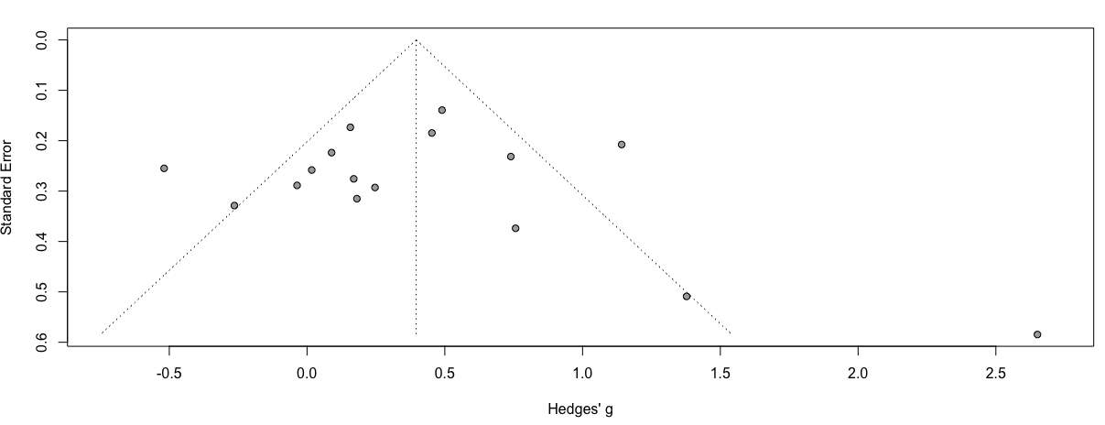

5.2 Funnel Plot TMT B

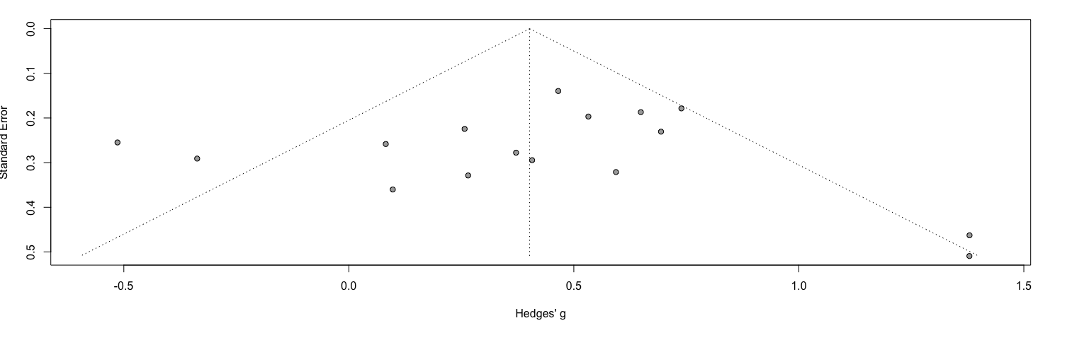

5.3 Funnel Plot Digits Backward

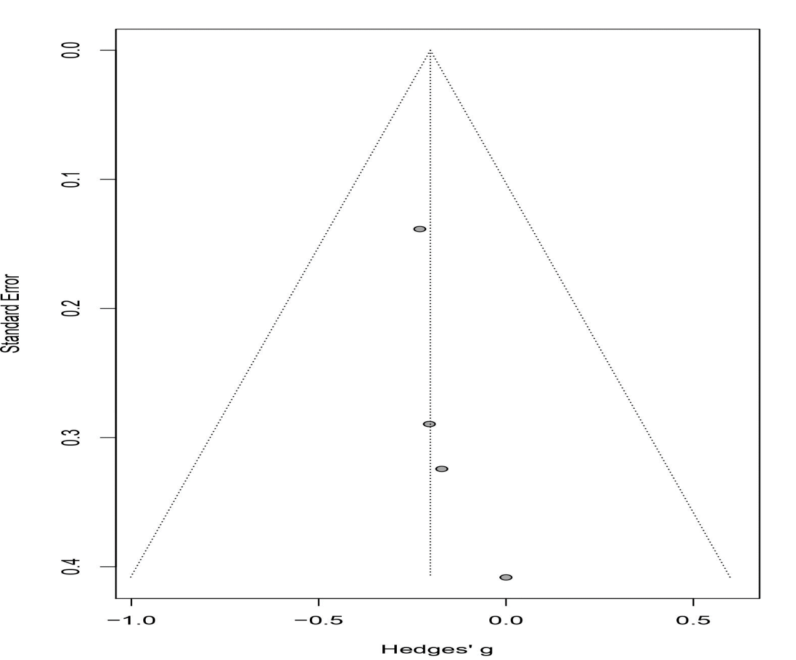

5.4 Funnel Plot Fluency Verbal
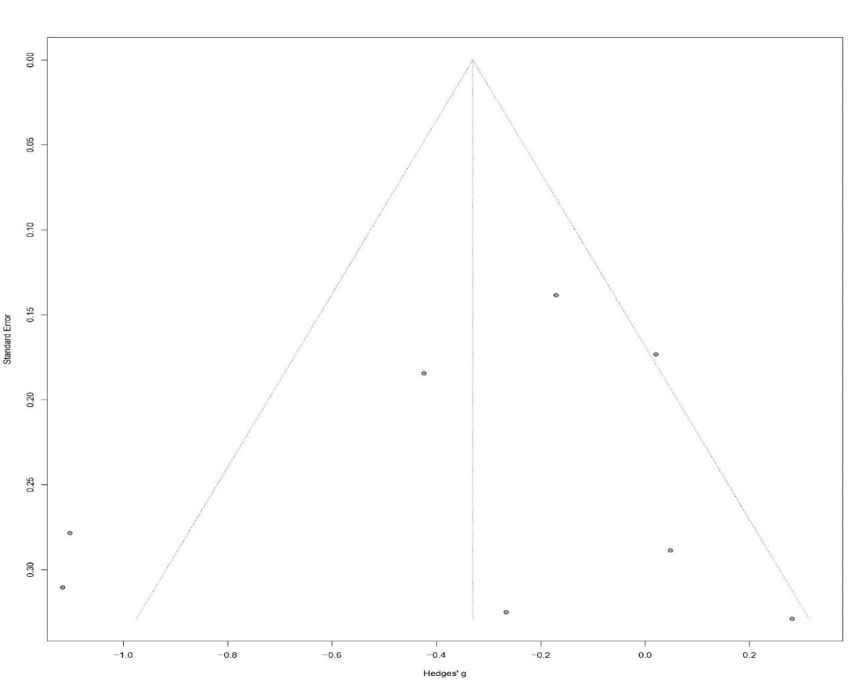
5.5 Funnel Plot Stroop Reading Test
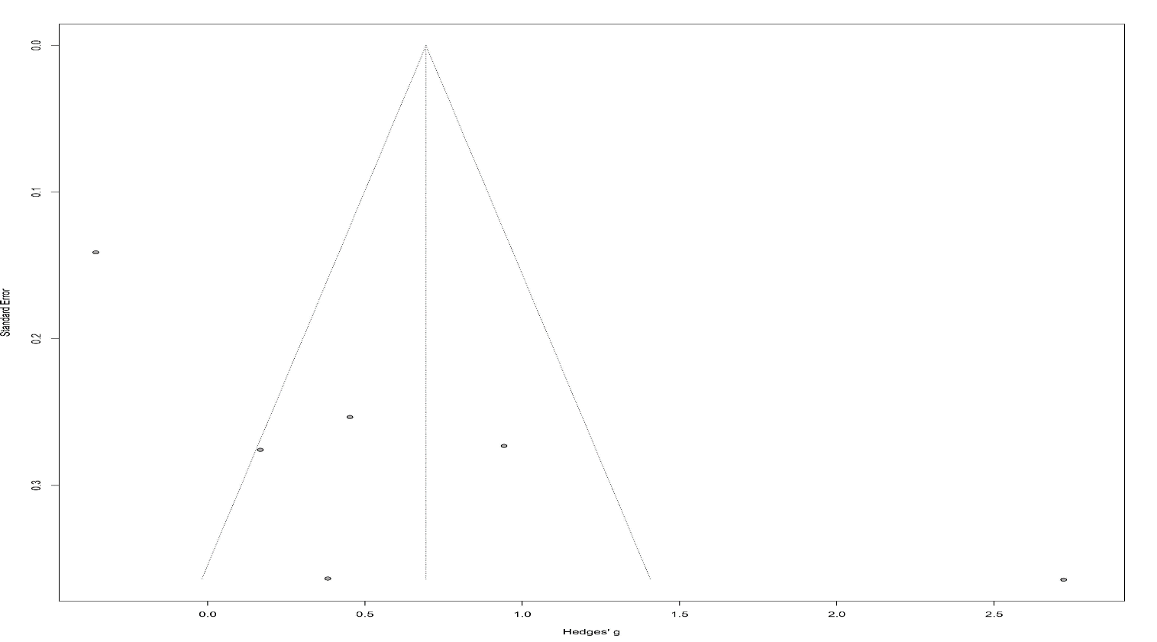

5.6 Funnel Plot Stroop Naming Test

5.7 Funnel Plot Stroop Interference Test
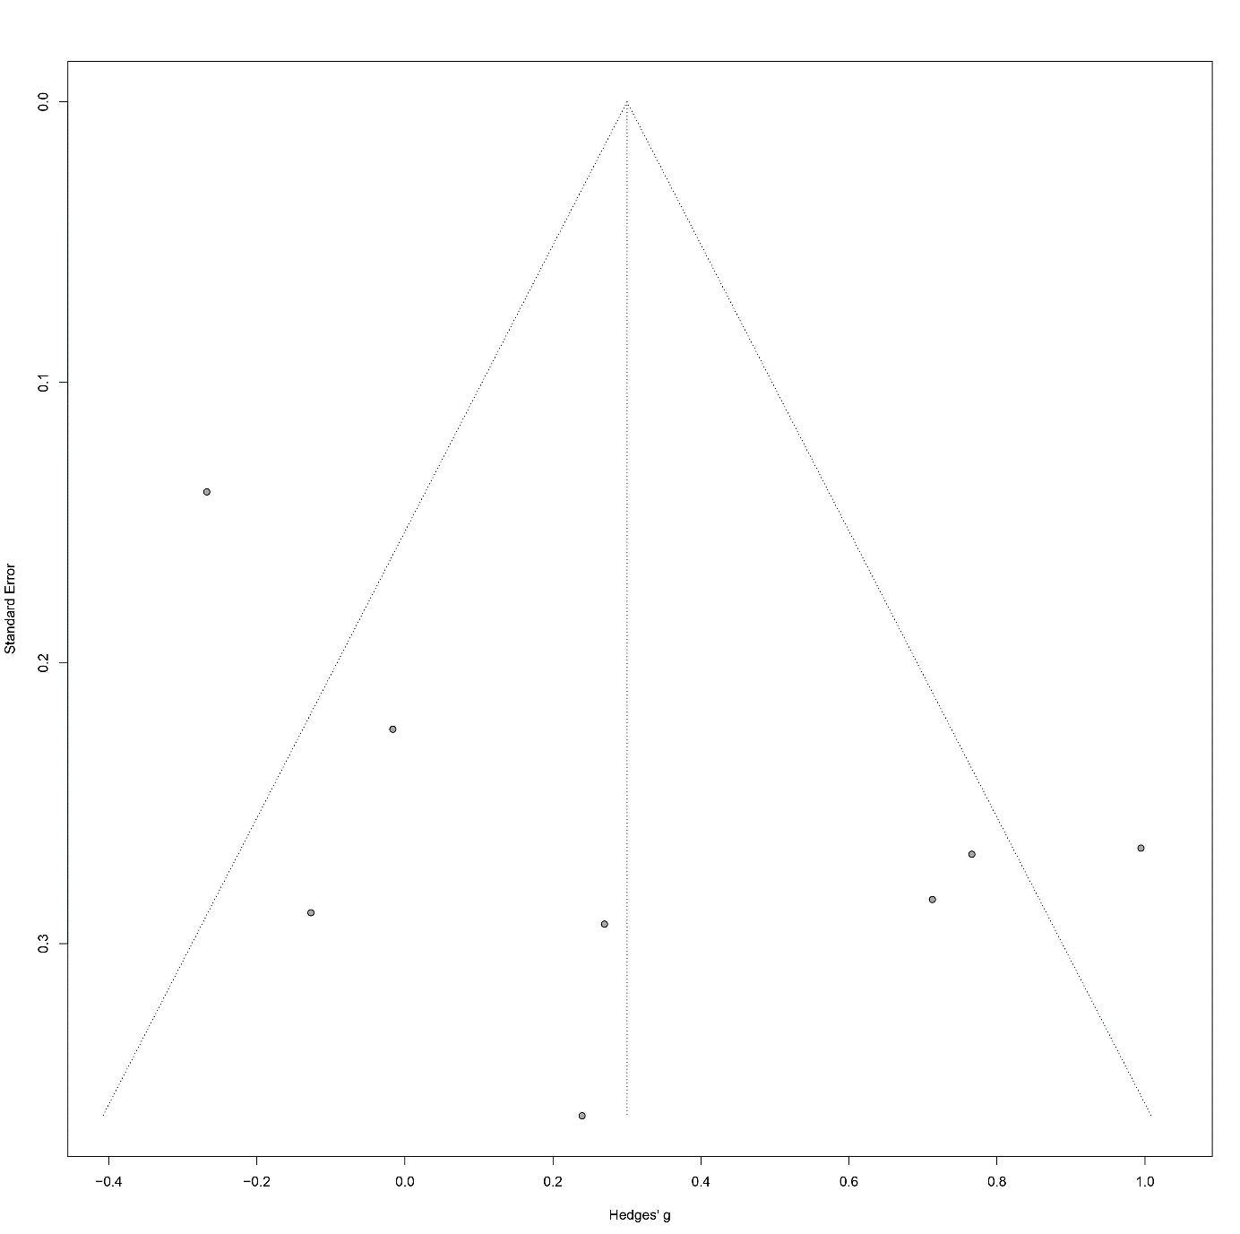
5.8 Funnel Plot Wisconsin Categories
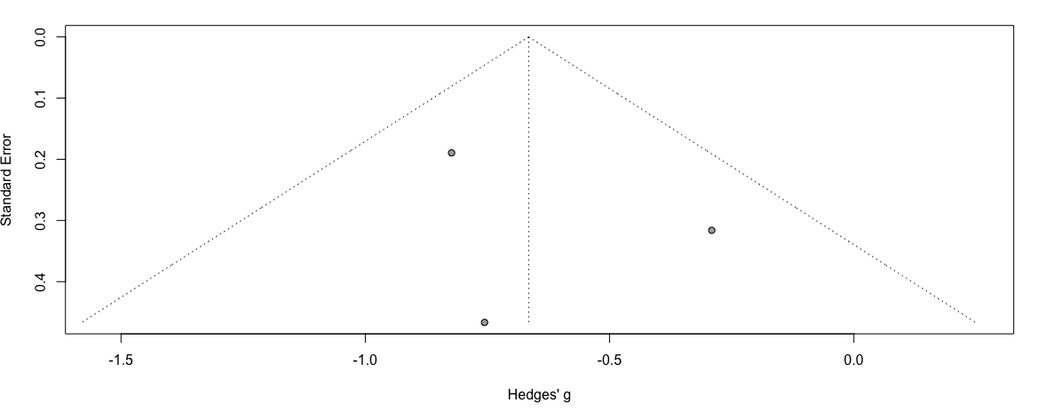

5.9 Funnel Plot Wisconsin Perseverative Errors
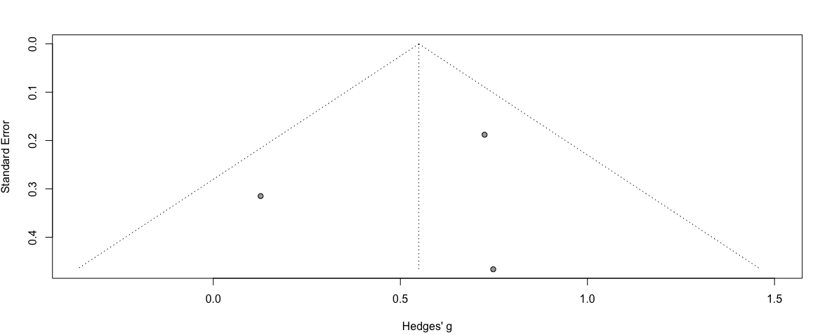
SUPLEMENTARY 6 – SUBGRUP ANALYSIS

6.1 TMT A MIGRAINE WITH AURA X WITHOUT AURA

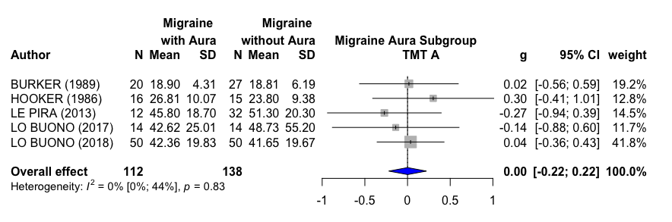
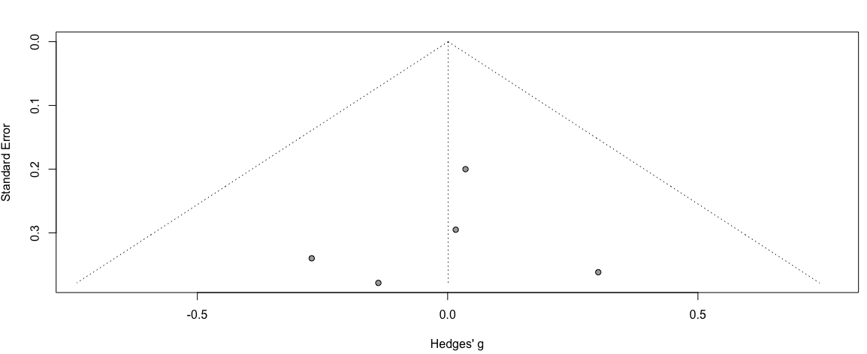

6.2 TMT A MIGRAINE WITHOU AURA X CONTROL
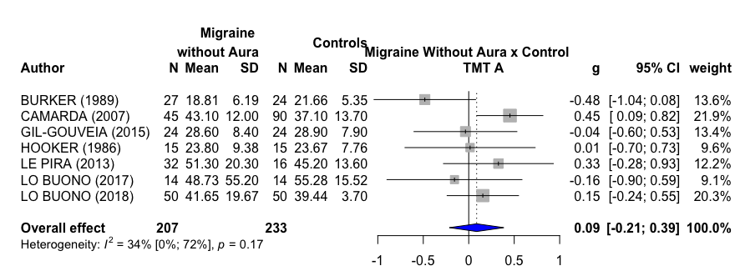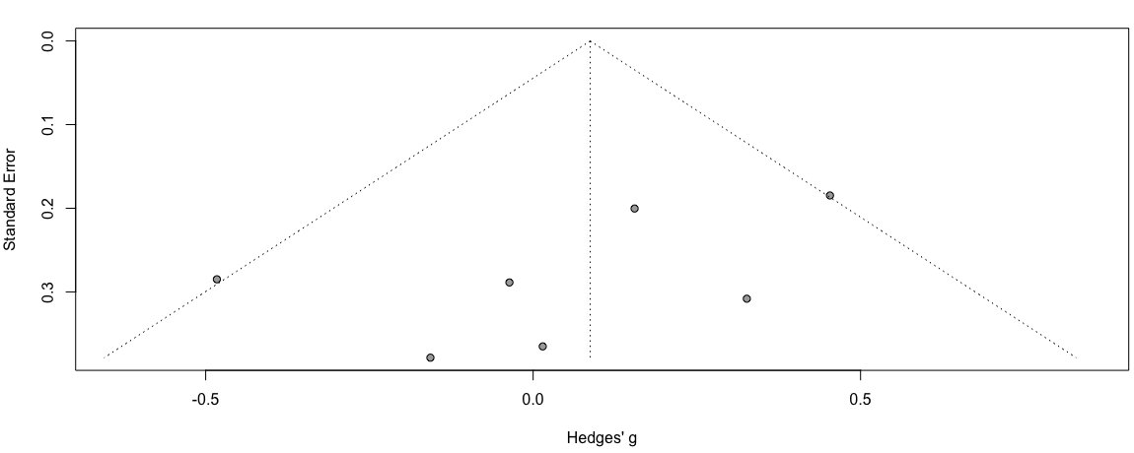

6.3 TMT A: MIGRAINE WITH AURA X CONTROL

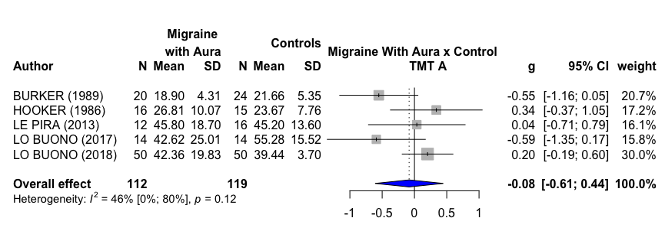
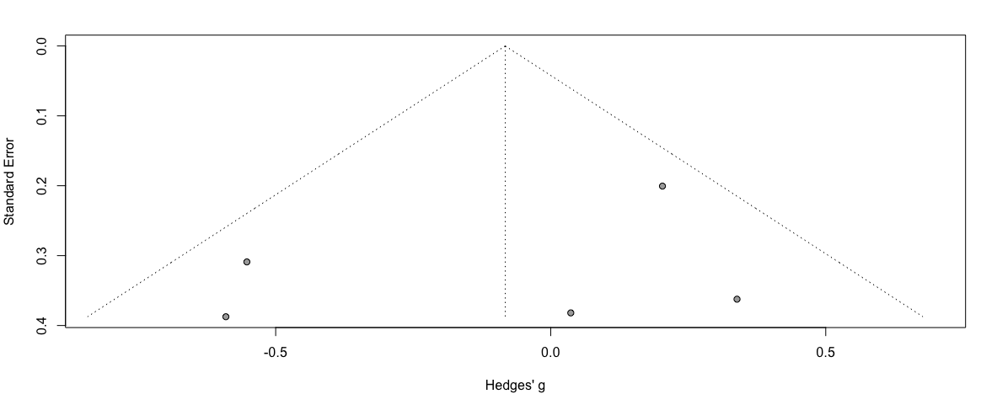
6.4 TMT B MIGRAINE WITH AURA X WITHOUT AURA
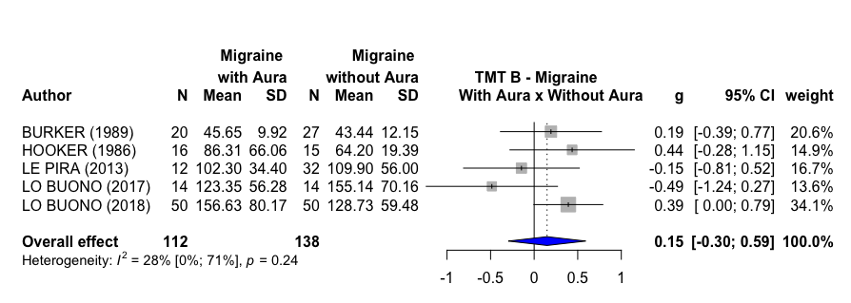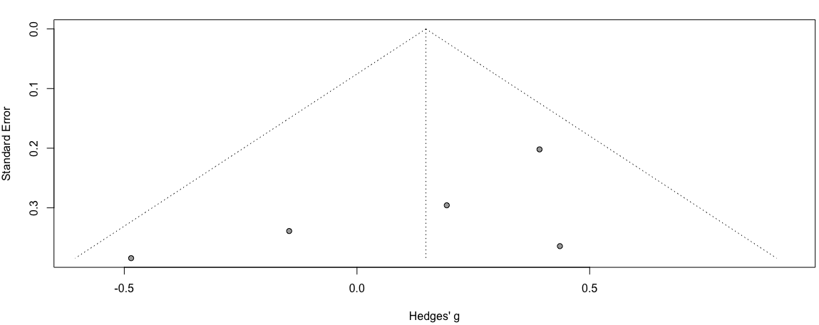

6.5 TMT B MIGRAINE WITHOUT AURA X CONTROL
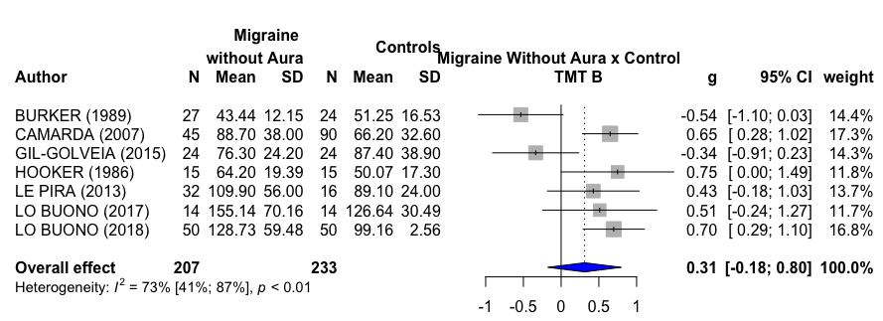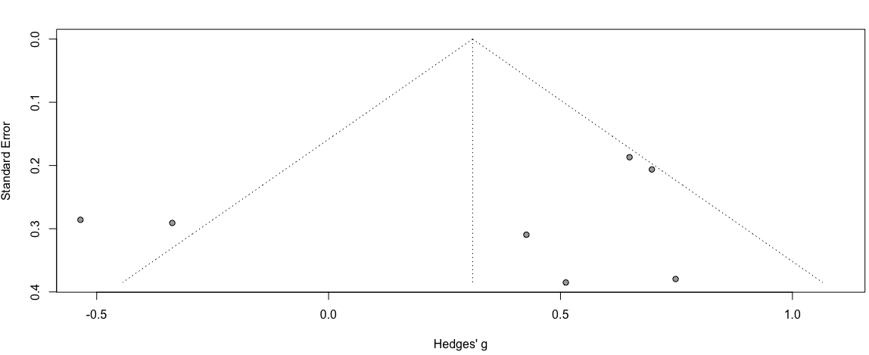

6.6 TMT B MIGRAINE WITH AURA X CONTROL
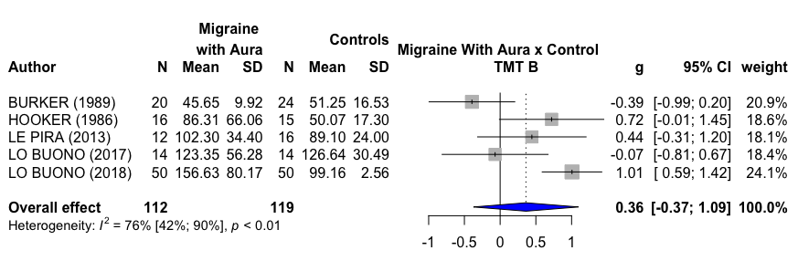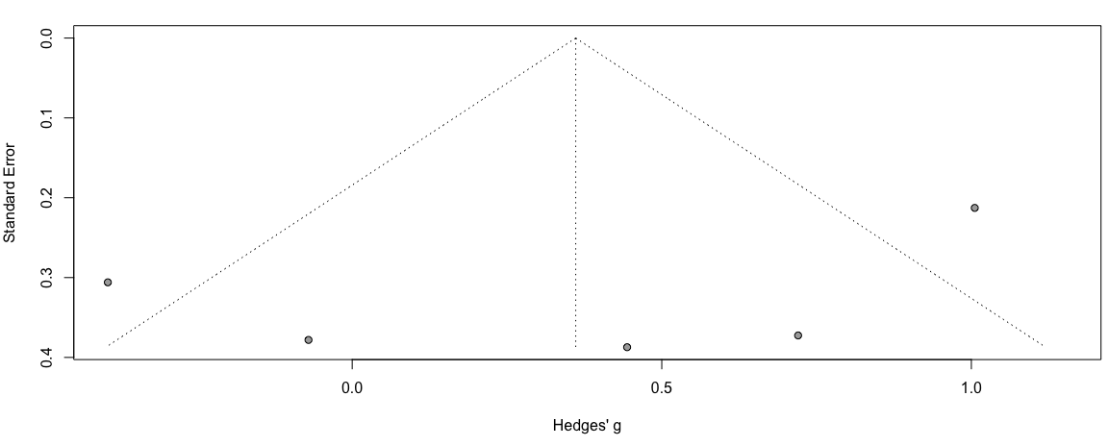
6.7 FLUENCY VERBAL MIGRAINE WITH AURA X MIGRAINE WITHOUT AURA
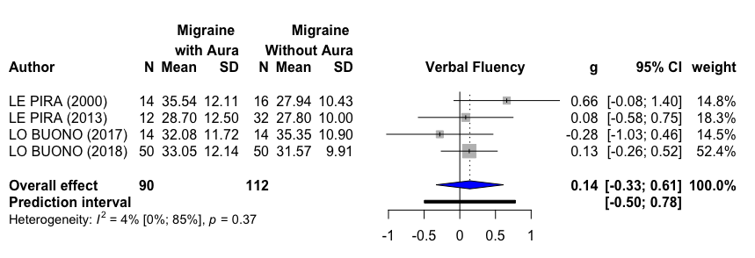
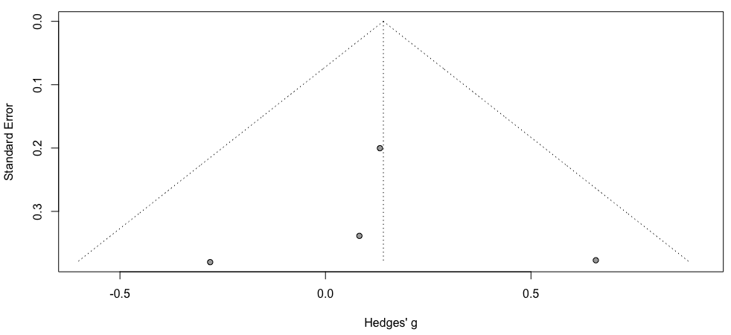
6.8 FLUENCY VERBAL MIGRAINE WITHOUT AURA X CONTROL
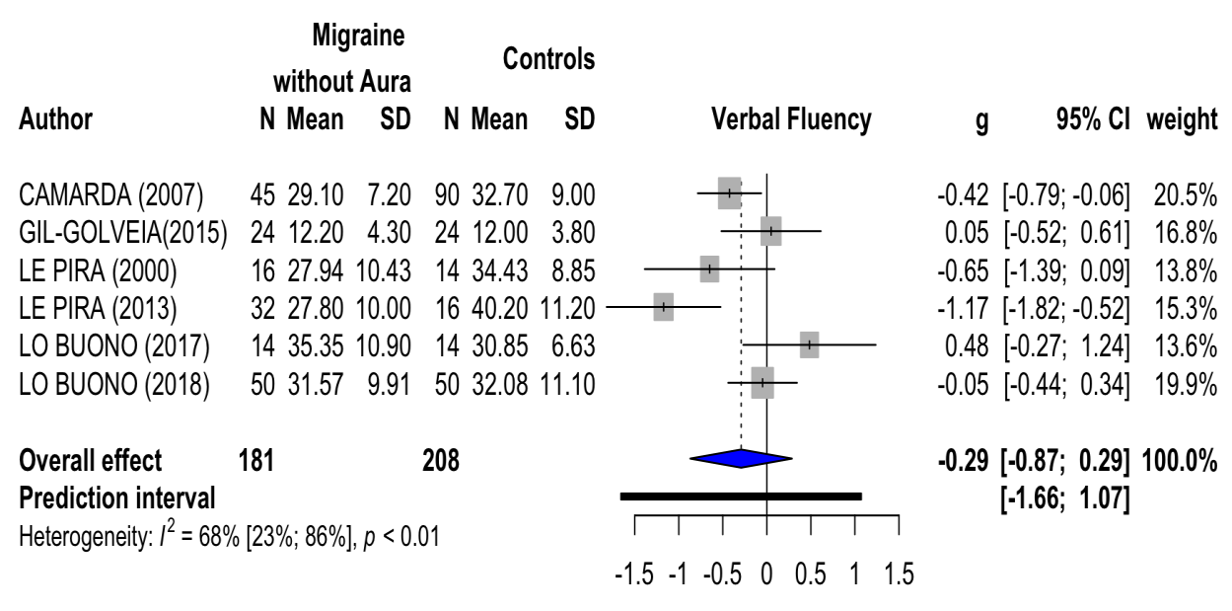
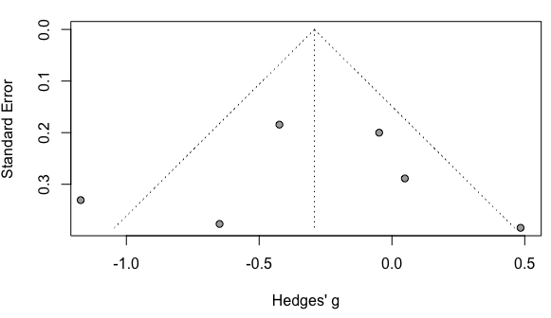
6.9 FLUENCY VERBAL MIGRAINE WITH AURA X CONTROL
