Appendix for the manuscript
News from Messenger? A Cross-National Comparative Study of News Media’s Audience Engagement Strategies via Facebook Messenger

Updated: 24-Aug-2022

Table A1
A list of the 38 countries/regions included in the study and the country-level statistics
Country (region) | IDI | Fb % | Media system | Press freedom
Argentina | 6.79 | 66.50% | Transitional democracies | 28.78
Australia | 8.24 | 68.60% | The liberal model | 20.21
Austria | 8.02 | 49.60% | The democratic corporatist Model | 15.78
Belgium | 7.81 | 64.10% | The polarized pluralist model | 12.57
Brazil | 6.12 | 69.40% | Transitional democracies | 33.92
Bulgaria | 6.86 | 55.50% | The polarized pluralist model | 35.06
Canada | 7.77 | 66.90% | The liberal model | 15.29
Chile | 6.57 | 80.70% | Transitional democracies | 27.31
Croatia | 7.24 | 50.60% | The polarized pluralist model | 28.51
Czech Republic | 7.16 | 44.80% | The democratic corporatist Model | 23.57
Denmark | 8.71 | 70.20% | The democratic corporatist Model | 8.13
Finland | 7.88 | 48.50% | The democratic corporatist Model | 7.93
France | 8.24 | 58.80% | The polarized pluralist model | 17.49
Germany | 8.39 | 44.90% | The democratic corporatist Model | 10.34
Greece | 7.23 | 44.90% | The polarized pluralist model | 28.8
Hong Kong SAR, China | 8.61 | 74.40% | Transitional democracies | 29.6
Hungary | 6.93 | 62.90% | Transitional democracies | 30.84
Ireland | 8.02 | 65.00% | The liberal model | 12.6
Italy | 7.04 | 57.80% | The polarized pluralist model | 23.69
Japan | 8.43 | 37.80% | The liberal model | 28.86
Malaysia | 6.38 | 82.50% | Transitional democracies | 33.12
Mexico | 5.16 | 70.80% | Transitional democracies | 41.36
Netherlands | 8.49 | 64.70% | The democratic corporatist Model | 9.96
Norway | 8.47 | 63.50% | The democratic corporatist Model | 7.84
Poland | 6.89 | 49.10% | Transitional democracies | 28.65
Portugal | 7.13 | 67.40% | The polarized pluralist model | 11.83
Romania | 6.48 | 56.40% | The polarized pluralist model | 25.91
Singapore | 8.05 | 77.20% | Hybrid model | 55.23
Slovakia | 7.06 | 49.70% | The democratic corporatist Model | 22.67
South Africa | 4.96 | 41.00% | Hybrid model | 22.41
South Korea | 8.85 | 83.80% | The liberal model | 23.7
Spain | 7.79 | 60.80% | The polarized pluralist model | 18.48
Sweden | 8.41 | 70.50% | The democratic corporatist Model | 9.25
Switzerland | 8.74 | 43.00% | The democratic corporatist Model | 10.62
Taiwan | 6.04 | 80.80% | The liberal model | 23.76
Turkey | 6.08 | 63.67% | The polarized pluralist model | 45.46
UK | 8.65 | 69.20% | The liberal model | 17.41
US | 8.18 | 90.30% | The liberal model | 23.85

Data sources:
- IDI: https://www.itu.int/net4/ITU-D/idi/2017/index.html#idi2017rank-tab and https://www.itu.int/en/ITU-D/Statistics/Documents/publications/mis2009/MIS2009_w5.pdf
- Facebook penetration rate: https://www.internetworldstats.com/facebook.htm
- Press freedom index: https://rsf.org/en/ranking_table

Table A2
Case selection and supporting references in each country/region (n = 365)
Country (region) | Media organizations selected | Media type | References
Argentina | Clarín | Print | (Márquez-Ramírez et al., 2020)
 | La Nación | Print
 | Página/12 | Print
 | Radio Mitre | Radio | (Newman et al., 2019)
 | TN | Television
 | Telefe | Television
 | Canal 13 | Television
 | C5N | Television
 | América TV | Television
 | A24 | Television
 | Crónica TV | Television
 | Canal 9 | Television
 | TV pública | Television
 | Canal 26 | Television
Australia | The Australian | Print | (Newman et al., 2019)
 | The Australian Financial Review | Print
 | ABC News | Television
Austria | Der Standard | Print | (Kinnebrock, 2012)
 | Kronen Zeitung | Print
 | Kleine Zeitung | Print
 | ORF | Radio | (Newman et al., 2019)
 | ORF1 | Television | (Esser et al., 2012)
 | ORF2 | Television
 | ATV | Television
Belgium | L’Avenir | Print | (Nozal Cantarero et al., 2017)
 | Le Soir | Print
 | Qmusic | Radio | (Newman et al., 2019)
 | Nostalgie | Radio
 | Joe FM | Radio
 | BRT1 | Television | (Esser et al., 2012)
 | BRT2 | Television
 | VTM | Television
Brazil | O Globo | Print | (Nozal Cantarero et al., 2017; Márquez-Ramírez et al., 2020)
 | Estadao | Print
 | Zero Hora | Print | (Márquez-Ramírez et al., 2020)
 | Folha de S. Paulo | Print
 | BandNews | Radio | (Newman et al., 2019)
 | Globo News | Television
 | Record News | Television
 | Jornal do SBT | Television
 | BandNews | Television
 | RedeTV! | Television
 | TV Brasil | Television
Bulgaria | 24 Chasa | Print | (Newman et al., 2019)
 | Telegraf | Print
 | Trud | Print
 | Sega | Print
 | BNR | Radio
 | Darik | Radio
 | NovaTV | Television
 | BTV | Television
 | BNT | Television
 | Bulgaria On Air | Television
 | TV Evropa | Television
 | Kanal 3 | Television
Canada | Toronto Star | Print | (Nozal Cantarero et al., 2017)
 | La Presse | Print
 | CBC | Radio | (Newman et al., 2019)
 | CTV News | Television
 | Global News | Television
 | CityTV | Television
Chile | El Mercurio | Print | (Márquez-Ramírez et al., 2020)
 | La Tercera | Print
 | Las Ultimas Noticias | Print
 | La Cuarta | Print
 | MEGA News | Television | (Newman et al., 2019)
 | Canal 13 | Television
 | Chilevisión | Television
 | TVN | Television
 | Bío Bío Chile | Television
Croatia | 24sata | Print | (Newman et al., 2019)
 | Jutarnji list | Print
 | Večernji list | Print
 | Antena radio | Print
 | Otvoreni radio | Radio
 | Narodni radio | Radio
 | Slobodna Dalmacija | Radio
 | HTV & HR | Television
Czech Republic | Mlada Fronta DNES | Print | (Newman et al., 2019)
 | Blesk | Print
 | Denik | Print
 | Lidove noviny | Print
 | Hospodarske noviny | Print
 | Czech Radio | Radio
 | Radio Impuls | Radio
 | Frekvence 1 | Radio
 | Evropa 2 | Radio
 | CT24 | Television
 | TV Barrandov | Television
 | Televize Seznam | Television
Denmark | B.T. | Print | (Russi et al., 2014)
 | Børsen | Print
 | Ekstra Bladet | Print
 | Jyllands-Posten | Print
 | Politiken | Print
 | MetroXpress | Print
 | Radio 24syv | Radio | (Newman et al., 2019)
 | TV2 | Television | (Deidre et al., 2013)
 | 24NORDJYSKE | Television
 | 24 Sjællandske | Television
Finland | Helsingin Sanomat | Print | (Grönlund & Björkroth, 2011)
 | Ilta-Sanomat | Print
 | Iltalehti | Print
 | Yle News | Television | (Newman et al., 2019)
 | MTV3 | Television
France | Le Figaro | Print | (Alarcón, 2010)
 | Le Monde | Print
 | France Inter | Radio | (Bonini et al., 2014)
 | Le Mouv’ | Radio
 | TF1 | Television | (Newman et al., 2019)
 | BFM TV | Television
 | France Télévisions | Television
 | M6 | Television
 | LCI | Television | (Newman et al., 2019)
Germany | Suddeutsche Zeitung | Print | (Nozal Cantarero et al., 2017; Márquez-Ramírez et al., 2020)
 | Frankfurter Allgemeine Zeitung | Print
 | BILD-Zeitung | Print | (Márquez-Ramírez et al., 2020)
 | 1Live | Radio | (Bonini et al., 2014)
 | Radio Fritz | Radio
 | NDR Kultur | Radio
 | ARD | Television | (Esser et al., 2012)
 | ZDF | Television
 | RTL | Television
 | SAT.1 | Television
Greece | Kathimerini | Print | (Márquez-Ramírez et al., 2020)
 | Nea | Print
 | Eleytheros Typos | Print
 | SKAI | Radio | (Newman et al., 2019)
 | ERT | Radio
 | Real News | Radio
 | ET1 | Television | (Esser et al., 2012)
 | ET2 | Television
 | Mega | Television
 | Antenna | Television
Hong Kong SAR, China | Ta Kung Pao | Print | (Márquez-Ramírez et al., 2020)
 | Ming Pao Daily | Print
 | Apple Daily | Print
 | AM730 | Radio | (Newman et al., 2019)
 | RTHK | Radio
 | TVB | Television
 | RTHK | Television
 | NowTV | Television
Hungary | Blikk | Print | (Márquez-Ramírez et al., 2020)
 | Bors | Print
 | Magyar Nemzet | Print
 | Népszabadság | Print
 | Magyar Rádió | Radio | (Newman et al., 2019)
 | Rádió 1 | Radio
 | Hir TV | Television | (Deidre et al., 2013)
 | Echo TV | Television
Ireland | Irish Independent | Print | (Márquez-Ramírez et al., 2020)
 | Daily Star | Print
 | RTÉ (Radio) | Radio | (Newman et al., 2019)
 | Today FM | Radio
 | Newstalk | Radio
 | RTÉ One (TV) | Television | (Deidre et al., 2013)
Italy | Corriere della Sera | Print | (Nozal Cantarero et al., 2017)
 | Repubblica | Print
 | Radio2 Rai | Radio | (Bonini et al., 2014)
 | Radio3 Rai | Radio
 | RAI1 | Television | (Esser et al., 2012)
 | RAI2 | Television
 | Canale5 | Television
 | Rete4 | Television
Japan | Yomiuri Shimbun | Print | (Newman et al., 2019)
 | Asahi Shimbun | Print
 | Nikkei | Print
 | Mainichi Shimbun | Print
 | Sankei Shimbun | Print
 | Weekly Bunshun | Print
 | NHK | Television
 | Nippon TV | Television
 | Asahi TV | Television
 | Fuji TV | Television
 | TBS | Television
 | TV Tokyo | Television
Malaysia | Berita Harian | Print | (Márquez-Ramírez et al., 2020)
 | Harian Metro | Print
 | New Straits Times | Print
 | The Sun | Print
 | TV3 | Television | (Newman et al., 2019)
 | Astro Awani | Television
 | NTV7 | Television
 | RTM | Television
 | TV9 | Television
 | 8TV | Television
Mexico | Reforma | Print | (Márquez-Ramírez et al., 2020)
 | La Jornada | Print
 | La Prensa | Print
 | Radio Fórmula | Radio | (Newman et al., 2019)
 | TV Azteca | Television
 | Televisa | Television
 | Milenio Televisión | Television
 | Imagen Televisión | Television
Netherlands | NRC Handelsblad | Print | (Berkers et al., 2011)
 | de Volkskrant | Print
 | NOS | Radio | (Newman et al., 2019)
 | BNR | Radio
 | Ned1 | Television | (Esser et al., 2012)
 | Ned2 | Television
 | RTL4 | Television
 | SBS6 | Television
Norway | Aftenposten | Print | (Graedler, 2014)
 | VG | Print
 | NRK | Radio | (Newman et al., 2019)
 | P4 | Radio
 | Radio Norge | Radio
 | NRK1 | Television | (Esser et al., 2012)
 | NRK2 | Television
 | TV2 | Television
 | TVNorge | Television
Poland | Gazeta Wyborcza | Print | (Márquez-Ramírez et al., 2020)
 | Rzeczpospolita | Print
 | Nasz Dziennik | Print
 | Fakt | Print
 | Radio1 Polish Radio | Radio | (Bonini et al., 2014)
 | Polskie Radio SA Programme 3 | Radio
 | Radio 3 Polish Radio | Radio
 | TVP Info | Television | (Deidre et al., 2013)
 | TVN24 | Television
 | TTV | Television
 | Polsat news | Television
Portugal | Correio da Manhá | Print | (Nozal Cantarero et al., 2017)
 | Journal de noticias | Print
 | RFM | Radio | (Newman et al., 2019)
 | TSF | Radio
 | Rádio Renascença | Radio
 | RTP1 | Television | (Esser et al., 2012)
 | RTP2 | Television
 | SIC | Television
 | TV1 | Television
Romania | Adevărul | Print | (Newman et al., 2019)
 | Libertatea | Print
 | Radio Europa FM | Radio
 | Radio Romania | Radio
 | Radio ZU | Radio
 | Pro TV | Television
 | Digi24 | Television
 | Antena 1 | Television
 | Realitatea TV | Television
 | TVR | Television
 | Antena 3 | Television
 | Romania TV | Television
 | B1TV | Television
 | Prima TV | Television
 | Kanal D | Television
Singapore | The Straits Times | Print | (Newman et al., 2019)
 | The New Paper | Print
 | Lianhe Zaobao | Print
 | Lianhe Wanbao | Print
 | Shin Min Daily | Print
 | Berita Harian | Print
 | MediaCorp Radio | Radio
 | MediaCorp Channel News Asia | Television
 | MediaCorp Channel 8 | Television
 | MediaCorp Channel 5 | Television
 | MediaCorp Suria Berita | Television
 | MediaCorp Tamil Seithi | Television
Slovakia | Nový Čas | Print | (Newman et al., 2019)
 | SME | Print
 | Plus 7 dní | Print
 | Pravda | Print
 | Plus Jeden Deň | Print
 | Hospodárske noviny | Print
 | Rádio Expres | Radio
 | Rádio Vlna | Radio
 | Rádio Jemné | Radio
 | Rádio Europa 2 | Radio
 | TV Markíza | Television
 | TV JOJ | Television
 | RTVS | Television
 | TA3 | Television
South Africa | The Sunday Times | Print | (Newman et al., 2019)
 | Daily Sun | Print
 | The Citizen | Print
 | City Press | Print
 | The Star | Print
 | SAFM | Radio
 | SABC Radio | Radio
 | 702/Cape Talk | Radio
 | SABC TV | Television
 | eNCA | Television
 | CNN | Television
 | Sowetan | Television
South Korea | Chosun Ilbo | Print | (Newman et al., 2019)
 | Joongang Ilbo | Print
 | Dong-a Ilbo | Print
 | Hankyoreh Shinmun | Print
 | Maeil Business Newspaper | Print
 | Kyunghyang Shinmun | Print
 | JTBC | Television
 | KBS | Television
 | YTN | Television
 | SBS | Television
 | MBC | Television
 | Yonhap TV | Television
 | MBN | Television
 | TV Chosun | Television
 | Channel A | Television
Spain | El País | Print | (Nozal Cantarero et al., 2017; Márquez-Ramírez et al., 2020)
 | El Mundo | Print
 | La Razón | Print | (Márquez-Ramírez et al., 2020)
 | ABC | Print
 | Radio Nacional de España | Radio | (Bonini et al., 2014)
 | Radio 3 | Radio
 | Catalunya Ràdio | Radio
 | TVE1 | Television | (Esser et al., 2012)
 | TVE2 | Television
 | Antena3 | Television
 | Tele5 | Television
Sweden | Dagens Nyheter | Print | (De Cock et al., 2018)
 | Aftonbladet | Print
 | Sveriges Radio P3 | Radio | (Bonini et al., 2014)
 | Sveriges Radio P4 | Radio
 | SVT1 | Television | (Esser et al., 2012)
 | SVT2 | Television
 | TV3 | Television
 | TV4 | Television
Switzerland | Neue Zurcher Zeitung | Print | (Nozal Cantarero et al., 2017; Márquez-Ramírez et al., 2020)
 | 24 heures | Print | (Nozal Cantarero et al., 2017)
 | Blick | Print | (Márquez-Ramírez et al., 2020)
 | Le Temps | Print
 | Le Matin | Print
 | Corriere del Ticino | Print
 | RTS | Radio | (Newman et al., 2019)
 | SF1 | Television | (Esser et al., 2012)
 | SF2 | Television
 | TeleZüri | Television
 | TeleBärn | Television
Taiwan | Liberty Times | Print | (Newman et al., 2019)
 | China Times | Print
 | TVBS | Print
 | Chung Tien | Television
 | Next TV | Television
 | Taiwan Television | Television
Turkey | Sözcü | Print | (Newman et al., 2019)
 | Cumhuriyet | Print
 | Fox TV | Television
 | CNN Türk | Television
 | NTV | Television
 | TRT | Television
 | Kanal D | Television
 | ATV | Television
 | Habertürk TV | Television
 | Star TV | Television
 | Show TV | Television
 | Ahaber | Television
UK | The Sun | Print | (Nozal Cantarero et al., 2017)
 | Daily Telegraph | Print
 | BBC Radio 1 | Radio | (Bonini et al., 2014)
 | BBC Radio 4 | Radio
 | BBC Radio 5 | Radio
 | BBC1 | Television | (Esser et al., 2012)
 | BBC2 | Television
 | ITV1 | Television
 | C4 | Television
US | The New York Times | Print | (Nozal Cantarero et al., 2017; Márquez-Ramírez et al., 2020)
 | USA Today | Print
 | Washington Post | Print | (Márquez-Ramírez et al., 2020)
 | Los Angeles Times | Print
 | Wall Street Journal | Print
 | NPR | Radio | (Pew Research Center, 2016)
 | Fox News | Television
 | CNN | Television
 | MSNBC/NBC | Television

References for the case selection reported in Table A2

Alarcón, A. V. M. (2010). Media representation of the European Union: Comparing newspaper coverage in France, Spain and the United Kingdom. International Journal of Communication, 4(18), 398-415.
Berkers, P., Janssen, S., & Verboord, M. (2011). Globalization and ethnic diversity in Western newspaper coverage of literary authors: Comparing developments in France, Germany, the Netherlands, and the United States, 1955 to 2005. American Behavioral Scientist, 55(5), 624-641. https://doi.org/10.1177/0002764211398083
Bonini, T., Fesneau, E., Perez, J., Luthje, C., Jedrzejewski, S., Pedroia, A., ... & Stiernstedt, F. (2014). Radio formats and social media use in Europe–28 case studies of public service practice. Radio Journal: International Studies in Broadcast & Audio Media, 12(1-2), 89-107. https://doi.org/10.1386/rjao.12.1-2.89_1
De Cock, R., Mertens, S., Sundin, E., Lams, L., Mistiaen, V., Joris, W., & d’Haenens, L. (2018). Refugees in the news: Comparing Belgian and Swedish newspaper coverage of the European refugee situation during summer 2015. Communications, 43(3), 301-323. https://doi.org/10.1515/commun-2018-0012
Deidre, K., Pellicanò, F., & Schneeberger, A. (2013, October). Television news channels in Europe: Based on a report prepared by the European Audiovisual Observatory for the European Commission—DG COMM. http://www.obs.coe.int/documents/205595/264629/ European+news+Market+2013+FINAL.pdf/116afdf3-758b-4572-af0f-61297651ae80
Esser, F., De Vreese, C. H., Strömbäck, J., Van Aelst, P., Aalberg, T., Stanyer, J., ... & Reinemann, C. (2012). Political information opportunities in Europe: A longitudinal and comparative study of thirteen television systems. The International Journal of Press/Politics, 17(3), 247-274. https://doi.org/10.1177/1940161212442956
Graedler, A. L. (2014). Attitudes towards English in Norway: A corpus-based study of attitudinal expressions in newspaper discourse. Multilingua-Journal of Cross-Cultural and Interlanguage Communication, 33(3-4), 291-312. https://doi.org/10.1515/multi-2014-0014
Grönlund, M., & Björkroth, T. (2011). Newspaper market concentration, competitive pressure and financial performance: The case of Finland. Journal of Media Business Studies, 8(3), 19-50. https://doi.org/10.1080/16522354.2011.11073525
Kinnebrock, S. (2012). Puzzling gender differently? Acomparative study of newspaper coverage in Austria, Germany and Switzerland. Interactions: Studies in Communication & Culture, 2(3), 197-208. https://doi.org/10.1386/iscc.2.3.197_1
Márquez-Ramírez, M., Mellado, C., Humanes, M. L., Amado, A., Beck, D., Davydov, S., ... & Wang, H. (2020). Detached or interventionist? Comparing the performance of watchdog journalism in transitional, advanced and non-democratic countries. The International Journal of Press/Politics, 25(1), 53-75. https://doi.org/10.1177/1940161219872155
Newman, N., Fletcher, R., Kalogeropoulos, A., & Nielsen, R. K. (2019). Reuters institute digital news report 2019. Reuters Institute fort he Study of Journalism. https://reutersinstitute.politics.ox.ac.uk/sites/default/files/inline-files/DNR_2019_FINAL.pdf
Nozal Cantarero, T., González-Neira, A., & Valentini, E. (2020). Newspaper apps for tablets and smartphones in different media systems: A comparative analysis. Journalism, 21(9), 1264–1282. https://doi.org/10.1177/1464884917733589
Pew Research Center (Ed.). (2016). The state of the news media 2016. http://assets.pewresearch.org/wp-content/uploads/sites/13/2016/06/30143308/state-of-the-news-media-report-2016-final.pdf
Russi, L., Siegert, G., Gerth, M. A., & Krebs, I. (2014). The relationship of competition and financial commitment revisited: A fuzzy set qualitative comparative analysis in European newspaper markets. Journal of Media Economics, 27(2), 60-78. https://doi.org/10.1080/08997764.2014.903958

Table A3
A full list of the annotating queries on news recommendation and search goals and text inputs for the annotators
Recommendation and search goals | Description | Sentence Query | Keywords Query
1. Objective | based on known information
Query #1: news genre | “type or category” | I want to know the latest situation of covid-19. | Latest news on covid-19
Query #2: language | We selected two languages: one is Chinese; and another is the native language of the annotators | 你會說中文嗎？ | 中文 Chinese
Query #3: release date | We picked up a date when WHO announces the Covid-19 as a global pandemic. | I want to know some news stories on covid-19 on 12 Mar 2020. | Covid-19 on 12 Mar 2020
Query #4: Region | primary places where the news event is happened | I want to know some news stories on covid-19 in the DC Washington | Covid-19 DC Washington
Query #5: deep features of the news | Exemplars in the news | I want to read an investigative report on the immigrants of covid-19 prevention. | Covid-19 immigrants
Query #6: people in the news | people featured in the news story (the national leader in our study) | I want to know how Donald Trump discusses the covid-19. | Covid-19 Donald Trump
2. Informational
Query #7: advice |  | Tell me how to avoid being infected for the covid-19. | Avoid being infected by covid-19
Query #8: un-directed | tell me about X | Tell me about the quarantine policy in the New York City | Quarantine covid-19 New York City
Query #9: directed-closed | a question with a single and non-ambiguous answer | What is the current quarantine policy in [the largest city of the country]? | Quarantine policy [the largest city of the country]
Query #10: directed-open | a question with an open answer | Why the New York City would have such a crazy current quarantine policy? | Why Quarantine policy New York City
Query #11: list | a list of information | Tell me where to get the information about the covid-19 | Information about the covid-19
Query #12: locate | some real-world service can be provided | Tell me where to get masks! | Masks store
3. Subjective
Query #13: emotion |  | Do you have some good news on covid-19 to share? | Happy news covid-19
Query #14: Quality |  | Do you have some credible news stories on covid-19 to share with me? | Credible news covid-19
Query #15: relationship to another news (sports) | We selected three international news on different beats | Do you have some news on covid-19 that is related to the Tokyo Olympics? | Covid-19 Olympics
Query #16: relationship to another news (politics) | We selected three international news on different beats | Do you have some news on covid-19 that is related to the 2020 US Election? | Covid-19 Election
Query #17: relationship to another news (finance) | We selected three international news on different beats | Do you have some news on covid-19 that is related to the Dow Jones Index? | Covid-19 Dow Jones
4. Resource
Query #18: obtain | to obtain a resource that does not require a computer to use, such as print it out and show on the screen, etc. | “I want to get a table showing the numbers of confirmed cases in different countries all around the world” | Numbers of confirmed cases global
Query #19: interact | interact with a resource using another program/services available on the website | Can I contact the news editor of this news story? | Contacting
Query #20: download | to download a resource to my computers. | I want to download the podcast audio files. | App download
Query #21: entertainment |  | Do you have some music to play? | Music to play
5. Navigation | as a goal of the initial search
Query #22: navigation | go to a specific known website | I want to go to the webpage of the New York Times. | The website of New York Times
The search queries are modified from Kang et al (2017, p. 233), Rose and Levinson (2004, p. 15)

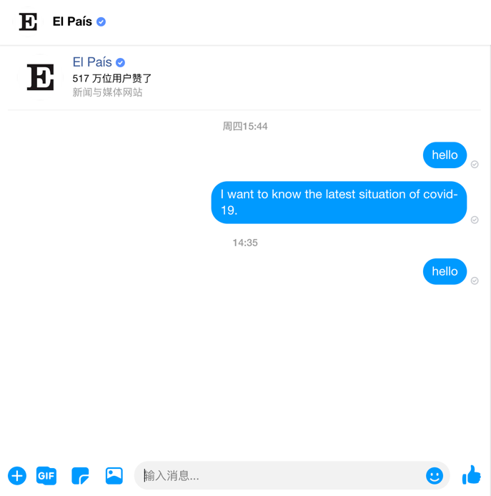

Figure A1: non-workable chatbots: not being able to produce any message

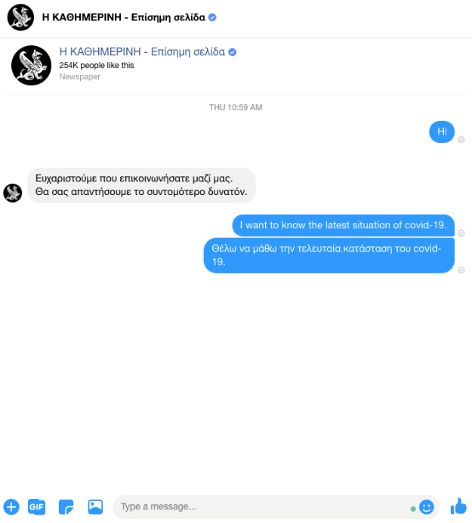 | 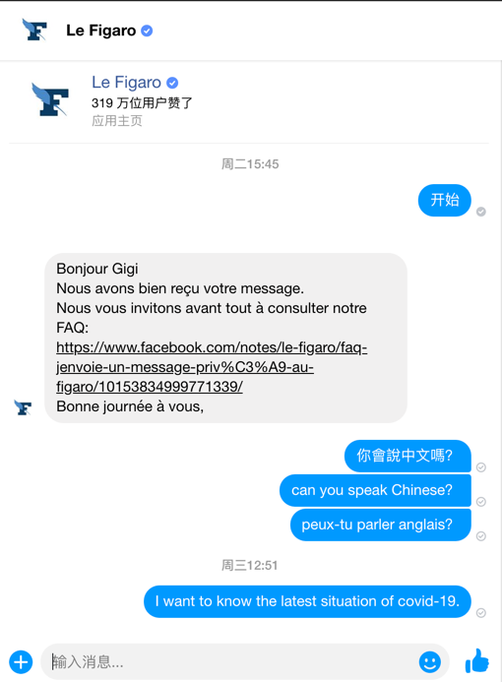

Figure A2: examples of workable but out-of-service chatbots

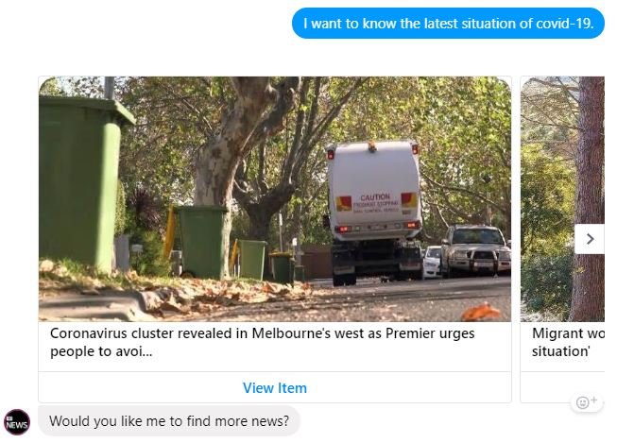 | 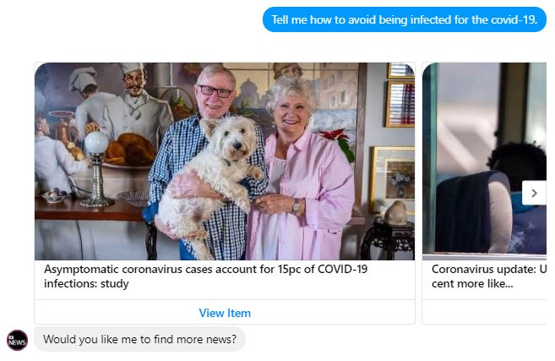
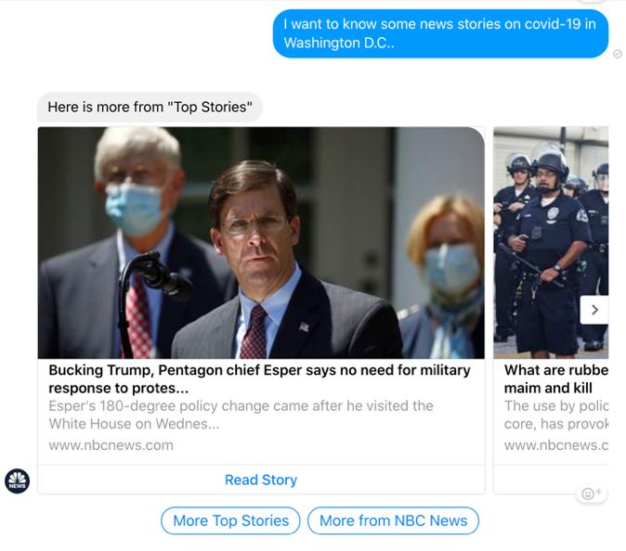 | 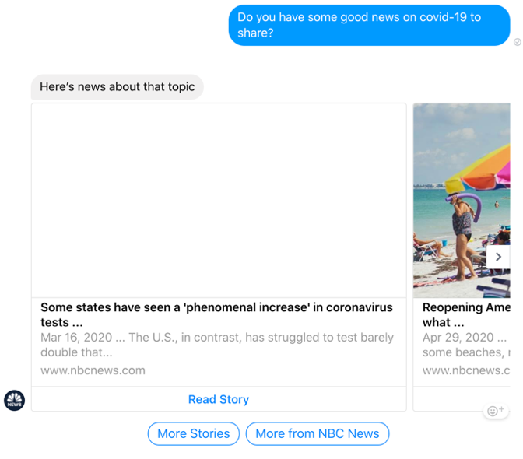
Figure A3: examples of workable chatbots: producing responses to most of the queries with news articles

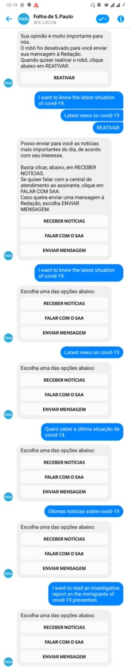 | 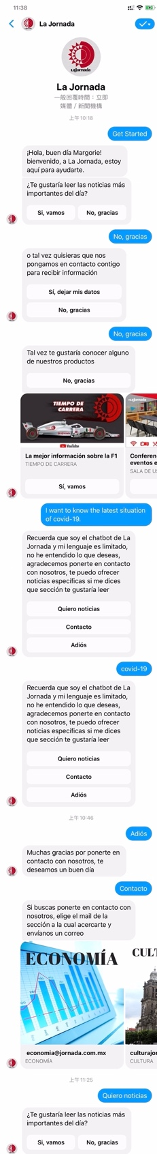
Figure A4: examples of chatbots’ reparative strategies: offering pre-defined options as responding to the search queries

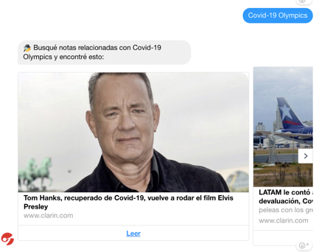 | 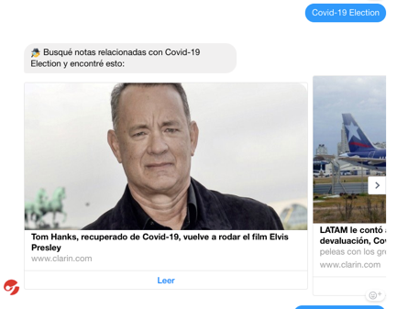 | 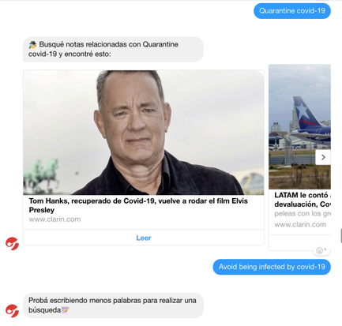
Figure A5-1: When searching three different keywords, the chatbot returned the same results (Clarin)

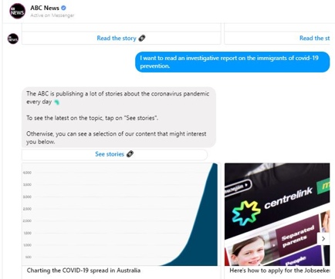 | 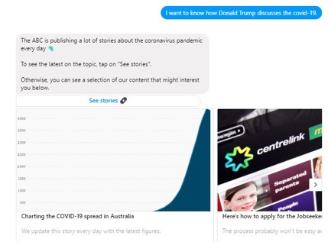 | 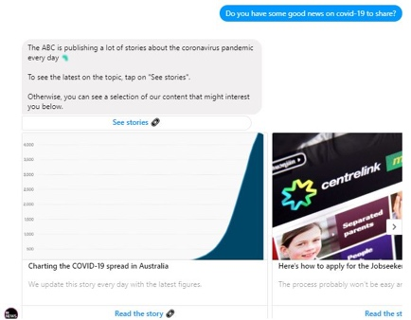

Figure A5-2: When searching three different keywords, the chatbot returned the same results (ABC)

