**Quantification of economically feasible mitigation potential from agriculture, forestry and other land uses in Mexico**

## **Supplemental Materials**

#### **Crop data sources**

Maize, wheat and sugarcane are Mexico’s major crops, accounting for over 70% of national fertilizer use (IFA 2017) and therefore the bulk of emissions from crop production. Current crop management information for maize and wheat were obtained from the electronic field book of the Sustainable Modernization of Traditional Agriculture program (MasAgro) (CIMMYT 2019), which records plot level information on planting and crop management, fertilizer applications and yield, and geo-referencing of plot locations (Fig. S1). Plot-specific soil data, including pH, organic carbon (C) and nitrogen (N) content and bulk density, were obtained from Mexico’s Instituto Nacional de Investigaciones Forestales y Agrícolas y Pecuarias (INIFAP 1995) and from the International Soil Reference and Information Centre (ISRIC) (Hengl et al. 2017). Climate zone designations were based on Intergovernmental Panel on Climate Change (IPCC) climate categories (IPCC 2006) (Fig. S2). State and district level areas under specific crops and their yield levels were obtained from the Servicio de Información Agroalimentaria y Pesquera (SIAP) for 2017 and 2018 (SIAP 2019).

In addition, a database was utilized that covered crop-specific inorganic and organic fertilizer use data by district as well as production system divided by rainfed and irrigated agriculture, derived from point observations from microdata results of the 2014 Encuesta Nacional Agropecuaria (ENA), a representative partial census of agricultural activities, (INEGI 2015; Ysimoto Monroy, 2020).

#### **Livestock data sources**

Municipal-level data on livestock population numbers and average weight of dairy and beef cattle and swine were obtained from SIAP (SIAP 2019). Beef and dairy cattle populations were divided based on the 2017 ENA (INEGI 2017) into three groups: animals under grazing management (AGM), confined animals (ACM) and animals under grazing-confinement management (AGCM). For nutritional characteristics under AGM, we used the results of Muñoz-González et al. (2016) and Reyes et al. (2009). For ACM and based on SARGARPA et al. (2010), we used the nutritional characteristics of maize, wheat and soybean (Hazard et al. 2004). Nutritional characteristics for AGCM comprised combinations of AGM and ACM.

Swine populations were divided into two groups: swine under intensive production (SIP) and swine under family production (SFP). For each, total populations were separated into breeding and market swine, based on the 2017 ENA (INEGI 2017). Swine production parameters were obtained from the LATAM-Benchmark of the Pig Improvement Company (PIC 2014).

Descriptions for swine, dairy and beef cattle manure and managements systems (M&MS) came from the Inventario Nacional de Emisiones de Gases y Compuestos de Efecto Invernadero (National GHG Inventory Report) of the Instituto Nacional de Ecología y Cambio Climático (INECC 2018). Climate conditions used for M&MS were obtained from the annual climate report of the Comisión Nacional del Agua (CONAGUA 2017). Mitigation options and mitigation potential were derived from official NDCs (República 2015), while costs were calculated according to Granollers (2016) and the Instituto Internacional de Recursos Renovables (IRRI 2014).

#### **FOLU data sources**

The FOLU baseline emissions and removals and future BAU scenarios or mitigation potentials described below were not estimated in this study but recovered from other sources and official studies:

1. Baseline scenario: National Inventory of Greenhouse Gas Emissions 1990-2015 and Forest Reference Emission Level of Six Mexican states: Campeche, Chiapas, Jalisco, Oaxaca, Quintana Roo and Yucatán.
2. BAU scenario for 2030 and mitigation potential of three goals for the FOLU sector: Developing implementation pathways for the nationally determined contributions to greenhouse gas and compounds (GYCEI) mitigation in the land use and forestry sector.
3. Mitigation potential in this study: Eight environmental indicators were used to determine the target population; six are from the list of the National System of Environmental Indicators and the two are from the Secretaría de Bienestar (Ministry of Welfare).

The emission factors and the maximum C densities calculated for Mexico and six stateswere used by the Specialized Technical Unit for Monitoring, Reporting and Verification of the National Forestry Commission during the compilation of the National Greenhouse Gas Inventory 1990-2015 (Annex FOLU S2).

## **Supplemental Tables and Figures**

|  |  |  |
| --- | --- | --- |
| **Table S1:** The government of Mexico has set the following three goals and courses of action in the USCUSS* sector. | | |
| **Goal** | **Objective** | **Course of action** |
| 0% net deforestation by 2030 | Reach a 0% net deforestation rate by 2030. | 1. Maintain the change from TNF to non-commercial TF. |
| 2. Reduce the changeover area from TF to TNF. |
| Sustainable forest management | Increase total biomass stocks in ecosystems under sustainable forest management. | 1. Improve the productivity of natural forest areas under commercial timber management. |
| 2. Incorporate natural forest areas without management to natural forest areas under commercial timber management. |
| 3. Incorporate new commercial forest plantations areas. |
| 4. Increase timber forest production. |
| Management of Natural Protected Areas (ANP) | Carry out good management of carbon stocks in protected natural areas to increase their impacts of CO2 sinks. | 1. Reduce deforestation in ANP. |
| 2. Increase rehabilitation area (reforested) in the ANPs. |

*Uso de Suelo, Cambio de Uso de Suelo y Silvicultura (Soil Use, Changes in Soil and Forestry Use).

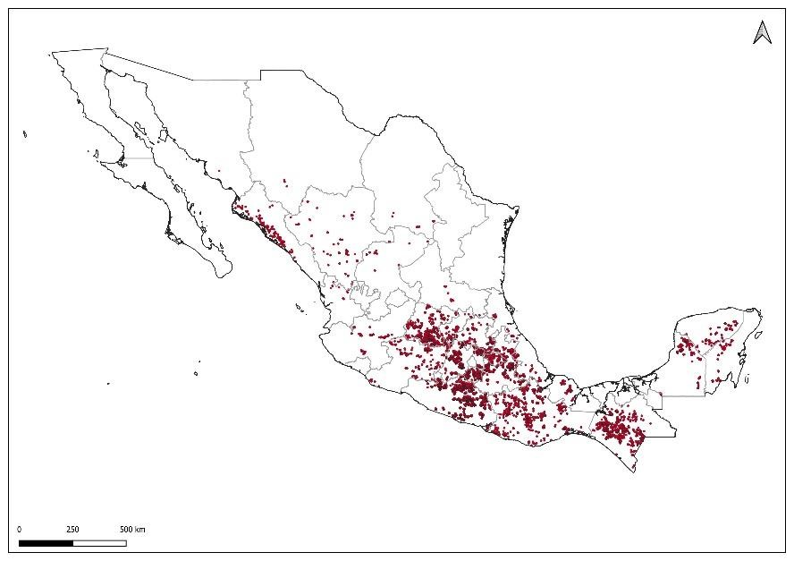

**Figure S1:** Distribution of plots with maize and wheat farming locations recorded in the electronic field book of MasAgro with management information for crops included in the model.

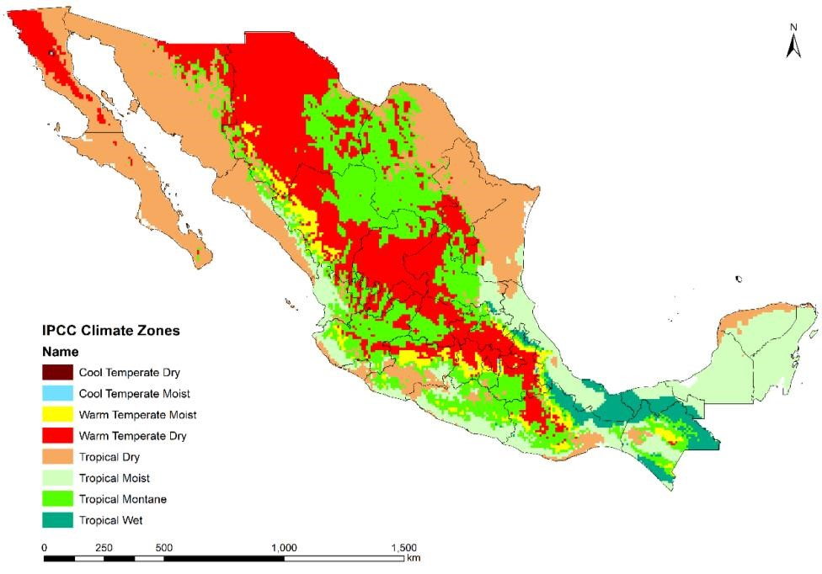

**Figure S2:** IPCC climate categories in Mexico included in the model.



**Figure S3:** Livestock emissions in Mexico under scenario base (2017), BAU and mitigation scenario (2030).

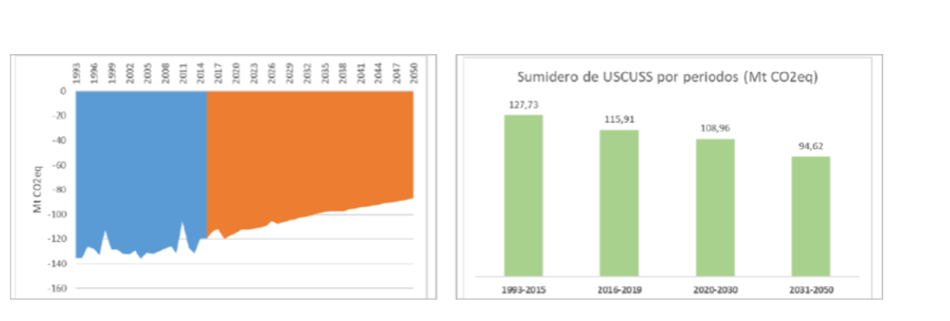

**Figure S4:** BAU scenario for FOLU (USCUSS) subsector.

Source: INECC 2018. Instrumentation development routes for the nationally determined contributions on Greenhouse Gases and Compounds (GYCEI) mitigation of the Land Use and Forestry sector in Mexico (p. 55-56).

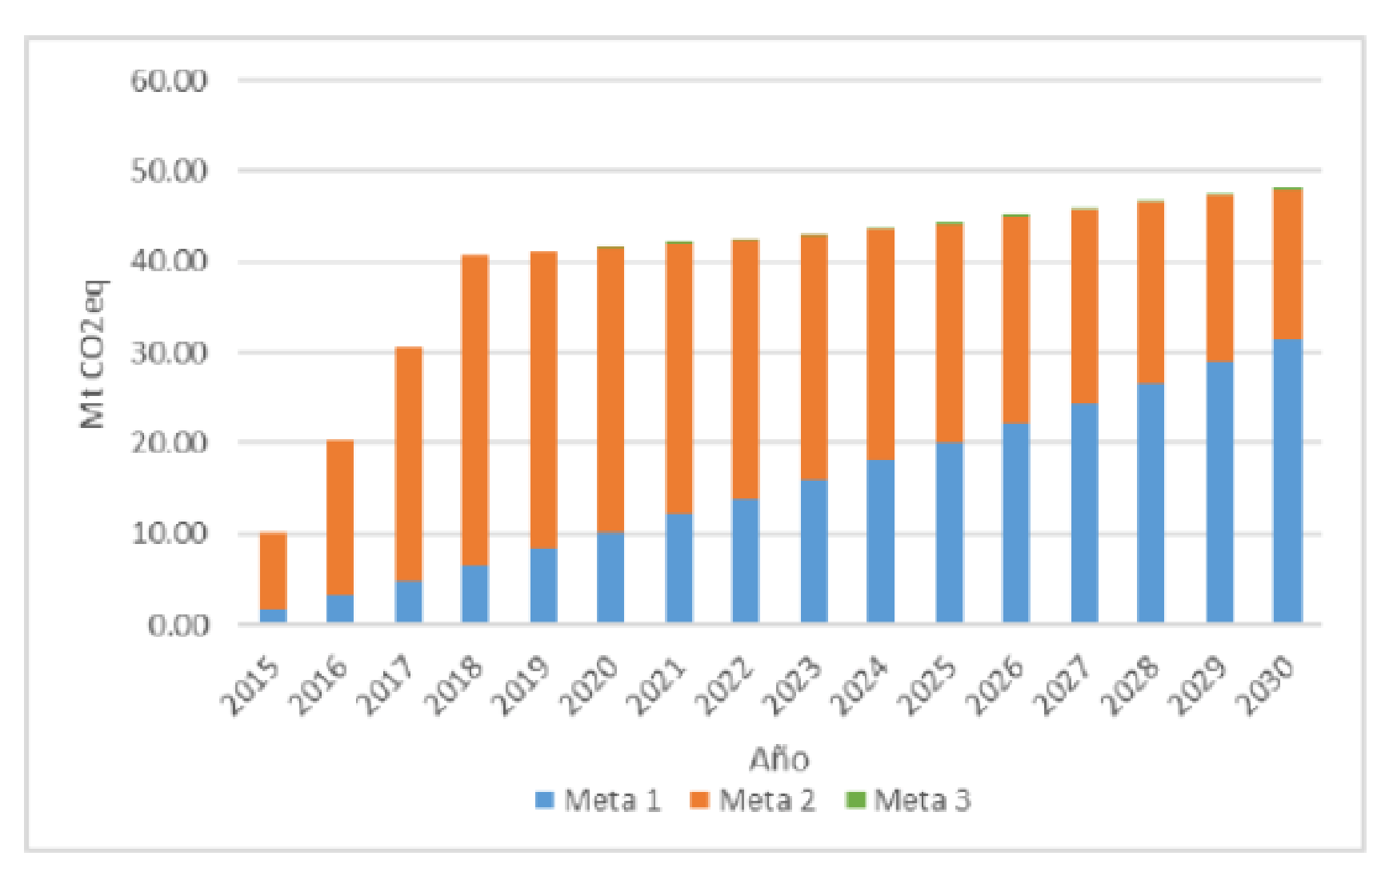

**Figure S5:** Mitigation potential goals by 2030 in the FOLU subsector, established and evaluated by the Mexican government.

## **Annex FOLU S1**

**Supuestos y parámetros / Assumptions and parameters**

1. Población potencial / Potential population

|  |  |  |  |
| --- | --- | --- | --- |
| **Programas de gobierno incluidos / Government programs included** | |  |  |
| **Consecutivo**  **/ Order** | **Nombre del Indicador / Indicator** | **Acrónimo/**  **Acronym** | **Institution/**  **Organization** |
| 1 | Superficie reforestada / Reforested area | REFO | CONAFOR |
| 2 | Superficie PFC plantada y verificada / PFC area planted and verified) | PFC | CONAFOR |
| 3 | Superficie autorizada MFS Maderable / Authorized surface MFS Timber | MFMAD | CONAFOR |
| 4 | Superficie autorizada PM Vida Silvestre / Authorized surface PM Wildlife | MVS | CONAFOR |
| 5 | Superficie en PSA Hidrológicos / Area in Hydrological PSA | PSAH | CONAFOR |
| 6 | Superficie en PSA Biodiversidad / Area in PSA Biodiversity | PSAB | CONAFOR |
| 7 | Sembrando Vida - Agroforestal / Sowing Life - Agroforestry | SVAF | Secretaría del Bienestar |
| 8 | Sembrando Vida - Forestal / Sowing Life - Forests | SVF | Secretaría del Bienestar |

|  |  |  |
| --- | --- | --- |
| **Parámetros / Paremeters** |  |  |
|  | ***De*** | ***A*** |
| Periodo de la Población Potencial / Potential  Population Period | 2010 | 2020 |

1. Población objetivo / Target population

|  |  |
| --- | --- |
| **Escenario / Scenerio** | **Porcentaje P. Potencial / Potential P. Percentage** |
| Pesimista / Pessimistic | 20% |
| Intermedio / Intermediate | 25% |
| Optimista / Optimistic | 30% |

1. Población atendida / Population served

|  |  |  |  |  |  |  |  |
| --- | --- | --- | --- | --- | --- | --- | --- |
| Parámetros / Paremeters | | | | | | | |
| **Escenario / Scenerio** | **2019** | **2020** | **2021** | **2022** | **2023** | **2024** | **Total** |
| Pesimista / Pessimistic | 0% | 0% | 25% | 25% | 25% | 25% | 100% |
| Intermedio / Intermediate | 0% | 0% | 33% | 33% | 34% | 0% | 100% |
| Optimista / Optimistic | 0% | 0% | 50% | 50% | 0% | 0% | 100% |

1. Cálculo de línea base / Baseline calculation

Parámetros / Paremeters

Transiciones asiganadas por actividad (programa) / Transitions assigned by activity (program)

|  |  |  |  |  |  |  |  |  |
| --- | --- | --- | --- | --- | --- | --- | --- | --- |
| **Consecutivo /**  **Order** | **Acrónimo /**  **Acronym** | **Transición asignada / Assigned transition** | **ID**  **Transición** | **BA** | **BS** | **MM** | **HOJ** | **COS** |
| 1 | REFO | Tierras convertidas a tierras forestales / Land converted to forest | 6_9 | X | X |  |  |  |
| 2 | PFC | Tierras convertidas a tierras forestales | 6_9 | X | X |  |  |  |
| 3 | MFMAD | Tierras forestales que permanecen como tales / Remaining forest lands | 6_1 | X | X |  |  |  |
| 4 | MVS | Tierras forestales que permanecen como tales | 6_1 | X | X |  |  |  |
| 5 | PSAH | Tierras forestales que permanecen como tales | 6_1 | X | X |  |  |  |
| 6 | PSAB | Tierras forestales que permanecen como tales | 6_1 | X | X |  |  |  |
| 7 | SVAF | Tierras convertidas a tierras forestales | 6_9 | X | X |  |  |  |
| 8 | SVF | Tierras convertidas a tierras forestales | 6_9 | X | X |  |  |  |

Porcentajes de la densidad máxima de Carbono por escenario y por estado al inicio del programa / Percentages of the maximum carbon density by stage and by state at the beginning of the program

|  |  |  |  |
| --- | --- | --- | --- |
| **Escenario / Scenario** | **Transición / Transition** | **% al inicio del programa / % at program start** | **% al fin del programa / % at program end** |
| Pesimista / pessisistic | Tierras convertidas a tierras forestales / Land converted to forest | 0% | 90% |
| Pesimista | Tierras forestales que permanecen como tales / Remaining forest lands | 85% | 90% |
| Intermedio / intermediate | Tierras convertidas a tierras forestales | 0% | 95% |
| Intermedio | Tierras forestales que permanecen como tales | 80% | 95% |
| Optimista / optimistic | Tierras convertidas a tierras forestales | 0% | 100% |
| Optimista | Tierras forestales que permanecen como tales | 75% | 100% |

Densidad máxima de Carbono por escenario y por estado al inicio y al fin del programa / Maximum Carbon Density by stage and by state at the beginning and end of the program

|  |  |  |  |  |  |
| --- | --- | --- | --- | --- | --- |
| **ID**  **Referencia** | **Escenario / Scenario** | **Id**  **Transición** | **Control 2** | **Starting stock**  **(tC/ha)** | **End stock**  **(tC/ha)** |
| 52 | Pesimista / pessisistic | 6_9 | 52_P_6_9 | - | 28.48 |
| 52 | Pesimista | 6_1 | 52_P_6_1 | 26.90 | 28.48 |
| 52 | Intermedio / intermediate | 6_9 | 52_I_6_9 | - | 30.06 |
| 52 | Intermedio | 6_1 | 52_I_6_1 | 25.32 | 30.06 |
| 52 | Optimista / optimistic | 6_9 | 52_O_6_9 | - | 31.65 |
| 52 | Optimista | 6_1 | 52_O_6_1 | 23.74 | 31.65 |
| 04 | Pesimista | 6_9 | 04_P_6_9 | - | 37.05 |
| 04 | Pesimista | 6_1 | 04_P_6_1 | 35.00 | 37.05 |
| 04 | Intermedio | 6_9 | 04_I_6_9 | - | 39.11 |
| 04 | Intermedio | 6_1 | 04_I_6_1 | 32.94 | 39.11 |
| 04 | Optimista | 6_9 | 04_O_6_9 | - | 41.17 |
| 04 | Optimista | 6_1 | 04_O_6_1 | 30.88 | 41.17 |
| 07 | Pesimista | 6_9 | 07_P_6_9 | - | 37.21 |
| 07 | Pesimista | 6_1 | 07_P_6_1 | 35.15 | 37.21 |
| 07 | Intermedio | 6_9 | 07_I_6_9 | - | 39.28 |
| 07 | Intermedio | 6_1 | 07_I_6_1 | 33.08 | 39.28 |
| 07 | Optimista | 6_9 | 07_O_6_9 | - | 41.35 |
| 07 | Optimista | 6_1 | 07_O_6_1 | 31.01 | 41.35 |
| 14 | Pesimista | 6_9 | 14_P_6_9 | - | 30.07 |
| 14 | Pesimista | 6_1 | 14_P_6_1 | 28.39 | 30.07 |
| 14 | Intermedio | 6_9 | 14_I_6_9 | - | 31.74 |
| 14 | Intermedio | 6_1 | 14_I_6_1 | 26.72 | 31.74 |
| 14 | Optimista | 6_9 | 14_O_6_9 | - | 33.41 |
| 14 | Optimista | 6_1 | 14_O_6_1 | 25.05 | 33.41 |
| 20 | Pesimista | 6_9 | 20_P_6_9 | - | 32.01 |
| 20 | Pesimista | 6_1 | 20_P_6_1 | 30.23 | 32.01 |
| 20 | Intermedio | 6_9 | 20_I_6_9 | - | 33.78 |
| 20 | Intermedio | 6_1 | 20_I_6_1 | 28.45 | 33.78 |
| 20 | Optimista | 6_9 | 20_O_6_9 | - | 35.56 |
| 20 | Optimista | 6_1 | 20_O_6_1 | 26.67 | 35.56 |
| 23 | Pesimista | 6_9 | 23_P_6_9 | - | 41.87 |
| 23 | Pesimista | 6_1 | 23_P_6_1 | 39.55 | 41.87 |
| 23 | Intermedio | 6_9 | 23_I_6_9 | - | 44.20 |
| 23 | Intermedio | 6_1 | 23_I_6_1 | 37.22 | 44.20 |
| 23 | Optimista | 6_9 | 23_O_6_9 | - | 46.53 |
| 23 | Optimista | 6_1 | 23_O_6_1 | 34.89 | 46.53 |
| 31 | Pesimista | 6_9 | 31_P_6_9 | - | 21.92 |
| 31 | Pesimista | 6_1 | 31_P_6_1 | 20.70 | 21.92 |
| 31 | Intermedio | 6_9 | 31_I_6_9 | - | 23.13 |
| 31 | Intermedio | 6_1 | 31_I_6_1 | 19.48 | 23.13 |
| 31 | Optimista | 6_9 | 31_O_6_9 | - | 24.35 |
| 31 | Optimista | 6_1 | 31_O_6_1 | 18.26 | 24.35 |

Factores de emisión por entidad por transición / Emission factors by entity by transition

|  |  |  |  |  |  |  |  |
| --- | --- | --- | --- | --- | --- | --- | --- |
| **ID Referencia** | **Referencia** | **ID**  **Transición** | **ID**  **Mapa** | **Factor** | **Control** | **BA**  **(tC/ha/año)** | **BS**  **(tC/ha/año)** |
| 52 | Nacional | 6_9 | 6_4 | 0.33333333  3 | 52_6_9_6_4 | 0.796669706 | 0.195536856 |
| 52 | Nacional | 6_1 | 6_4 | 1 | 52_6_1_6_4 | 0.312243802 | 0.077334398 |
| 04 | Campeche | 6_9 | 6_4 | 0.33333333  3 | 04_6_9_6_4 | 1.185780397 | 0.289739972 |
| 04 | Campeche | 6_1 | 6_4 | 1 | 04_6_1_6_4 | 0.66723378 | 0.160991767 |
| 07 | Chiapas | 6_9 | 6_4 | 0.33333333  3 | 07_6_9_6_4 | 1.464924784 | 0.359569789 |
| 07 | Chiapas | 6_1 | 6_4 | 1 | 07_6_1_6_4 | 1.04596598 | 0.250830811 |
| 14 | Jalisco | 6_9 | 6_4 | 0.33333333  3 | 14_6_9_6_4 | 0.87869991 | 0.224557991 |
| 14 | Jalisco | 6_1 | 6_4 | 1 | 14_6_1_6_4 | 0.462905596 | 0.113499598 |
| 20 | Oaxaca | 6_9 | 6_4 | 0.33333333  3 | 20_6_9_6_4 | 1.109389507 | 0.26840764 |
| 20 | Oaxaca | 6_1 | 6_4 | 1 | 20_6_1_6_4 | 0.914213304 | 0.213815382 |
| 23 | Quintana  Roo | 6_9 | 6_4 | 0.33333333  3 | 23_6_9_6_4 | 1.29874748 | 0.32172026 |
| 23 | Quintana  Roo | 6_1 | 6_4 | 1 | 23_6_1_6_4 | 0.050490827 | 0.014057427 |
| 31 | Yucatán | 6_9 | 6_4 | 0.33333333  3 | 31_6_9_6_4 | 0.239627008 | 0.239627008 |
| 31 | Yucatán | 6_1 | 6_4 | 1 | 31_6_1_6_4 | 0.866397632 | 0.218517768 |

1. Absorciones al año de proyección / Absorptions at one year of projection:

|  |
| --- |
| **Año de proyección / Projection year** |
| 2030 |

1. Costos / Cost:

|  |  |
| --- | --- |
| **Parámetros / Paremeters** |  |
| Superficie promedio por proyecto / Average surface per project (ha) | 5,000 |
| Intensidad de muestreo / Sampling intensity (%) | 3% |
| Costo unitario asistencia técnica ($/proyecto) / Unit cost technical assistance ($/draft) | $500,000.00 |
| Costo unitario parcela de inventario ($/parcela) / Inventory parcel unit cost ($/parcel) | $750.00 |
| Costo unitario georeferenciación / Georeferencing unit cost ($/ha) | $15.00 |
| Costo unitario supervisión ($/proyecto) / Supervision unit cost ($/project) | $200,000.00 |

## **Annex FOLU S2**

Densidades máximas de carbono en la biomasa de bosques y selvas primarios y factores de emisión en tierras que permanecen como bosque y en tierras convertidas en bosque en México y seis estados del país / Maximum carbon densities in the biomass of primary forests and jungles and emission factors in lands that remain as forests and in lands converted to forests in Mexico and six states of the country.

1. Densidades máximas de carbono / Maximum carbon densities

|  |  |  |  |  |  |  |  |  |  |  |  |
| --- | --- | --- | --- | --- | --- | --- | --- | --- | --- | --- | --- |
| **Referencia** | **Estado** | **Tipo de Vegetación** | **Clave de Vegetación** | **FE biomasa aérea (TonC/ha)** | **Incertidumbre**  **(%)** | **FE de raices**  **(TonC/ha)** | **Incertidumbre**  **(%)** | **Ton C/ha** | **Factor de ponderación** | **FEP biomasa aérea (TonC/ha)** | **FEP de raices (TonC/ha)** |
| 52 | Nacional | Bosque Cultivado | BC | - 46.03 | 48.12 | - 11.09 | 44.90 | - 57.12 | - 0.00 | 0.07 | 0.02 |
| 52 | Nacional | Bosque de Coniferas  Primario | BCO/P | - 32.85 | 2.35 | - 7.86 | 2.18 | - 40.71 | - 0.28 | 9.06 | 2.17 |
| 52 | Nacional | Bosque de Encino Primario | BE/P | - 20.10 | 2.96 | - 5.04 | 2.76 | - 25.14 | - 0.23 | 4.65 | 1.17 |
| 52 | Nacional | Bosque Mesofilo de  Montana Primario | BM/P | - 45.31 | 9.50 | - 0.65 | 8.78 | - 55.95 | - 0.03 | 1.27 | 0.30 |
| 52 | Nacional | Selva Caducifolia Primario | SC/P | - 11.77 | 5.35 | - 3.18 | 5.02 | - 14.94 | - 0.23 | 2.70 | 0.73 |
| 52 | Nacional | Selva Perennifolia Primario | SP/P | - 34.90 | 2.89 | - 8.70 | 2.74 | - 43.60 | - 0.17 | 6.04 | 1.51 |
| 52 | Nacional | Selva Subcaducifolia  Primario | SSC/P | - 25.85 | 4.16 | - 6.61 | 3.93 | - 32.46 | - 0.06 | 1.56 | 0.40 |
| 04 | Campeche | Bosque Cultivado | BC | - 46.03 | 48.12 | - 11.09 | 44.90 | - 57.12 | - 0.00 | 0.11 | 0.03 |
| 04 | Campeche | Bosque de Encino Primario | BE/P | - 20.10 | 2.96 | - 5.04 | 2.76 | - 25.14 | - 0.00 | 0.06 | 0.01 |
| 04 | Campeche | Selva Caducifolia Primario | SC/P | - 19.02 | 18.87 | - 5.01 | 18.06 | - 24.03 | - 0.06 | 1.18 | 0.31 |
| 04 | Campeche | Selva Perennifolia Primario | SP/P | - 35.28 | 5.17 | - 8.83 | 4.92 | - 44.10 | - 0.73 | 25.60 | 6.40 |
| 04 | Campeche | Selva Subcaducifolia  Primario | SSC/P | - 28.72 | 6.34 | - 7.34 | 6.07 | - 36.06 | - 0.21 | 5.94 | 1.52 |
| 07 | Chiapas | Bosque Cultivado | BC | - 46.03 | 48.12 | - 11.09 | 44.90 | - 57.12 | - 0.00 | 0.05 | 0.01 |
| 07 | Chiapas | Bosque de Coniferas  Primario | BCO/P | - 38.84 | 11.01 | - 9.30 | 10.12 | - 48.14 | - 0.20 | 7.86 | 1.88 |
| 07 | Chiapas | Bosque de Encino Primario | BE/P | - 30.57 | 20.26 | - 7.56 | 19.04 | - 38.13 | - 0.06 | 1.81 | 0.45 |
| 07 | Chiapas | Bosque Mesofilo de  Montana Primario | BM/P | - 35.52 | 17.28 | - 8.58 | 16.36 | - 44.10 | - 0.18 | 6.42 | 1.55 |
| 07 | Chiapas | Selva Caducifolia Primario | SC/P | - 13.31 | 15.28 | - 3.60 | 14.10 | - 16.91 | - 0.04 | 0.54 | 0.15 |
| 07 | Chiapas | Selva Perennifolia Primario | SP/P | - 32.11 | 12.55 | - 8.01 | 11.79 | - 40.12 | - 0.51 | 16.28 | 4.06 |
| 07 | Chiapas | Selva Subcaducifolia  Primario | SSC/P | - 25.85 | 4.16 | - 6.61 | 3.93 | - 32.46 | - 0.01 | 0.23 | 0.06 |
| 14 | Jalisco | Bosque Cultivado | BC | - 46.03 | 48.12 | - 11.09 | 44.90 | - 57.12 | - 0.00 | 0.00 | 0.00 |
| 14 | Jalisco | Bosque de Coniferas  Primario | BCO/P | - 35.69 | 8.39 | - 8.58 | 7.78 | - 44.27 | - 0.33 | 11.71 | 2.82 |
| 14 | Jalisco | Bosque de Encino Primario | BE/P | - 25.17 | 8.06 | - 6.27 | 7.58 | - 31.44 | - 0.37 | 9.25 | 2.30 |
| 14 | Jalisco | Bosque Mesofilo de  Montana Primario | BM/P | - 45.31 | 9.50 | - 10.65 | 8.78 | - 55.95 | - 0.02 | 0.72 | 0.17 |
| 14 | Jalisco | Selva Caducifolia Primario | SC/P | - 14.50 | 20.24 | - 3.90 | 18.74 | - 18.40 | - 0.23 | 3.32 | 0.89 |
| 14 | Jalisco | Selva Subcaducifolia  Primario | SSC/P | - 29.73 | 16.30 | - 7.63 | 15.08 | - 37.36 | - 0.06 | 1.76 | 0.45 |
| 20 | Oaxaca | Bosque Cultivado | BC | - 46.03 | 48.12 | - 11.09 | 44.90 | - 57.12 | - 0.00 | 0.19 | 0.05 |
| 20 | Oaxaca | Bosque de Coniferas  Primario | BCO/P | - 32.85 | 2.35 | - 7.86 | 2.18 | - 40.71 | - 0.35 | 11.38 | 2.72 |
| 20 | Oaxaca | Bosque de Encino Primario | BE/P | - 20.10 | 2.96 | - 5.04 | 2.76 | - 25.14 | - 0.10 | 2.08 | 0.52 |
| 20 | Oaxaca | Bosque Mesofilo de  Montana Primario | BM/P | - 45.31 | 9.50 | - 10.65 | 8.78 | - 55.95 | - 0.10 | 4.45 | 1.05 |
| 20 | Oaxaca | Selva Caducifolia Primario | SC/P | - 11.77 | 5.35 | - 3.18 | 5.02 | - 14.94 | - 0.22 | 2.57 | 0.69 |
| 20 | Oaxaca | Selva Perennifolia Primario | SP/P | - 34.90 | 2.89 | - 8.70 | 2.74 | - 43.60 | - 0.22 | 7.56 | 1.88 |
| 20 | Oaxaca | Selva Subcaducifolia  Primario | SSC/P | - 25.85 | 4.16 | - 6.61 | 3.93 | - 32.46 | - 0.01 | 0.34 | 0.09 |
| 23 | Quintana  Roo | Bosque Cultivado | BC | - 46.03 | 48.12 | - 11.09 | 44.90 | - 57.12 | - 0.00 | 0.00 | 0.00 |
| 23 | Quintana  Roo | Selva Caducifolia Primario | SC/P | - 12.48 | 17.88 | - 3.34 | 16.99 | - 15.82 | - 0.00 | 0.03 | 0.01 |
| 23 | Quintana  Roo | Selva Perennifolia Primario | SP/P | - 37.76 | 3.75 | - 9.37 | 3.55 | - 47.13 | - 0.93 | 35.08 | 8.70 |
| 23 | Quintana  Roo | Selva Subcaducifolia  Primario | SSC/P | - 31.50 | 13.99 | - 7.88 | 13.33 | - 39.38 | - 0.07 | 2.16 | 0.54 |
| 31 | Yucatán | Bosque Cultivado | BC | - 46.03 | 48.12 | - 11.09 | 44.90 | - 57.12 | - 0.00 | 0.02 | 0.00 |
| 31 | Yucatán | Selva Caducifolia Primario | SC/P | - 12.48 | 17.88 | - 3.34 | 16.99 | - 15.82 | - 0.35 | 4.42 | 1.18 |
| 31 | Yucatán | Selva Perennifolia Primario | SP/P | - 30.53 | 18.64 | - 7.67 | 17.81 | - 38.20 | - 0.03 | 1.06 | 0.27 |
| 31 | Yucatán | Selva Subcaducifolia  Primario | SSC/P | - 22.65 | 6.16 | - 5.84 | 5.90 | - 28.49 | - 0.61 | 13.84 | 3.56 |

Las densidades máximas de carbono ponderadas para la biomasa aérea, biomasa subterránea y biomasa total se muestran a continuación / The maximum weighted carbon densities for aboveground biomass, underground biomass, and total biomass are shown below:

|  |  |  |  |  |
| --- | --- | --- | --- | --- |
| **ID Estado** | **Estado** | **Densidades máximas de carbono BA (t C/ha)** | **Densidades máximas de carbono BS**  **(t C/ha)** | **Densidades máximas de carbono B**  **(t C/ha)** |
| 52 | Nacional | 25.36 | 6.28 | 31.65 |
| 04 | Campeche | 32.89 | 8.28 | 41.17 |
| 07 | Chiapas | 33.19 | 8.16 | 41.35 |
| 14 | Jalisco | 26.77 | 6.64 | 33.41 |
| 20 | Oaxaca | 28.56 | 7.00 | 35.56 |
| 23 | Quintana  Roo | 37.27 | 9.25 | 46.53 |
| 31 | Yucatán | 19.33 | 5.02 |  |

2. Factores de emisión para los bosques que permanecen como bosques (transición 6_1) y para las tierras convertidas en bosques (transición 6_9) / Emission factors for forests remaining as forests (transition 6_1) and for land converted to forests (transition 6_9)

|  |  |  |  |  |  |  |
| --- | --- | --- | --- | --- | --- | --- |
| **ID Referencia** | **Referencia** | **Transición** | **SumaDeCFEP_BA** | **U_FEP_BA** | **SumaDeCFEP_BS** | **U_FEP_BS** |
| 52 | Nacional | 6_1 | 0.303097566 | 11.35433285 | 0.075019187 | 10.59188874 |
| 52 | Nacional | 6_1 | 0.307370235 | 11.15983065 | 0.076101241 | 10.40971357 |
| 52 | Nacional | 6_1 | 0.309345662 | 11.1687509 | 0.076547904 | 10.41879541 |
| 52 | Nacional | 6_1 | 0.312243802 | 11.08427277 | 0.077334398 | 10.34370838 |
| 52 | Nacional | 6_9 | 7.07099295 | 19.10425818 | 1.737353318 | 18.28339171 |
| 52 | Nacional | 6_9 | 4.581325996 | 36.76718513 | 1.118854735 | 35.65426778 |
| 52 | Nacional | 6_9 | 3.489394602 | 45.93207413 | 0.85536116 | 44.44139196 |
| 52 | Nacional | 6_9 | 2.390009118 | 55.65974849 | 0.586610568 | 53.53684633 |
| 04 | Campeche | 6_1 | 0.669178013 | 21.5019963 | 0.161324983 | 21.0168311 |
| 04 | Campeche | 6_1 | 0.678680382 | 21.12872406 | 0.163490629 | 20.69097456 |
| 04 | Campeche | 6_1 | 0.682396264 | 21.5985899 | 0.164029758 | 21.17150999 |
| 04 | Campeche | 6_1 | 0.66723378 | 21.01437178 | 0.160991767 | 20.53691037 |
| 04 | Campeche | 6_9 | 10.0457939 | 41.55851933 | 2.445386258 | 39.84588659 |
| 04 | Campeche | 6_9 | 6.953259999 | 94.29563316 | 1.671146518 | 90.95825413 |
| 04 | Campeche | 6_9 | 4.867881257 | 83.70206664 | 1.183672297 | 80.1369021 |
| 04 | Campeche | 6_9 | 3.55734119 | 105.4589453 | 0.869219916 | 100.7976306 |
| 07 | Chiapas | 6_1 | 1.055717923 | 35.63580732 | 0.253074125 | 34.1764704 |
| 07 | Chiapas | 6_1 | 1.018192611 | 33.91272518 | 0.244375774 | 32.49921988 |
| 07 | Chiapas | 6_1 | 1.057265609 | 33.31202056 | 0.25344904 | 31.9158879 |
| 07 | Chiapas | 6_1 | 1.04596598 | 32.83072774 | 0.250830811 | 31.45250017 |
| 07 | Chiapas | 6_9 | 11.42133419 | 24.36148695 | 2.77522998 | 22.96480532 |
| 07 | Chiapas | 6_9 | 7.823542172 | 67.2810603 | 1.957523786 | 64.62014865 |
| 07 | Chiapas | 6_9 | 4.971117301 | 57.70476533 | 1.222867979 | 53.94624313 |
| 07 | Chiapas | 6_9 | 4.394774351 | 73.74413299 | 1.078709366 | 70.2854236 |
| 14 | Jalisco | 6_1 | 0.458898199 | 32.62952388 | 0.112959569 | 30.97470048 |
| 14 | Jalisco | 6_1 | 0.463057679 | 32.64988975 | 0.113527557 | 30.92227047 |
| 14 | Jalisco | 6_1 | 0.463741719 | 32.67965851 | 0.113743404 | 30.95697188 |
| 14 | Jalisco | 6_1 | 0.462905596 | 32.58967043 | 0.113499598 | 30.85396106 |
| 14 | Jalisco | 6_9 | 8.340798056 | 26.36394877 | 2.127567172 | 25.17255487 |
| 14 | Jalisco | 6_9 | 4.760639061 | 45.03714575 | 1.212617685 | 44.76250165 |
| 14 | Jalisco | 6_9 | 3.636857745 | 56.75459459 | 0.934595909 | 54.06655386 |
| 14 | Jalisco | 6_9 | 2.636099729 | 77.33804802 | 0.673673972 | 73.90402845 |
| 20 | Oaxaca | 6_1 | 0.98075697 | 25.61356393 | 0.229083058 | 24.75942833 |
| 20 | Oaxaca | 6_1 | 0.942363946 | 24.97648116 | 0.220212735 | 24.10442839 |
| 20 | Oaxaca | 6_1 | 0.939848799 | 24.66920508 | 0.219644634 | 23.79161261 |
| 20 | Oaxaca | 6_1 | 0.914213304 | 24.70416771 | 0.213815382 | 23.81869608 |
| 20 | Oaxaca | 6_9 | 10.68292025 | 23.02123685 | 2.519757502 | 21.44261314 |
| 20 | Oaxaca | 6_9 | 5.805966916 | 35.1274994 | 1.38559154 | 33.29669876 |
| 20 | Oaxaca | 6_9 | 4.306522153 | 54.26161723 | 1.035899699 | 52.18283971 |
| 20 | Oaxaca | 6_9 | 3.328168522 | 65.15257713 | 0.805222919 | 61.61705366 |
| 23 | Quintana Roo | 6_1 | 0.054186887 | 303.4309235 | 0.014976743 | 256.7223483 |
| 23 | Quintana Roo | 6_1 | 0.051292927 | 319.6616191 | 0.014175955 | 270.9461066 |
| 23 | Quintana Roo | 6_1 | 0.049636587 | 336.7301223 | 0.013795211 | 282.8980565 |
| 23 | Quintana Roo | 6_1 | 0.050490827 | 327.9042694 | 0.014057427 | 275.3245864 |
| 23 | Quintana Roo | 6_9 | 11.09809445 | 47.00787671 | 2.719764087 | 44.11967561 |
| 23 | Quintana Roo | 6_9 | 7.004621414 | 67.45307851 | 1.710089447 | 64.18574989 |
| 23 | Quintana Roo | 6_9 | 5.785076643 | 94.6697741 | 1.437730406 | 97.51256616 |
| 23 | Quintana Roo | 6_9 | 3.896242441 | 91.29170082 | 0.96516078 | 92.32069243 |
| 31 | Yucatán | 6_1 | 0.792393731 | 13.24941781 | 0.201108575 | 12.79404923 |
| 31 | Yucatán | 6_1 | 0.848488081 | 11.51970843 | 0.214536554 | 11.146269 |
| 31 | Yucatán | 6_1 | 0.868949296 | 11.67484587 | 0.218967863 | 11.20882496 |
| 31 | Yucatán | 6_1 | 0.866397632 | 11.19135503 | 0.218517768 | 10.79417534 |
| 31 | Yucatán | 6_9 | 7.583729467 | 25.38564037 | 1.901384111 | 25.31032047 |
| 31 | Yucatán | 6_9 | 4.307502341 | 35.27369613 | 1.064304095 | 35.13661916 |
| 31 | Yucatán | 6_9 | 0.969291833 | 41.34931658 | 0.969291833 | 41.34931658 |
| 31 | Yucatán | 6_9 | 0.718881025 | 70.12267533 | 0.718881025 | 70.12267533 |

## **References**

CIMMYT. 2019. Bitacora Electronica MASAGRO (BEM). Texcoco, Mexico: International Maize and Wheat research Center (CIMMYT).

CONAGUA. 2017. Reporte del Clima en México, Servicio Meteorológico Nacional.

Granollers A. 2016. Guía práctica para el diseño y la explotación de plantas de compostaje. Cataluña, España.

Hazard S, Rojas C, Hewstone C. 2004. Comparación Entre Grano De Maíz Y Trigo Brotado En Raciones De Vacas Lecheras Paridas En Otoño Y Que Consumen Ensilaje De Maíz. *Agricultura Técnica*, 64:25-33.

Hengl T, Mendes de Jesus J, Heuvelink GBM, Ruiperez Gonzalez M, Kilibarda M, Blagotić A, et al. 2017. SoilGrids250m: Global gridded soil information based on machine learning. *PLoS ONE*, 12(2).

IFA. 2017. Nitrogen fertilizer consumption data. Paris, France: International Fertilizer Association (IFA).

INECC. 2018. Inventario Nacional de Emisiones de Gases y Compuestos de Efecto Invernadero 1990-2015 [WWW Document]. Instituto Nacional de Ecología y Cambio Climático (INECC). Invernadero 1990-2015.

INEGI. 2015. Encuesta Nacional Agropecuaria 2014. Instituto Nacional de Estadística y Geografía. Mexico City, Mexico: Dirección General Adjunta de Censos Económicos y Agropecuarios.

INEGI. 2017. Encuesta Nacional Agropecuaria 2017 [WWW Document]. Instituto Nacional de Estadística y Geografía. Mexico City, Mexico: Dirección General Adjunta de Censos Económicos y Agropecuarios.

INIFAP. 1995. Instituto Nacional de investigaciones Forestales y Agropecuarias (INIFAP) - Comisión Nacional para el Conocimiento y Uso de la Biodiversidad (CONABIO). Mexico City, Mexico: Edafología.

IPCC. 2006. Volume 4, Agriculture, Forestry and Other Land Use, In: Eggleston S, Buendia L, Miwa K, Ngara T, Tanabe K. (Eds.) 2006 IPCC Guidelines for National Greenhouse Gas Inventories, Prepared by the National Greenhouse Gas Inventories Programme. Institute for Global Environmental Strategies, Japan.

IRRI. 2014. Manual para la Implementación de Proyectos de Captura de Metano Emitido por la Agricultura y Ganadería en México. Instituto Internacional de Recursos Renovables (IRRI).

Muñoz-González JC, Huerta-Bravo M, Lara-Bueno A, Rangel-Santos R, De la Rosa-Arana JL. 2016. Producción y calidad nutrimental de forrajes en condiciones del Trópico Húmedo de México - Production and nutritional quality of forages in conditions Humid Tropics of Mexico Resumen. *Revista mexicana de ciencias agrícolas*, 3329-3341. (ISSN: 20070934).

PIC. 2014. Análisis de la industria porcina en latinoamerica 2014. Pig Improvement Company (PIC).

República G, de la. 2015. Compromisos de mitigación y adaptación ante el cambio climático para el periodo 2020-2030. Gonierno de la República.

Reyes ASJ, Soto MAC, Ornelas EG, Treviño EMR, Negrete JC, Barragán HB. 2009. Estimación del valor nutricional de pastos tropicales a partir de análisis convencionales y de la producción de gas in vitro. *Técnica Pecuaria en México*, 47:55-67.

SARGARPA, FIRCO, CNSP, COLPOS. 2010. Estudio de gran visión y factibilidad económica y financiera para el desarrollo de infraestructura de almacenamiento y dsitribución de granos y oleaginosas para el mediano y largo plazo a nivel nacional. Ciudad de México.

SIAP. 2019. Anuario Estadístico de la Producción Agrícola. Mexico City, Mexico: Servicio de Información Agroalimentaria y Pesquera (SIAP).

Ysimoto Monroy DK. 2020. Uso de fertilizantes nitrogenados en cultivos de maíz en Mexico. Reporte de Investigación. Facultad de Ciencias. Universidad Nacional Autónoma de Mexico. CDMX, Mexico.