Supplementary documents
Supp. Figure 1. Chondrite-normalized REE spectra of magnetite-grunerite-hedenbergite of silicate facies iron formation (a) and microclinized biotite gneisses III (b) of the Olenegorsk deposit, as well as of zircons from these rocks (c and d, respectively) (Ivanyuk et al. 2017). REE spectra of oceanic basalts are provided for comparison (Ivanyuk et al. 2017).
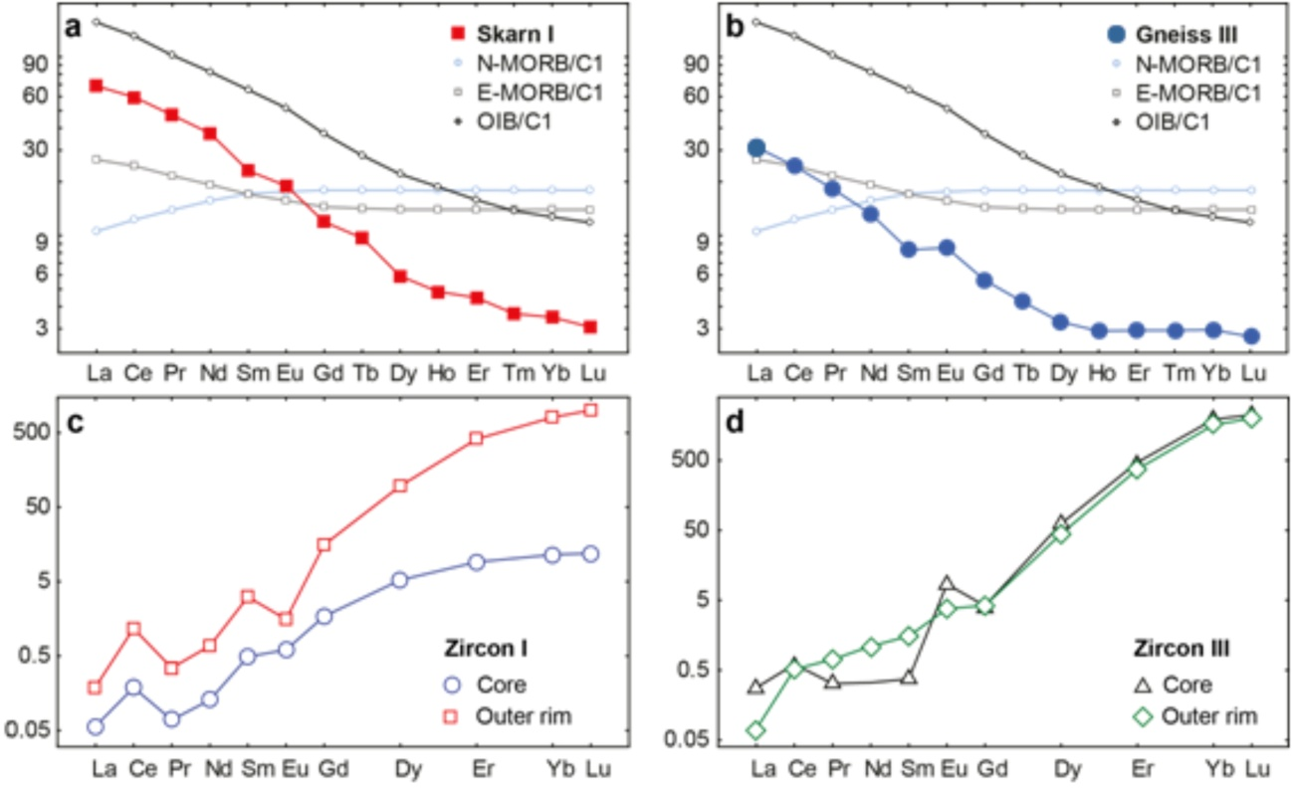

Supp. Table 1. Summarized U-Pb (zr, bd) isotope data on the Olenegorsk, Kirovogorsk and Eastern Bolshaya Litsa BIF bands.
Petrography | Locality | U-Pb (zr, bd) age, Ma
Amphibolites | Eastern Bolshaya Litsa BIF | 2813±48
Tonalite, country rocks | Pecheguba | 2790±7
Muscovite gneisses, country rocks | Kirovogorsk deposit | 2760±7
Rhyolite, intra-ore rhyolite | Komsomolsk BIF | 2750±24
Kirovogorsk BIF
BIF | Kirovogorsk deposit | 2780±13
Cutting dolerite dykes | Kirovogorsk deposit | 2740±11  2738±6
Zeolitized intra-ore granite pegmatite | Kirovogorsk deposit | 2650-2644
Olenegorsk BIF
Scapolite-quartz-plagioclase segregation in hornblendite gneisses | Olenegorsk deposit | 2670-2570
Intra-ore feldspar-rich pegmatites | Olenegorsk deposit | 2750±15

Supp. Table 2. Isotope Sm-Nd and initial (I_{Sr}) data on main rocks from BIFs of the Olenegorsk area.
See description of the Rb-Sr method in (Bayanova et al. 2009).
Name | Petrology | Sm,  ppm | Nd,  ppm | ¹⁴⁷Sm/¹⁴⁴Nd | ¹⁴³Nd/¹⁴⁴Nd  ±2σ | εNd  (2.7 Ga) | TDM | I_{Sr} | ±2σ
MSK-72/1 | BIF | 4.67 | 15.28 | 0.1546 | 0.512338±7 | +1.76 | 3154 | 0.7074 | ±9
MSK-72/2 | Qtz-Fsp | 0.68 | 2.82 | 0.1455 | 0.512034±10 | +1.25 | 2988 | 0.7083 | ±8
MSK-72/3 | Amphibolite | 3.45 | 12.31 | 0.1592 | 0.512297±9 | +2.82 | 2917 | 0.7039 | ±11
MSK-72/4 | Gar-Bt-gneisses | 0.87 | 4.65 | 0.1130 | 0.511447±21 | +2.21 | 2670 | 0.7075 | ±12
MSK-72/5 | Dolerite dyke | 4.07 | 19.27 | 0.1278 | 0.511559±10 | +2.83 | 2811 | 0.7031 | ±9
MSK-72/6 | Metasomatite | 0.39 | 1.84 | 0.1276 | 0.511636±10 | -0.70 | 2772 | 0.7091 | ±13
MSK-72/7 | Gabbro-norite dyke | 1.69 | 7.64 | 0.1335 | 0.511498±17 | -0.38 | 3125 | 0.7037 | ±9
MSK-73/1 | Gar-Bt-gneisses | 2.33 | 12.65 | 0.1115 | 0.511267±9 | +2.78 | 2797 | 0.7196 | ±6
MSK-74/1 | Bt-gneisses | 2.67 | 14.91 | 0.1082 | 0.511080±17 | +0.27 | 2976 | 0.7099 | ±8
MSK-75/1 | Bt-gneisses | 2.30 | 11.32 | 0.1230 | 0.511294±13 | -0.71 | 3103 | 0.7101 | ±11

Supp. Table 3. Isotope U-Pb data on different types of zircon from rocks of the Olenegorsk and Kirovogorsk BIFs.
Type | Weight, mg | Content,  ppm |  | Isotope ratio * |  |  | Age, Ma** |  |  | Rho***
 |  | Pb | U | ²⁰⁶Pb  ²⁰⁴Pb | ²⁰⁶Pb  ²⁰⁷Pb | ²⁰⁶Pb  ²⁰⁸Pb | ²⁰⁷ Pb  ²³⁵ U | ²⁰⁶ Pb  ²³⁸ U | ²⁰⁷ Pb  ²⁰⁶ Pb
Magnetite-grunerite-hedenbergite of silicate facies iron formation, Olenegorsk deposit
I-1 | 0.40 | 185.2 | 364.1 | 2458 | 5.3944 | 29.151 | 11.9918 | 0.482109 | 2657 | 0.97
I-2 | 0.40 | 102.6 | 197.5 | 1464 | 5.2532 | 15.330 | 11.8312 | 0.475811 | 2666 | 0.96
I-3 | 0.50 | 190.9 | 369.6 | 3869 | 5.4477 | 42.554 | 12.3343 | 0.495869 | 2657 | 0.91
Microclinized biotite gneisses III, Olenegorsk deposit (metamorphic zircon)
III-1 | 0.55 | 313.2 | 629.1 | 44369 | 5.4354 | 50.846 | 12.1811 | 0.480908 | 2687 | 0.96
III-2 | 0.25 | 130.3 | 262.0 | 6493 | 5.4076 | 27.037 | 11.9160 | 0.472138 | 2681 | 0.96
III-3 | 0.60 | 315.1 | 634.5 | 6451 | 5.4213 | 16.940 | 11.6639 | 0.463350 | 2676 | 0.96
Nodular muscovite gneisses V, Kirovogorsk deposit (magmatic zircon)
V-1 | 0.25 | 10.3 | 16.13 | 398 | 4.4575 | 4.6711 | 13.3578 | 0.494999 | 2779 | 0.95
V-2 | 0.40 | 69.0 | 128.0 | 6451 | 5.1971 | 9.9926 | 12.8671 | 0.484033 | 2747 | 0.97
V-3 | 0.40 | 84.5 | 158.1 | 5152 | 5.1696 | 9.6920 | 12.6949 | 0.477997 | 2752 | 0.92
*All ratios are corrected for blanks of 0.08 ng for Pb and 0.04 ng for U and for mass discrimination of 0.12±0.05%.
**Correction for common Pb was determined for the age according to Stacey and Kramers (1975).
***Correlation between ²⁰⁶Pb/²³⁸U vs. ²⁰⁷Pb/²³⁵U axis.

Supp. Table 4. SHRIMP-II isotope data on single zircon grains from rocks of the Olenegorsk BIF.
Zone | Weight,  Mg | Content,  ppm |  | Isotope ratio* |  |  |  | Age, Ma** |  |  | Discordance, %
 |  | Pb | U | ²⁰⁶Pb/²⁰⁴Pb | ²⁰⁶Pb/²³⁸U  ±2σ | ²⁰⁷Pb/²³⁵U  ±2σ | ²⁰⁷Pb/²⁰⁶Pb  ±2σ | ²⁰⁶Pb/ ²³⁸U  ±2σ | ²⁰⁷Pb/²³⁵U  ±2σ | ²⁰⁷Pb/²⁰⁶Pb  ±2σ
Magnetite-grunerite-hedenbergite of silicate facies iron formation, Olenegorsk deposit
1 | 0.04 | 126.95 | 237.24 | 18261 | 0.5095±0.0010 | 12.805±0.026 | 0.18141±0.00010 | 2655±5 | 2661±5 | 2665.8±2 | 0.4
2 | 0.04 | 122.88 | 232.77 | 7614.7 | 0.5035±0.0010 | 12.634±0.027 | 0.18170±0.00011 | 2629±5 | 2651±6 | 2668.5±2 | 1.5
3 | 0.06 | 154.48 | 280.96 | 2211.3 | 0.5019±0.0008 | 12.607±0.022 | 0.18145±0.00009 | 2622±4 | 2647±6 | 2666.2±1 | 1.7
4 | 0.05 | 190.94 | 369.62 | 3869.4 | 0.4959±0.0008 | 12.434±0.021 | 0.18040±0.00008 | 2596±4 | 2630±4 | 2656.6±1 | 2.3
Microclinized biotite gneisses III, Olenegorsk deposit
1 | 0.06 | 22.457 | 82.931 | 929.98 | 0.4629±0.0037 | 11.212±0.111 | 0.11342±0.00067 | 1504±12 | 1657±16 | 2455±14 | 38.7
2 | 0.03 | 33.722 | 62.98 | 1777.4 | 0.4977±0.0030 | 12.526±0.077 | 0.18251±0.00027 | 2604±16 | 2645±16 | 2675±4 | 2.7
3 | 0.03 | 33.722 | 61.706 | 1979.4 | 0.5080±0.0031 | 12.885±0.081 | 0.18251±0.00027 | 2648±16 | 2664±17 | 2686±4 | 1.4
*All ratios are corrected for blanks of 1 pg for Pb and 10 pg for U and for mass discrimination of 0.12 ± 0.05%.
**Correction for common Pb was determined for the age according to Stacey and Kramers (1975).

Supp. Table 5. SHRIMP data on metamorphic zircons from metasomatic rocks of the Olenegorsk and Kirovogorsk BIFs.
Probe | ²⁰⁶Pb_{c,} % | U,  ppm | Th, ppm | ²³²Th/ ²³⁸U | ²⁰⁶Pb*, ppm | Age, Ma ²⁰⁶Pb/  ²³⁸U | Age, Ma  ²⁰⁷Pb/  ²⁰⁶Pb | Dis. % | Total  ²³⁸U/²⁰⁶Pb  ±% | Total  ²⁰⁷Pb/²⁰⁶Pb  ±% | ²³⁸U/²⁰⁶Pb*  ±% | ²⁰⁷Pb*/²⁰⁶Pb*  ±% | ²⁰⁷Pb*/²³⁵U  ±% | ²⁰⁶Pb*/²³⁸U  ±% | Err.  corr.
Quartz-epidote-andradite-diopside of silicate facies iron formation, Olenegorsk deposit
II-1-1 | – | 138 | 83 | 0.62 | 64.9 | 2816±34 | 2778.2±9.8 | -1 | 1.826±1.5 | 0.1941±0.6 | 1.826±1.5 | 0.1942±0.6 | 14.67±1.6 | 0.5478±1.5 | 0.93
II-1-2 | 0.00 | 5 | 2 | 0.32 | 2.03 | 2440±88 | 2664±70 | 9 | 2.174±4.3 | 0.1812±4.2 | 2.174±4.3 | 0.1812±4.2 | 11.49±6 | 0.46±4.3 | 0.71
II-2-1 | 0.01 | 168 | 149 | 0.92 | 76.1 | 2734±34 | 2783.8±9.3 | 2 | 1.893±1.5 | 0.1950±0.56 | 1.893±1.5 | 0.1949±0.57 | 14.2±1.6 | 0.5283±1.5 | 0.94
II-2-2 | 0.06 | 678 | 21 | 0.03 | 301 | 2684±31 | 2646±7.9 | -1 | 1.935±1.4 | 0.17976±0.46 | 1.936±1.4 | 0.17926±0.47 | 12.76±1.5 | 0.5164±1.4 | 0.95
II-3-1 | 0.01 | 238 | 145 | 0.63 | 118 | 2942±34 | 2761.7±7.9 | -6 | 1.729±1.4 | 0.19237±0.48 | 1.729±1.4 | 0.19228±0.48 | 15.33±1.5 | 0.5782±1.4 | 0.95
II-3-2 | 0.00 | 20 | 0 | 0.01 | 9.23 | 2807±49 | 2641±27 | -6 | 1.832±2.1 | 0.1787±1.6 | 1.832±2.1 | 0.1787±1.6 | 13.44±2.7 | 0.546±2.1 | 0.80
II-3-3 | 0.00 | 17 | 0 | 0.02 | 8.09 | 2845±51 | 2654±29 | -7 | 1.802±2.2 | 0.1801±1.7 | 1.802±2.2 | 0.1801±1.7 | 13.78±2.8 | 0.555±2.2 | 0.79
II-4-1 | 0.00 | 288 | 255 | 0.92 | 146 | 2998±36 | 2788.4±7.3 | -7 | 1.689±1.5 | 0.19544±0.45 | 1.689±1.5 | 0.19544±0.45 | 15.96±1.6 | 0.5922±1.5 | 0.96
II-4-2 | 0.03 | 508 | 14 | 0.03 | 222 | 2652±30 | 2642.7±6.3 | 0 | 1.965±1.4 | 0.17915±0.38 | 1.965±1.4 | 0.1789±0.38 | 12.55±1.5 | 0.5089±1.4 | 0.97
II-5 | 0.03 | 142 | 62 | 0.46 | 65.5 | 2777±36 | 2786±11 | 0 | 1.857±1.6 | 0.1954±0.67 | 1.857±1.6 | 0.1952±0.68 | 14.49±1.7 | 0.5385±1.6 | 0.92
II-6 | 0.04 | 134 | 69 | 0.53 | 61.6 | 2766±36 | 2777±15 | 0 | 1.865±1.6 | 0.1945±0.91 | 1.866±1.6 | 0.1941±0.92 | 14.34±1.8 | 0.5359±1.6 | 0.87
Magnetite-calcite-dolomite rock IV, Kirovogorsk deposit
IV-1-1 | 0.05 | 258 | 151 | 0.60 | 117.0 | 2738±32 | 2655±12 | -3 | 1.889±1.4 | 0.1806±0.71 | 1.890±1.4 | 0.1802±0.73 | 13.15±1.6 | 0.5291±1.4 | 0.89
IV-1-2 | 0.03 | 224 | 115 | 0.53 | 91.9 | 2515±31 | 2646.1±8.3 | 5 | 2.095±1.5 | 0.17954±0.49 | 2.096±1.5 | 0.17927±0.5 | 11.80±1.6 | 0.4772±1.5 | 0.95
IV-2-1 | 0.00 | 236 | 96 | 0.42 | 103.0 | 2643±31 | 2652.4±7.9 | 0 | 1.973±1.4 | 0.17995±0.48 | 1.973±1.4 | 0.17995±0.48 | 12.57±1.5 | 0.5068±1.4 | 0.95
IV-2-2 | 0.00 | 186 | 58 | 0.32 | 88.8 | 2844±34 | 2651.2±9.2 | -7 | 1.803±1.5 | 0.17982±0.55 | 1.803±1.5 | 0.17982±0.55 | 13.75±1.6 | 0.5546±1.5 | 0.94
IV-3 | 0.14 | 196 | 76 | 0.40 | 88.0 | 2711±32 | 2645.8±9.7 | -2 | 1.910±1.4 | 0.18046±0.53 | 1.912±1.4 | 0.1792±0.59 | 12.92±1.6 | 0.5229±1.4 | 0.93
IV-4 | 0.15 | 190 | 81 | 0.44 | 82.9 | 2647±34 | 2645±10 | 0 | 1.966±1.5 | 0.18052±0.55 | 1.969±1.5 | 0.1792±0.61 | 12.54±1.7 | 0.5078±1.5 | 0.93
IV-5 | – | 241 | 93 | 0.40 | 109.0 | 2722±33 | 2655.1±8.2 | -2 | 1.904±1.5 | 0.1802±0.49 | 1.903±1.5 | 0.18024±0.49 | 13.06±1.6 | 0.5254±1.5 | 0.95
IV-6 | 0.03 | 240 | 77 | 0.33 | 106.0 | 2670±32 | 2649.1±8.7 | -1 | 1.948±1.4 | 0.17988±0.5 | 1.949±1.4 | 0.17959±0.52 | 12.71±1.5 | 0.5131±1.4 | 0.94
All errors are corrected for 1 σ level; Pb_{c} and Pb* are portions of common and radiogenic Pb; standards
Supp. Table 6. REE content in zircon and country rocks of the Bauman quarry of the Olenegorsk BIF (ppm).
Element | Magnetite-grunerite-hedenbergitre of silicate facies iron formation |  |  | Microclinized biotite gneisses III
 | Zircon |  | Rock | Zircon |  | Rock
 | Core | Rim |  | Core | Rim
La | 0.42 | 1.42 | 7.38 | 4.58 | 1.18 | 16.27
Ce | 2.81 | 17.5 | 14.94 | 22.2 | 18.8 | 36.46
Pr | 0.12 | 0.60 | 1.73 | 1.44 | 3.19 | 4.48
Nd | 0.79 | 4.22 | 6.17 | 5.78 | 19.1 | 17.38
Sm | 0.62 | 3.95 | 1.27 | 1.32 | 5.40 | 3.53
Eu | 0.30 | 0.77 | 0.50 | 9.35 | 4.15 | 1.10
Gd | 1.97 | 18 | 1.16 | 10.2 | 10.3 | 2.45
Tb | – | – | 0.16 | – | – | 0.36
Dy | 4.37 | 80.3 | 0.83 | 93.8 | 66.9 | 1.50
Ho | – | – | 0.17 | – | – | 0.27
Er | 4.44 | 199.4 | 0.49 | 348 | 277 | 0.74
Tm | – | – | 0.08 | – | – | 0.09
Yb | 5.78 | 405.6 | 0.50 | 1140 | 955 | 0.59
Lu | 0.83 | 69.4 | 0.07 | 176 | 156 | 0.08

