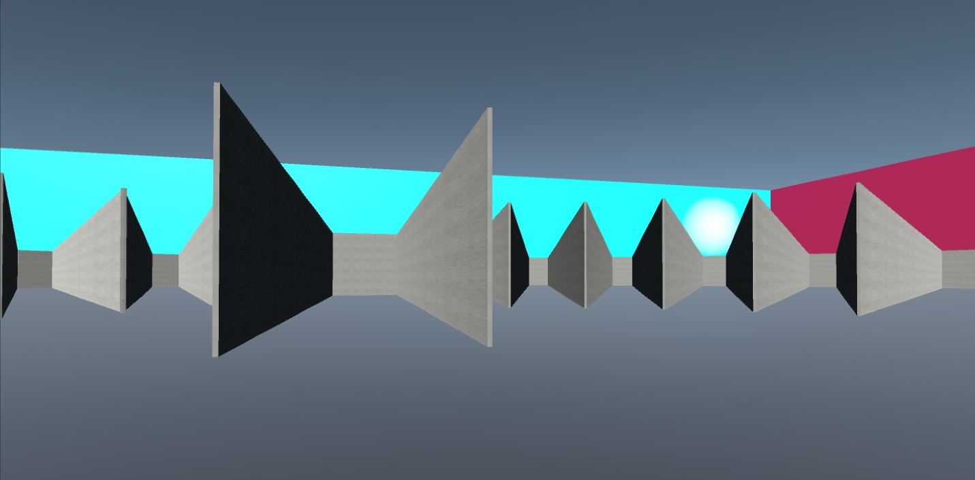

Supplemental 6: Test environment of Experiment 2 centered on Hallway CD.

