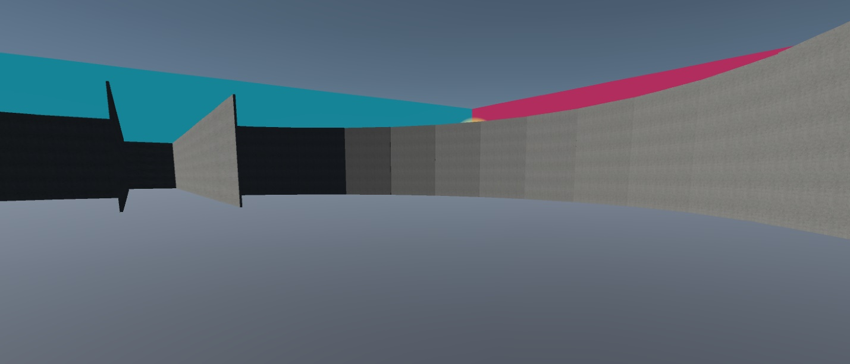

Supplemental 5: Right of Hallway CD in the Training environment in the Light Stable condition used in Experiment 2.

