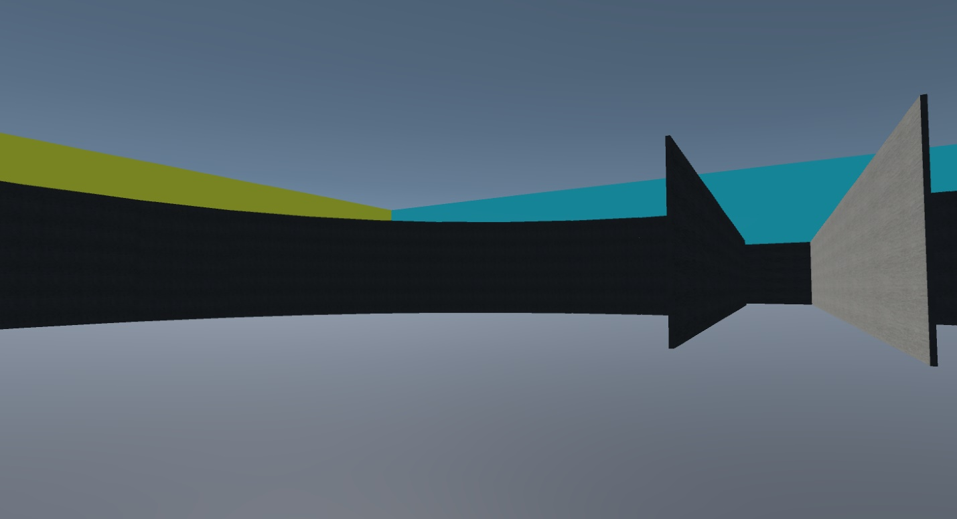

Supplemental 4: Left of Hallway CD in the Training environment in the Light Stable condition used in Experiment 2.

