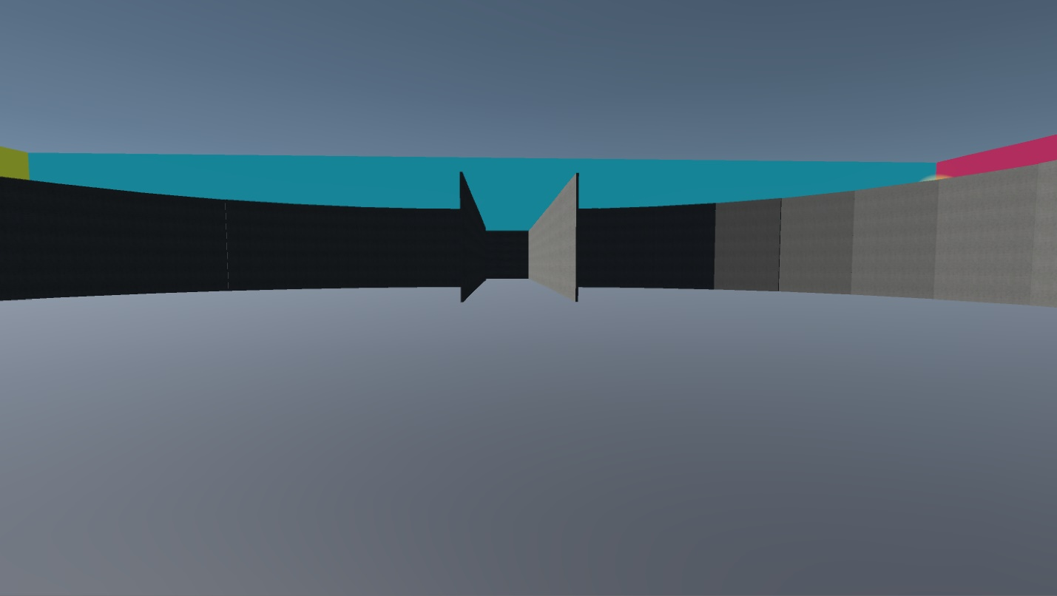

Supplemental 3: Center on hallway CD of the Training environment in the Light Stable condition used in Experiment 2.

