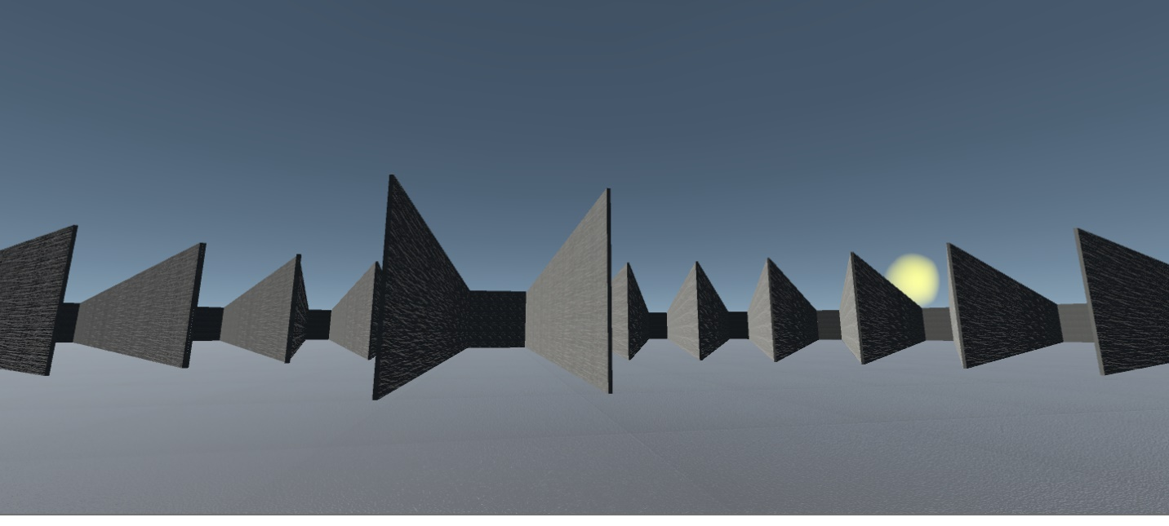

Supplemental 2: Test environment in the Light Stable condition.

