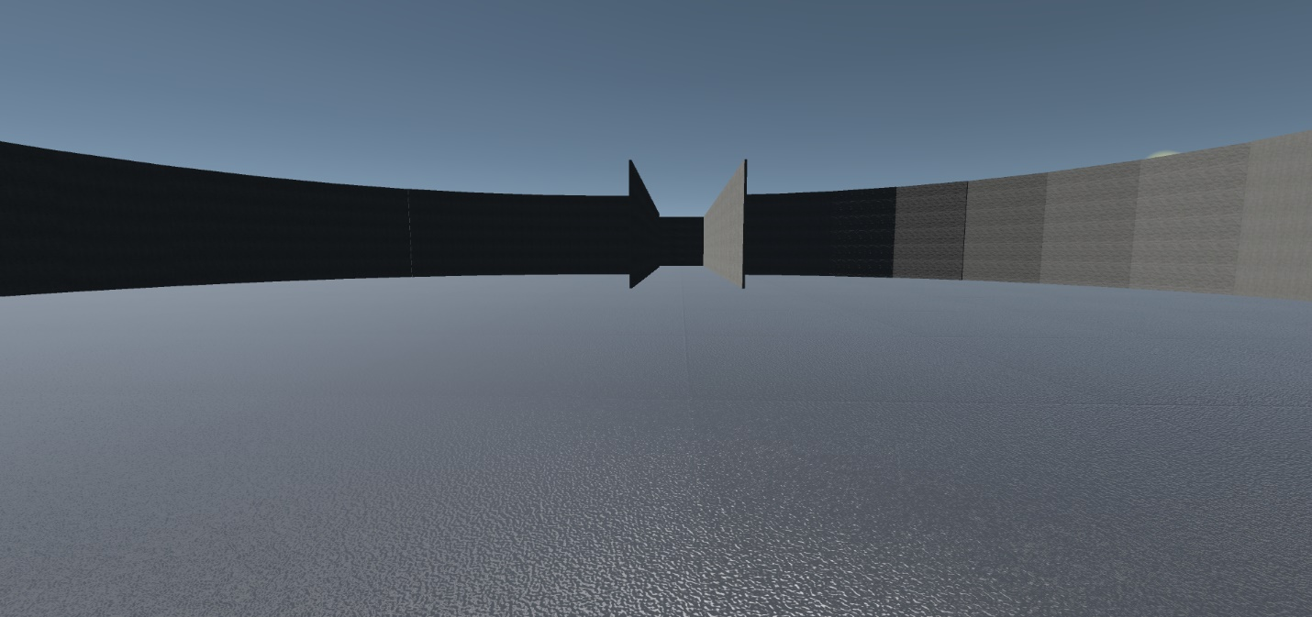

Supplemental 1: Image of the training environment in Experiments 1 and 3

