**Supplementary material**

***Model calculations table***

Supplementary Table 1. Calculations used in the model

|  |  |
| --- | --- |
| **Equation** | **Formula** |
| 1 | $${NP}_{i} = N*P*\prod_{1}^{i}{F_{i-1}}$$ |
| 2 | $${NN}_{i} = N*(1-P)*\prod_{1}^{i}{F_{i-1}}$$ |
| 3 | $$TP = \sum_{i=1}^{n}{ {NP}_{i}* {Sen}_{i} * (1-F_{i})}$$ |
| 4 | $$TN = \sum_{i=1}^{n}{{NN}_{i} * {Spe}_{i} * (1-F_{i})}$$ |
| 5 | $$FP = \sum_{i=1}^{n}{{NP}_{i} *(1-{Spe}_{i}) * (1-F_{i})}$$ |
| 6 | $$FN = \sum_{i=1}^{n}{{NN}_{i} *(1-{Sen}_{i} )* (1-F_{i})}$$ |
| **Variable** | **Definition** |
| $$F_{i}$$ | Possibility of taking follow-on confirmatory diagnostic procedure in the *i* round, *F0* = 1 |
|  | Number of false negative patients |
| $$FP$$ | Number of false positive patients |
| n | Total number of rounds of diagnostic procedures |
| $$N$$ | Total number of patients |
| $${NP}_{i}$$ | Number of positive patients at the start of the *i* round |
| $${NN}_{i}$$ | Number of negative patients at the start of the *i* round |
| $$P$$ | Prevalence of the disease |
| $${Sen}_{i}$$ | Sensitivity of the diagnostic procedure in the *i* round |
| $${Spe}_{i}$$ | Specificity of the diagnostic procedure in the *i* round |
| $$TN$$ | Number of true negative patients |
| $$TP$$ | Number of true positive patients |

***Targeted literature review elements***

Primary and secondary objectives are in Supplementary Table 2.

Supplementary Table 2. Targeted literature search objectives and sub-objectives

|  |  |
| --- | --- |
| **Primary objective** | **Sub-objectives** |
| Define the burden of metastatic colorectal cancer diagnosis and treatment | Define mCRC diagnosis costs  Define mCRC treatment costs |
| Identify the impact of Primovist on standard practice compared to other modalities | Identify specificity, sensitivity and safety of Primovist compared to other modalities  Define the rate of unnecessary treatments carried out with Primovist relative to other modalities  Evaluate the rate of confirmatory imaging required with Primovist relative to other modalities |
| Identify patient outcomes with Primovist compared to other modalities | Identify the precision of lesion characterisation for Primovist compared to other methods  Evaluate the recurrence and mortality rates for Primovist compared to other methods  Consider quality of surgical planning and treatment plans with Primovist compared to other methods  Identify the rate of intraoperative modifications with Primovist compared to other methods |
| Consider the budget impact of Primovist across the total treatment pathway | Identify the size of the Japanese/Chinese/US mCRC (liver specific) patient population  Consider current mCRC (liver specific) treatments  Consider costs associated with current mCRC (liver specific) treatments  Identify costs associated with Primovist as first-line imaging compared to other modalities  Assess the cost of using Primovist compared to total mCRC patient costs |
| Abbreviations: mCRC, metastatic colorectal cancer. | |

The inclusion criteria used in the targeted review are explained in Supplementary Table 3.

Supplementary Table 3. Inclusion and exclusion criteria used in the targeted review

|  |  |  |
| --- | --- | --- |
| **Characteristics** | **Inclusion criteria** | **Exclusion criteria** |
| Population | Colorectal cancer patients with liver metastases |  |
| Interventions | Primovist-enhanced screening |  |
| Comparators | ECCM-MRI, MDCT |  |
| Outcomes | 1. Burden of mCRC  2. Impact of Primovist on standard practice  3. Patient outcomes with Primovist  4. Budget impact of Primovist |  |
| Study design | Any | No restrictions |
| Language/Geography | English, Japanese, South Korean, and Chinese language literature, with translation software used to translate from Japanese/Chinese/South Korean to English when necessary | Non-English, Japanese, South Korean or Chinese language |
| Publication type and status | Published, grey literature (conference abstracts) |  |
| Date of publication | Published 2015-2020, expanding to 2004-2020 if data is limited  Conference abstracts 2018-2020 |  |

Literature search key words used to conduct electronic searches are recorded in Supplementary Table 4.

Supplementary Table 4. Literature search key words

|  |  |  |  |
| --- | --- | --- | --- |
| **#** | **Search term** | **Search in** | **Number of hits** |
| *Disease string* | | | |
| 1 | colorectal cancer/ | MeSH terms | 201,588 |
| 2 | metastases/ | MeSH terms | 204,005 |
| 3 | liver metastases/ | Title/Abstract | 17,448 |
| 4 | metastatic colorectal cancer | Title/Abstract | 8,297 |
| 5 | CRCLM | Title/Abstract | 154 |
| 6 | 1-5 (or) |  | 398,028 |
| *Intervention string* | | | |
| 7 | dimeglumine, gadolinium dtpa | MeSH terms | 12,022 |
| 8 | primovist | Title/Abstract | 76 |
| 9 | eovist | Title/Abstract | 45 |
| 10 | EOB-MRI | Title/Abstract | 154 |
| 11 | Gd-EOB-DTPA | Title/Abstract | 733 |
| 12 | gadoxetic acid | Title/Abstract | 764 |
| 13 | 7-12 (or) |  | 12,405 |
| *Study string* | | | |
| 14 | cancer screening/ | MeSH Terms | 25,652 |
| 15 | diagnosis/ | MeSH Terms | 8,550,530 |
| 16 | safety/ | MeSH Terms | 80,432 |
| 17 | sensitivity and specificity/ | MeSH Terms | 585,716 |
| 18 | cost | Title/Abstract | 432,057 |
| 19 | lesion | Title/Abstract | 330,775 |
| 20 | morbidity/ | MeSH Terms | 559,160 |
| 21 | mortality/ | MeSH Terms | 383,317 |
| 22 | 14-21 (or) |  | 9,726,918 |
| *Country string* | | | |
| 23 | japan* | All Fields | 1,312,057 |
| 24 | china | All Fields | 1,780,043 |
| 25 | united states | All Fields | 4,241,092 |
| 26 | usa | All Fields | 4,499,199 |
| 27 | 25 or 26 |  | 6,772,014 |
| 28 | south korea* | All Fields | 90,860 |
| *Final* | | | |
| 29 | 6 and 13 and 22 |  | 448 |
| 30 | 29 and 23 |  | 56 |
| 31 | 29 and 24 |  | 21 |
| 32 | 29 and 27 |  | 74 |
| 33 | 29 and 28 |  | 6 |
| *Note: Search strategy presented for MEDLINE using PubMed.* Abbreviations: /= MeSH term; * = truncation; | | | |

***Model input data sources***

Supplementary Table 5. Model input data sources and reason for use

|  |  |  |
| --- | --- | --- |
| **Model input** | **Data source** | **Reason for data source choice** |
| Number of patients and prevalence | Expert interviews (All countries) | Due to lack of local published data, inputs from expert interviews were used. |
| Sensitivity/Specificity | Targeted literature search (All countries) | Cantisani et al. 2014, Mao et al. 2020 and Vreugdenburg et al. 2016 were all selected as recent reviews or meta-analyses conducted for imaging modalities used in the diagnosis of CRCLM. Asato et al. 2017 and Shiozawa et al. 2017 were selected for Japan as local studies. |
| Probabilities requiring further imaging/diagnostic procedures | Targeted literature search (China)  Expert interviews (All countries) | Probabilities for the US and Japan models were based on expert interviews due to gaps in the published literature, while probabilities for the China model were taken from He et al. 2018 for all modalities except CEUS, where a conservative estimation based on expert interviews in the US and Japan was used due to lack of usage of CEUS in China. |
| Distributions of diagnostic procedures in the follow-up examinations | Expert interviews (US and China)  Assumption (based on guidelines and clinical practice, validated through expert interviews)  (All countries) | Distributions were derived from expert interviews or assumptions based on guidelines, clinical practice and validated by clinicians through interviews |
| Distributions of disease stages and treatment options in each stage | Expert interviews (All countries) | Due to lack of published literature, distributions were derived from expert interviews. |
| Costs | Targeted literature search (All countries) | US and Japan input costs were derived from local database information, while He et al. 2018 provided costs for the China model (adjusted for inflation). Some cost inputs were assumed based on literature or database costs. |
| Time from initial consultation to diagnostic procedure and waiting between diagnostic procedures | Expert interviews (All countries) | Due to lack of published literature, data was derived from expert interviews. |

Abbreviations: US, United States; CRCLM, colorectal cancer liver metastases; CEUS, contrast-enhanced ultrasound

***Detailed diagnostic distributions data***

Supplementary Table 6. Diagnostic distributions (2nd round) – US

|  |  |  |
| --- | --- | --- |
| **1st modality** | **2nd modality/procedure** | **Value** |
| MDCT | Biopsy | 50.0% |
| MDCT | ECCM-MRI | 25.0% |
| MDCT | EOB-MRI | 25.0% |
| ECCM-MRI | Biopsy | 90.0% |
| ECCM-MRI | EOB-MRI | 10.0% |
| EOB-MRI | Biopsy | 100.0% |
| CEUS | Biopsy | 20.0% |
| CEUS | ECCM-MRI | 40.0% |
| CEUS | EOB-MRI | 40.0% |

Abbreviations: MDCT, multidetector computed tomography; ECCM-MRI, extracellular contrast media-magnetic resonance imaging; CEUS, contrast-enhanced ultrasound

Supplementary Table 7. Diagnostic distributions (3rd round) – US

|  |  |  |  |
| --- | --- | --- | --- |
| **1st modality** | **2nd modality** | **3rd modality/procedure** | **Value** |
| MDCT | ECCM-MRI | Biopsy | 100.0% |
| MDCT | EOB-MRI | Biopsy | 100.0% |
| ECCM-MRI | EOB-MRI | Biopsy | 100.0% |
| CEUS | ECCM-MRI | Biopsy | 100.0% |
| CEUS | EOB-MRI | Biopsy | 100.0% |

Abbreviations: MDCT, multidetector computed tomography; ECCM-MRI, extracellular contrast media-magnetic resonance imaging; CEUS, contrast-enhanced ultrasound

Supplementary Table 8. Diagnostic distributions (2nd round) – Japan

|  |  |  |
| --- | --- | --- |
| **1st modality** | **2nd modality/procedure** | **Value** |
| MDCT | EOB-MRI | 90.0% |
| MDCT | CEUS | 10.0% |
| EOB-MRI | CEUS | 100.0% |
| CEUS | EOB-MRI | 100.0% |

Abbreviations: MDCT, multidetector computed tomography; ECCM-MRI, extracellular contrast media-magnetic resonance imaging; CEUS, contrast-enhanced ultrasound

Supplementary Table 9. Diagnostic distributions (3rd round) – Japan

|  |  |  |  |
| --- | --- | --- | --- |
| **1st modality** | **2nd modality** | **3rd modality/procedure** | **Value** |
| MDCT | EOB-MRI | CEUS | 100.0% |
| MDCT | CEUS | EOB-MRI | 100.0% |

Abbreviations: MDCT, multidetector computed tomography; ECCM-MRI, extracellular contrast media-magnetic resonance imaging; CEUS, contrast-enhanced ultrasound

Supplementary Table 10. Diagnostic distributions (2nd round) – China

|  |  |  |
| --- | --- | --- |
| **1st modality** | **2nd modality/procedure** | **Value** |
| MDCT | ECCM-MRI | 70.0% |
| MDCT | EOB-MRI | 30.0% |
| ECCM-MRI | Biopsy | 10.0% |
| ECCM-MRI | EOB-MRI | 90.0% |
| EOB-MRI | Biopsy | 100.0% |
| CEUS | ECCM-MRI | 50.0% |
| CEUS | EOB-MRI | 50.0% |

Abbreviations: MDCT, multidetector computed tomography; ECCM-MRI, extracellular contrast media-magnetic resonance imaging; CEUS, contrast-enhanced ultrasound

Supplementary Table 11. Diagnostic distributions (3rd round) – China

|  |  |  |  |
| --- | --- | --- | --- |
| **1st modality** | **2nd modality** | **3rd modality/procedure** | **Value** |
| MDCT | ECCM-MRI | Biopsy | 10.0% |
| MDCT | ECCM-MRI | EOB-MRI | 90.0% |
| MDCT | EOB-MRI | Biopsy | 100.0% |
| ECCM-MRI | EOB-MRI | Biopsy | 100.0% |
| CEUS | ECCM-MRI | Biopsy | 10.0% |
| CEUS | ECCM-MRI | EOB-MRI | 90.0% |
| CEUS | EOB-MRI | Biopsy | 100.0% |

Abbreviations: MDCT, multidetector computed tomography; ECCM-MRI, extracellular contrast media-magnetic resonance imaging; CEUS, contrast-enhanced ultrasound

Supplementary Table 12. Diagnostic distributions (4th round) – China

|  |  |  |  |  |
| --- | --- | --- | --- | --- |
| **1st modality** | **2nd modality** | **3rd modality/procedure** | **4th procedure** | **Value** |
| MDCT | ECCM-MRI | EOB-MRI | Biopsy | 90.0% |
| CEUS | ECCM-MRI | EOB-MRI | Biopsy | 90.0% |

Abbreviations: MDCT, multidetector computed tomography; ECCM-MRI, extracellular contrast media-magnetic resonance imaging; CEUS, contrast-enhanced ultrasound

***Markov model inputs***

Supplementary Table 13. Markov model utility value inputs

|  |  |  |  |
| --- | --- | --- | --- |
| **Input** | **US** | **China** | **Japan** |
| True positve | 0.61[30] | 0.61[30] | 0.61[30] |
| True negative | 1.00a | 0.90a | 0.90a |
| False positive | 0.90a | 0.87a | 0.87a |
| False negative | 0.70a | 0.62a | 0.62a |
| Treatment: resectable | 0.80[33] | 0.80[33] | 0.80[33] |
| Treatment: unresectable | 0.63[33] | 0.63[33] | 0.63[33] |
| Unnecessary treatment | 0.80a | 0.70a | 0.70a |
| Post treatment | 0.71a | 0.71a | 0.71a |
| Post unnecessary treatment | 0.90a | 0.75a | 0.75a |
| Tumour-related death | 0.00a | 0.00a | 0.00a |
| Other death (all cause mortality) | 0.00a | 0.00a | 0.00a |

aAssumption validated in expert interviews. Abbreviations: US, United States

Supplementary Table 14. Markov model annual discount

|  |  |  |  |
| --- | --- | --- | --- |
| **Discount (annual)** | **US** | **China** | **Japan** |
| Cost | 3%a | 3%a | 2%[31] |
| Utility | 3%a | 3%a | 2%[31] |

aAssumption validated in expert interviews. Abbreviations: US, United States

Supplementary Table 15. Markov model transition probabilities

|  |  |  |  |
| --- | --- | --- | --- |
| **Transition probability** | **US** | **China** | **Japan** |
| Probability of transition from false positive to unnecessary treatment | 100.00%a | 100.00%a | 100.00%a |
| Probability of transition from unnecessary treatment to post unnecessary treatment | 100.00%a | 100.00%a | 100.00%a |
| Probability of being cured after resectable treatment | 100.00%a | 90.00%[32] | 91.00%[29] |
| Probability of being cured after unresectable treatment | 80.00%a | 48.00%[32] | 70.00%a |
| Mortality for patients who are detected having CRCLM (TP) | 0.00%a | 31.00%a | 0.00%a |
| Mortality for patients who are undetected (FN) | 20.00%a | 36.30%a | 3.00%a |
| Mortality for patients who receive resectable treatment | 0.00%a | 10.00%a | 9.00%a |
| Mortality for patients who receive unresectable treatment | 10.00%a | 52.00%a | 30.00%[29] |

aAssumption validated in expert interviews. Abbreviations: US, United States

***Supplementary figures***

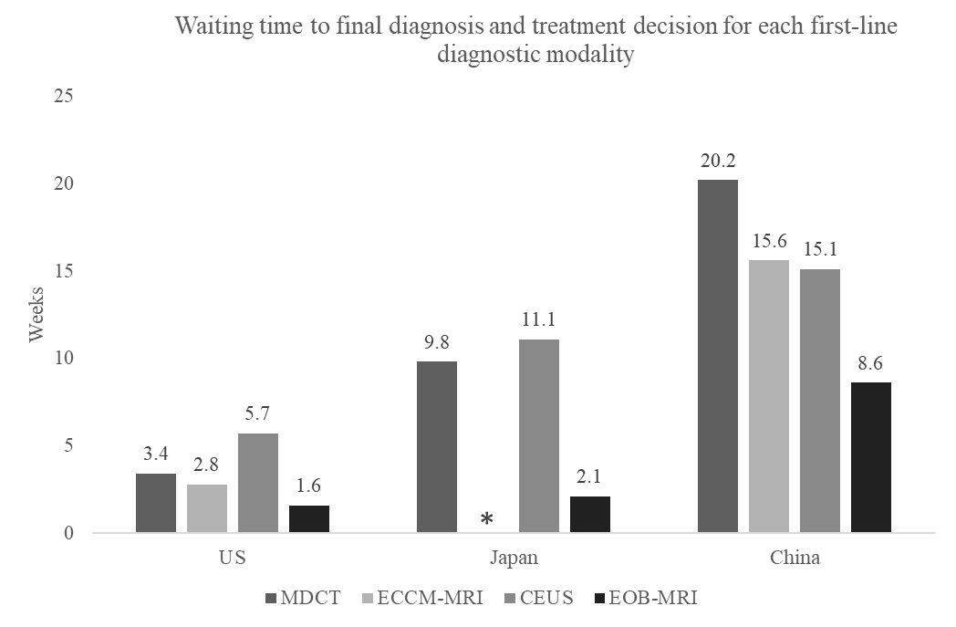

Supplementary figure 1 - Waiting time to final diagnosis and treatment decision for each first-line diagnostic modality. ECCM-MRI is not recommended in Japan, and therefore there is no column for ECCM-MRI in Japan. Abbreviations: US, United States; MDCT, multidetector computed tomography; EOB-MRI, gadoxetic acid-magnetic resonance imaging; ECCM-MRI, extracellular contrast media-magnetic resonance imaging; CEUS, contrast-enhanced ultrasound

Supplementary figure 2 - Average time to diagnosis and treatment decision for current practice compared to an increase of 35% in EOB-MRI usage. Abbreviations: US, United States; EOB-MRI, gadoxetic acid-magnetic resonance imaging



Supplementary figure 3 – Per patient cost-offset results for different EOB-MRI usage levels compared to baseline values (9.3% in US; 25% in Japan; 18% in China). Abbreviations: US, United States; EOB-MRI, gadoxetic acid-magnetic resonance imaging

Supplementary figure 4 – Markov one-way sensitivity analysis results 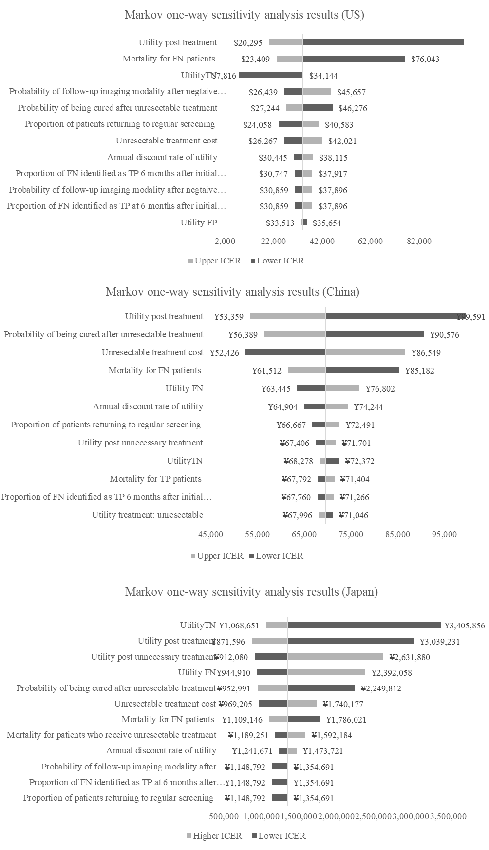

***CHEERS checklist***

|  |  |  |  |
| --- | --- | --- | --- |
| **Topic** | **No.** | **Item** | **Location where item is reported** |
| **Title** |  |  |  |
| 1 | Identify the study as an economic evaluation and specify the interventions being compared. | Title, Page 1 |
| **Abstract** |  |  |  |
| 2 | Provide a structured summary that highlights context, key methods, results, and alternative analyses. | Abstract, Page 3 |
| **Introduction** |  |  |  |
| **Background and objectives** | 3 | Give the context for the study, the study question, and its practical relevance for decision making in policy or practice. | Introduction |
| **Methods** |  |  |  |
| **Health economic analysis plan** | 4 | Indicate whether a health economic analysis plan was developed and where available. | Not applicable |
| **Study population** | 5 | Describe characteristics of the study population (such as age range, demographics, socioeconomic, or clinical characteristics). | Methods, Patient population section |
| **Setting and location** | 6 | Provide relevant contextual information that may influence findings. | Methods, model structure and perspective |
| **Comparators** | 7 | Describe the interventions or strategies being compared and why chosen. | Methods, Decision tree section |
| **Perspective** | 8 | State the perspective(s) adopted by the study and why chosen. | Methods, model structure and perspective |
| **Time horizon** | 9 | State the time horizon for the study and why appropriate. | Methods, Decision tree and Markov model sections |
| **Discount rate** | 10 | Report the discount rate(s) and reason chosen. | Supplementary material |
| **Selection of outcomes** | 11 | Describe what outcomes were used as the measure(s) of benefit(s) and harm(s). | Results, page 20-22 |
| **Measurement of outcomes** | 12 | Describe how outcomes used to capture benefit(s) and harm(s) were measured. | Methods, Decision tree and Markov model sections |
| **Valuation of outcomes** | 13 | Describe the population and methods used to measure and value outcomes. | Methods, Patient population section |
| **Measurement and valuation of resources and costs** | 14 | Describe how costs were valued. | Methods, Cost inputs section |
| **Currency, price date, and conversion** | 15 | Report the dates of the estimated resource quantities and unit costs, plus the currency and year of conversion. | Methods, Cost inputs section |
| **Rationale and description of model** | 16 | If modelling is used, describe in detail and why used. Report if the model is publicly available and where it can be accessed. | Methods, Decision tree and Markov model sections |
| **Analytics and assumptions** | 17 | Describe any methods for analysing or statistically transforming data, any extrapolation methods, and approaches for validating any model used. | Not applicable |
| **Characterising heterogeneity** | 18 | Describe any methods used for estimating how the results of the study vary for subgroups. | Not applicable |
| **Characterising distributional effects** | 19 | Describe how impacts are distributed across different individuals or adjustments made to reflect priority populations. | Not applicable |
| **Characterising uncertainty** | 20 | Describe methods to characterise any sources of uncertainty in the analysis. | Methods, Sensitivity analyses section |
| **Approach to engagement with patients and others affected by the study** | 21 | Describe any approaches to engage patients or service recipients, the general public, communities, or stakeholders (such as clinicians or payers) in the design of the study. | Methods, Model input data section |
| **Results** |  |  |  |
| **Study parameters** | 22 | Report all analytic inputs (such as values, ranges, references) including uncertainty or distributional assumptions. | Methods |
| **Summary of main results** | 23 | Report the mean values for the main categories of costs and outcomes of interest and summarise them in the most appropriate overall measure. | Results, page 19-23 |
| **Effect of uncertainty** | 24 | Describe how uncertainty about analytic judgments, inputs, or projections affect findings. Report the effect of choice of discount rate and time horizon, if applicable. | Results, page 20-23 |
| **Effect of engagement with patients and others affected by the study** | 25 | Report on any difference patient/service recipient, general public, community, or stakeholder involvement made to the approach or findings of the study | Not reported |
| **Discussion** |  |  |  |
| **Study findings, limitations, generalisability, and current knowledge** | 26 | Report key findings, limitations, ethical or equity considerations not captured, and how these could affect patients, policy, or practice. | Discussion |
| **Other relevant information** |  |  |  |
| **Source of funding** | 27 | Describe how the study was funded and any role of the funder in the identification, design, conduct, and reporting of the analysis | End of manuscript |
| **Conflicts of interest** | 28 | Report authors conflicts of interest according to journal or International Committee of Medical Journal Editors requirements. | End of manuscript |