One-pot synthesis and fluorescent property of novel syringaldehyde a-aminophosphonate derivatives

Si Ke, Duanyi Zhang, Yu Li, Ziwei Gong, Pengcheng Tang & Wanxia Tang*

Department of Pharmacy Engineering, College of Chemistry and Chemical Engineering, Qiqihar university, Qiqihar, Heilongjiang Province, China

email: 01722@qqhru.edu.cn

**Supplemental Materials**



**Figure S 1:** IR spectrum of diethyl-(3,5-dimethoxy-4-hydroxyphenyl)-phenyl-aminophosphonate (**1**)



**Figure S 2:** IR spectrum of diethyl-(3,5-dimethoxy-4-hydroxyphenyl)-(4-methylphenyl)-aminophosphonate (**2**)



**Figure S 3:** IR spectrum of diethyl-(3,5-dimethoxy-4-hydroxyphenyl)-(3-methylphenyl)-aminophosphonate (**3**)



**Figure S 4:** IR spectrum of diethyl-(3,5-dimethoxy-4-hydroxyphenyl)-(3-brombenzene)-aminophosphonate (**4**)



**Figure S 5:** IR spectrum of diethyl-(3,5-dimethoxy-4-hydroxyphenyl)-benzyl-aminophosphonate (**5**)



**Figure S 6:** IR spectrum of diethyl-(3,5-dimethoxy-4-hydroxyphenyl)-(4-benzoic acid)-aminophosphonate (**6**)



**Figure S 7:** IR spectrum of diethyl-(3,5-dimethoxy-4-hydroxyphenyl)-(4-benzamide)-aminophosphonate (**7**)

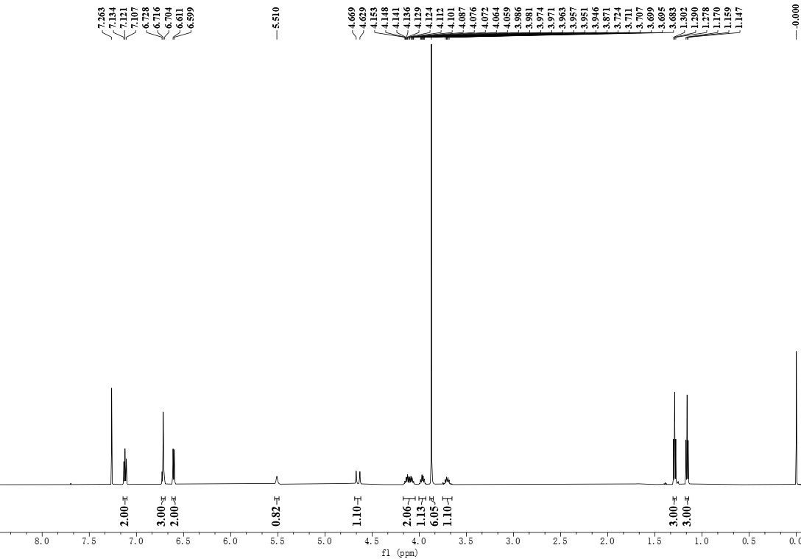



Diethyl-(3,5-dimethoxy-4-hydroxyphenyl)-phenyl-aminophosphonate **(1)**

**Figure S 8:** 1H NMR spectrum of diethyl-(3,5-dimethoxy-4-hydroxyphenyl)-phenyl-aminophosphonate (**1**) in CDCl3

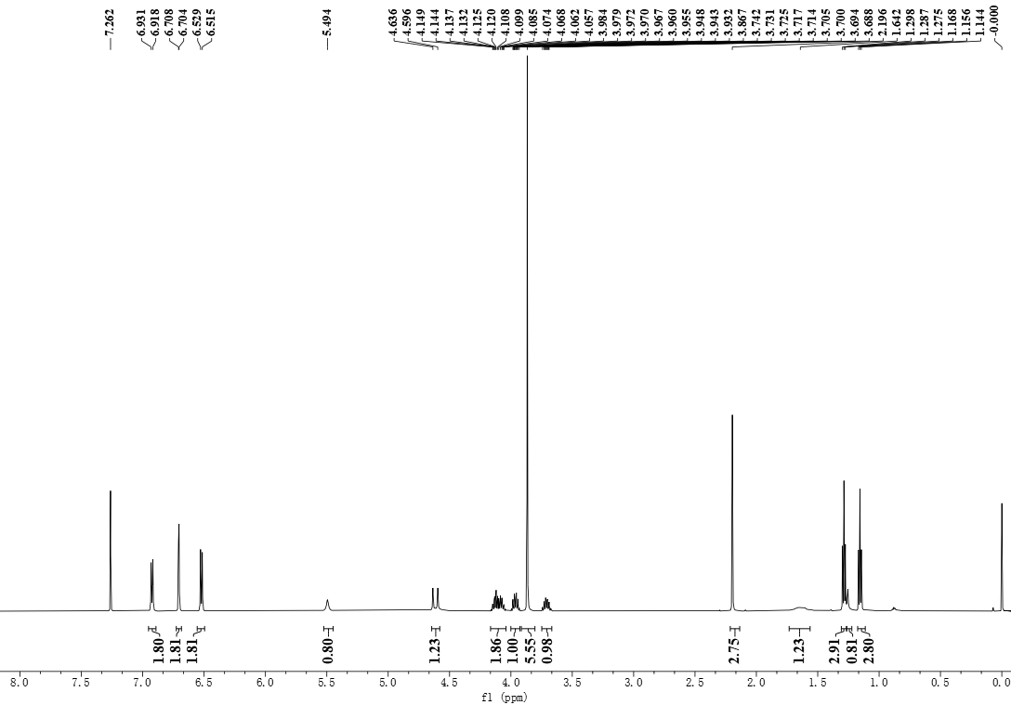



Diethyl-(3,5-dimethoxy-4-hydroxyphenyl)-(4-methylphenyl)-aminophosphonate **(2)**

**Figure S 9:** 1H NMR spectrum of diethyl-(3,5-dimethoxy-4-hydroxyphenyl)-(4-methylphenyl)-aminophosphonate (**2**) in CDCl3

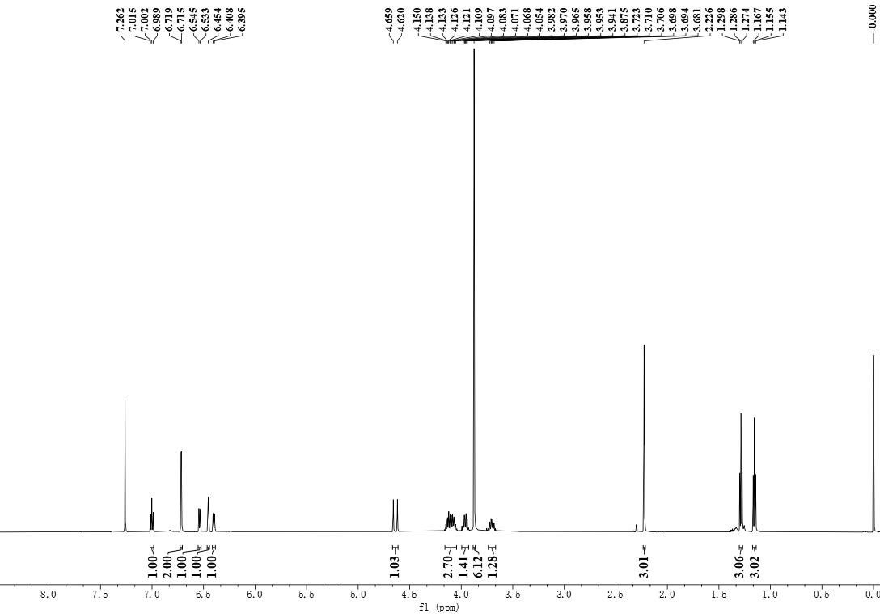



Diethyl-(3,5-dimethoxy-4-hydroxyphenyl)-(3-methylphenyl)-aminophosphonate **(3)**

**Figure S 10:** 1H NMR spectrum of diethyl-(3,5-dimethoxy-4-hydroxyphenyl)-(3-methylphenyl)-aminophosphonate (**3**) in CDCl3

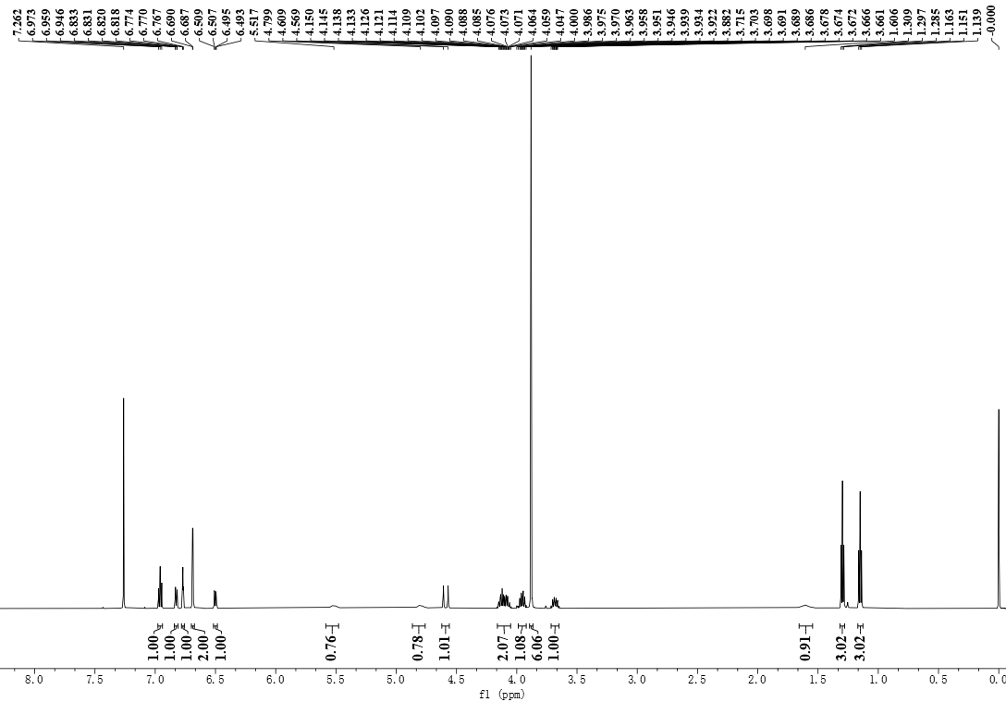



Diethyl-(3,5-dimethoxy-4-hydroxyphenyl)-(3-brombenzene)-aminophosphonate **(4)**

**Figure S 11:** 1H NMR spectrum of diethyl-(3,5-dimethoxy-4-hydroxyphenyl)-(3-brombenzene)-aminophosphonate (**4**) in CDCl3

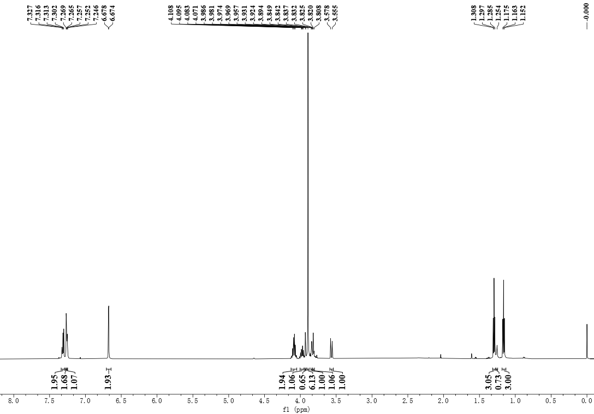



diethyl-(3,5-dimethoxy-4-hydroxyphenyl)-benzyl-aminophosphonate **(5)**

**Figure S 12:** 1H NMR spectrum of diethyl-(3,5-dimethoxy-4-hydroxyphenyl)-benzyl-aminophosphonate (**5**) in CDCl3

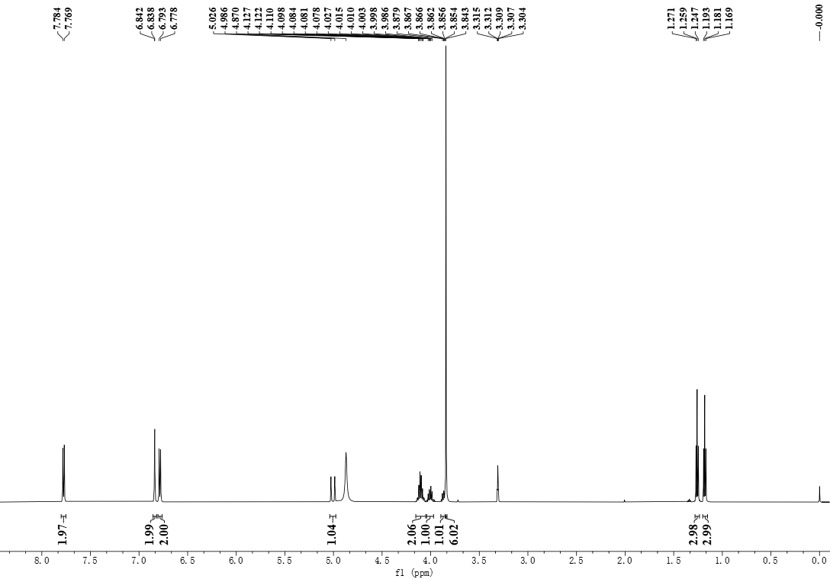



Diethyl-(3,5-dimethoxy-4-hydroxyphenyl)-(4-benzoic acid)-aminophosphonate **(6)**

**Figure S 13:** 1H NMR spectrum of diethyl-(3,5-dimethoxy-4-hydroxyphenyl)-(4-benzoic acid)-aminophosphonate (**6**) in CD3OD

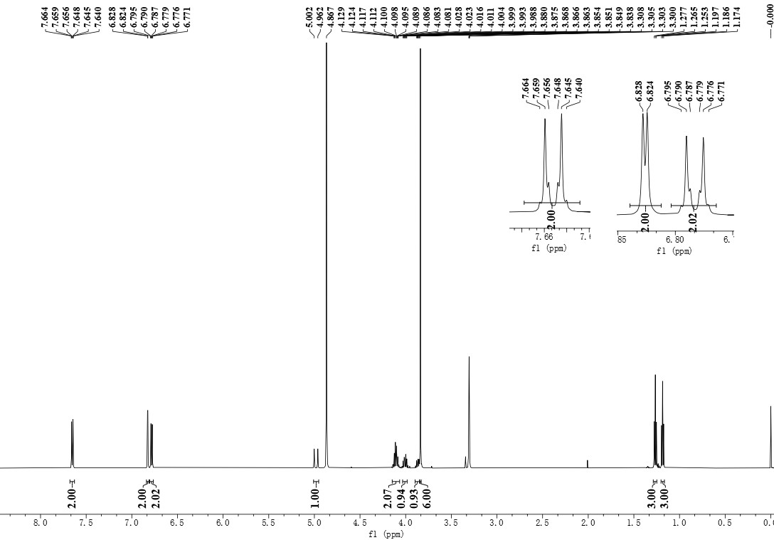



Diethyl-(3,5-dimethoxy-4-hydroxyphenyl)-(4-benzamide)-aminophosphonate **(7)**

**Figure S 14:** 1H NMR spectrum of diethyl-(3,5-dimethoxy-4-hydroxyphenyl)-(4-benzamide)-aminophosphonate (**7**) in CD3OD

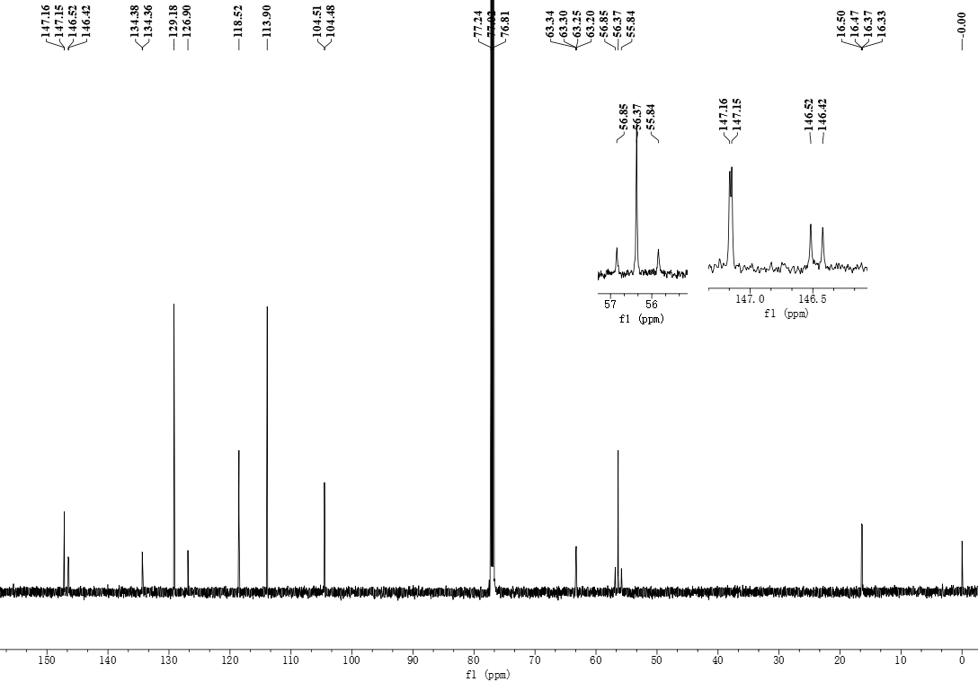



Diethyl-(3,5-dimethoxy-4-hydroxyphenyl)-phenyl-aminophosphonate **(1)**

**Figure S 15:** 13C NMR spectrum of diethyl-(3,5-dimethoxy-4-hydroxyphenyl)-phenyl-aminophosphonate (**1**)in CDCl3

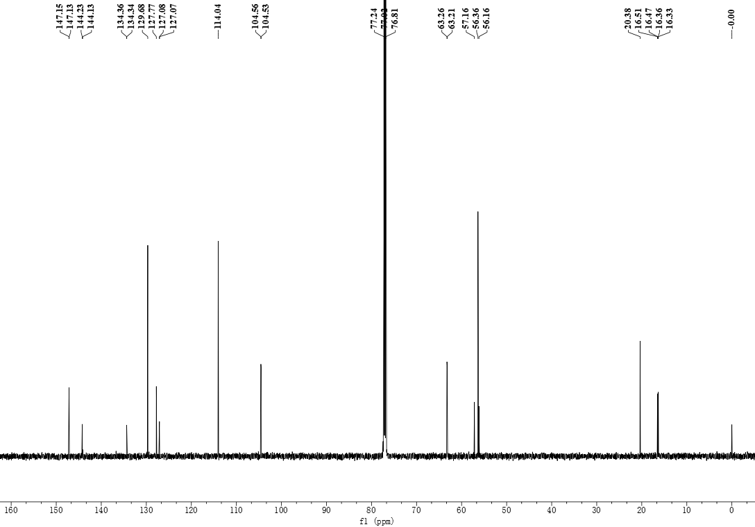



Diethyl-(3,5-dimethoxy-4-hydroxyphenyl)-(4-methylphenyl)-aminophosphonate **(2)**

**Figure S 16:** 13C NMR spectrum of diethyl-(3,5-dimethoxy-4-hydroxyphenyl)-(4-methylphenyl)-aminophosphonate (**2**) in CDCl3

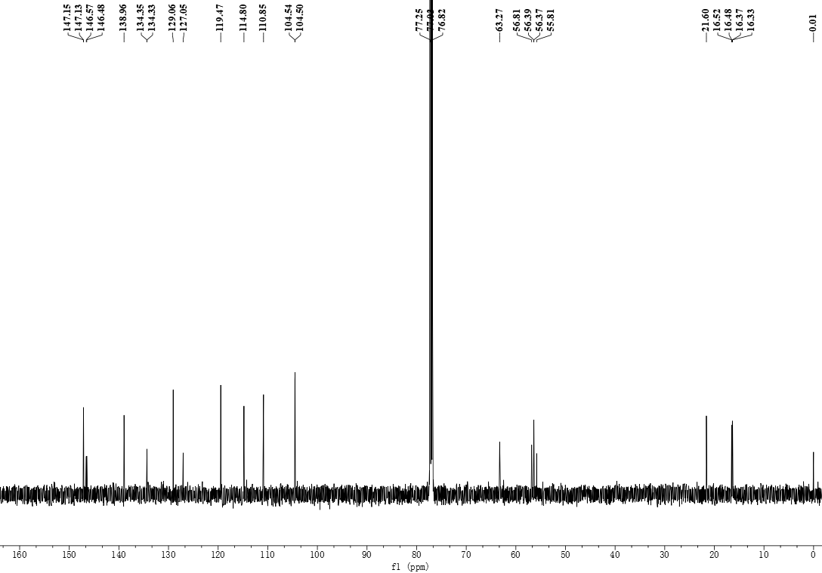



Diethyl-(3,5-dimethoxy-4-hydroxyphenyl)-(3-methylphenyl)-aminophosphonate **(3)**

**Figure S 17:** 13C NMR spectrum of diethyl-(3,5-dimethoxy-4-hydroxyphenyl)-(3-methylphenyl)-aminophosphonate (**3**) in CDCl3

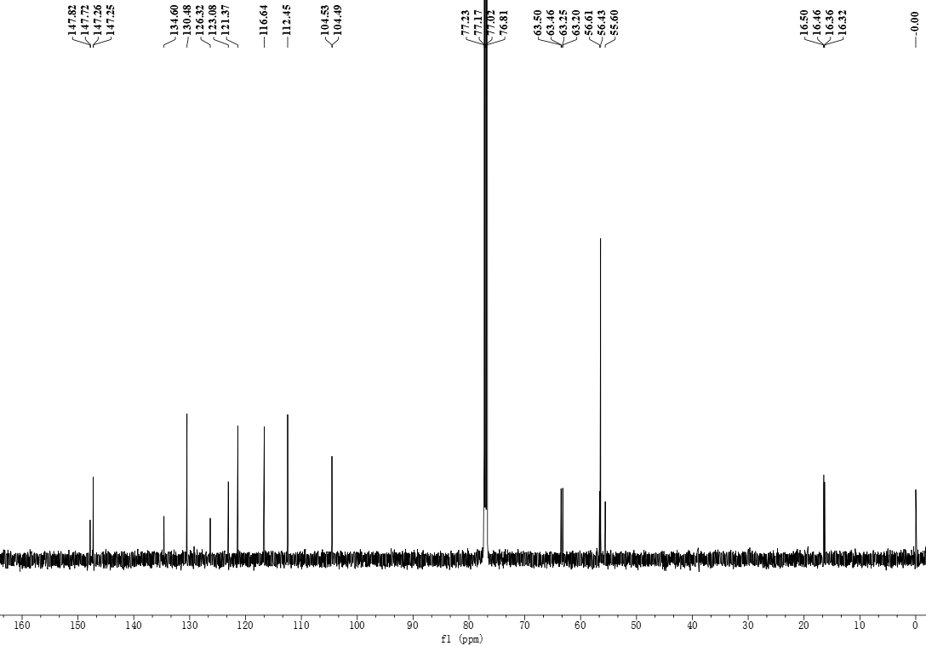



Diethyl-(3,5-dimethoxy-4-hydroxyphenyl)-(3-brombenzene)-aminophosphonate **(4)**

**Figure S 18:** 13C NMR spectrum of diethyl-(3,5-dimethoxy-4-hydroxyphenyl)-(3-brombenzene)-aminophosphonate (**4**) in CDCl3

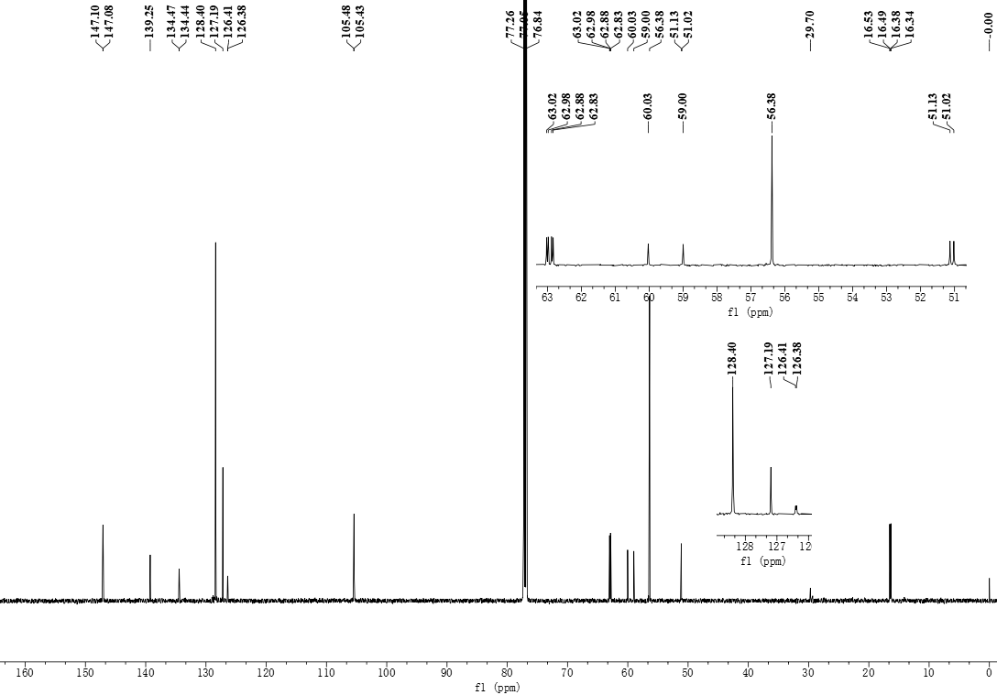



Diethyl-(3,5-dimethoxy-4-hydroxyphenyl)-benzyl-aminophosphonate **(5)**

**Figure S 19:** 13C NMR spectrum of diethyl-(3,5-dimethoxy-4-hydroxyphenyl)-benzyl-aminophosphonate (**5**) in CDCl3

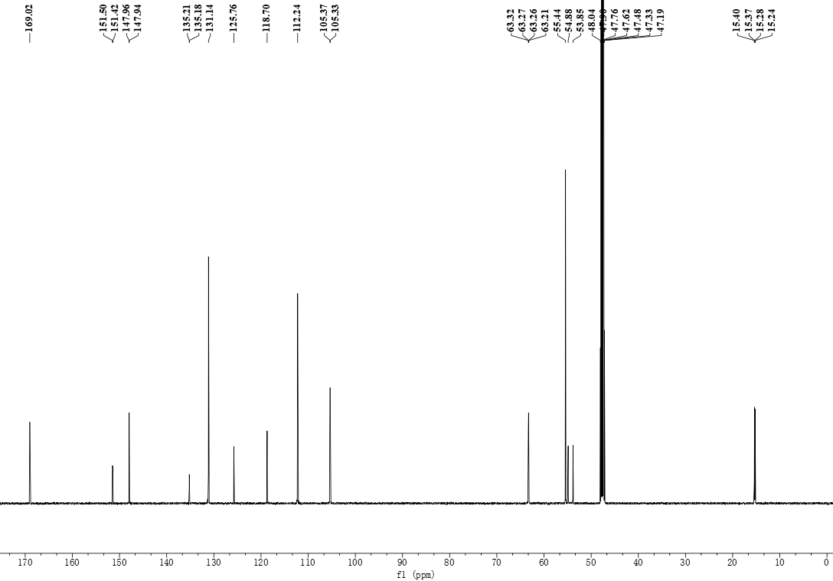



Diethyl-(3,5-dimethoxy-4-hydroxyphenyl)-(4-benzoic acid)-aminophosphonate **(6)**

**Figure S 20:** 13C NMR spectrum of diethyl-(3,5-dimethoxy-4-hydroxyphenyl)-(4-benzoic acid)-aminophosphonate (**6**) in CD3OD

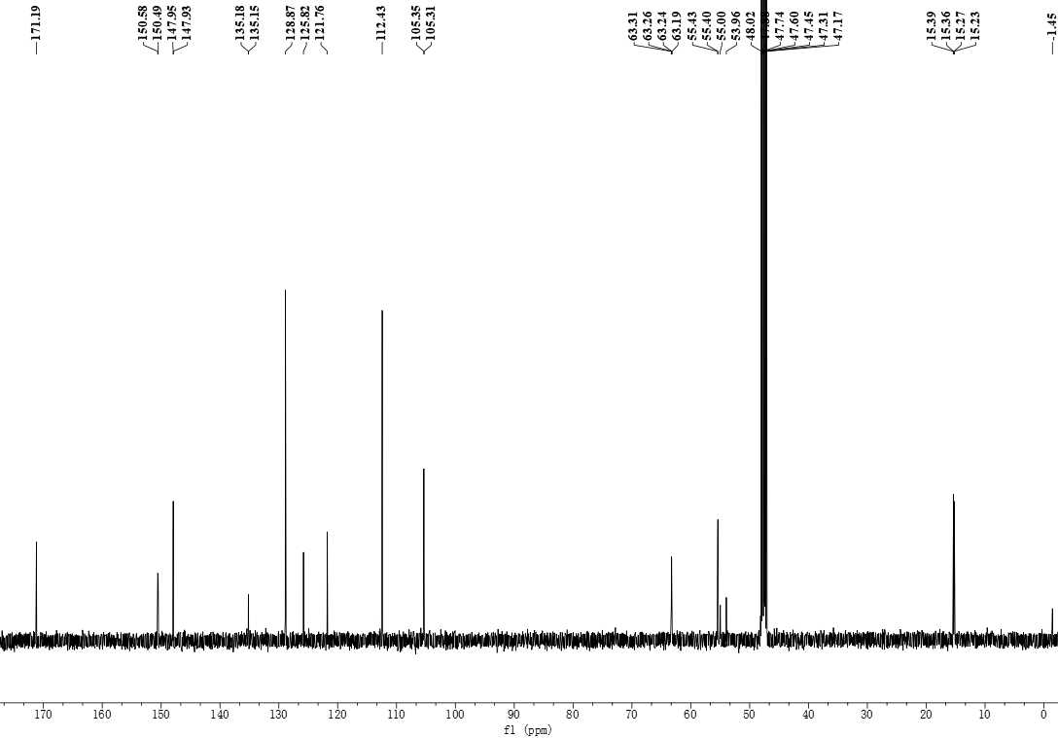



Diethyl-(3,5-dimethoxy-4-hydroxyphenyl)-(4-benzamide)-aminophosphonate **(7)**

**Figure S 21:** 13C NMR spectrum of diethyl-(3,5-dimethoxy-4-hydroxyphenyl)-(4-benzamide)-aminophosphonate (**7**) in CD3OD



**Figure S 22:** MS spectrum of complex diethyl-(3,5-dimethoxy-4-hydroxyphenyl)-phenyl-aminophosphonate (**1**)



**Figure S 23:** MS spectrum of complex diethyl-(3,5-dimethoxy-4-hydroxyphenyl)-(4-methylphenyl)-aminophosphonate (**2**)



**Figure S 24:** MS spectrum of complex diethyl-(3,5-dimethoxy-4-hydroxyphenyl)-(3-methylphenyl)-aminophosphonate (**3**)



**Figure S 25:** MS spectrum of complex diethyl-(3,5-dimethoxy-4-hydroxyphenyl)-(3-brombenzene)-aminophosphonate (**4**)



**Figure S 26:** MS spectrum of complex diethyl-(3,5-dimethoxy-4-hydroxyphenyl)-benzyl-aminophosphonate (**5**)



**Figure S 27:** MS spectrum of complex diethyl-(3,5-dimethoxy-4-hydroxyphenyl)-(4-benzoic acid)-aminophosphonate (**6**)



**Figure S 28:** MS spectrum of complex diethyl-(3,5-dimethoxy-4-hydroxyphenyl)-(4-benzamide)-aminophosphonate (**7**)

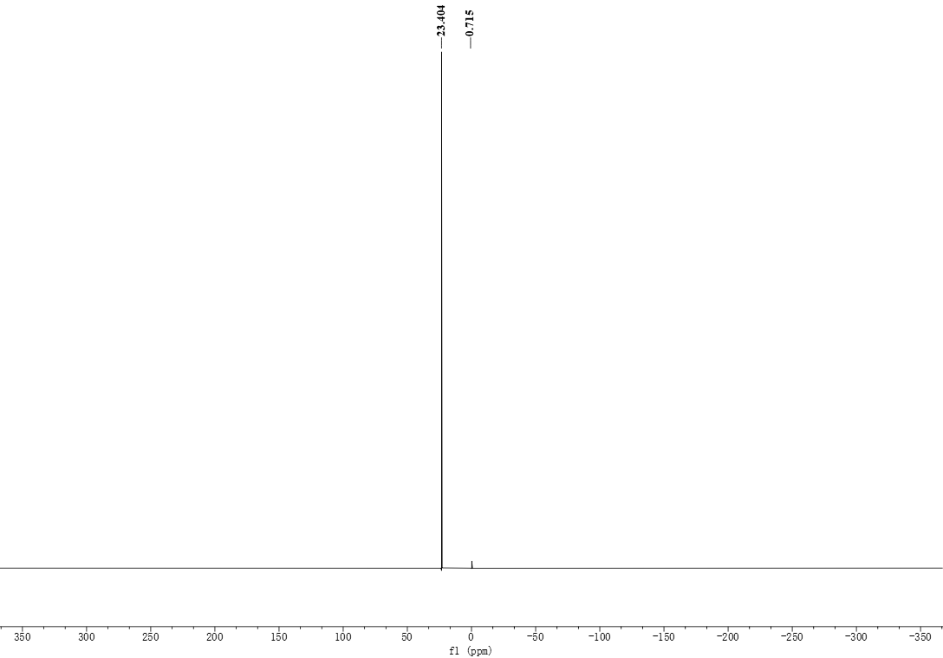



Diethyl-(3,5-dimethoxy-4-hydroxyphenyl)-phenyl-aminophosphonate **(1)**

**Figure S 29:** 31P NMR spectrum of diethyl-(3,5-dimethoxy-4-hydroxyphenyl)-phenyl-aminophosphonate (**1**) in CDCl3

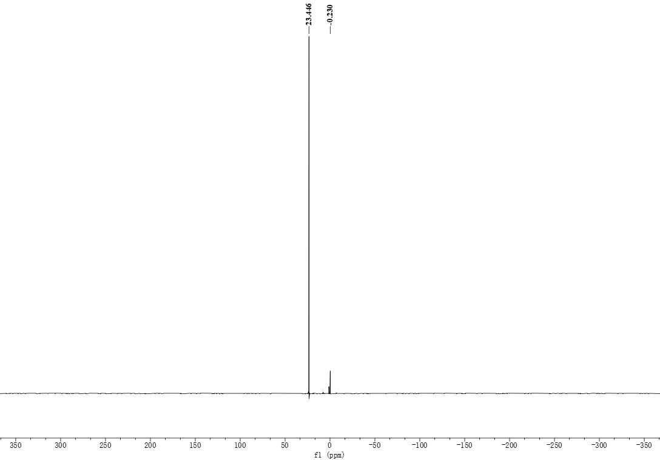



Diethyl-(3,5-dimethoxy-4-hydroxyphenyl)-(4-methylphenyl)-aminophosphonate **(2)**

**Figure S 30:** 31P NMR spectrum of diethyl-(3,5-dimethoxy-4-hydroxyphenyl)-(4-methylphenyl)-aminophosphonate (**2**) in CDCl3

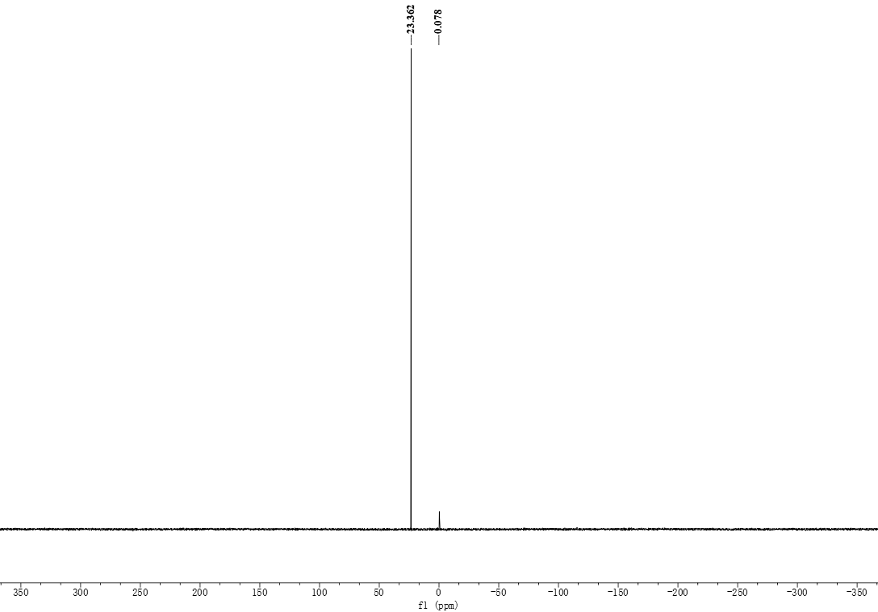



Diethyl-(3,5-dimethoxy-4-hydroxyphenyl)-

(3-methylphenyl)-aminophosphonate **(3)**

**Figure S 31:** 31P NMR spectrum of diethyl-(3,5-dimethoxy-4-hydroxyphenyl)-(3-methylphenyl)-aminophosphonate (**3**) in CDCl3

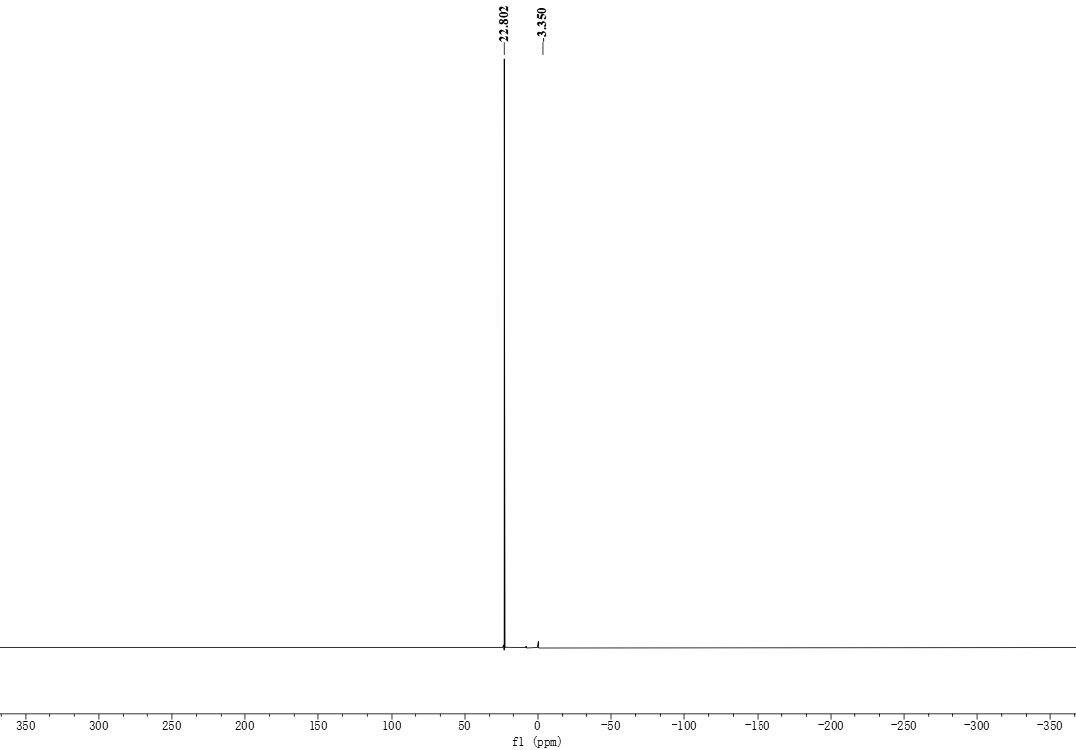



Diethyl-(3,5-dimethoxy-4-hydroxyphenyl)-

(3-brombenzene)-aminophosphonate **(4)**

**Figure S 32:** 31P NMR spectrum of diethyl-(3,5-dimethoxy-4-hydroxyphenyl)-(3-brombenzene)-aminophosphonate (**4**) in CDCl3

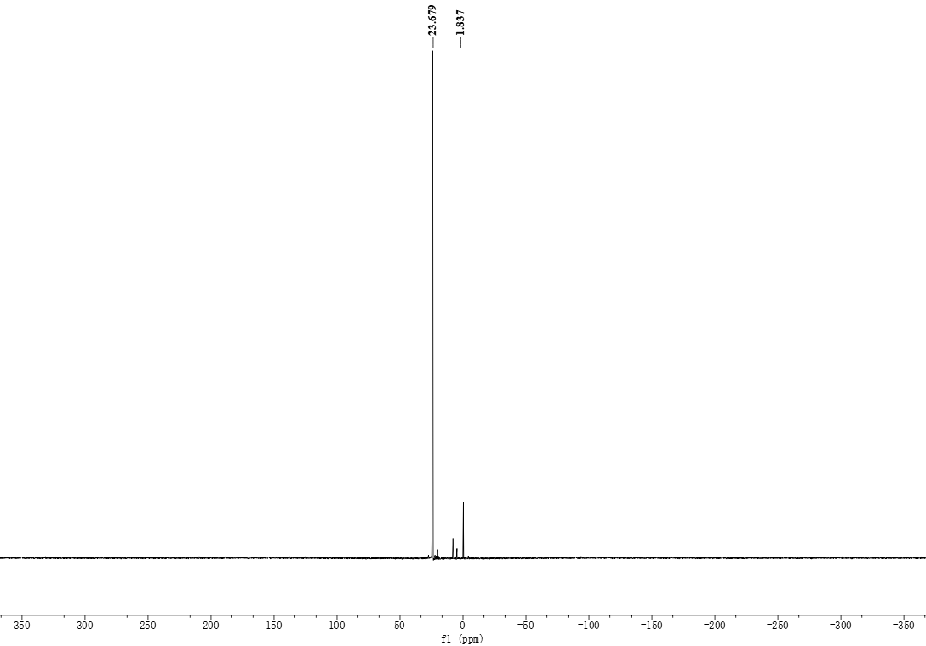



Diethyl-(3,5-dimethoxy-4-hydroxyphenyl)-benzyl-

aminophosphonate **(5)**

**Figure S 33:** 31P NMR spectrum of diethyl-(3,5-dimethoxy-4-hydroxyphenyl)-benzyl-aminophosphonate (**5**) in CDCl3

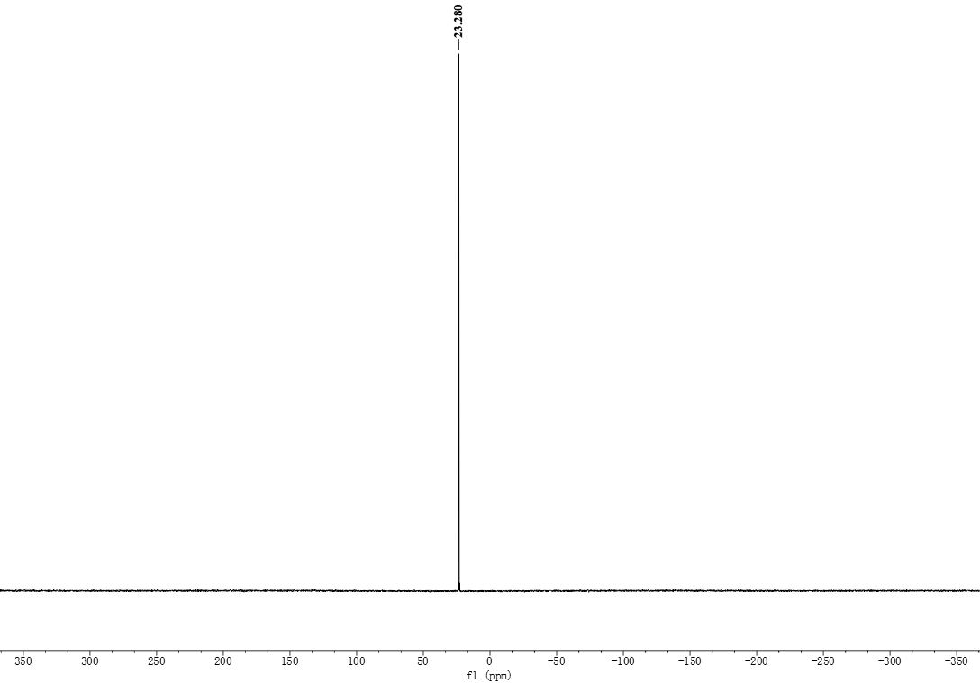



Diethyl-(3,5-dimethoxy-4-hydroxyphenyl)-(4-benzoic acid)-aminophosphonate **(6)**

**Figure S 34:** 31P NMR spectrum of diethyl-(3,5-dimethoxy-4-hydroxyphenyl)-(4-benzoic acid)-aminophosphonate (**6**) in CD3OD

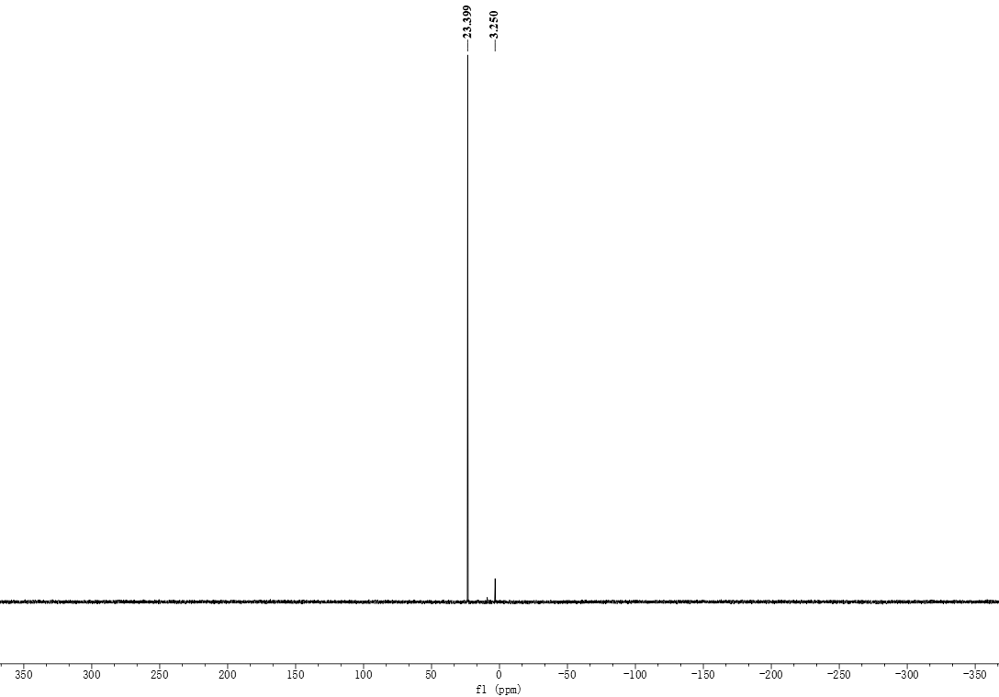



Diethyl-(3,5-dimethoxy-4-hydroxyphenyl)-(4-benzamide)-aminophosphonate **(7)**

**Figure S 35:** 31P NMR spectrum of diethyl-(3,5-dimethoxy-4-hydroxyphenyl)-(4-benzamide)-aminophosphonate (**7**) in CD3OD