Fig. S1 SNA of fertilizer information sources- Vadamugam Vellode-B village  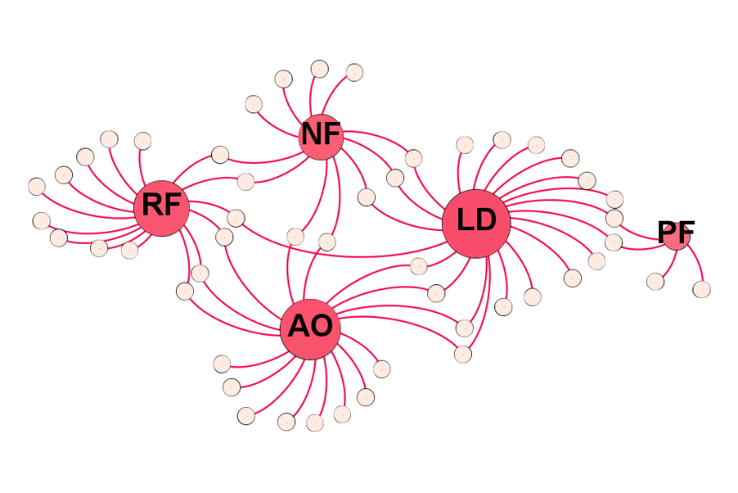 | Fig. S2 SNA of fertilizer information sources- Kanagapuram-A village  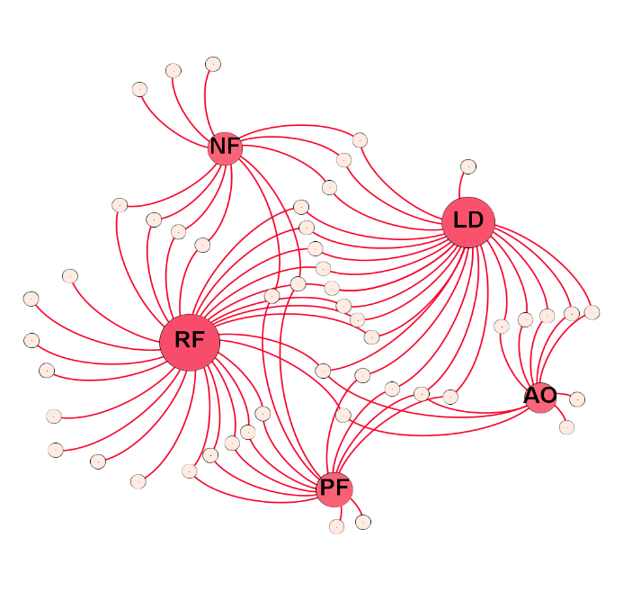
Fig. S3 SNA of fertilizer information sources- Thenmugam Vellode-B village  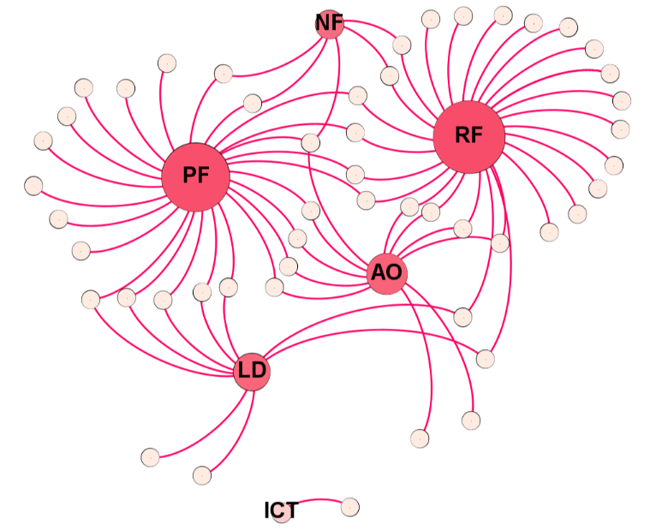 | Fig. S4 SNA of fertilizer information sources- Vadugapatti-A village  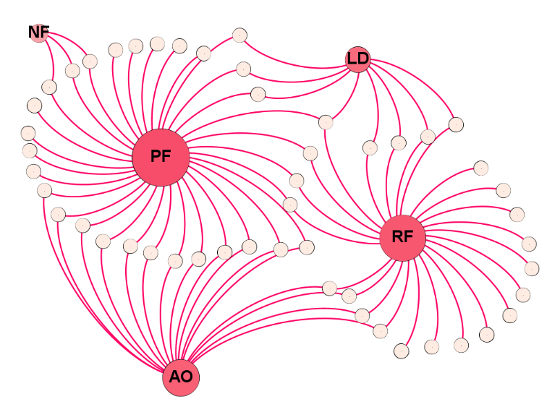
Fig. S5 SNA of fertilizer information sources- Sivagiri-A village  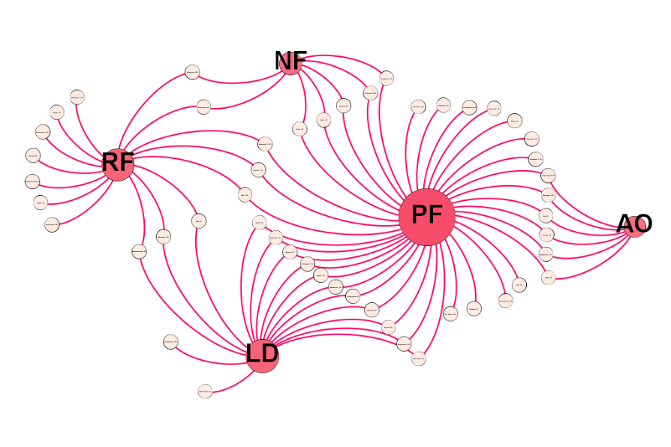 | Fig. S6 SNA of fertilizer information sources- KollenKovil-B village  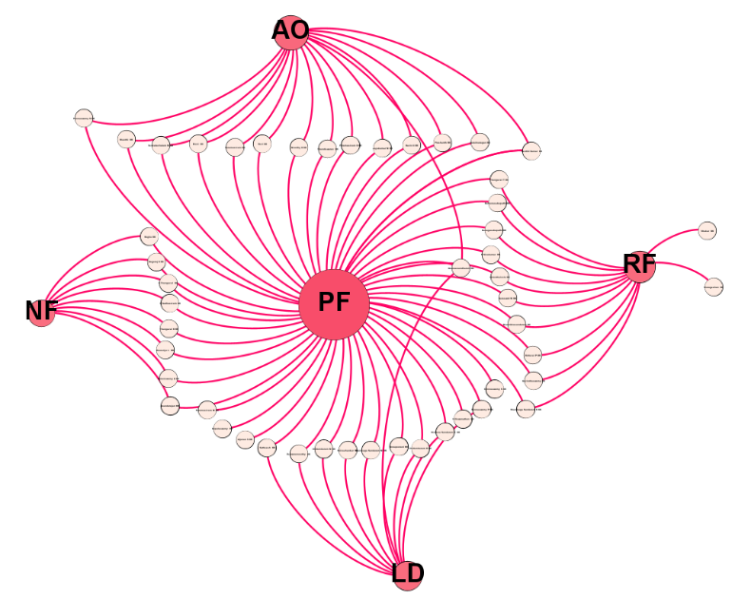
Fig. S7 SNA of fertilizer information sources- Kathirampatti village  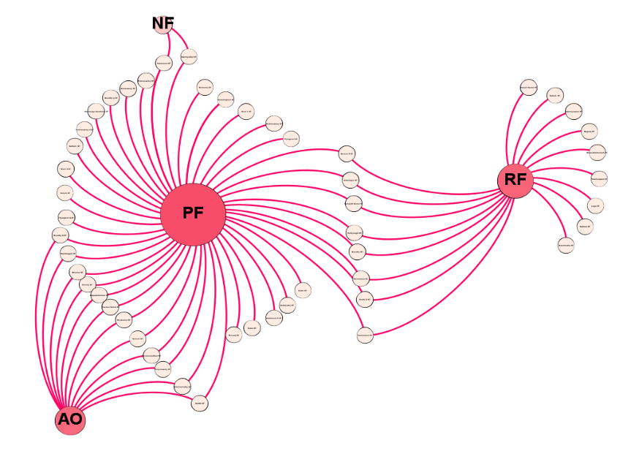 | Fig. S8 SNA of fertilizer information sources- Nasiyanur village  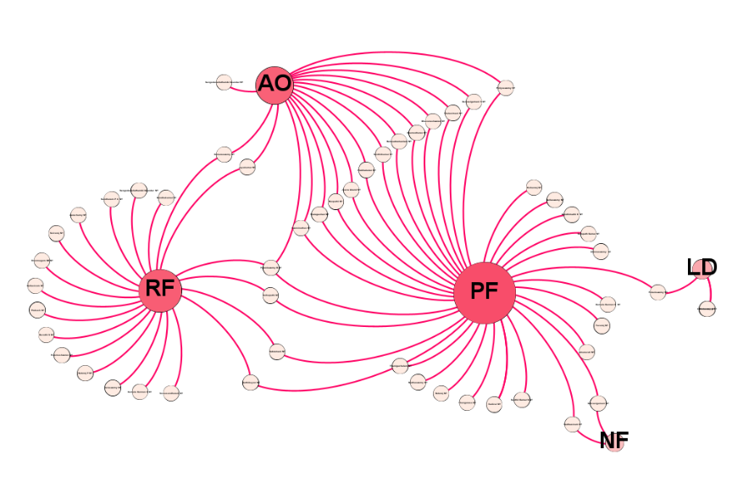
Fig. S9 SNA of fertilizer information sources- Kadhampalayam village  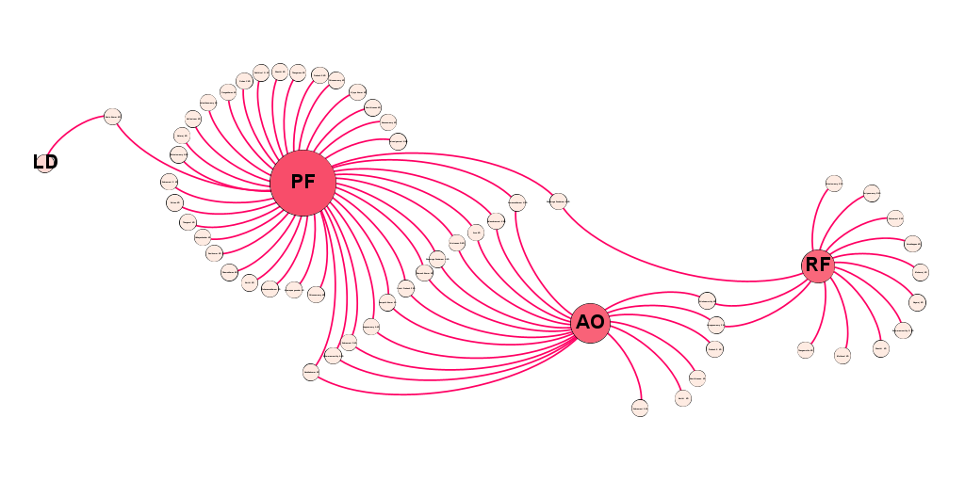 | Fig. S10 SNA of fertilizer information sources- Nallampatti village  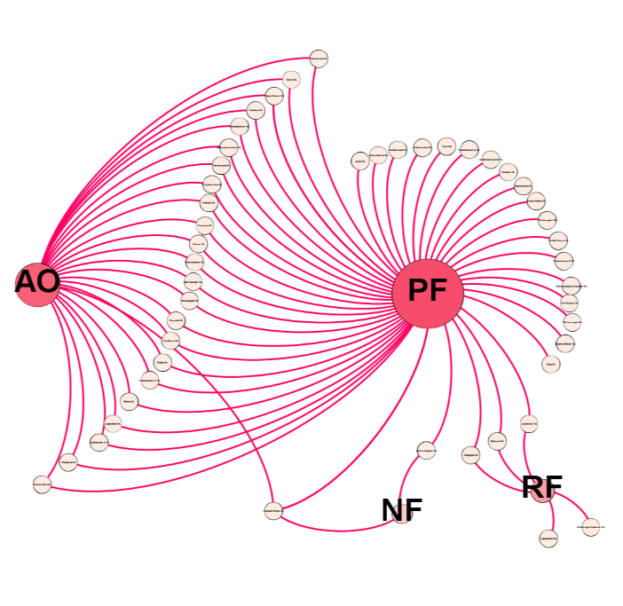

Conversion factors used for estimating nutrient application
Nitrogen in various fertilizers and manure
The following yardsticks were used for estimating nitrogen,
Table S1 Nitrogen in various fertilizers and manure (TNAU Agritech Portal 2014)
Fertilizer | Percentage of nitrogen | Quantity | Nitrogen per kg of fertilizer
Urea | 46% | 1 kg | 460 g
Ammonium chloride | 25 % | 1 kg | 250 g
Diammonium phosphate | 18 % | 1 kg | 180 g
17:17:17 | 17 % | 1 kg | 170 g
20:20:0:13 | 20 % | 1 kg | 200 g
Farmyard manure | 0.5 % | 1 kg | 5 g

Phosphorus in various fertilizers and manure
The following yardsticks were used for estimating phosphorus,
Table S2 Phosphorus in various fertilizers and manure (TNAU Agritech Portal 2014)
Fertilizer | Percentage of nitrogen | Quantity | Nitrogen per kg of fertilizer
Diammonium phosphate | 46 % | 1 kg | 460 g
17:17:17 | 17 % | 1 kg | 170 g
20:20:0:13 | 20 % | 1 kg | 200 g
Farmyard manure | 0.2 % | 1 kg | 2 g

Potassium in various fertilizers and manure
The following yardsticks were used for estimating potassium,
Table S3 Potassium in various fertilizers and manure (TNAU Agritech Portal 2014)
Fertilizer | Percentage of nitrogen | Quantity | Nitrogen per kg of fertilizer
Muriate of potash | 60 % | 1 kg | 600 g
17:17:17 | 17 % | 1 kg | 170 g
Farmyard manure | 0.5 % | 1 kg | 5 g
The fertilizer recommendation was collected from TNAU Agritech Portal (2014).
Table S4 ANOVA table of surveyed farmer’s socioeconomic characters
Variable |  | Age of the respondent  (In years) | Years of schooling  (In years) | Household size  (In numbers) | Land owned  (In acres) | Years of experience in farming  (in years) | Expenditure  (In rupees)
Vadamugam  Vellode- B | Mean | 53.20 | 9.40 | 3.76 | 2.05 | 33.44 | 8256.4
 | SD | 11.08 | 4.84 | 1.35 | 2.11 | 11.25 | 5344.07
Kanagapuram- A | Mean | 54.96 | 10.94 | 3.32 | 4.45 | 30.46 | 11770
 | SD | 11.50 | 3.92 | 1.04 | 3.05 | 10.56 | 4092.31
Thenmugam  Vellode- B | Mean | 50.54 | 10.32 | 3.36 | 4.72 | 27.06 | 10140
 | SD | 11.30 | 3.74 | 1.22 | 3.30 | 10.66 | 3741.71
Vadugapatti- A | Mean | 56.96 | 10.12 | 3.34 | 5.47 | 33.7 | 10170
 | SD | 11.41 | 3.91 | 1.14 | 4.87 | 12.89 | 4856.73
Sivagiri- A | Mean | 55.70 | 10.36 | 3.18 | 6.69 | 33.16 | 9200
 | SD | 11.23 | 3.87 | 1.24 | 5.94 | 10.69 | 3010.19
Kollen  Kovil- B | Mean | 52.56 | 11.14 | 3.60 | 6.15 | 30.96 | 9400
 | SD | 11.30 | 3.87 | 1.23 | 5.13 | 12.83 | 3131.47
Kathirampatti | Mean | 48.68 | 11.32 | 3.70 | 3.16 | 25.94 | 8210
 | SD | 10.23 | 3.37 | 1.31 | 3.21 | 10.89 | 2880.42
Nasiyanur | Mean | 56.02 | 10.16 | 3.24 | 3.44 | 35.18 | 10300
 | SD | 12.64 | 4.39 | 1.42 | 1.66 | 14.11 | 3592.79
Kandham  palayam | Mean | 53.58 | 10.68 | 3.66 | 3.65 | 31.74 | 12620
 | SD | 13.22 | 4.14 | 1.38 | 1.43 | 13.89 | 9487.67
Nallampatti | Mean | 45.02 | 12.38 | 4.08 | 7.23 | 24.56 | 14450
 | SD | 9.36 | 3.68 | 1.10 | 3.93 | 11.26 | 4789.71
F |  | 5.33 | 2.10 | 2.57 | 9.97 | 4.55 | 8.28
p |  | 0.000 | 0.028 | 0.007 | 0.000 | 0.000 | 0.000
Note: SD is the Standard Deviation.

