SUPPLEMENTAL MATERIALS

Methods
Multiple Imputation Procedure
Missing data were addressed with multiple imputation using Statistical Package for Social Science (SPSS) software, version 27.0 (IBM, 2020). Unlike other techniques for dealing with missing data, multiple imputation preserves the estimates of the mean and standard deviation, even in cases of large amounts missing data, by accounting for uncertainty of the missing values through the creation of multiple, plausible imputed datasets and pooling the results of each. (Stern et al., 2009; Streiner, 2002). Multiple imputation is a sophisticated procedure for generating possible values for missing data via a series of regression analyses and an iterative, Bayesian algorithm to generate new estimates for each generated set of imputations (Enders, 2017). See van Ginkel et al., 2020 for a recent discussion of multiple imputation as a technique for dealing with missing data in applied scientific research.
In the present study, 633 healthcare workers and public safety personnel consented to participate. One-hundred and thirty-three (n=133) of these participants were removed due to insufficient survey completion (i.e., they did not complete the demographic form and at least one full scale), yielding n=500 participants in the working data set. For the multiple imputation procedure, healthcare workers (HCWs; n=300) and public safety personnel (PSP; n=200) were split into separate datasets to account for potential population differences between these related, yet distinct professional groups. Accordingly, healthcare worker data was imputed separately from public safety personnel data.
Among healthcare workers, 6.5% of variables (349 variables total) had missing data, 3.7% of cases (300 cases total) had missing data and 28.6% of values (104,700 values total) had missing data. Among public safety personnel, 11.1% of variables (289 variables total) had missing data, 25.5% of cases (200 cases total) had missing data and 24.9% of values (57800 values total) had missing data. Missingness in the data may be related to the length of the survey (approximately 50 to 60 minutes to complete), the personal nature of the mental health and functioning questionnaires and the populations completing the survey (i.e., trauma exposed group working on the frontlines of the COVID-19 pandemic). No systematic relationship between missing data was determined; missing data was assumed to be missing at random.
All variables were included in each multiple imputation procedure. Only items that contributed to a scale's total score were imputed; demographic data, yes/no responses and any other types of variables were not imputed but were used as predictors of missing values. Five imputed datasets were produced from imputation and pooled into a final, imputed dataset. Total scores from the imputed dataset were compared to total scores from the original data set with missing values and no meaningful differences were found.
Supplemental Table 1. Pre and Post Imputation Participant Characteristics for HCWs.
TOTAL N = 300 | Raw Data |  |  |  | Imputed Data
Scale | N | M | SD | Mdn | N | M | SD | Mdn
DASS-21 Depression | 299 | 14.82 | 9.22 | 14 | 300 | 14.45 | 9.23 | 14
DASS-21 Anxiety | 296 | 10.32 | 7.3 | 10 | 300 | 10.37 | 7.3 | 10
DASS-21 Stress | 298 | 18.68 | 7.9 | 18 | 300 | 18.73 | 7.89 | 18
PCL-5 | 194 | 28.35 | 18.61 | 26 | 300 | 28.43 | 15.27 | 28
MDI Depersonalization | 206 | 7.64 | 3.41 | 6 | 300 | 7.93 | 2.86 | 8
MDI Derealization | 206 | 7.71 | 3.28 | 7 | 300 | 7.99 | 2.76 | 8
MDI Memory Disturbance | 206 | 7.75 | 3.22 | 7 | 300 | 8.08 | 2.71 | 8
MDI Disengagement | 206 | 11.74 | 3.95 | 11 | 300 | 11.94 | 3.26 | 12
MDI Emotional Constriction | 206 | 9.48 | 4.86 | 8 | 300 | 9.7 | 4.02 | 9
MDI Identity Dissociation | 206 | 5.4 | 1.32 | 5 | 300 | 5.51 | 1.1 | 5
ACES | 203 | 2.24 | 2.38 | 1 | 300 | 3.11 | 2.44 | 2.44
DERS | 181 | 81.8 | 24.64 | 76 | 300 | 82.55 | 19.69 | 83
AUDIT | 178 | 3.59 | 3.91 | 2 | 300 | 3.92 | 3.15 | 4
DUDIT | 178 | 1.75 | 4.29 | 0 | 300 | 2.26 | 3.45 | 2
CUDIT | 182 | 1.75 | 3.85 | 0 | 300 | 2.06 | 3.11 | 1
Note. Mdn = Median; DASS-21 = Depression, Anxiety, Stress Scale-21; PCL-5 = Posttraumatic Stress Disorder Checklist for Diagnostic Statistical Manual-5; MDI = Multiscale Dissociation Inventory; ACES = Adverse Childhood Experiences Scale; DERS = Difficulties in Emotion Regulation Scale; AUDIT = Alcohol Use Disorder Identification Test; DUDIT = Drug Use Disorder Identification Test; CUDIT = Cannabis Use Disorder Identification Test

Supplemental Table 2. Pre and Post Imputation Participant Characteristics for PSP.
TOTAL N = 200 | Raw Data |  |  |  | Imputed Data
Scale | N | M | SD | Mdn | N | M | SD | Mdn
DASS-21 Depression | 178 | 13.07 | 9.81 | 12 | 200 | 13.13 | 9.33 | 12
DASS-21 Anxiety | 178 | 8.03 | 7.33 | 6 | 200 | 8.33 | 7.07 | 8
DASS-21 Stress | 179 | 16.63 | 8.96 | 16 | 200 | 16.69 | 8.52 | 16
PCL-5 | 155 | 27.26 | 19.49 | 26 | 200 | 27.2 | 17.26 | 27
MDI Depersonalization | 150 | 7.57 | 3.45 | 6 | 200 | 7.74 | 3.05 | 7
MDI Derealization | 150 | 7.97 | 3.41 | 7 | 200 | 8.18 | 3 | 8
MDI Memory Disturbance | 150 | 8.95 | 4.15 | 8 | 200 | 9.14 | 3.64 | 9
MDI Disengagement | 150 | 11.97 | 4.74 | 11 | 200 | 12.05 | 4.15 | 12
MDI Emotional Constriction | 150 | 10.37 | 5.3 | 9 | 200 | 10.53 | 4.63 | 10
MDI Identity Dissociation | 150 | 5.67 | 1.73 | 5 | 200 | 5.83 | 1.55 | 5
ACES | 143 | 2.06 | 2.27 | 1 | 200 | 2.76 | 2.42 | 2
DERS | 125 | 84.38 | 23.87 | 84 | 200 | 86.61 | 20.73 | 88
AUDIT | 128 | 5.67 | 5.87 | 4 | 200 | 6.16 | 4.86 | 5
DUDIT | 128 | 1.9 | 3.35 | 0 | 200 | 2.25 | 2.98 | 2
CUDIT | 129 | 2.12 | 3.86 | 0 | 200 | 2.41 | 3.2 | 2
Note. Mdn = Median; DASS-21 = Depression, Anxiety, Stress Scale-21; PCL-5 = Posttraumatic Stress Disorder Checklist for Diagnostic Statistical Manual-5; MDI = Multiscale Dissociation Inventory; ACES = Adverse Childhood Experiences Scale; DERS = Difficulties in Emotion Regulation Scale; AUDIT = Alcohol Use Disorder Identification Test; DUDIT = Drug Use Disorder Identification Test; CUDIT = Cannabis Use Disorder Identification Test

Data Analytic Plan

The following latent factors were used within the mediation models. First, a latent factor for PTSD was created using the four symptom cluster scores from the PCL-5: Intrusions (Cluster B), Avoidance (Cluster C), NACM (Cluster D), and Alterations in Arousal (Cluster E) (refer to supplemental figure 1 for measurement model). Second, a latent factor for dissociative symptomatology was created using the six subscales of dissociation on the MDI: Disengagement, Depersonalization, Derealization, Emotional Constriction/Numbing, Memory Disturbance, and Identity Dissociation (refer to supplemental figure 2 for measurement model). Third, a latent factor for emotional dysregulation was created using the six subscales of the DERS: (1) non-acceptance of emotional responses, (2) difficulty engaging in goal-directed behaviour, (3) impulse control difficulties, (4) lack of emotional awareness, (5) limited access to emotion regulation strategies, and (6) lack of emotional clarity (refer to supplemental figure 3 for measurement model). The lack of emotional awareness subscale was subsequently dropped from the measurement model due to low factor loading (beta = 0.2) compared to other subscales (beta = 0.5-0.8). For the secondary cluster models, the PTSD symptoms latent factor was replaced with the four subscales of the PCL-5 as independent variables: Intrusions, Avoidance, Negative Alterations in Cognition and Mood (NACM), and Reactivity.
Results
Measurement Models
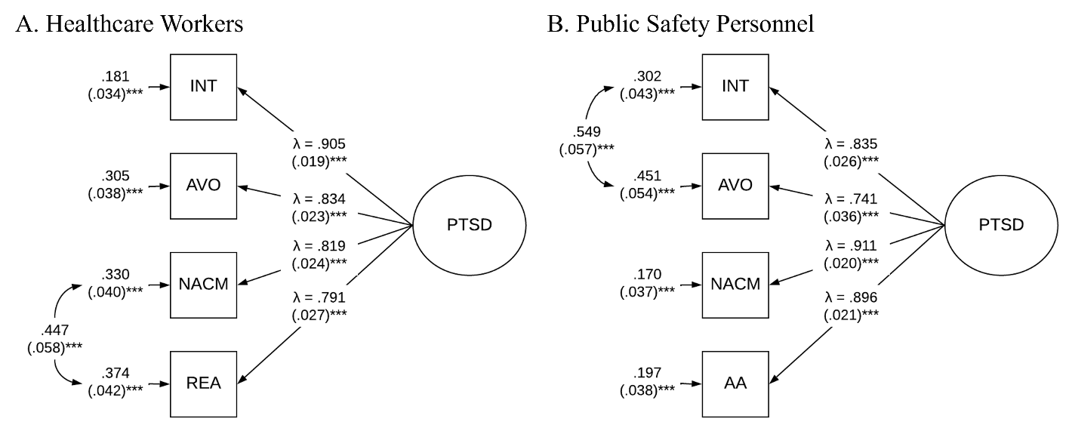
Figure S1. PTSD Measurement Models in HCWs and PSP.
All values are standardized. Standard error for residuals and covariances in parentheses. PTSD = PTSD latent factor, INT = Intrusions, AVO = Avoidance, NACM = Negative Alterations in Cognition and Mood, REA = Reactivity. Panel A represents measurement model for HCWs. The HCWs model fit was excellent (χ ²(1, N = 299) = 0.399, p > .05, TLI = 1.00, CFI = 1.00, RMSEA = 0.00 [95% CI = .000 - .130], SRMR = 0.002). Panel B represents measurement model for PSP. The PSP model fit was adequate (χ ²(1, N = 199) = 6.248, p = .01, TLI = .951, CFI = .992, RMSEA = 0.162 [95% CI = .060 - .293], SRMR = 0.01). * p < .05; ** p < .01; *** p < .001

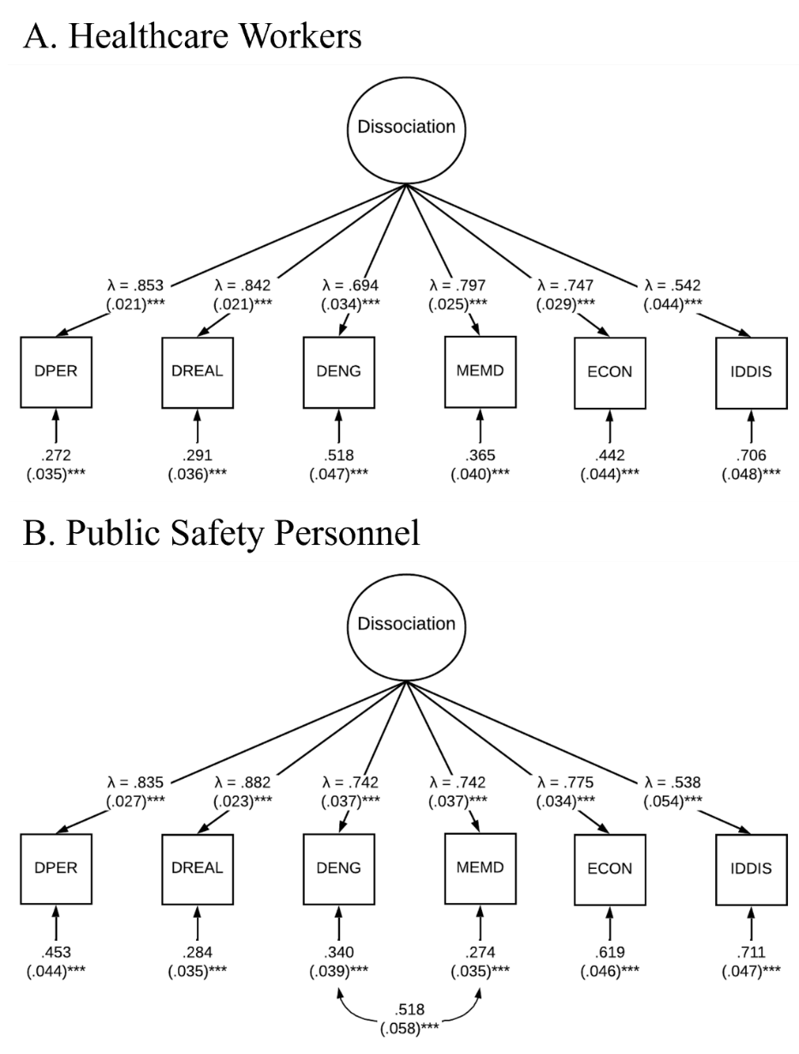
Figure S2. Dissociation Measurement Models in HCW and PSP.
All values are standardized. Standard error for residuals and covariances in parentheses. DPER = Depersonalization, DREAL = Derealization, DENG = Disengagement, MEMD = Memory Disturbances, ECON = Emotional Constriction, IDDIS = Identity Dissociation. Panel A represents measurement model for HCWs. The HCWs model fit was excellent (χ ²(9, N = 299) = 32.04, p < .001, TLI = .958, CFI = .975, RMSEA = .092 [95% CI = .059 - .128], SRMR = 0.03). Panel B represents measurement model for PSP. The PSP model fit was adequate (χ ²(8, N = 199) = 27.48, p < .001, TLI = .949, CFI = .973, RMSEA = 0.110 [95% CI = .067 - .157], SRMR = 0.03). * p < .05; ** p < .01; *** p < .001
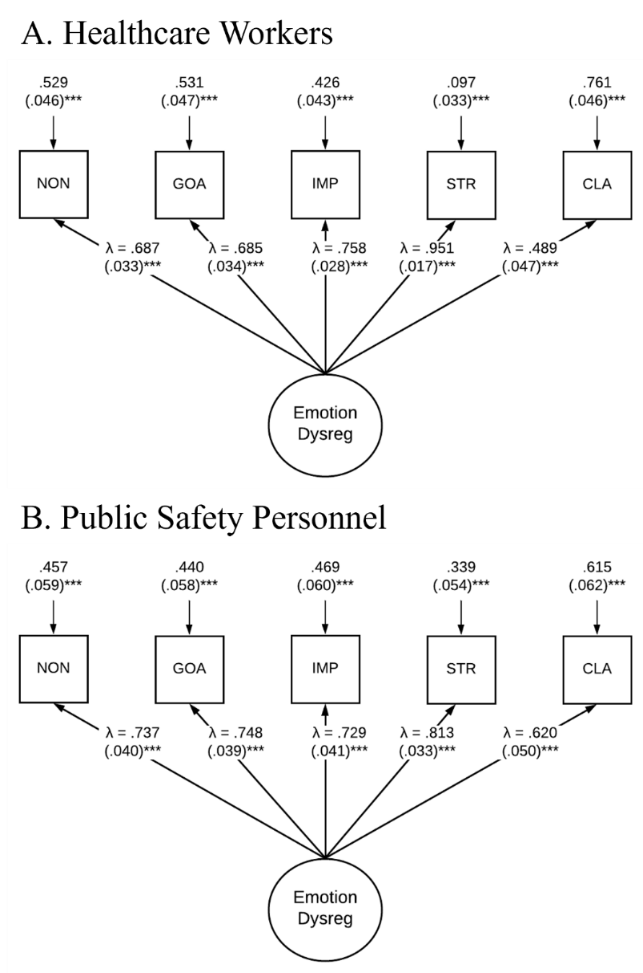
Figure S3. Emotion Dysregulation Measurement Models in HCWs and PSP.
All values are standardized. Standard error for residuals and covariances in parentheses. NON = Non-Acceptance of Emotional Responses, GOA = Difficulty Engaging in Goal-Directed Behaviour, IMP = Impulse Control Difficulties, STR = Lack of Access to Emotion Regulation Strategies, CLA = Lack of Emotional Clarity. The HCWs model fit was excellent (χ ²(8, N = 299) = 27.90, p < .001, TLI = .952, CFI = .974, RMSEA = .091 [95% CI = .056 - .129], SRMR = 0.04). Panel B represents measurement model for PSP. The PSP model fit was excellent (χ ²(5, N = 199) = 12.24, p < .05, TLI = .963, CFI = .982, RMSEA = 0.085 [95% CI = .023 - .147], SRMR = 0.03). * p < .05; ** p < .01; *** p < .001
Initial HCWs PTSD and Substance Use Model
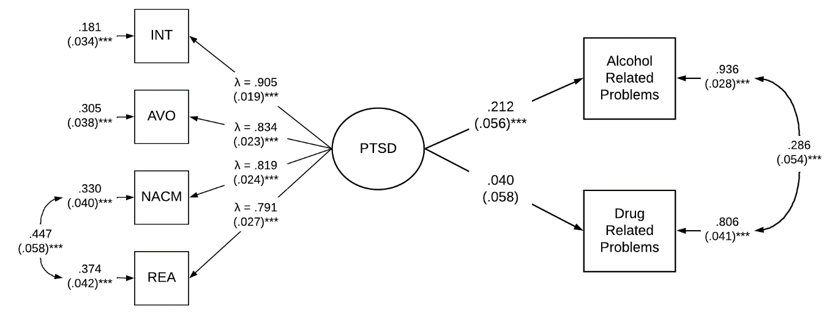
Figure S4. Associations between PTSD and Alcohol and Drug Related Problems among HCWs. All values are standardized. Standard error for residuals and covariances in parentheses. PTSD = PTSD latent factor, INT = Intrusions, AVO = Avoidance, NACM = Negative Alterations in Cognition and Mood, REA = Reactivity. Age, sex, education, childhood adversity, depressive symptoms, anxiety symptoms, and stress symptoms were controlled for. Model fit was excellent (χ ²(33, N = 299) = 64.43, p < .0001, TLI = .962, CFI = .976, RMSEA = 0.056 [95% CI = .035 - .077], SRMR = 0.04). * p < .05; ** p < .01; *** p < .001

Initial PSP PTSD and Substance Use Model
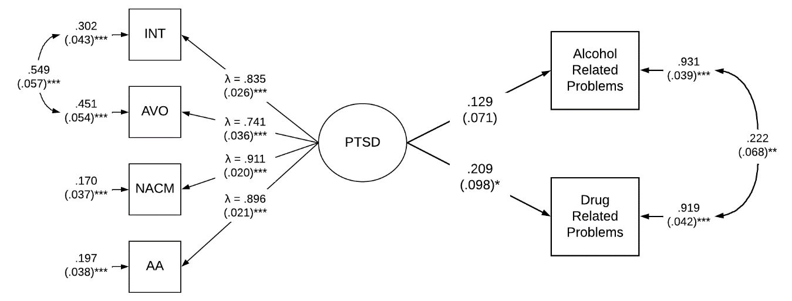
Figure S5. Associations between PTSD and Alcohol and Drug Related Problems among PSP. All values are standardized. Standard error for residuals and covariances in parentheses. PTSD = PTSD latent factor, INT = Intrusions, AVO = Avoidance, NACM = Negative Alterations in Cognition and Mood, REA = Reactivity. Age, sex, education, childhood adversity, depressive symptoms, anxiety symptoms, and stress symptoms were controlled for. Model fit was excellent (χ ²(36, N = 199) = 57.66, p < .05, TLI = .972, CFI = .980, RMSEA = 0.055 [95% CI = .026 - .081], SRMR = 0.05). * p < .05; ** p < .01; *** p < .001

HCWs Secondary Cluster Model
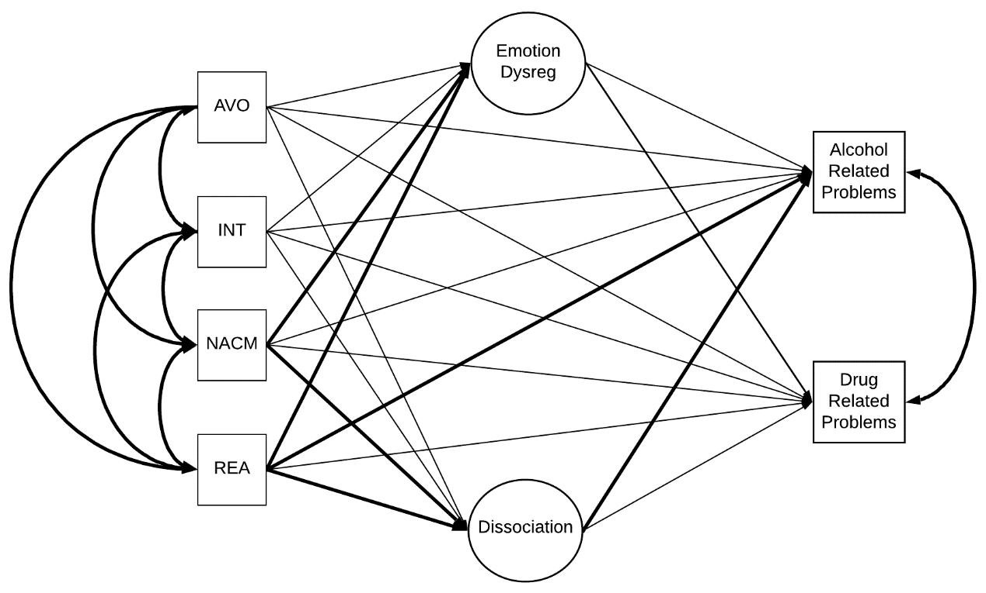
Figure S6. Parallel Mediation Model with PTSD Symptom Clusters among HCWs.
All values are standardized. Standard error for residuals and covariances in parentheses. PTSD = PTSD latent factor, INT = Intrusions, AVO = Avoidance, NACM = Negative Alterations in Cognition and Mood, REA = Reactivity. Age, sex, education, childhood adversity, depressive symptoms, anxiety symptoms, and stress symptoms were controlled for. Model fit was poor (χ ²(178, N = 299) = 425.42, p < .00001, TLI = .883, CFI = .910, RMSEA = 0.068 [95% CI = .060 - .076], SRMR = 0.06). * p < .05; ** p < .01; *** p < .001

The secondary cluster model evaluated the direct and indirect (mediated via dissociation or emotion dysregulation) paths from each of the four PTSD symptoms clusters to alcohol and drug use related problems. Overall, the model accounted for 8.3% of the variance in alcohol use related problems (r² = .083, p < .05) and 9.2% of the variance in drug use related problems (r² = .092, p < .05). Prior to mediation, the direct paths from the four PTSD symptoms clusters to alcohol-related problems were as follows: Intrusions (β = .018, p > .05), Avoidance (β = -.098, p > .05), NACM (β = -.056, p > .05), and Reactivity (β = .267, p = .007). Following mediation, the direct paths to alcohol-related problems were not significant for any of the clusters (βs = -.254 - .171, ps > .05). The indirect paths from the PTSD symptom clusters to alcohol-related problems via dissociation (βs = .000 - .005, ps > .05) were not significant. However, the indirect path from NACM to alcohol related problems via emotion dysregulation was significant (indirect effect β = .101, p < .05) but the indirect paths for the other symptom clusters were not (βs = -.031 - .076, ps > .05). Prior to mediation, the direct paths from the four PTSD symptoms clusters to drug use related problems were as follows: Intrusions (β = .000, p > .05), Avoidance (β = -.019, p > .05), NACM (β = -.049, p > .05), and Reactivity (β = .117, p > .05). Following mediation, the direct paths to drug use related problems were not significant for any of the clusters (βs = -.109 - .086, ps > .05). The indirect paths from the PTSD symptom clusters to drug use related problems via dissociation (βs = .000 - .004, ps > .05) and emotion dysregulation (βs = -.016 - .051, ps > .05) were not significant.

PSP Secondary Cluster Model
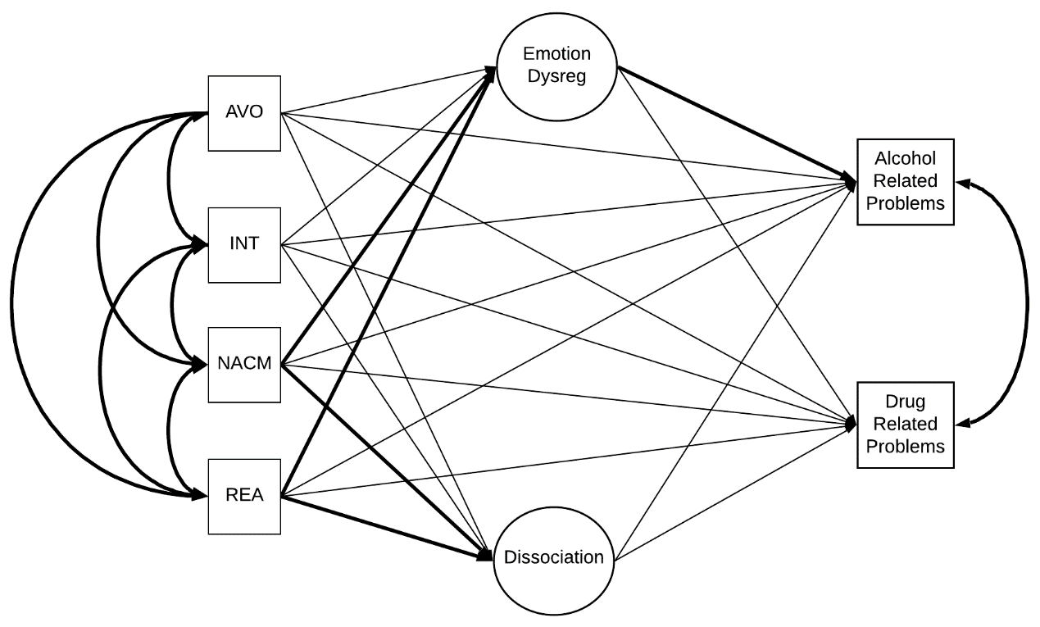
Figure S7. Parallel Mediation Model with PTSD Symptom Clusters among PSP.
All values are standardized. Standard error for residuals and covariances in parentheses. PTSD = PTSD latent factor, INT = Intrusions, AVO = Avoidance, NACM = Negative Alterations in Cognition and Mood, REA = Reactivity. Age, sex, education, childhood adversity, depressive symptoms, anxiety symptoms, and stress symptoms were controlled for. Model fit was poor (χ ²(153, N = 199) = 371.40, p < .00001, TLI = .848, CFI = .881, RMSEA = 0.084 [95% CI = .074 - .095], SRMR = 0.076). * p < .05; ** p < .01; *** p < .001

The secondary cluster model evaluated the direct and indirect (mediated via dissociation or emotion dysregulation) paths from each of the four PTSD symptoms clusters to alcohol and drug use related problems. Overall, the model accounted for 8.5% of the variance in alcohol use related problems (r² = .085, p < .05) and 8.7% of the variance in drug use related problems (r² = .087, p < .05). Prior to mediation, the direct paths from the four PTSD symptoms clusters to alcohol-related problems were as follows: Intrusions (β = -.212, p > .05), Avoidance (β = .128, p > .05), NACM (β = .048, p > .05), and Reactivity (β = .175, p > .05). Following mediation, the direct paths to alcohol-related problems were significant for Reactivity only (β = .259, p < .01), but not the others (β’s = -.147 - .016, ps > .05). However, the indirect paths from the PTSD symptom clusters to alcohol-related problems via dissociation (βs = -.007 - .056, ps > .05) and emotion dysregulation (βs = .005 - .000, ps > .05) were not significant. Prior to mediation, the direct paths from the four PTSD symptoms clusters to drug use related problems were as follows: Intrusions (β = -.099, p > .05), Avoidance (β = .068, p > .05), NACM (β = .006, p > .05), and Reactivity (β = .110, p > .05). Following mediation, the direct paths to drug use related problems were not significant for any of the clusters (β’s = -.180 - .023, ps > .05). The indirect paths from the PTSD symptom clusters to drug use related problems via dissociation (βs = -.005 - .043, ps > .05) and emotion dysregulation (βs = -.003 - .089, ps > .05) were not significant.

Non-Imputed Results

Supplemental Table 3. Results of the Non-Imputed Primary Parallel Mediation Model for HCWs
Path | β | S.E. | p
PTSD Dissociation | .699 | .041 | .00
PTSD Emotion Dysregulation | .772 | .039 | .00
PTSD Alcohol-Related Problems | .069 | .150 | .66
PTSD Drug-Related Problems | -.185 | .154 | .23
Dissociation Alcohol-Related Problems | .226 | .111 | .04
Dissociation Drug-Related Problems | .190 | .107 | .08
Emotion Dysregulation Alcohol-Related Problems | -.028 | .144 | .85
Emotion Dysregulation Drug-Related Problems | .140 | .140 | .32
PTSD Dissociation Alcohol-Related Problems | .158 | .079 | .04
PTSD Dissociation Drug-Related Problems | .133 | .075 | .08
PTSD Emotion Dysregulation Alcohol-Related Problems | -.021 | .111 | .85
PTSD Emotion Dysregulation Drug-Related Problems | .108 | .109 | .32
Note: N = 260 for all paths. Model fit was adequate: (χ ²(208, N = 260) = 424.76, p < .00001, TLI = .907, CFI = .922, RMSEA = 0.059 [95% CI = .051 - .067], SRMR = 0.067).

Supplemental Table 4. Results of the Non-Imputed Primary Parallel Mediation Model for PSP
Path | β | S.E. | p
PTSD Dissociation | 0.775 | 0.042 | .00
PTSD Emotion Dysregulation | .747 | .050 | .00
PTSD Alcohol-Related Problems | -.069 | .201 | .73
PTSD Drug-Related Problems | .307 | .236 | .19
Dissociation Alcohol-Related Problems | .010 | .161 | .95
Dissociation Drug-Related Problems | -.051 | .166 | .76
Emotion Dysregulation Alcohol-Related Problems | .306 | .157 | .05
Emotion Dysregulation Drug-Related Problems | .203 | .156 | .193
PTSD Dissociation Alcohol-Related Problems | .007 | .125 | .95
PTSD Dissociation Drug-Related Problems | -.039 | .129 | .76
PTSD Emotion Dysregulation Alcohol-Related Problems | .229 | .120 | .06
PTSD Emotion Dysregulation Drug-Related Problems | .151 | .117 | .20
Note: N = 142 for all paths. Model fit was poor: (χ ²(176, N = 142) = 353.88, p < .00001, TLI = .887, CFI = .905, RMSEA = 0.084 [95% CI = .072 - .097], SRMR = 0.086).

