Appendix A: Brief on usage of L-T CHART_ RECESSIVE PARAMETER RETRIEVAL SYSTEM

Step 1：Before using the system, users are required to register an account and not properly registered users can’t log into the system, as shown in Figures 1 and 2.
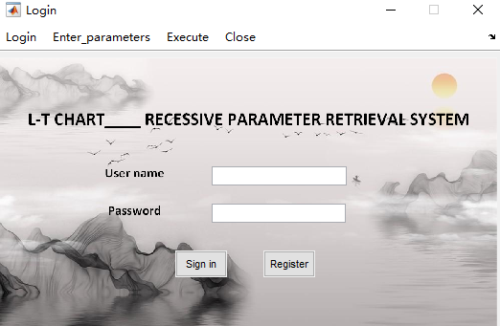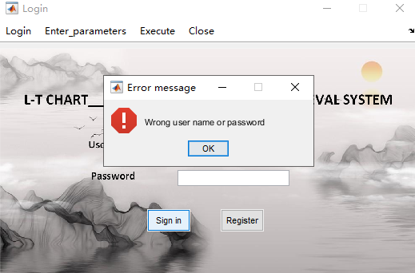
Figure 1 Figure 2
Step 2：Select the number of function parameters in the source system and input the parameter information and the corresponding function information. Click "Operation" to retrieve the dimension of the parameter in the L-T table, as shown in Figure 3.
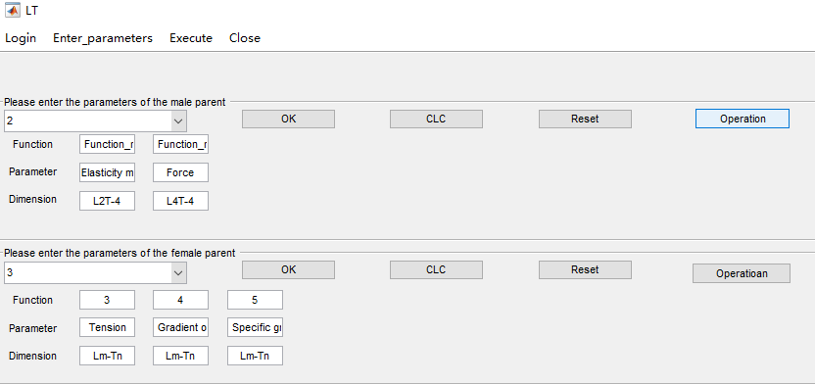
Figure 3
Step 3：Click "OK" to upload the parameter and function information, as shown in Figure 4.
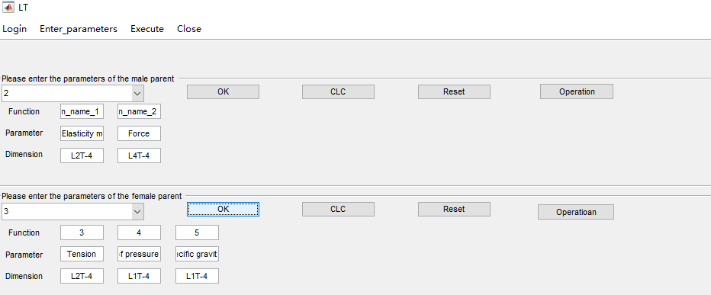
Figure 4
Step 4：Click "Execute" to enter the recessive parameter retrieval interface, as shown in Figure 5. Click the "OK" button on the left panel in the "Carried_out" interface to convert the information of parameter and function, as shown in Figure 6.
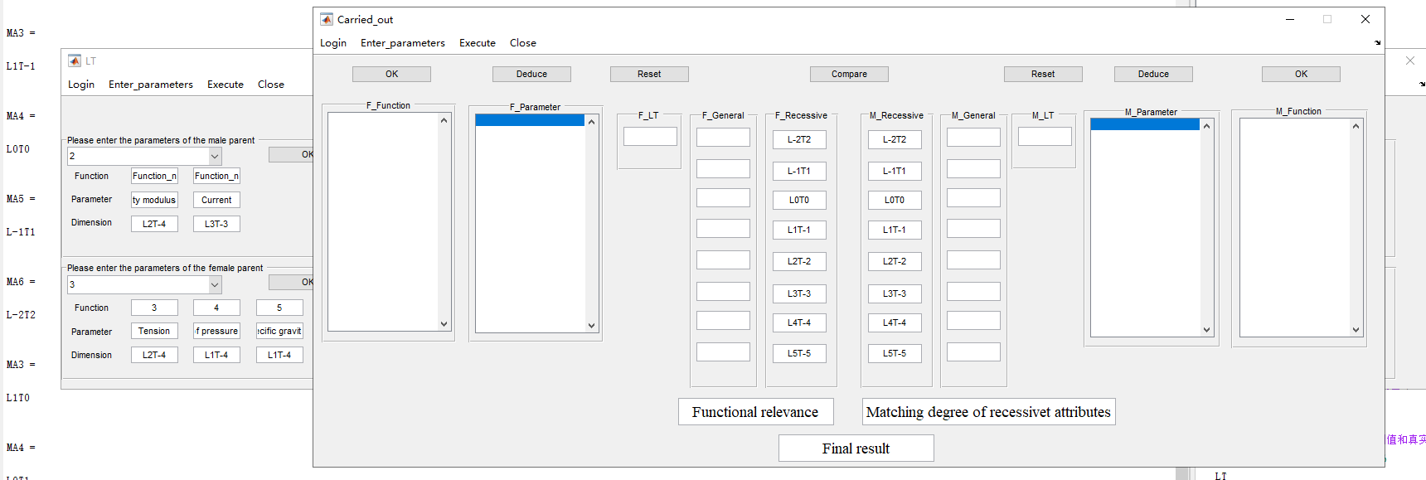
Figure 5
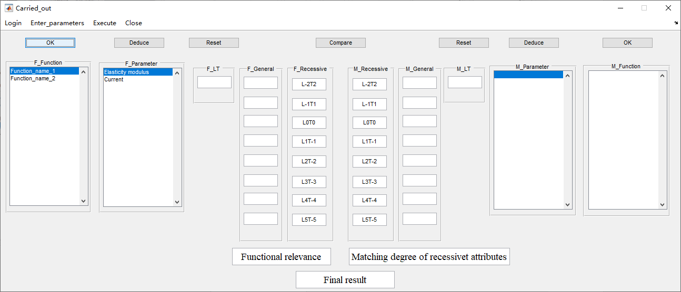
Figure 6
Step 5：The function information and parameter information uploaded from the input interface are analyzed and calculated. Select the parameter name and click “Deduce” to output the split results, as shown in Figure 7.
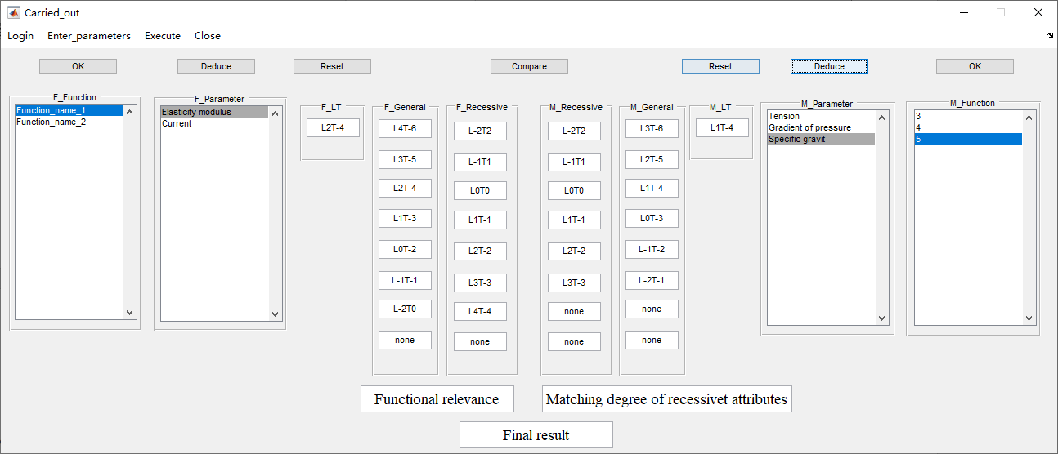
Figure 7

Step 6：After all parameters have been analyzed, click "Compare". The system will read the functional correlation data and calculate the coupling pairing of the parameters to obtain the final coupling strength result. This example is only for demonstration purpose and there is no analysis data for the functional correlation, so the result is displayed as "None" as shown in Figure 8.
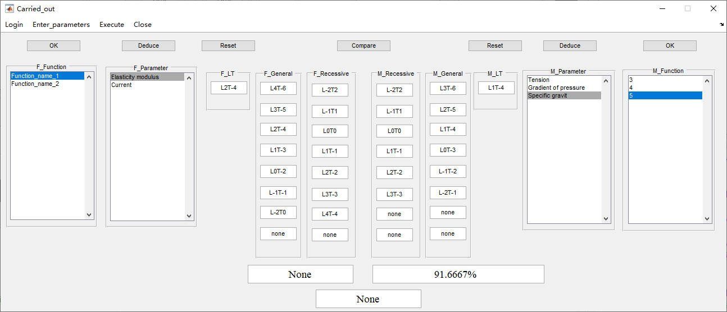
Figure 8

An additional note is that when the selected parameter is the "recessive parameter" summarized in the text, the system will prompt. The results at this time require specific analysis, as shown in Figure 9.
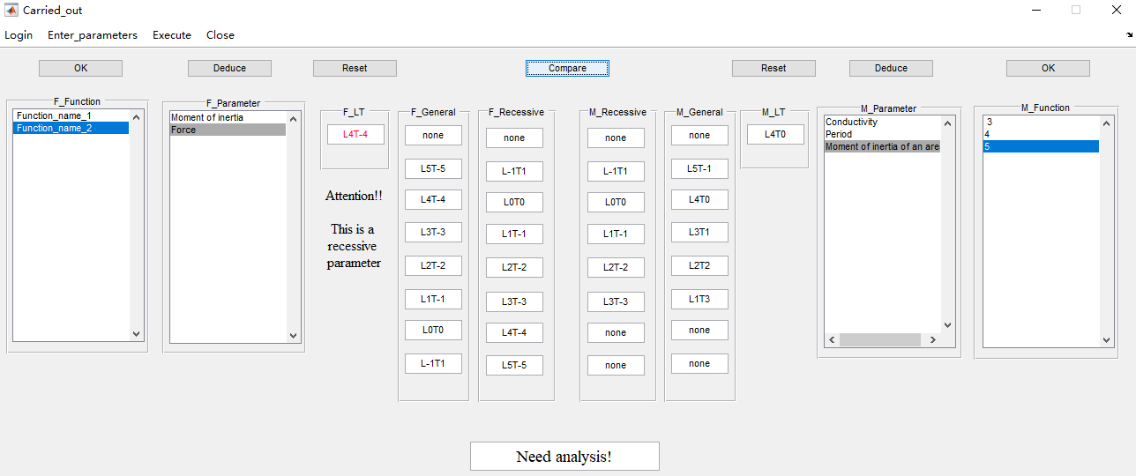
Figure 9

