Appendix E: The process of comparative design

Step 1 Establish total functional structure
The total function of the system is to transport irregular workpieces. The input materials in this system are irregular workpieces and manipulators. The energy is electrical energy, and the signal is a control signal. The output materials are the removed irregular workpieces and manipulators, and the relevant energy is kinetic energy and mechanical energy, and the signal is the number of transferred workpieces. Schematic for the total functional structure is shown in Figure 1.
Figure 1 Schematic for general function of grasping complex workpieces
Step 2 Build function tree
The total function is subdivided, and the total function is decomposed into component functions until it is decomposed into functional elements. The function tree of the descendant system, as shown in Figure 2, is then constructed.
Figure 2 Function tree
Step 3 Root cause analysis
By analyzing the problems exhibiting in the existing system, the causal chain is established as shown in Figure 3 and the root causes of these problems are analyzed.
Figure 3 Causal chain
From the root cause analysis of the system, the key points of the problems are obtained:
1. The shape of the parts is irregular.
2. The grabbing efficiency is low.
3. The manipulator has no identification device.

Step 4: Analysis of available resources
TRIZ theory believes that the essence of problem solving is the rational use of resources, and the use of three-dimensional resources in the system or its environment can increase its idealization level in the following ways: generate additional useful features and reduce costs by using unused resources, internal instead of external resources, low-cost or very readily reachable resources. Table 1 demonstrates example for analysis of available resources inside the system.
Table 1 Analysis of available resources inside the system
Material resources | Field resources | Time resources | Space resources | Information resources | Energy resources
Transfer box | Electric field | Transport workpiece time | Internal space of the transfer box | Temporal information | Electric energy
Job | Mechanical field | Production time per day | Internal space of the production workshop | Workpiece weight | Gravitational potential energy
 | Gravitational field |  |  | Transport box volume | Kinetic energy
Step 5 Final ideal solution analysis
(1) What is the ultimate goal to be achieved?
——Shaped workpieces can be quickly transported to the next production step.
(2) What are the obstacles to be overcome in order to achieve idealization?
——Traditional manipulators cannot grab irregular workpieces.
(3) What is the consequence of the disorder?
——The traditional manipulator is difficult to grasp.
(4) What are the conditions for the obstacle not to appear?
—— Looking for a device that can grab an irregular workpiece.
(5) What resources are available to cater for conditions to prevent obstacles?
——The internal space of the transfer box, the time to transfer the workpiece, and the electrical energy.
According to the ideal solution analysis, the problem-solving idea is proposed:
Option 1: Design an overall mechanical device that can automatically detect and grab irregular workpieces.
Option 2: Select parts with reasonable price and accurate grasping through comparison.
Step 6 Technical Conflict
Solving problems based on TRIZ principle requires transforming a practical problem to be solved into a problem model, a solution model, and finally a solution to the problem. The TRIZ problem model includes technical conflict, physical conflict, and so on. Technical conflict refers to the mutual constraints between two parameters in a technical system.
Start with "low labor efficiency" as the key point:
(1) Conflict description: In order to reduce human workload and improve efficiency, use corresponding equipment to replace human work. But the complexity of the mechanical structure will be increased.
(2) Convert to TRIZ standard conflict
Improved parameter：39 Productivity
Deteriorating parameter：36 Complexity of the device
- Find the conflict matrix and get the following invention principle:
No.12: Equipotentiality
No.17: Dimensional change
No.28: Mechanical system instead
No.24: Intermediary
(4) According to the selected invention principle, the following solutions are derived:
Option 3: According to No.12, make the conveyor belt and the irregular workpiece on the same plane, thereby reducing the work done to transfer the irregular workpiece to the conveyor belt.
Option 4: According to No.28, use a manipulator instead of a human to grab an irregular workpiece.
Option 5: According to No.28, sensors are used to detect the position and quantity of irregular workpieces as shown in Figure 4.
Option 6: According to No.24, use a manipulator instead of a person to move the irregular workpiece to the conveyor belt.
Figure 4 Adding ultrasonic sensors to detect the position and quantity of irregular workpieces
Step 7 Physical Conflict
It can be seen from the system function analysis and causal analysis that more sensors can be arranged to improve the grasping speed and accuracy to address the problem that the mechanical device does not have an identification device. However, since the more the number of sensors, the higher the cost. It is hoped that the number of sensors should be as small as possible. The physical conflict arising from that it is desirable to increase the detection accuracy, but it is at the expense of increased cost of the equipment. Condition-based separation is one of the contents of the separation principle, and the following solutions are obtained according to the available principles:
According to NO.5: Merge, the solution seven is obtained: the ranging sensors on the horizontal plane are installed in a straight line, so that the ranging sensors on the line can move back and forth to measure multiple workpiece points, as shown in Figure 5.
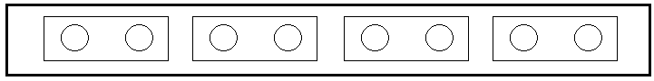
Figure 5 Arrangement of ultrasonic sensor lines
There are two movable directions of X and Y. The sensor transmits signals in the Z direction and scans in the X direction at the same time. After completing one scan in the X direction, there is a displacement in the Y direction, and then scans in the opposite direction of the X direction. Cyclic scanning is implemented to achieve objective multi-point measurement at the same position, and the specific movement direction of the ultrasonic sensor is shown in Figure 6.
Figure 6 Line arrangement movement mode
Step 8 Matter-Field Analysis
From the system function analysis and causal analysis, taking the sensor detection position and quantity as an example, the sensor needs to detect the position and quantity of the irregular workpiece in the transfer device. However, since the irregular workpiece is of complex shape, the sensor cannot directly measure the position of the workpiece. The matter-field model is established as shown in Figure 7.
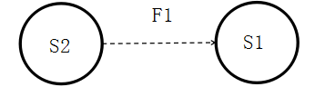
S2-Sensor, S1-special workpiece, F1-electric field
Figure 7 Material-field model corresponding to detection element and irregular workpiece
For the sensor detection problem substance-field model, the fourth type of standard solution is applied: No.59 (4.5.2).
No.59 (4.5.2) Standard solution: indirect measurement instead of direct measurement: the first or second derivative of the measurable space.
Analyzing the determined solutions, two solutions can be specified:
Option 8: According to No.59 (4.5.2) standard solution, use the infrared sensor to measure the position of the differential housing, and indirectly measure the distance from the workpiece to the sensor by measuring the infrared reflection time, and then determine the position of the workpiece, as shown in Figure 8.
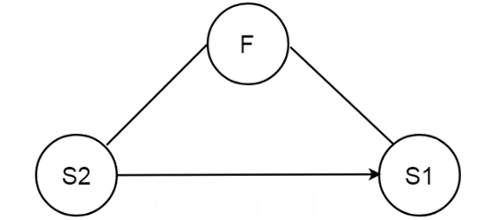
S2-Isensor, S1-special workpiece, F-electromagnetic field
Figure 8 Material-field model for infrared detection
Option 9: According to the standard solution of No.59 (4.5.2), the ultrasonic sensor is used to measure the position and quantity of the irregular workpiece. The distance from the workpiece to the sensor can be indirectly derived by measuring the ultrasonic reflection time, and the position and quantity of the workpiece can then be determined as shown in Figure 9.

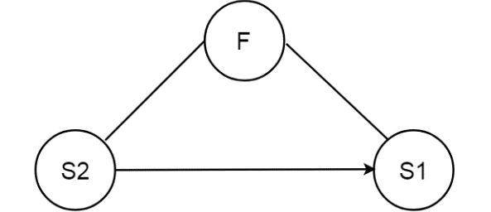
S2-Ultrasonic sensor, S1-special workpiece, F-sound field
Figure 9 Material-field model for ultrasonic detection
Step 9 All technical solutions and evaluation
- Evaluate and summarize the above programs, see Table 2.
Table 2 Summary of technical plans
Order number | Scheme | The principle of innovation | Availability assessment
1 | Use machinery instead of labor | The final ideal solution | available
2 | Use low-cost components | The final ideal solution | available
3 | Place the artifact and the conveyor belt on the same plane | 12: Equipotentiality | Available, but it increases costs
4 | The manipulator grabs the different piece instead of people | 28: Mechanical system instead | available
5 | Using sensor | 28: Mechanical system instead | available
6 | Use a manipulator instead of a person | 24 Intermediary | available
7 | Install the range sensor on the horizontal level | 5 Merge | available
8 | The measurements were performed using the infrared sensors | No.59 (4.5.2) Standard solution | Available, but it increases costs
9 | The measurements were performed using the ultrasonic sensors | No.59 (4.5.2) Standard solution | available

Step 10 Determine the final plan
According to evaluation and summary of the above schemes, options 1, 2, 4, 5, 6, 7, and 9 are finally determined and the optimal solution is identified. Final solution: The irregular workpiece grabbing device adopts the ultrasonic sensor array scanning method to detect the position of the workpiece during the transfer process, and the system controls the manipulator to grab the workpiece in the transfer box and place it at the designated position according to the position information. Prototype and test according to the final design. The test part of the prototype is shown in the Figure 10.
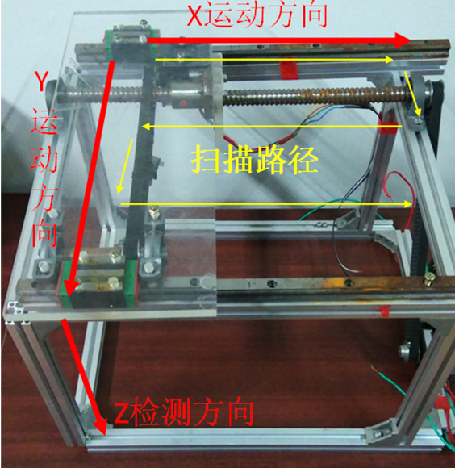
Figure 10 Scanning path for ultrasound detection

