Investigating ten years of warming and enhanced snow depth on nutrient availability and greenhouse gas fluxes in a High Arctic ecosystem

Jacqueline K.Y. Hung*^{1,2}, Neal A. Scott¹, and Paul M. Treitz¹
¹Queen’s University, Kingston, Ontario, Canada, K7L 3N6
²Woodwell Climate Research Center, Falmouth, Massachusetts, USA, 02540

*Corresponding author: Jacqueline K.Y. Hung
Email: jhung@woodwellclimate.org

Supplemental Information
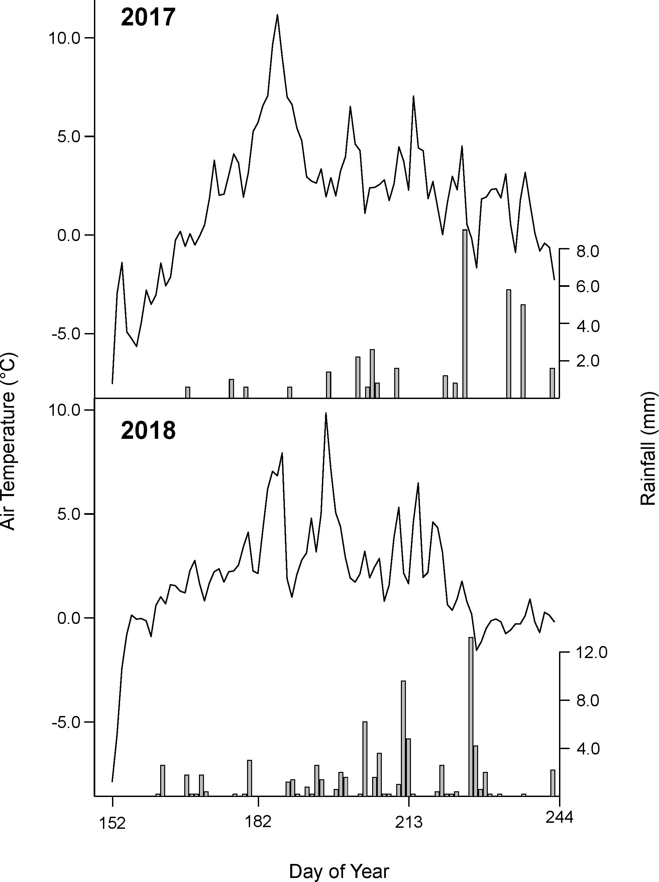
Figure S1. Air temperature and rainfall patterns for 2017 (top) and 2018 (bottom) at the Cape Bounty Arctic Watershed Observatory (CBAWO) during the summer months of June, July and August (JJA).

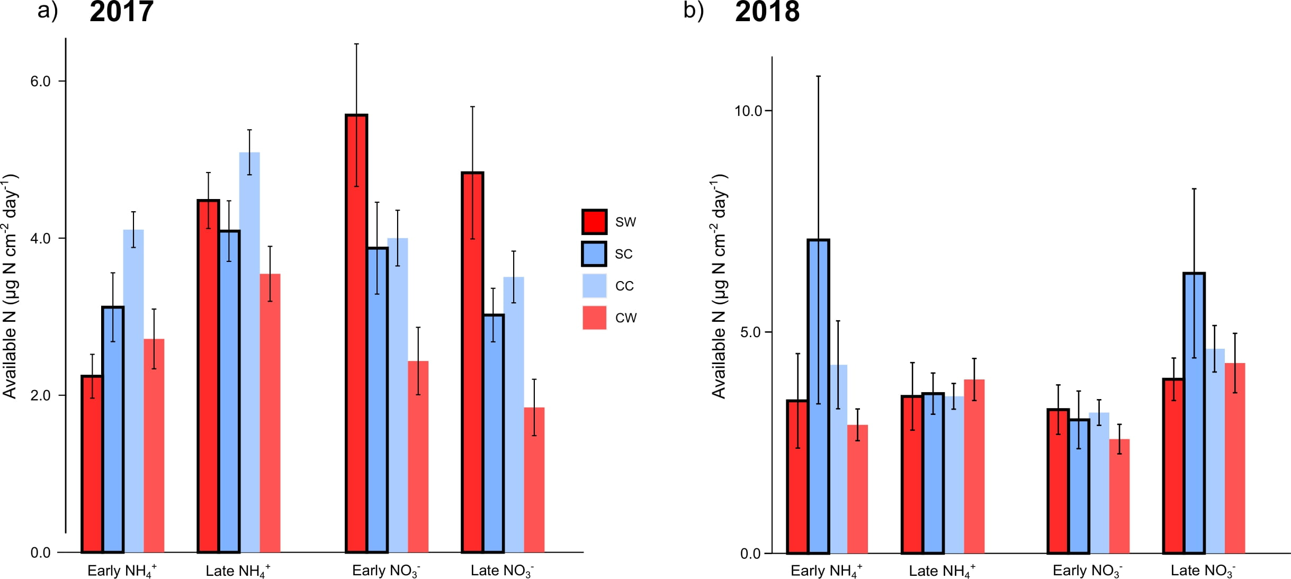
Fig. S2 Seasonal patterns of NH₄⁺-N availability and NO₃⁻-N availability in a) 2017 and b) 2018. Treatments are coded as snow-warmed (SW), snow-control (SC), control warmed (CW), and control-control (CC). Error bars indicate one standard error for all plots. Note differences in y-axis scales between the two years.

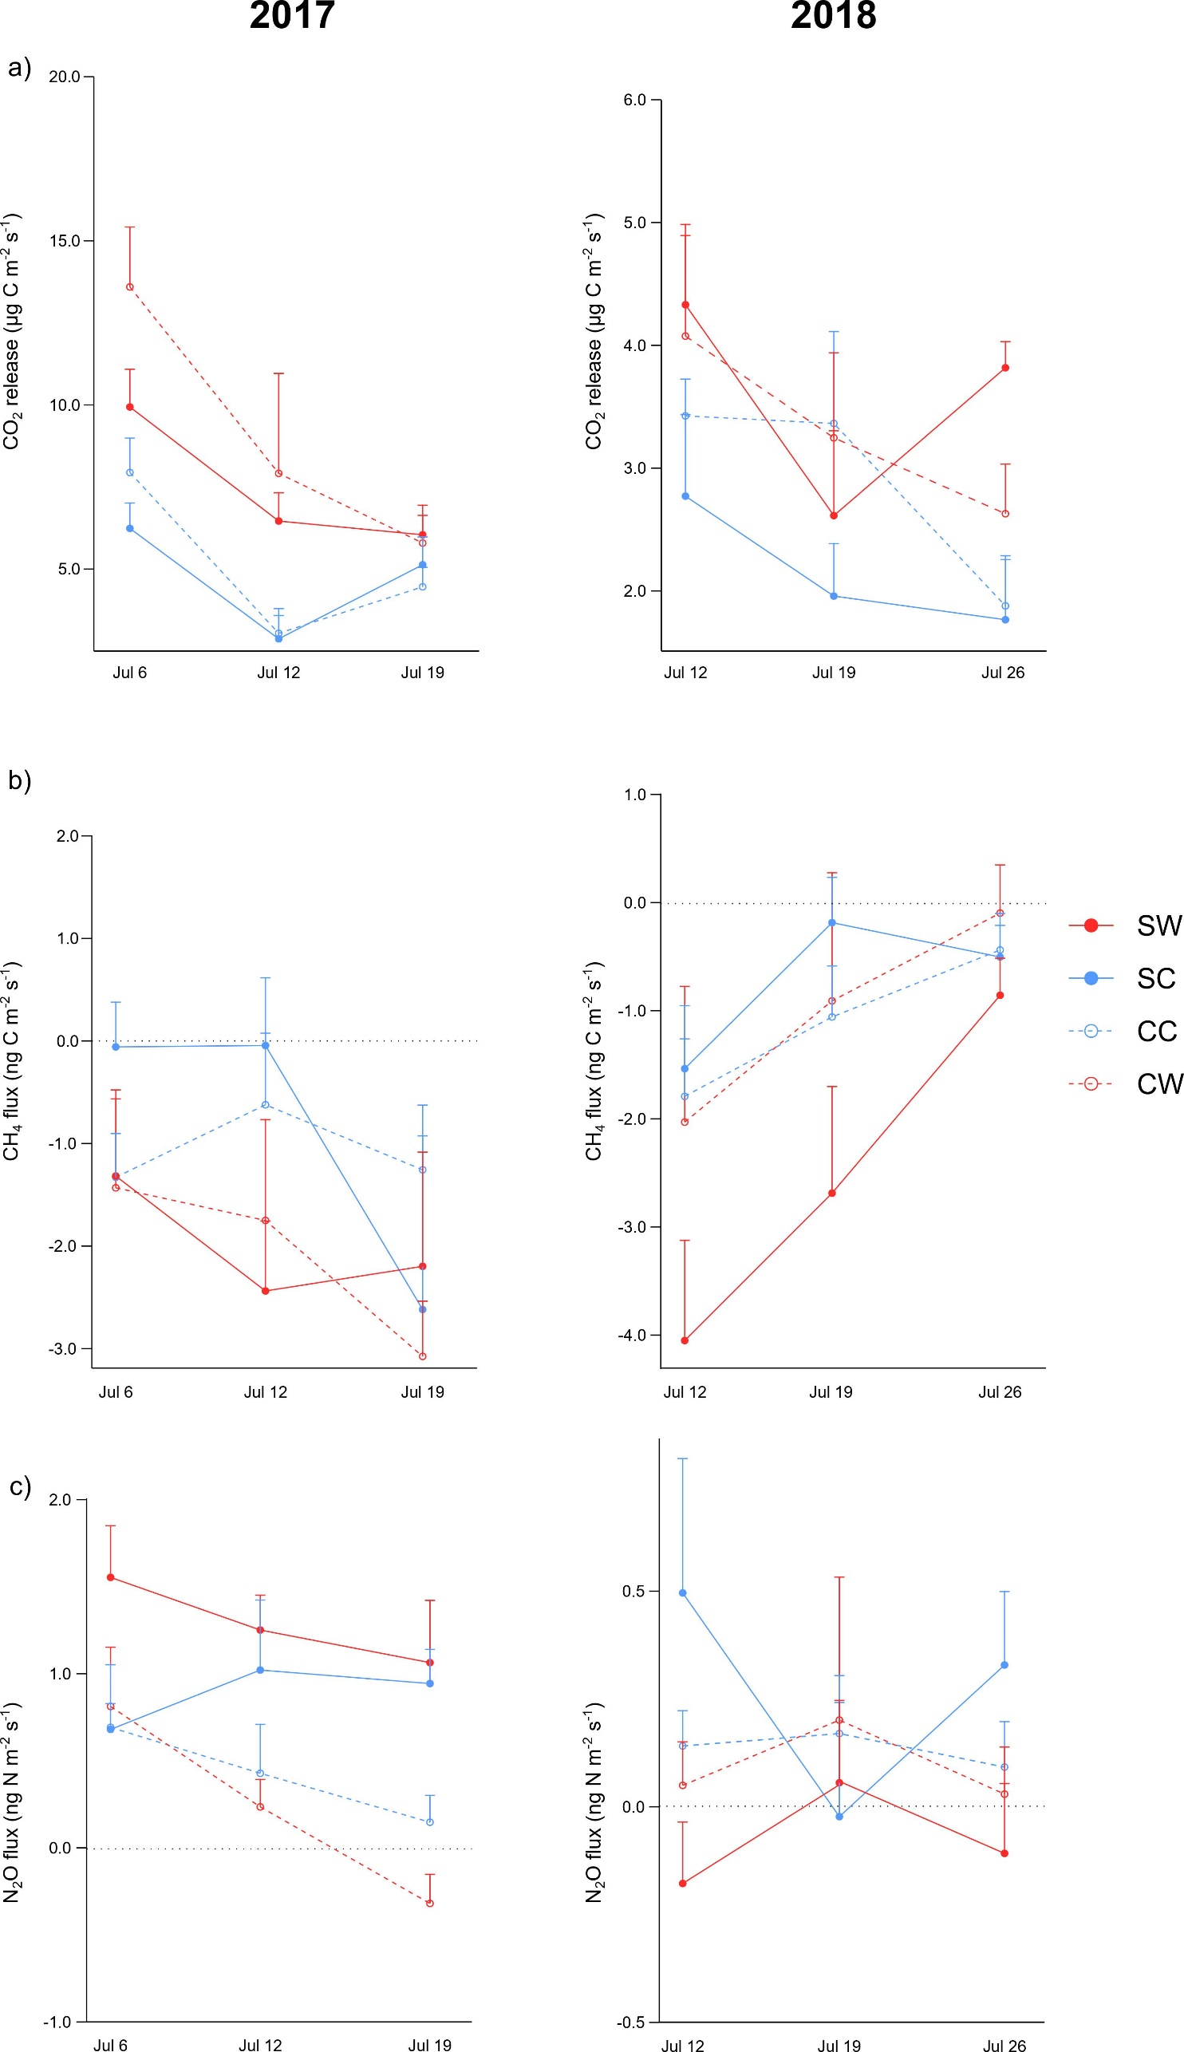

Fig. S3 Seasonal patterns of a) CO₂ release, b) CH₄ flux, and c) N₂O flux in 2017 (left) and 2018 (right). Treatments are coded as snow-warmed (SW), snow-control (SC), control warmed (CW), and control-control (CC). Error bars indicate upper limit of one standard error for all plots. Note differences in y-axis scales between the two years.
Table S1. Four-way repeated measures analysis of variance (ANOVA) results for assessing two-way interactions of enhanced snow depth, warming, and study year (between subjects) and within study years (within subjects) on soil temperature, active layer depth, soil moisture, NH₄⁺-N availability, NO₃⁻-N availability, CO₂ release, CH₄ flux, and N₂O flux. Significance values are reported as significant (**, p < 0.05) or non-significant (p > 0.05).
Variable | Df | Snow × Warm |  | Snow × Year |  | Warm × Year |  | Snow × Time |  | Warm × Time |  | Year × Time
 |  | F | Sig. | F | Sig. | F | Sig. | F | Sig. | F | Sig. | F | Sig.
Soil temperature | 1,53 | 5.95 | 0.02** | 1.48 | 0.230 | 0.13 | 0.72 | 1.44 | 0.24 | 0.46 | 0.50 | 1.07 | 0.31
Active layer depth | 1,53 | 4.45 | 0.04** | 11.24 | 0.00** | 0.43 | 0.52 | 4.42 | 0.04** | 0.13 | 0.73 | 8.80 | 0.01**
Soil moisture | 1,53 | 0.49 | 0.49 | 0.13 | 0.72 | 0.65 | 0.43 | 0.43 | 0.51 | 0.97 | 0.33 | 10.26 | 0.00**
NH₄⁺-N availability | 1,53 | 0.70 | 0.38 | 1.59 | 0.21 | 2.08 | 0.16 | 0.87 | 0.36 | 0.20 | 0.66 | 1.19 | 0.28
NO₃⁻-N availability | 1,53 | 1.95 | 0.17 | 1.92 | 0.17 | 0.38 | 0.54 | 0.470 | 0.50 | 0.01 | 0.94 | 4.07 | 0.05**
CO₂ release | 1,53 | 0.21 | 0.65 | 1.32 | 0.26 | 2.18 | 0.15 | 0.01 | 0.40 | 6.28 | 0.02** | 6.30 | 0.02**
CH₄ flux | 1,53 | 0.63 | 0.43 | 0.08 | 0.78 | 0.37 | 0.55 | 0.13 | 0.73 | 1.43 | 0.24 | 9.66 | 0.00**
N₂O flux | 1,53 | 0.31 | 0.58 | 14.28 | 0.00** | 0.01 | 0.94 | 0.05 | 0.82 | 0.06 | 0.81 | 0.39 | 0.54

