Supplementary figures
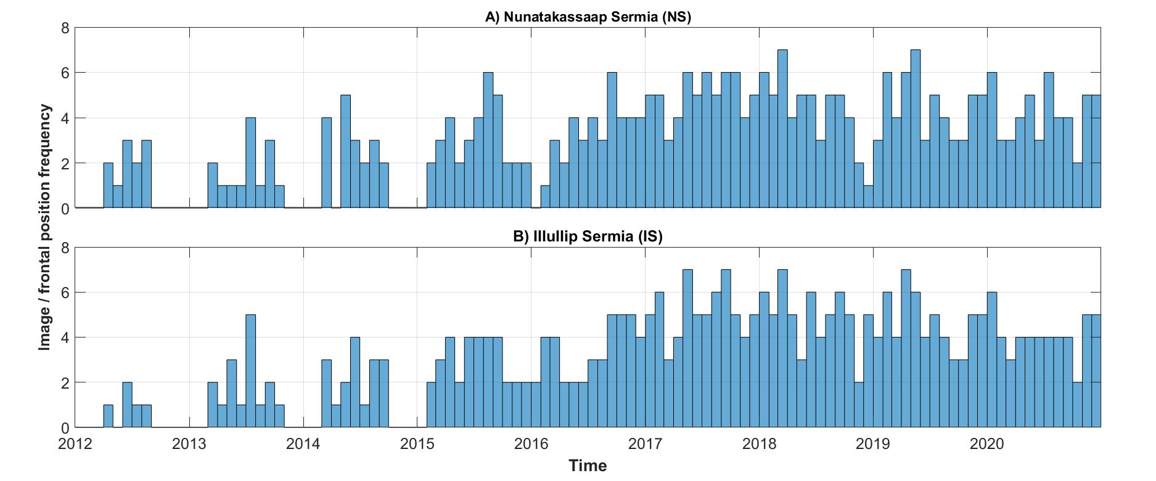
Supplementary Information Figure 1. Histogram of image, and hence frontal position, frequency during the study period for A) Nunatakssap Sermia (NS) and; B) Illullip Sermia (IS). Bar length indicates the number of images / terminus traces acquired during each month.
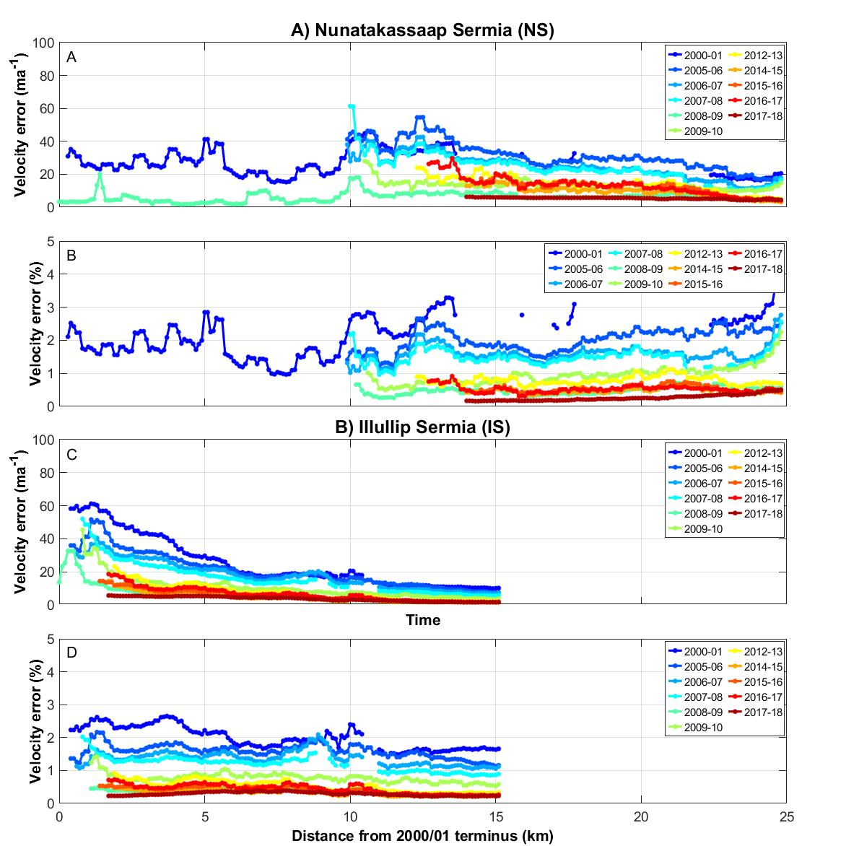
Supplementary Information Figure 2. Errors in interannual winter velocity dataset at NS (A & B) and IS (C & D), with absolute errors (A & C) and percentage errors (B & D). Ice velocity errors are colour-coded according to year of the winter velocity mosaic. Note that NS had a floating ice tongue in 2000-1, which had collapsed by the subsequent winter velocity mosaic in 2005-06. X-axis values are relative to the 2000-01 termini for each glacier. Source: MEaSUREs Greenland Ice Sheet Velocity Map from InSAR Data, Version 2 product (Joughin et al, 2015, updated 2018, Joughin et al, 2010).

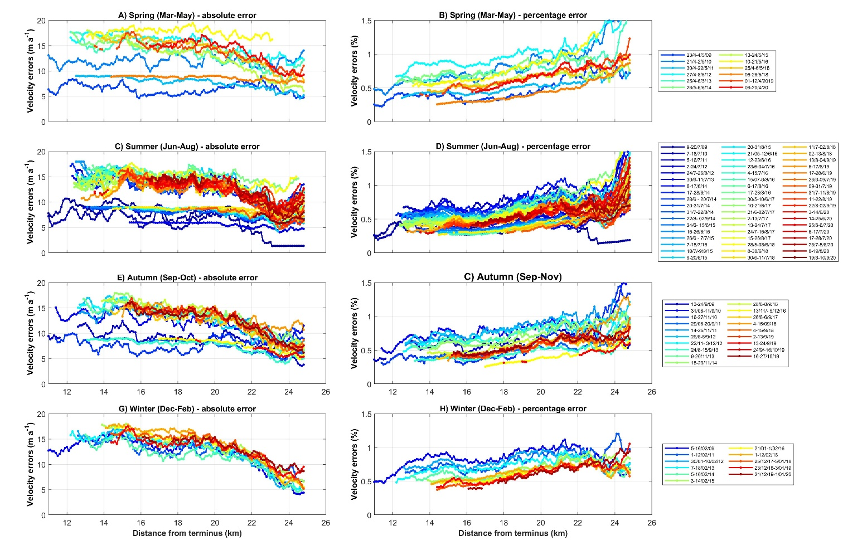
Supplementary Information Figure 3. Errors in seasonal ice velocities at Nunatakssap Sermia (NS), for spring (A & B); summer (C & D); autumn (E & F); and winter (G & H). Both absolute error (A,C,E & G) and percentage error (B,D,F & H) are given. Ice velocities are colour-coded according to date. X-axis values are relative to the 2000-01 termini for each glacier. Source: MEaSUREs Selected Glacier Site Velocity Maps generated from the InSAR Version 2 dataset were used to provide seasonal velocity data from 2009-2020 (Joughin et al, 2020).

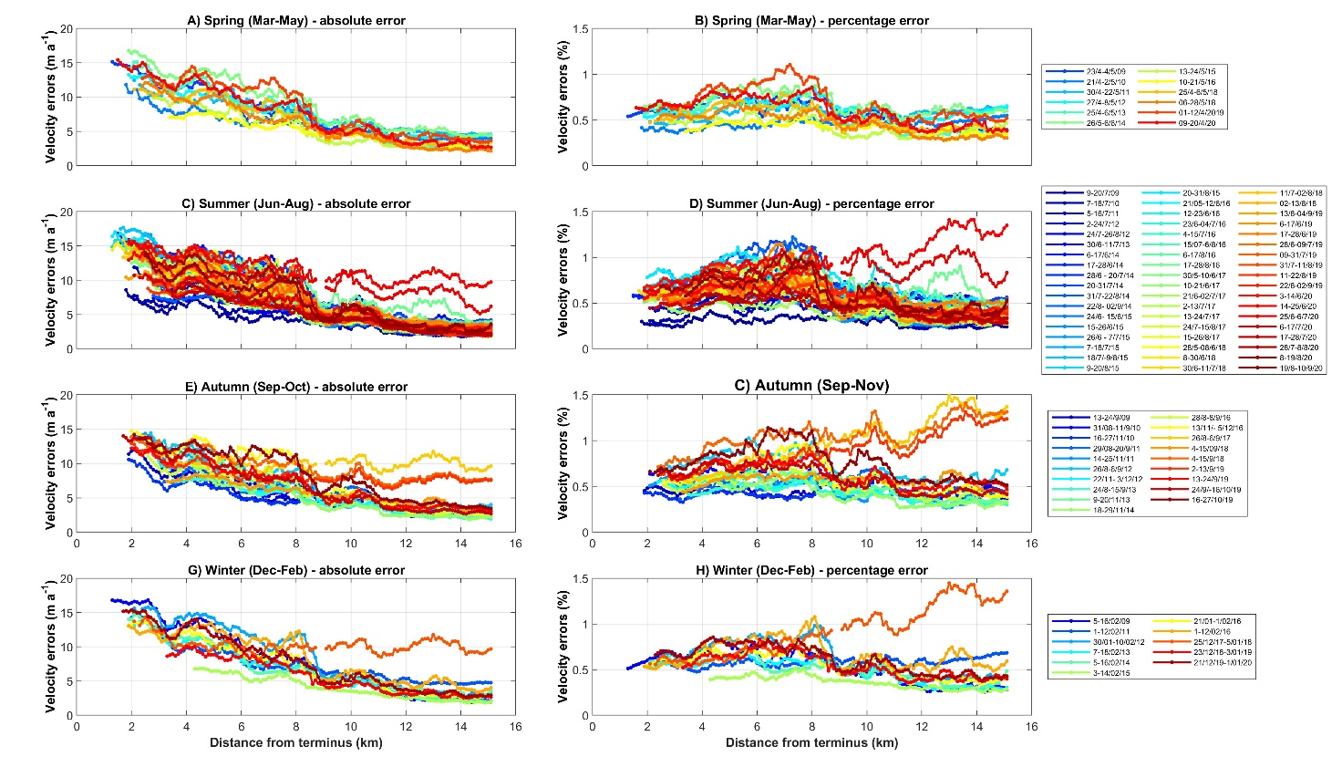
Supplementary Information Figure 4. Errors in seasonal ice velocities at Illullip Sermia (IS), for spring (A & B); summer (C & D); autumn (E & F); and winter (G & H). Both absolute error (A,C,E & G) and percentage error (B,D,F & H) are given. Ice velocities are colour-coded according to date. X-axis values are relative to the 2000-01 termini for each glacier. Source: MEaSUREs Selected Glacier Site Velocity Maps generated from the InSAR Version 2 dataset were used to provide seasonal velocity data from 2009-2020 (Joughin et al, 2020).

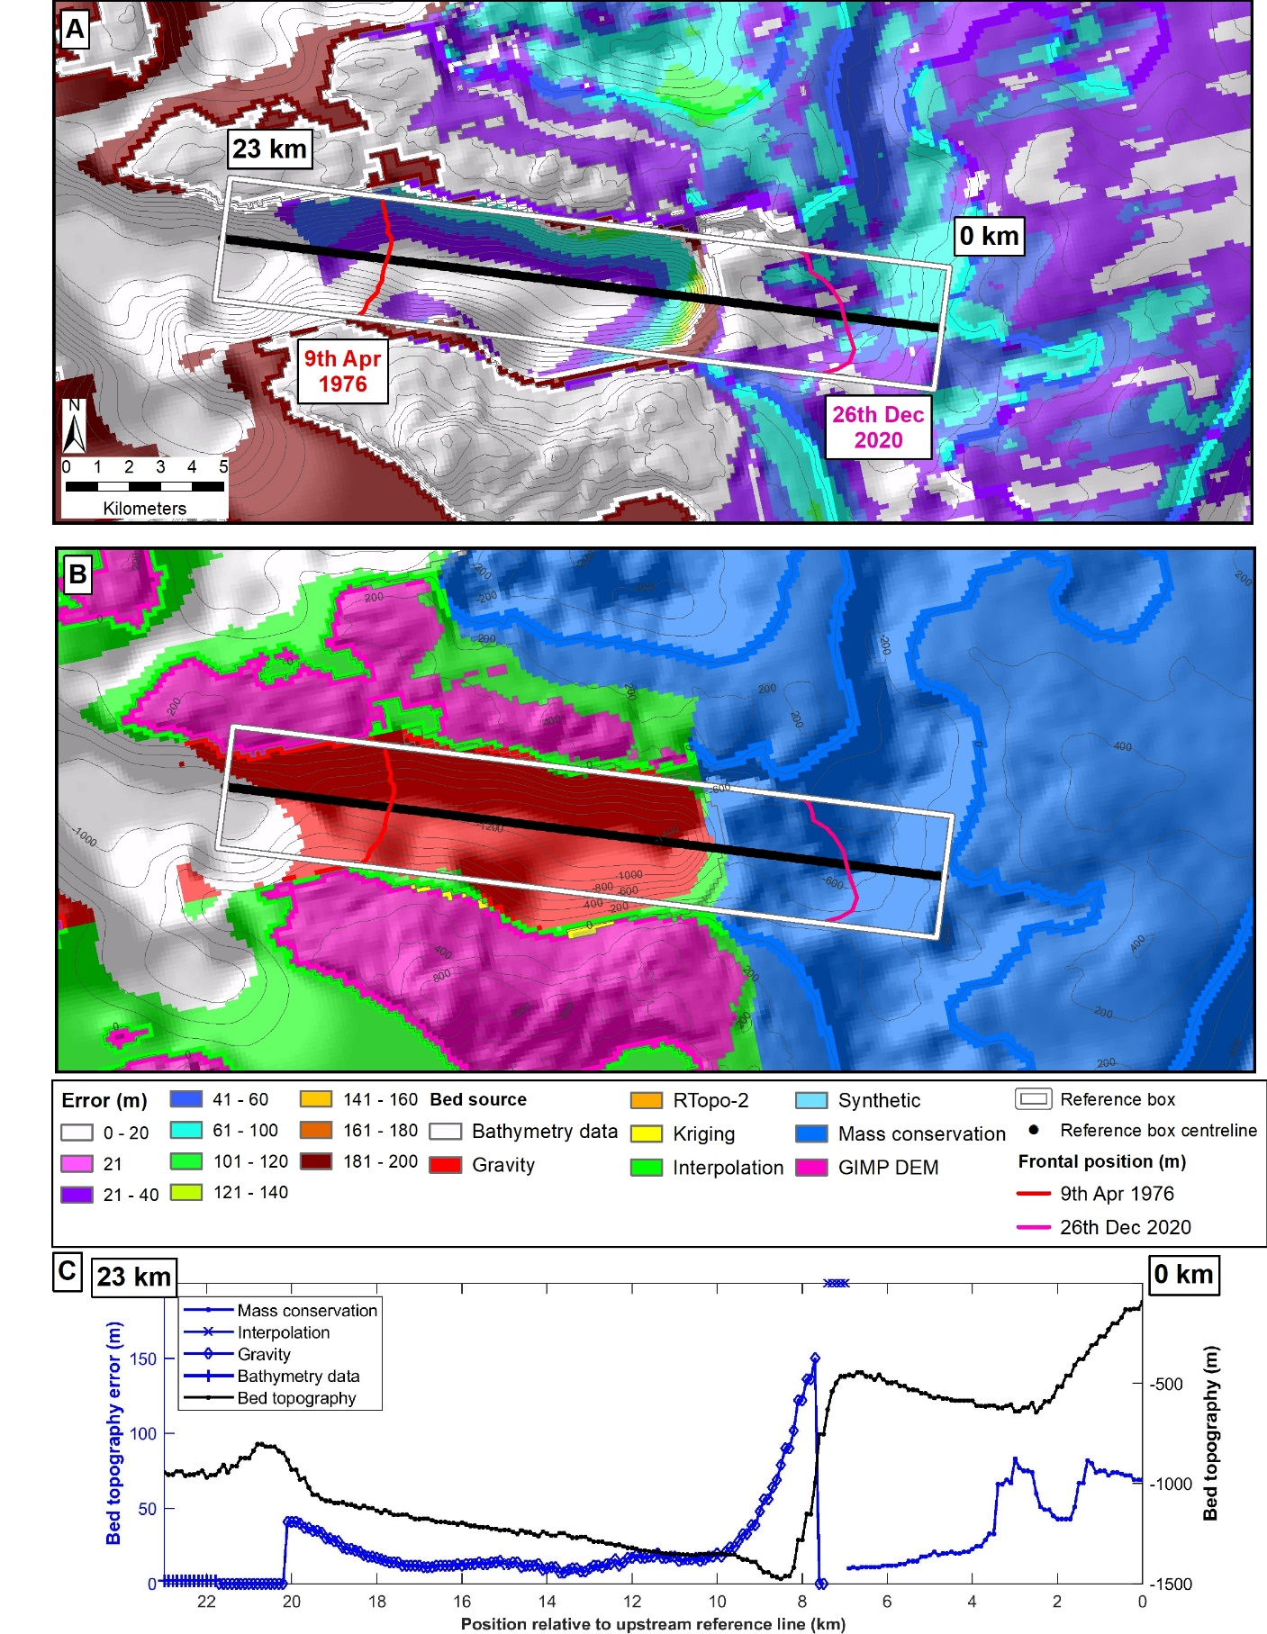
Supplementary information Figure 5. Errors and data sources of basal topography data for Nunatakssap Sermia (NS). A) Errors in basal topography beneath NS and within its fjord, determined from BedMachine v3 (Morlighem et al., 2017). Contour interval is 200m. White box indicates the extent of the reference box used to digitise terminus positions and the terminus locations are marked for the earliest (9th Apr 1976; red) and latest (26th Dec 2020; pink) frontal positions available during the study period. B) Data sources for basal topography data.
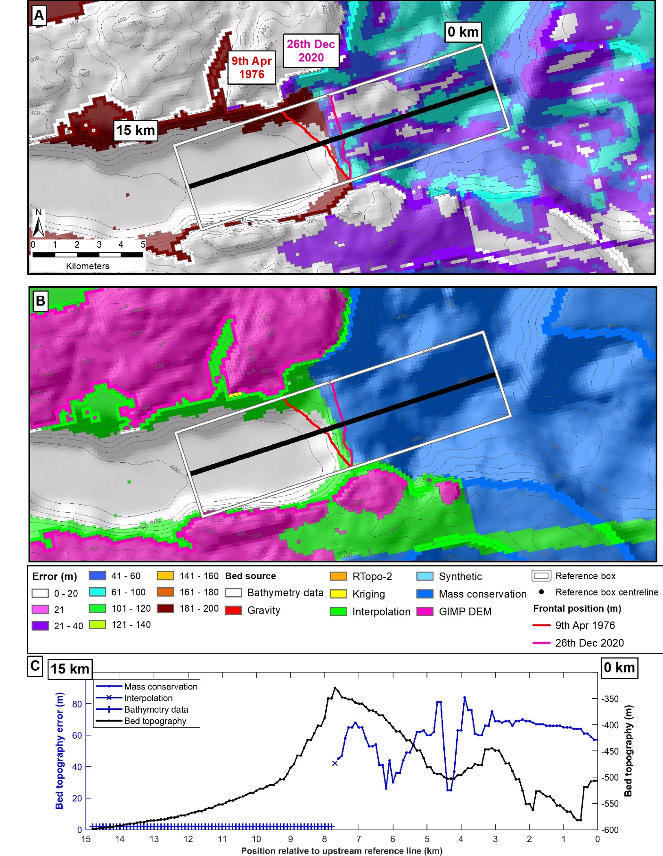
Supplementary information Figure 6. Errors and data sources of basal topography data for Illullip Sermia (IS). A) Errors in basal topography beneath IS and within its fjord, determined from BedMachine v3 (Morlighem et al., 2017). Contour interval is 200m. White box indicates the extent of the reference box used to digitise terminus positions and the terminus locations are marked for the earliest (9th Apr 1976; red) and latest (26th Dec 2020; pink) frontal positions available during the study period. B) Data sources for basal topography data.

Dataset name | Data type | Spatial resolution | Temporal coverage | Temporal resolution | Filenames | Source
Operation IceBridge BedMachine Version 3 | Basal topography | 150 m, | N/A | N/A | BedMachineGreenland-2017-09-20.nc | Morlighem et al., 2017
Arctic DEM | Surface elevation | 2 m | 20010-2017 | Weekly-monthly | SETSM_W1W1_20100829_102001000EB97200_102001000F10B700_seg1_2m_v3.0_dem.tif  SETSM_W2W2_20100516_103001000500A200_1030010005069700_seg1_2m_v3.0_dem.tif  SETSM_WV01_20110325_102001001231C300_1020010012D21900_seg1_2m_v3.0_dem.tif  SETSM_WV01_20110402_1020010012934C00_102001001211A500_seg1_2m_v3.0_dem.tif  SETSM_WV01_20110403_10200100120C0100_10200100129A8200_seg1_2m_v3.0_dem.tif  SETSM_WV01_20110411_1020010012D16200_10200100129BF800_seg1_2m_v3.0_dem.tif  SETSM_WV01_20110610_1020010012A8D200_102001001354D000_seg1_2m_v3.0_dem.tif  SETSM_WV01_20110610_1020010013AA1900_1020010012044900_seg1_2m_v3.0_dem.tif  SETSM_WV01_20110718_1020010013804300_10200100159A8D00_seg1_2m_v3.0_dem.tif  SETSM_WV01_20110719_1020010015159F00_102001001537F900_seg1_2m_v3.0_dem.tif  SETSM_WV01_20110810_102001001425C600_10200100144A9500_seg1_2m_v3.0_dem.tif  SETSM_WV01_20110821_102001001533A200_1020010016BC7400_seg3_2m_v3.0_dem.tif  SETSM_WV01_20120411_102001001A262700_102001001A27A600_seg1_2m_v3.0_dem.tif  SETSM_WV01_20120627_102001001B5DA700_102001001C367F00_seg1_2m_v3.0_dem.tif  SETSM_WV01_20130310_10200100200DB600_10200100213C8900_seg1_2m_v3.0_dem.tif  SETSM_WV01_20150313_102001003B94B200_10200100381AAF00_seg1_2m_v3.0_dem.tif  SETSM_WV01_20160427_102001004CBC5800_102001004EE0D700_seg1_2m_v3.0_dem.tif  SETSM_WV01_20160718_102001005074FC00_102001005397AE00_seg1_2m_v3.0_dem.tif  SETSM_WV01_20160718_10200100511F2D00_10200100520AFB00_seg8_2m_v3.0_dem.tif  SETSM_WV01_20160808_10200100525C1100_102001005216CD00_seg1_2m_v3.0_dem.tif  SETSM_WV01_20160810_1020010053C81000_10200100553CDB00_seg1_2m_v3.0_dem.tif  SETSM_WV01_20160815_1020010055021B00_102001005469F600_seg7_2m_v3.0_dem.tif  SETSM_WV01_20160817_1020010051AF4300_1020010051812F00_seg1_2m_v3.0_dem.tif  SETSM_WV01_20160912_10200100571F7100_102001005575BE00_seg1_2m_v3.0_dem.tif  SETSM_WV01_20161004_1020010056ABE600_102001005689B900_seg1_2m_v3.0_dem.tif  SETSM_WV01_20170307_102001005A7E2200_102001005FA63F00_seg1_2m_v3.0_dem.tif  SETSM_WV01_20170321_102001005FAF2600_102001005D2DAF00_seg1_2m_v3.0_dem.tif  SETSM_WV01_20170628_10200100654AC200_102001006311E000_seg1_2m_v3.0_dem.tif  SETSM_WV01_20170705_1020010064808900_1020010065CB8500_seg1_2m_v3.0_dem.tif  SETSM_WV01_20170719_102001006683D200_1020010063971A00_seg1_2m_v3.0_dem.tif  SETSM_WV01_20170724_10200100635F6300_10200100622CBB00_seg1_2m_v3.0_dem.tif  SETSM_WV01_20170804_10200100650D2100_10200100657A3700_seg1_2m_v3.0_dem.tif  SETSM_WV01_20170905_1020010066291600_10200100678CD800_seg1_2m_v3.0_dem.tif  SETSM_WV01_20170927_1020010066051E00_1020010065088D00_seg4_2m_v3.0_dem.tif  SETSM_WV02_20110325_1030010009565300_1030010009653900_seg1_2m_v3.0_dem.tif  SETSM_WV02_20110403_103001000A7D9400_103001000A87A000_seg1_2m_v3.0_dem.tif  SETSM_WV02_20110410_103001000A2C3F00_103001000ACDE700_seg1_2m_v3.0_dem.tif  SETSM_WV02_20120617_1030010019715500_1030010019718D00_seg1_2m_v3.0_dem.tif  SETSM_WV02_20120719_103001001A73FD00_103001001A9B6B00_seg8_2m_v3.0_dem.tif  SETSM_WV02_20120826_103001001A1DFD00_103001001B41B000_seg1_2m_v3.0_dem.tif  SETSM_WV02_20120826_103001001C0AD300_103001001A685300_seg2_2m_v3.0_dem.tif  SETSM_WV02_20130410_1030010021BB6700_1030010021283500_seg1_2m_v3.0_dem.tif  SETSM_WV02_20140422_103001003082B000_103001002FA23900_seg1_2m_v3.0_dem.tif  SETSM_WV02_20150421_103001004195DF00_10300100406B1900_seg1_2m_v3.0_dem.tif  SETSM_WV02_20160321_1030010052A9D900_1030010053B0A300_seg1_2m_v3.0_dem.tif  SETSM_WV02_20160730_103001005AD40F00_103001005BBF4400_seg1_2m_v3.0_dem.tif  SETSM_WV02_20161016_103001005E26B400_103001005EC33A00_seg3_2m_v3.0_dem.tif  SETSM_WV02_20170324_10300100674FEC00_1030010066A13300_seg1_2m_v3.0_dem.tif  SETSM_WV03_20161019_104001002432D000_104001002472BA00_seg2_2m_v3.0_dem.tif  SETSM_WV03_20170222_1040010029D40F00_1040010028019900_seg1_2m_v3.0_dem.tif  SETSM_WV03_20170305_104001002A7BA000_104001002A4EBD00_seg1_2m_v3.0_dem.tif  SETSM_WV03_20170714_104001002F624100_104001002F829900_seg1_2m_v3.0_dem.tif | https://www.pgc.umn.edu/  guides/arcticdem/introduction-to-arcticdem/).
MEaSUREs Greenland Ice Sheet Velocity Map from InSAR Data, Version 2 | Ice velocity | 500 m | 2000-01 to 2017-18 | Annual (winter average) | greenland_vel_mosaic200_2017_2018_vx_v02.1.tif  greenland_vel_mosaic500_2000_2001_vx_v021.tif  greenland_vel_mosaic500_2005_2006_vx_v021.tif  greenland_vel_mosaic500_2006_2007_vx_v021.tif  greenland_vel_mosaic500_2007_2008_vx_v021.tif  greenland_vel_mosaic500_2008_2009_vx_v021.tif  greenland_vel_mosaic500_2009_2010_vx_v021.tif  greenland_vel_mosaic500_2012_2013_vx_v021.tif  greenland_vel_mosaic500_2014_2015_vx_v021.tif  greenland_vel_mosaic500_2015_2016_vx_v021.tif  greenland_vel_mosaic500_2016_2017_vx_v021.tif  greenland_vel_mosaic500_2017_2018_vx_v021.tif | (https://nsidc.org/data/NSIDC-0478/versions/2(Joughin et al., 2010b, 2015, updated 2018).
MEaSUREs Selected Glacier Site Velocity Maps generated from the InSAR Version 4 | Ice velocity | 100 m | 2009-2020 | Weekly to monthly | TSX_W74.50N_09Jul09_20Jul09_20-34-01_vv_v04.0.tif  TSX_W74.50N_23Apr09_04May09_20-33-58_vv_v04.0.tif  TSX_W74.50N_13Sep09_24Sep09_20-34-05_vv_v04.0.tif  TSX_W74.50N_07Jul10_18Jul10_20-34-07_vv_v04.0.tif  TSX_W74.50N_31Aug10_11Sep10_20-34-10_vv_v04.0.tif  TSX_W74.50N_16Nov10_27Nov10_20-34-11_vv_v04.0.tif  TSX_W74.50N_21Apr10_02May10_20-34-05_vv_v04.0.tif  TSX_W74.50N_01Feb11_12Feb11_20-34-07_vv_v04.0.tif  TSX_W74.50N_29Aug11_20Sep11_20-34-15_vv_v04.0.tif  TSX_W74.50N_05Jul11_16Jul11_20-34-12_vv_v04.0.tif  TSX_W74.50N_30Apr11_22May11_20-34-08_vv_v04.0.tif  TSX_W74.50N_14Nov11_25Nov11_20-34-15_vv_v04.0.tif  TSX_W74.50N_02Jul12_24Jul12_20-34-16_vv_v04.0.tif  TSX_W74.50N_27Apr12_08May12_20-34-13_vv_v04.0.tif  TSX_W74.50N_22Nov12_03Dec12_20-34-19_vv_v04.0.tif  TSX_W74.50N_30Jan12_10Feb12_20-34-11_vv_v04.0.tif  TSX_W74.50N_24Jul12_26Aug12_20-34-18_vv_v04.0.tif  TSX_W74.50N_26Aug12_06Sep12_20-34-19_vv_v04.0.tif  TSX_W74.50N_07Feb13_18Feb13_20-34-16_vv_v04.0.tif  TSX_W74.50N_25Apr13_06May13_20-34-18_vv_v04.0.tif  TSX_W74.50N_09Nov13_20Nov13_20-34-26_vv_v04.0.tif  TSX_W74.50N_30Jun13_11Jul13_20-34-22_vv_v04.0.tif  TSX_W74.50N_24Aug13_15Sep13_20-34-25_vv_v04.0.tif  TSX_W74.50N_03Feb15_14Feb15_20-34-26_vv_v04.0.tif  TSX_W74.50N_22Aug14_02Sep14_20-34-29_vv_v04.0.tif  TSX_W74.50N_05Feb14_16Feb14_20-34-23_vv_v04.0.tif  TSX_W74.50N_26May14_06Jun14_20-34-25_vv_v04.0.tif  TSX_W74.50N_06Jun14_17Jun14_20-34-26_vv_v04.0.tif  TSX_W74.50N_28Jun14_20Jul14_20-34-27_vv_v04.0.tif  TSX_W74.50N_17Jun14_28Jun14_20-34-26_vv_v04.0.tif  TSX_W74.50N_31Jul14_22Aug14_20-34-29_vv_v04.0.tif  TSX_W74.50N_18Nov14_29Nov14_20-34-40_vv_v04.0.tif  TSX_W74.50N_20Jul14_31Jul14_20-34-28_vv_v04.0.tif  TSX_W74.50N_07Jul15_18Jul15_20-34-31_vv_v04.0.tif  TSX_W74.50N_20Aug15_31Aug15_20-34-34_vv_v04.0.tif  TSX_W74.50N_09Aug15_20Aug15_20-34-33_vv_v04.0.tif  TSX_W74.50N_24May15_15Jun15_20-34-30_vv_v04.0.tif  TSX_W74.50N_13May15_24May15_20-34-29_vv_v04.0.tif  TSX_W74.50N_26Jun15_07Jul15_20-34-32_vv_v04.0.tif  TSX_W74.50N_15Jun15_26Jun15_20-34-31_vv_v04.0.tif  TSX_W74.50N_18Jul15_09Aug15_20-34-32_vv_v04.0.tif  TSX_W74.50N_01Feb16_12Feb16_20-34-33_vv_v04.0.tif  TSX_W74.50N_15Jul16_06Aug16_20-34-38_vv_v04.0.tif  TSX_W74.50N_04Jul16_15Jul16_20-34-38_vv_v04.0.tif  TSX_W74.50N_17Aug16_28Aug16_20-34-41_vv_v04.0.tif  TSX_W74.50N_05Feb09_16Feb09_20-33-56_vv_v04.0.tif  TSX_W74.50N_21Jan16_01Feb16_20-34-33_vv_v04.0.tif  TSX_W74.50N_06Aug16_17Aug16_20-34-40_vv_v04.0.tif  TSX_W74.50N_21May16_12Jun16_20-34-37_vv_v04.0.tif  TSX_W74.50N_10May16_21May16_20-34-36_vv_v04.0.tif  TSX_W74.50N_23Jun16_04Jul16_20-34-38_vv_v04.0.tif  TSX_W74.50N_12Jun16_23Jun16_20-34-38_vv_v04.0.tif  TSX_W74.50N_28Aug16_08Sep16_20-34-41_vv_v04.0.tif  TSX_W74.50N_13Nov16_05Dec16_20-34-44_vv_v04.0.tif  TSX_W74.50N_02Jul17_13Jul17_20-34-46_vv_v04.0.tif  TSX_W74.50N_24Jul17_15Aug17_20-34-47_vv_v04.0.tif  TSX_W74.50N_10Jun17_21Jun17_20-34-45_vv_v04.0.tif  TSX_W74.50N_25Dec17_05Jan18_20-34-50_vv_v04.0.tif  TSX_W74.50N_13Jul17_24Jul17_20-34-47_vv_v04.0.tif  TSX_W74.50N_26Aug17_06Sep17_20-34-49_vv_v04.0.tif  TSX_W74.50N_15Aug17_26Aug17_20-34-48_vv_v04.0.tif  TSX_W74.50N_30May17_10Jun17_20-34-45_vv_v04.0.tif  TSX_W74.50N_21Jun17_02Jul17_20-34-45_vv_v04.0.tif  TSX_W74.50N_02Aug18_13Aug18_20-34-55_vv_v04.0.tif  TSX_W74.50N_23Dec18_03Jan19_20-34-57_vv_v04.0.tif  TSX_W74.50N_04Sep18_15Sep18_20-34-57_vv_v04.0.tif  TSX_W74.50N_25Apr18_06May18_20-34-51_vv_v04.0.tif  TSX_W74.50N_06May18_28May18_20-34-51_vv_v04.0.tif  TSX_W74.50N_28May18_08Jun18_20-34-52_vv_v04.0.tif  TSX_W74.50N_08Jun18_30Jun18_20-34-52_vv_v04.0.tif  TSX_W74.50N_30Jun18_11Jul18_20-34-53_vv_v04.0.tif  TSX_W74.50N_11Jul18_02Aug18_20-34-54_vv_v04.0.tif  TSX_W74.50N_13Aug18_04Sep18_20-34-55_vv_v04.0.tif  TSX_W74.50N_01Apr19_12Apr19_20-34-56_vv_v04.0.tif  TSX_W74.50N_17Jun19_28Jun19_20-35-00_vv_v04.0.tif  TSX_W74.50N_02Sep19_13Sep19_20-35-05_vv_v04.0.tif  TSX_W74.50N_21Dec19_01Jan20_20-35-05_vv_v04.0.tif  TSX_W74.50N_06Jun19_17Jun19_20-35-00_vv_v04.0.tif  TSX_W74.50N_22Aug19_02Sep19_20-35-05_vv_v04.0.tif  TSX_W74.50N_09Jul19_31Jul19_20-35-01_vv_v04.0.tif  TSX_W74.50N_24Sep19_16Oct19_20-35-06_vv_v04.0.tif  TSX_W74.50N_11Aug19_22Aug19_20-35-03_vv_v04.0.tif  TSX_W74.50N_28Jun19_09Jul19_20-35-01_vv_v04.0.tif  TSX_W74.50N_13Sep19_24Sep19_20-35-05_vv_v04.0.tif  TSX_W74.50N_31Jul19_11Aug19_20-35-02_vv_v04.0.tif  TSX_W74.50N_16Oct19_27Oct19_20-35-06_vv_v04.0.tif  TSX_W74.50N_03Jun20_14Jun20_20-35-08_vv_v04.0.tif  TSX_W74.50N_17Jul20_28Jul20_20-35-10_vv_v04.0.tif  TSX_W74.50N_06Jul20_17Jul20_20-35-10_vv_v04.0.tif  TSX_W74.50N_19Aug20_10Sep20_20-35-12_vv_v04.0.tif  TSX_W74.50N_08Aug20_19Aug20_20-35-11_vv_v04.0.tif  TSX_W74.50N_25Jun20_06Jul20_20-35-09_vv_v04.0.tif  TSX_W74.50N_09Apr20_20Apr20_20-35-04_vv_v04.0.tif  TSX_W74.50N_28Jul20_08Aug20_20-35-10_vv_v04.0.tif  TSX_W74.50N_10Sep20_21Sep20_20-35-12_vv_v04.0.tif  TSX_W74.50N_14Jun20_25Jun20_20-35-08_vv_v04.0.tif  TSX_W74.50N_09Jul09_20Jul09_20-34-01_vv_v04.0.tif  TSX_W74.50N_23Apr09_04May09_20-33-58_vv_v04.0.tif  TSX_W74.50N_13Sep09_24Sep09_20-34-05_vv_v04.0.tif  TSX_W74.50N_07Jul10_18Jul10_20-34-07_vv_v04.0.tif  TSX_W74.50N_31Aug10_11Sep10_20-34-10_vv_v04.0.tif  TSX_W74.50N_16Nov10_27Nov10_20-34-11_vv_v04.0.tif  TSX_W74.50N_21Apr10_02May10_20-34-05_vv_v04.0.tif  TSX_W74.50N_01Feb11_12Feb11_20-34-07_vv_v04.0.tif  TSX_W74.50N_29Aug11_20Sep11_20-34-15_vv_v04.0.tif  TSX_W74.50N_05Jul11_16Jul11_20-34-12_vv_v04.0.tif  TSX_W74.50N_30Apr11_22May11_20-34-08_vv_v04.0.tif  TSX_W74.50N_14Nov11_25Nov11_20-34-15_vv_v04.0.tif  TSX_W74.50N_02Jul12_24Jul12_20-34-16_vv_v04.0.tif  TSX_W74.50N_27Apr12_08May12_20-34-13_vv_v04.0.tif  TSX_W74.50N_22Nov12_03Dec12_20-34-19_vv_v04.0.tif  TSX_W74.50N_30Jan12_10Feb12_20-34-11_vv_v04.0.tif  TSX_W74.50N_24Jul12_26Aug12_20-34-18_vv_v04.0.tif  TSX_W74.50N_26Aug12_06Sep12_20-34-19_vv_v04.0.tif  TSX_W74.50N_07Feb13_18Feb13_20-34-16_vv_v04.0.tif  TSX_W74.50N_25Apr13_06May13_20-34-18_vv_v04.0.tif  TSX_W74.50N_09Nov13_20Nov13_20-34-26_vv_v04.0.tif  TSX_W74.50N_30Jun13_11Jul13_20-34-22_vv_v04.0.tif  TSX_W74.50N_24Aug13_15Sep13_20-34-25_vv_v04.0.tif  TSX_W74.50N_03Feb15_14Feb15_20-34-26_vv_v04.0.tif  TSX_W74.50N_22Aug14_02Sep14_20-34-29_vv_v04.0.tif  TSX_W74.50N_05Feb14_16Feb14_20-34-23_vv_v04.0.tif  TSX_W74.50N_26May14_06Jun14_20-34-25_vv_v04.0.tif  TSX_W74.50N_06Jun14_17Jun14_20-34-26_vv_v04.0.tif  TSX_W74.50N_28Jun14_20Jul14_20-34-27_vv_v04.0.tif  TSX_W74.50N_17Jun14_28Jun14_20-34-26_vv_v04.0.tif  TSX_W74.50N_31Jul14_22Aug14_20-34-29_vv_v04.0.tif  TSX_W74.50N_18Nov14_29Nov14_20-34-40_vv_v04.0.tif  TSX_W74.50N_20Jul14_31Jul14_20-34-28_vv_v04.0.tif  TSX_W74.50N_07Jul15_18Jul15_20-34-31_vv_v04.0.tif  TSX_W74.50N_20Aug15_31Aug15_20-34-34_vv_v04.0.tif | https://nsidc.org/data/nsidc-0481/versions/ (Joughin et al., 2010a; Joughin et al., 2021)
Supp. Info Table 1. List of all datasets used in the analysis, including bed data, surface elevation and ice velocities.

Supplementary references
Joughin, I., Smith, B., Howat, I. M., Scambos, T., and Moon, T., 2010a: Greenland flow variability from ice-sheet-wide velocity mapping. Journal of Glaciology, 56(197): 415-430.
Joughin, I., Smith, B. E., Howat, I., and Scambos, T., 2010b: MEaSUREs Greenland Ice Sheet Velocity Map from InSAR Data. Boulder, Colorado, USA: National Snow and Ice Data Center. Digital media.
Joughin, I., Smith, B. E., Howat, I., and Scambos, T., 2015, updated 2018: MEaSUREs Greenland Ice Sheet Velocity Map from InSAR Data, Version 2. In Boulder, C. U. (ed.). NASA National Snow and Ice Data Center Distributed Active Archive Center.
Joughin, I., Howat, I., Smith, B., and Scambos, T., 2021: MEaSUREs Greenland Ice Velocity: Selected Glacier Site Velocity Maps from InSAR, Version 4 [Data Set]. Boulder, Colorado USA.: NASA National Snow and Ice Data Center Distributed Active Archive Center.

