Supporting Online Information
Appendix S1: Details of the colony survey protocols and population size estimation methods.
During colony surveys breeding activity and presence of nesting tropicbirds in cavities was often given away by fresh guano deposits, protruding tail streamers and the sound of adults and/or chicks calling. Estimation of the numbers of breeding pairs and mature individuals were derived from a combination of historic and recent colony surveys as well as recent personal observations (See Table 1 for details). Adults observed in flight during colony counts were excluded. Breeding pairs were a sum of observed incubating adults (adults confirmed with an egg or chick), apparently incubating adults (adults observed sitting in a nest scrape but with no confirmed visual of an egg or chick) and nests with nestlings, assuming that each nest was attended by two adults. Adults occupying territories (adults occupying a nesting cavity but no evidence of nesting, e.g. guano covered scrape, egg or chick), adults observed roosting (birds present on the colony but not associated with a nesting cavity) and breeding pairs (assuming two adults to each nest) were pooled to provide numbers of observed individuals. Results are presented as the range of values (minima and maxima) in a month observed during the monitoring period.

Appendix S2: Additional description of statistical analyses used to determine breeding cycle interval, reproductive success and nest site and cavity characteristics.

Breeding cycle interval
We used GLMMs to assess whether the interval between breeding cycles varied between sexes or consecutive breeding periods (e.g. consecutive: 2014 to 2015; non-consecutive: 2014 to 2016). Given the high level of between-season mate fidelity, nest site fidelity and their observed positive effect on breeding success in tropicbirds (Sommerfeld et al. 2015), and the potential effect of breeding success on breeding cycle interval (Snow 1965; Harris 1969; Prys-Jones and Peet 1980), we tested whether the interval between breeding attempts varied by 1) initial breeding outcome, 2) partner fidelity, 3) cavity fidelity, 4) initial breeding outcome and partner fidelity, 5) initial breeding outcome and cavity fidelity or, 6) initial breeding outcome, cavity fidelity and partner fidelity or, 7) partner fidelity and cavity fidelity. We excluded any individuals of unknown sex, and those that did not breed in consecutive breeding periods and/or where the breeding outcome or partner fidelity were unknown. We used a model selection approach using Akaike's information criterion adjusted for small sample size (AICc) to identify the most parsimonious model (Burnham and Anderson 2002).
We used GLMMs to assess whether the decision to lay a replacement clutch following initial breeding failure additionally affected the breeding cycle interval, using only data from individuals that initially failed to breed. Individuals which had multiple consecutive breeding cycle intervals were also investigated further, to assess any effect of a) the previous breeding cycle interval and b) the previous breeding outcome on breeding cycle interval. We used a LRT as described above, excluding any cycles that had unknown initial breeding outcomes and/or unknown previous breeding outcomes.

Reproductive success
We excluded 54 of 212 nesting attempts where the fate of the egg or chick could not be ascertained. Estimates of hatching success (proportion of chicks hatched from eggs laid), fledging success (the proportion of chicks fledged from eggs hatched), and productivity (proportion of chicks fledged from eggs laid) were calculated assuming a 43 day incubation period and 85 day chick rearing period, respectively (Stonehouse 1962; Harris 1969). Daily nest survival rates were calculated using Mayfield (1975), and standard errors following Johnson (1979). Differences in breeding performance between the mainland and offshore monitoring sites were assessed by pooling historical and recent nest data. We tested for differences between years in hatching and fledging success, assessed over 5 years (2013-2017), as well as comparing mainland and offshore (Egg Island) monitoring sites using logistic exposure GLMMs (Shaffer 2004), and LRTs to compare candidate models to a null model (Lewis et al. 2011).

Nest site and cavity characteristics
We used GLMMs to firstly examine whether occupancy of a cavity (number of individuals identified using each cavity per year) and nest occurrence (coded as 1 for presence of at least one nest per cavity per year, or 0 for absence of any nest) on the mainland monitoring sites varied with cavity characteristics. Then we used GLMMs to investigate whether reproductive performance varied with cavity characteristics, including known replacement clutches and both mainland and Egg Island breeding attempts. Nesting attempts with either unknown outcomes and/or cavity characteristic data were excluded. For each response, we tested all possible model combinations using the 'dredge' function in R package MuMIn (Barton 2020). We used a model selection approach using AICc's to identify the most parsimonious model. All candidate models were ranked based on their delta AIC value. We report models with a delta AIC ≤ 1 (Semmens et al. 2009).

References
Barton K (2020). Multi-Model Inference. Available at: https://cran.r-project.org/package=MuMIn
Burnham KP, Anderson DR (2002). ‘Model selection and multimodel inference. A practical information-theoretic approach’ 2nd editio. (Springer: New York)
Harris MP (1969). Factors influencing the breeding cycle of the Red-billed Tropicbird in the Galapagos Islands. Ardea 57, 149–157.
Johnson DH (1979). Estimating nest success: the Mayfield method and an alternative. The Auk 96, 651–661.
Lewis F, Butler A, Gilbert L (2011). A unified approach to model selection using the likelihood ratio test. Methods in Ecology and Evolution 2, 155–162. doi:10.1111/j.2041-210X.2010.00063.x
Mayfield HF (1975). Suggestions for calculating nest success. Wilson Bulletin 87, 456–466.
Prys-Jones RP, Peet C (1980). Breeding periodicity, nesting success and nest site selection among Red-tailed Tropicbirds Phaethon rubricauda and White-tailed Tropicbirds P. lepturus on Aldabra Atoll. Ibis 122, 76–81. doi:10.1111/j.1474-919X.1980.tb00873.x
Semmens BX, Moore JW, Ward EJ (2009). Improving Bayesian isotope mixing models: a response to Jackson et al. (2009). Ecology Letters 12, E6–E8. doi:10.1111/j.1461-0248.2009.01283.x
Shaffer TL (2004). A unified approach to analyzing nest success. The Auk 121, 526–540. doi:10.1642/0004-8038(2004)121[0526:AUATAN]2.0.CO;2
Snow DW (1965). The breeding of the Red-billed Tropic Bird in the Galapagos Islands. The Condor 67, 210–214. doi:10.2307/1365398
Sommerfeld J, Stokes T, Baker GB (2015). Breeding success, mate-fidelity and nest-site fidelity in Red-tailed Tropicbirds (Phaethon rubricauda) on Christmas Island, Indian Ocean. Emu - Austral Ornithology 115, 214–222. doi:10.1071/MU14016
Stonehouse B (1962). The Tropic Bird (Genus Phaethon) of Ascension Island. Ibis 103B, 124–161. doi:10.1111/j.1474-919X.1962.tb07242.x

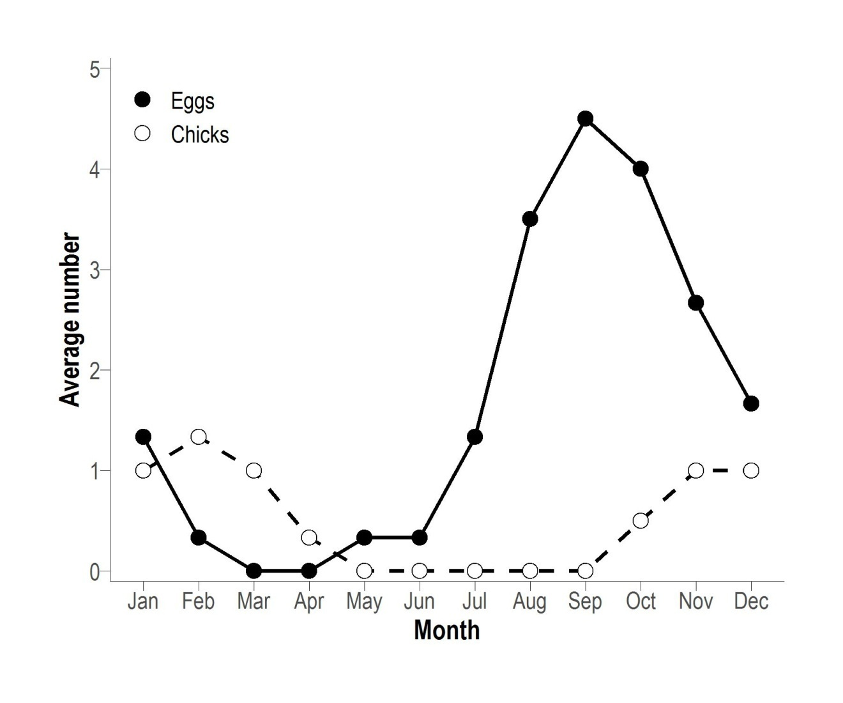
Figure S1. Breeding phenology of Red-billed Tropicbirds on Egg Island, St Helena from October 2004 to August 2007.

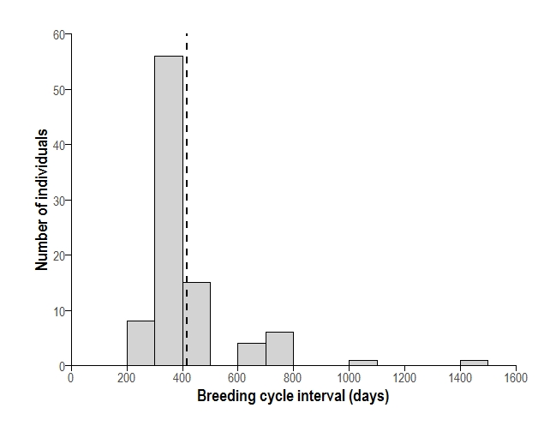
Figure S2. Frequency distribution of breeding cycle intervals of individual Red-billed Tropicbirds 2013-2017 (n = 91), based on recapture of individuals whilst breeding and estimation of laying dates. Dashed black line represents the mean (416±176 days SD).

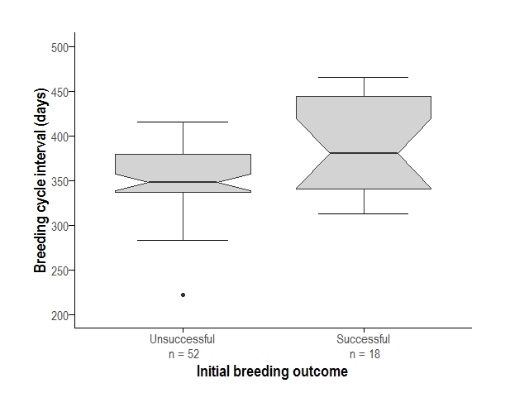
Figure S3. Breeding cycle interval (duration of time between nesting attempts in different breeding periods) for successful and unsuccessful nesting attempts of Red-billed Tropicbirds in St Helena between 2013-2017. Unsuccessful = the interval between the date when the prior nest failed and the first egg date of the subsequent breeding attempt. Successful = the interval between the date when the prior nest successfully fledged a chick and the first egg date of the subsequent breeding attempt.

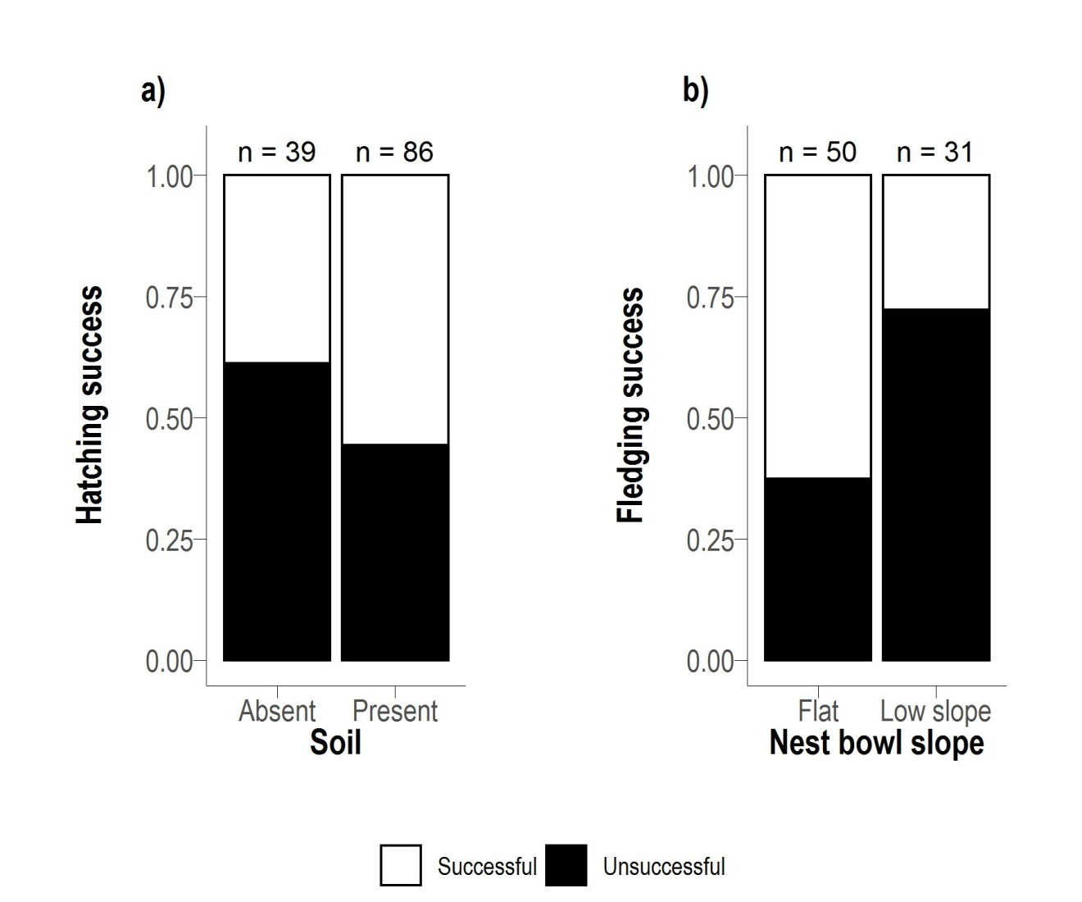
Figure S4. Stacked bar charts showing the proportion of successful and unsuccessful nests in a) soil substrate and b) each nest bowl slope. In successful breeding attempts - white and unsuccessful breeding attempts - black.

Table S1. Summary of cavity and nest monitoring of mainland St Helena Red-billed Tropicbirds, 2013-2017.
Year | Number of cavities monitored | Total number of nests monitored | Minimum visual inspection | Number of cavities, cameras used | Camera deployment details
2013 | 24 | 29 | daily | 0 | Not available
2014 | 28 | 24 | daily | 10 | 4 nests from incubation, 7 from chick rearing
2015 | 28 | 24 | daily | 11 | 5 nests from incubation, 6 from chick rearing
2016 | 28 | 16 | Mondays, Wednesdays, Fridays | 24 | All active nesting attempts (13 cavities) plus 11 frequently used cavities.
2017 | 27 | 16 | Mondays, Wednesdays, Fridays | 25 | Installed outside frequently used cavities for complete monitoring period

Table S2. Categories of breeding failure based on the following evidence from visual inspection and/or camera trap images.
Category | Evidence
broken egg | occurring earlier than the expected hatch date based on the mean incubation period (43 days) and not indicative of predation
abandonment | intact egg incubated less than 43 days
failed to hatch | egg incubated longer than 43 days and failed to hatch
predation | remains of an egg or chick with evidence of predation, e.g. bite marks, blood, tissue, feather remains
starvation | where the carcass of a large chick was found
neglect/exposure | carcass of a small chick found with no signs of predation
unknown | egg or chick missing with no evidence of cause

Table S3. Variables recorded for each cavity including characteristics of the surrounding site, cavity entrance and nest site.
Variable | Description
Site
Slope | F= flat (0°); LS= low slope (1°-5°); MS = moderate slope (5°-20°), steep slope (20°-45°)
Aspect | North = 314°-45°, East = 46°-135°, South = 136°-225°, West = 226°-315°
Cavity type | Open (1), overhang (2), crevice (3) and tube (4)
Cavity entrance
Number of entrances | 1 or >1
Orientation | Mid-point of the nest entrance (degrees)
Height | Maximum height of cavity at entrance (cm)
Width | Maximum width of cavity at entrance (cm)
Nest site
Min tunnel size | Height x width at narrowest point (cm²)
Depth | Maximum length, outside edge of entrance to centre point of nest bowl (cm)
Chamber volume | Maximum height x depth x width from the mid-point of the nest bowl (cm²)
Nest bowl slope | Flat = 0°, Moderate slope = 1°-5°, steep slope = 5°-10°
Substrate | Rock, (present (1) or absent (0)); Gravel, (present (1) or absent (0)); Soil, (present (1) or absent (0))
Predator access | Yes (1), No (0)

Table S4. Explanatory variables tested for effects on cavity occupancy, nest occurrence, hatching success and fledging success. Predicted increase (↑ ) and decrease (↓) of response variables for the appropriate independent variables are shown. Independent variables that were not tested towards a specific dependant variable are denoted with (X), presence (1) or absence (0).
Explanatory variable | Cavity occupancy | Nesting occurrence | Hatching success | Fledging success
Site
Slope | ↑ with slope | ↑ with slope | ↑ with slope | ↑ with slope
Aspect | ↓ with angle | ↓ with angle | ↓ with angle | ↓ with angle
Cavity type | ↓ with type | ↓ with type | ↓ with type (exposure) | ↓ with type
Cavity entrance
No. of entrances | ↓ with >1 | ↓ with >1 | ↓ with >1 | ↓ with >1
Orientation | ↓ with direct sun | ↓ with direct sun | ↓ with direct sun | ↓ with direct sun
Height | ↓ with height | ↓ with height | ↓ with height | ↓ with height
Width | ↓ with width | ↓ with width | ↓ with width | ↓ with width
Nest site
Min. tunnel size | ↑ with size | ↑ with size | ↑ with size | ↑ with size
Depth | ↑ with depth | ↑ with depth | ↑ with depth | ↑ with depth
Chamber volume | ↑ with volume | ↑ with volume | ↑ with volume | ↑ with volume
Nest bowl slope | ↓ with slope | ↓ with slope | ↓ with slope | ↓ with slope
Substrate; Rock | X | X | ↓ with (1) | X
Gravel | X | X | ↓ with (1) | X
Soil | X | X | ↑ with (1) | X
Predator access | X | X | ↑ with (1) | ↑ with (1)

Table S5. Description of all generalised linear mixed models (GLMMs). n = sample size. AICc = Second-order Akaike Information Criterion. LRT = Likelihood ratio test.
Dependant and independent variables tested | Error distribution | Link function | Random effects | Fixed effect | Assessment method | n
Breeding cycle interval
Breeding cycle interval = Sex | gamma | log | individual identity | - | LRT | 90
Breeding cycle interval = Breeding period | gamma | log | individual identity | - | LRT | 79
Breeding cycle interval = initial breeding outcome | gamma | log | individual identity | - | AICc | 70
Breeding cycle interval = partner fidelity | gamma | log | individual identity | - | AICc | 70
Breeding cycle interval = cavity fidelity | gamma | log | individual identity | - | AICc | 70
Breeding cycle interval =initial breeding outcome and partner fidelity | gamma | log | individual identity | - | AICc | 70
Breeding cycle interval = initial breeding outcome and cavity fidelity | gamma | log | individual identity | - | AICc | 70
Breeding cycle interval = initial breeding outcome + cavity fidelity and partner fidelity | gamma | log | individual identity | - | AICc | 70
Breeding cycle interval = partner fidelity and cavity fidelity | gamma | log | individual identity | - | AICc | 70
Breeding cycle interval = initial breeding outcome+ partner fidelity + cavity fidelity + initial breeding outcome and partner fidelity + initial breeding outcome and cavity fidelity + initial breeding outcome + cavity fidelity and partner fidelity + partner fidelity and cavity fidelity | gamma | log | individual identity | - | AICc | 70
Breeding cycle interval = Previous breeding cycle interval | gamma | log | individual identity | Breeding outcome | LRT | 33
Breeding cycle interval = Previous breeding outcome | gamma | log | individual identity | Breeding outcome | LRT | 30
Breeding cycle interval = Replacement clutch | gamma | log | individual identity | - | LRT | 66
Productivity
Hatching success = Location | binomial | Logistic exposure | Cavity identity | - | LRT | 135
Hatching success = Year | binomial | Logistic exposure | Cavity identity | - | LRT | 107
Fledging success = Location | binomial | Logistic exposure | Cavity identity | - | LRT | 99
Fledging success = Year | binomial | Logistic exposure | Cavity identity | - | LRT | 84
Nest site and cavity characteristics
Adult occupancy = Slope + Aspect + Cavity type + Number of entrances + Orientation + Height + Width + Minimum tunnel size + Depth + Chamber volume + Nest bowl slope | Poisson | Square root | cavity identification and year | - | AICc via dredge | 136
Nest occurrence = Slope + Aspect + Cavity type + Number of entrances + Orientation + Height + Width + Minimum tunnel size + Depth + Chamber volume + Nest bowl slope | binomial | probit | cavity identification and year | - | AICc via dredge | 136
Hatching success = Slope + Aspect + Cavity type + Number of entrances + Orientation + Height + Width + Minimum tunnel size + Depth + Chamber volume + Nest bowl slope + Substrate + Predator access | binomial | cloglog | cavity identification and year | - | AICc via dredge | 125
Fledging success = Slope + Aspect + Cavity type + Number of entrances + Orientation + Height + Width + Minimum tunnel size + Depth + Chamber volume + Nest bowl slope + Predator access | binomial | cloglog | cavity identification and year | - | AICc via dredge | 81

Table S6. Model selection table evaluating the effect of initial breeding outcome, cavity fidelity and partner fidelity on the breeding cycle interval of Red-billed Tropicbirds 2013-2017 (n = 70). k: number of estimable parameters; AICc: Akaike's information criterion; Delta AICc: difference in AICc units to the most parsimonious model; wAICc: relative weight of evidence for each model.
Model | k | AICc | Delta AIC | wAICc
Initial breeding outcome + Cavity fidelity | 5 | 733.713 | 0.000 | 0.303
Initial breeding outcome | 4 | 733.967 | 0.254 | 0.266
Initial breeding outcome + Partner fidelity | 5 | 735.584 | 1.871 | 0.119
Initial breeding outcome + Partner fidelity + Cavity fidelity | 6 | 735.795 | 2.082 | 0.107
Cavity fidelity | 4 | 735.799 | 2.086 | 0.107
Cavity fidelity + Partner fidelity | 5 | 737.063 | 3.350 | 0.057
Partner fidelity | 4 | 738.874 | 5.161 | 0.023
Null | 3 | 739.235 | 5.522 | 0.019

Table S7. Summary of Red-billed Tropicbirds nests monitored on St Helena, 2013-2017. Mayfield daily nest and chick survival estimates (± 1 standard error). Hatching success is the proportion of chicks hatched from eggs laid, fledging success is the proportion of chicks fledged from eggs hatched and productivity is the proportion of chicks fledged from eggs laid.
 | Monitoring period
 | 2013 | 2014 | 2015 | 2016 | 2017 | Sum
Total eggs laid | 27 | 30 | 24 | 22 | 25 | 128
Daily nest survival | 0.989±0.004 | 0.984±0.005 | 0.987±0.005 | 0.978±0.006 | 0.990±0.004
Total chicks hatched | 20 | 19 | 16 | 10 | 19 | 84
Hatching success (%) | 74 | 63 | 67 | 45 | 76
Daily chick survival | 0.978±0.006 | 0.986±0.005 | 0.979±0.006 | 0.974±0.009 | 0.998±0.001
Total chicks fledged | 5 | 9 | 5 | 2 | 17 | 38
Fledging success (%) | 25 | 47 | 31 | 20 | 89
Productivity (%) | 19 | 30 | 21 | 9 | 68

