*Supplementary Information*

Low temperature destruction of gas-phase per- and polyfluoroalkyl substances using an alumina-based catalyst

Erin P. Shields* and M. Ariel Geer Wallace

US EPA, Office of Research and Development, Center for Environmental Measurement and Modeling, Air Methods and Characterization Division, Research Triangle Park, NC

* corresponding author: shields.erin@epa.gov

**S1. Materials and Methods**

**Chemicals**

1. B. 

C.  D. 

**Figure S1.** The PFAS used for the temperature dependent destruction studies. 8:2 FTOH (A) and NEt-FOSE (B) were the primary molecules used, and NEt-FOSA (C) and PFOSA (C) were observed as an impurity, a byproduct of NEt-FOSE, or were observed as a result of NEt-FOSE breakdown during the thermal desorption process.

**Flameless Tube Furnace Setup**

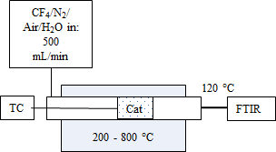

A,.

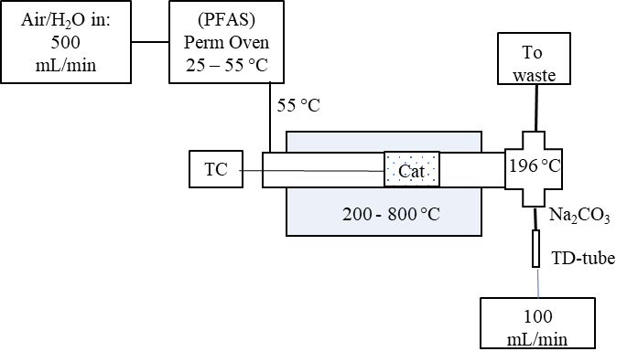

B..

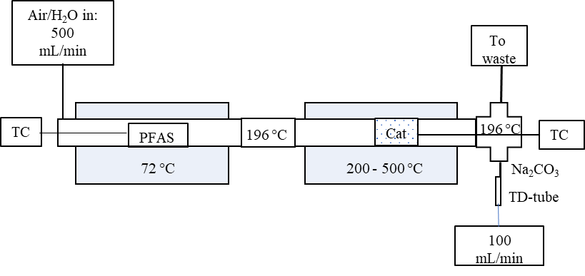

C.

**Figure S2.** Diagram of the tube furnace setup used for catalyst testing experiments. The thermal only runs had the same setup, but with an empty tube with no catalyst (Cat) in the hot furnace. The thermocouples are labeled TC. (A) Setup for the use of an FTIR to measure the water content and a preliminary CF4 test. (B) Setup for the 8:2 FTOH experiment. A permeation oven was used to volatize the FTOH and then the gas-phase FTOH was fed into the high temperature zone. The emissions were sampled using TD-tubes. The union between the ovens and the tee used for sampling were held at 196 °C to limit adsorption of the PFAS. (C) Setup for the NEt-FOSE experiment. The PFAS was volatilized in the low temperature furnace and transported into the higher temperature zone. The emissions were sampled using TD-tube. The union between the ovens and the tee used for sampling were held at 196 °C to limit adsorption of the PFAS.

**TD-tube Conditioning and Sampling**

Samples were collected on Universal sorbent tubes (Markes International, C2-CXXX-5266). Sorbent tubes were conditioned prior to sampling using research grade helium at a flow rate of approximately 75 mL/min at 100 °C for 30 min, 200 °C for 30 min, 300 °C for 30 min, and then 330 °C for 30 min. Sorbent tubes were blanked before first use. Active sorbent tube sampling was conducted with a flow rate of 100 mL/min for 5 min. Samples were collected when the tube furnace was at temperatures ranging from 200-800 °C for thermal only treatment and 200-500 °C from thermal + catalyst treatment.

**TD-GC/MS Analysis**

Thermal desorption tube samples were analyzed on a Markes International TD-100xR thermal desorber coupled to an Agilent 6890N/5977B GC/MS system, and samples were recollected onto the same tubes for reanalysis. The TD was operated with a standby split of 20 mL/min and a flow path temperature of 120 °C. Sorbent tubes were dry purged for 2 min at a flow rate of 50 mL/min. Universal sorbent tubes were desorbed at 300 °C for 10 min with a trap flow of 50 mL/min. The Air Toxics cold trap (Markes International, U-T15ATA-2S) was purged for 2 min at a flow rate 50 mL/min and was rapidly heated from 6 to 300 °C at a rate of 40 °C/s and then desorbed for 3 min. An outlet split of 18 mL/min was applied. Analytes were chromatographically separated using a Restek Rtx-VMS GC column (30 m x 0.25 mm x 1.4 µm) with a helium flow rate of 2 mL/min. The column temperature was held at 30 °C for 3 min, increased at a rate of 8 °C/min to 150 °C, then ramped at 36 °C/min to 240 °C and held for 5 min. The transfer line temperature was set to 290 °C and the quadrupole and source temperatures were 150 and 230 °C, respectively. The electron ionization (EI) source was operated at 70 eV and the MS was operated in selected ion monitoring (SIM)/scan mode with a scan range from 30 to 300 m/z. Ions indicative of PFAS [m/z 31 (CF), m/z 69 (CF3), and m/z 95 (CF2C2H5O)] were included in the SIM method with dwell times of 100 ms. Data were analyzed using Agilent’s ChemStation software. Area percent reports were generated in ChemStation to determine the area percent of the total chromatogram that were represented by PIDs. These reports were used to determine which PIDs were most abundant for figure generation when parent compounds were found to be fully destroyed in the presence of the catalyst.

The recollected TD tube samples were then analyzed on a Markes International UNITY-xR TD with an ULTRA-xR autosampler coupled to a Thermo GC-Q-Exactive Orbitrap mass spectrometer for non-targeted analysis. Sorbent tubes were desorbed using the same parameters as above with the exception of a 3 min dry purge and an outlet split of 13 mL/min. Analytes were separated using a Restek Rtx-VRX column (30 m x 0.25 mm x 1.4 µm) with a helium flow rate of 1.5 mL/min. The column temperature increased from 35 to 150 °C at a rate of 5 °C/min and then was increased at a rate of 30 °C/min to 240 °C and held for 5 min. The MS transfer line and ion source temperatures were 230 °C and the MS transfer line temperature was 240 °C. Spectra were collected in EI mode in full MS-SIM with a scan range of 50 to 750 m/z and a resolution of 60,000. Spectra were also collected in PCI mode in full MS-SIM and Top5 dd-MS2 with a scan range from 100 to 1500 m/z.

**S2. Supplementary Figures**

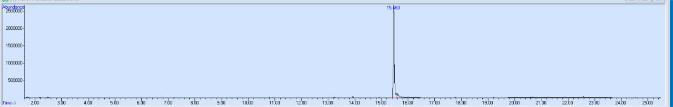  
**Figure S3.** Chromatogram for 8:2 FTOH experiment with thermal only treatment at 200 °C. The retention time of the 8:2 FTOH standard is 15.460 min.

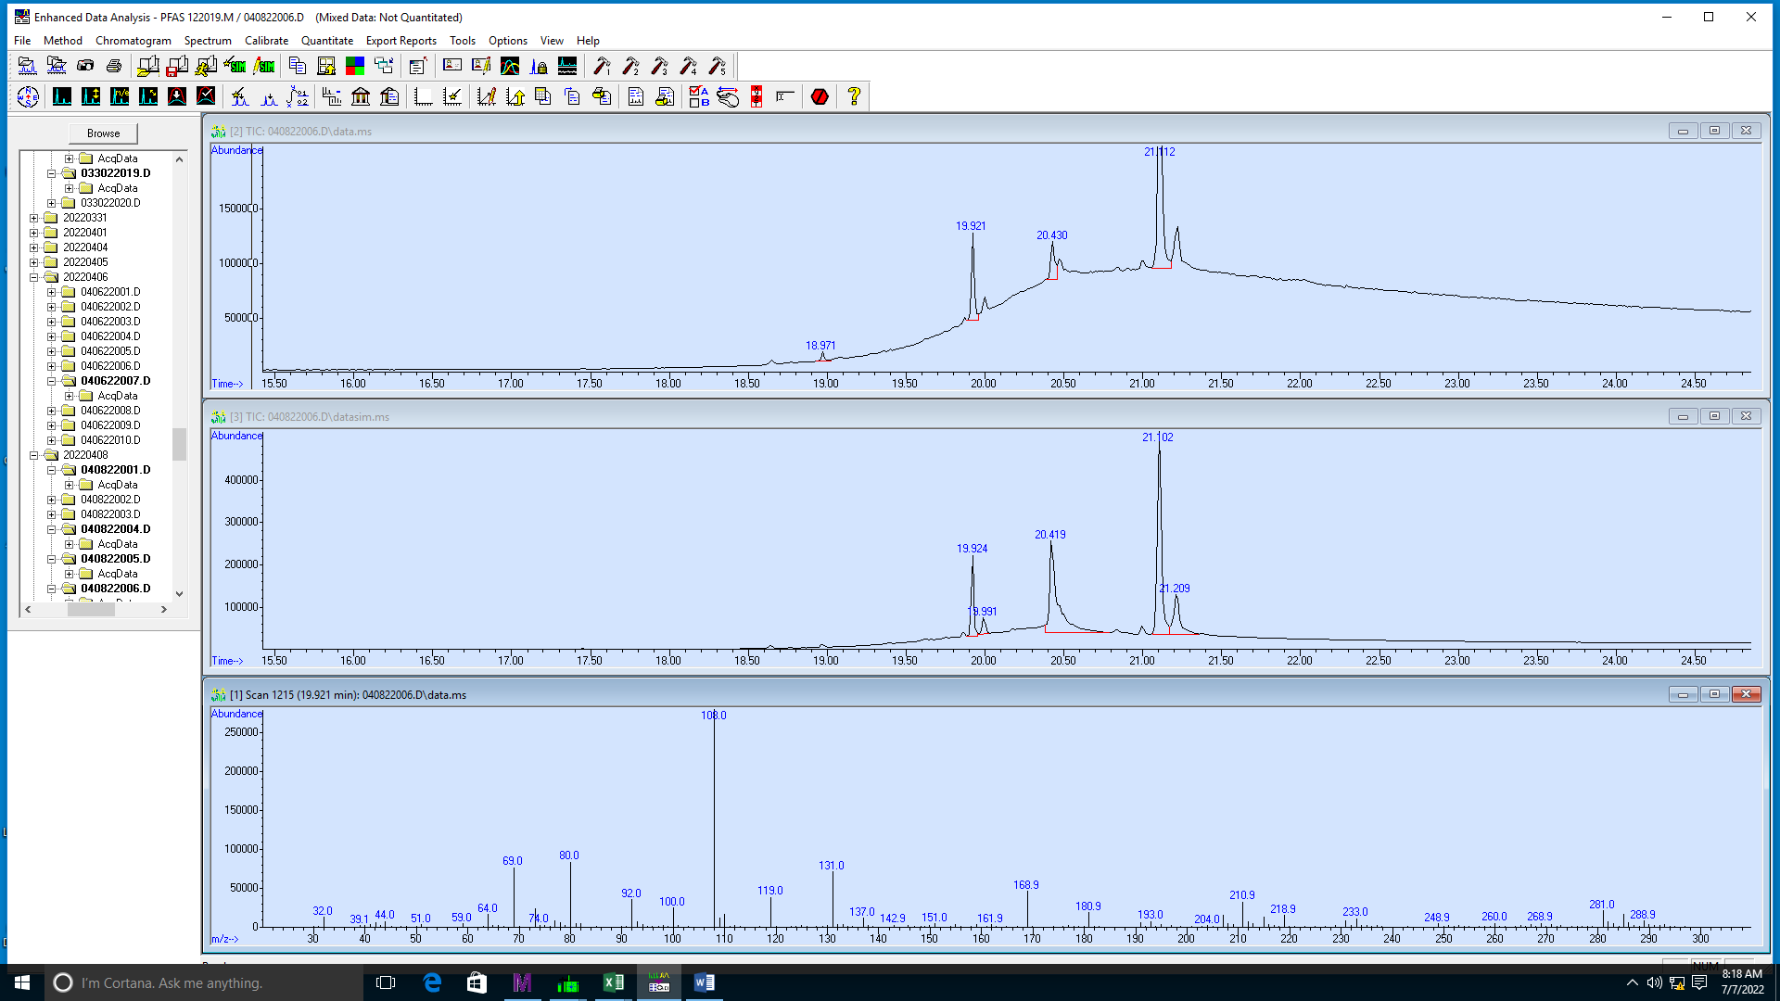

**Figure S4.** Chromatogram for Synquest NEt-FOSE standard spiked onto TD tubes without thermal or catalyst treatment. The spectrum for the peak at 19.924 min is shown and matches the spectrum for NEt-FOSA as reported in the SI of Roth et al. 2020.1

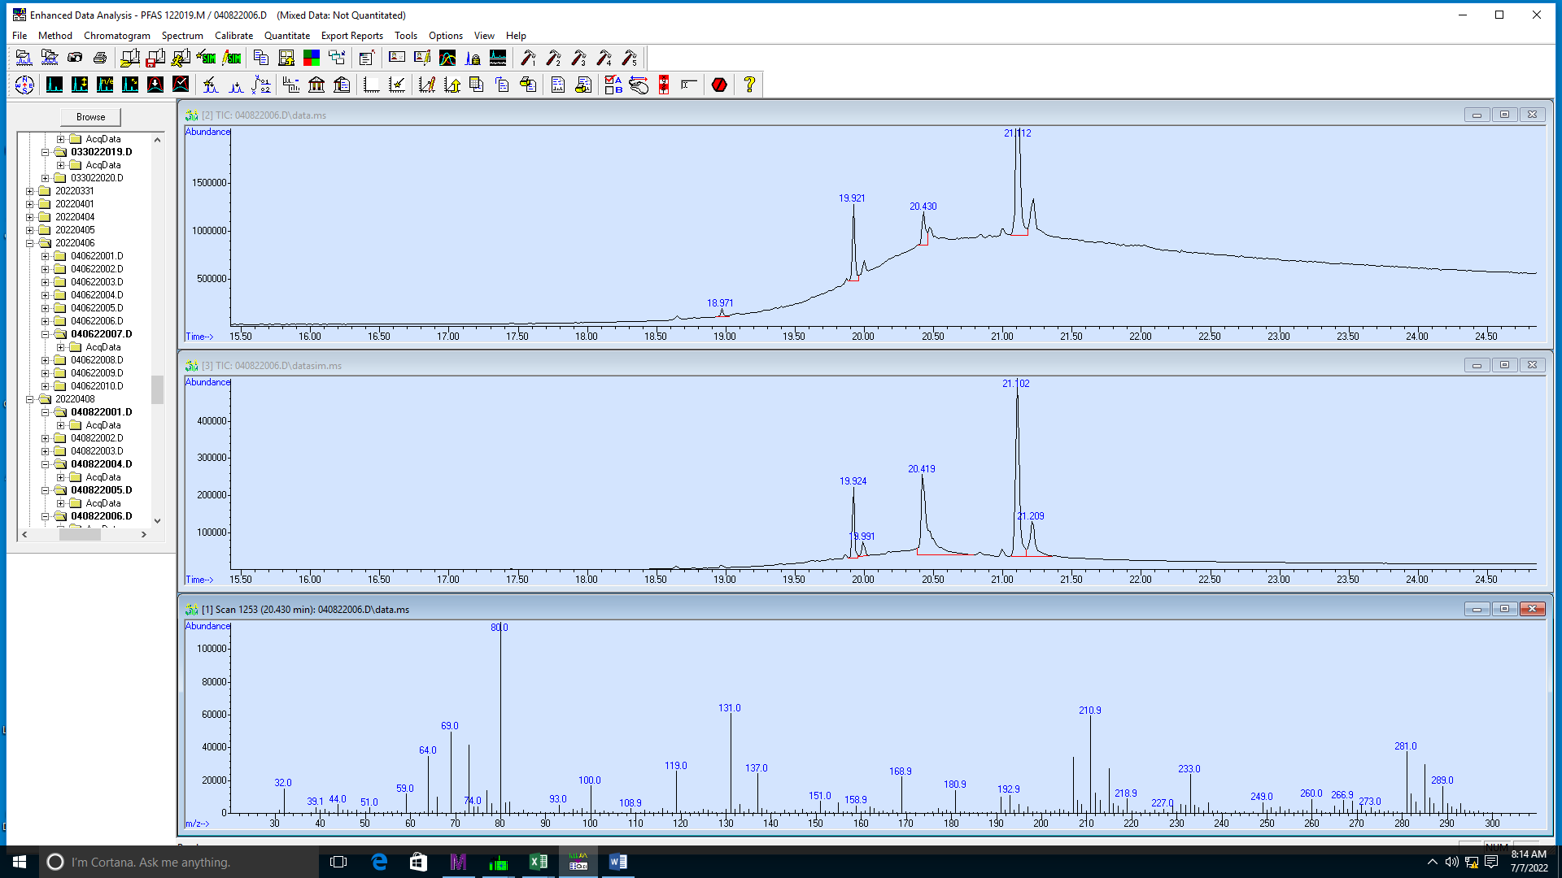

**Figure S5.** Chromatogram for NEt-FOSE Synquest standard spiked onto TD tubes without thermal or catalyst treatment. The spectrum is shown for the peak at 20.419. Then retention time and spectrum for this peak match that of the PFOSA Synquest standard in Figure S6.

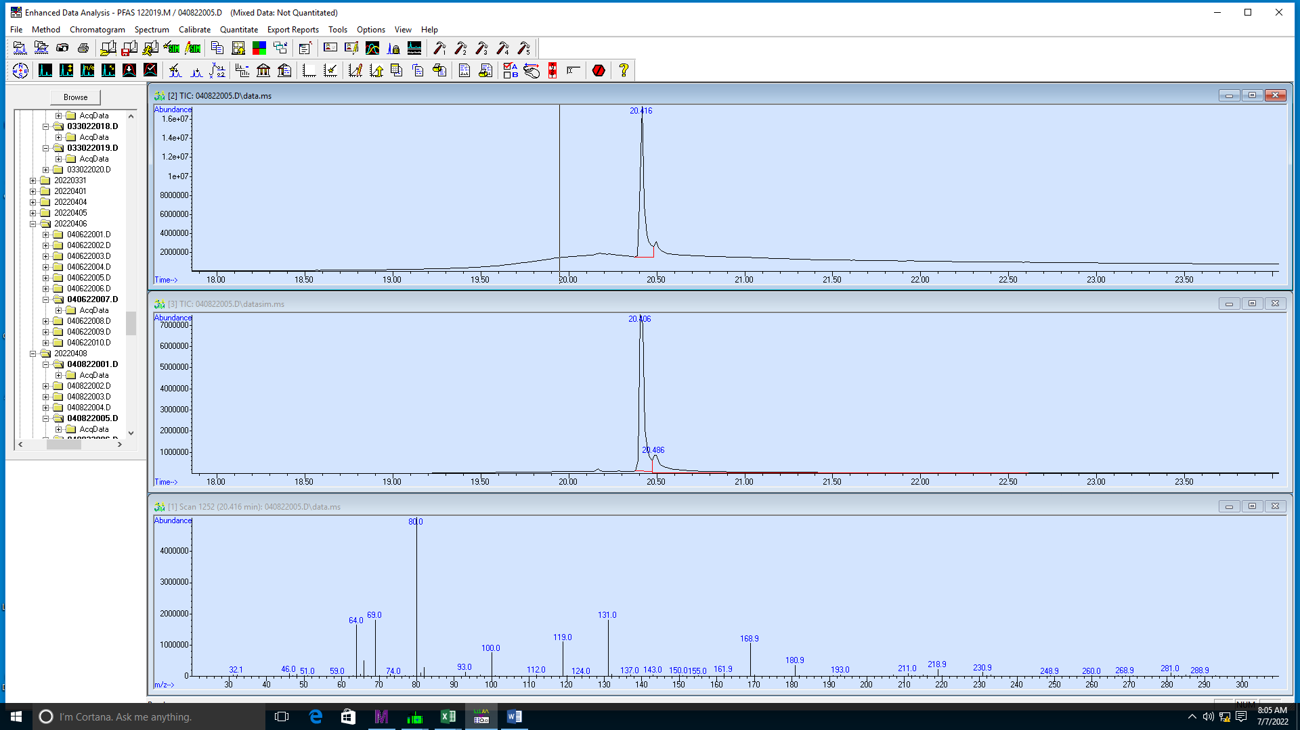

**Figure S6.** PFOSA standard chromatogram and spectrum at a retention time of 20.406 min. The Synquest PFOSA standard was spiked onto TD tubes and analyzed by TD-GC/MS without thermal or catalyst treatment to confirm the retention time and spectral match.

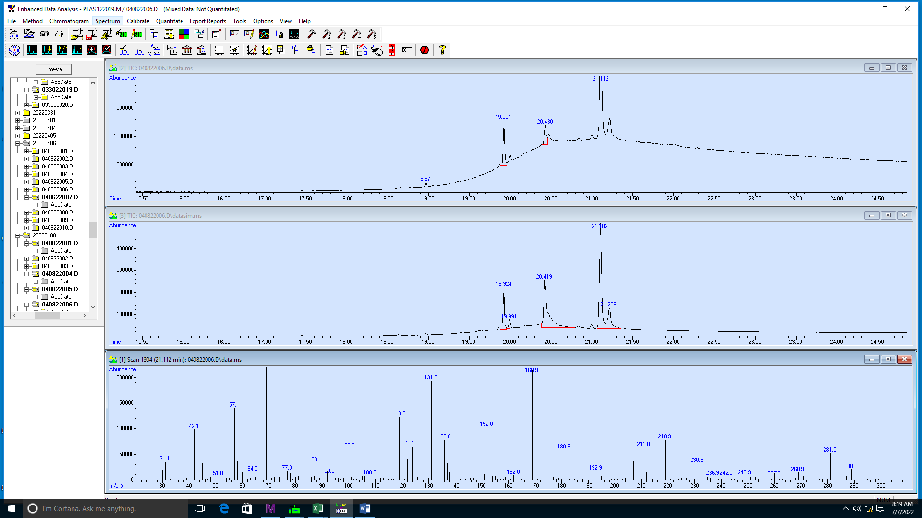

**Figure S7.** Chromatogram for NEt-FOSE Synquest standard spiked onto TD tubes without thermal or catalyst treatment. The spectrum for the peak at 21.112 min matches the spectrum for NEt-FOSE as reported in the SI of Roth et al 2020.1

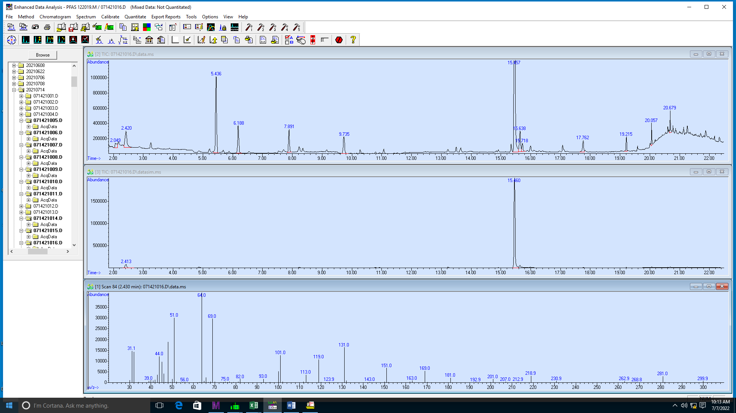

**Figure S8**. Chromatogram for 8:2 FTOH experiment with thermal treatment only at 400 °C. The spectrum for a fluorinated PID detected at 2.430 min is shown.

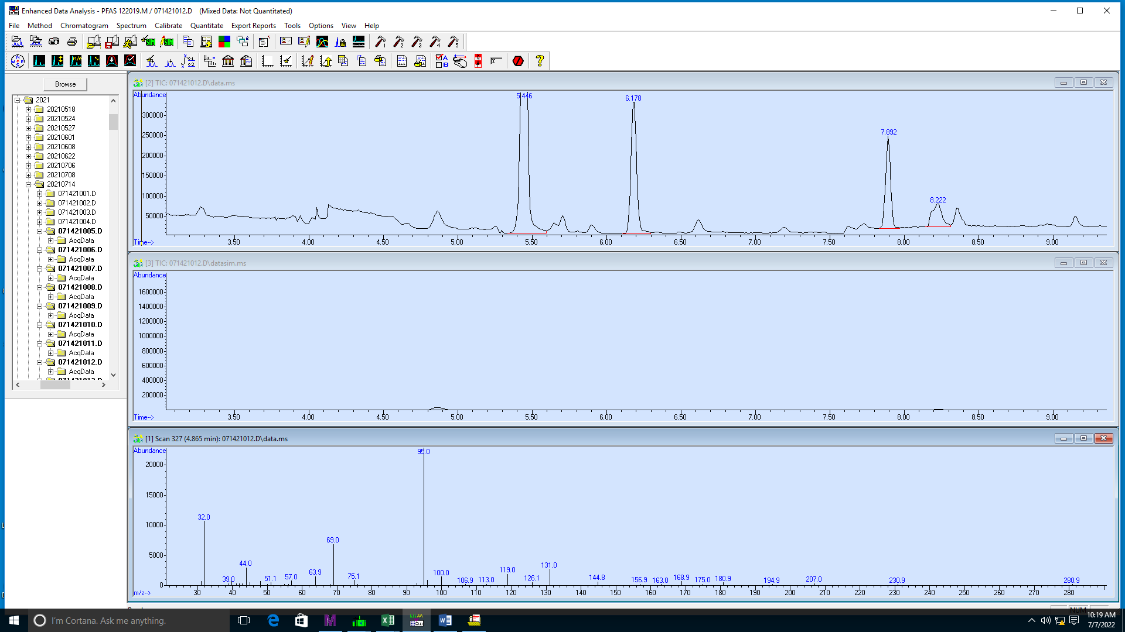

**Figure S9**. Chromatogram for 8:2 FTOH experiment with thermal treatment only at 500°C. The spectrum for a fluorinated PID detected at 4.865 min is shown.

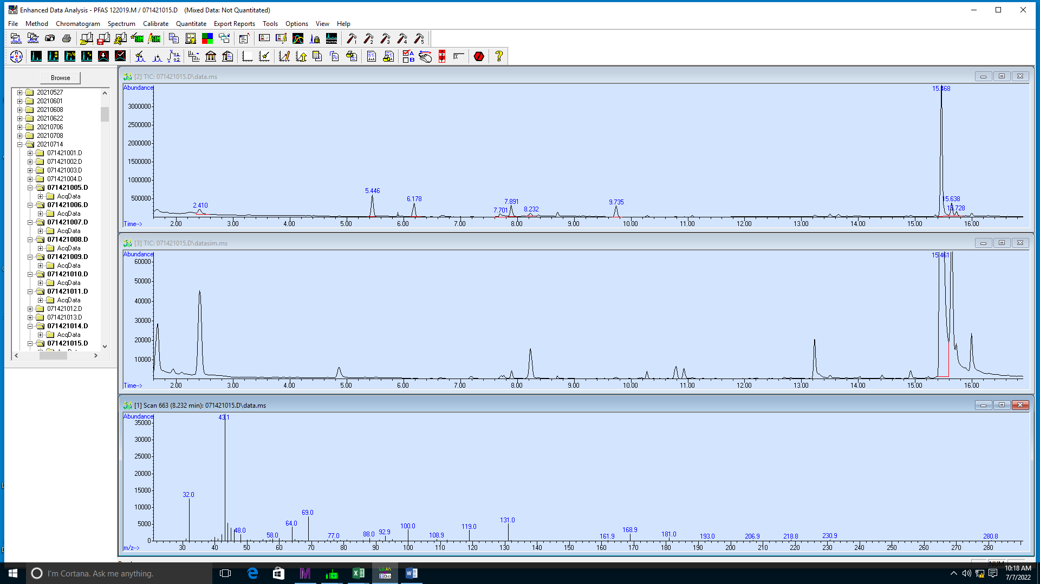

**Figure S10.** Chromatogram for 8:2 FTOH experiment with thermal treatment only at 400 °C. The spectrum for a fluorinated PID detected at 8.232 min is shown.

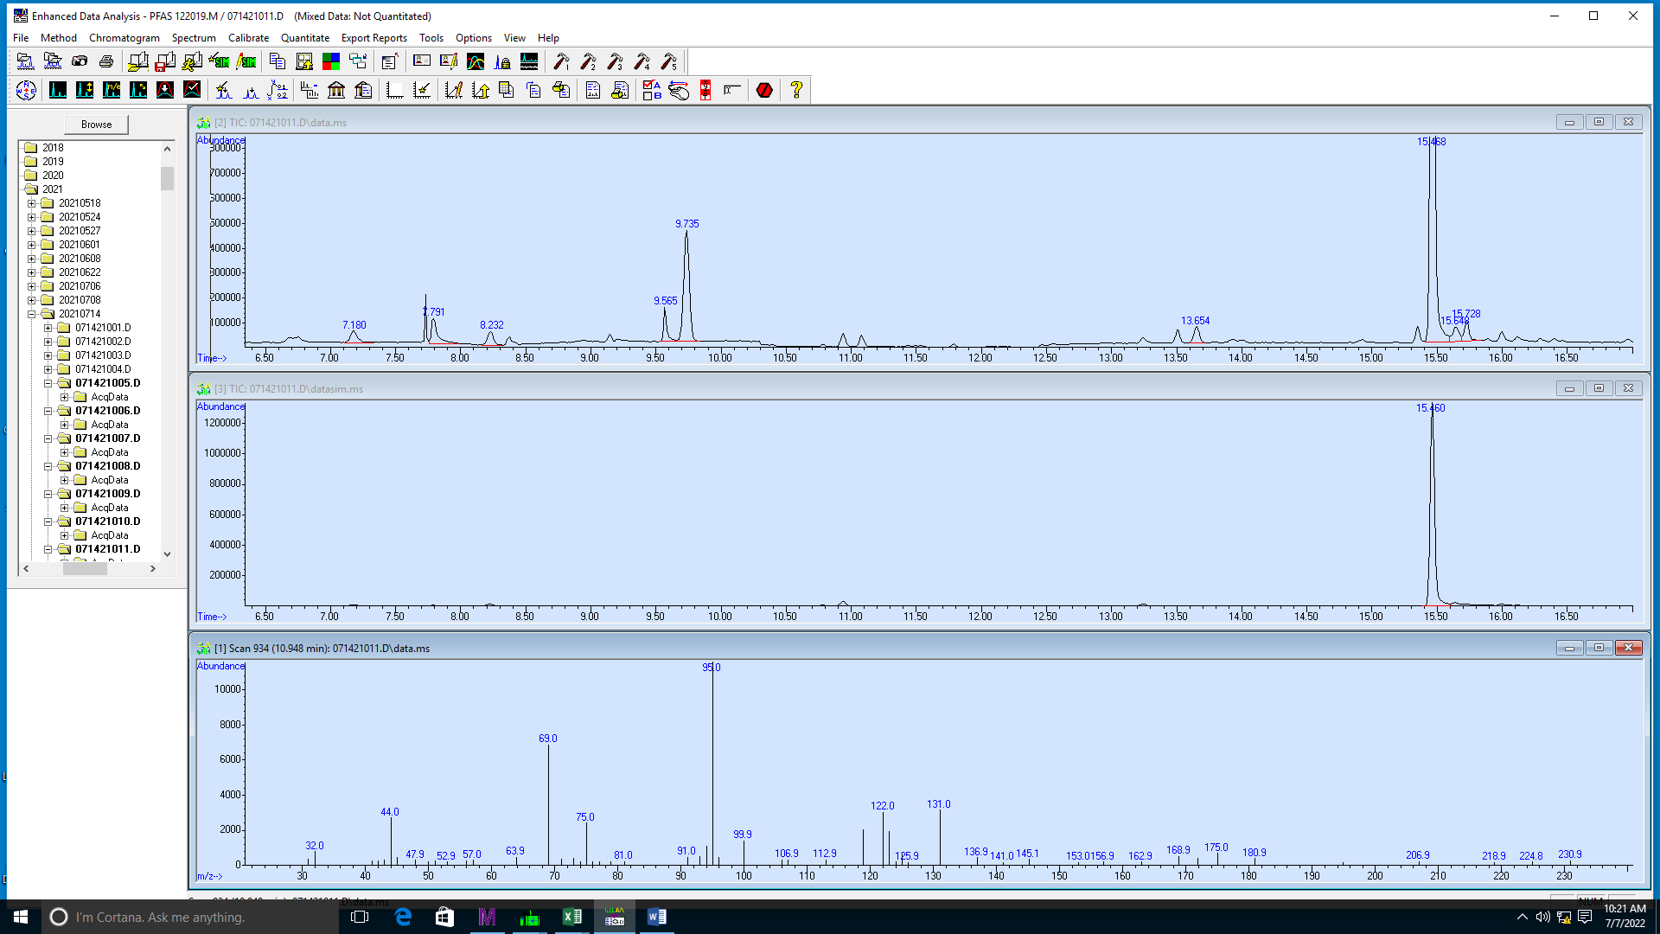

**Figure S11**. Chromatogram for 8:2 FTOH experiment with thermal treatment at 600 °C. The spectrum for a fluorinated PID detected at 10.948 min is shown.

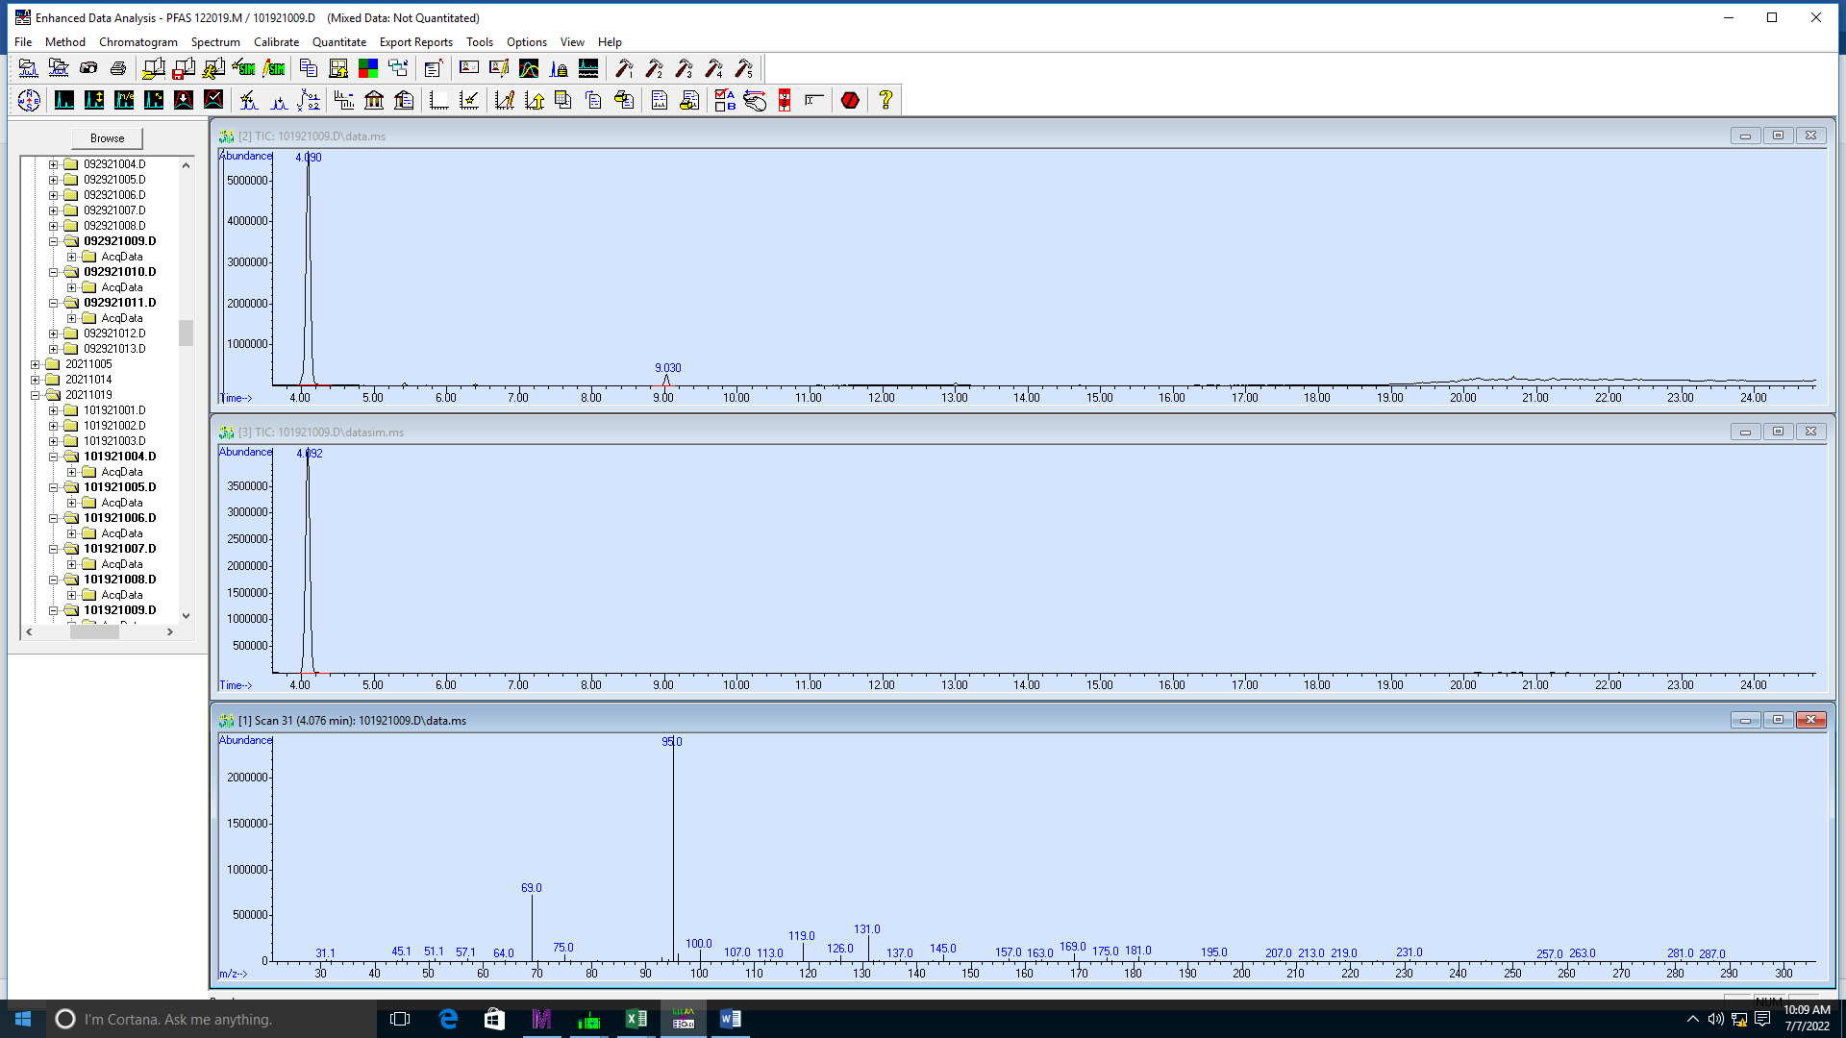

**Figure S12**. Chromatogram for 8:2 FTOH experiment with catalyst treatment at 200 °C. The spectrum for a fluorinated PID detected at 4.076 min is shown. The fluorinated PID represents 96.686% of the total ion chromatogram area in scan mode and was the only PID detected at this temperature.

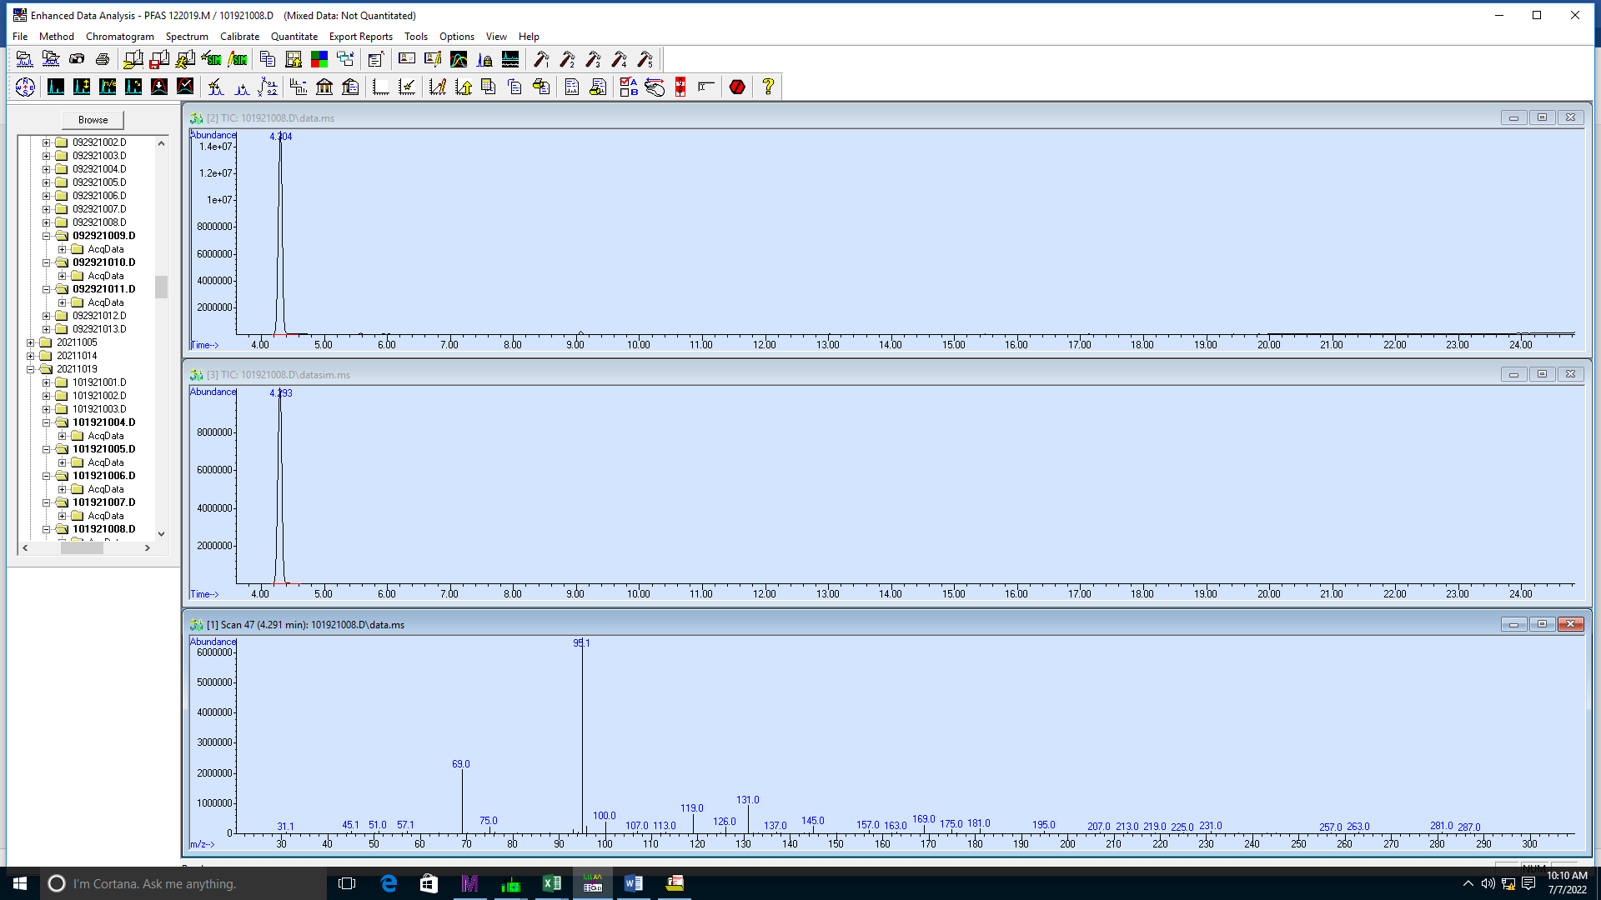

**Figure S13**. Chromatogram for 8:2 FTOH experiment with catalyst treatment at 250 °C. The spectrum for a fluorinated PID detected at 4.291 min is shown. This PID represents 100% of the total ion chromatogram area in scan mode and was the only PID detected at this temperature. This PID also represents 64.842% of the area at 300 C and 12.524% of the area at 350 C (chromatograms not shown). The PID is not observed at any higher temperatures.

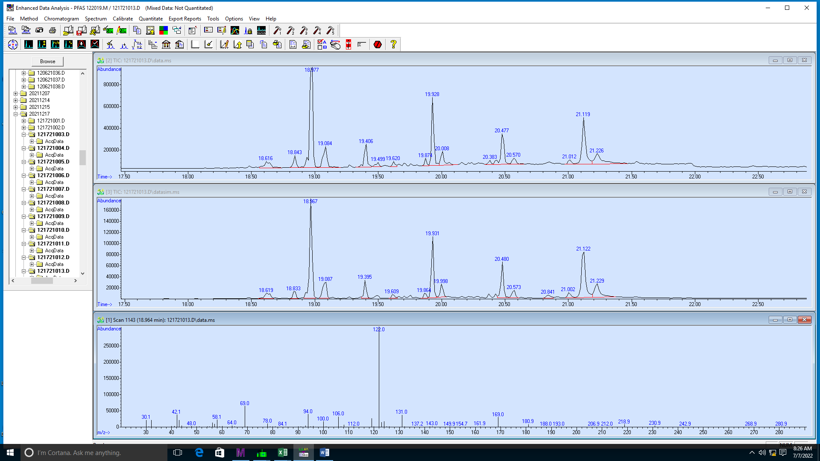

**Figure S14**. Chromatogram for NEt-FOSE experiment with thermal treatment only at 199°C analyzed by TD-GC/MS. The spectrum for a fluorinated PID at 18.967 min is shown. This peak is not present in the chromatogram of the NEt-FOSE standard (see Figure S4). The fragment peak 122 *m/z* is likely SO2NC3H8.

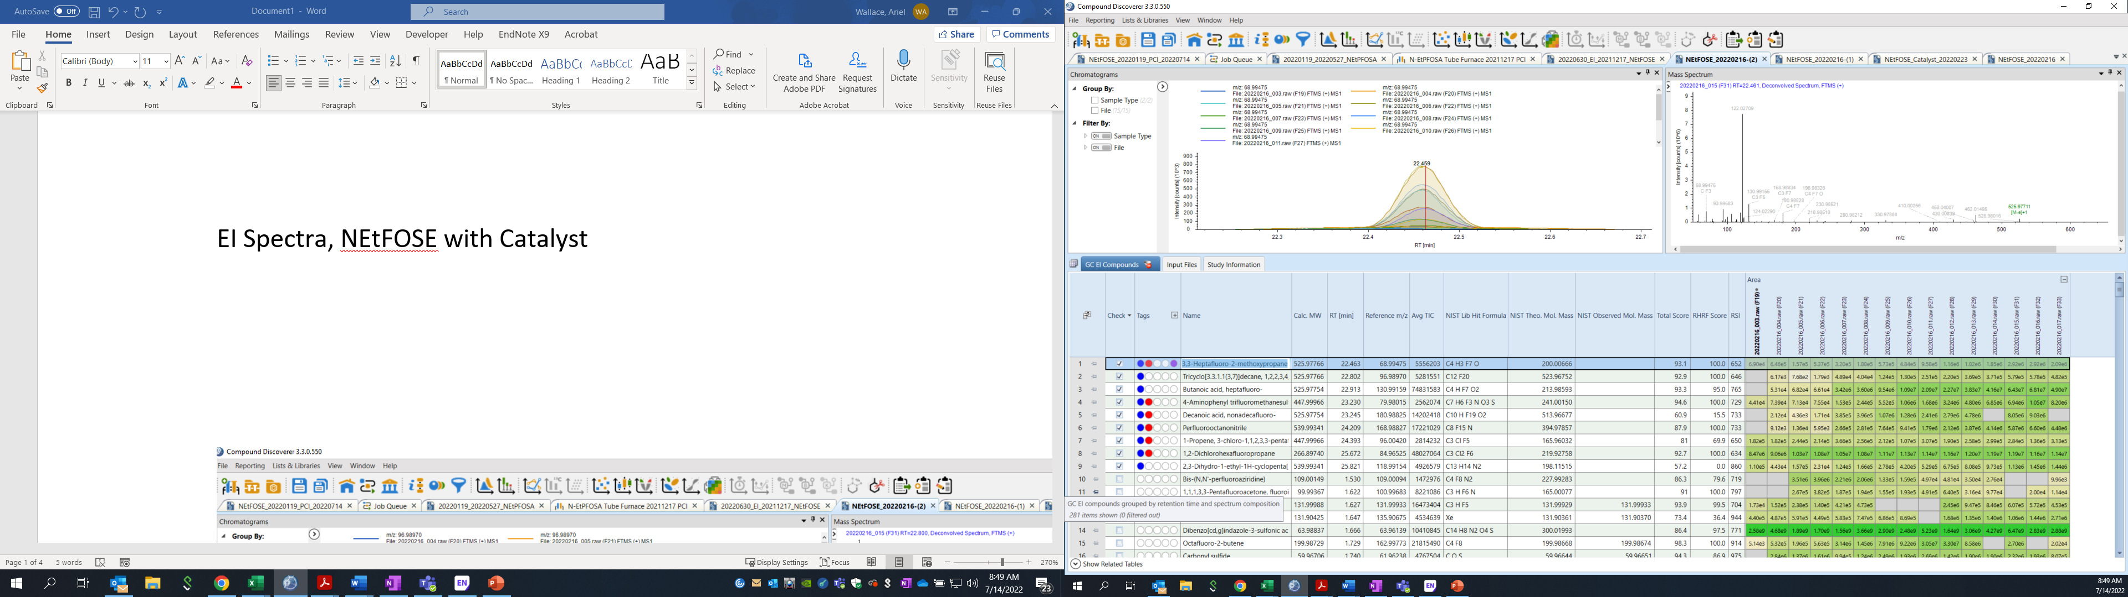

**Figure S15**. EI spectrum for a PID generated in the NEt-FOSE experiment with catalyst and analyzed by TD-GC-Orbitrap-MS. Retention time 23.250 min and exact mass 525.97754 Da.

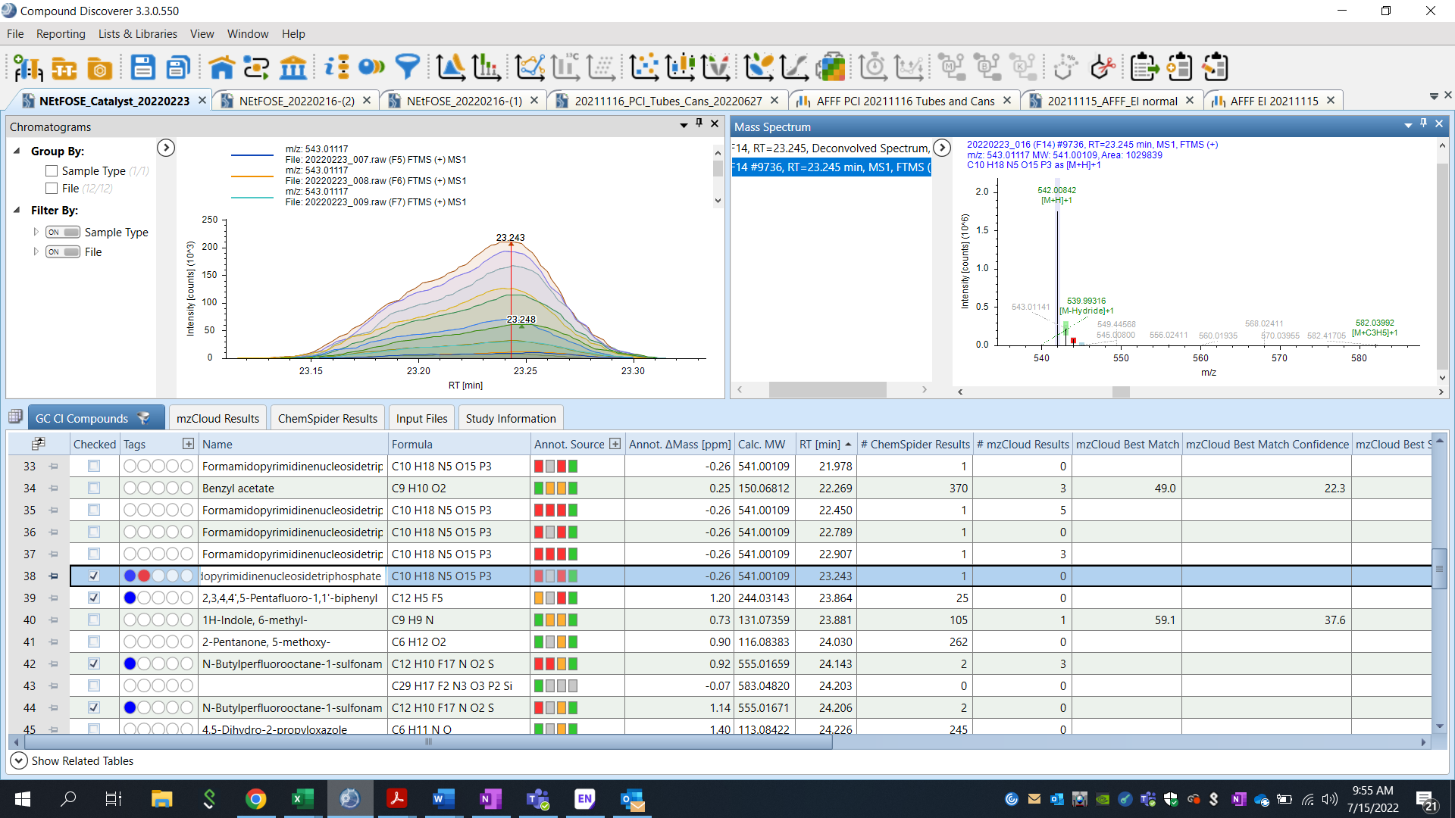

**Figure S16**. PCI MS1 spectrum for PID generated in the NEt-FOSE experiment with catalyst and analyzed by TD-GC-Orbitrap-MS. Retention time of 23.245 min with exact mass of 541.0022 Da; spectrum was matched to Figure S15 based on retention time of 23.250 min. The difference of 15.02446 Da between PCI and EI spectra indicates the absence of the molecular ion in EI mode, or the potential loss of a CH3 group during electron ionization.



**Figure S17**. Likely structure of the PID, retention time of 18.967 min, found in NEt-FOSE degradation tests. The molecular formula is C­11H8F17NO2S with a measured molecular weight of 541.00122 g/mol.

Table S1: Observed PIDs in 8:2 FTOH Experiment

|  |  |  |  |  |
| --- | --- | --- | --- | --- |
| Retention Time (min) | Temperatures (°C) | With Catalyst | NIST Match | Reverse Match Score |
| 2.430 | 400 | No |  |  |
| 4.865 | 500 | No |  |  |
| 8.232 | 400 | No |  |  |
| 10.948 | 600 | No |  |  |
| 4.076 | 200 | Yes | Figure S12 |  |
| 4.291 | 250 | Yes | Figure S13 |  |
|  |  |  |  |  |

Table S2: Observed PIDs in NEt-FOSE Experiment

|  |  |  |  |  |
| --- | --- | --- | --- | --- |
| Retention Time (min) | Temperatures (°C) | With Catalyst |  |  |
| 18.967 | 199 | Yes |  |  |
|  |  |  |  |  |
|  |  |  |  |  |
|  |  |  |  |  |

**References:**

1. Roth, J.; Abusallout, I.; Hill, T.; Holton, C.; Thapa, U.; Hanigan, D., Release of Volatile Per- and Polyfluoroalkyl Substances from Aqueous Film-Forming Foam. *Environmental Science & Technology Letters* **2020,** *7*, (3), 164-170. 10.1021/acs.estlett.0c00052