Supplementary Material

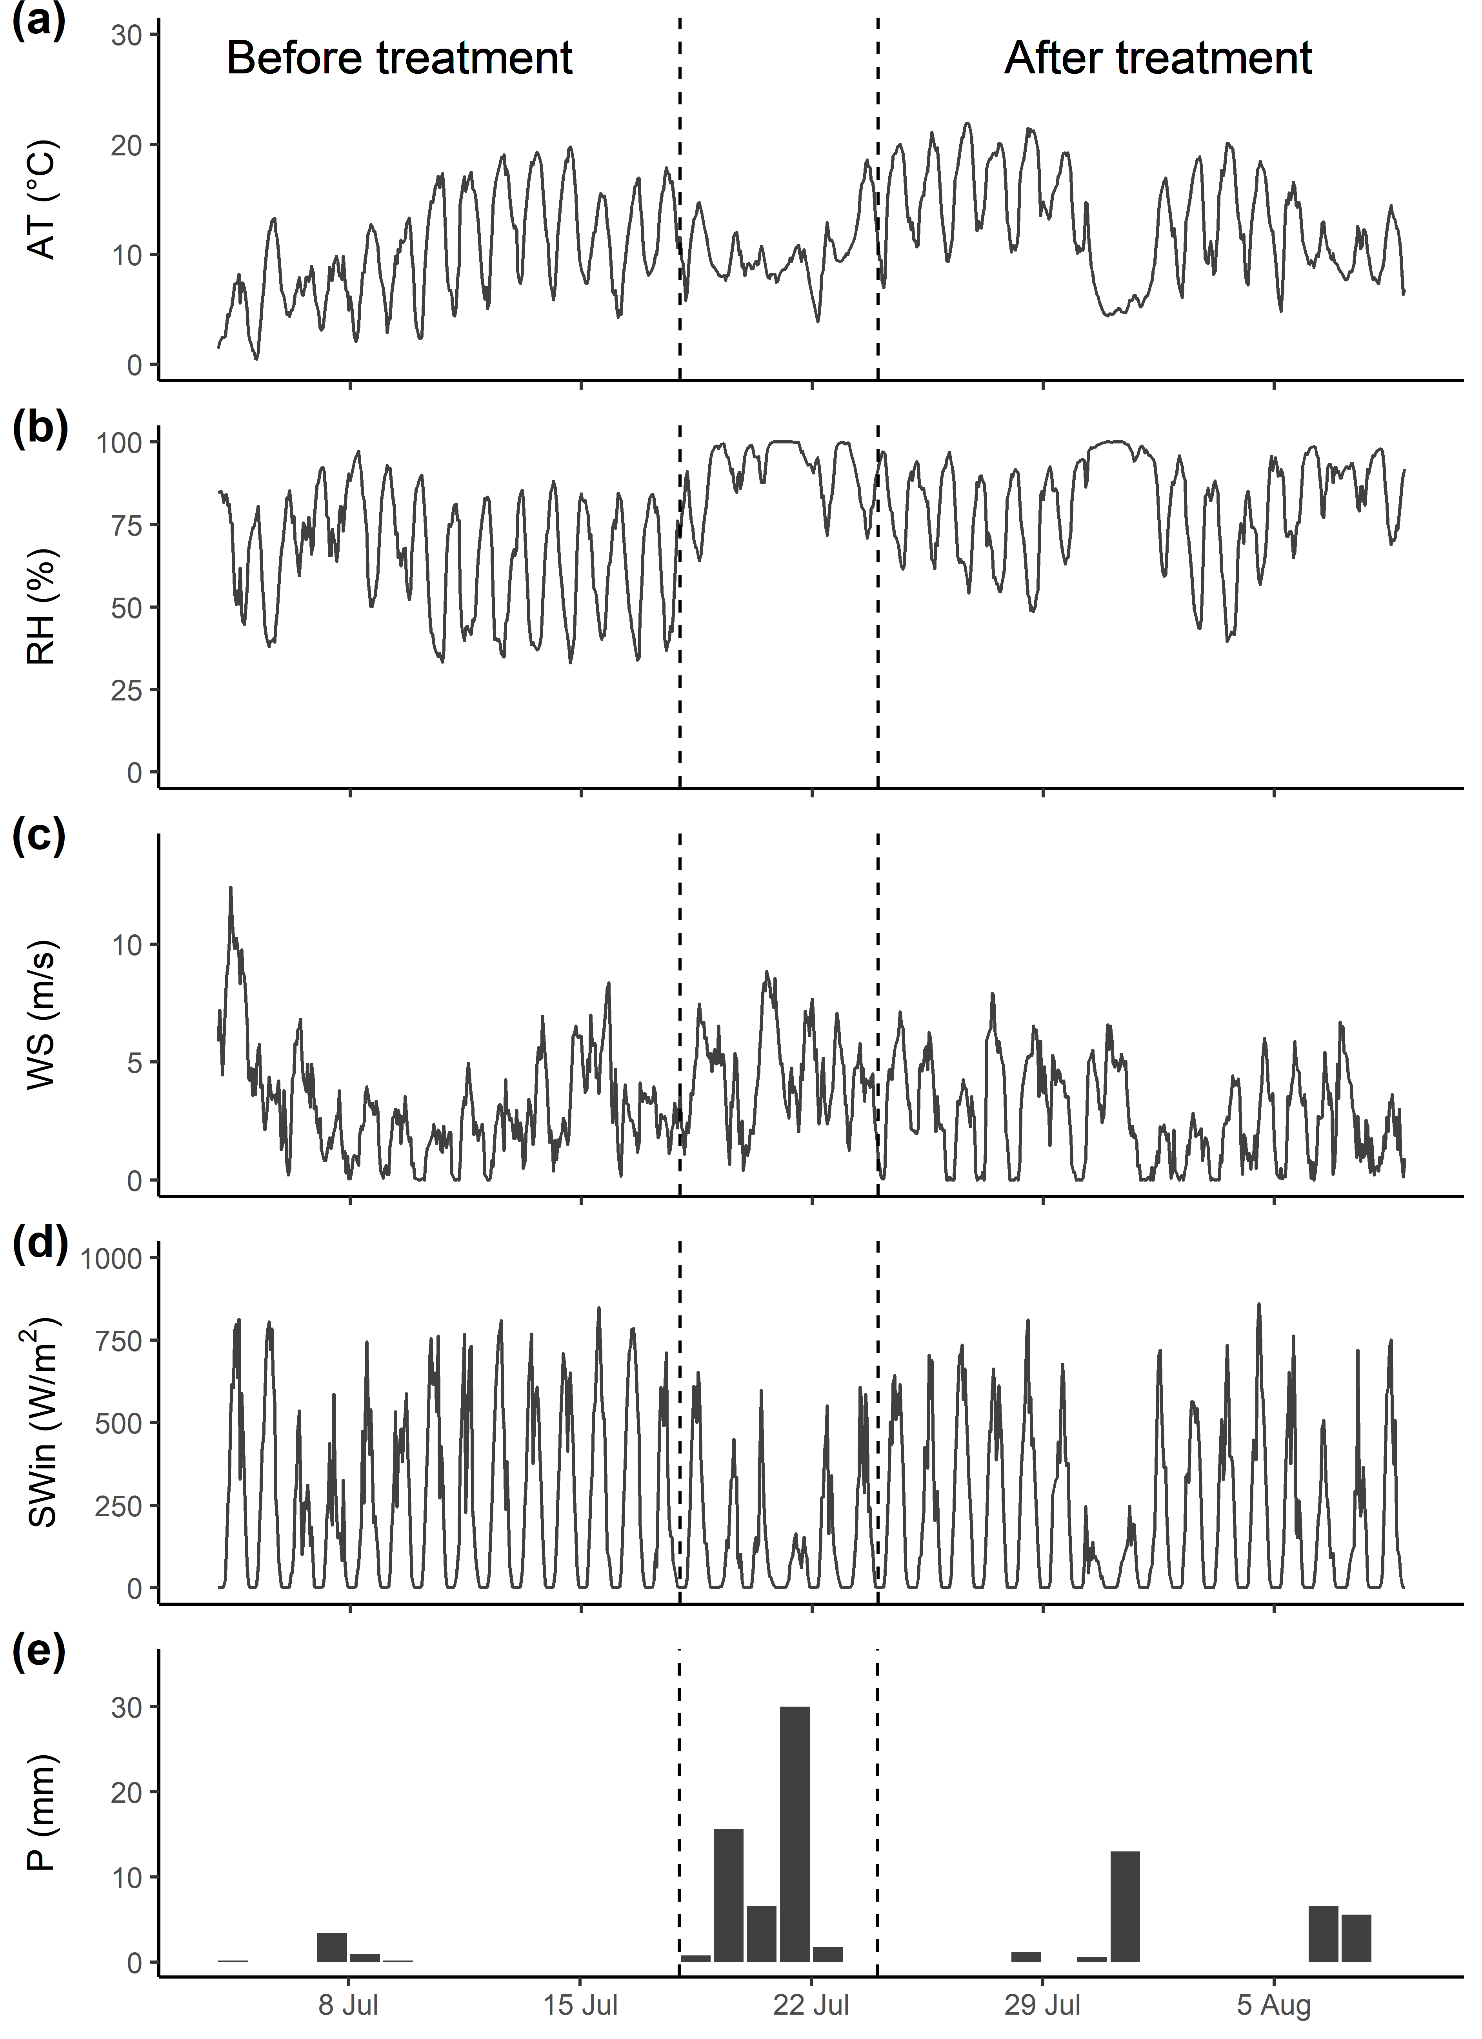
Supplementary Information 1
Figure S1: Time series of the air temperature at 2 m height (a), relative humidity (b), wind speed (c), incoming solar radiation (d) and daily total precipitation (e) during the field season measured with a HOBO RX3000 remote weather station. Time series are constructed with hourly averages.

Supplementary Information 2
Table S2.1: Detailed output for the interaction term in the mixed-effect models. We considered a significant effect of the treatment on the soil temperature variable when this interaction term is significant (p < 0.05, indicated in bold). df ≈ 27 for all tests. Abbreviations of soil temperature variables are explained in Table 2.
Soil temp variable | Vegetation | Treatment | SS | F | p-value
Mean | Lichen | Bare Soil | 2.26 | 68.62 | < 0.001
 |  | Add Litter | 0.51 | 9.14 | 0.005
 |  | Wet | 0.04 | 0.67 | 0.419
 | Shrub | Remove Litter | 0.80 | 4.52 | 0.043
 |  | Wet | 0.01 | 0.11 | 0.746
Amplitude | Lichen | Bare Soil | 38.18 | 119.44 | < 0.001
 |  | Add Litter | 0.67 | 2.60 | 0.118
 |  | Wet | 0.05 | 0.18 | 0.675
 | Shrub | Remove Litter | 1.00 | 5.58 | 0.025
 |  | Wet | 0.07 | 0.47 | 0.499
ΔTimeMax | Lichen | Bare Soil | 4.73 | 43.90 | < 0.001
 |  | Add Litter | 1.50 | 11.97 | 0.002
 |  | Wet | 0.03 | 0.22 | 0.643
 | Shrub | Remove Litter | 1.76 | 1.92 | 0.177
 |  | Wet | 0.08 | 0.09 | 0.761
ΔTimeMin | Lichen | Bare Soil | 2.80 | 32.71 | < 0.001
 |  | Add Litter | 0.35 | 4.75 | 0.038
 |  | Wet | 0.02 | 0.23 | 0.633
 | Shrub | Remove Litter | 2.11 | 5.77 | 0.023
 |  | Wet | 0.02 | 0.05 | 0.823
CumSTMax | Lichen | Bare Soil | 5144 | 157 | < 0.001
 |  | Add Litter | 249 | 6.85 | 0.014
 |  | Wet | 3 | 0.09 | 0.766
 | Shrub | Remove Litter | 395 | 6.47 | 0.016
 |  | Wet | 0 | 0 | 0.973
CumSTMin | Lichen | Bare Soil | 210 | 16.43 | < 0.001
 |  | Add Litter | 18 | 1.39 | 0.250
 |  | Wet | 22 | 1.80 | 0.192
 | Shrub | Remove Litter | 35 | 1.25 | 0.274
 |  | Wet | 15 | 1.02 | 0.321
Heat sum | Lichen | Bare Soil | 810 | 115.19 | < 0.001
 |  | Add Litter | 101 | 8.39 | 0.007
 |  | Wet | 11 | 0.92 | 0.345
 | Shrub | Remove Litter | 166 | 4.66 | 0.040
 |  | Wet | 4 | 0.22 | 0.641

Supplementary Information 3
Vegetation | Treatment | Mean(°C) |  | Amplitude(°C) |  | ΔTimeMax(h) |  | ΔTimeMin(h) |  | CumSTMax(°Cd) |  | CumSTMin(°Cd) |  | HeatSum(°Cd)
 |  | Before | After | Before | After | Before | After | Before | After | Before | After | Before | After | Before | After
Lichen | BareSoil | -0.15 | 0.90 | -0.59 | 3.41 | -0.06 | -1.46 | 0.11 | -0.96 | -6.93 | 40.61 | 1.33 | -7.11 | -2.80 | 16.75
 | AddLitter | 0.33 | -0.05 | -0.24 | -0.75 | -0.10 | 0.68 | 0.16 | 0.54 | 2.19 | -6.56 | 5.60 | 3.88 | 3.90 | -1.34
 | Wet | -0.16 | -0.20 | -0.60 | -0.43 | 0.07 | 0.16 | 0.10 | 0.20 | -7.00 | -6.77 | 1.40 | -0.69 | -2.80 | -3.73
Shrub | RemoveLitter | -0.64 | -0.07 | 0.14 | 0.77 | -0.23 | -1.07 | -0.03 | -0.95 | -7.61 | 4.96 | -9.57 | -5.85 | -8.59 | -0.44
 | Wet | 0.09 | 0.03 | 0.05 | 0.21 | 0.21 | 0.39 | 0.34 | 0.43 | 1.94 | 1.81 | 1.24 | -1.19 | 1.59 | 0.31
Table S3.1: The difference between the treatment and the control plots for each soil temperature variable and for each period (before and after treatment). Difference = Treatment – Control. For example: before the treatment, the mean soil temperature below the Lichen BareSoil plots was 0.15 °C lower than the mean soil temperature below the Lichen Control plots. After the treatment, the mean soil temperature below the Lichen BareSoil plots was 0.90 °C higher than the mean soil temperature below the Lichen Control plots. Abbreviations of soil temperature variables are explained in Table 2.

Table S3.2: Change in soil temperature variable per treatment relative to the control plots and relative to the period before the treatment. Change = After – Before per soil temperature variable per treatment from Table S3.1. When the effect of the treatment on the soil temperature variable was significant (Table 3), the value is indicated in bold. Abbreviations of soil temperature variables are explained in Table 2.
Vegetation | Treatment | Mean(°C) | Amplitude(°C) | ΔTimeMax(h) | ΔTimeMin(h) | CumSTMax(°Cd) | CumSTMin(°Cd) | HeatSum(°Cd)
Lichen | BareSoil | + 1.05 | + 4.00 | - 1.40 | - 1.07 | + 47.54 | - 8.44 | + 19.55
 | AddLitter | - 0.38 | - 0.51 | + 0.78 | + 0.38 | - 8.75 | - 1.72 | - 5.24
 | Wet | - 0.04 | + 0.17 | + 0.09 | + 0.10 | + 0.23 | - 2.09 | - 0.93
Shrub | RemoveLitter | + 0.57 | + 0.63 | - 0.84 | - 0.92 | + 12.57 | + 3.72 | + 8.15
 | Wet | - 0.06 | + 0.16 | + 0.18 | + 0.09 | - 0.13 | - 2.43 | - 1.28

Supplementary Information 4
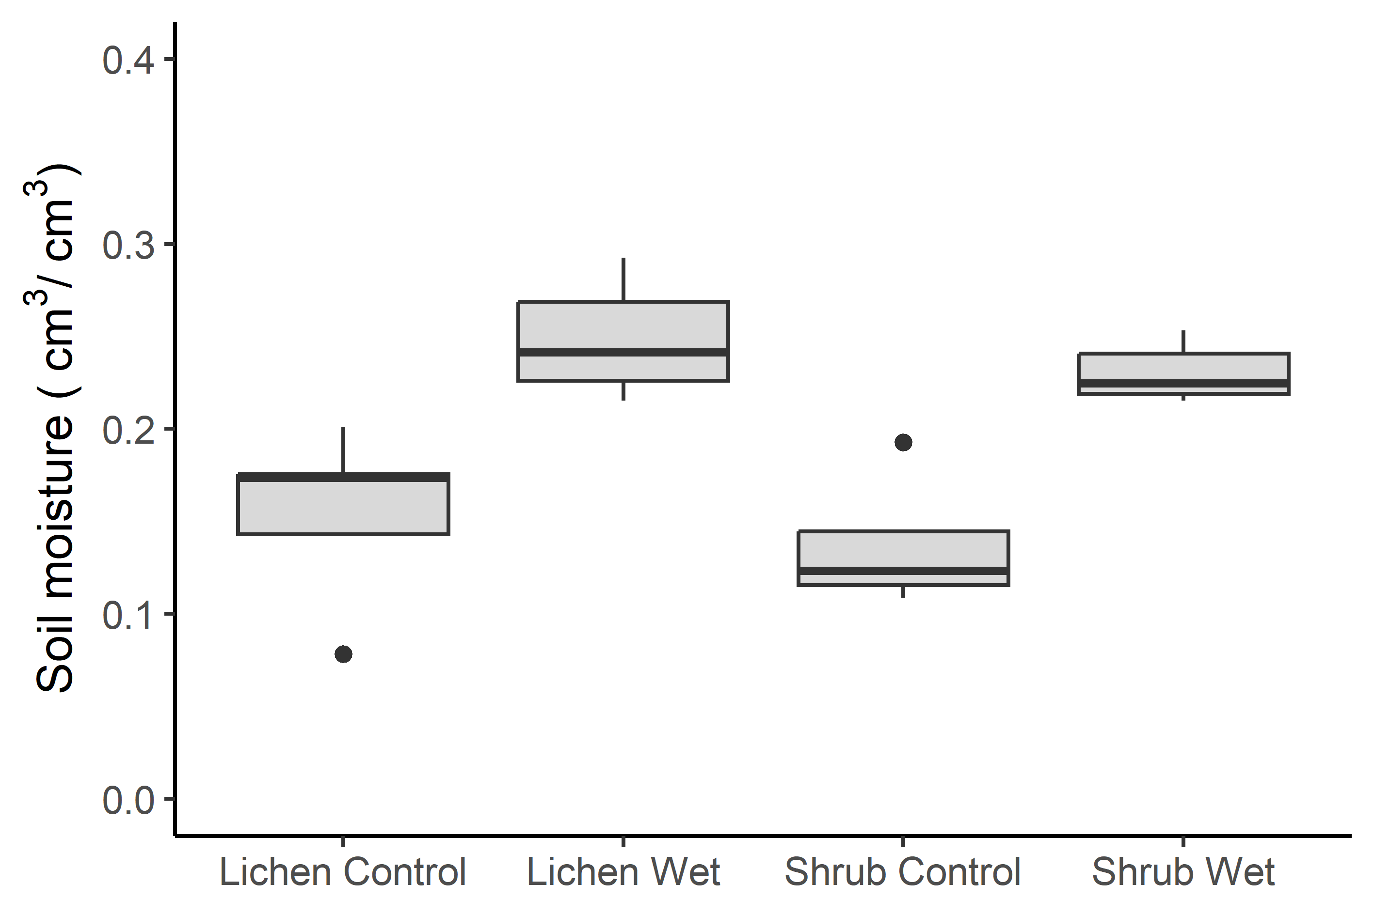
Figure S4: The volumetric soil moisture content of the Lichen Control, Lichen Wet, Shrub Control and Shrub Wet plots measured on one day (3 August) during the treatment period.

