Table S1 Habitat characteristics at high, medium and low disturbance bryophyte collection sites near Diavik Canada and and Heiðmörk Iceland.
Disturbance  Level | Habitat Characteristics
 | Diavik
Low | Uphill, pristine dwarf shrub heath tundra several km from anthropogenic impact on an island near diamond mining operations. Some collecting occurred at low lying areas near a lake.
Medium | Rocky dwarf shrub heath in proximity to diamond mining operations, characterized by rock lichen communities on exposed till boulders and bedrock, with seepage zones supporting localized wetlands of sedge, moss and lowland dwarf shrubs.
High | Edges of an access road, with sparsely vegetated sand and gravel.
 | Heiðmörk
Low | Bouldery lava field, at least 20 m from anthropogenic impact.
Medium | Near a secondary road, in small protected ditch.
High | High traffic gravel parking lot and walking path areas.

Table S2. Mean (±SD) soil pH, volumetric water content, temperature, electrical conductivity with and without erosion control treatment by substrates at Diavik Canada and Heiðmörk Iceland research sites.
Site | Substrate | pH | Erosion Control | Volumetric Water Content  (m³ m⁻³) | Temperature (°C) | Electrical Conductivity (dS cm⁻¹)
Diavik | Crushed  rock | 7.3 | No | 0.1(0.1) | 13.7 (4.3) | 6.4 e⁻⁰³
 |  |  | Yes | 0.1(0.1) | 13.4(4.2) | 7.7 e⁻⁰³
 | Lake  sediment | 6.4 | No | 0.1(0.1) | 13.0(4.3) | 0.1
 |  |  | Yes | 0.1(0.1) | 13.1(4.1) | 0.1
 | Processed  kimberlite | 8.5 | No | 0.2(0.1) | 13.5(4.2) | 0.1
 |  |  | Yes | 0.2(0.1) | 14.1(4.0) | 0.0
Heiðmörk | Crushed  lava rock | 5.3 | No | 0.1(0.1) | 12.2(1.5) | 0.0
 |  |  | Yes | 0.1(0.1) | 12.5(1.5) | 4.2 e⁻⁰⁴
 | Volcanic  silt loam | 5.6 | No | 0.2(0.1) | 11.1(1.0) | 4.2 e⁻⁰³
 |  |  | Yes | 0.2(0.1) | 11.4(1.0) | 3.5 e⁻⁰³

Table S3. Total species abundance for size treatments at Diavik Canada and Heiðmörk Iceland research sites in year two. * New species
Species | Fragment Sizes
 | Small | Medium | Large
Aulacomium turgidum | 2 | 3 | 14
Brachythecium albicans |  | 4
Bryum argenteum | 21 | 21 | 22
Bryum pseudotriquetrum | 14 | 10 | 14
Ceratodon purpureus | 32 | 43 | 52
Dicranum fulvum |  | 2 | 2
Dicranum groenlandicum |  |  | 3
Diplophyllum obtusifolium | 12 | 11 | 10
Hylocomium splendens |  |  | 4
Pleurozium schreberi | 5 | 16 | 5
Polytrichum commune |  |  | 2
Polytrichum piliferum |  | 1 | 1
Polytrichum strictum | 2 | 5 | 3
Ptilidium ciliare |  | 1
Racomitrium fasciculare | 10 | 16 | 19
Racomitrium lanuginosum | 21 | 45 | 43
Rhytidiadelphus squarrosus | 17 | 24 | 9
Rhytidiadelphus triquetrus | 2 | 1 | 1
Rhytidium rugosum | 15 | 17 | 14
Sanionia uncinata | 12 | 27 | 14
Unknown * | 23 | 25 | 14
Protonema | 1 | 3
* Unknown= Unidentified bryophytes
Table S4. Species occurrence (x) in planted samples and final collection at Diavik Canada and Heiðmörk Iceland research sites.

Species | Diavik |  | Heiðmörk
 | Planted Year | Final Year | Planted Year | Final Year
Aulacomium turgidum | x | x
Bartramia ithyphylla |  |  | x
Brachythecium albicans |  |  | x | x
Bryum argenteum |  | x
Bryum pseudotriquetrum | x | x | x | x
Calliergon richardsonii | x
Cephalozia sp | x |  | x
Ceratodon purpureus | x | x | x | x
Dicranum fulvum |  |  | x | x
Dicranum groenlandicum | x | x
Dicranum scoparium | x |  | x
Diplophyllum albicans |  |  | x
Diplophyllum obtusifolium |  |  |  | x
Fissidens sp |  |  | x
Hylocomium splendens | x | x | x | x
Pleurozium schreberi | x |  | x | x
Polytrichum commune |  |  |  | x
Polytrichum juniperinum |  |  | x
Polytrichum piliferum | x |  |  | x
Polytrichum strictum | x |  |  | x
Ptilidium ciliare | x | x | x
Racomitrium canescens |  |  | x
Racomitrium fasciculare |  |  | x | x
Racomitrium lanuginosum | x | x | x | x
Rhytidiadelphus loreus |  |  | x
Rhytidiadelphus squarrosus |  |  | x | x
Rhytidiadelphus triquetrus |  |  | x | x
Rhytidium rugosum | x | x
Sanionia uncinata | x | x | x | x
Sphagnum capilifolium | x
Sphagnum warnstorfii | x
Tetralophozia setiformis | x
Tortella tortuosa |  |  | x
Unknown * |  | x |  | x
Protonema |  | x |  | x
* Unknown= Unidentified bryophytes

Figure S1. Location and layout of Diavik Diamond Mine, Canada research site. Map adapted from google.

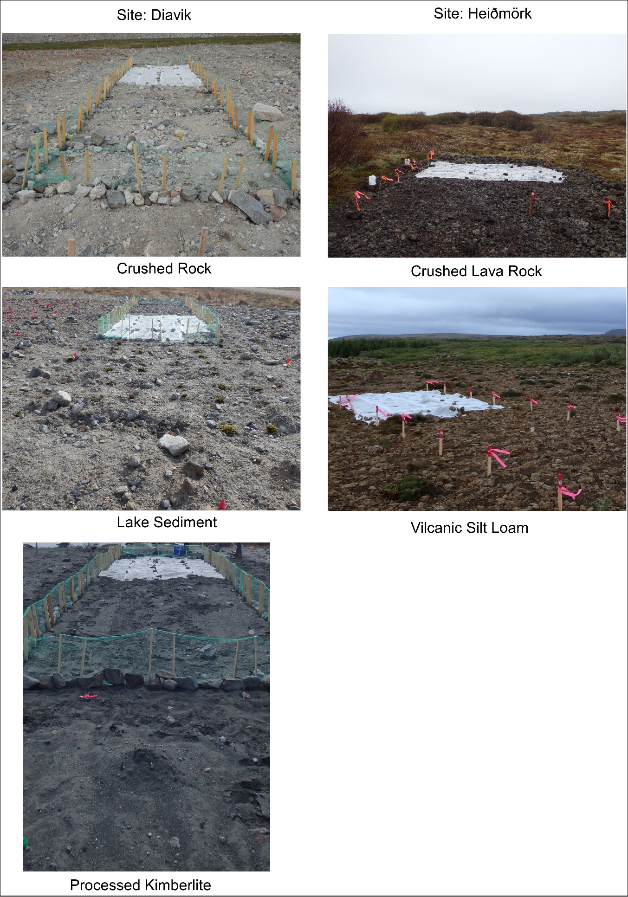
Figure S2. Photos of research sites with different treatments.

