Tumor reduction potentials of Vernonia cinerea sesquiterpenes by induction of ferroptosis
Supplementary Information
Supplementary Methodology
SM1- Lipid Peroxidation Assay
Thiobarbituric acid reactive species (TBARS) assay was conducted to measure the ability of the plant extracts to inhibit the lipid peroxidation. Egg homogenate was used as lipid rich media. To 500 μL of egg homogenate (10% v/v in PBS), 100 μL of plant extract dissolved in DMSO was added and made up to 1 mL using distilled water. To this, 50 μl of FeSO₄ (0.074 M) and 20 μL of ascorbic acid (0.1 M) was added and incubated for 1 h at 37⁰ C to induce lipid peroxidation. Thereafter, 1.5 mL of 20% acetic acid and 1.5 mL of 0.8% TBA in 1.1 % w/v SDS were added and heated to 95⁰ C for 60 minutes. Then allowed the mixture to cool and 5 ml of butanol was added. Then centrifuged at 3000 rpm for 10 min. Absorbance of the organic layer was read at 532 nm. Percentage inhibition of lipid peroxidation was calculated using this equation.
Percentage inhibition = (A₀ - A_{s})/A₀ where, A₀ = absorbance of control; A_{s} = absorbance of sample.
SM 2 - DPPH radical scavenging Assay
To the 1.5mL (30mM) methanolic solution of DPPH (2, 2-diphenyl-1-picryl -hydrazyl-hydrate), 10 μL of various extracts and 1.49 mL of methanol were added. After 30 min of incubation, discoloration of purple color was measured at 518 nm. Percentage DPPH scavenging was calculated using this equation.
Percentage Scavenging of DPPH radical = (A₀ - A_{s}) / A₀ where, A₀ is the absorbance of control and A_{s} is the absorbance of the sample.
SM 3 - ABTS radical scavenging Assay
ABTS (2,2’ -azino-bis(3-ethylbenzothiazoline-6-sulfonic acid)) solution (7mM) was mixed with 2.45mM ammonium persulphate (1:1 v/v) and kept at dark for 8- 10 h for generating ABTS radical. This solution was diluted using ethanol to an absorbance of 0.700 at 734 nm. 10 μL of extract was mixed with 2990 μL of radical solution and incubated for 30 minutes. Absorbance was measured at 734 nm. Percentage ABTS radical scavenging was calculated using this equation.
Percentage Scavenging of ABTS radical = (A₀ - A_{s} ) / A₀ where, A₀ is the absorbance of control and A_{s} is the absorbance of the sample.
SM 4 - Haematoxylin and Eosin staining
A small portion of the tumor mass was fixed in 10% formaldehyde and used for after several rounds of dehydration in alcohol, embedded in paraffin wax for making sections (4μm thickness) to spread on glass slides. It was then stained with haematoxylin and eosin for observation under microscope (Leica DM 500). Images were captured using the LAZ software at 40× magnification.
SM 5 - TUNEL staining
Tunel staining was performed using Tunel enzyme and Tunel Label mix containing fluorescein dUTP and dNTPs (Roche-Sigma Aldrich). Briefly, the slides of tumor tissues from the in vivo study were immersed in 0.1M Tris HCl containing 3%BSA and 20% normal bovine serum for 30 min and rinsed twice with PBS. 50µL of tunel mixture (45µl Tunel label +5µL Tunel enzyme) was added to the tissues and incubated at 37°C for 60 min in the dark. Slides were then rinsed in PBS for 5 min and 10µL of Propidium Iodide (10 mg mL⁻¹) was added and washed in PBS for 5 min. Analysis of the samples were made after placing a drop of PBS under Fluorescent Cell Imager (BIO RAD) and images were captured at 100× magnification.
Supplementary Results
Table S1: Long term cytotoxicity screening of VCEA against YAC-1 cell lines
---------------------------------------------------------------------------------------------------------------------
Percentage cell death (%)
Concentrations of extract (㎍/ml) ------------------------------------------------------------------------
Zero hour 12hour 24hour 48hour
------------------------------------------------------------------------------------------------------------------
Control 0 0 10 9
5 0 18 24 25
10 0 39 50 66
15 0 51 82 92
---------------------------------------------------------------------------------------------------------------------

Table S2: Antioxidant potentials of various extracts of V. cinerea and Nerolidol
---------------------------------------------------------------------------------------------------------------------
Concentrations of extract (㎍ mL⁻¹) % inhibition % scavenging of % scavenging
of lipid peroxidation DPPH radical ABTS radical
—------------------------------------------------------------------------------------------------------------------
VCEA (100 ㎍ mL⁻¹) 20.84 17.2 8.82
VCEA (500 ㎍ mL⁻¹) 26.07 31.38 27.94
VCE (100 ㎍ mL⁻¹) 53.85 49.9 38.23
VCE (500 ㎍ mL⁻¹) 65.28 74.57 98.52
VCW (100 ㎍ mL⁻¹) 52.30 15.49 44.11
VCW (500 ㎍ mL⁻¹) 56.30 59.12 97.05
Nerolidol (10 ㎍ mL⁻¹) 7.98 8.9 1.47
Nerolidol (50 ㎍ mL⁻¹) 9.87 14.2 1.47
---------------------------------------------------------------------------------------------------------------------

Table S3: Short-term cytotoxicity screening of deferoxamine and cyclophosphamide against DLA cells
---------------------------------------------------------------------------------------------------------------------
Concentrations (µM) Percentage (%) cell death after 3h treatment
---------------------------------------------------------------------------------------------------------------------
Deferoxamine Cyclophosphamide
---------------------------------------------------------------------------------------------------------------------
25.0 2.7 15.0
50.0 2.7 24.0
100.0 3.0 30.0
150.0 3.6 40.0
250.0 8.1 45.0
---------------------------------------------------------------------------------------------------------------------
LC₅₀ value >250.0 >250.0
---------------------------------------------------------------------------------------------------------------------

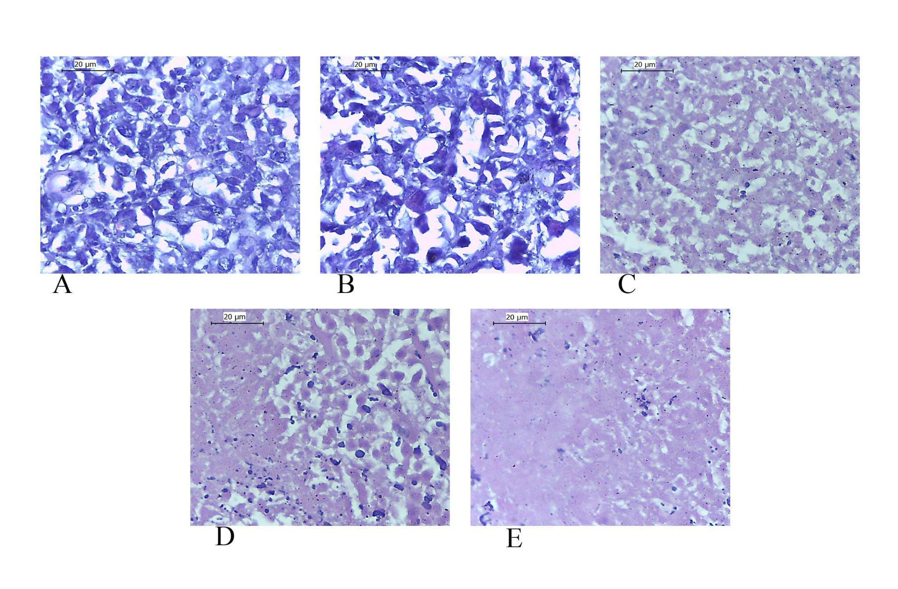
Figure S1: Haematoxylin and eosin stained sections of tumor mass excised from DLA induced solid tumor from Swiss albino mice. Control without any treatment (A), treated with vehicle only (B), treated with Cyclophosphamide (C), treated with 25 mg kg⁻¹ b. w. VCEA (D) and treated with 50 mg kg⁻¹ b. w. VCEA (E). (Magnification ×40)
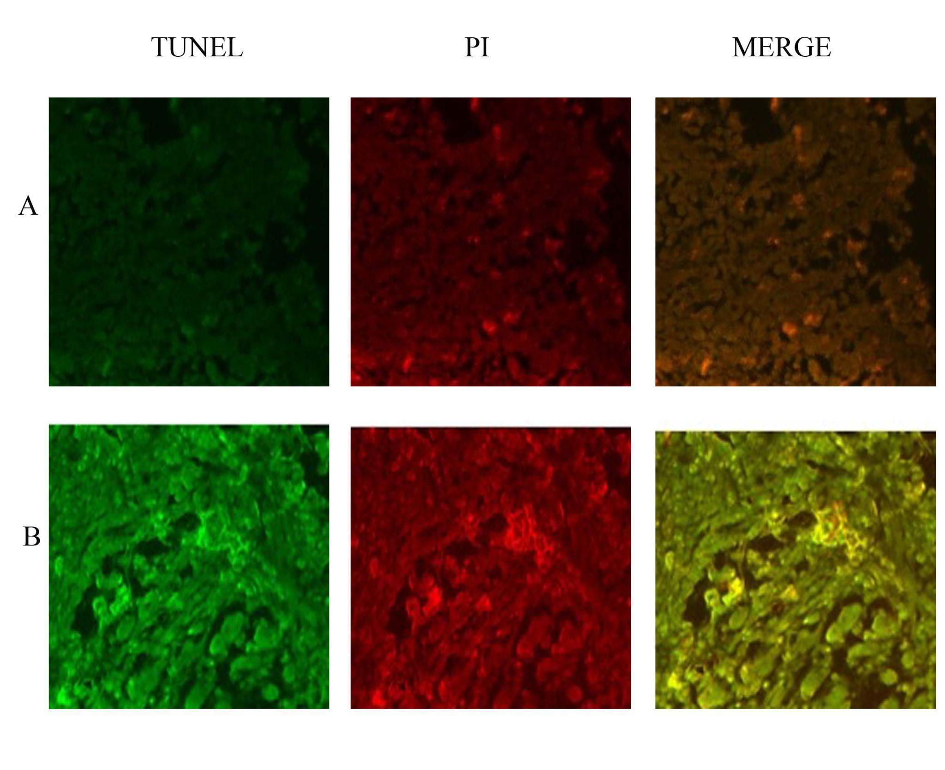
Figure S2: Representative pictures of TUNEL staining for apoptotic cells in DLA induced tumor tissue excised from mice. (A) Untreated control and (B) VCEA treated at the dose of 50 mg kg⁻¹ b. w. Green fluorescence indicates early to middle stages of apoptosis with dUTP-FITC positive cells. Red fluorescence indicates late stages of apoptosis and necrosis. (Magnification ×40).

