Study | 1 | 2 | 3 | 4 | 5 | 6 | 7 | 8 | 9 | 10 | 11 | 12 | 13 | 14 | Total score | Quality rating
Cao, 2010 | Yes | Yes | Yes | Yes | No | Yes | Yes | NA | Yes | No | Yes | NR | Yes | No | 10 | Fair
Kovanlikaya, 2011 | Yes | Yes | Yes | Yes | No | Yes | Yes | NA | Yes | Yes | Yes | NR | Yes | No | 11 | Good
Ulrich, 2014 | Yes | Yes | Yes | Yes | No | Yes | Yes | NA | Yes | Yes | Yes | Yes | Yes | No | 12 | Good
Okada, 2006 | Yes | Yes | Yes | Yes | No | Yes | Yes | NA | Yes | Yes | Yes | NR | Yes | No | 11 | Good
Chen, 2007 | Yes | Yes | Yes | Yes | No | Yes | Yes | NA | Yes | Yes | Yes | Yes | Yes | No | 12 | Good
Ulrich, 2014 | Yes | Yes | Yes | Yes | No | Yes | No | NA | Yes | Yes | Yes | NR | Yes | No | 10 | Fair
Zdunczyk, 2021 | Yes | Yes | Yes | Yes | No | Yes | Yes | NA | Yes | Yes | Yes | NR | Yes | No | 11 | Good
Topcuoglu, 2021 | Yes | Yes | Yes | Yes | No | Yes | Yes | NA | Yes | Yes | Yes | NR | Yes | No | 11 | Good
Cannizzaro, 2019 | Yes | Yes | Yes | Yes | No | Yes | Yes | NA | No | NR | Yes | NR | Yes | No | 9 | Fair
Frischer, 2014 | Yes | Yes | Yes | Yes | No | Yes | Yes | NA | No | Yes | Yes | NR | Yes | Yes | 11 | Good
Chen, 2014 | Yes | Yes | Yes | Yes | No | Yes | Yes | NA | Yes | No | Yes | NR | Yes | No | 10 | Fair
Yao, 2015 | Yes | Yes | Yes | Yes | No | Yes | Yes | NA | Yes | Yes | Yes | NR | Yes | No | 11 | Good
González-Darder, 2020 | Yes | Yes | Yes | Yes | No | Yes | Yes | NA | Yes | No | Yes | NR | Yes | No | 10 | Fair
Arslan, 2020 | Yes | Yes | Yes | Yes | No | Yes | Yes | NA | Yes | No | Yes | NR | Yes | Yes | 11 | Good
Zhang, 2017 | Yes | Yes | Yes | Yes | No | Yes | Yes | NA | Yes | No | Yes | NR | Yes | No | 10 | Fair
Zhang, 2016 | Yes | Yes | Yes | Yes | No | Yes | Yes | NA | No | No | Yes | NR | Yes | Yes | 10 | Fair
Januszewski, 2016 | Yes | Yes | Yes | Yes | No | Yes | Yes | NA | Yes | No | Yes | NR | Yes | Yes | 11 | Good
Flores, 2015 | Yes | Yes | Yes | Yes | No | Yes | Yes | NA | Yes | No | Yes | NR | Yes | Yes | 11 | Good

NA, Not applicable; NR, Not reported.
1. Was the research question or objective in this paper clearly stated?
2. Was the study population clearly specified and defined?
3. Was the participation rate of eligible persons at least 50%?
4. Were all the subjects selected or recruited from the same or similar populations (including the same time period)? Were inclusion and exclusion criteria for being in the study prespecified and applied uniformly to all participants?
5. Was a sample size justification, power description, or variance and effect estimates provided?
6. For the analyses in this paper, were the exposure(s) of interest measured prior to the outcome(s) being measured?
7. Was the timeframe sufficient so that one could reasonably expect to see an association between exposure and outcome if it existed?
8. For exposures that can vary in amount or level, did the study examine different levels of the exposure as related to the outcome (e.g., categories of exposure, or exposure measured as continuous variable)?
9. Were the exposure measures (independent variables) clearly defined, valid, reliable, and implemented consistently across all study participants?
10. Was the exposure(s) assessed more than once over time?
11. Were the outcome measures (dependent variables) clearly defined, valid, reliable, and implemented consistently across all study participants?
12. Were the outcome assessors blinded to the exposure status of participants?
13. Was loss to follow-up after baseline 20% or less?
14. Were key potential confounding variables measured and adjusted statistically for their impact on the relationship between exposure(s) and outcome(s)?
Table S1: The NIH tool for quality assessment for included observational cohort studies.

Study | 1. Were patient’s demographic characteristics clearly described? | 2. Was the patient’s history clearly described and presented as a timeline? | 3. Was the current clinical condition of the patient on presentation clearly described? | 4. Were diagnostic tests or assessment methods and the results clearly described? | 5. Was the intervention(s) or treatment procedure(s) clearly described? | 6. Was the post-intervention clinical condition clearly described? | 7. Were adverse events (harms) or unanticipated events identified and described? | 8. Does the case report provide takeaway lessons?
Hosainey, 2014 | Yes | Yes | Yes | Yes | Yes | Yes | Yes | Yes
Pandurang, 2014 | Yes | Yes | Yes | Yes | Yes | Yes | Yes | Yes
Sharma, 2019 | Yes | Yes | Yes | Yes | Yes | Yes | Yes | Yes
McLaughlin, 2012 | Yes | Yes | Yes | Yes | Yes | Yes | Yes | Yes
Saliba, 2020 | Yes | Yes | Yes | Yes | No | Yes | Yes | Yes
Chen, 2007 | Yes | No | Yes | Yes | Yes | Yes | Yes | Yes
Alikhani, 2017 | Yes | Yes | Yes | Yes | Yes | Yes | Yes | Yes
Dong, 2021 | Yes | Yes | Yes | Yes | Yes | Yes | Yes | Yes
Delaunois, 2017 | Yes | Yes | Yes | Yes | Yes | Yes | Yes | Yes

Table S2. The Joanna Briggs Institute (JBI) Critical Appraisal for included Case Reports.

Support for judgement | Risk of bias | Li, 2018
They stated that randomization was done “by using stratified blocked randomization.” | Low risk | Random sequence generation (selection bias)
“The allocation sequence was generated by an independent third party of the National Center for Cardiovascular Disease of the People’s Republic of China, which also performed the randomization process” | Low risk | Allocation concealment (selection bias)
“Participants and the surgeons were not blinded.” | High risk | Blinding of participants and personnel (performance bias)
“Outcome assessors were blinded to patient management” | Low risk | Blinding of outcome assessment (detection bias)
The proportion of missing outcome is not significant and balanced in numbers across groups; 11.3% lost to follow-up. | Low risk | Incomplete outcome data (attrition bias)
The study protocol is not available but all of the study’s pre-specified outcomes that are of interest have been reported in the pre-specified way. | Low risk | Selective reporting (reporting bias)
There is insufficient information to assess whether an important risk of bias exists. | Unclear risk | Other bias
Table S3: Authors' judgments and justifications of the included RCTs using Cochrane assessment table for the risk of bias.

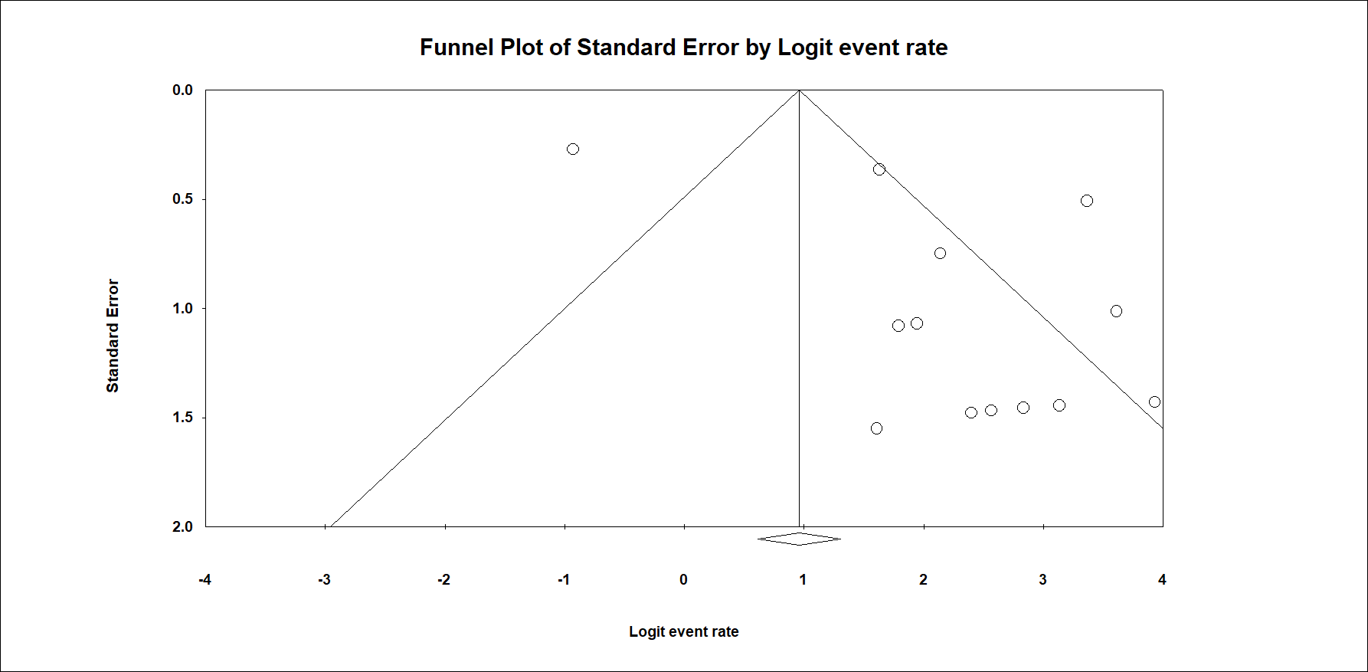
Figure S1: A funnel plot of the total resection

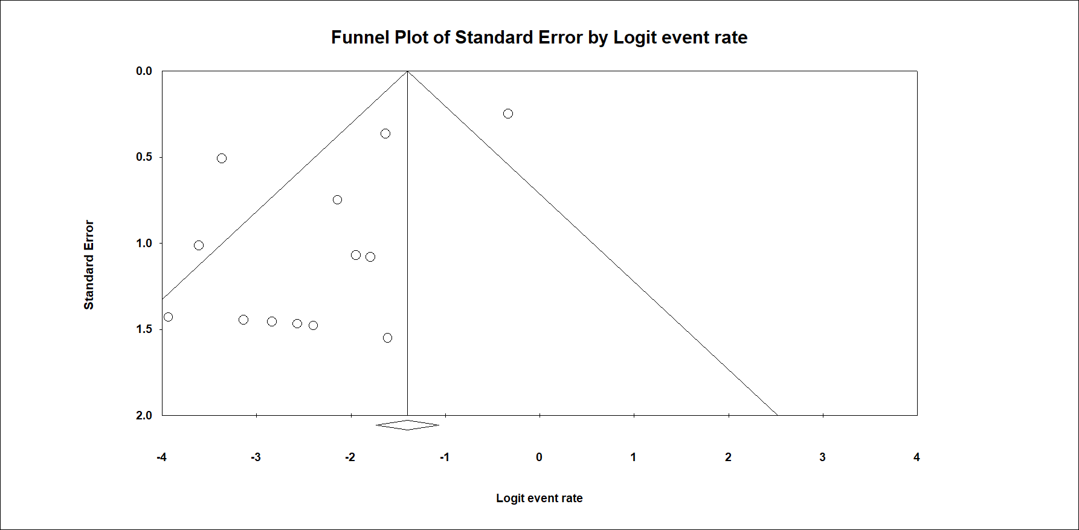
Figure S2: A funnel plot of the partial resection.

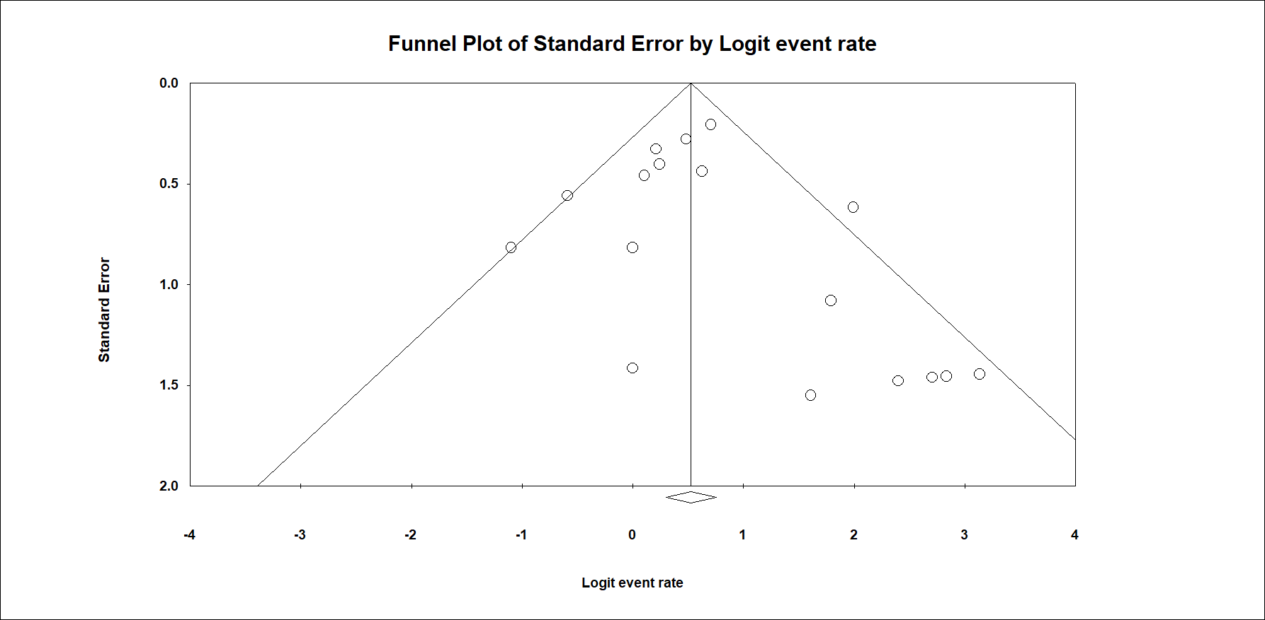
Figure S3: A funnel plot of the improved cases.

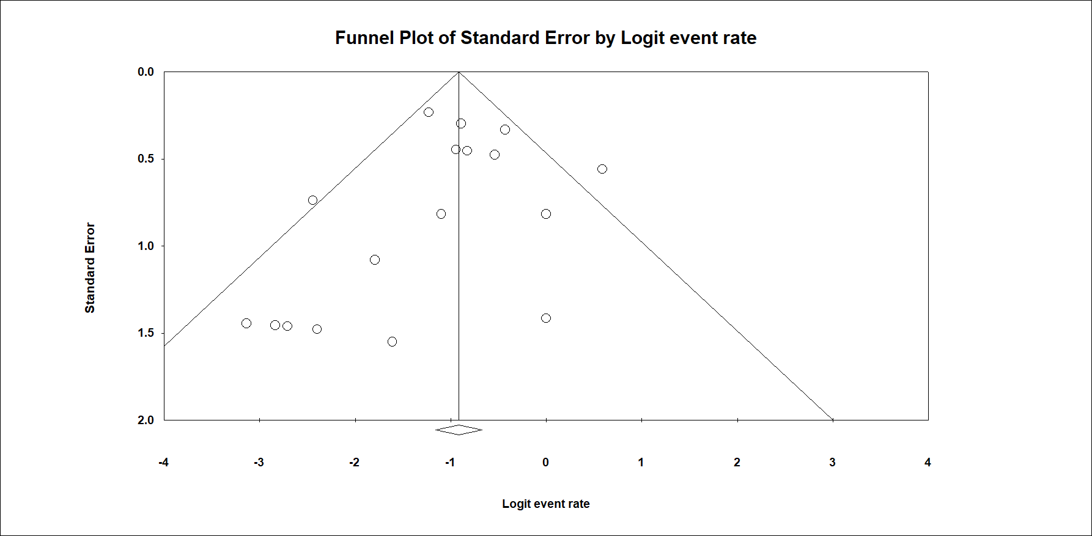
Figure S4: A funnel plot of the same condition.

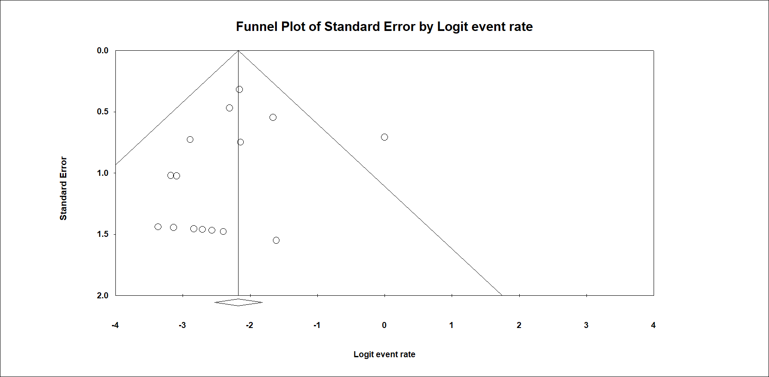
Figure S5: A funnel plot of the worsened cases.

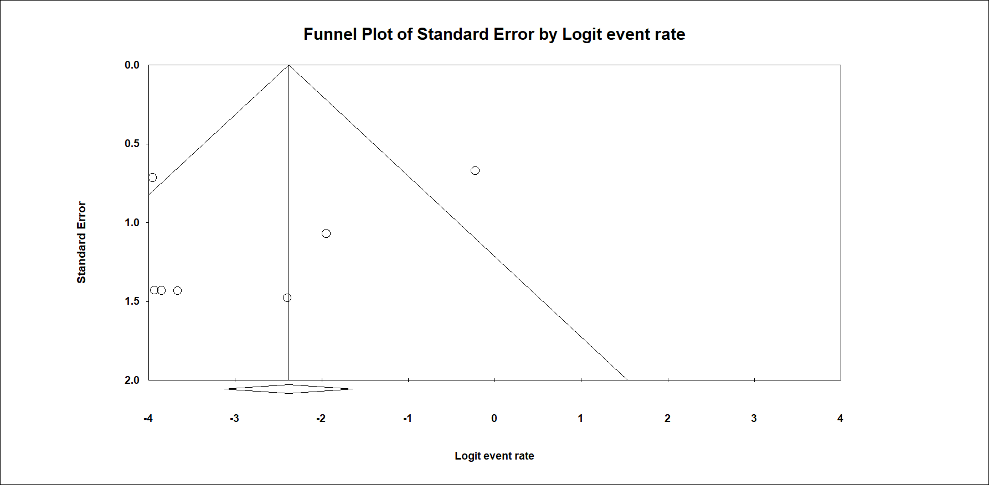
Figure S6: A funnel plot of the postoperative re-bleeding.

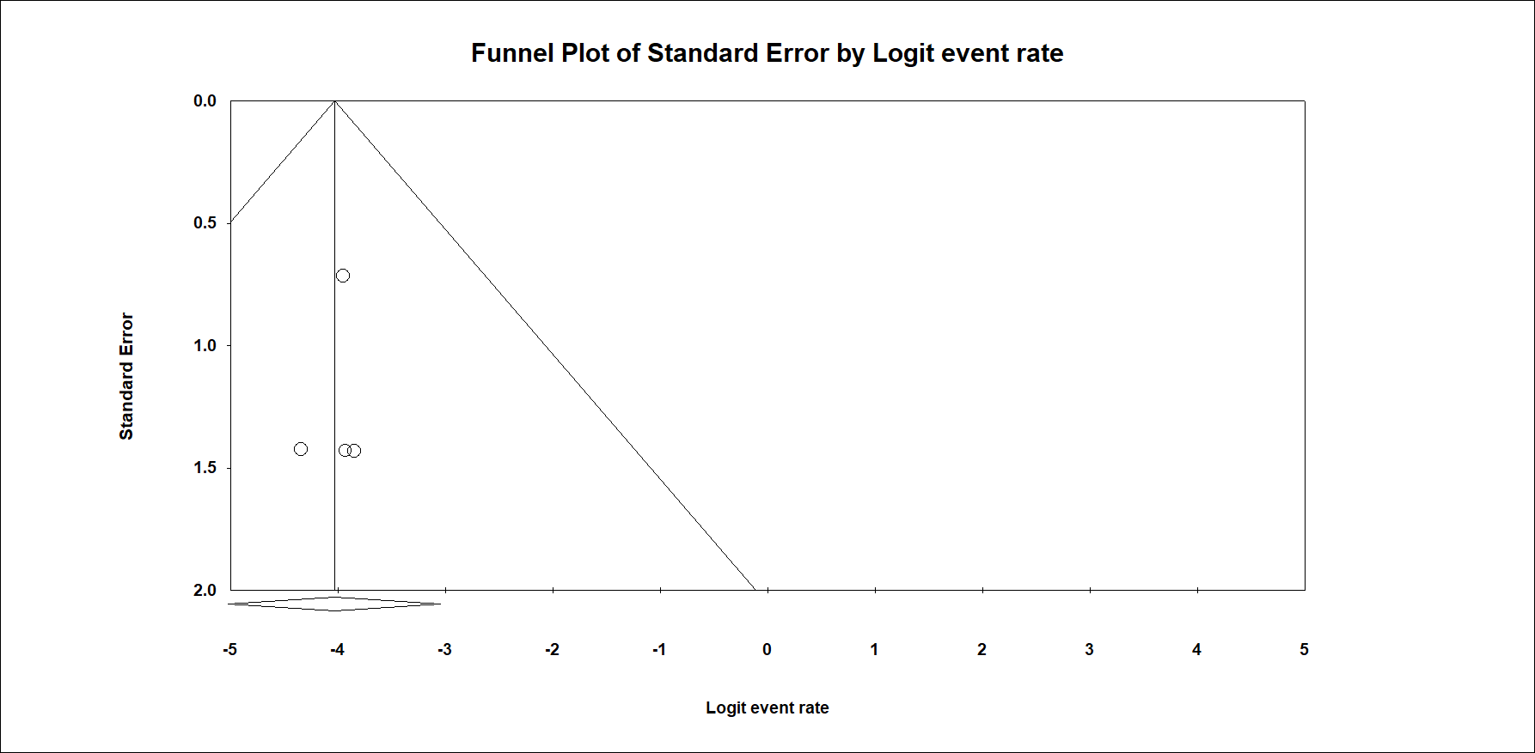
Figure S7: A funnel plot of the death-surgery related.

