

**Supplementary Figure 1 Changes in water salinity during rice growth in 3 communes (GH, GT and ND) in spring (a) and summer (b) seasons, in the varietal and irrigation management studies (combined data). Vertical bars represent ±SD.**

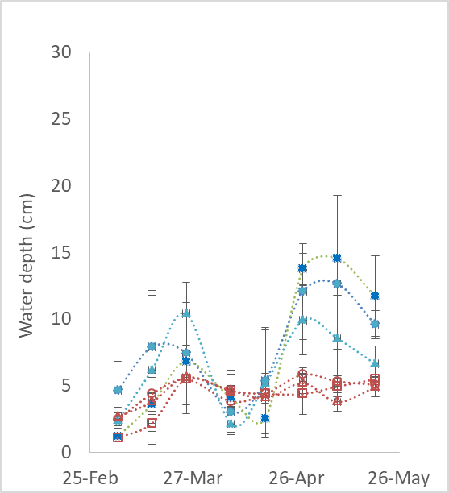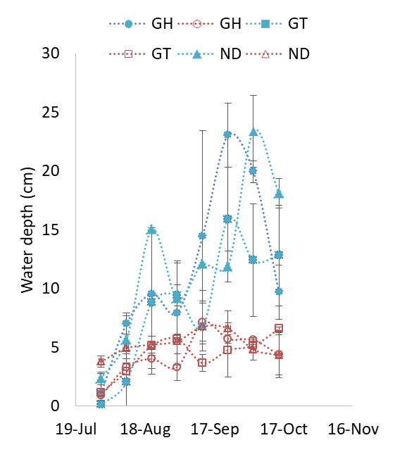

a

b

**Supplementary Figure 2 Water depth in the control (Wc) and shallow (Ws) water depth treatments in 3 communes (GH, GT, ND) during spring (a) and summer (b) seasons, in the irrigation management study. Data are from 2017; vertical bars represent ±SD.**

**Supplementary Table 1 Overview of the on-farm experiments in the varietal study and the irrigation management study.**

|  |  |  |  |  |  |
| --- | --- | --- | --- | --- | --- |
| Trial | Crop season | Number of experiments | Variety | Location | Treatments |
| Variety study  (10 trials) | 2016 spring | 3 | M2, M14, BC15 a | GH, GTa, ND | Salinity resistant varieties (M2, M14)  vs.  conventional varieties (BC15, Cuu Dahe 1, Thien uu 8) |
| 2016 summer | 3 | M2, M14, BC15 a | GH, GT, ND a |
| 2017 spring | 2 | M2, M14, BC15 | GH, GT |
| 2017 summer | 2 | M2, M14, BC15 | GH, GT |
| Irrigation management  (10 trials) | 2016 spring | 3 | BT7 | GH | Shallow depth (<5 cm)  vs.  conventional (deeper) depth |
| Cuu Dahe 1 | GT |
| Nhi uu 838 | ND |
| 2016 summer | 3 | M2, M14, BC15 | GH |
| M14, BC15 | GT |
| M14,  Thien uu 8 | ND |
| 2017 spring | 2 | BC15 | GH, GT |
| 2017 summer | 2 | BC15 | GH, GT |

a Instead of rice variety BC15, variety Cuu Dahe 1 was grown in the GT field in 2016 spring, and variety Thien uu 8 was grown in ND in 2016 summer.

**Supplementary Table 2 Mean fertilizer application rates in the varietal study and the irrigation management study.**

|  |  |  |  |  |  |
| --- | --- | --- | --- | --- | --- |
| Year | Season | Commune | N (kg ha-1) | P2O5 (kg ha-1) | K2O (kg ha-1) |
| 2016 | spring | GH | 215 | 46 | 55 |
| GT | 258 | 25 | 43 |
| ND | 226 | 69 | 21 |
| summer | GH | 171 | 90 | 64 |
| GT | 219 | 47 | 56 |
| ND | 255a | 50 | 15 |
| 2017 | spring | GH | 173 | 39 | 78 |
| GT | 206 | 35 | 47 |
| summer | GH | 183 | 33 | 73 |
| GT | 210 | 21 | 63 |

a The farmers in ND in summer 2016 re-applied N fertilizer after re-transplanting because the first group of seedlings died shortly after transplanting.

**Supplementary Table 3 Main effects and two-way interactions of year, commune, season, and variety on grain yield (g m-2), in the varietal study.**

|  |  |  |  |  |  |
| --- | --- | --- | --- | --- | --- |
| Main effects | | Interactions | | | |
| Year** | | Season x Variety ** | | Commune x Variety** | |
| 2016 | 606 a | Spring | | GH | |
| 2017 | 645 b | M2 | 665 | M2 | 635 |
| Commune** | | M14 | 644 | M14 | 635 |
| GH | 652 b | Vc | 728 | Vc | 686 |
| GT | 667 b | Summer | | GT | |
| ND | 470 a | M2 | 557 | M2 | 632 |
| Season** | | M14 | 574 | M14 | 618 |
| Spring | 679 b | Vc | 560 | Vc | 751 |
| Summer | 564 a |  |  | ND | |
| Variety ns | |  |  | M2 | 523 |
| M2 | 611 |  |  | M14 | 539 |
| M14 | 609 |  |  | Vc | 348 |
| Vc | 644 |  |  |  |  |

Means in each category are from ANOVA with unbalanced sample numbers.

*, ** significantly different at p<0.05 and p< 0.01, respectively

ns not significantly different.

Means followed by different lower case letters are significantly different at the 5% level by Tukey multiple range tests.

**Supplementary Table 4 Main effects and two-way interactions of year, commune, season, and water treatment on grain yield (g m-2) in the irrigation management study.**

|  |  |  |  |
| --- | --- | --- | --- |
| Main effects | | Interaction effects | |
| Year ns | | Commune x Water depth* | |
| 2016 | 631 | GH | |
| 2017 | 697 | Conventional | 660 |
| Commune** | | Shallow | 665 |
| GH | 663 b | GT | |
| GT | 714 c | Conventional | 728 |
| ND | 534 a | Shallow | 700 |
| Season** | | ND | |
| Spring | 758 b | Conventional | 571 |
| Summer | 557 a | Shallow | 496 |
| Water depth* | |  |  |
| Conventional | 669 b |  |  |
| Shallow | 645 a |  |  |

*, ** significantly different at p<0.05 and p<0.01, respectively.

ns not significantly different.

Means in each category are from ANOVA with unbalanced numbers of samples.

Means followed by different lower case letters are significantly different at the 5% level by Tukey multiple range tests.