SUPPLEMENTARY MATERIAL
A new iridoid glucoside from the roots of Morinda officinalis

Le Thi Huyenª,* Nguyen Viet Duy Anh^{b}, Vu Mai Thao^{b}, Nguyen Thi Kim Thoa^{c}, Nguyen Thi Minh Hang^{b,}*

ªVNU University of Science, Vietnam National University, Hanoi, 334 Nguyen Trai, Thanh Xuan, Hanoi, Viet Nam
^{b}Institute of Marine Biochemistry, Vietnam Academy of Science and Technology, Hanoi 10072, Vietnam
^{c}Faculty of Basic Science, Hanoi University of Mining and Geology, Hanoi, Vietnam

Correspondence to:
Le Thi Huyen, Ph.D.
VNU University of Science, Vietnam National University, Hanoi
334 Nguyen Trai, Thanh Xuan, Hanoi, Viet Nam
Hanoi 11512, Vietnam
E-mail address: lethihuyen@hus.edu.vn
Nguyen Thi Minh Hang, Ph.D.
Institute of Marine Biochemistry, Vietnam Academy of Science and Technology
Hanoi 10072, Vietnam
E-mail address: hangimbc@gmail.com
Contents
1. The chemical structures of compounds 2−10. 3
2. Cytotoxic assay 3
3. Inhibitory NO production in RAW264.7 cells assay 3
4. IR spectrum of compound 1 4
5. HR-ESI-MS of compound 1 4
6. ¹H-NMR spectrum of compound 1 in CD₃OD 6
7. ¹³C-NMR spectrum of compound 1 in CD₃OD 7
8. HSQC spectrum of compound 1 7
9. HMBC spectrum of compound 1 8
10. COSY spectrum of compound 1 8
11. NOESY spectrum of compound 1 9

The chemical structures of compounds 2−10.

Cytotoxic assay
To determine the viability of RAW 264.7 cells in the presence of compounds, cells were incubated for 24 h with compounds at a wide range of concentrations. The cell viability was evaluated by MTT assay. With this result, concentrations of sample (cell viability >80%) were selected for subsequent NO inhibition experiment.

Inhibitory NO production in RAW264.7 cells assay
The inhibitory effects of samples on NO production were evaluated in LPS-activated murine macrophage RAW 264.7 cells. Briefly, RAW 264.7 cells were cultured in Dulbecco’s modified Eagle’s medium (DMEM) supplemented with penicillin G sodium (100 units/ml), streptomycin sulfate (100 μg/ml), amphotericin B (0.25 μg/ml), and 10% fetal bovine serum (FBS). The cells were seeded in 96-well culture plates with 2 × 10⁵ cells/well and incubated for 24 h at 37°C in a humidified atmosphere containing 5 % CO₂. The cells were treated with samples dissolved in phenol red-free DMEM for 30 min followed by 1 μg/ml of LPS treatment for 24 h. The amount of NO in the cultured medium was measured by the Griess reagent. The standard curve was created by using known concentrations of sodium nitrite, and the absorbance was measured at 540 nm. To evaluate the cytotoxic effect of samples in RAW 264.7 cells in the assay condition, MTT assay was performed. The MTT assays were performed as follows: human cancer cells (1.5 ~ 2.5×10⁵ cells/ml) were treated for 3 days with the samples in the dimethylsulfoxide (DMSO): compounds (500 μM). After incubation, 0.1 mg (50 μL of a 2 mg/ml solution) MTT (Sigma, Saint Louis, MO, USA) was added to each well and the cells were then incubated at 37°C for 4 h. The plates were centrifuged at 1000 rpm for 5 min at room temperature and the supernatant was then carefully aspirated. DMSO (50 μL) was then added to each well to dissolve the formazan crystals. The plates were read immediately at 540 nm on a microplate reader (Amersham Pharmacia Biotech., USA).

IR spectrum of compound 1
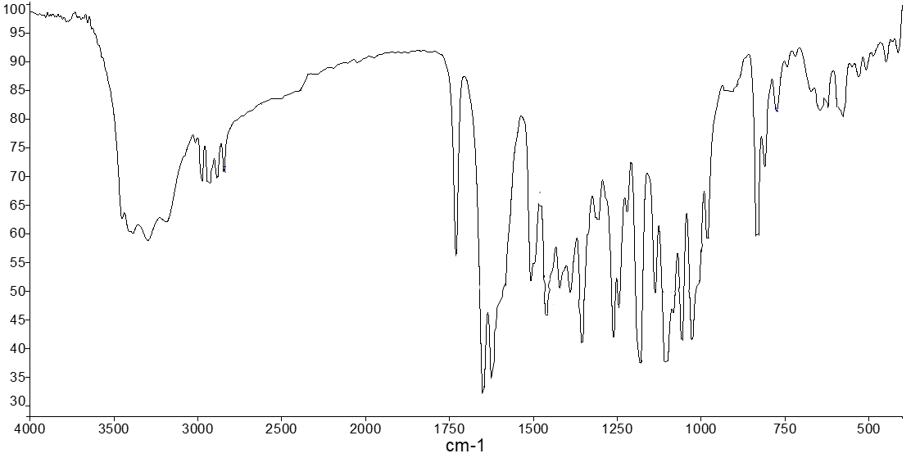

HR-ESI-MS of compound 1
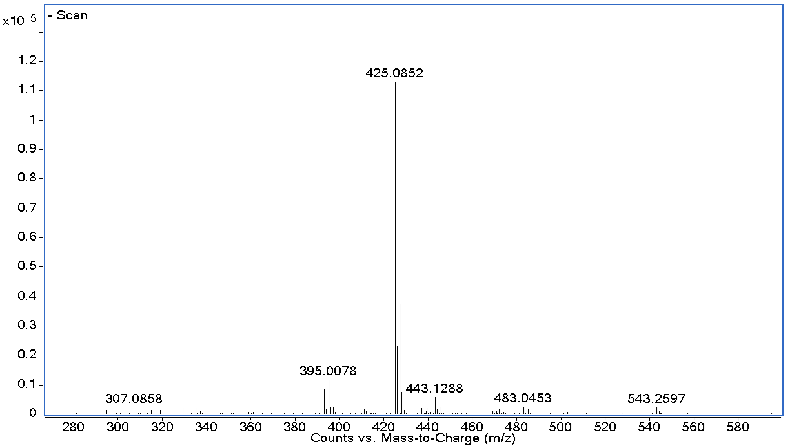

¹H-NMR spectrum of compound 1 in CD₃OD
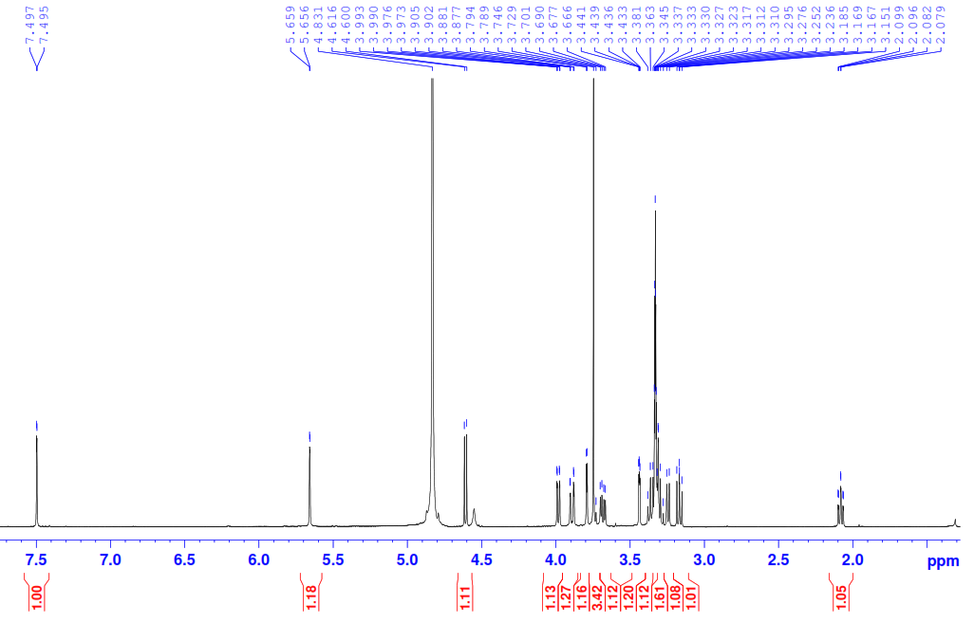

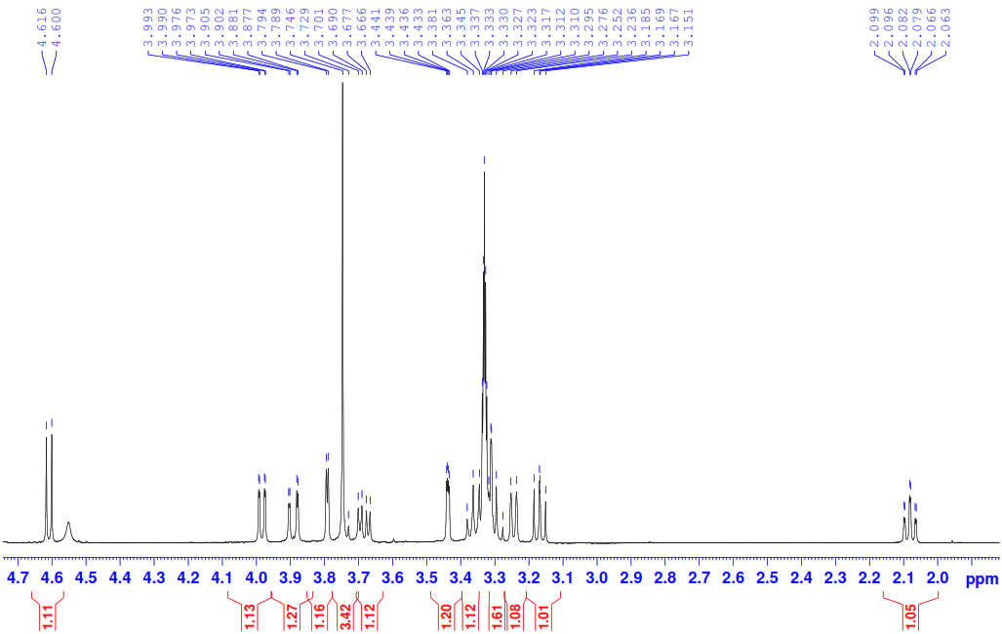

¹³C-NMR spectrum of compound 1 in CD₃OD
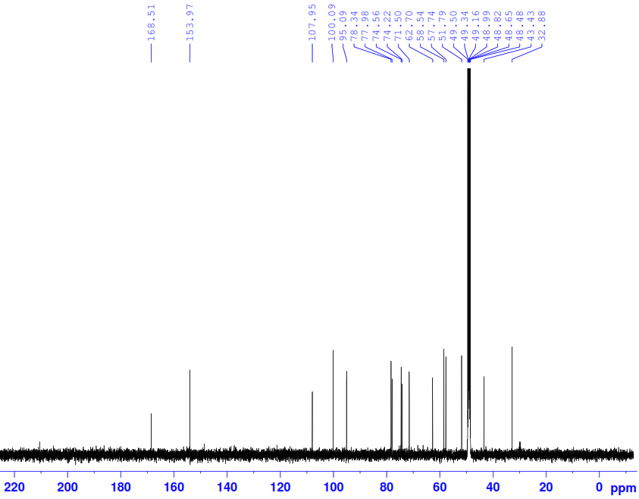

HSQC spectrum of compound 1
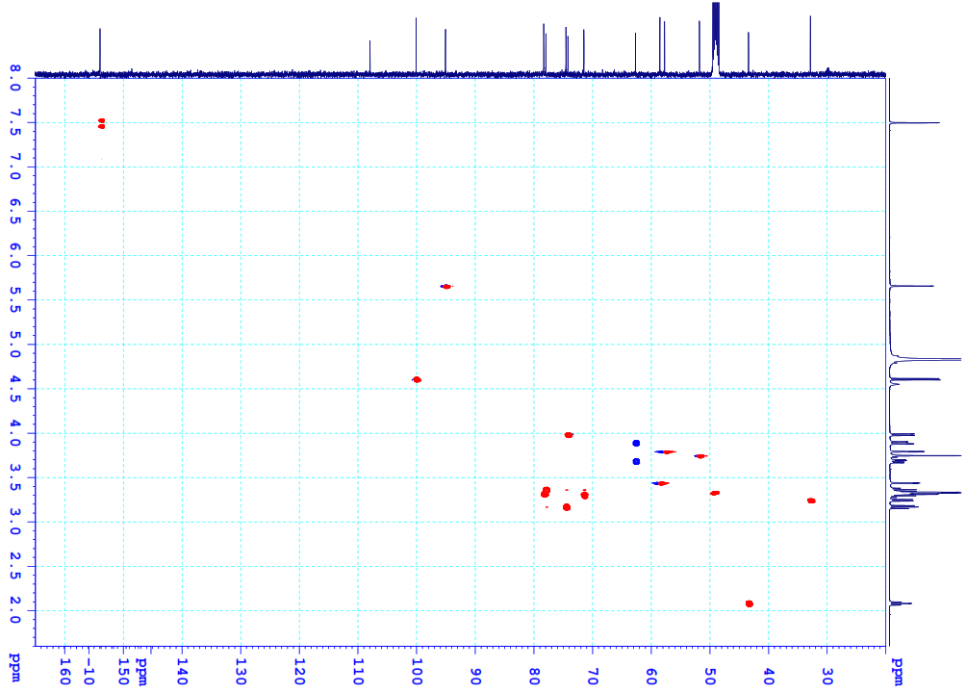

HMBC spectrum of compound 1
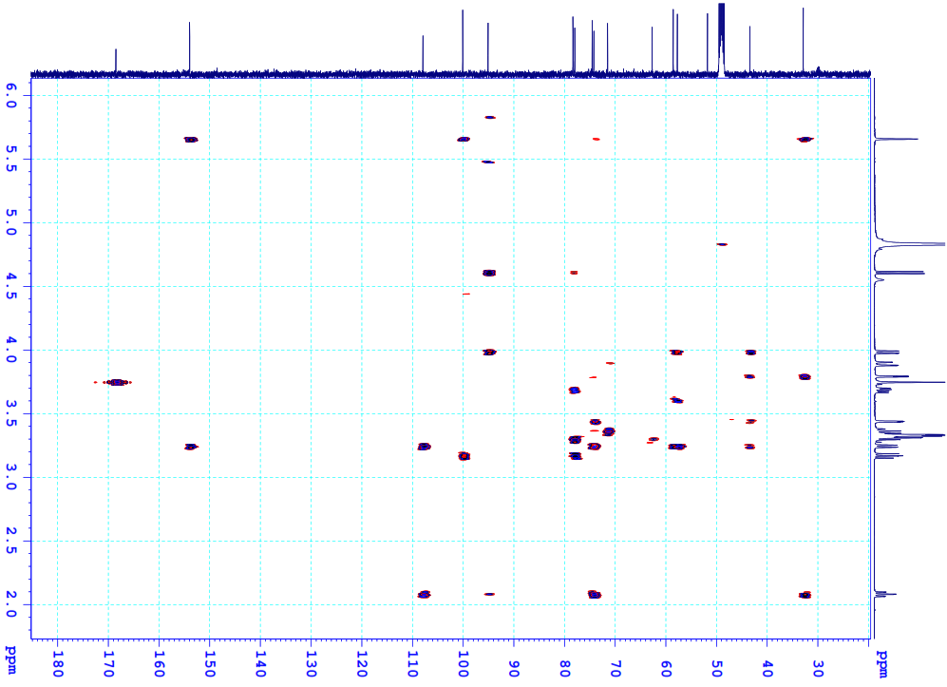

COSY spectrum of compound 1
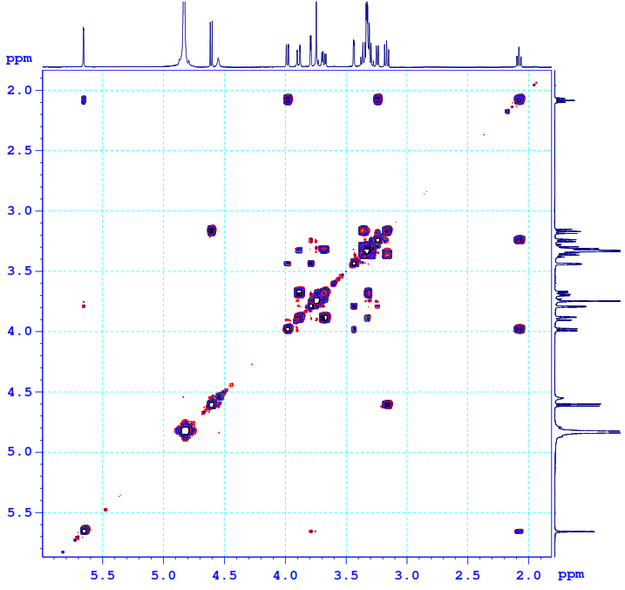

NOESY spectrum of compound 1
