Bioassay-guided identification of antithrombotic compounds from Cnidoscolus aconitifolius (Mill.) I.M. Jhonst.: molecular docking, bioavailability, and toxicity prediction
Juan Pablo Quintal Martínez¹, Irma Guadalupe Quintal Ortiz², Ligia Gabriela Alonso Salomón², Karlina García-Sosa³, Luis Manuel Peña Rodríguez³, José Antonio Guerrero Analco⁴, Juan Luis Monribot Villanueva⁴, Abraham Vidal Limón⁴, and Maira Rubi Segura Campos¹*

Docking molecular validation
For the validation of molecular docking methodologies, a decoy set of ligands was used along with the co-crystallized ligands. For decoy dataset generation, the co-crystal ligand (PDB ID: 4PY0, 4XNW, 1DWC, 2GDE, 2J4I, 1A5H) was used. The physicochemical properties of co-crystallized ligands, such as molecular weight, number of hydrogen bond acceptors and donors and LogP were used for decoy selection from ChEMBL database. Finally, all ligands were re-docked by previously described method under same parameters. ROC AUC (receiver opereting curve) was generated for all the afore mentioned ligands and included in supplementary material as Figure S1. The use of molecular docking methodologies, as shown in Figure S1, classified the data with a good performance of ~ 0.9, which represents a better classifier when selecting a true positive ligand upon all data set.
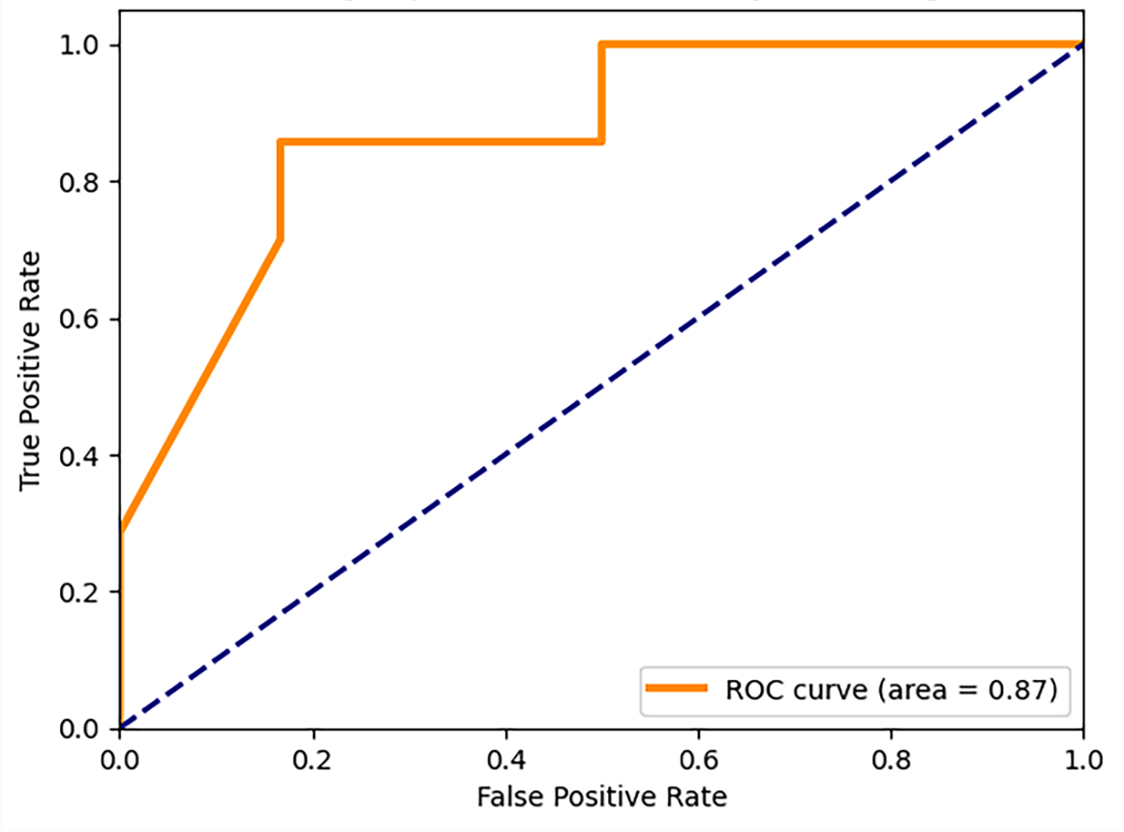
Figure S1. The ROC curve constructed based on the data set of 6 co-crystallized compounds. Data sets are presented as orange solid curve.

